ITAI 4373 – The New Nature of Work in AI

Muskaan Shahzad

Professor Patricia Mcmanus

Fall 2024

**Lab: Exploring AnyLogic Through Simulation: A Reflective Journal**

**(Bank Office Simulation model)**

**Introduction**

I chose the AnyLogic Bank Office simulation tutorial to gain practical experience with discrete-event modeling. This tutorial simulates the customer flow in a bank office, from arrival to service, and focuses on optimizing resources like tellers. Given my interest in AI applications for real-world systems, the scenario felt relevant and practical for understanding resource management in a bank setting.

**Learning Objectives**

My primary goal was to learn the basics of AnyLogic software and how to build a basic agent-based model and simulate workflows using AnyLogic. I wanted to explore how customer arrivals, service times, and available resources interact to impact system performance. Additionally, I aimed to become more familiar with the AnyLogic interface.

**Step-by-Step Reflection**

* **Step 1: Setting Up the Environment**: I started by designing the layout and adding customers and tellers as agents. The step was simple, though it required attention to ensure all components were logically placed.
* **Step 2: Configuring Customer Flow**: Using the ‘Source’ block, I defined customer arrivals at random intervals, representing variability in real-world scenarios, such as different times of day.
* **Step 3: Setting Up Tellers**: I created tellers and used the 'Service' block to control service times. This was key to managing customer wait times, as adjusting the parameters/properties significantly influenced the flow.
* **Step 4: Running the Simulation**: I observed how queues formed and how tellers handled customer demand. I also observed that the number of customers using the ATM and going to the tellers was the same because we had input this condition in properties.

**Challenges**

The biggest challenge for me was that I started encountering an error when I was running my simulation at the end. It was that time was somehow not completely accounted for. I went back and compared all my steps to the tutorial but still couldn’t find out what was wrong. I was able to run my simulation for a little amount of time before that error occurred.

**Insights**

This tutorial showed me the impact of small parameter changes on overall performance. The use of queues to handle customer demand was particularly interesting, as it highlighted the importance of efficient resource management.

**Key Takeaways**

I learned how to build and modify agent-based models, and how changes to individual components affect the entire system. This skill is crucial for analyzing real-world systems in different industries.

**Final Model**

My final model simulated a bank office with four tellers and tracked customer wait times and resource utilization. It also showed a 3d model where you could see customers waiting in queues to use the ATM or to use the Teller services. The final model represents an efficient system for managing customer service.

**Conclusion**

This tutorial provided a strong foundation in simulation modeling. It enhanced my understanding of how agent-based models can optimize workflows, and how these principles can be applied to real-world scenarios like healthcare, logistics, or a bank like in my used example.

**Screenshots and Key Points (not in a particular order)**

My model (in progress) in the AnyLogic software

**

Tellers (Office workers) and tables (3d objects) in the 3d simulation

Customers using the ATM machine

**

Customers (3d animation)

3d window at the bottom and Main

Path and node in 3d animation

Rotating the path and node using the shift key in 3d animation

Building a simple queue model

Ran into an error when used visual simulation

Inspect window

Queue model, path, and node in Main

Running the simulation of the simple queue model

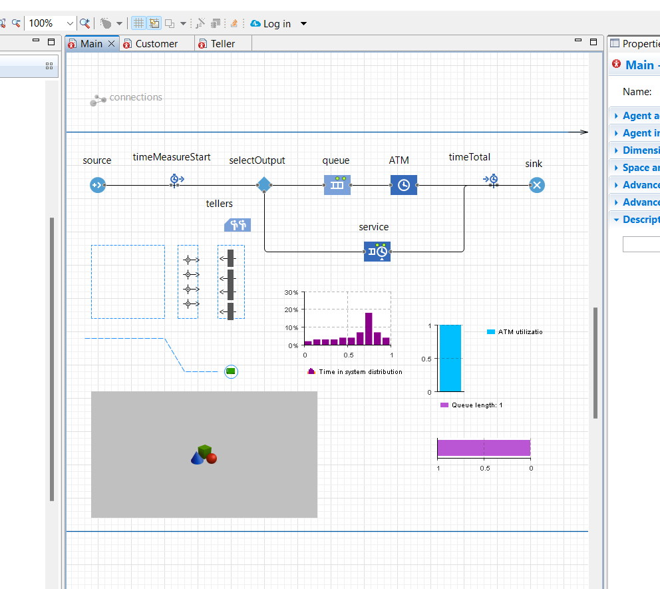

Final model in Main

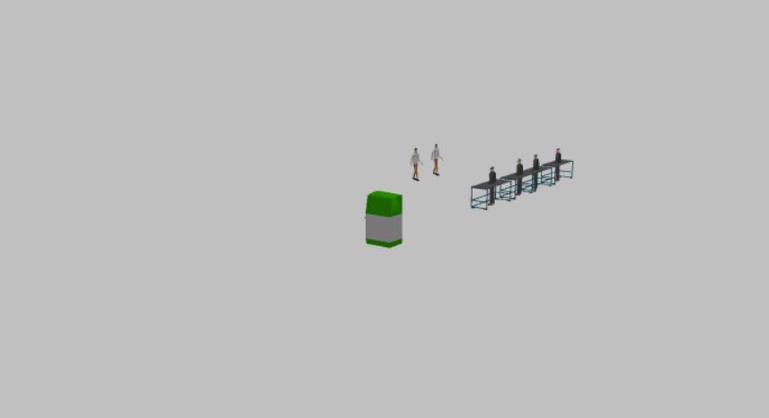

Final model (3d Animation)

---------------------------------------------------------------------------------------------------------------------

**Citations**

1. <https://anylogic.help/tutorials/bank-office/index.html>