**Assignment – 1**

**Muskan Malhotra**

**1) Create &amp; remove environment variable:**

**Variable Name - TEST**

**Variable Value - C:\Program Files (x86)\Test\**

[Environment]::SetEnvironmentVariable("TEST","C:\Program Files (x86)\Test\","User")

if want to create a user environment variable

[Environment]::SetEnvironmentVariable("TEST","C:\Program Files (x86)\Test**\**","Machine")

if want to create a system environment variable

**#for removal**

REG delete “HKCU\Environment” /F /V “TEST”

**2) Create a shortcut with below parameters and set icon for that shortcut.**

**Location - C:\ProgramData\Microsoft\Windows\Start Menu\Programs\Test\**

**Shortcut Name – Internet Explorer Test.lnk**

**Target EXE - &quot;C:\Program Files (x86)\Internet Explorer\iexplore.exe&quot;**

**Start in - &quot;C:\Program Files\Internet Explorer&quot;**

**Icon – Yes**

**\*\*\*\*\*\*\*\*\*\*\*\*\*\*\*\*\*\*\*\*\*\*\*\*\*\*\*\*\*\*\*\*\*\*\*\*\*\*\*\*\*\*\*\*\*\*\*\*\*\*\*\*\*\*\*\*\*\*\*\*\*\*\*\*\*\*\*\*\*\*\*\*\*\*\*\*\*\*\*\*\*\*\*\*\*\*\*\*\*\*\*\*\*\*\*\*\*\*\*\*\*\*\***

#we will be using windows script host(older technology)

#win script host is instantiated first.

$WinObj = New-Object -ComObject WScript.Shell

#using createshortcut method and assigning it to a variable

#this is location where the shortcut needs to be created

#this dont create shortcut rather just instantiates the create shortcut object.

$ShortCut = $WinObj.CreateShortcut("C:\ProgramData\Microsoft\Windows\Start Menu\Programs\Test\Internet Explorer Test.lnk")

#Path to file shortcut will open

#location of the file which we want our shortcut to open

$ShortCut.TargetPath = "C:\\Program Files (x86)\Internet Explorer\iexplore.exe"

#start in????**********************

#adding icon for the shortcut

$ShortCut.IconLocation = "C:\Users\HP\OneDrive\Desktop\star.ico"

$ShortCut.Save()

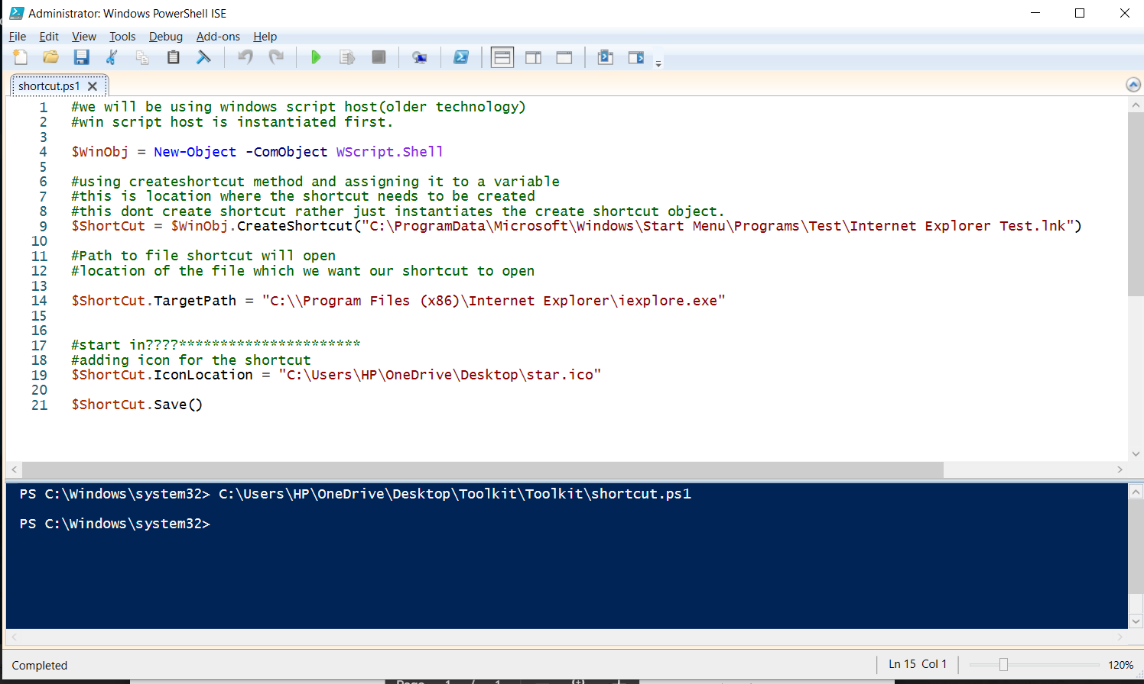

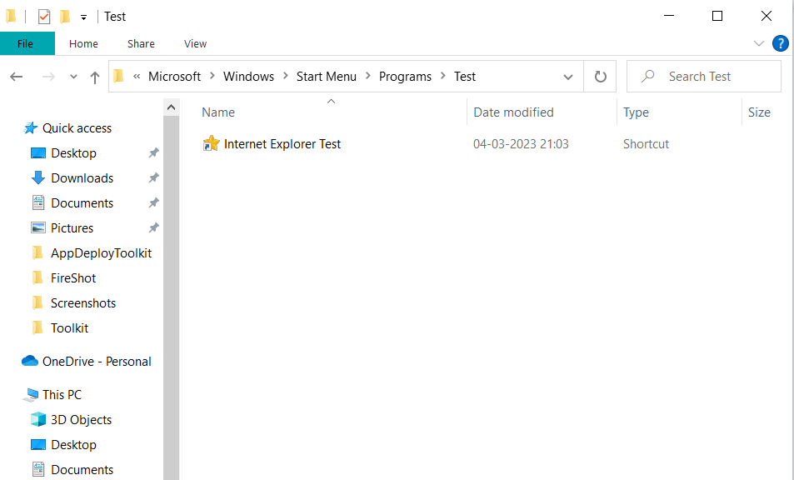

******************************************************************************************************************************************************************************************************************

**4) Read .ini file and update it.**

**VMClient.ini**

**Current Value - IndigoTcpPort=8100**

**New Value - IndigoTcpPort=8000**

**Also check if value MUOptIn = 0 is exists, If yes then set it to ‘1’ else add MUOptIn = 1**

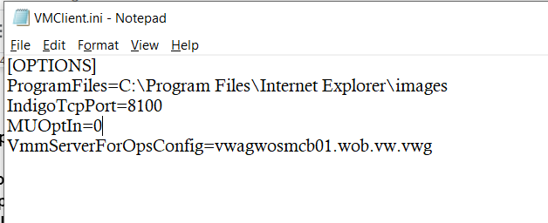

$GetiniContent = Get-Content "C:\Users\HP\OneDrive\Desktop\VMClient.ini"

($iniContent) | ForEach-Object { $_ -replace "IndigoTcpPort=8100","IndigoTcpPort=8000" } |

Set-Content "C:\Users\HP\OneDrive\Desktop\VMClient.ini"

Write-Host $iniContent

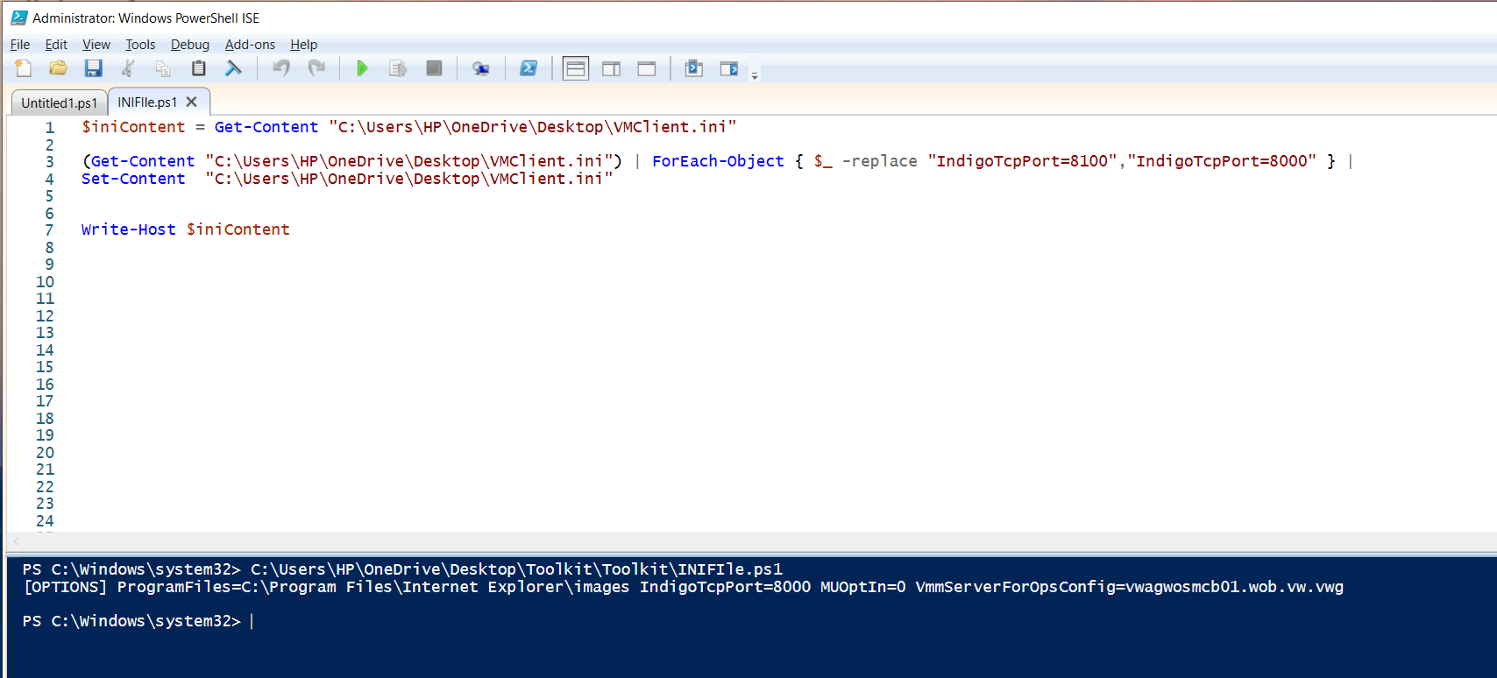

$GetiniContent = Get-Content "C:\Users\HP\OneDrive\Desktop\VMClient.ini"

($iniContent) | ForEach-Object { $_ -replace "IndigoTcpPort=8100","IndigoTcpPort=8000" } |

Set-Content "C:\Users\HP\OneDrive\Desktop\VMClient.ini"

Write-Host $iniContent

#Write-Host $iniContent[3]

if ($iniContent[3].Contains("MUOptIn=0")){

($iniContent) | ForEach-Object{$_ -replace "MUOptIn=0","MUOptIn=1"} |

Set-Content "C:\Users\HP\OneDrive\Desktop\VMClient.ini"

}

Write-Host $iniContent

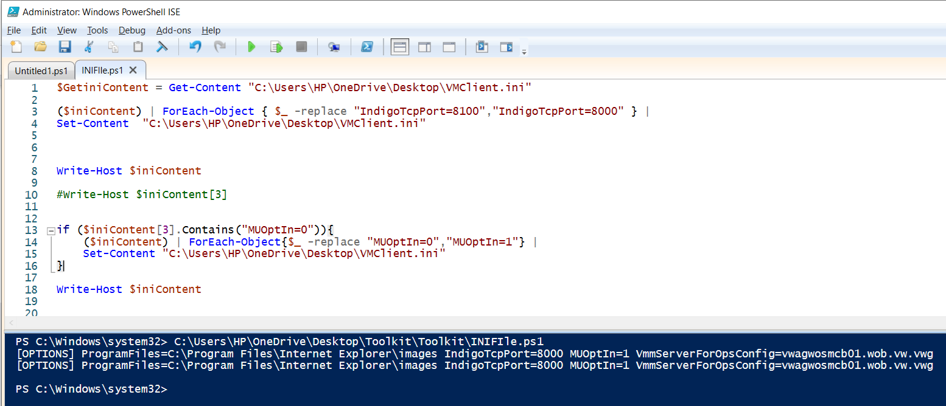

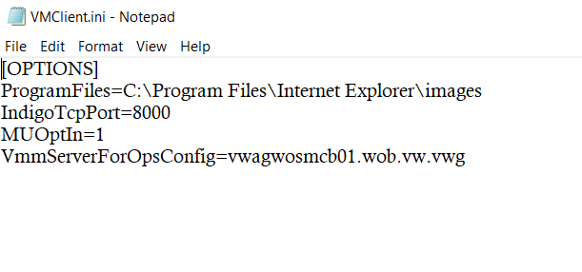

**\*\*\*\*\*\*\*\*\*\*\*\*\*\*\*\*\*\*\*\*\*\*\*\*\*\*\*\*\*\*\*\*\*\*\*\*\*\*\*\*\*\*\*\*\*\*\*\*\*\*\*\*\*\*\*\*\*\*\*\*\*\*\*\*\*\*\*\*\*\*\*\*\*\*\*\*\*\*\*\*\*\*\*\*\*\*\*\*\*\*\*\*\*\*\*\*\*\*\*\*\*\*\*\*\*\*\*\*\*\*\*\*\*\*\*\*\*\*\*\*\*\*\*\*\*\*\*\*\*\*\*\*\*\*\*\*\*\*\*\*\*\*\*\*\*\*\*\*\*\*\*\*\*\*\*\*\*\*\*\*\*\*\*\*\*\*\*\*\*\*\*\*\*\*\*\*\*\*\*\*\*\*\*\*\*\*\*\*\*\*\*\*\*\*\*\*\*\*\*\*\*\*\*\*\*\*\*\*\*\***

**(5)**

**Check system architecture of OS:**

**If operating system is x86 (32-bit) then displays a message “C:\Program Files\Test\”**

**If operating system is x64 (64-bit) then displays a message “C:\Program Files (x86)\Test\”**

**Displays a message accordingly in message Box.**

**\*\*\*\*\*\*\*\*\*\*\*\*\*\*\*\*\*\*\*\*\*\*\*\*\*\*\*\*\*\*\*\*\*\*\*\*\*\*\*\*\*\*\*\*\*\*\*\*\*\*\*\*\*\*\*\*\*\*\*\*\*\*\*\*\*\*\*\*\*\*\*\*\*\*\*\*\*\*\*\*\*\*\*\*\*\*\*\*\*\*\*\*\*\*\*\*\*\*\*\*\*\*\*\*\***

If ($Is64BitProcess) { [System.Windows.MessageBox]::Show("C:\Program Files\Test\")

Write-Host "This is 32Bit OS" }

Else { [System.Windows.MessageBox]::Show("C:\Program Files (x86)\Test\")

Write-Host "This is 64Bit OS" }

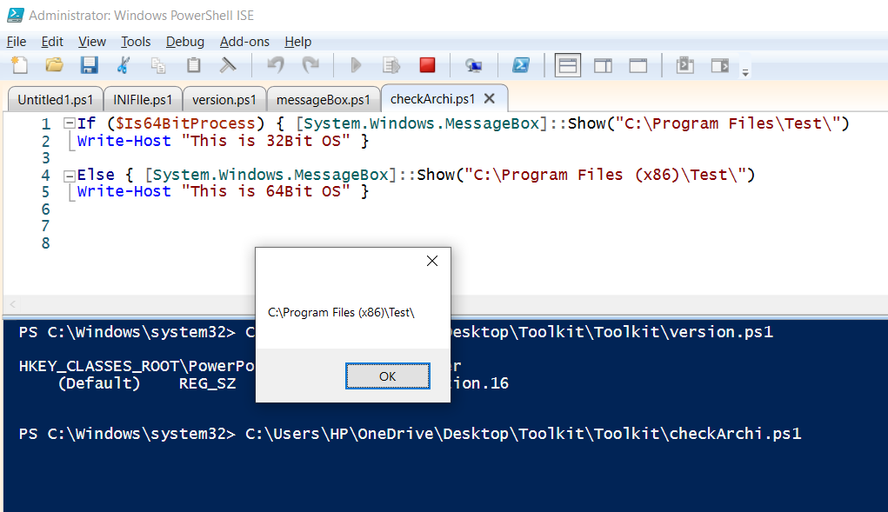

**(6) Check installed Microsoft Office version on the machine and displays a message accordingly.**

