**Muskan Malhotra**

**HandOn - Bash Script**

**#IF - ELSE CONDITION**

**~$ vi if.sh**

**Bash file -> if.sh**

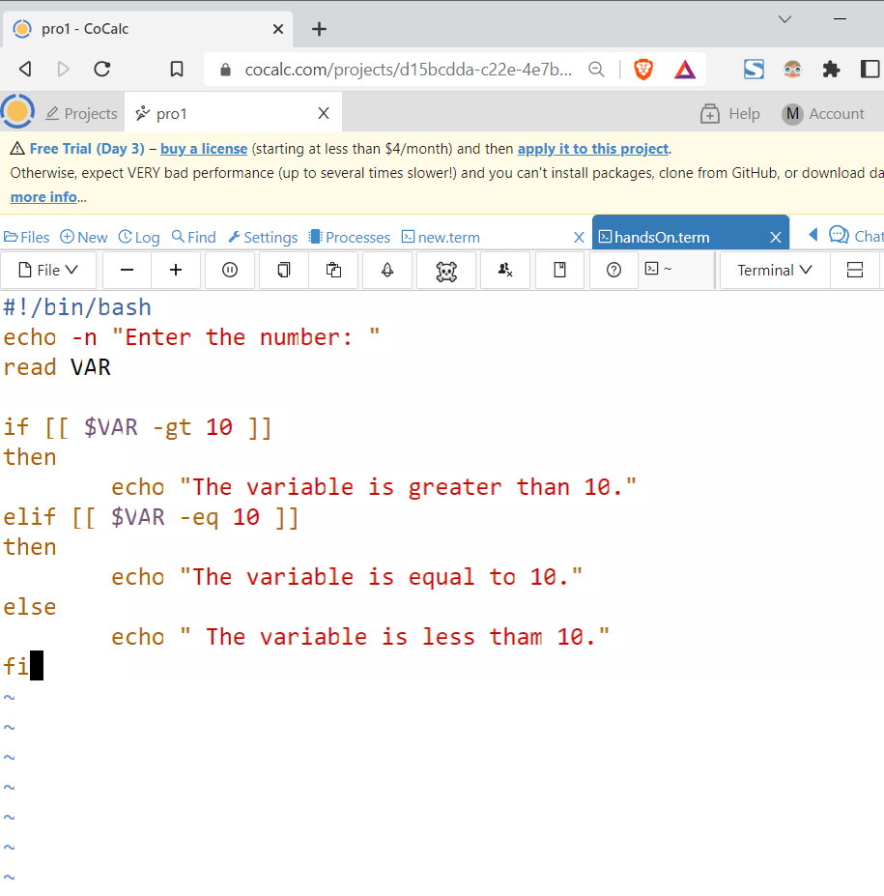

**~$ chmod +x if.sh**

**~$ ./if.sh**

Enter the number: 25

The variable is greater than 10.

**#LARGEST NUMBER**

**~$ vi largest.sh**

largest.sh

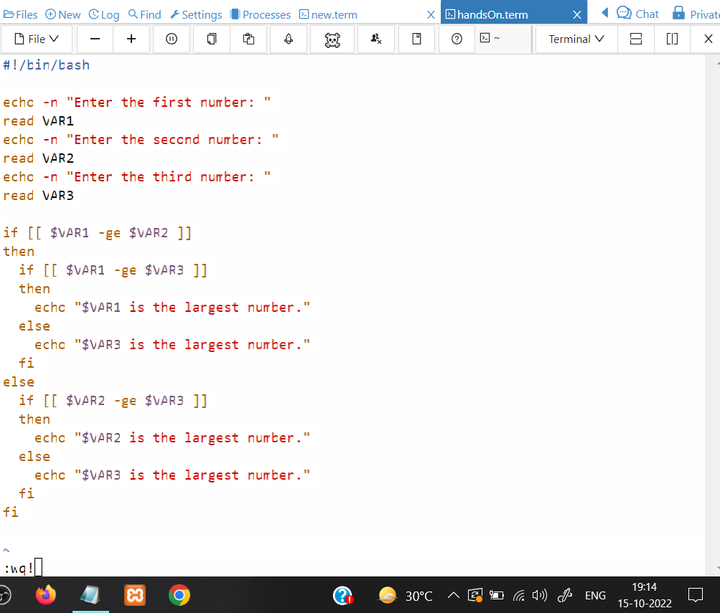

**~$ chmod +x largest.sh**

**~$ ./largest.sh**

Enter the first number: 25

Enter the second number: 10

Enter the third number: 36

36 is the largest number.

**#SWITCH**

**~$ vi switch.sh**

**switch.sh**

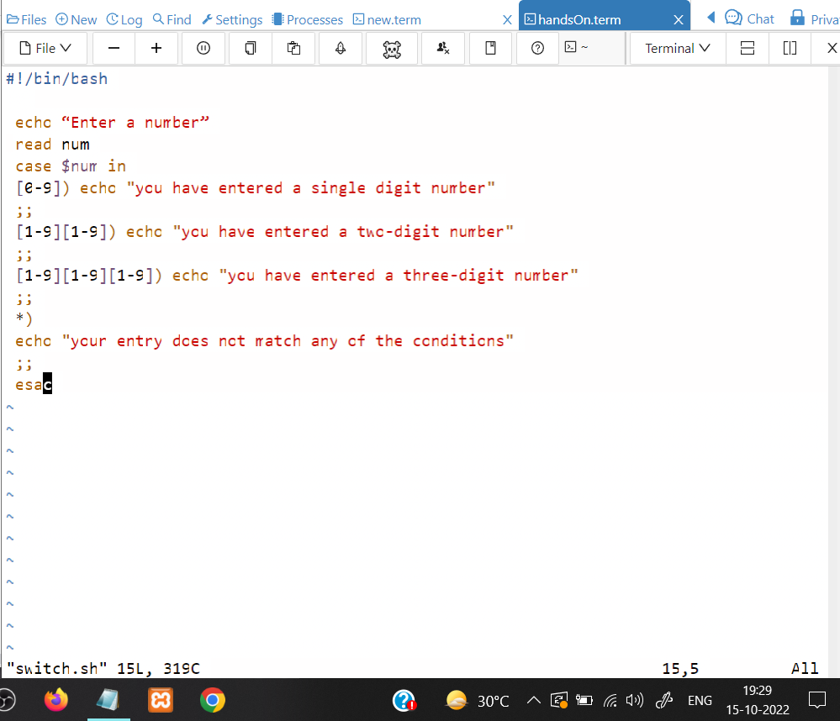

**~$ chmod +x switch.sh**

**~$ ./switch.sh**

“Enter a number”

24

you have entered a two-digit number

**#FOR LOOP**

**~$ vi forloop.sh**

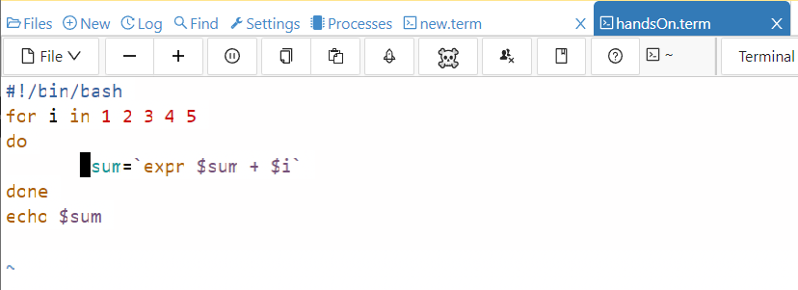

**~$ chmod +x forloop.sh**

**~$ ./forloop.sh**

15

**#WHILE LOOP**

**~$ vi while.sh**

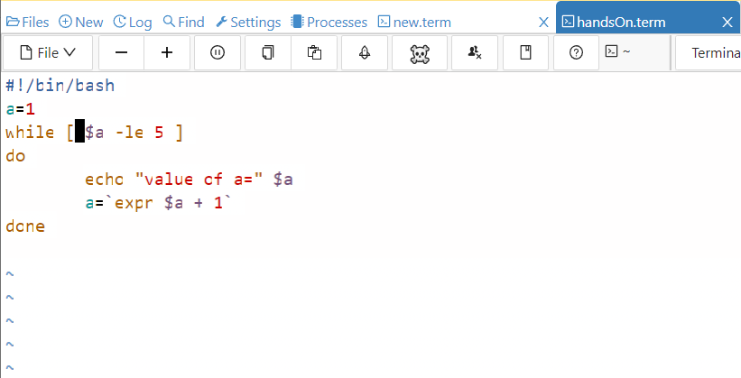

**~$ chmod +x while.sh**

**~$ ./while.sh**

value of a= 1

value of a= 2

value of a= 3

value of a= 4

value of a= 5

**# UNTIL LOOP**

**~$ vi until.sh**

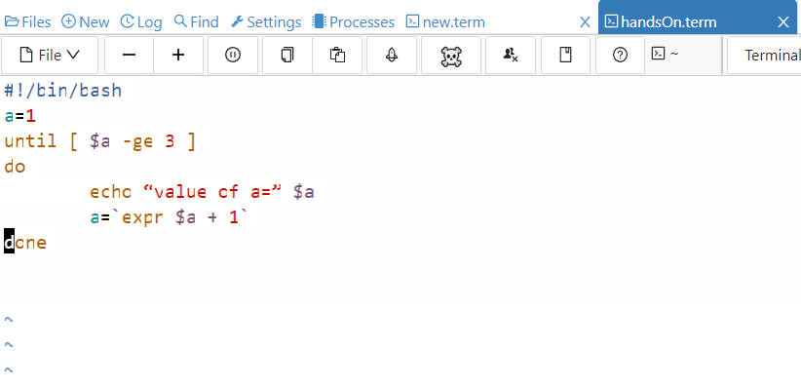

**~$ chmod +x until.sh**

**~$ ./until.sh**

“value of a=” 1

“value of a=” 2

**#META CHARACTERS**

**~$ vi meta.sh**

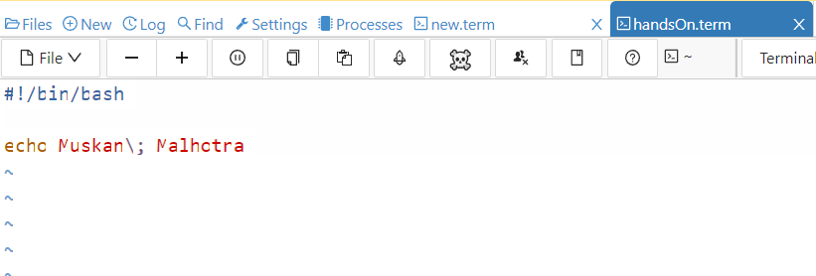

**~$ chmod +x meta.sh**

**~$ ./meta.sh**

Muskan; Malhotra

**#BASH COMMANDS**

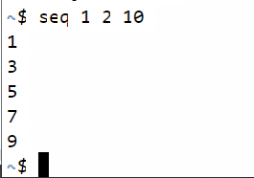

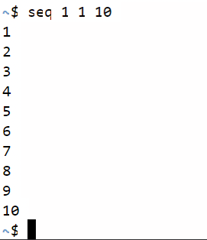

**~$ echo $(seq 1 2 10)**

1 3 5 7 9

**~$ echo `seq 1 2 10`**

1 3 5 7 9

**#FUNCTION**

**~$ vi function.sh**

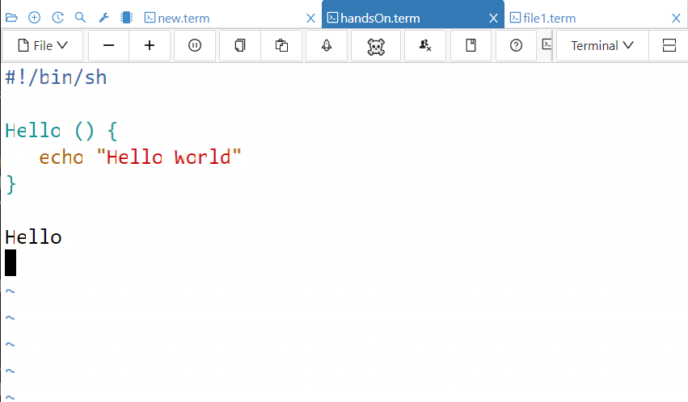

**~$ chmod +x function.sh**

**~$ ./function.sh**

Hello World

**#NESTED FUNCTION**

**~$ vi function.sh**

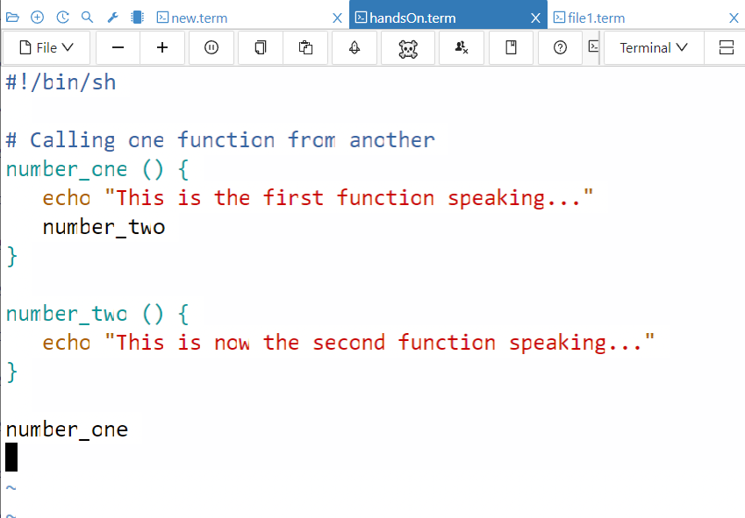

**~$ chmod +x function.sh**

**~$ ./function.sh**

This is the first function speaking...

This is now the second function speaking...