DecodeLabs Industrial Training

EDA for E-Commerce Dashboard

Name : Muskan
Batch: 2026
Tool Used: Microsoft Excel 2016

E-Commerce Exploratory Data Analysis (EDA) Dashboard Report

Project Overview
This project analyzes an e-commerce dataset using Microsoft Excel. The dataset was cleaned, explored using descriptive statistics, analyzed with Pivot Tables, and presented through an interactive dashboard.

Objectives
- Clean and prepare the dataset.
- Perform descriptive statistics.
- Analyze sales trends.
- Create Pivot Tables and Pivot Charts.
- Build an interactive dashboard.
- Generate business insights.

Tools Used
Microsoft Excel 2016
Pivot Tables
Pivot Charts
Data Cleaning
Data Visualization

Dataset
The dataset contains 1,200 e-commerce orders with OrderID, Date, CustomerID, Product, Quantity, UnitPrice, PaymentMethod, OrderStatus, ReferralSource, and TotalPrice.

Data Cleaning
- Handled missing values.
- Removed duplicates.
- Trimmed extra spaces.
- Checked consistency.
- Formatted dates.

Descriptive Statistics
Statistic | Quantity | UnitPrice | ItemsInCart | TotalPrice
Count | 1200 | 1200 | 1200 | 1200
Average | 2.95 | 356.41 | 5.49 | 1053.97
Median | 3 | 364.21 | 5 | 823.62
Minimum | 1 | 11.39 | 1 | 11.39
Maximum | 5 | 699.93 | 10 | 3456.40

Dashboard Components
- Orders by Product
- Orders by Payment Method
- Order Status Distribution
- Orders by Referral Source
- Revenue by Product

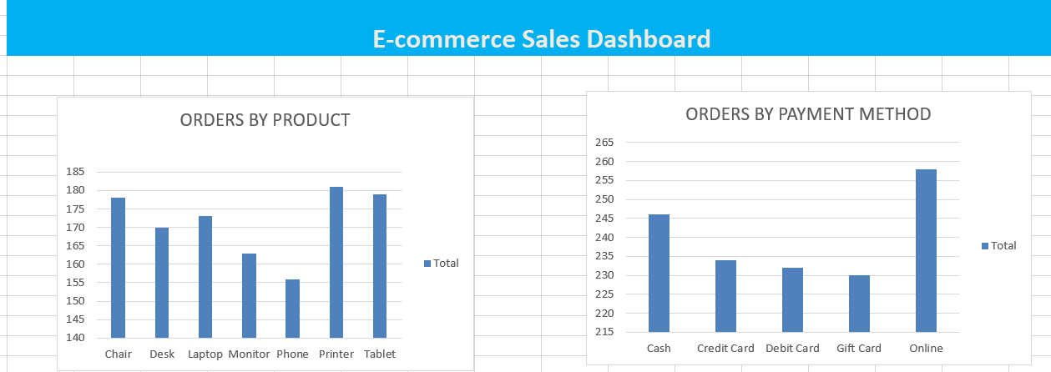
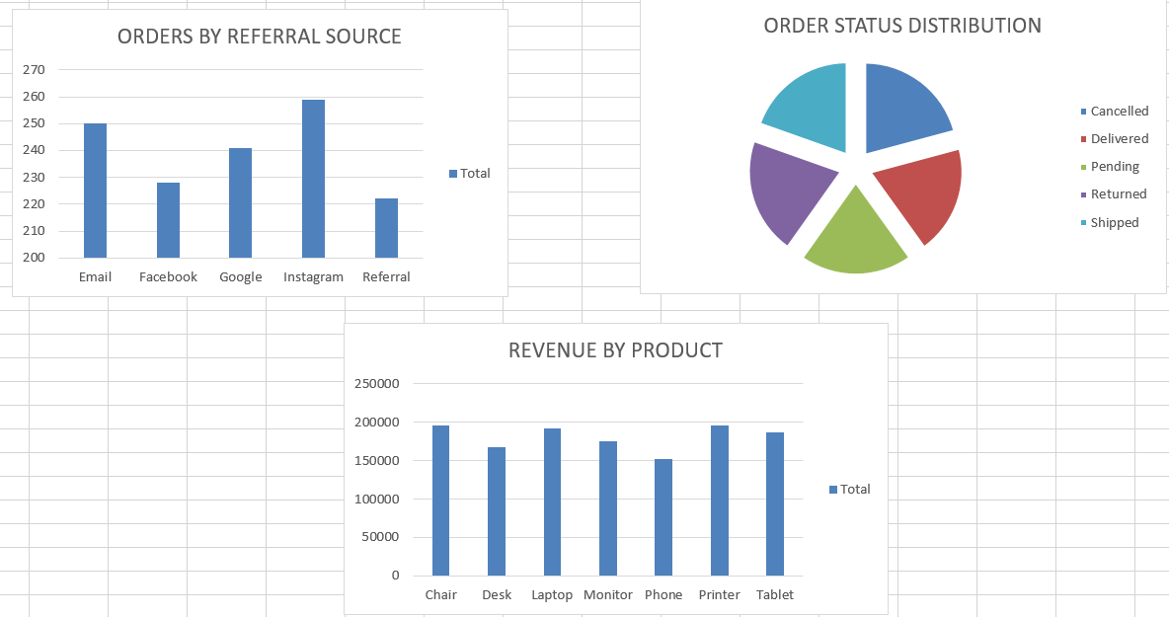

Key Insights
- Total Orders: 1200
- Most Ordered Product: Printer (181 orders)
- Dashboard highlights payment method usage, order status distribution, referral sources, and revenue by product.

Conclusion
This project demonstrates practical Excel skills for data cleaning, exploratory data analysis, and dashboard creation as part of the Decode Labs Data Analytics Internship.

