5. ReactJS-HOL
1. CohortDetails.module.css
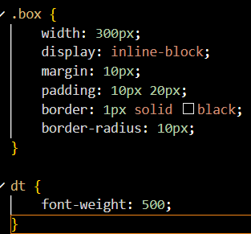

2. CohortDetails.js
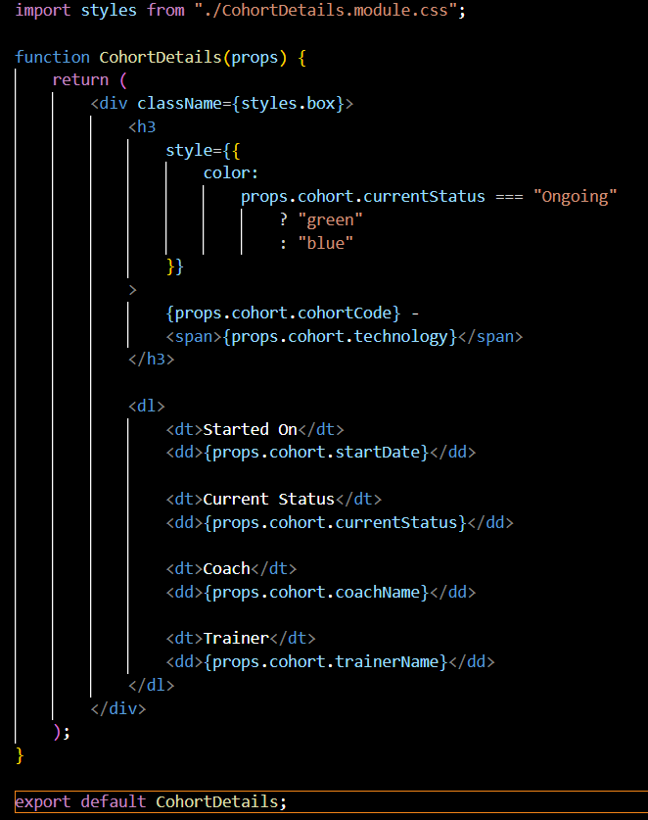

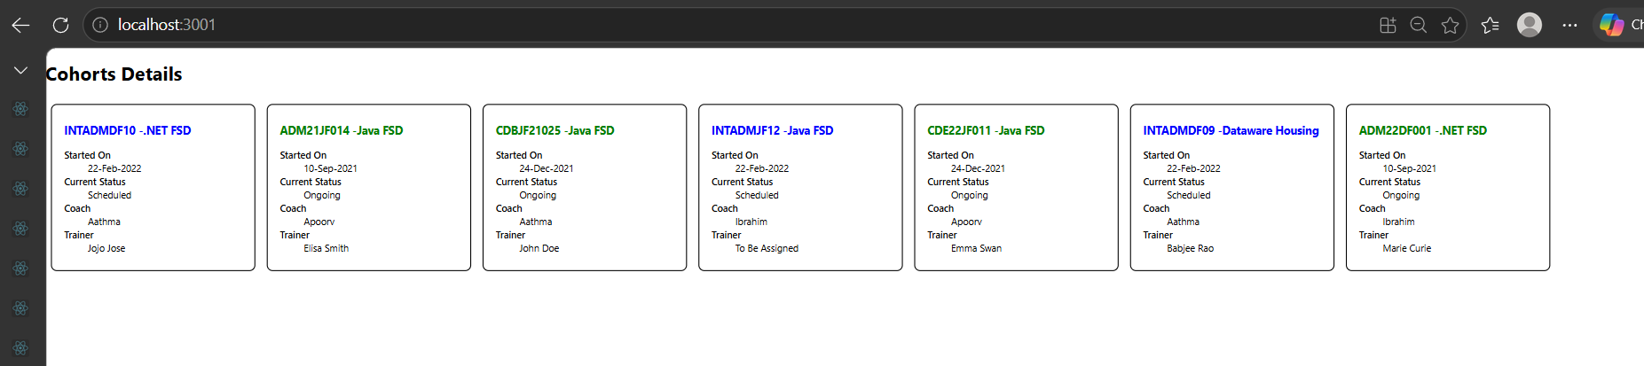
3.

