1. Explain the Need and Benefits of Component Life Cycle
Answer:
The Component Lifecycle in React refers to the different stages a component goes through from its creation until it is removed from the application. Lifecycle methods allow developers to perform specific actions at each stage.
Benefits:
- Fetch data from APIs after the component loads.
- Update the UI when data changes.
- Handle errors gracefully.
- Improve application performance.
- Clean up resources before the component is removed.

2. Identify Various Lifecycle Hook Methods
Answer:
Some important React lifecycle methods are:
- constructor() – Initializes the component and state.
- render() – Displays the UI of the component.
- componentDidMount() – Executes after the component is added to the DOM. Used for API calls.
- componentDidUpdate() – Executes after state or props are updated.
- componentWillUnmount() – Executes before the component is removed. Used for cleanup.
- componentDidCatch() – Handles errors occurring in child components.

3. List the Sequence of Steps in Rendering a Component
Answer:
The rendering sequence of a React class component is:
- Constructor
- Render
- ComponentDidMount
When the component updates:
- Render
- ComponentDidUpdate
When the component is removed:
- ComponentWillUnmount
If an error occurs:
- ComponentDidCatch

Post.js
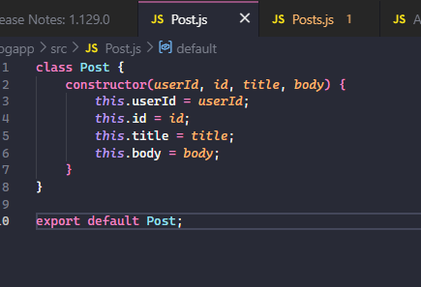

Posts.js
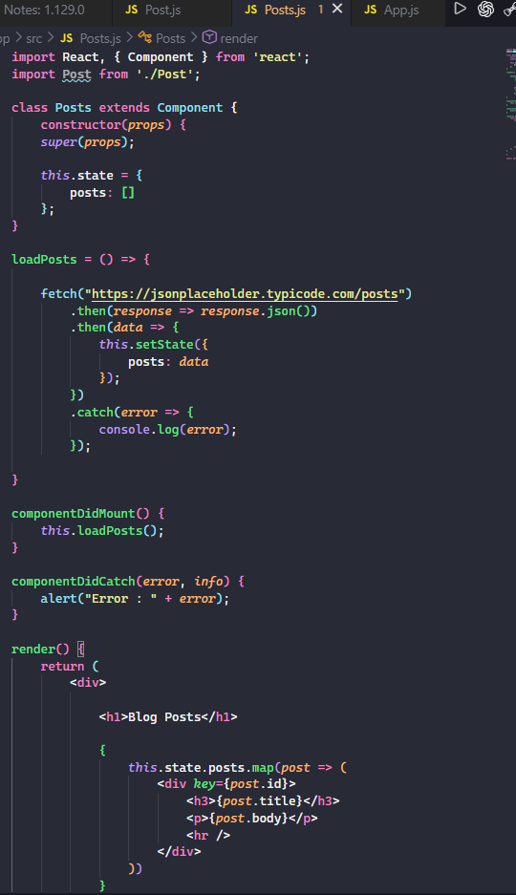
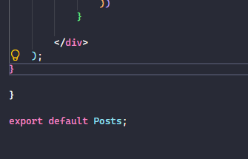
App.js
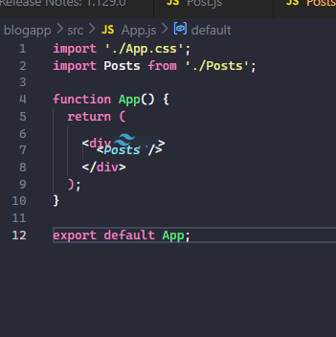

OUTPUT:
