11. ReactJS-HOL
1. Counter Section
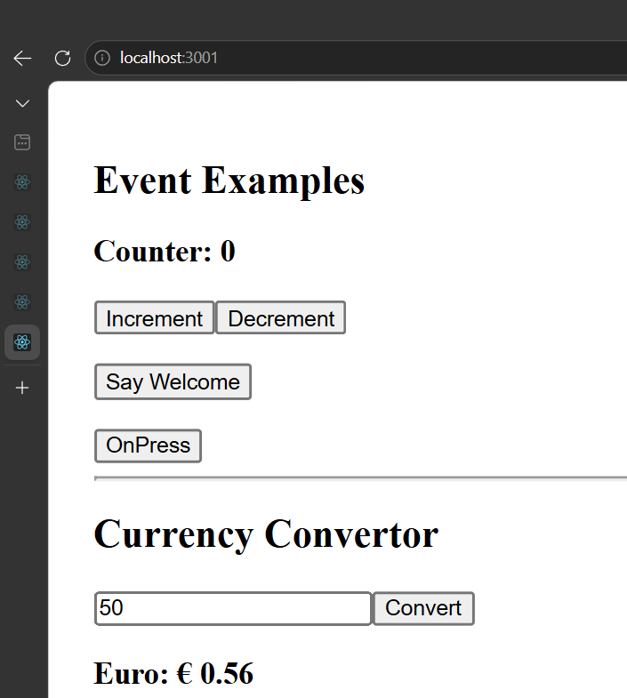

2. After Clicking Increment
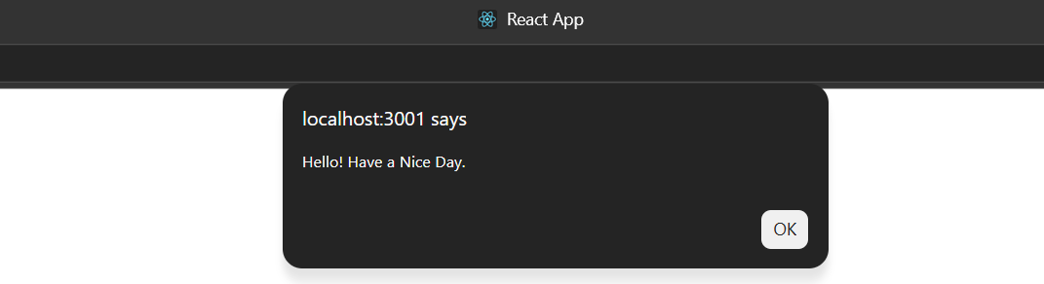

3. After Clicking Say Welcome
3. After Clicking Say Welcome
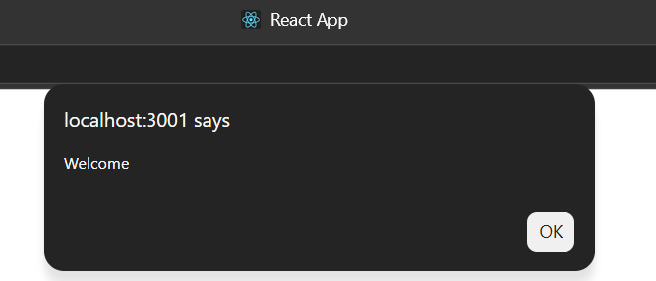

4. After Clicking OnPress
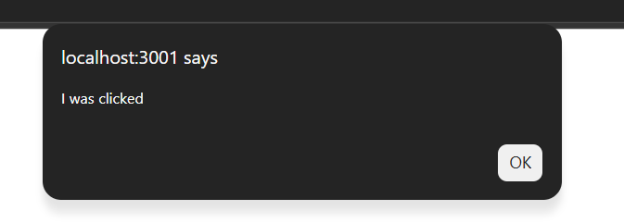

5. Currency Convertor
