1. Explain React Components
Answer:
React components are reusable and independent pieces of code that define how a part of the user interface (UI) should appear. Components help divide the UI into smaller, manageable parts, making the code easier to develop, maintain, and reuse.

2. Identify the Differences Between Components and JavaScript Functions
React Components | JavaScript Functions
Used to create user interface elements. | Used to perform general programming tasks.
Return JSX (HTML-like syntax). | Return any JavaScript value.
Can receive props as input. | Accept parameters as input.
Used in React applications. | Used in all JavaScript programs.

3. Identify the Types of Components
Answer:
There are two types of React components:
- Functional Component
  - Created using JavaScript functions.
  - Simpler and easier to write.
  - Uses Hooks for state and lifecycle features.
- Class Component
  - Created using ES6 classes.
  - Uses lifecycle methods.
  - Can manage its own state.

4. Explain Class Component
Answer:
A class component is a React component created using an ES6 class. It extends React.Component and must contain a render() method to display the UI. Class components can maintain state and use lifecycle methods.
Example:
class Welcome extends React.Component {
render() {
return <h1>Hello World</h1>;
}
}

5. Explain Functional Component
Answer:
A functional component is a JavaScript function that returns JSX. It is simple, lightweight, and commonly used in modern React applications. Functional components can use Hooks to manage state and other React features.
Example:
function Welcome() {
return <h1>Hello World</h1>;
}

6. Define Component Constructor
Answer:
The constructor is a special method used in class components to initialize the component's state and bind event handlers. It is called automatically when the component is created.
Syntax:
constructor(props) {
super(props);
this.state = {};
}
7. Define render() Function
Answer:
The render() function is a mandatory method in class components. It returns the JSX that React displays on the screen. Whenever the component's state or props change, the render() method is executed again to update the UI.
Example:
render() {
return <h1>Welcome to React</h1>;}
CalculateScore.js
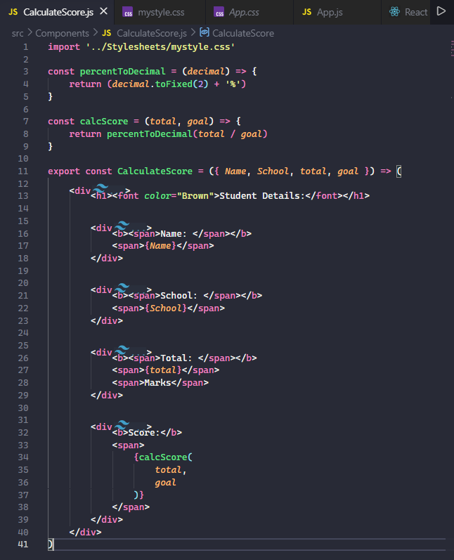

mystyle.css
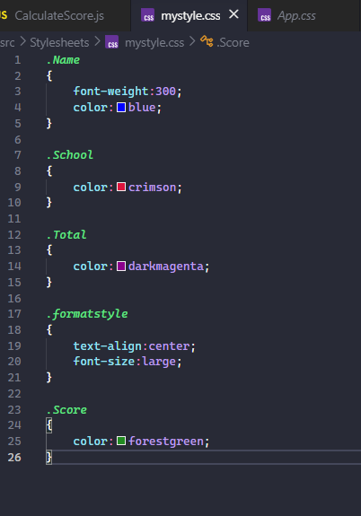

App.js
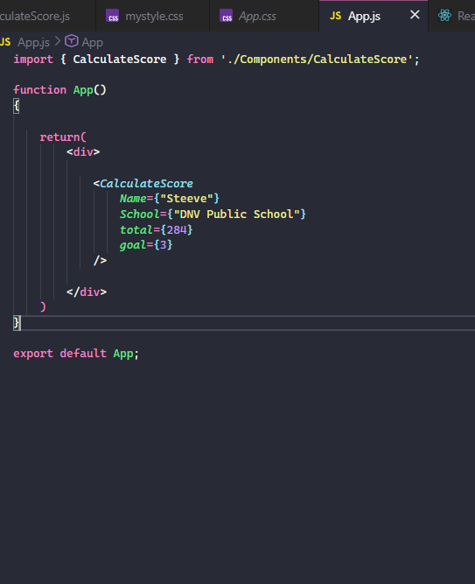

Output:


