02_React
1. Explain React Components
Answer:
A React component is a reusable piece of code that represents a part of the user interface (UI). Components help divide a large application into smaller, manageable parts. Each component can have its own logic, design, and functionality, making the code easier to develop, understand, and maintain.
For example, in a Student Management Portal, the Home, About, and Contact pages can each be created as separate components.

2. Difference Between React Components and JavaScript Functions
React Component | JavaScript Function
Used to create UI elements. | Used to perform a specific task or calculation.
Returns JSX (HTML-like code). | Returns any type of value such as numbers, strings, or objects.
Can maintain state and lifecycle (class components). | Cannot manage React state or lifecycle by itself.
Used only in React applications. | Can be used in any JavaScript program.
Example:
JavaScript Function
function add(a, b) {
return a + b;
}
React Component
function Home() {
return <h1>Welcome Home</h1>;
}

3. Types of React Components
Answer:
React mainly has two types of components:
1. Functional Component
- Created using a JavaScript function.
- Simpler and easier to write.
- Uses Hooks (like useState and useEffect) to manage state and other features.
- Most commonly used in modern React applications.
Example
function Home() {
return <h1>Home Page</h1>;
}

2. Class Component
- Created using ES6 classes.
- Extends the React.Component class.
- Uses a render() method to display content.
- Can manage state and lifecycle methods.
Example
class Home extends React.Component {
render() {
return <h1>Home Page</h1>;
}
}

4. Explain Class Component
Answer:
A class component is a React component created using an ES6 class. It extends the React.Component class and must include a render() method that returns JSX. Class components can manage their own state and use lifecycle methods such as componentDidMount() and componentDidUpdate().
Although functional components are more popular today, class components are still important to understand because many existing React projects use them.

5. Explain Functional Component
Answer:
A functional component is a simple JavaScript function that returns JSX. It is easy to create, easy to understand, and requires less code than a class component. With React Hooks, functional components can also manage state and lifecycle features.
They are the preferred choice for developing modern React applications.
Example
function Contact() {
return <h2>Contact Page</h2>;
}

6. Define Component Constructor
Answer:
A constructor is a special method in a class component that is automatically called when the component is created. It is mainly used to initialize the component's state and bind methods.
The constructor must call super(props) before using this.
Example
class Home extends React.Component {
constructor(props) {
super(props);

this.state = {
name: "Student"
};
}

render() {
return <h2>{this.state.name}</h2>;
}
}

7. Define render() Function
Answer:
The render() function is a required method in every React class component. It returns JSX, which React converts into HTML and displays in the browser.
Whenever the component's data or state changes, the render() function runs again to update the UI.
Example
class Home extends React.Component {
render() {
return (
<h2>Welcome to Home Page</h2>
);
}
}

App.js
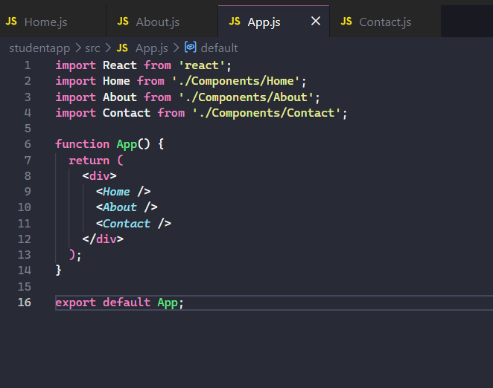

Home.js
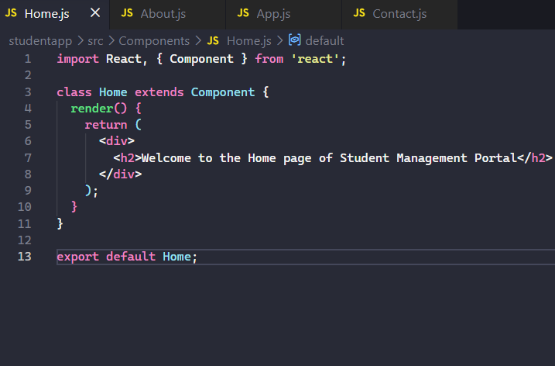

About.js
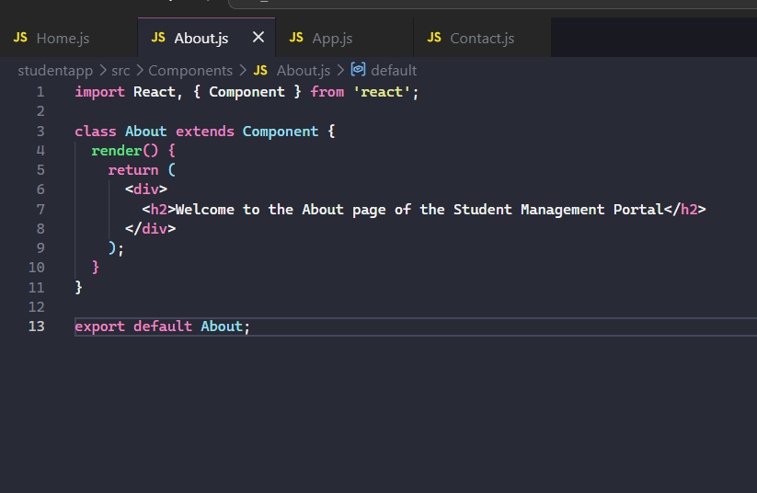

Contact.js
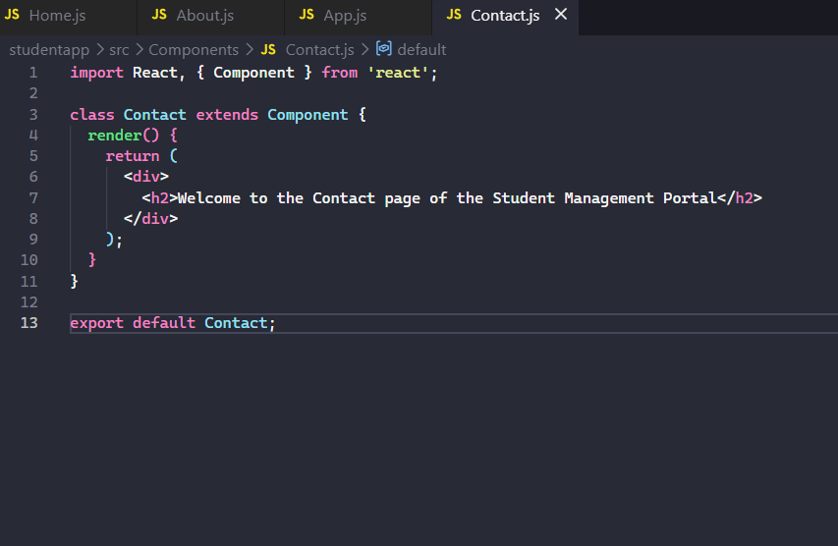

Output:
