Customer Segmentation
Using RFM Analysis
Deep dive report

1. Project Overview
This project explores customer purchasing behaviour through customer segmentation. A customer-level summary is used to examine Recency, Frequency and Monetary Value (RFM), and the results are presented in an interactive Power BI dashboard. The purpose is to make customer patterns easier to compare and to identify groups that may benefit from different business actions.

2. Objectives
- Define measurable customer-analysis KPIs and explain their business purpose.
- Group customers using documented business rules based on RFM behaviour.
- Compare customer counts, revenue, order frequency and purchase recency by segment.
- Provide City and Category slicers so users can explore the data interactively.
- Translate the observed patterns into practical business recommendations.

3. Dataset and Preparation
The analysis uses the cleaned sales dataset and a customer-level summary table. Relevant fields include Customer_ID, Order_ID, Order_Date, City, Category and Total_Sales. The customer summary contains Customer_ID, Customer_Segment, Frequency, Last_Order_Date, Monetary_Value and Recency.

4. Core KPIs: RFM Analysis

4.1 Recency
Definition: number of days between a customer's most recent order date and the selected analysis date.
Formula: Recency = Analysis Date − Last Order Date.
Business rationale: a lower Recency value means the customer purchased more recently. Higher values can help identify customers who may need re-engagement.

4.2 Frequency
Definition: number of distinct orders placed by a customer during the period covered by the dataset.
Formula: Frequency = DISTINCTCOUNT(Order_ID) for each Customer_ID.
Business rationale: distinguishes frequent purchasers from occasional buyers and helps inform loyalty efforts.

4.3 Monetary Value
Definition: total sales value associated with a customer during the period covered by the dataset.
Formula: Monetary Value = SUM(Total_Sales) for each Customer_ID.
Business rationale: helps identify customers who contribute a larger share of sales.

5. Methodology
- Load the cleaned sales dataset into Power BI.
- Create or use a customer-level summary table with one record per customer.
- Calculate Recency, Frequency and Monetary Value for each customer.
- Apply the project's business rules to assign each customer to a segment.
- Build charts comparing customer count, revenue, total order frequency and average recency by segment.
- Add City and Category slicers and configure the model so the slicers filter the customer-level visuals.
- Review the charts and derive findings and recommendations from the displayed results.

6. Customer Segments
The current dashboard displays four business-rule-based segments. The final report should use the exact conditions implemented in the Customer_Segment calculation.
- At-Risk Customers: Customers assigned by the project's rules to a group requiring attention or re-engagement.
- Regular Customers: Customers who meet the defined criteria for regular purchasing behaviour.
- Loyal Customers: Customers who meet the defined loyalty-related purchasing criteria.
- High-Value Customers: Customers identified by the selected monetary-value and/or RFM criteria as valuable.

7. Interactive Power BI Dashboard
The dashboard contains a total-customer ID, Customer Distribution by Segment, Revenue by Customer Segment, Average Recency by Customer Segment, and Total Orders by Customer Segment. City and Category slicers support interactive exploration.
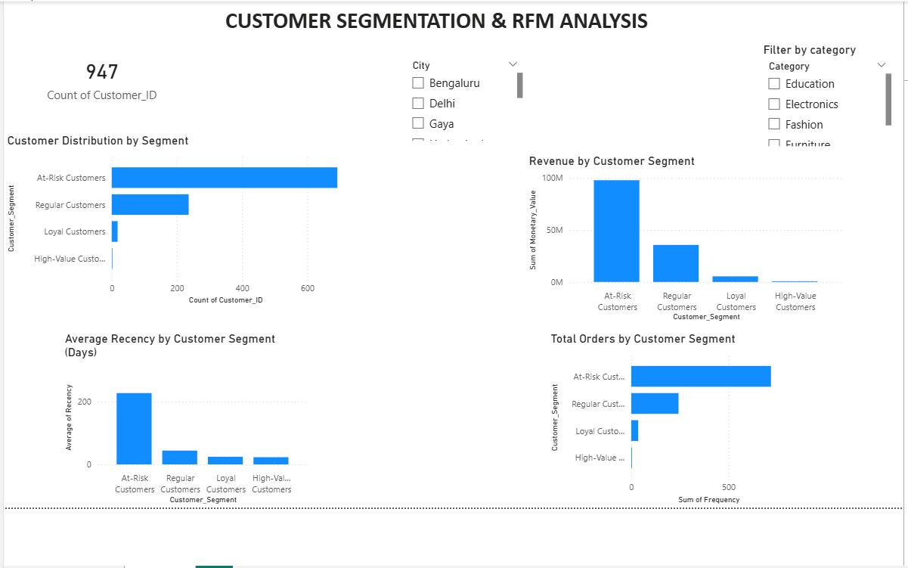
Figure 1. Power BI dashboard for customer segmentation and RFM analysis.

8. Observations from the Current Dashboard
The Figure 1. shows 947 in the customer-count card. With the slicers cleared, the visible charts suggest the following qualitative patterns:
- At-Risk Customers form the largest visible customer group.
- At-Risk Customers also contribute the largest visible share of monetary value in the revenue chart.
- The At-Risk segment has the highest average Recency, meaning its customers' last purchases are older on average than those in the other displayed segments.
- The At-Risk segment has the highest total Frequency in the current chart. Check the aggregation and segment definitions before interpreting this as a typical customer ordering more often; totals can be high simply because the segment contains many customers.
- High-Value Customers appear as a very small group in the current visuals, so review the segment thresholds and customer counts to ensure the business rules are behaving as intended.

9. Business Recommendations
- Review the At-Risk segment definition and consider targeted re-engagement messages or offers for customers with high Recency.
- Use loyalty benefits or relevant recommendations for customers who purchase frequently, based on validated Frequency values.
- Offer personalized promotions to customers with high Monetary Value while monitoring profitability.
- Compare patterns across cities and product categories using the slicers, then tailor campaigns only where the data supports a difference.
- Review the segment rules periodically and monitor the number of customers in each group over time.

10. Conclusion
This project demonstrates how RFM metrics and business-rule-based segmentation can be used to explore customer purchasing behaviour. Power BI brings the customer count, revenue, order frequency and recency comparisons into an interactive dashboard. Reliable conclusions depend on validated calculations, clear segment thresholds and checking how slicer selections affect the displayed results.

