***Assisgnment of PF***

By Muskan Makhija…

Pseudocodes

Question =1

Starts

“Greeting”

Display “welcome to KFC, how may I help you.”

Display “there is the menu

A_ burgers _RS 500

B_Burgers+fries_RS 600

C_coldrink_ RS100”

Read order

Calculate bill

Display bill

Get cash

End

Algorithm

1start with greetings ,

2 display menu,

3 ask what they would like to order,

4 repeat the order what food customer has choose

5 calculate bill

6 display bill

7 get cash

8 end.

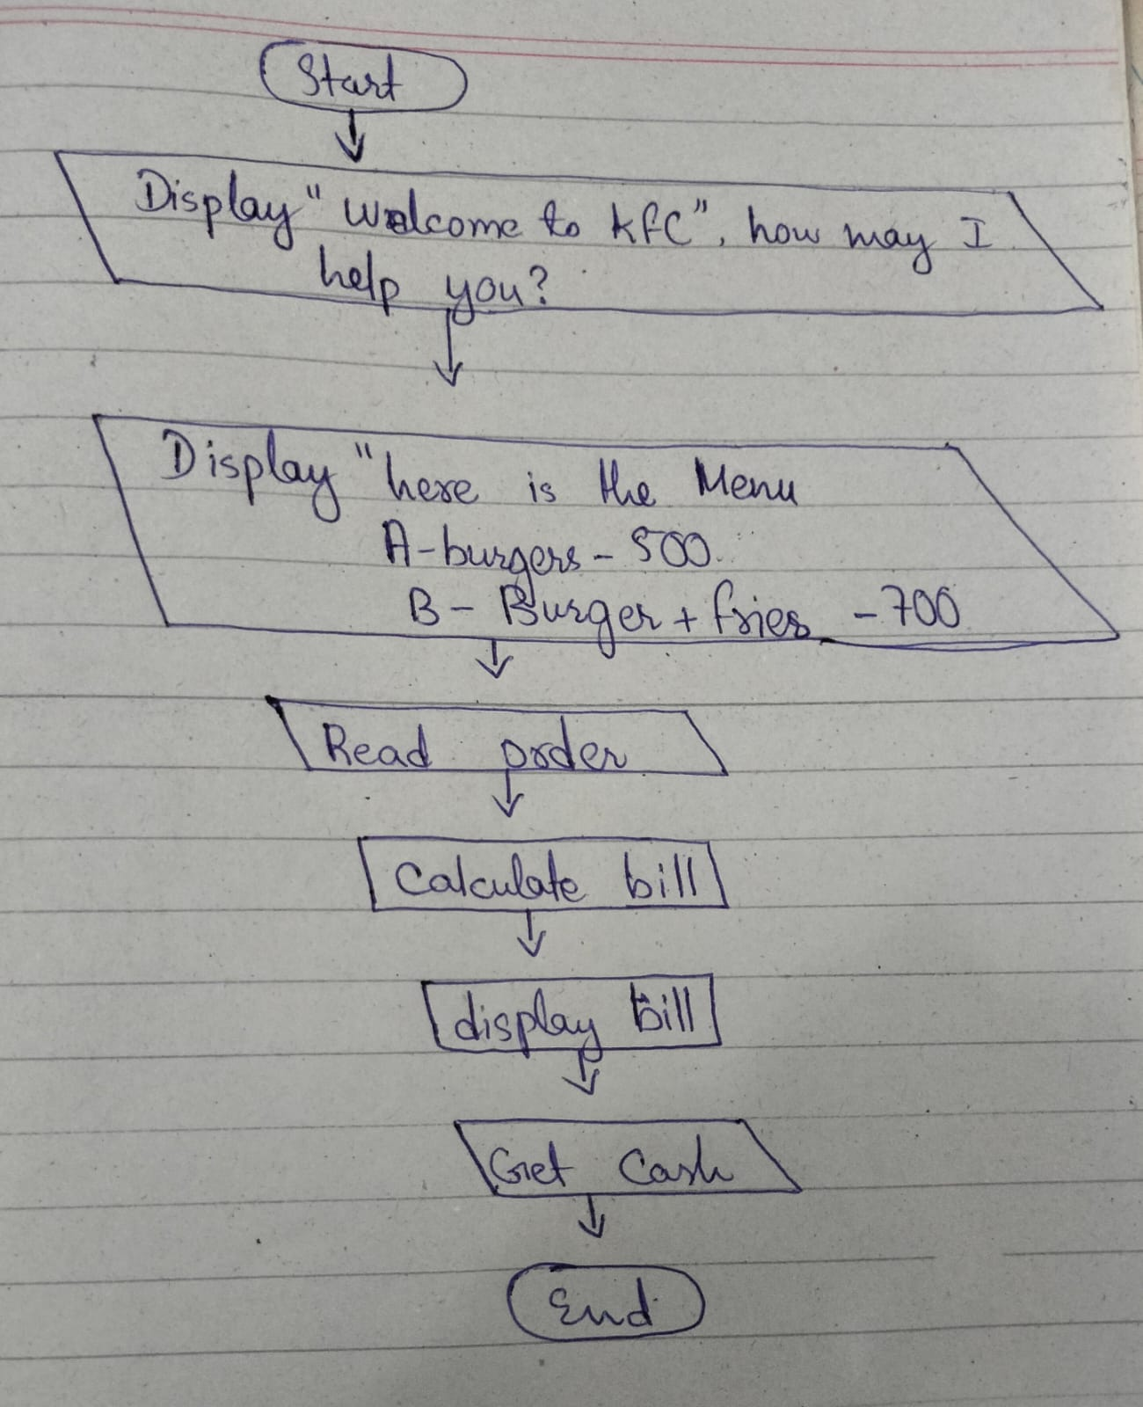

.Question 2

Start

Display” account number , deposit amount”

Account validate

If “account number is valid”

Then print”next”

If “ account number is not valid”

Then print ”incorrect number”

Return

End if

If “account number is valid then update account balance”

Account balance= account balance+deposite amount

Print”deposite successful”

Print”new balance”

End

Algorithm

.Input customer account number, verify account validity,if account Is valid input deposit amount with checking deposit conditions if there is any,if deposit amount is valid ,update account balance, print deposit slip and confirm the new amount balance ,End.

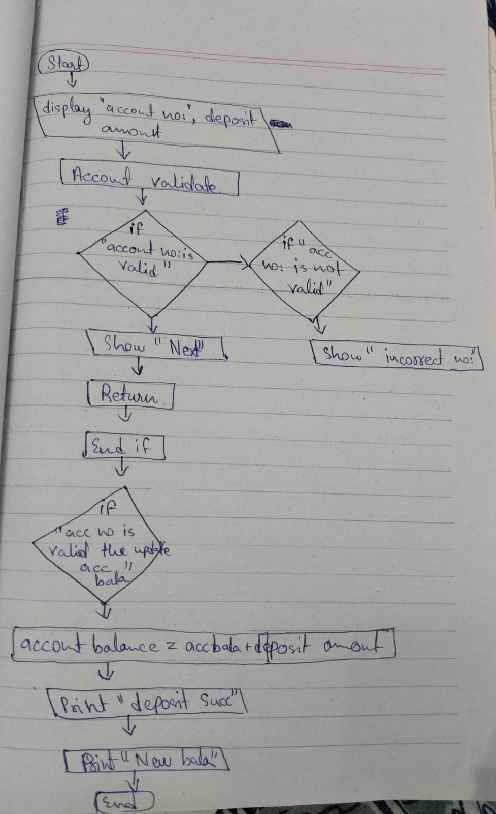

Question 3

pseudocode

Start

Display”which number is greater”

Numbers= x,y,z

If”x>=y” and “x>=z”

Then “x is greatest”

If “y>=x” and “y>=z”

Then “y is greatest”

If “z>=x” and “z>=y”

Then “z is greatest”

Repeat

End

Algorithm

1 write three number

2 compare two numbers which number is greatest

3 the one which is greatest among them is greater

4 repeat

5 end

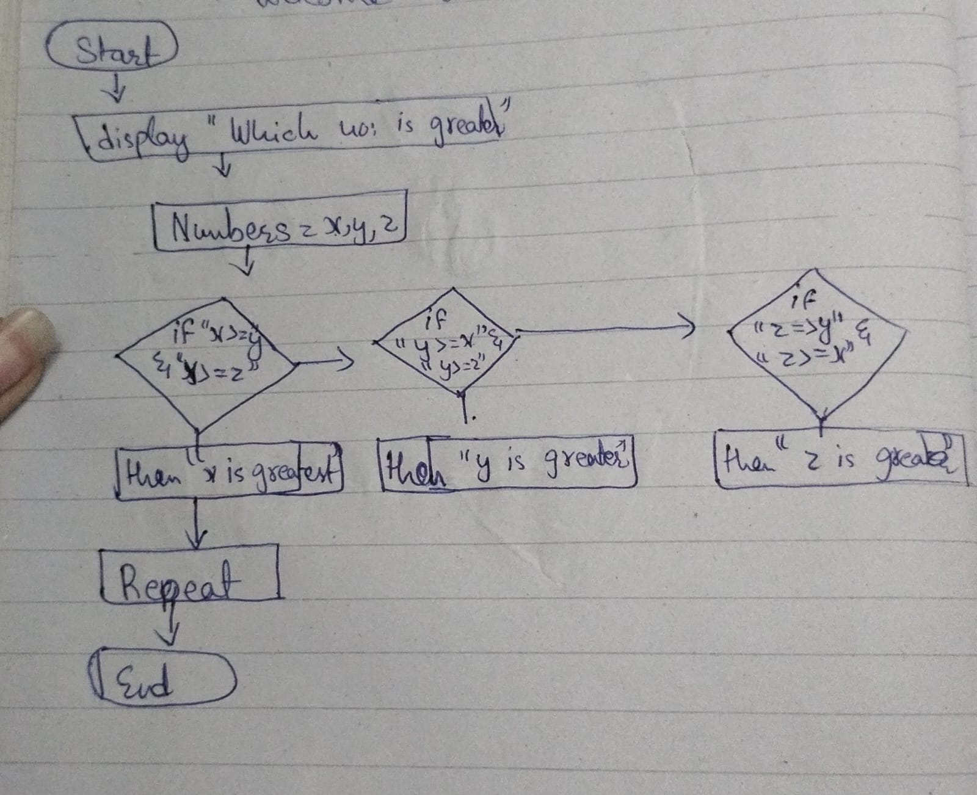

Algorithm

Question4

Display month

Input: month_number

Month-names{ “jan”,”feb”,”march”,”April”,”may”,”June”,”July”,”august”,”September”,”October”,”november”,”December”}

If month number<1 and or month number>12 then print “invalid month number”

Else print month names(month number -1)

End if

End procedure

Pseudocode

Question 5

Start

Display”num1 ,operator,num2”

If “operator==+”

Then”result:num1+num2”

Print”result”

Else if “operator== -“

Then” result: num1 -num2”

Print”result”

Else print”invalid ( only + and – are allowed)”

End if

end

question6 (flowchart)

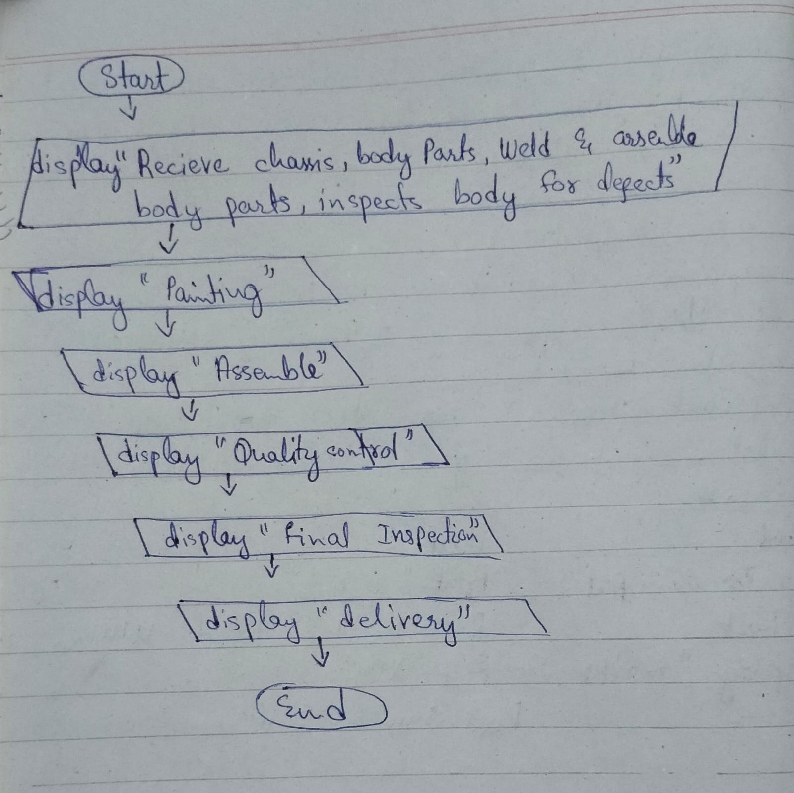

Algorithm

Question7

num1 ,operator,num2”

If “operator==+”

Then”result:num1+num2”

Print”result”

Else if “operator== -“

Then” result: num1 -num2”

If “operator==*”

Then”num1*num2”

If “operator==/”

Then”num1/num2”

If “operator==%”

Then “num1 mod num2”

Result==num1*100/num2

Else print”error:division by zero”

Return

Else

Print”invalid operator only (+,-,%,/,*) allowed”

Return

repeat

End if

End

Question 9

A .gitignore file is used to tell git which files or directories to ignore in a repository. Here are some reasons why we use .gitignore:

1. Exclude unnecessary files
2. Keep sensitive information private:
3. Reduce repository size:
4. Streamline development:
5. Prevent conflicts:

Conclude:

some files,like temporary files,log files,or combiled binaries,are not needed in the respository. Files containing sensitive information,like passwords or API keys,should not be commited to a public repository, prevets conflicts between team members.

Question 10

Algorithm:

. A step by step procedure for solving a problem or archieving a specific goal.

. A well defined procedure that takes some input and produces a corresponding output.

. can be expressed in various forms, such as natural language , flowcharts, or pseudocode

. focuses on the logic and sequence of steps to solve a problem

Pseudocode:

. A mixture of natural language and programming lamguage like syntax

. used to describe the logic and steps of an algorithm in a more formal and concise way

. typically omits low level details ,such as variable declerations and memory management

. A high level representation of an algorithm using structured English like language.

question6 (flowchart)

num1 ,operator,num2”

If “operator==+”

Then”result:num1+num2”

Print”result”

Else if “operator== -“

Then” result: num1 -num2”

Print”result”

Else print”invalid ( only + and – are allowed)”

End if

end

question6 (flowchart)