C++
Loops
Highest factorial
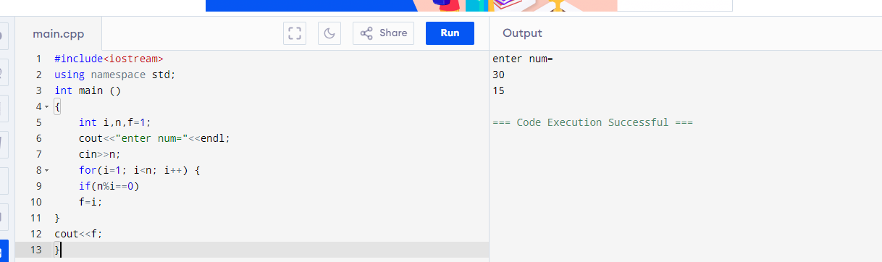
Pattern printing
Triangle
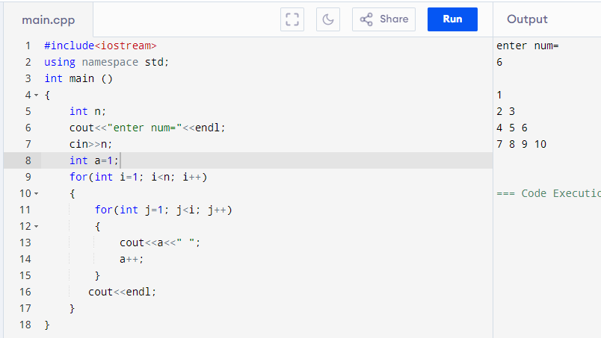
1 and 0 triangle (i+j)%2==0 prints 1
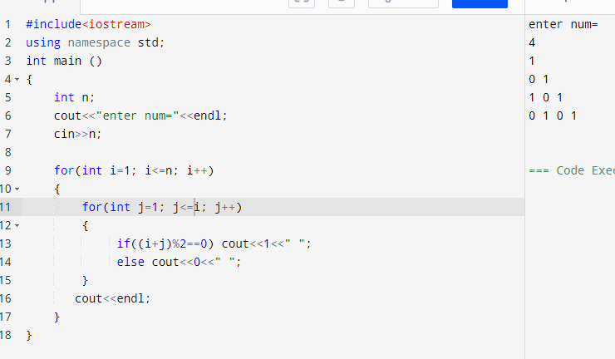
Functions
Using libarary function
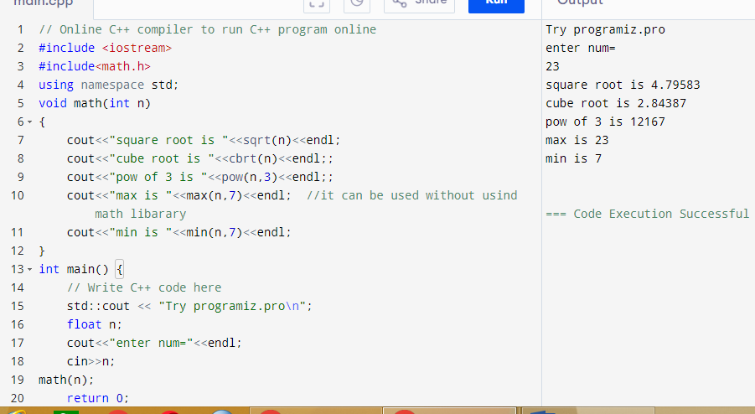
Recursion
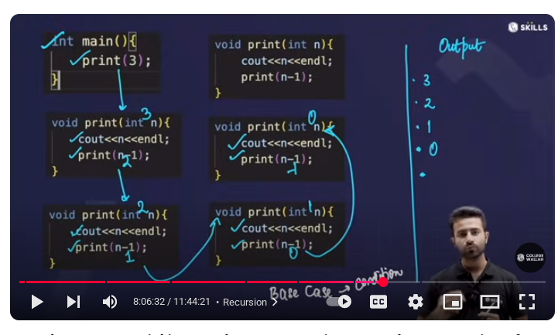
Print n to 1 num
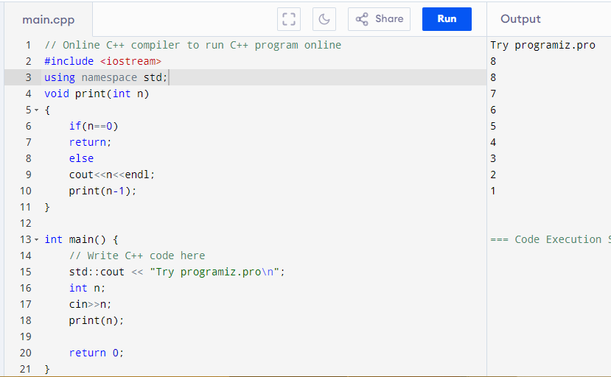
1 to n
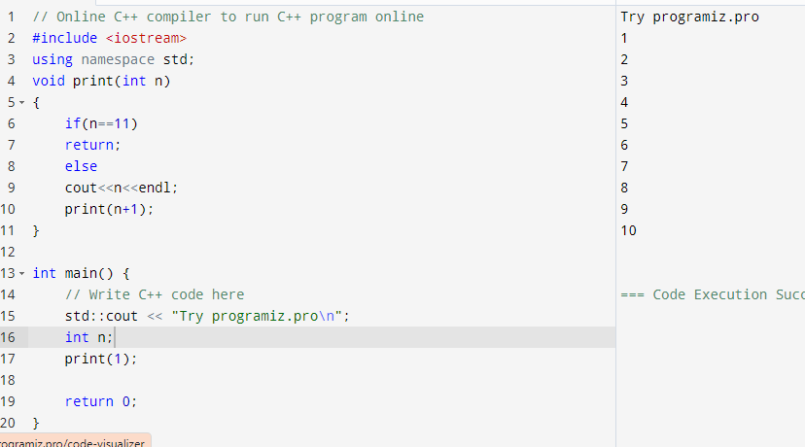
Return type
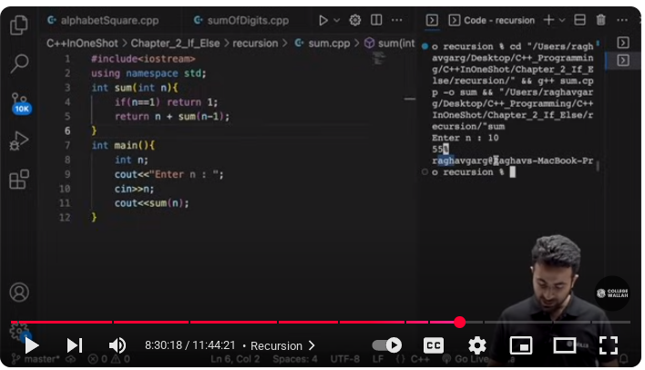
Factorial using return type
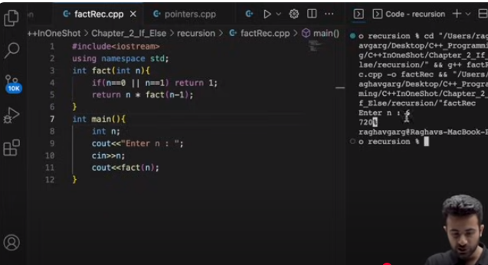
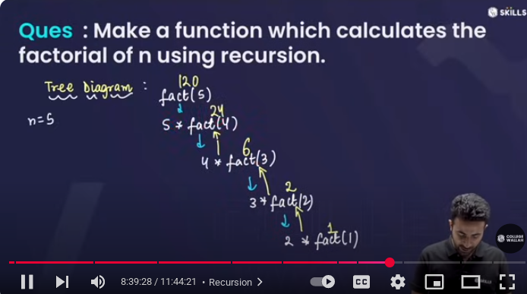
Array (subaaray and its max sum)
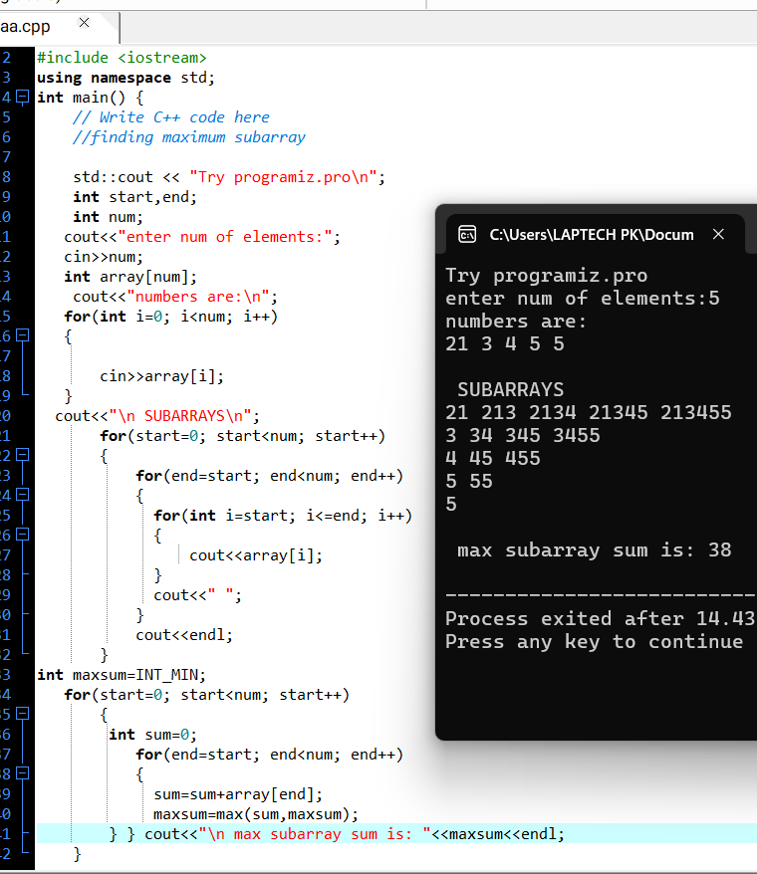Bank project
// Online C++ compiler to run C++ program online
#include <iostream>
using namespace std;
void balance(float &b)
{
cout<<"enter balance=";
cin>>b;
cout<<"current balance: "<<b<<endl;
}
float deposit()
{
float d;
cout<<"how much u want to deposit money=";
cin>>d;
return d;
}
float withdraw()
{
float w;
cout<<"how much you want to deposit money=";
cin>>w;
return w;
}
void display(float b, float w, float d)
{
cout << "Displaying balance details:\n";
cout << "New balance after deposit: " << d << endl;
cout << "New balance after withdarw: " << w << endl;
cout << "New balance after updation: " << b << endl;
}
int main() {
// Write C++ code here
float b=0,w=0,d=0;
std::cout << "Try programiz.pro\n";
int n;
cout<<"for how many customers you want record for="<<endl;
cin>>n;
int choice;
for(int i=0; i<n; i++)
{
cout << "\nCustomer " << (i + 1) << ":\n";
do {
cout<<"1.enter balance:\n";
cout<<"2.depoit money:\n";
cout<<"3.withdraw money:\n";
cout<<"4.display:\n";
cout<<"5.exit:\n";
cout << "Enter your choice: ";
cin >> choice;

switch(choice)
{
case 1: balance(b);
break;
case 2: d=deposit();
b+=d;
cout << "New balance after deposit: " << b << endl;
break;
case 3: w=withdraw();
b-=w;
cout << "New balance after withdraw: " << b << endl;
break;
case 4: display(b,d,w);
break;
case 5: cout<<"thanks for visiting\n";
break;
default: cout<<"Invalid choice\n";
}
} while(choice!=5);
} }

Multiple objects using array
#include<iostream>
#include<limits>
using namespace std;

class student{
string name;
int roll;

public:
void setstudent(string n,int r)
{
name=n;
roll=r;
}
void getstudent()
{
cout<<"name:"<<name<<" roll:"<<roll<<endl;
}
};
int main()
{
struct student s[5];
string name;
int roll;
for(int i=0; i<5; i++)
{
cout<<"enter name and roll "<<i+1<<":";
cin>>name>>roll;
s[i].setstudent(name,roll);
}
for(int i=0; i<5; i++)
{
cout<<"student:"<<i+1<<endl;
s[i].getstudent();
}
}

