PST_API_ReportAnalysis_Guidelnes

**How to enable Macros in Excel**

* On the File tab, go to Options > Customize Ribbon.
* Under Customize the Ribbon and under Main Tabs, select the Developer check box.
* After that a new tab will be there as ‘Developer’ , and inside ‘Developer’ tab ‘Macros’ option will be there.

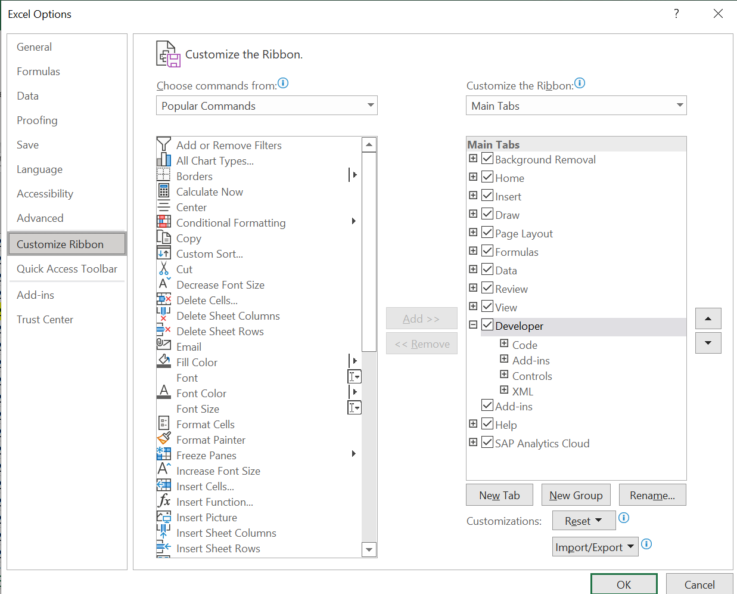

* To use VBA/Macros we’ve to change the file format from Xlsx to Xlsm.

**Condition for Highlighting:**

For the sheet <{}DXCAssureClaims_Compare Performance_Results_22.4_22.3.xlsx{}>, highlight the column - Compare Results (Column 'C' & 'J')

* Green Font: when Improvement  is  <=(-20%)
* Black Font: when Improvement/Degradation Between -20% to 20%
* Red Font: When Degradation is >=20%

**Reference for the updated code Of CompareResults**



For the sheet <DXCAssureClaims_Performance_Results_22.4_API.xlsx{}>, highlight the column - Actual Degradation

1. 5 Users, more than 10%
2. 10 Users, more than 20%
3. 20 Users, more than 30%
4. 50 Users, more than 50%
5. 100 Users, more than 75%

**Reference for the updated code Of Summary of API TCs**

