NAME: MUSKAN AGARWAL
ROLL NO. :202401100200206
BRANCH: CSE-C

- GitHub repository URL
Muskan1981/github-skills-challenge
- Pull request URL used to validate the workflows
ONLY TEST TESTED IN THIS PULL REQUEST
Document pull request test execution by Muskan1981 · Pull Request #1 · Muskan1981/github-skills-challenge
BOTH TEST AND COVERAGE WORKFLOW TESTED IN THIS PULL REQUEST
Add pull request coverage workflow by Muskan1981 · Pull Request #2 · Muskan1981/github-skills-challenge

- Screenshot showing the GitHub Actions workflows
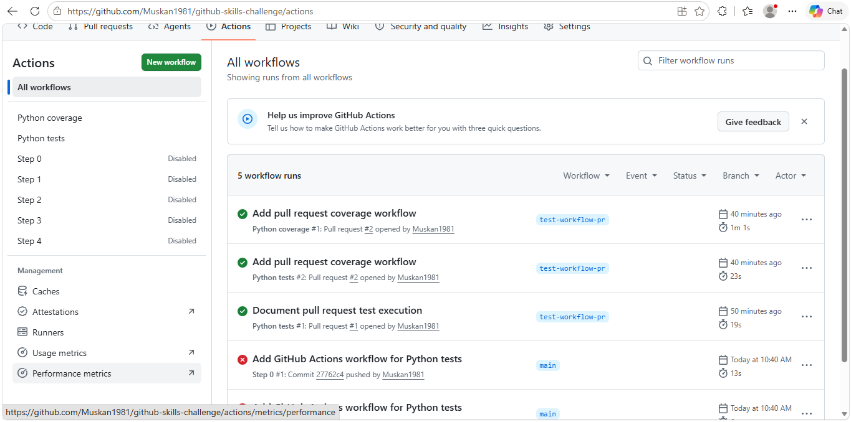

- Screenshot showing a successful test workflow execution
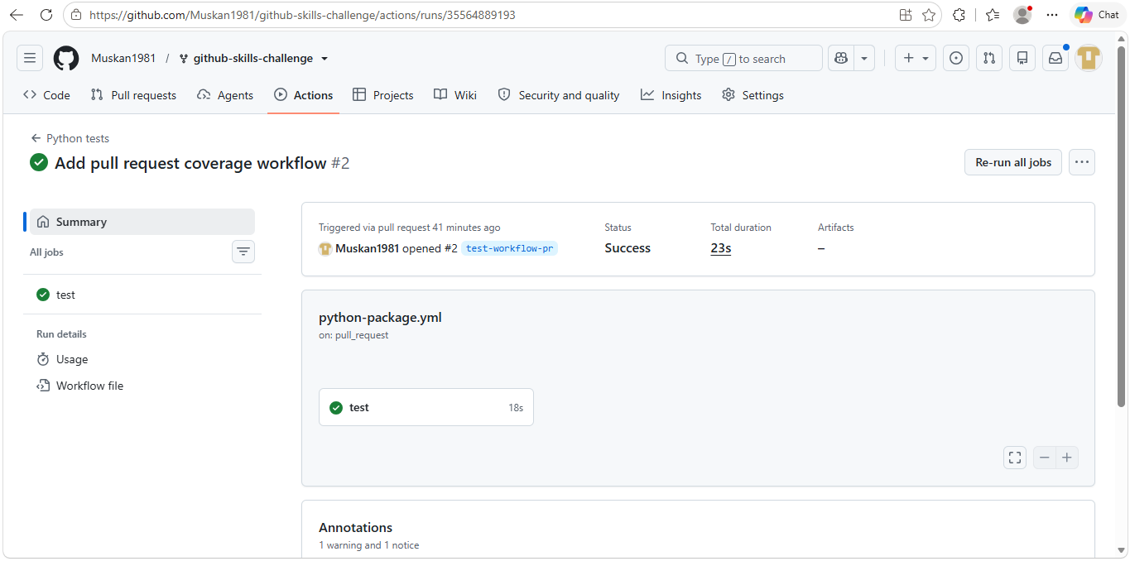
- Screenshot showing the coverage result/comment on the pull request
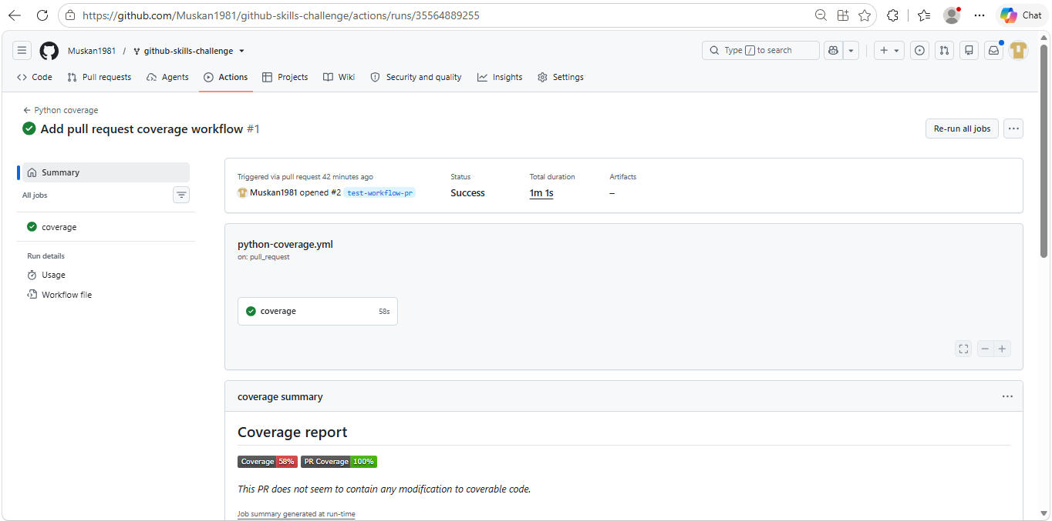

- Screenshot showing the final repository/workflow files
