Online Judge

SECURED ONLINE CODING PLATFORM (DJANGO-BASED WEBSITE)

System Design Document

Muskan (2020CSB1100)

Tummala Sanjana Reddy (2020CSB1137)

Kushal Agrawal (2020CSB1096)

Ruchika Sharma (2020CSB1119)

Isha Goyal (2020CSB1089)

What online judge is supposed to perform?

Online judge should be able to evaluate the source code submitted by the users and tests it against various test cases, constraints i.e. time limit constraint.

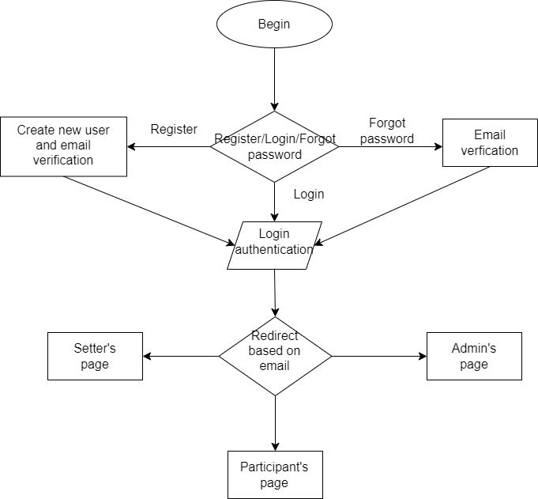

Important factors should be taken into considerations in the design

Authentication: It is used for verifying the user.

Authorisation: It determines what an authenticated user is allowed to do i.e. which urls or pages should be accessible to which user.

User Permissions: The user’s source code has to be secure, i.e. no user should be able to view another user’s source code.

Setter Permissions: No other setter should be allowed to modify problem of the other setter.

Secure Environment: To avoid attacks and information leak through malicious code, we should use an isolated environment where the code will execute without affecting the system i.e. Docker. We will have separate containers for different languages for ensuring some level of scalability when used in deployment.

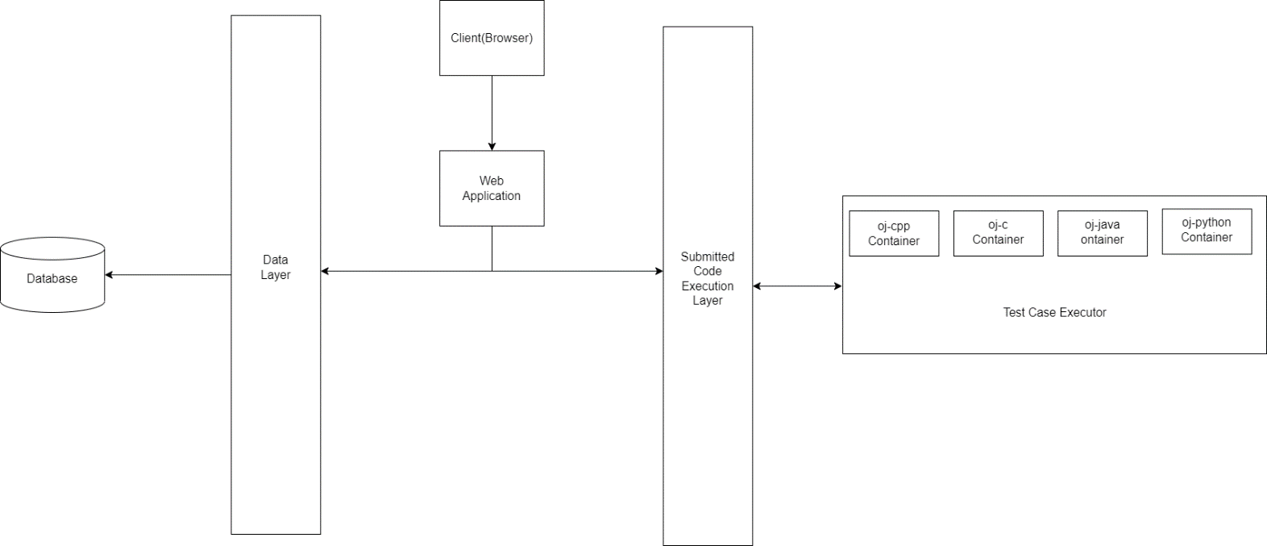

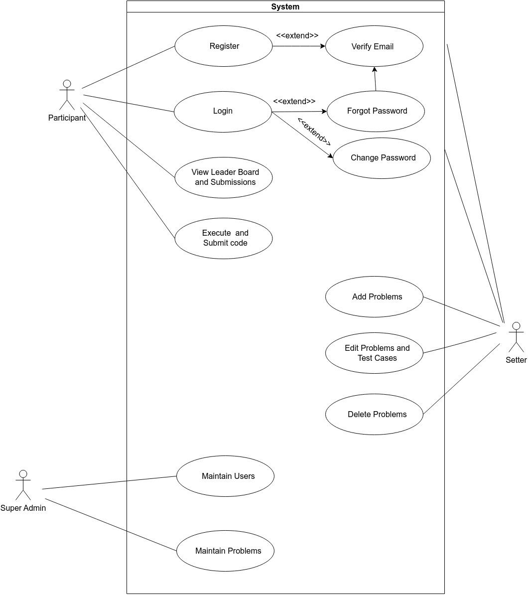

Which database to use? Relational or Non Relational

Why do we need database in online judge?

* Store information of users.
* Storing the submitted codes
* Storing the problems and their corresponding test cases.

This will help users to view their submissions and rank in the system.

Problems and test cases are anyway the least need of any online judge.

Our system is going to support compilers for 4 different languages i.e. Java, C, C++, Python.

Relational DB can handle much data effectively so SQLite (Portable Database that is included in Python by default) is preferred and sufficient. Also, Relational Database can handle relations effectively in this case. Although, using NoSQL seems to be efficient but turns out to be costly for this and there’s no need for it in case of online judge.

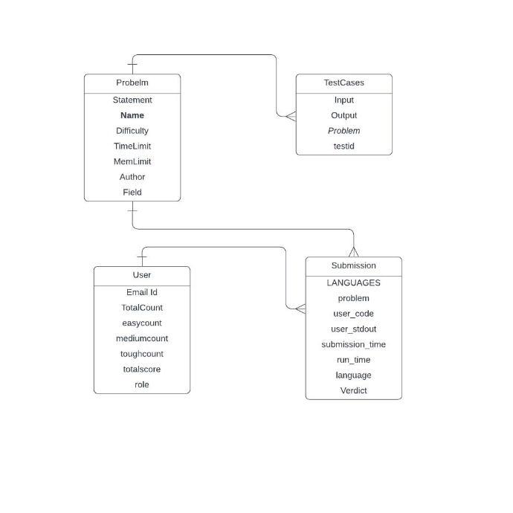

Which rendering technique to use?

We will be going with server-side rendering of web pages to make the product more accessible(weighing accessibility over scalability as problems are persistent in the system for the whole duration).

Some complications that should be handled in the coding judge:

Time Limit Exceeded: Program should run in fixed time.

Compilation Error: Program should be syntactically correct in order to be compiled.

Runtime Error: To handle errors i.e. bugs at runtime after compilation.

Specificity: On which test case the error is coming should be displayed.