Testing Document and Code Coverage

This document describes all the requirements and commands used for performing testing and getting code coverage reports.

**Testing**

There are three apps involved in our project – enduser, oj, oj2

Inside each of the folders a test.py file exists in which all the test cases for testing that particular app are written.

To run all the tests together use the command:

**python manage.py test**

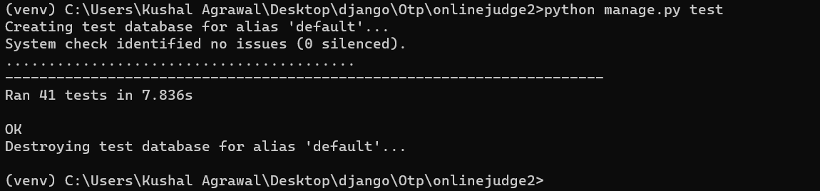

To run all tests within a particular app use the commands:

**python manage.py test enduser**

**python manage.py test oj2**

**python manage.py test oj**

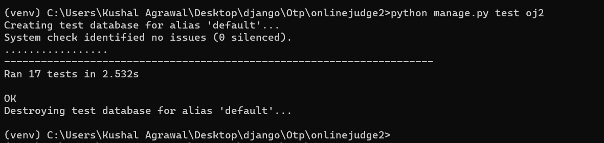

**Code Coverage**

For getting the code coverage reports we will use the package coverage. The command to generate coverage reports: **coverage run --source "oj2,oj,enduser" manage.py test -v 2 && coverage report && coverage html**

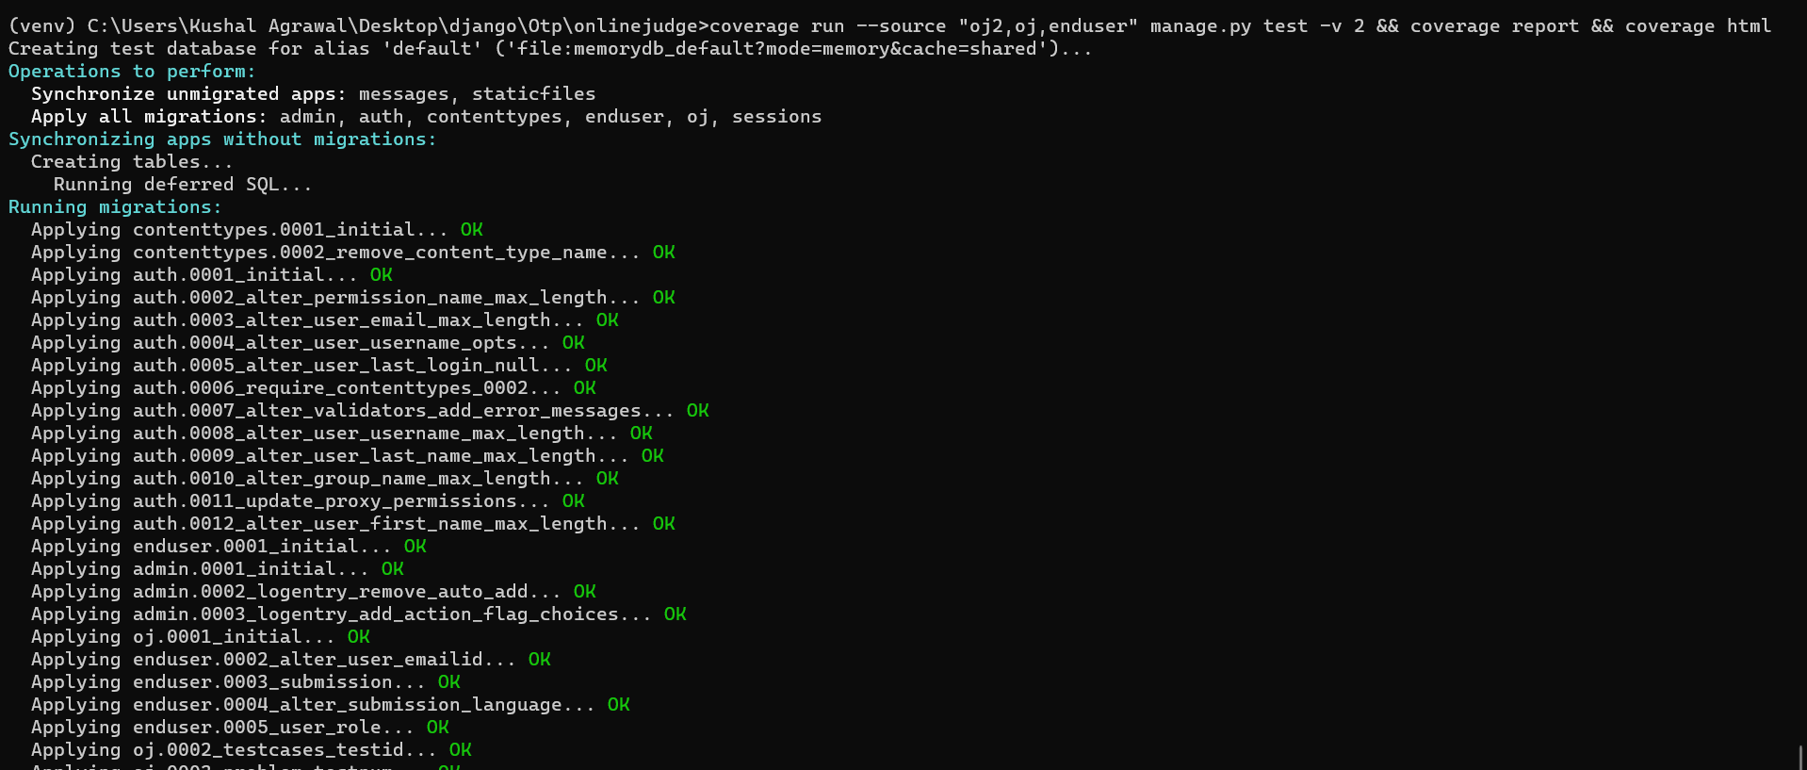

There is a file “.coveragerc” which has the files that we don’t want to include in our coverage report/testing.

The statistics of different files are shown in the terminal as shown below -

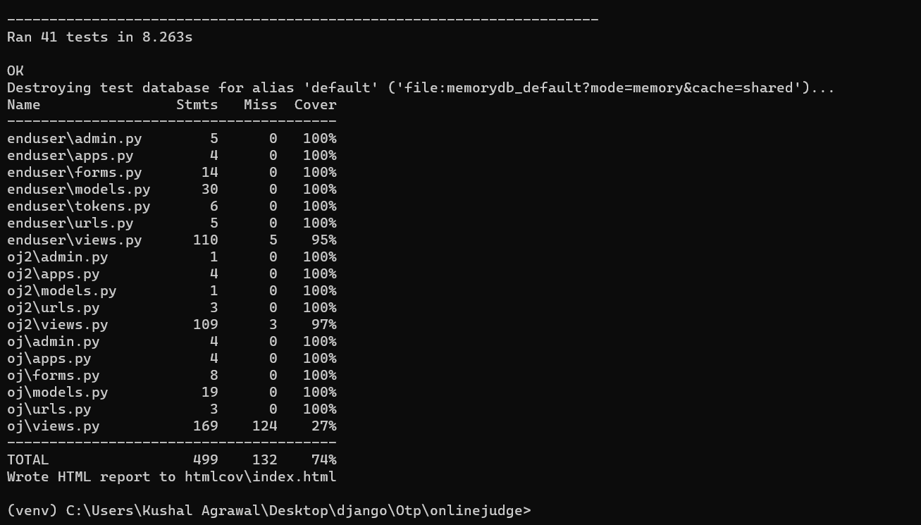

Also a folder ‘**htmlcov**’ is created in the directory where an **index.html** is created. View this file for all the coverage reports related to different files. The following can be seen from index.html -

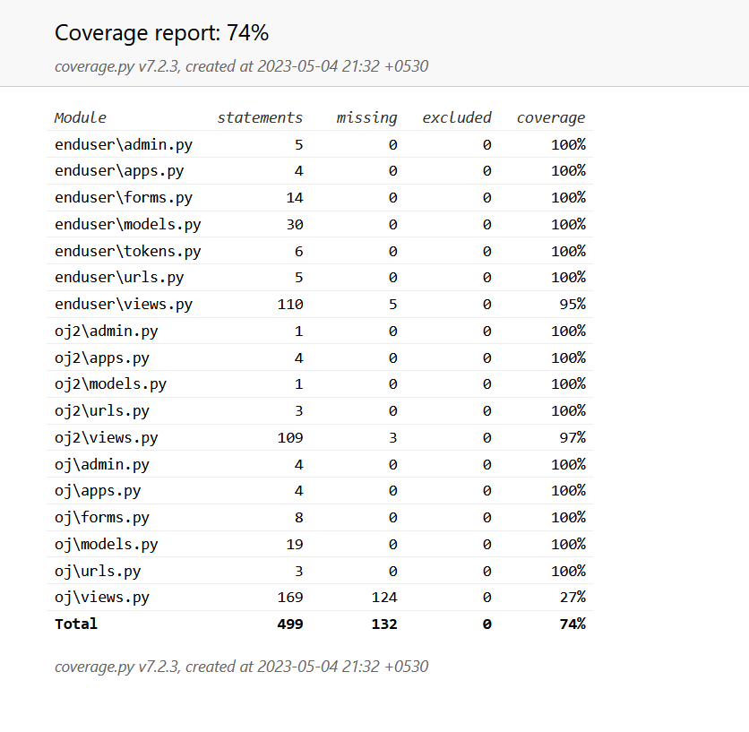

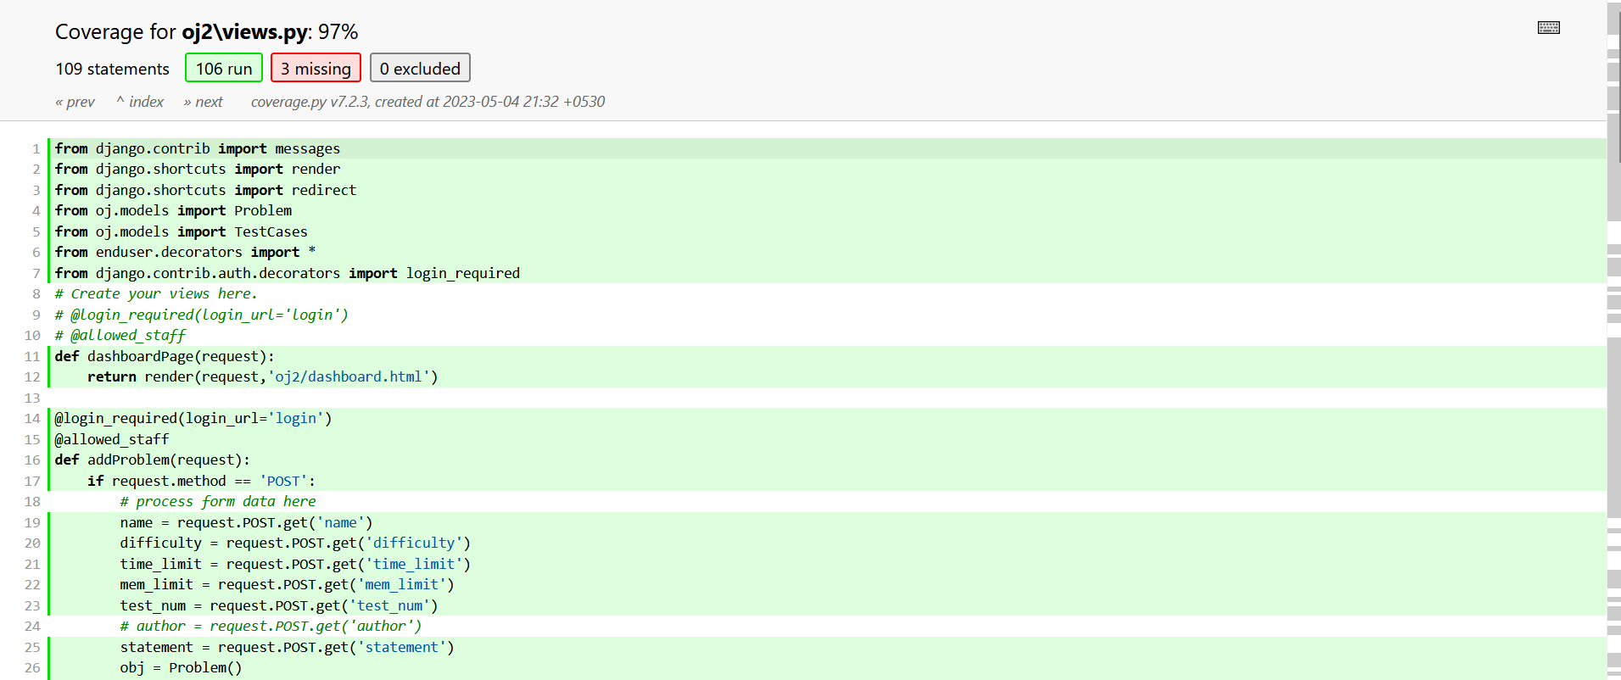

`

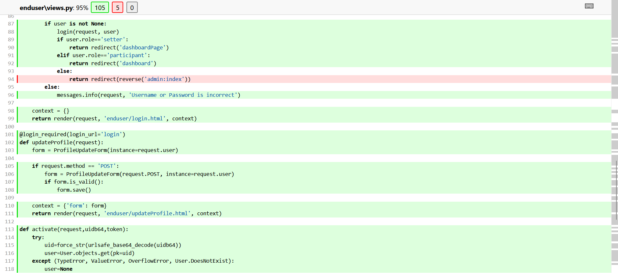

**Manually testing done**

Test cases for testing verdict functionality-

1. Verdict - Accepted

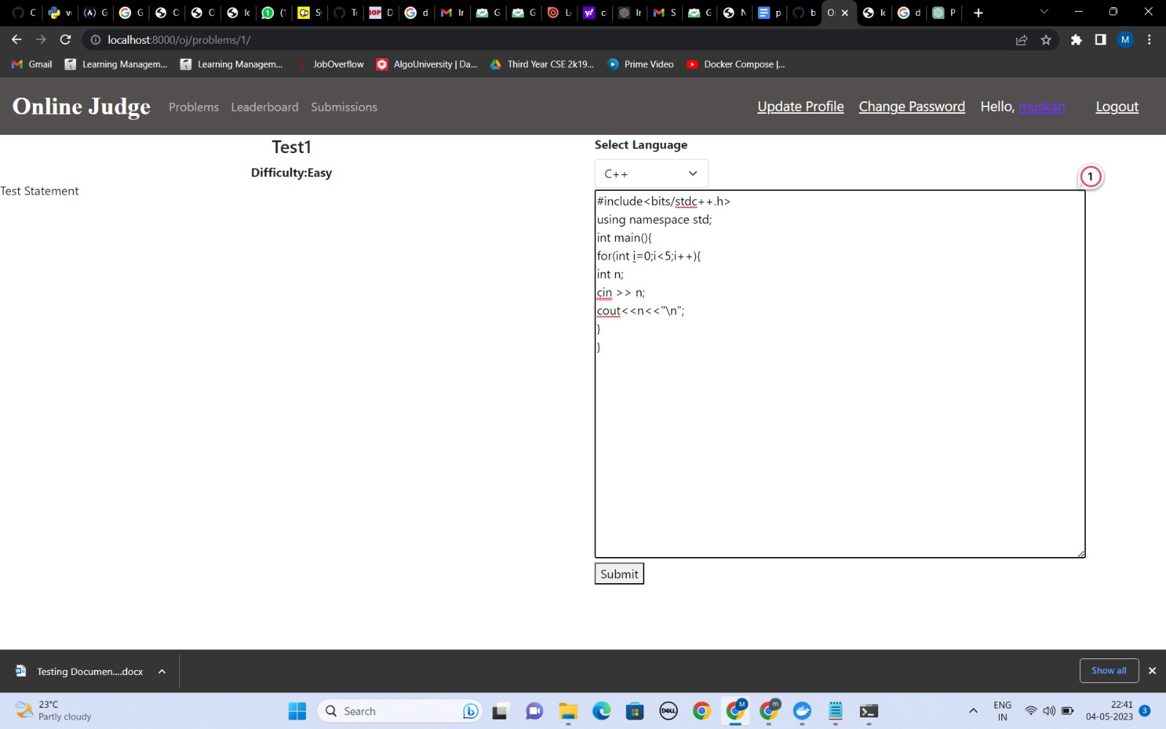 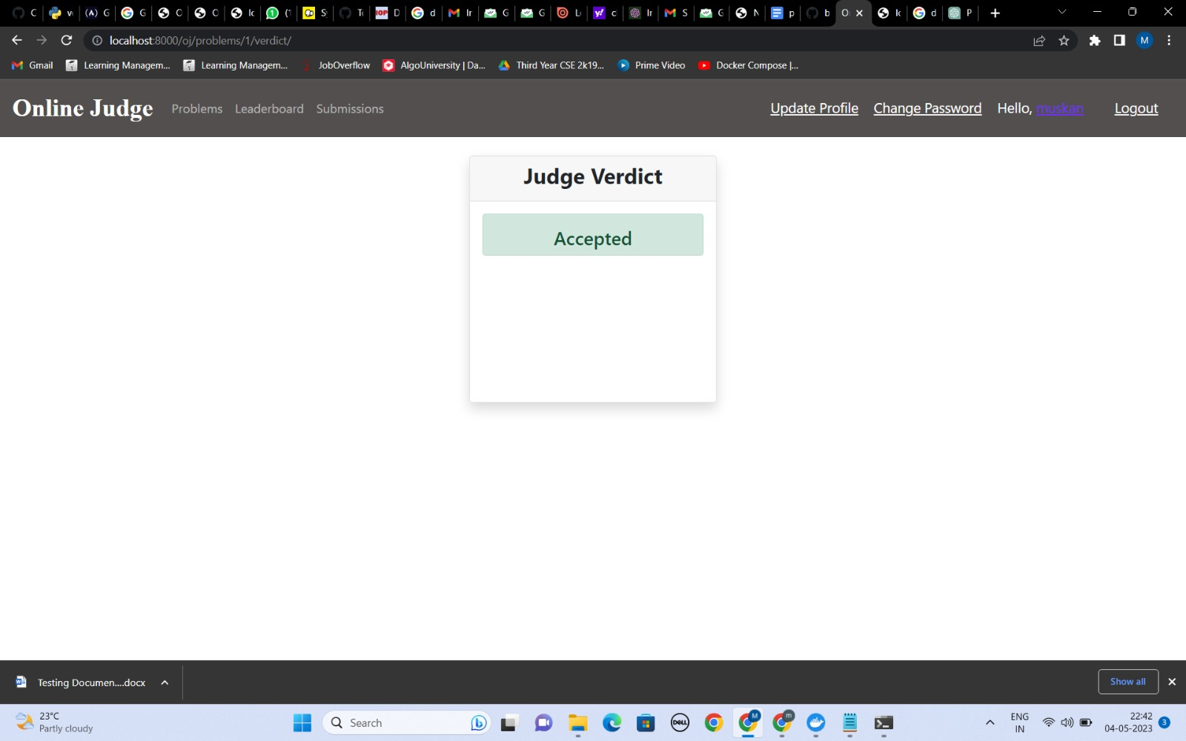

1. Verdict – Compilation Error

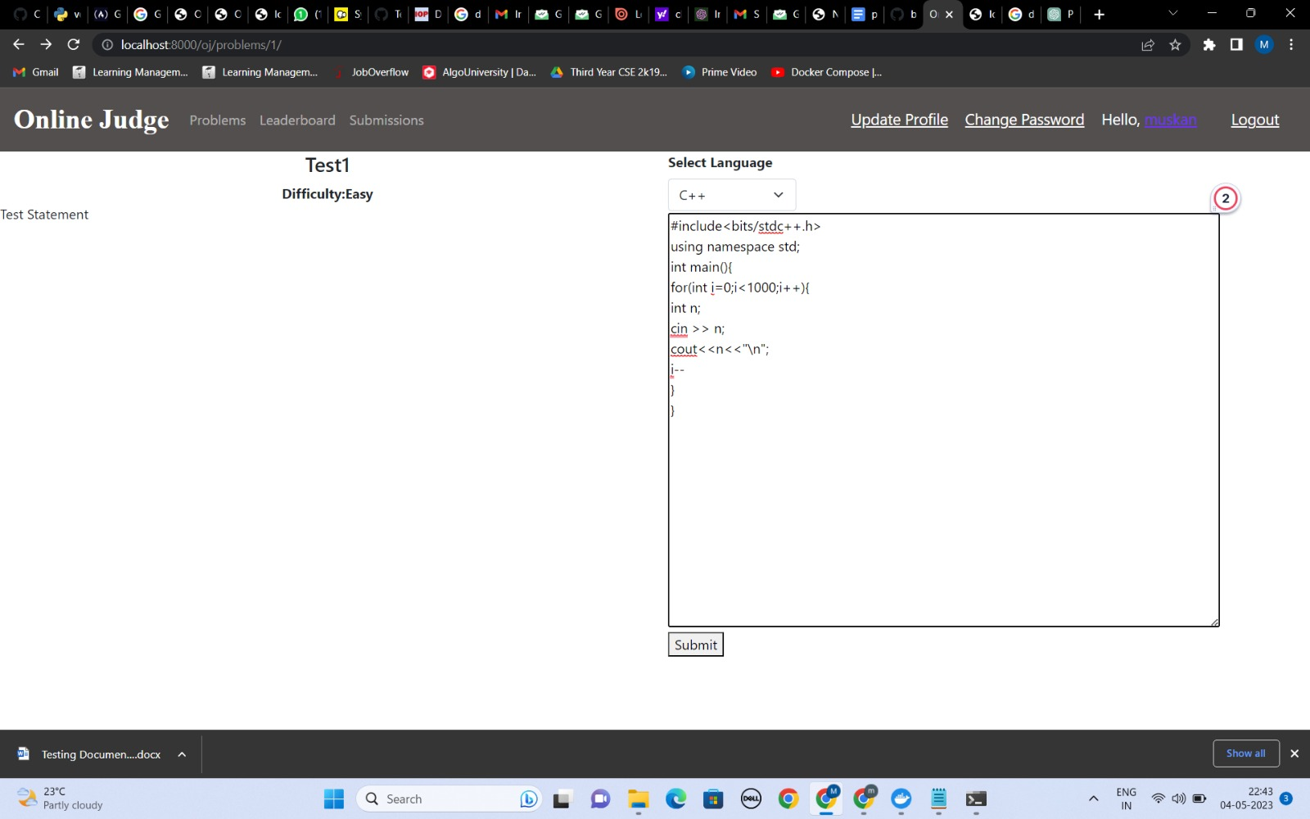 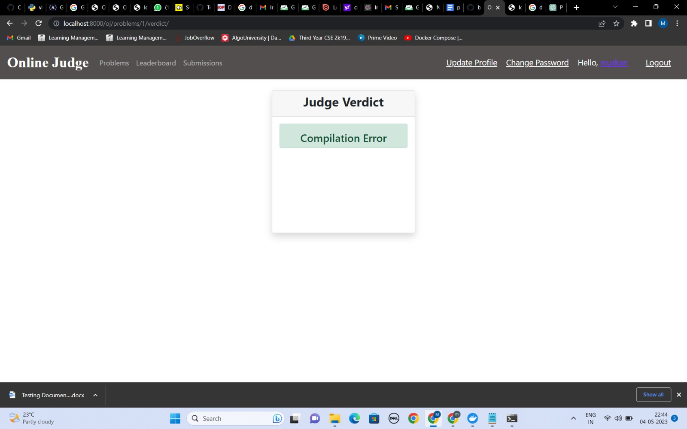

3. Verdict – Time Limit Exceeded

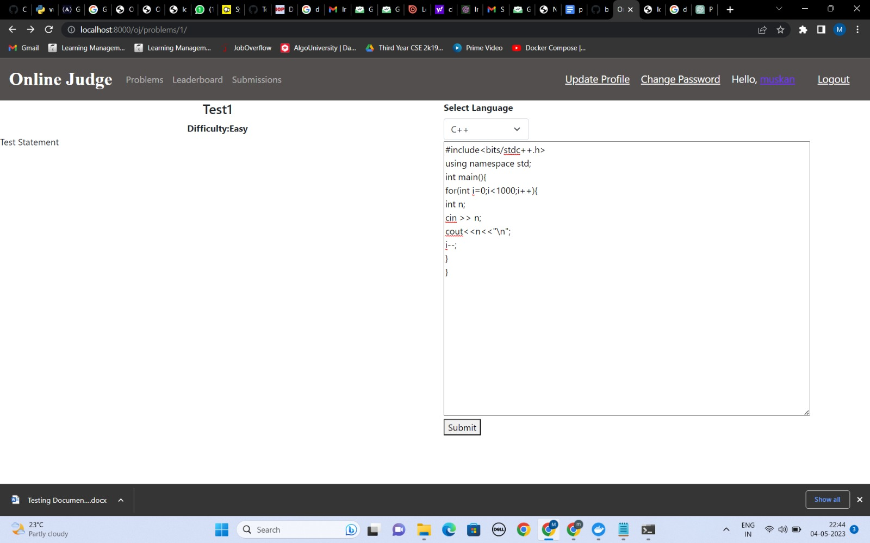 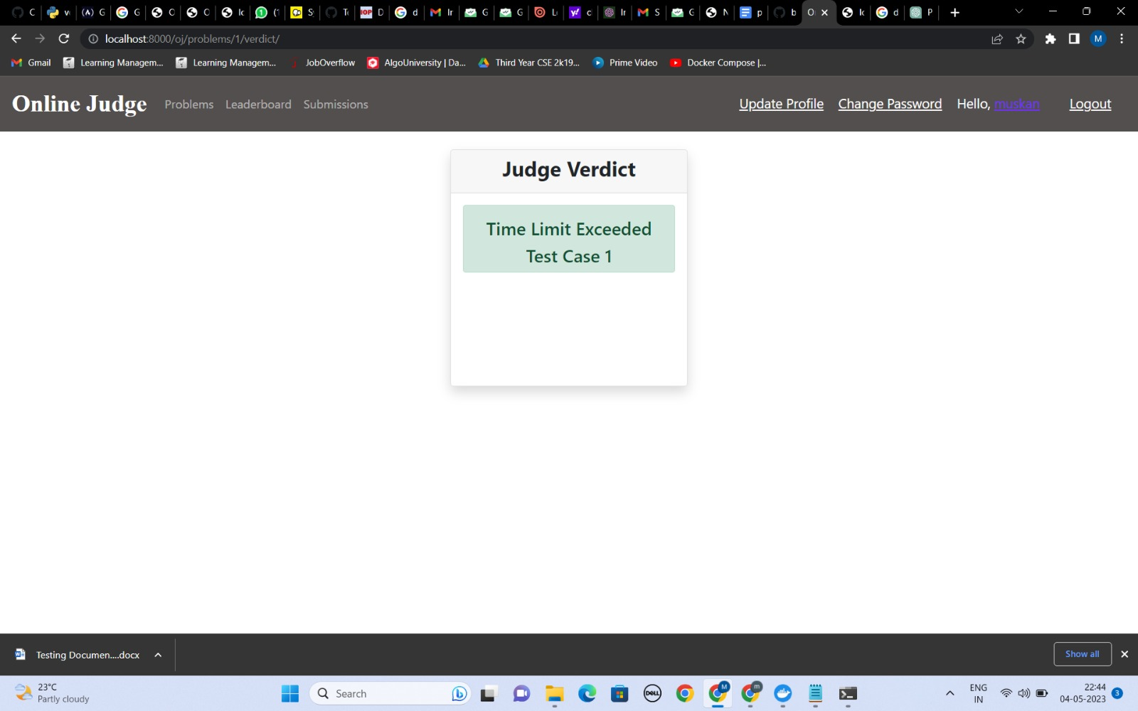

1. Verdict- Wrong Answer

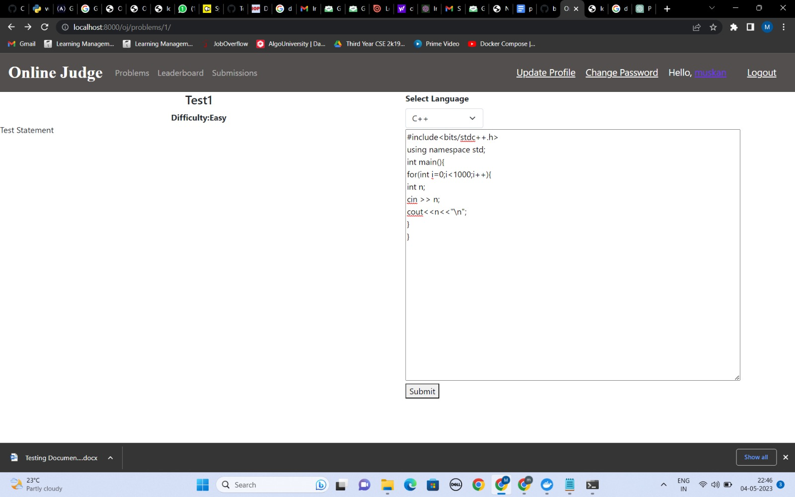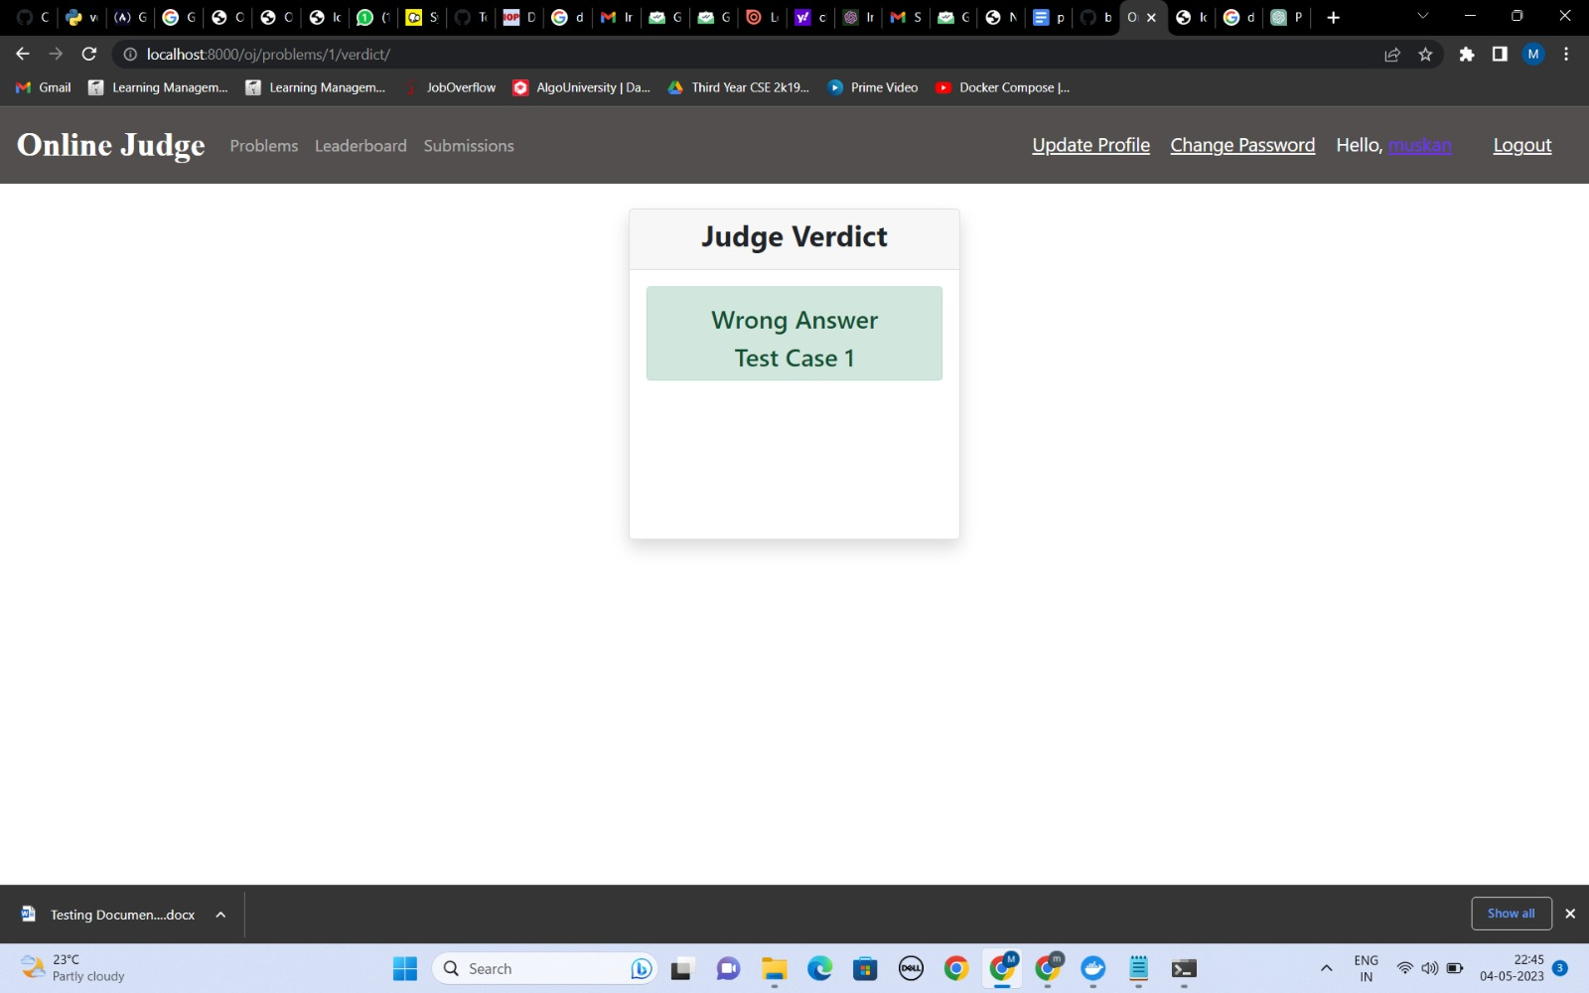

1. Verdict- Runtime Error

