DECODELABS

ARTIFICIAL INTELLIGENCE INTERNSHIP
PROJECT 2

DATA CLASSIFICATION USING ARTIFICIAL INTELLIGENCE

Submitted By:
Muskan

Batch:
1 june to 1 july 2026

Submitted To:
DecodeLabs

1.
INTRODUCTION
Artificial Intelligence (AI) is a technology that enables computers to learn from data and make intelligent decisions. One of the most important applications of AI is Machine Learning.
Classification is a supervised learning technique where a model learns from labeled data and predicts the category of new data.
In this project, the Iris flower dataset is used to classify flowers into three species:
1. Setosa
2. Versicolor
3. Virginica
The classification is performed using Decision Tree and K-Nearest Neighbors (KNN) algorithms.

2.
OBJECTIVE

The objective of this project is to build a machine learning model that can classify flower species based on their measurements.

DATASET DESCRIPTION

Dataset Name: Iris Dataset
Total Samples: 150

Features:
1. Sepal Length
2. Sepal Width
3. Petal Length
4. Petal Width

Target Classes:
1. Setosa
2. Versicolor
3. Virginica

Dataset Shape: (150, 4)

3.
METHODOLOGY

Step 1:
Load the Iris dataset using Scikit-learn.

Step 2:
Split the dataset into training and testing data.

Training Data: 80%
Testing Data: 20%

Step 3:
Train the machine learning models.

Algorithms Used:
• Decision Tree Classifier
• K-Nearest Neighbors (KNN)

Step 4:
Make predictions using the trained models.

Step 5:
Evaluate the performance using accuracy score and confusion matrix.

4.
Code Screenshot

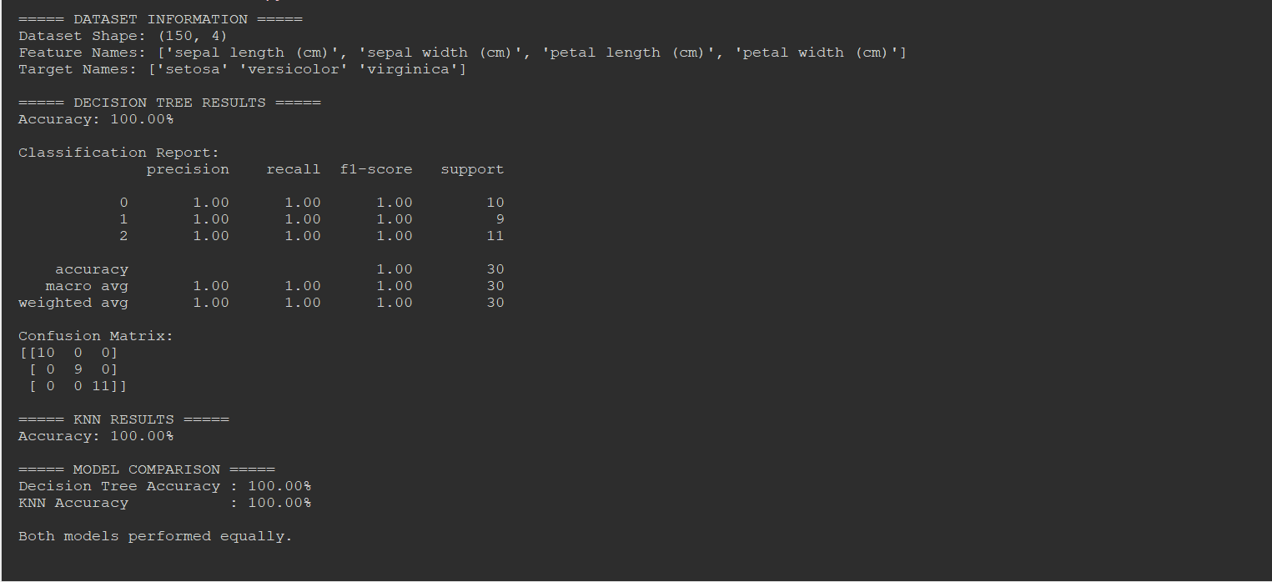
Figure 1: Python implementation of Iris flower classification using Decision Tree and KNN algorithms.

5.

Graph Screenshot

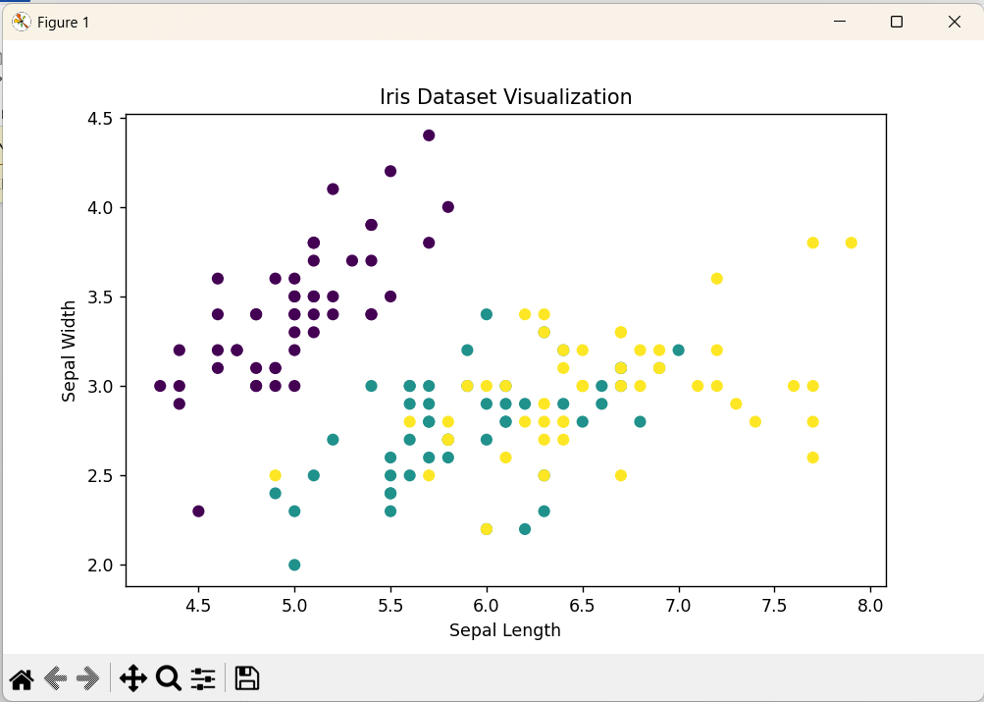
Figure 2: Visualization of Iris Dataset.
The graph shows the distribution of flower samples based on sepal length and sepal width.
Different colors represent different flower species.

6.
Conclusion

The project successfully demonstrated the implementation of supervised machine learning for data classification.
Both Decision Tree and KNN algorithms were trained and tested using the Iris dataset. The models achieved 100% accuracy and correctly classified all flower species.
This project improved understanding of dataset handling, model training, prediction, and evaluation techniques in Artificial Intelligence.

7.
FUTURE SCOPE

1. Use larger datasets.
2. Apply more machine learning algorithms.
3. Develop a graphical user interface.
4. Deploy the model as a web application.
5. Use real-world classification problems.

8.

