Muskan Singh
Cse-c
- GitHub repository URL

https://github.com/Muskan3631/github-skills-challenge
- Pull request URL used to validate the workflows

https://github.com/Muskan3631/github-skills-challenge/pull/4
- Screenshot showing the GitHub Actions workflows

- 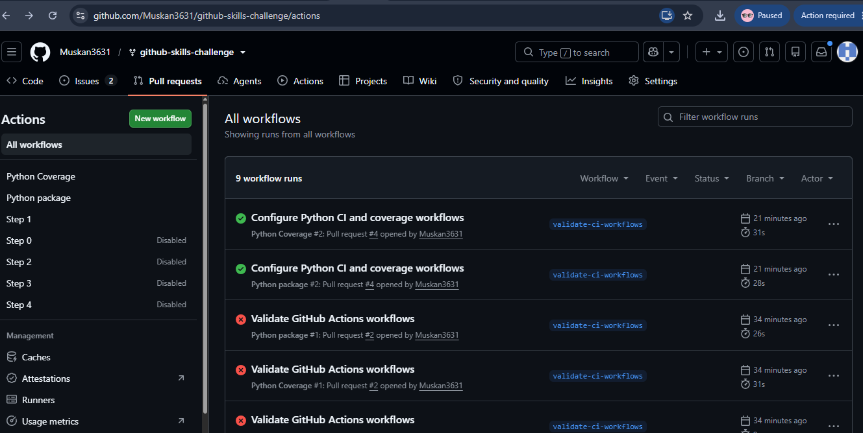

- Screenshot showing a successful test workflow execution

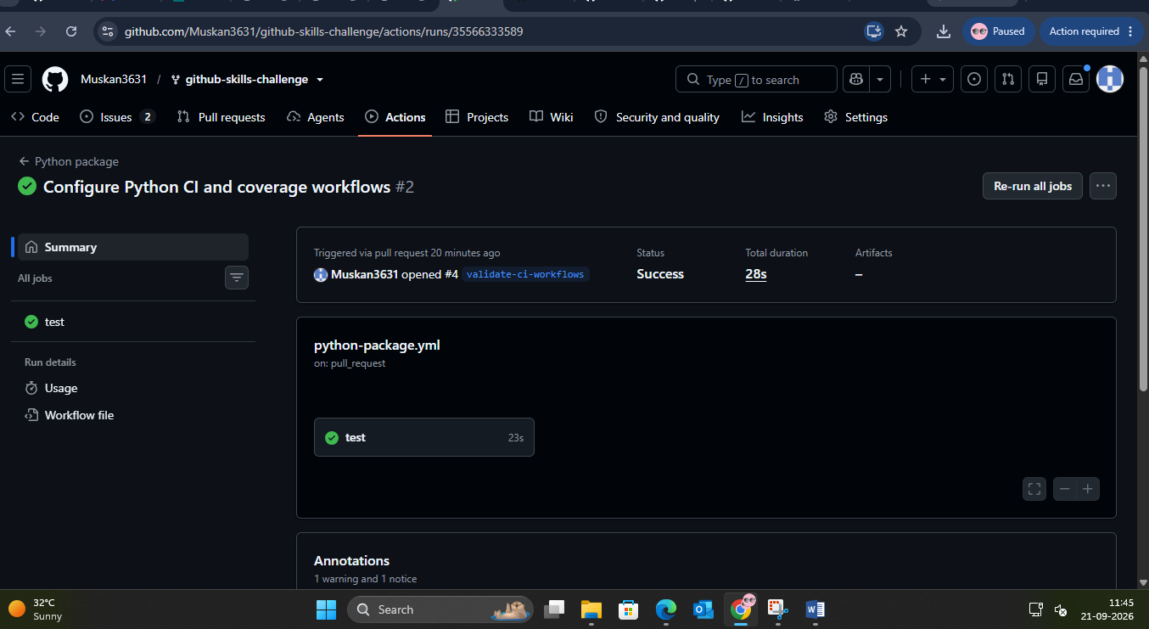
- Screenshot showing the coverage result/comment on the pull request
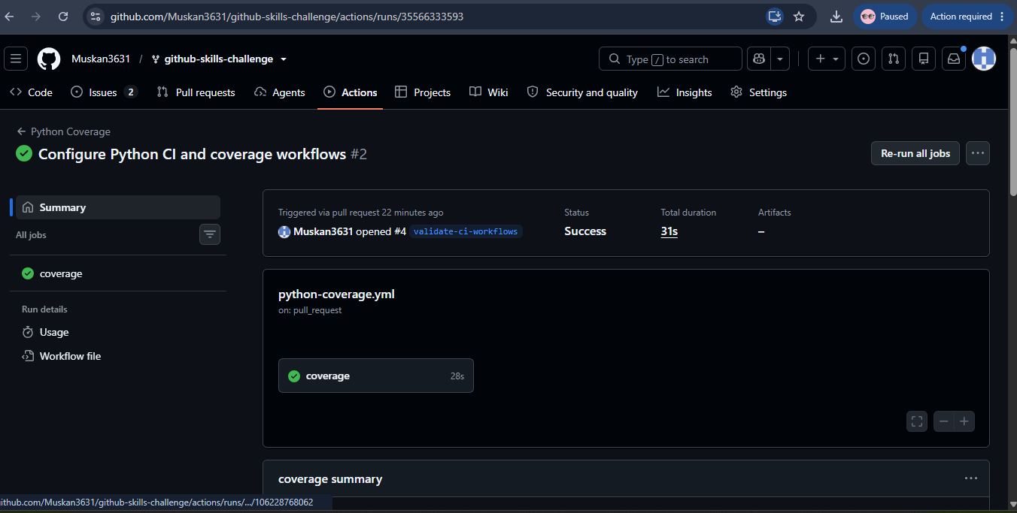
- Screenshot showing the final repository/workflow files
