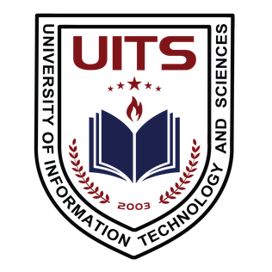
PROJECT PROPOSAL
Vashasetu
Turn any regional dialect into Standard Bangla — by voice, instantly.
Software Engineering
CSE 355
Student 1 (Team Member): | Sadia Akter Liza (ID: 0432320005101110)
Student 2 (Team Member): | Shobnom Sultana Muskan (ID: 0432320005101142)
Academic Program & Term: | B.Sc. in CSE - 8-Week Lab Project
Course Instructor: | Dr. Mahfida Amjad Dipa
Date of Submission: | August 18, 2026

