
Vashasetu (ভাষাসেতু)
A Regional Bangla Dialect Translator and Learning App
Software Test Report
CSE 416 – Software Project Design and Development
Department of CSE | Autumn 2026
Submitted by:

Name | ID | Section
Shobnom Sultana Muskan | 0432320005101142 | 7B1
Sadia Akter Liza | 0432320005101110 | 7B1

Submitted To:
Dr. Mahfida Amjad Dipa
Assistant Professor, CSE Dept.
Date: 31.10.2026
CSE 416 – Software Project Design and Development (Lab)
Software Test Report
Test plan, test cases and results (based on ISO/IEC/IEEE 29119-3)
Project | Vashasetu (ভাষাসেতু): A Regional Bangla Dialect Translator and Learning App
Team ID | Section: 7B1
Member 1 | 0432320005101142 – Shobnom Sultana Muskan – Developer & Test lead
Member 2 | 0432320005101110 – Sadia Akter Liza – Manual tester
Instructor | Dr. Mahfida Amjad Dipa, Assistant Professor, Dept. of CSE, UITS
Submitted | 31 October 2026

Document Control
Repository | https://github.com/Muskan37/Vashasetu
Version tested | Build of 31 October 2026 (VashaSetu_FULL_latest.zip, service-worker cache v47)
Where it runs | XAMPP on the laptop (http://localhost/vashasetu); shared to phones through a Cloudflare tunnel
Report version | 1.0
Prepared by | Shobnom Sultana Muskan, Sadia Akter Liza

Version | Date | Changes
1.0 | 31 Oct 2026 | First version: system, UI, security, load, reliability and accessibility suites, PHPUnit suite (unit, data, integration, HTTP), coverage report, generated-test review, mutation testing, defects D1–D38, native-speaker reviews of the Noakhali, Garo and Chattogram word lists

1. Introduction

1.1 Purpose
This report covers how we tested Vashasetu at the build of 31 October 2026: what we tested, how, the results, and whether it is ready to be released.

1.2 Product overview
Vashasetu translates between Standard Bangla, English and eleven regional Bangla dialects (and Chakma, Marma and Garo), shows a word box with the meaning and reliability of every word, and teaches a dialect step by step. Input can be typed in Bangla, Banglish or English, spoken, or scanned from a photo. It is an installable web app (PWA) in vanilla JavaScript with a PHP 8 API and a MySQL database, run on XAMPP.

1.3 Scope
In scope | Requirements | Levels
Translation, exact sentences, word boxes | FR1, FR3, FR4 | Unit, Integration, System, E2E
Bangla, Banglish, English, voice and photo input | FR2 | Unit, Integration, E2E
Words dictionary, edits, edit log, admin undo | FR5, FR6 | Integration, System, E2E, Reliability
Learning path and quizzes | FR7 | Integration, System, E2E
Accounts, history, profile, word of the day | FR8 | Integration, System, E2E
Phone use, install, offline, accessibility | NFR1 | E2E, Accessibility
Speed and many users | NFR2 | Performance, Reliability
Security | NFR3 | Unit, Integration, Security
Honest labelling and quality of the word data | NFR4 | Data, Integration

Out of scope | Why
Linguistic quality of every dialect word | Needs native speakers. Reviewed so far: the Noakhali, Garo and Chattogram word lists. We test that reviewed words are used and labelled correctly.
Google text-to-speech download | The test computer has no internet. We test the message the app shows instead.
Safari and Firefox | Only Chromium is installed on the test computer.

1.4 References
Document | Version / Link
SRS and design (CSE 355 / CSE 416 project report) | v1.0, 27 Oct 2026
Lab handout: Software Testing and Quality Assurance (CO3) | Steps 1–4
ISO/IEC/IEEE 29119-3; ISO/IEC 25010; OWASP Top 10; WCAG 2.1 AA | 2021 / 2018 editions

1.5 Abbreviations
EP: Equivalence Partitioning.
BVA: Boundary Value Analysis.
AAA: Arrange, Act, Assert.
E2E: End to End (real phone-sized browser).
RTM: Requirement Traceability Matrix.
p95: 95th percentile response time.
PCOV: PHP line-coverage driver.

2. Test Environment
OS | Linux test computer (2 CPU cores); the app normally runs on Windows with XAMPP
Runtimes | Apache 2.4.58 (prefork, 150 workers) + mod_php 8.3 with PCOV 1.0 for coverage; MariaDB 10.11 set up like XAMPP (root without password, display_errors On); Python 3; Node 20
Test database | vashasetu, loaded from the CSV data with setup.php?reset=1 before every full run
Browser | Chromium (Playwright 1.56) as a 390 × 844 px phone, Bangla locale; 320–1366 px for layout checks
Test tools | PHPUnit 9.6.17, php-code-coverage 9.2, Playwright, axe-core 4, requests; our scripts: tests/*.py, tests/mutation_check.py, tests/run_coverage.sh

2.1 Test data
Every full run starts from a fresh database loaded from the committed CSV files. Tests create their own accounts (…@example.com), words and history entries with a random code, and remove them again; database changes made by the in-PHP integration tests run inside a transaction that is rolled back. Expected values come from native-speaker sentences and the native-speaker-reviewed word lists, never from the code's own output.

2.2 How to run
• Start Apache and MySQL in XAMPP and open http://localhost/vashasetu/setup.php?reset=1 once
• composer require --dev phpunit/phpunit:^9.6 (once)
• vendor\bin\phpunit (Unit, Data, Integration and HttpFlows suites)
• python tests/system_tests.py / ui_tests.py / security_tests.py / load_tests.py / reliability_tests.py / a11y_perf_tests.py
• python tests/mutation_check.py (planted-bug check of the assertions)
• bash tests/run_coverage.sh (everything with coverage, merged HTML report)

3. Test Strategy
Level / type | Objective | Technique | Tool
Unit | Password, dialect and address rules, Bangla text helpers, phonetic matching, English grammar, Noakhali rule | EP, BVA, AAA | PHPUnit
Data | Word lists: complete rows, valid Bangla script, no duplicates | Rule check over every row | PHPUnit
Integration | Translation pipeline and dictionary with the real database; every API endpoint over HTTP | EP, BVA, error guessing, use cases | PHPUnit
System / E2E | All features as a user uses them on a phone-sized browser | Use cases | Python, Playwright
Regression | Full suite after every fix; one test per fixed defect | Re-run | phpunit, CI
Performance | Speed with 1–300 users, spike, soak, page speed | Load test | load_tests.py, Chrome metrics
Security | OWASP Top 10 that apply: access control, injection, auth, CSRF, headers | OWASP checklist, fuzzing | security_tests.py
Reliability | Parallel edits, database stop/start, restart | Fault injection | reliability_tests.py
Accessibility | 10 screens, keyboard, zoom, screen sizes | WCAG audit | axe-core
Test quality | Do the assertions catch real bugs? | Mutation testing (24 planted bugs) | mutation_check.py

Why these tools: the API is plain PHP, so PHPUnit fits, and calling it over HTTP tests routing, sessions and SQL too. Playwright drives a real Chromium on a phone screen. PCOV records coverage both in PHPUnit and in every request the web server answers, so the Python suites count towards coverage as well.

3.1 Entry criteria
• All PHP, JavaScript and Python files pass the syntax check (code_scan.py CS-01–CS-03)
• Every requirement has acceptance criteria in the SRS
• The environment and test data are ready (section 2)

3.2 Exit criteria
Criterion | Target | Result | Met?
Requirements with a test | 100% | 100% (12 of 12) | Yes
P1 test cases passing | 100% | 100% (59/59) | Yes
Line coverage, core logic | 60% | 90.9% (whole PHP code 90.1%) | Yes
Planted bugs caught (mutation score) | 80% | 23/24 (96%) | Yes
Open S1 / S2 defects | 0 | 0 | Yes

4. Traceability Matrix
Built from the test catalogue in section 5: each test case names the requirements it checks, and the status comes from the actual run. Requirements are those of our SRS.
Req | Requirement | Test case IDs | Status
FR1 | Translate Standard ↔ dialect, dialect ↔ dialect, English | TC-U03, TC-U09, TC-U10, TC-U11, TC-U17 +14 | Pass
FR2 | Bangla, Banglish, English, voice and photo input; auto-detect | TC-U06, TC-U07, TC-U12, TC-U13, TC-U14 +8 | Pass
FR3 | Exact sentence first, word by word only when allowed | TC-U08, TC-U10, TC-01, TC-05, TC-09 +2 | Pass
FR4 | Word box with meaning and reliability | TC-06, TC-35, E2E-01, E2E-05 | Pass
FR5 | Dictionary: search, browse, add, edit, delete | TC-08, TC-09, TC-19, TC-20, TC-21 +4 | Pass
FR6 | Edit log by address; administrator undo | TC-32, REL-01 | Pass
FR7 | Learning path and quizzes | TC-25, TC-36, TC-37, TC-34, E2E-03 +1 | Pass
FR8 | Accounts, history, profile, word of the day | TC-U01, TC-11, TC-12, TC-13, TC-14 +5 | Pass
NFR1 | Phone use, installable, offline start, accessible | TC-36, E2E-04, A11Y-01, A11Y-02 | Pass
NFR2 | Fast; works with many users | PT-01, PT-02, PT-03, PT-04, REL-02 | Fail
NFR3 | Security: hashed passwords, prepared SQL, limits, sessions, protected files | TC-U01, TC-U02, TC-U04, TC-U05, TC-10 +11 | Pass
NFR4 | Unverified meanings labelled; reviewed data is correct | TC-D01, TC-D02, TC-D03, TC-D04, TC-D05 +3 | Pass

Requirements | 12 (8 FR, 4 NFR)
With at least one test | 12 (100%)
With a negative test | 8 (67%)

5. Test Cases Specification

5.1 Test case list
84 test cases. Each one is a PHPUnit test method (often with a data provider of several equivalence classes or boundary values) or a group of cases from the earlier suites; "Runs" is the number of individual checks behind it.
TC ID | Req ID | Title / Test Case | Level | Priority | Runs | Result
TC-U01 | FR8, NFR3 | Password length boundaries: 0, 7 and 201 characters refused; 8, 9, 199 and 200 accepted | Unit | P1 | 16 | Pass
TC-U02 | NFR3 | Every refused password gets a readable reason | Unit | P2 | 1 | Pass
TC-U03 | FR1 | Only the 11 supported dialects are accepted (exact names) | Unit | P1 | 16 | Pass
TC-U04 | NFR3 | Visitor address from the tunnel header is trusted only from this computer | Unit | P1 | 5 | Pass
TC-U05 | NFR3 | HTTPS is detected directly, behind a proxy and through the tunnel | Unit | P2 | 7 | Pass
TC-U06 | FR2 | Bangla text is normalised (spaces, punctuation, joiners, two spellings of য় and ড়) | Unit | P1 | 16 | Pass
TC-U07 | FR2 | ো typed as ে + া is the same letter as ো | Unit | P1 | 6 | Pass
TC-U08 | FR3 | Verb spelling variants at the 2/3-letter boundary (খাবো / খাব) | Unit | P2 | 6 | Pass
TC-U09 | FR1 | English contractions are expanded (can't, won't, curly apostrophe) | Unit | P2 | 6 | Pass
TC-U10 | FR1, FR3 | Text is split into sentences; Mr./Dr. and list numbers do not end a sentence | Unit | P1 | 14 | Pass
TC-U11 | FR1 | The input's punctuation is put back into the translation | Unit | P1 | 23 | Pass
TC-U12 | FR2 | Banglish full stops become দাঁড়ি; ... and 2.5 stay | Unit | P2 | 5 | Pass
TC-U13 | FR2 | Roman typing of a Bangla word matches it (ami = আমি); different words do not | Unit | P1 | 5 | Pass
TC-U14 | FR2 | Phonetic edit distance: boundaries, symmetry and costs | Unit | P2 | 8 | Pass
TC-U15 | FR2 | Roman letter rules (chh, x, f, w, y, doubled letters) | Unit | P2 | 8 | Pass
TC-U16 | FR2 | Fuzzy look-up keys never contain the empty key (1-letter boundary) | Unit | P2 | 3 | Pass
TC-U17 | FR1 | English verbs get the right Bangla ending for 15 tense/person forms | Unit | P1 | 15 | Pass
TC-U18 | FR1 | Base verb of English forms, including -ie verbs (dies, died) | Unit | P1 | 16 | Pass
TC-U19 | FR1 | Bangla place ending -এ / -তে / -য় / -য়ে (বইয়ে) | Unit | P1 | 8 | Pass
TC-U20 | FR1 | Bangla possessive ending -র / -ের / -য়ের (ভাইয়ের) | Unit | P1 | 8 | Pass
TC-U21 | FR1 | Imperatives, verbal nouns and fixed English phrases | Unit | P2 | 2 | Pass
TC-U22 | FR1 | Noakhali "will not" rule: খাবো না = খাইতান ন, both ways | Unit | P1 | 8 | Pass
TC-D01 | NFR4 | Every word list row is complete, without stray spaces, with a known status (25 lists) | Data | P1 | 26 | Pass
TC-D02 | NFR4 | No certain typing mistakes (same vowel sign twice, split ো) | Data | P1 | 26 | Pass
TC-D03 | NFR4 | No duplicate rows in any word list | Data | P2 | 26 | Pass
TC-D04 | NFR4 | Words approved by a native speaker are written in valid Bangla script | Data | P1 | 27 | Pass
TC-D05 | NFR4 | The verified list curated.csv is clean | Data | P1 | 1 | Pass
TC-01 | FR1, FR3 | Native-speaker sentences translate exactly (Standard ↔ Noakhali, Standard → Chattogram) | Integration | P1 | 17 | Pass
TC-02 | FR1, NFR4 | Approved Noakhali, Chattogram and Garo words are used both ways | Integration | P1 | 17 | Pass
TC-03 | NFR4 | The three native-speaker-reviewed lists are loaded with their alternatives | Integration | P1 | 4 | Pass
TC-04 | FR1 | English sentences follow Bangla grammar (I will eat rice → আমি ভাত খাবো) | Integration | P1 | 19 | Pass
TC-05 | FR3 | A text of several sentences is matched sentence by sentence | Integration | P1 | 1 | Pass
TC-06 | FR4 | Every word gets a word box | Integration | P1 | 1 | Pass
TC-07 | FR1 | An unknown language is rejected | Integration | P1 | 1 | Pass
TC-08 | FR5 | A word added on the Words screen is used by the translator, then deleted | Integration | P1 | 2 | Pass
TC-09 | FR3, FR5 | A saved phrase is found as an exact sentence | Integration | P2 | 1 | Pass
TC-10 | NFR3 | Rate limit: 2 and 3 of 3 requests allowed, the 4th blocked; the XAMPP computer is never limited | Integration | P1 | 4 | Pass
TC-11 | FR8 | Register → me → log out → me → log in again (email in capitals) | Integration | P1 | 1 | Pass
TC-12 | FR8, NFR3 | Registration input classes and boundaries (password 7/8, email 150/151, empty name, list instead of text) | Integration | P1 | 11 | Pass
TC-13 | FR8 | A second account with the same email is refused (409) | Integration | P1 | 1 | Pass
TC-14 | FR8 | Login with empty fields gets 400 | Integration | P2 | 1 | Pass
TC-15 | FR1 | Translate API gives the native-speaker sentence | Integration | P1 | 1 | Pass
TC-16 | FR2 | Invalid translate input gets 400 with a message (no text, unknown language, list) | Integration | P1 | 8 | Pass
TC-17 | FR2 | Text length 1, 499, 500, 501 and 3,000 characters: at most 500 translated, never refused | Integration | P1 | 5 | Pass
TC-18 | FR8 | A logged-in user's translation is saved in History and can be deleted | Integration | P1 | 1 | Pass
TC-19 | FR5 | Words screen: add, search, edit, translate with, and delete a word | Integration | P1 | 1 | Pass
TC-20 | FR5 | Word and meaning length 100 / 101 letters, empty values, unsupported language | Integration | P1 | 7 | Pass
TC-21 | FR5, NFR3 | Words page number kept between 1 and 100,000; % and _ are searched as letters | Integration | P2 | 8 | Pass
TC-22 | NFR3 | User B cannot delete user A's history; a guest cannot read it | Integration | P1 | 2 | Pass
TC-23 | FR2 | ো typed as ে + া gives the same translation and is found in Words | Integration | P1 | 1 | Pass
TC-24 | FR2, FR1 | Banglish full stop becomes । ; "Mr." does not end an English sentence | Integration | P2 | 2 | Pass
TC-25 | FR7 | A lesson answer needs a logged-in user (401) | Integration | P1 | 1 | Pass
TC-26 | FR8 | Profile: spoken language, district and dialect are saved; unknown values refused | Integration | P2 | 8 | Pass
TC-27 | FR5 | Word contributions: valid, missing meaning, unsupported dialect, logged-in user | Integration | P2 | 5 | Pass
TC-28 | NFR3 | Wrong HTTP methods get 405; invalid history ids get 400 | Integration | P2 | 6 | Pass
TC-29 | FR8 | Word of the day works without a language (Chattogram) | Integration | P2 | 1 | Pass
TC-35 | FR1, FR4 | Dialect to dialect (Noakhali ↔ Chattogram): word boxes and the Bridge show the target dialect word; dialect → Standard unchanged | Integration | P1 | 3 | Pass
TC-36 | FR7, NFR1 | Learning instructions in the learner's language: Standard Bangla for Bangla varieties, reviewed words or symbols for Garo and Mro, never English; unknown language refused | Integration | P1 | 5 | Pass
TC-37 | FR7, NFR4 | Word questions show the learner's own word only from a native-speaker reviewed list (Garo ছি = পানি; none for Mro) | Integration | P1 | 1 | Pass
TC-30 | FR1, FR3 | Translation system cases: every direction, exact sentence first, English grammar (33 cases) | System | P1 | 33 | Pass
TC-31 | FR2, FR3 | Input validation and limits (8 cases) | System | P1 | 8 | Pass
TC-32 | FR5, FR6 | Dictionary browse, search, edit log by address and administrator undo (19 cases) | System | P1 | 19 | Pass
TC-33 | FR8 | Accounts, history, quiz and word of the day (27 cases) | System | P1 | 27 | Pass
TC-34 | FR7 | Learning path and graded lessons (10 cases) | System | P1 | 10 | Pass
E2E-01 | FR1, FR2, FR4 | Phone browser: translate, voice, Listen, Scan and word boxes (UI-01–UI-15, UI-40) | E2E | P1 | 16 | Pass
E2E-02 | FR5 | Phone browser: Words screen add, edit, delete, XSS shown as text (UI-16–UI-22) | E2E | P1 | 7 | Pass
E2E-03 | FR7, FR8 | Phone browser: history, profile, Learn path and quiz (UI-23–UI-30, UI-38) | E2E | P1 | 9 | Pass
E2E-04 | NFR1 | Layout at 360–414 px, install, offline start, long words (UI-31–UI-37, UI-39) | E2E | P1 | 8 | Pass
E2E-05 | FR4, FR7 | Phone browser: Bridge shows the word pairs, dialect-to-dialect boxes, Mro learner sees no English (UI-41–UI-43) | E2E | P1 | 3 | Pass
PT-01 | NFR2 | One user and 20 users: translation fast, no errors (LT-01, LT-02) | Performance | - | 2 | Pass
PT-02 | NFR2 | 50–300 users and a 500-request spike: slower but no errors (LT-03–LT-06) | Performance | - | 4 | Fail
PT-03 | NFR2 | 3-minute soak, memory, recovery, MySQL connections (LT-07–LT-10) | Performance | - | 4 | Pass
PT-04 | NFR2 | Page speed on fast and slow 4G, repeat visit, click to result (PF-05–PF-08) | Performance | - | 4 | Pass
SEC-01 | NFR3 | Password guessing: blocked after 8, 2,000-attempt flood, faked addresses (BF-01–BF-07) | Security | P1 | 7 | Pass
SEC-02 | NFR3 | Flooding edits, sign-ups, contributions and voice (FL-01–FL-04) | Security | P1 | 4 | Pass
SEC-03 | NFR3 | SQL injection (117 strings × 13 fields), XSS, JSON type, mass assignment (IN-01–IN-07) | Security | P1 | 7 | Pass
SEC-04 | NFR3 | Sessions and passwords: logout, fixation, bcrypt, weak passwords, enumeration (SS-01–SS-05) | Security | P1 | 5 | Pass
SEC-05 | NFR3 | Access control: admin pages, path traversal, hidden files, TRACE (AC-01–AC-06) | Security | P1 | 6 | Pass
SEC-06 | NFR3 | Security headers, error leaks, fuzzing, CSRF, CORS, clickjacking (HD, FZ, BR) | Security | P1 | 10 | Pass
SEC-07 | NFR3 | Static code checks: syntax, dangerous functions, SQL, escaping, secrets, locks (CS-01–CS-09) | Security | P2 | 9 | Pass
REL-01 | FR5, FR6 | 40 people editing at once; edits survive a reset; deletes (RL-01–RL-05) | Reliability | P1 | 5 | Pass
REL-02 | NFR2 | MySQL stops and starts; Apache restarts (RL-06–RL-09) | Reliability | P1 | 4 | Pass
A11Y-01 | NFR1 | WCAG 2.1 AA on 10 screens, keyboard, 200 % zoom (AX-01–AX-04) | Accessibility | - | 4 | Pass
A11Y-02 | NFR1 | 6 screen sizes, dark mode, reduced motion (DV-01–DV-03) | Accessibility | - | 3 | Pass

Summary. Total test cases: 84. Pass: 83. Fail: 1. Behind them are 673 individual runs.

5.2 Detailed test cases
Six of the most important cases:
ID | Requirement | Setup | Steps | Expected | Result
TC-01 | FR1, FR3: native sentence translates exactly | Database loaded; Noakhali native sentence pair | Translate আমি ভাত খাবো না to Noakhali, and back | আইঁ ভাত খাইতান ন / আমি ভাত খাবো না | Pass
TC-U01 | FR8, NFR3: password length | none (unit) | vs_password_problem() with 0, 7, 8, 9, 199, 200, 201 characters and 7/8 Bangla letters | Refused below 8 and above 200 letters | Pass
TC-12 | FR8: registration boundaries | App on Apache | Register with a valid 150- and 151-character email | 200, then 400 "Email address is too long" | Pass
TC-22 | NFR3: users cannot touch each other's data | Users A and B; A has a history entry | B deletes A's entry by its id; guest reads history | Not deleted; B and the guest see nothing | Pass
TC-D04 | NFR4: approved words are valid Bangla | All word lists | Check every approved word for a vowel sign on a vowel letter | None (8 approved as written by the reviewer) | Pass
SEC-01 | NFR3: password guessing | App on Apache | 2,000 logins from 40 attackers; faked addresses | Blocked after 8; no errors; others keep translating | Pass

5.3 Boundary value analysis
Each input is tested at and just beside its limits. Test numbers refer to the list in 5.1.
Input | Valid | Boundaries tested | Tests
Password | 8 to 200 letters | 0, 7, 8, 9, 199, 200, 201; 7 and 8 Bangla letters; 200 Bangla letters | TC-U01, TC-12
Email | valid address, at most 150 characters | 150, 151 (part before @ at most 64) | TC-12
Translate text | 1 to 500 characters (more is cut) | 0, only spaces, 1, 499, 500, 501, 3,000 | TC-16, TC-17
Word / meaning | 1 to 100 letters | 0, 100, 101 | TC-20
Words page | 1 to 100,000 | 0, -5, text, 1, 100,000, 100,001, 10^15 | TC-21
Rate limit | max requests per window | max-1, max, max+1 | TC-10
Verb variant | words longer than 2 letters | 2, 3, 4 letters | TC-U08
Fuzzy key | any length | 0, 1, 2 tokens | TC-U14, TC-U16
Visitor address header | up to 64 characters | 64, 100 | TC-U04

5.4 Word review states
needs_native_review → native_speaker_reported (main form) or native_speaker_alternative (other spelling of the same Standard word). Only reported and alternative words are shown as verified; only main forms are used when translating into a dialect. We test each state (TC-02, TC-03, TC-D04) and the wrong ones: an unreviewed word used as trusted (TC-D04), an odd unreviewed spelling marked as approved (TC-D04), an edited word keeping its old meaning (TC-08).

6. Test Execution Results

6.1 Summary
Level | Runs | Passed | Failed | Pass %
Unit | 202 | 202 | 0 | 100.0%
Data | 106 | 106 | 0 | 100.0%
Integration | 147 | 147 | 0 | 100.0%
System | 97 | 97 | 0 | 100.0%
E2E | 43 | 43 | 0 | 100.0%
Performance | 14 | 10 | 4 | 71.4%
Security | 48 | 48 | 0 | 100.0%
Reliability | 9 | 9 | 0 | 100.0%
Accessibility | 7 | 7 | 0 | 100.0%
Total | 673 | 669 | 4 | 99.4%

PHPUnit in numbers: 421 tests and 43,985 assertions (Unit 202, Data 106, Integration 33, HttpFlows 80), 0 failures. The data suite has many assertions because it checks every row of 25 word lists. The GitHub CI pipeline runs PHPUnit with coverage, the code checks and the functional suites on every push.

6.2 Test run evidence
Each suite was run in a terminal from the project folder on the tested build. Per-test names come from PHPUnit --testdox and the PASS/FAIL lines of our Python suites.
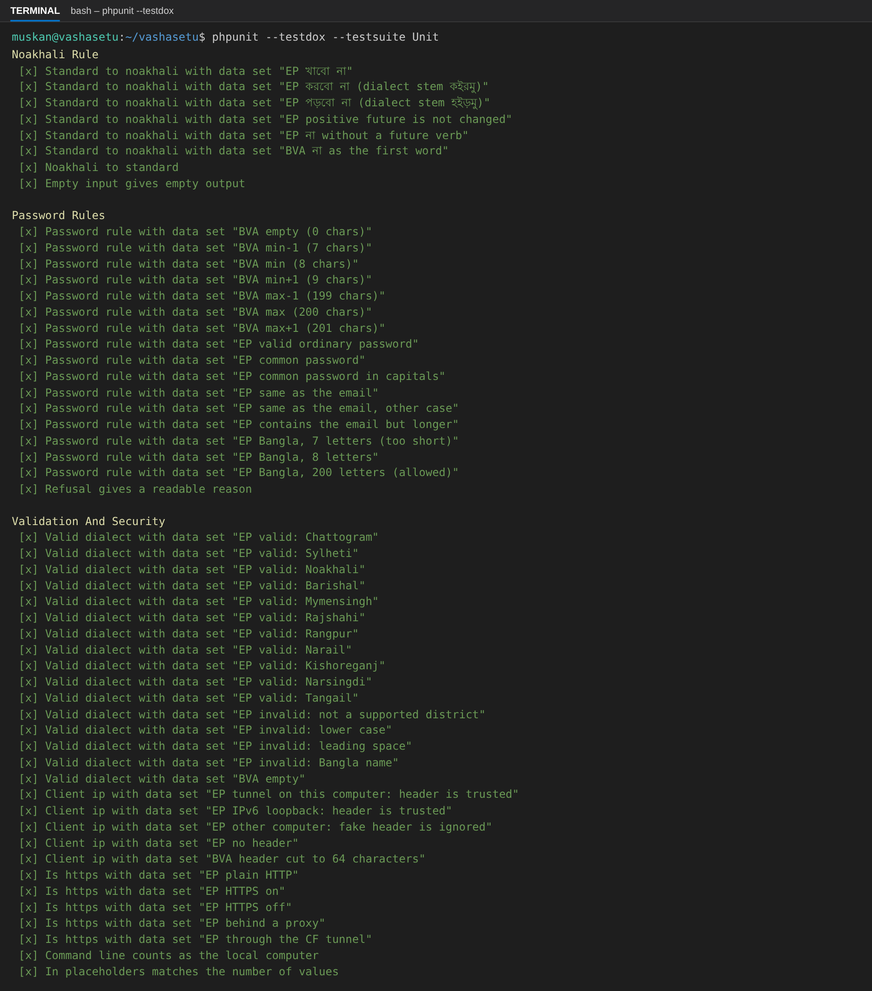
Figure 1: PHPUnit, all four suites (TestDox, part of the list)
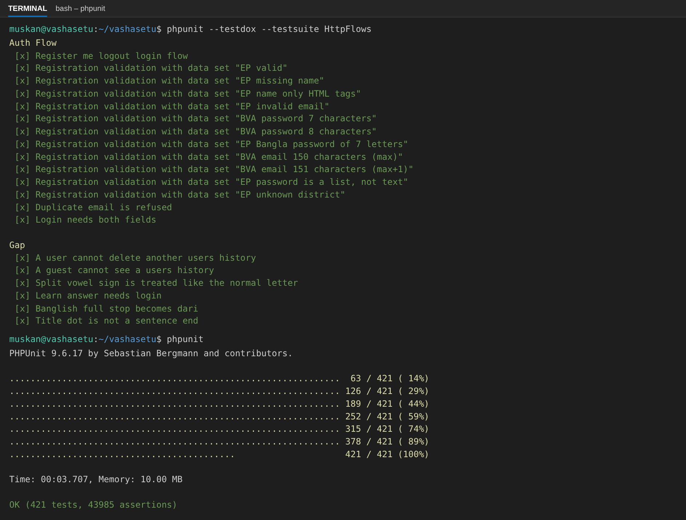
Figure 2: PHPUnit summary and the data suite
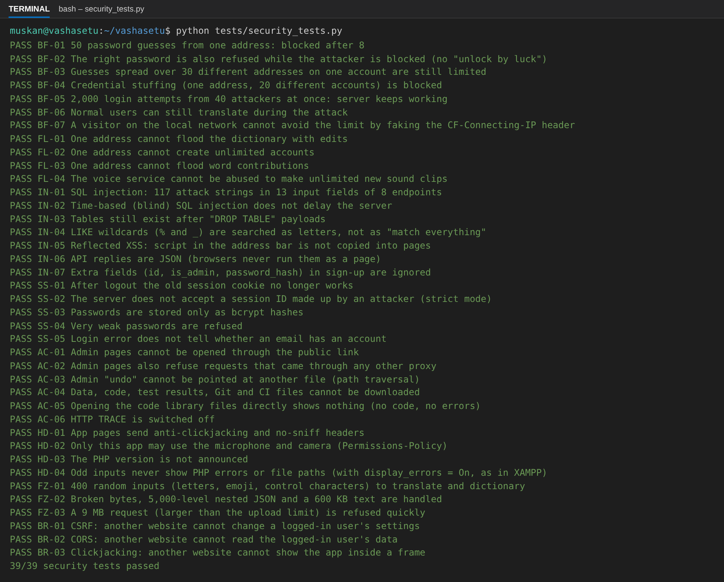
Figure 3: Security tests (39 passed)
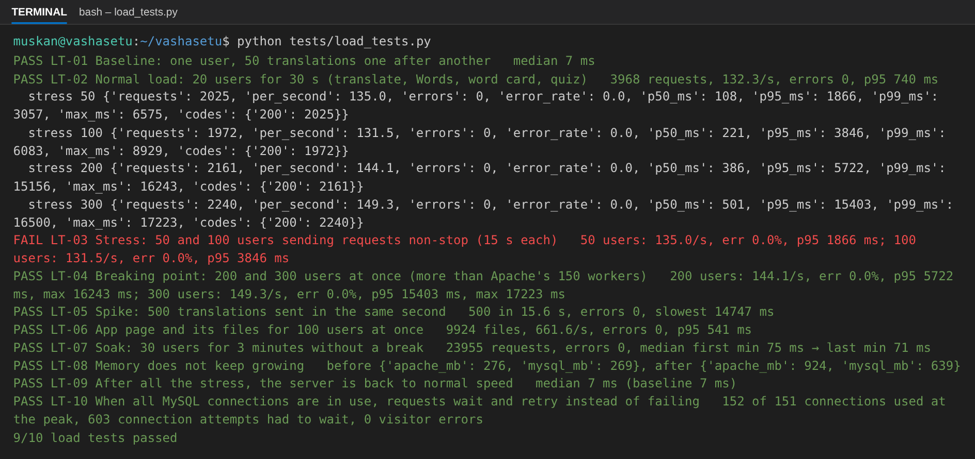
Figure 4: Load, stress, spike and soak tests (10 passed)
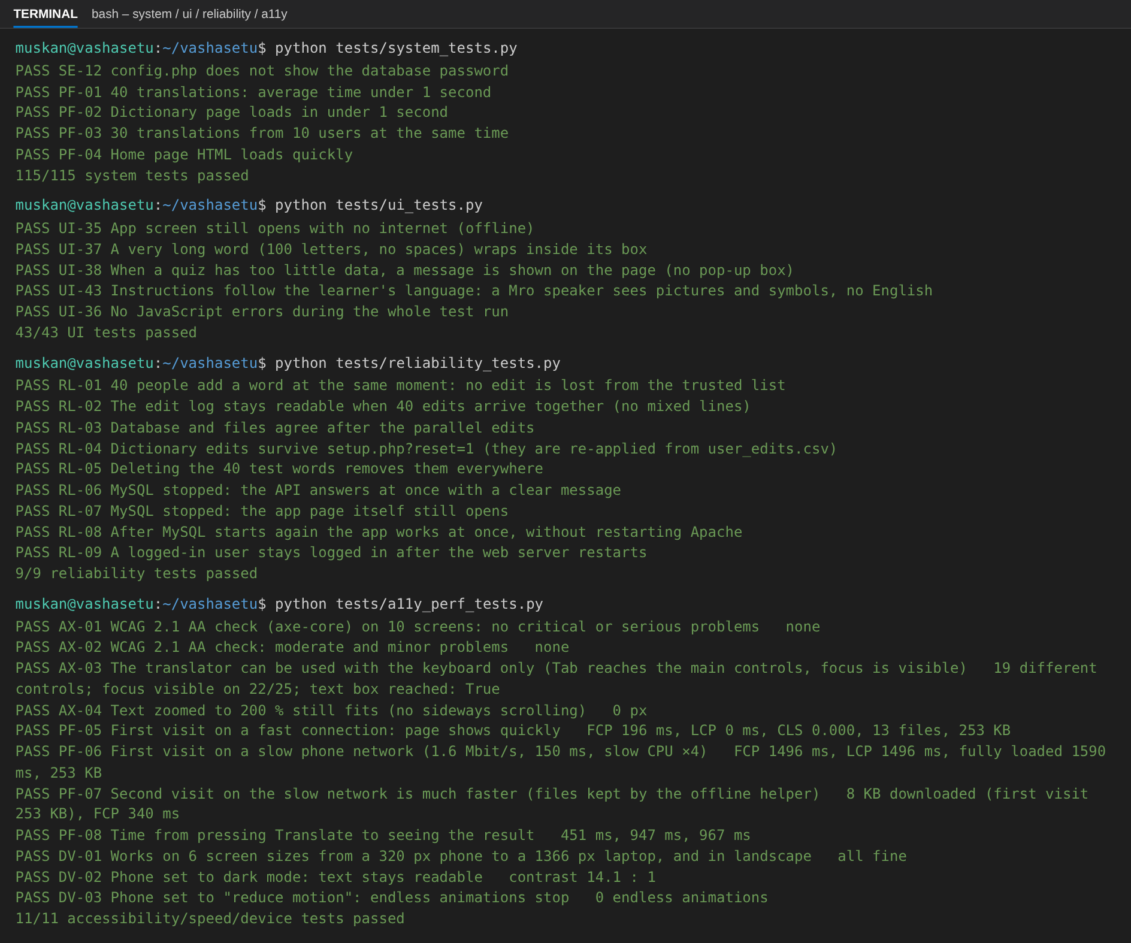
Figure 5: System, UI, reliability and accessibility suites
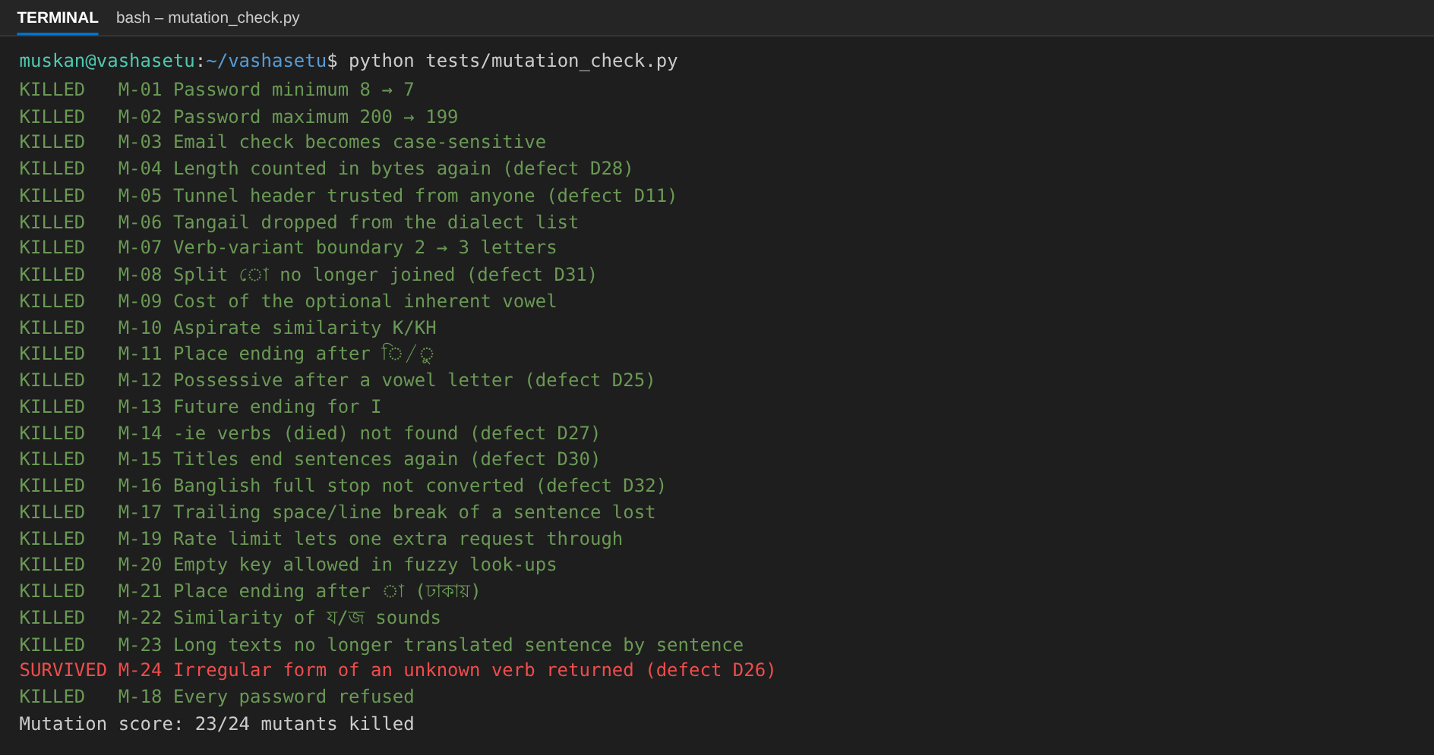
Figure 6: Mutation testing: planted bugs and the result

6.3 Failed tests
Test | Why it fails | Defect
PT-02 | LT-03: with 100 users sending requests non-stop, 95% of replies took 3.85 s, over our own 3 s target (0 errors). The test computer was restarted during the session and now answers about 132 requests per second instead of 190–215 in earlier runs of the same code; LT-04 to LT-06 (200–300 users, spike) still had no errors. | D34

The test stays in the suite so the gap is visible. Every other test case passes.

7. Code Coverage
Layer | PHPUnit only | All suites | Target
Data access, config and security | 30.6% (55/180) | 85.6% (154/180)
Translation engine and helpers | 76.9% (1247/1621) | 91.1% (1476/1621) | 60%
API endpoints | 0.0% (0/754) | 87.8% (649/739)
Pages and setup | 0.0% (0/259) | 93.7% (238/254)
Whole PHP code | 46.3% | 90.1% (2517/2794) | 60%

Lowest files: api/learn.php 77.0%, api/tts.php 78.8%, api/edit_lib.php 81.8%. The lines not covered are catch blocks for a database failure in the middle of a request, the Google voice download (no internet on the test computer), settings that are switched off (login-only editing), and one dead branch in api/word.php found by the coverage report. Coverage of the PHP code is recorded both inside PHPUnit and for every web request during the HTTP and Python suites (tests/phpunit/coverage/prepend.php), and merged into one report (tests/results/coverage/html/index.html). The JavaScript front end is covered by the E2E tests only.
Mutation testing. To check that the tests assert the right behaviour and do not only run the code, tests/mutation_check.py planted 24 small bugs one at a time (for example "< 8" became "< 7", or a fixed defect was put back). 23 of 24 were caught. At first 4 survived; we added tests for 3 of them. The last one cannot be seen from outside with the current data (an equivalent mutant).
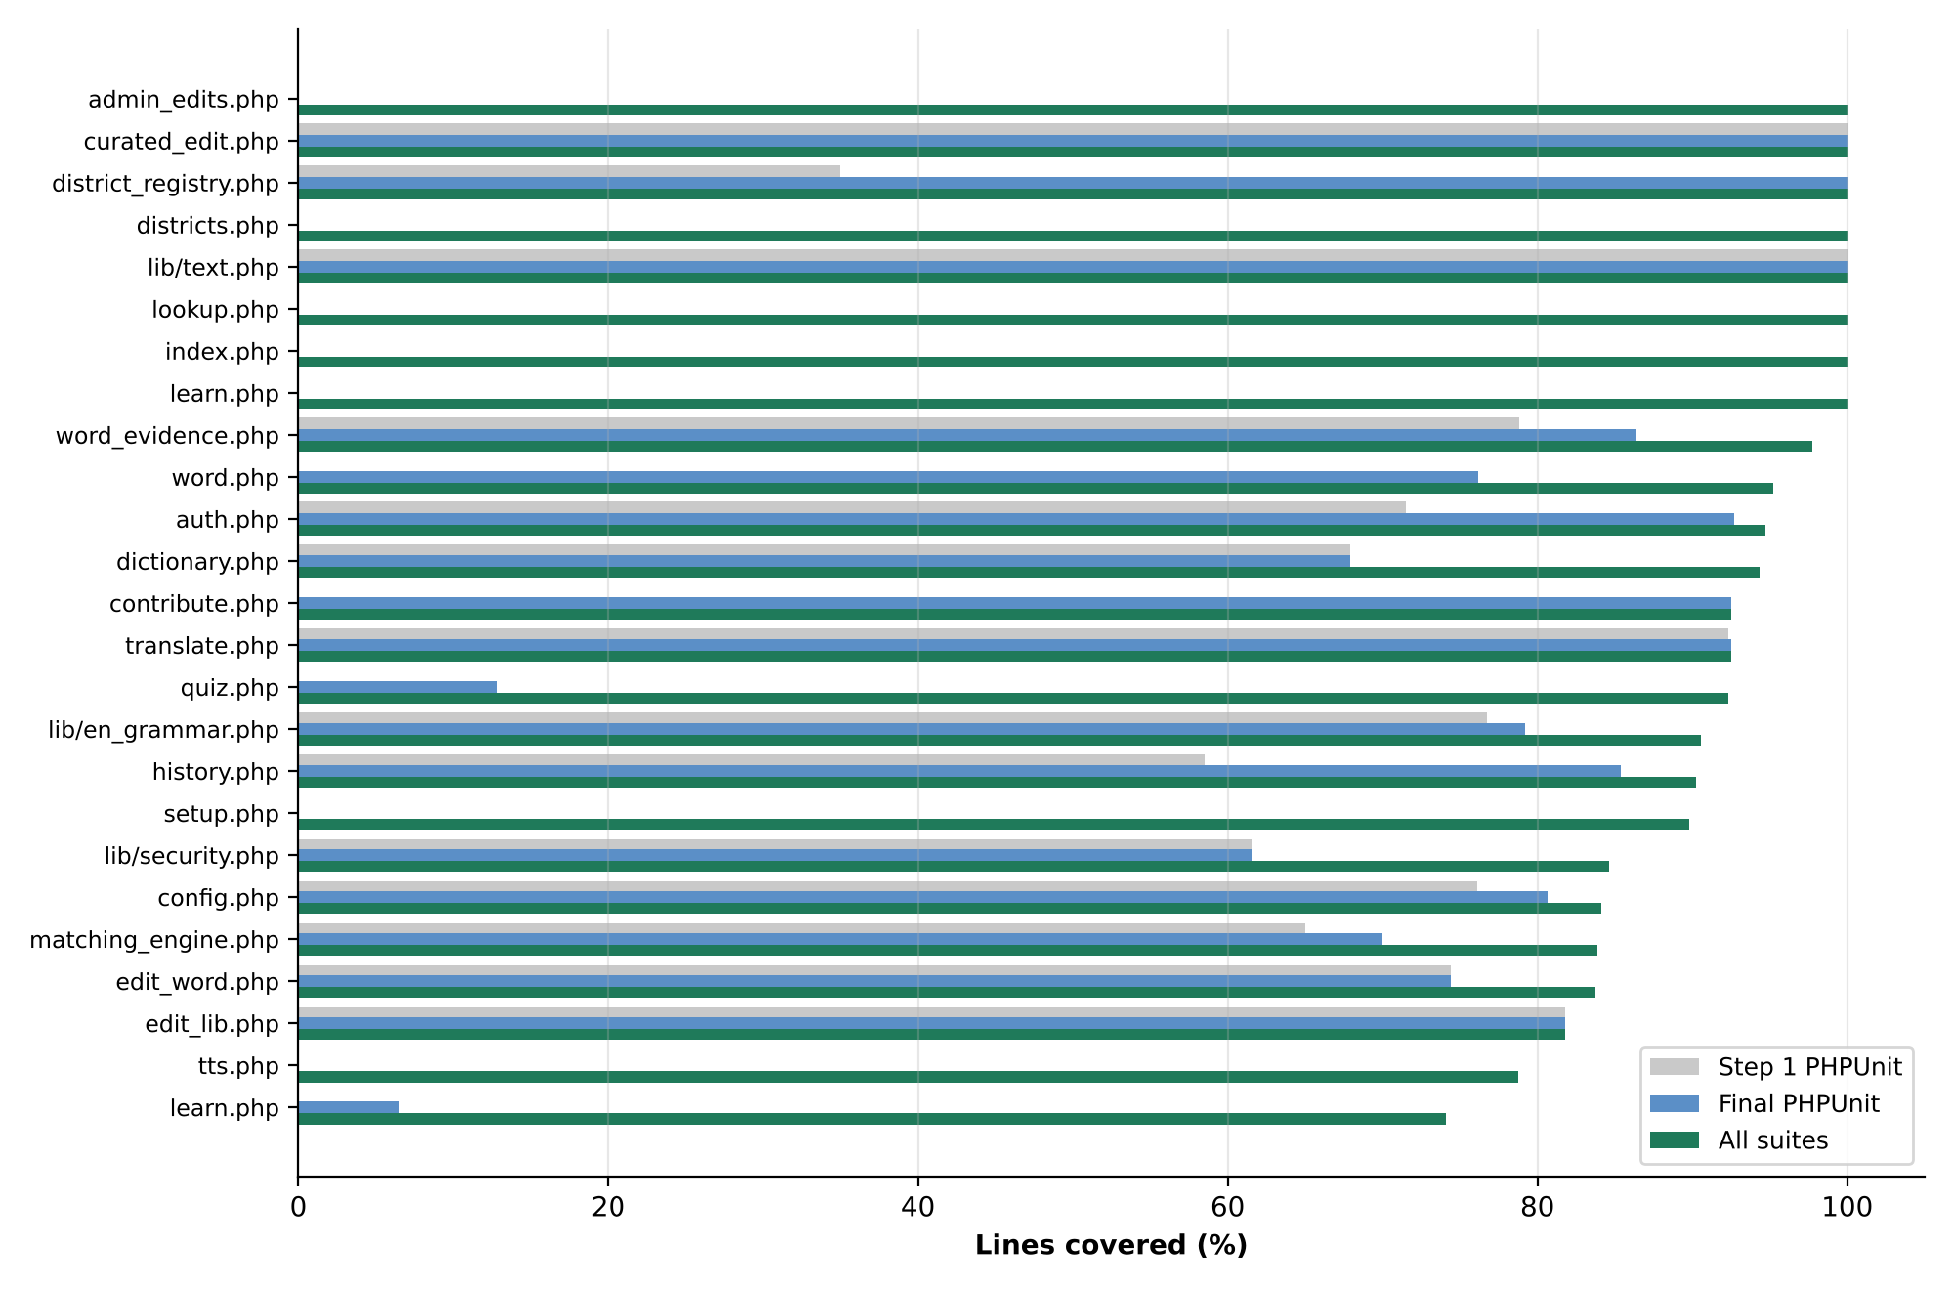
Figure 7: Line coverage by file – Step 1 PHPUnit suite, final PHPUnit suite, all suites

8. Non-Functional Testing

8.1 Performance
Load | p50 | p95 | Errors | Result
20 users, mixed requests | 47 ms | 740 ms | 0/3,968 | Pass
50 users, mixed requests | 108 ms | 1,866 ms | 0/2,025 | Pass
100 users, mixed requests | 221 ms | 3,846 ms | 0/1,972 | Pass
200 users, mixed requests | 386 ms | 5,722 ms | 0/2,161 | Pass
300 users, mixed requests | 501 ms | 15,403 ms | 0/2,240 | Pass
500 translations at once (spike) | – | last after 15.6 s | 0/500 | Pass
30 users for 3 minutes (soak) | – | drift ×0.95 | 0/23,955 | Pass

Users sent requests without any pause (60% translations, 20% Words pages, 10% word cards, 10% quizzes) on 2 CPU cores. Above 150 users – Apache's worker limit – requests wait in a queue and get slower, but none fail. The SRS asks for a translation in under 1 second for normal use: a single translation takes a median of 7 ms. Page speed: first content after 196 ms on a fast connection and 1496 ms on slow 4G (Google's "good" limit is 1,800 ms).

8.2 Security
Check | How | Result
Password guessing | Blocked after 8 tries per address/account; 2,000-attempt flood; faked addresses (SEC-01) | Pass
Flooding | Limits on edits, sign-ups, contributions, voice (SEC-02) | Pass
Access control | User B tries A's history (TC-22); admin pages through the public link; path traversal; hidden files (SEC-05) | Pass
SQL injection | ' OR 1=1 -- and 116 more strings in 13 fields; time-based; LIKE wildcards (SEC-03, TC-21) | Pass
XSS | Script in inputs and the address bar shown as text (SEC-03, E2E-02) | Pass
Sessions | Logout ends the session; made-up session id refused; bcrypt hashes (SEC-04) | Pass
CSRF, CORS, clickjacking | Evil page in a real browser (SEC-06) | Pass
Error leaks | No PHP warnings or paths even with display_errors On (HD-04) | Pass
Secrets in code | Static scan of PHP and JS (CS-08) | Pass

8.3 Static analysis
php -l on all PHP files, node --check on the JavaScript and py_compile on the Python scripts: 0 errors. code_scan.py also checks that no dangerous PHP functions are used, that no SQL is built from user input, that page output is escaped and that shared files are written under a lock (9 of 9 checks pass).

8.4 Accessibility and devices
Screen | axe-core WCAG 2.1 AA problems
splash | 0
home | 0
translate | 0
dictionary | 0
history | 0
profile | 0
quiz | 0
login | 0
register | 0
learn | 0

Keyboard: the translator can be used with Tab only; text zoomed to 200% needs no sideways scrolling; works on 6 screen sizes from 320 to 1366 px, in dark mode (contrast 14:1) and with "reduce motion" (A11Y-01, A11Y-02).

8.5 Usability
Not done as a formal task test yet. Native speakers who reviewed the word lists used the app to check translations. Plan: three students from other sections translate a sentence, add a word and finish one lesson; we will record completion and time.

9. Defect Report

9.1 Summary by severity
S1 – data loss or a working attack on accounts; S2 – wrong result or a feature fails; S3 – fails only for some inputs or a hardening gap; S4 – code or test quality.
Severity | Found | Fixed | Open
S1 | 2 | 2 | 0
S2 | 21 | 21 | 0
S3 | 11 | 10 | 1
S4 | 4 | 4 | 0
Total | 38 | 37 | 1

9.2 Defect log
ID | Problem | Sev | Found by | Status | Regression test
D1 | An unknown input or output language returned "500 Translation failed" instead of a clear 400 message. | S2 | TV-03, TV-04 | Closed | TV-03, TV-04
D2 | Sending a list where text is expected (e.g. password ["…"]) stopped PHP with an empty 500 reply, on every API. | S2 | TV-08, ED-08, AU-07 | Closed | TV-08, ED-08, AU-07
D3 | Noakhali → another dialect showed the Standard Bangla bridge (আমি ভাত খাবো) instead of the other dialect (আঁই ভাত খাইয়ুম). The old test only checked that some text came back. | S2 | TR-08 | Closed | TR-08
D4 | A very long word (no spaces) ran out of its dictionary row (1,779 px) and out of the result card (992 px) on a 360 px phone. | S2 | Exploratory → UI-37 | Closed | Exploratory → UI-37
D5 | Learn showed problems in a browser pop-up (alert), which blocks the phone screen. | S3 | Exploratory → UI-38 | Closed | Exploratory → UI-38
D6 | After opening the app with no internet, a logged-in person stayed a "guest" (Learn asked to log in) until the page was reloaded. | S3 | Found while running UI-38 → UI-39 | Closed | Found while running UI-38 → UI-39
D7 | Two button actions (stopMic, dictMore) were defined twice in app.js. | S4 | Code review | Closed | Code review
D8 | Regression test T17 used a fixed account; a second run within 15 minutes failed because the login limit blocked it. | S4 | Regression run | Closed | Regression run
D9 | English sentences that are not in the phrase list were translated word by word in English order: "I will eat rice" → আমি অভিলাষ খাওয়া ভাত instead of আমি ভাত খাবো. English → a dialect gave no result at all. | S2 | TR-19 | Closed | TR-19
D10 | No limit on dictionary edits, contributions or new accounts: one script could add thousands of words or accounts in minutes. | S2 | FL-01–FL-03 | Closed | FL-01–FL-03
D11 | The server trusted the CF-Connecting-IP header from anyone, so a visitor could name a new address on every guess and never be blocked. | S1 | BF-07 | Closed | BF-07
D12 | CSRF: a form on another website could send changes to the API as the logged-in user; in the test it even logged the user out. | S2 | BR-01 | Closed | BR-01
D13 | No anti-clickjacking headers: another website could show the app in a hidden frame. | S2 | BR-03, HD-01 | Closed | BR-03, HD-01
D14 | Very weak passwords (6 characters, "123456", the email itself) were accepted. | S2 | SS-04 | Closed | SS-04
D15 | The server accepted a session id made up by an attacker (session fixation risk). | S3 | SS-02 | Closed | SS-02
D16 | tests/ (with results) and .github/ could be downloaded. | S4 | AC-04 | Closed | AC-04
D17 | PHP announced its version, and with XAMPP's display_errors = On a warning could show file paths. | S4 | HD-03, HD-04 | Closed | HD-03, HD-04
D18 | A very large Words page number (page=10^15) gave an empty 500 error. | S3 | Fuzzing | Closed | Fuzzing
D19 | Persistent MySQL connections: each Apache worker kept a connection for ever, so under load all 151 connections were used and new requests failed. | S2 | LT-10 | Closed | LT-10
D20 | With 200–300 users, 14–21% of requests got 503 because finished connections were still closing when new ones started. | S2 | LT-04 (second run) | Closed | LT-04 (second run)
D21 | 40 people adding words at the same moment could wipe the trusted word list (curated.csv: 81 rows → 5). | S1 | RL-01 | Closed | RL-01
D22 | Noakhali rule: পড়বো না stayed পড়বো না instead of হইড়তান ন. | S2 | UT-11 | Closed | UT-11
D23 | Accessibility: the clickable map was marked as a picture, the dialect list in Profile had no label, and some Learn text had too little contrast. | S3 | AX-01, AX-02 | Closed | AX-01, AX-02
D24 | After the whole Noakhali word list was approved, আমি had three approved spellings (আইঁ, আঁই, আই) and word-by-word translation picked আই, so আমি ভাত খাবো became আই ভাত খামু. The Words screen also hid approved alternative spellings. | S3 | TR-17 (after the native-speaker review) | Closed | TR-17 (after the native-speaker review)
D25 | English place/possessive endings after a vowel letter gave invalid Bangla (বইে, ভাইের) | S2 | TC-U19, TC-U20 | Closed | TC-U19, TC-U20
D26 | "I am lying" stopped PHP with a TypeError; the user saw a wrong error message | S2 | TC-U18 | Closed | TC-U18
D27 | -ie verbs (dies, died) not recognised | S3 | TC-U18 | Closed | TC-U18
D28 | Password length counted in bytes: 7 Bangla letters accepted, 200 refused | S2 | TC-U01 | Closed | TC-U01
D29 | Email longer than 150 characters gave 500 instead of 400 | S3 | TC-12 | Closed | TC-12
D30 | "Mr."/"Dr." ended a sentence: মি। Karim এখানে আছে। | S2 | TC-U10, TC-24 | Closed | TC-U10, TC-24
D31 | ো typed as ে + া not recognised: wrong translation, nothing found in Words | S2 | TC-U07, TC-23 | Closed | TC-U07, TC-23
D32 | Banglish "." stayed "." instead of "।" | S3 | TC-U12, TC-24 | Closed | TC-U12, TC-24
D33 | 34 typing mistakes, 1 duplicate row, 2 invalid approved spellings in the word lists | S2 | TC-D02–TC-D04 | Closed | TC-D02–TC-D04
D34 | With 100 users non-stop, 95% of replies take more than 3 s (3.85 s in this run) on the 2-core test computer (no errors) | S3 | PT-02 (LT-03) | Open | PT-02 (LT-03)
D35 | The Bridge screen stayed empty after a translation (JavaScript error "pairShown is not defined") | S2 | E2E-05 (UI-41) | Closed | E2E-05 (UI-41)
D36 | Noakhali → Chattogram: word boxes and the Bridge showed the Standard word in between (খাবো) instead of the Chattogram word (খাইয়ুম) | S2 | TC-35, UI-42 | Closed | TC-35, UI-42
D37 | Learning page instructions were in English for every learner, also for Mro and Garo speakers | S2 | TC-36, UI-43 | Closed | TC-36, UI-43
D38 | Word questions showed the answer's spelling in English letters (ma, pani) before answering | S3 | Found in use; checked by hand | Closed | Found in use; checked by hand

D1–D24 were found by the system, UI, security, load, reliability and accessibility suites; D25–D33 by the PHPUnit suite, the generated-test review and the gap analysis; D34 by the load test; D35–D38 by a user while using the app on a phone; D35–D37 are now covered by new tests (TC-35–TC-37, UI-41–UI-43) and D38 was checked by hand. Every fixed defect has a test that failed before the fix and passes after it.

9.3 Main defects
ID | Test | Observed | Cause | Fix
D21 | REL-01 | 40 parallel edits: curated.csv went from 81 rows to 5 | Each edit read, changed and rewrote the file without a lock | File lock, write to a temp file, replace in one step
D11 | SEC-01 | Unlimited password guesses with a new fake address each time | CF-Connecting-IP trusted from anyone | Header trusted only from the tunnel on this computer
D19 | PT-03 | 151/151 MySQL connections in use; requests failed | Persistent PDO connections held by every Apache worker | Normal connections; wait and retry when MySQL is full (D20)
D26 | TC-U18 | "I am lying" → 400 "Invalid input…" | "lying" mapped to the verb lie, which has no Bangla forms → TypeError | Such forms are ignored; removed from the list
D30 | TC-U10 (generated G-01) | মি। Karim এখানে আছে। | The full stop of "Mr." was taken as a sentence end | Titles and list numbers stay with the next words
D31 | TC-23 | আমি ভাত খাবো typed with ে + া → আঁই ভাত খাবো | Text compared byte by byte, not as Unicode letters | bn_compose() joins split vowel signs (same as NFC)

10. Tool-Assisted Testing Log
The PHPUnit tests and scripts were written with the help of an AI assistant (Claude) under our direction, and it also generated the 25 edge-case tests of Step 2 (Qodo needs its IDE plugin and an account, and Diffblue Cover only supports Java). Every expected value was checked by us against the specification, native-speaker data or Bangla grammar. What the tool got wrong:
Test | What the tool got wrong | What we did
TC-U10 (G-01, G-02) | Expected "Dr. Rahim came." to be two sentences – it copied the buggy output | Corrected the expectation; fixed the bug (D30)
TC-U10 (G-03) | Expected a list number "১." to be a sentence of its own | Expectation changed to the rule after the fix
TC-U14 | Expected distance 1.5 for vowel vs consonant; delete + insert (1.3) is cheaper | Fixed the expected value; added a substitution-cost test
TC-12 | Built a 150-character email with a 130-character part before @ (invalid; max 64) | Made the domain longer; the valid address then found D29
TC-25 | Sent the learning action in the URL; the API reads it from the JSON body | Fixed the request
TC-29 | Expected 400 without a language; the code uses Chattogram (the 400 branch is dead code) | Test checks the real behaviour; dead code noted in section 7
Mutation run | 4 planted bugs not caught (weak assertions) | Added 3 tests; 1 is an equivalent mutant

Summary of the generated tests: 25 generated, 22 correct, 2 wrong, 1 questionable (tests/phpunit/generated_review.json).

11. Test Completion Summary

11.1 Exit criteria evaluation
All 5 exit criteria of section 3.2 are met. Not met or not done yet: the 3 s target at 100 non-stop users (D34, by 0.85 s), Safari/Firefox, and a formal usability test.

11.2 Residual risks and known issues
Risk | Impact on users | What to do
Most dialect words not reviewed yet | Unreviewed words may be wrong; they are labelled "needs native review" | Continue the native reviews for the other dialects
8 approved Chattogram words with unusual script | They show a dotted circle on some phones | Ask the reviewer for the intended spelling
Open dictionary editing | Anyone with the link can edit (logged, limited, undoable) | Set REQUIRE_LOGIN = true for public use
Only Chromium tested | Unknown layout issues on Safari/Firefox | Check by hand before wider release
Slower replies above about 100 users at once (D34) | Replies can take 3 s or more, but do not fail | For a bigger audience: more CPU cores and Apache workers
Login block can hit the real owner | Up to 15 minutes blocked during an attack | Accepted trade-off

11.3 Release Recommendation
Go with known issues. 83 of 84 test cases pass (the one failure is a 0.85 s miss of our own load target, D34), both S1 defects (word list wiped by parallel edits, login limit bypass) are fixed, and the reviewed word lists are used correctly. Before wider public use: require login for editing and finish the native reviews of the most common words.

11.4 Lessons learned
• Testing at the boundaries with Bangla input (letters, not bytes; vowel letters; split vowel signs) found bugs that English test data never shows.
• A test generator that copies the current output locks bugs in; every generated expected value has to be checked.
• The data is part of the product: a data test found 37 errors in the word lists that no code test could see.
• Coverage shows what is run, mutation testing shows what is really checked; both together gave us confidence.

12. Individual Contribution
Member | Test cases | Defects found | Defects fixed
Shobnom Sultana Muskan | All (84) | 38 | 37
Sadia Akter Liza | Manual testing on phones (all screens) | – | –

13. Sign-off and Declaration
I declare that this report describes testing done on the stated version. Results can be reproduced from the project files with the commands in section 2.2. Tool use is disclosed in section 10.
 | Name | Signature | Date
Prepared by | Shobnom Sultana Muskan |  | 31 Oct 2026
Prepared by | Sadia Akter Liza |  | 31 Oct 2026

Appendix A: Evidence Index
All in tests/results/ of the project.
# | Evidence | File
A1 | PHPUnit results | phpunit-junit.xml, phpunit-testdox.txt
A2 | System, UI, security, load, reliability, accessibility results | system_results.json, ui_results.json, security_results.json, load_results.json, reliability_results.json, a11y_perf_results.json, screens/
A3 | Coverage | coverage/html/index.html, coverage/clover.xml, coverage/summary.txt
A4 | Mutation testing | mutation_results.json
A5 | Generated-test review | tests/phpunit/generated_review.json
A6 | Code checks and unit checks | code_scan_results.json, unit_results.json
A7 | Native-speaker reviewed lists | Google Sheets Vashasetu_Noakhali_Words, Vashasetu_Garo_Words, Vashasetu_Chattogram; database/languages/*/words.csv

Appendix B: Pre-Submission Checklist
Yes: version stated and all results come from it
Yes: tests run from the commands in section 2.2
Yes: CI runs PHPUnit with coverage on every push
Yes: every FR and NFR has a test
Yes: coverage numbers match the report files
Yes: no open S1 defects; every fixed defect has a regression test
Yes: tool use disclosed
Yes: no real personal data or secrets in tests (…@example.com accounts only)

