Roll No…………….. Total No. of Pages: 3
ST-I
FIRST SEMESTER 2022-23
CS22001 - Problem Solving using Python Programming
Time allowed: 02 Hours Max. Marks: 20
General Instructions:
- Follow the instructions given in each section.
- Make sure that you attempt the questions in order.
SECTION-A (10*1 mark=10 marks)
(All questions are compulsory)
Q1. Given the following four patterns,
Pattern A Pattern B Pattern C Pattern D
1 1 2 3 4 5 1 1 2 3 4 5
1 2 1 2 3 4 2 1 1 2 3 4
1 2 3 1 2 3 3 2 1 1 2 3
1 2 3 4 1 2 4 3 2 1 1 2
1 2 3 4 5 1 5 4 3 2 1 1
Which of the pattern is produced by the following code?
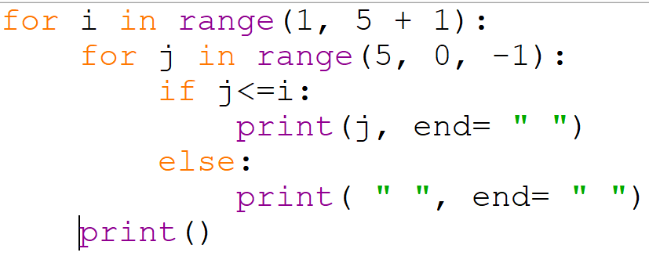
- Pattern A
- Pattern B
- Pattern C
- Pattern D

Q2. What is the output of the following code:
lst=[3,4,6,1,2]
lst[1:2]=[7,8]
print(lst)

- [3, 7, 8, 6, 1, 2]
- Syntax error
- [3, [7,8],6,1,2]
- [3,4,6,7,8]
Output: [3, 7, 8, 6, 1, 2]

Q3. What is the output of the following code:
def fn(x):
x += [1]
mylist = [1, 2, 3, 4,7,87,83]
fn(mylist)
print(len(mylist))
- 1
- 7
- 9
- 8
Output: 8

Q4.
What is the output of the following code:
def f(i, values = []):
values.append(i)
return values
f(1)
f(2)
v = f(3)
print(v)
- [1] [2] [3]
- [1] [1, 2] [1, 2, 3]
- [1, 2, 3]
- 1 2 3
Output: [1, 2, 3]

Q5. The correct way to get the length of a List in Python:
a) len(mylist)
- length(mylist)
c) mylist.count()
d) count(mylist)
Q6 Given a list
L=[10,20,30,40,50,60,70]
What would L[2:-2] return?
- [10, 20, 30, 40]
- [20, 30, 40, 50]
- [20, 30, 40]
- [30, 40, 50]

Q7 i = 0
while i < 5:
print(i)
i += 5
if i==3:
continue
break
What will be the output of this statement?

- 0
- 0 5
- 0 5 10 15
- 0 0 5 5

Q8 func = lambda x: return x
print(func(2))

What will be the output of the following code

- 2
- 2.0
- Syntax Error
- 0
Q9 a=[0,11,22,33,44,55,66,77,88,99]
a[7:2:-1]
Identify Output
  - [77, 66, 55, 44, 33]
  - [44,33,22,11,0]
  - [99,88,77,66,55]
  - [0,11,22,33,44]
Q10 def main():
arg=4
square(arg)
print(arg)
def square(n):
n*=n
main()
What is the ouput?
  - 4
  - 16
  - 80
  - 25

SECTION-B(Coding Question) (1x10 marks=10 marks)

Q1 Problem Statement
Tina went to a fruit market to buy some fruits. She filled her fruit basket with different types of fruits all together. But the vendor now asked Tina to separate each type of fruit and count them, so that he can make the bill. Each type of fruit has a particular number written on it. Tina finds it difficult to do so. Help her to count the number of fruits of each type.

You have given a list A of size N, which stores the number written on each fruit in the basket. Your task it to count the number of fruits of each type.

Input Format:
The first line contains an integer N denoting the total number of fruits in the basket
The next N line contains N integers in sorted order representing the fruit number on each type of fruit.

Output Fomrat:
For each fruit type, print in a new line, print the number written on the fruit and the count of that fruit in the basket separated by space.

CONSTRAINTS:
1<=N<=100
1<=A[i]<=100

Sample Input:
7 #N: Number of fruits
#list of N numbers in sorted order denoting the fruit type
1
1
1
2
3
3
4
Sample Output:
1 3 #here 1 is the number written on fruit, and the count of fruit is 3
2 1 #here 2 is the number written on fruit, and the count of fruit is 1
3 2
4 1

Input 1:
Input 1:
2
1
1
Output 1:
1 2

Input 2:
4
1
2
2
2

Output 2:
1 1
2 3

Input 3:
7
1
1
1
1
2
3
4

Output 3:
1 4
2 1
3 1
4 1

Input 4:
4
1
2
3
4

Output 4:
1 1
2 1
3 1
4 1

Input 5:
7
1
1
2
3
4
5
5

Output 5:
1 2
2 1
3 1
4 1
5 2

Suitable Solution:

n=int(input())
li=[]
for i in range(0, n):
ele = int(input())
li.append(ele)
c=1 # to count number of fruits
for i in range(0, n-1):
if(li[i]==li[i+1]):
c=c+1
if(i==n-2): #if i the second last element and it is same as the last element
print(li[i],c)
else:
print(li[i],c)
c=1

if(li[n-1]!=li[n-2]): #if the last element has occured only once
print(li[n-1],1)

