HIRING PROCESS ANALYTICS

MUSKAN BANSAL

DESCRIPTION:

Hiring process is the fundamental and the most important function of a company. Here, the MNCs get to know about the major underlying trends about the hiring process. Trends such as- number of rejections, number of interviews, types of jobs, vacancies etc. are important for a company to analyse before hiring freshers or any other individual. Thus, making an opportunity for a Data Analyst job here too!  
  
As a Data Analyst, my job is to go through these trends and draw insights out of it for hiring department to work upon.

I am given a dataset of a company where the details about people who registered for a particular post in a department of this company. I am required to use my knowledge in statistics and use different formulas in excel and draw necessary conclusions about the company.  
  
APPROACH:

1. Gathering data.
2. Understanding given dataset and its various colmuns.
3. Performing EDA and cleaning data.
4. Checking for missing values, Clubbing columns with multiple categories and checking for outliers.
5. Understanding the given questions and solving them.
6. Analysing data and using visualisation tools and amking charts.
7. Drawing Data Summary.

TECH-STACK USED:

Microsoft Excel for the data analysis and Word for the documentation.

Data Set Provided:

Total Number of Rows: 7168

Total Number of Columns: 7

1. Application_id

2. Interview taken on

3. Status

4. Event_name

5. Department

6. Post name

7. Offered Salary

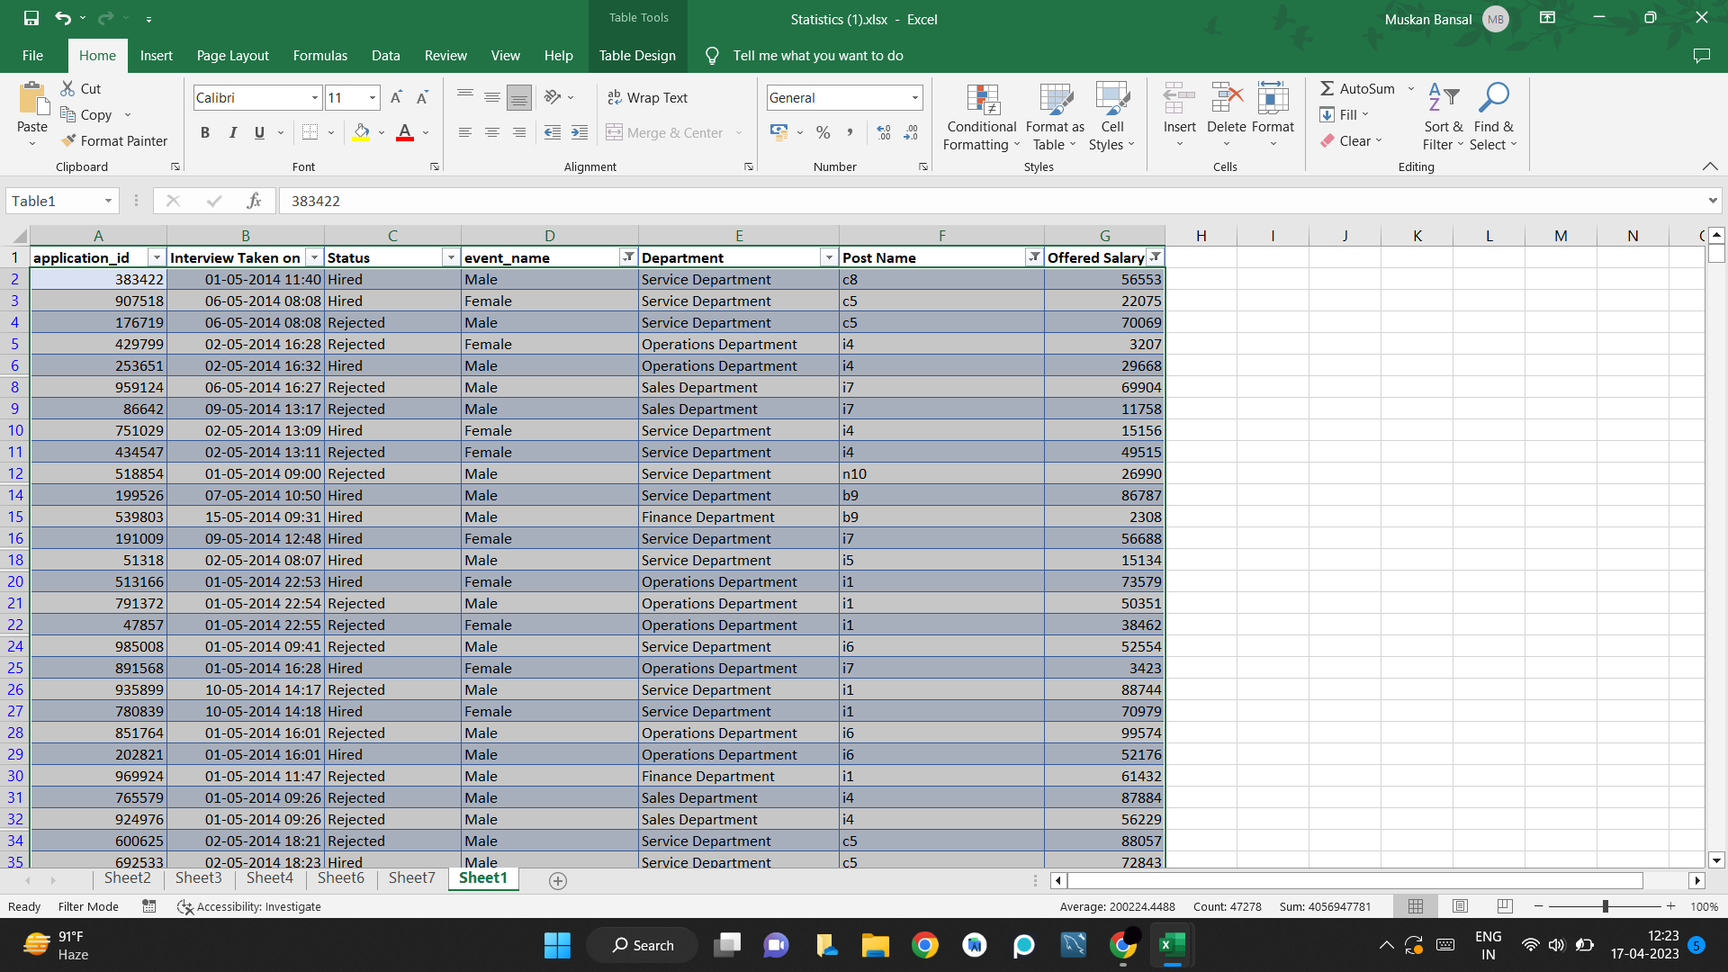

QUESTIONS:

**QUESTION1. Hiring:** Process of intaking of people into an organization for different kinds of positions.

**Your task:** How many males and females are Hired ?

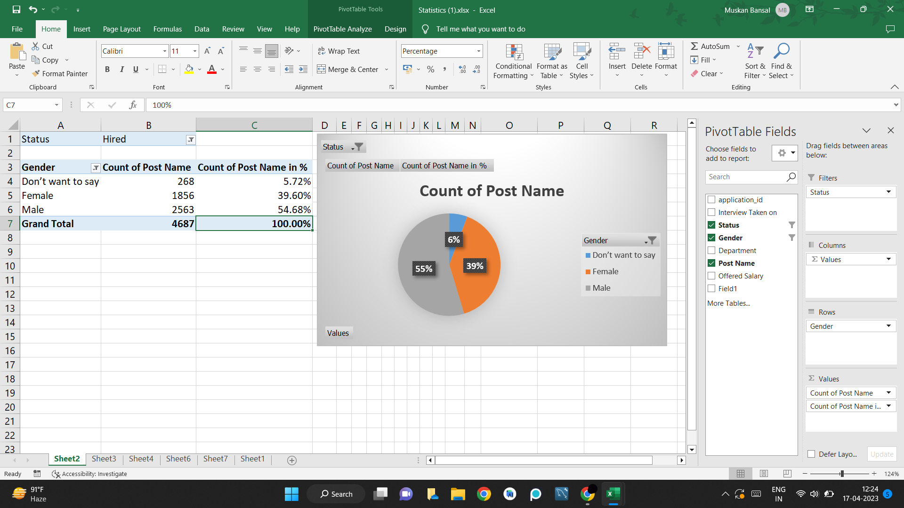

RESULT:

From the above visualisation it is clear that about 6% prefer not to disclose their gender, while 55% are male and 39% are female.

**QUESTION2. Average Salary:** Adding all the salaries for a select group of employees and then dividing the sum by the number of employees in the group.

**Your task:** What is the average salary offered in this company ?

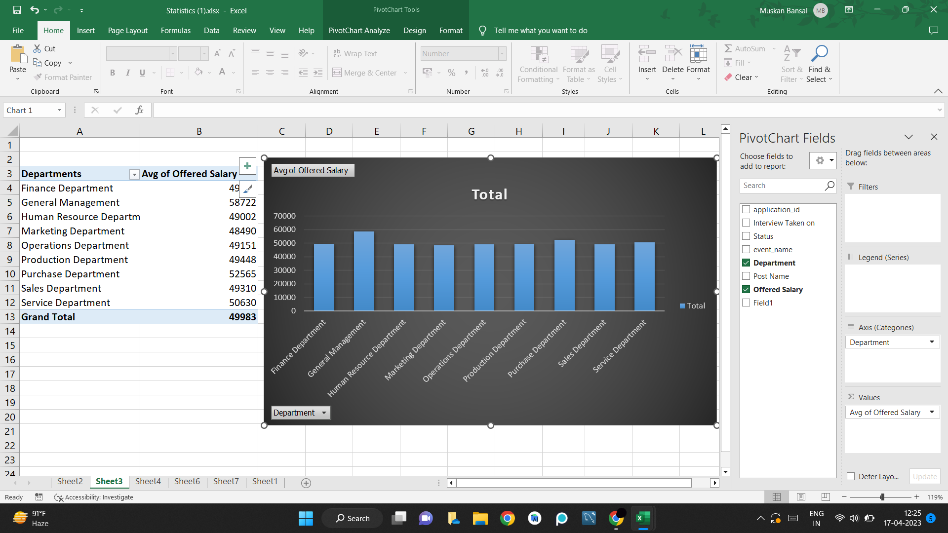

RESULT:

From the above visualisation it is clear that general management department has the highest average salary.

**QUESTION3. Class Intervals:** The class interval is the difference between the upper class limit and the lower class limit.

**Your task:**Draw the class intervals for salary in the company ?

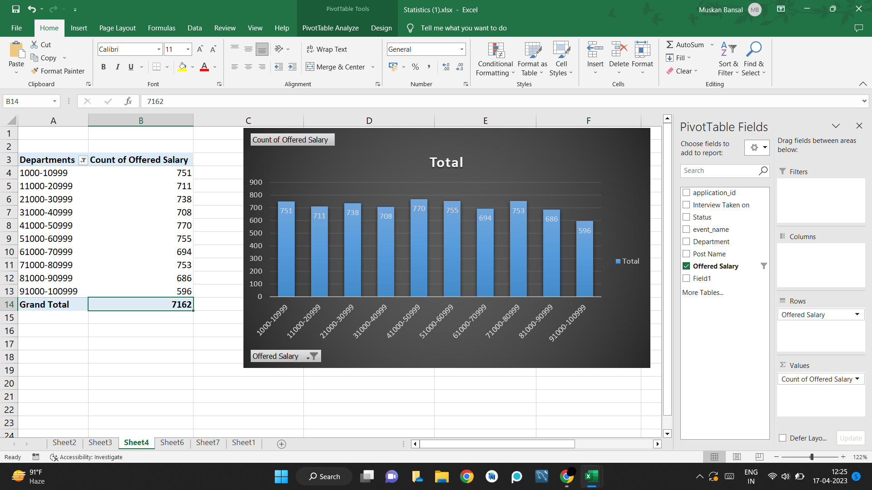

RESULT:

From the above visualisation it is clear that most of the people are earning salary between 41,000-50,999.

**QUESTION4. Charts and Plots:**This is one of the most important part of analysis to visualize the data.

**Your task:**Draw Pie Chart / Bar Graph ( or any other graph ) to show proportion of people working different department ?

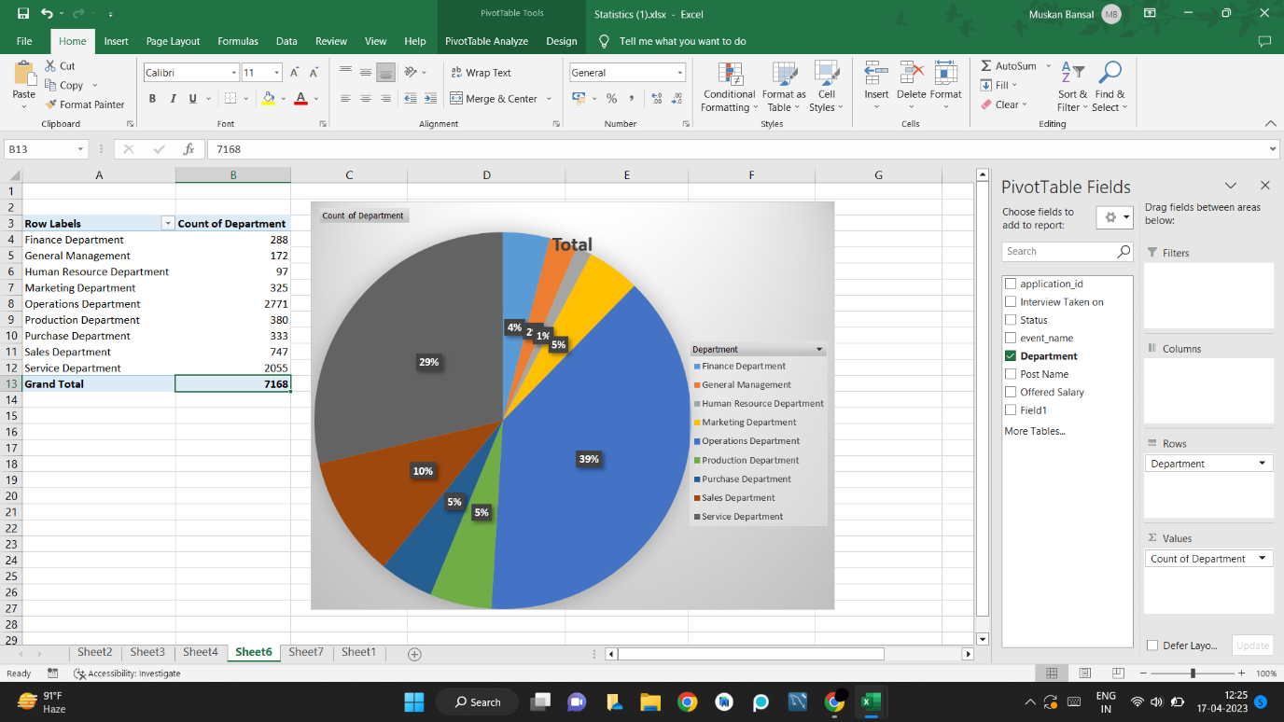

RESULT:

From the above visualisation it is clear that 4% is in finance department, 2% is in general department, 1% is in HR department, 39% is in operations department, 5% is in production department, 5% is in purchase department, 10% is in sales department and 29% is in service department.

**QUESTION5. Charts:**Use different charts and graphs to perform the task representing the data.

**Your task:**Represent different post tiers using chart/graph?

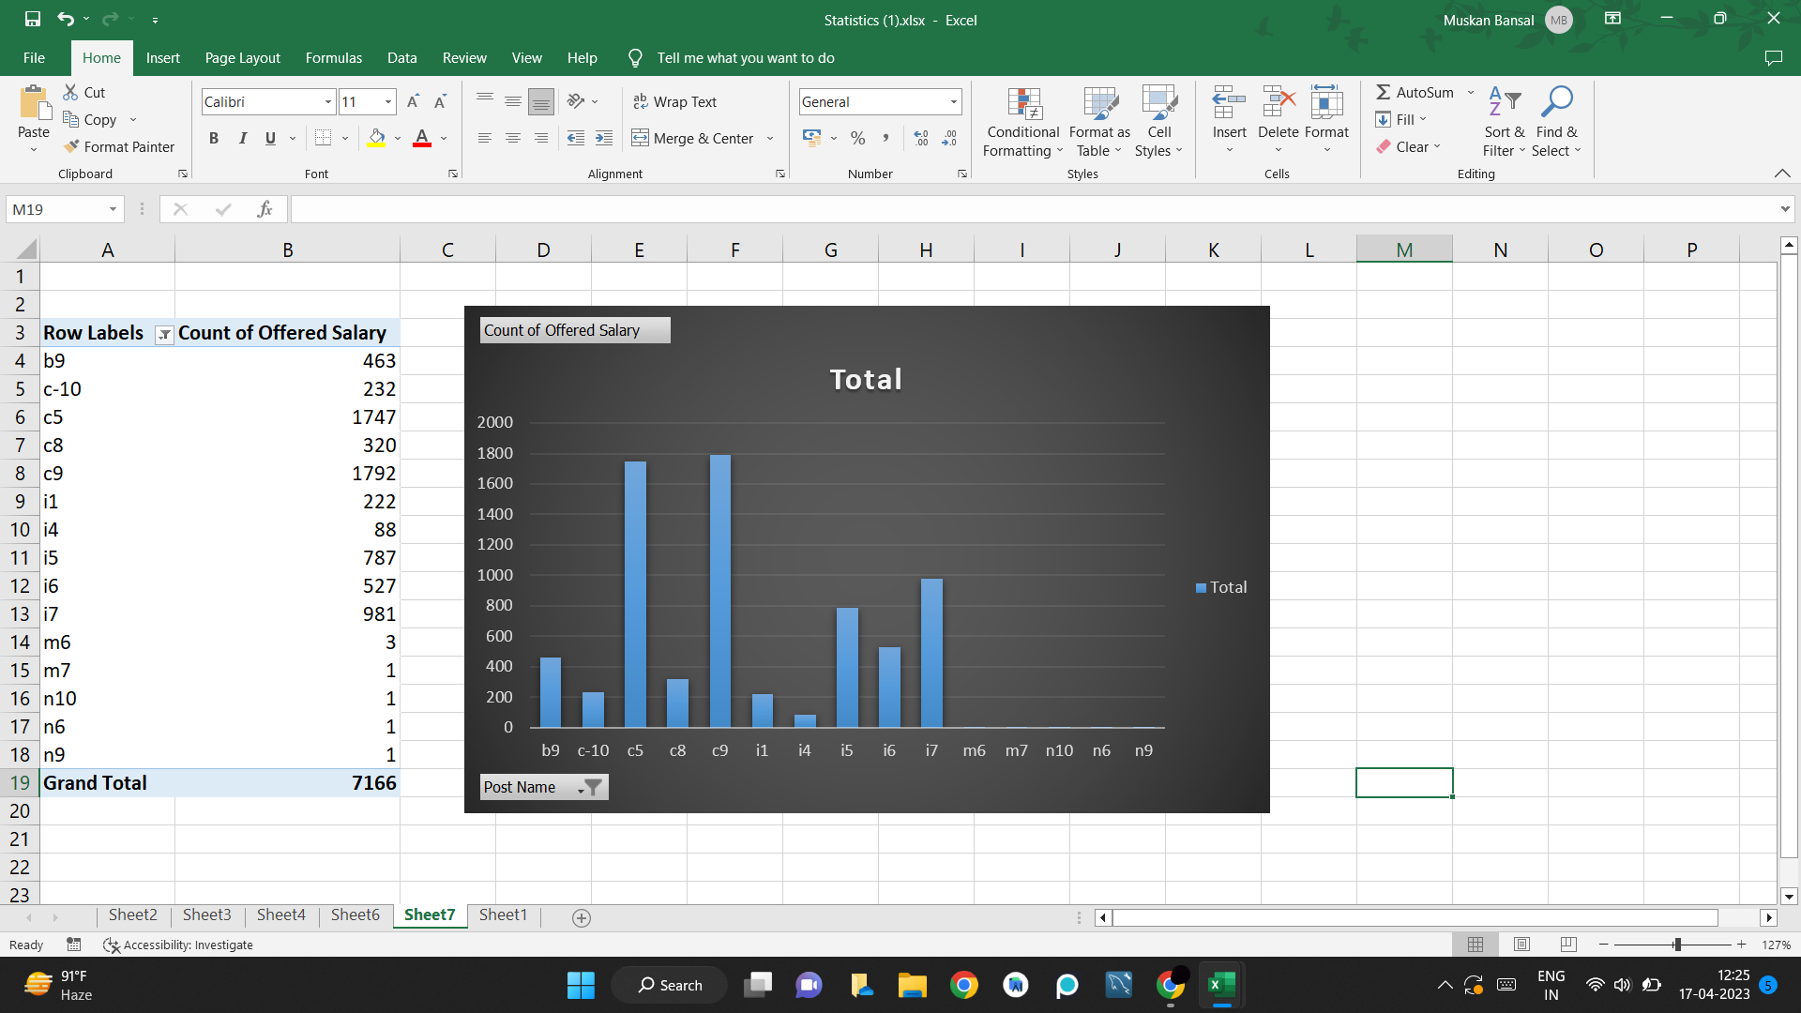

RESULT:

From the above visualisation it is clear that c9 has the most number of people.