In [5]:

**import** pandas **as** pd

In [6]:

df**=**pd**.**read_csv('car data.csv')

In [7]:

df**.**head()

# Out[7]: Car_Name Year Selling_Price Present_Price Kms_Driven Fuel_Type Seller_Type Transmission Owner

|  |  |  |  |  |  |  |  |  |
| --- | --- | --- | --- | --- | --- | --- | --- | --- |
| **0** | ritz 2014 | 3.35 | 5.59 | 27000 | Petrol | Dealer | Manual | 0 |
| **1** | sx4 2013 | 4.75 | 9.54 | 43000 | Diesel | Dealer | Manual | 0 |
| **2** | ciaz 2017 | 7.25 | 9.85 | 6900 | Petrol | Dealer | Manual | 0 |
| **3** | wagon r 2011 | 2.85 | 4.15 | 5200 | Petrol | Dealer | Manual | 0 |
| **4** | swift 2014 | 4.60 | 6.87 | 42450 | Diesel | Dealer | Manual | 0 |

In [8]:

df**.**shape

Out[8]: (301, 9)

In [9]:

print(df['Seller_Type']**.**unique()) print(df['Transmission']**.**unique()) print(df['Owner']**.**unique())

['Dealer' 'Individual'] ['Manual' 'Automatic'] [0 1 3]

In [10]:

df**.**isnull()**.**sum()

Out[10]: Car_Name 0

Year 0

Selling_Price 0

Present_Price 0

Kms_Driven 0

Fuel_Type 0

Seller_Type 0

Transmission 0

Owner 0

dtype: int64

In [11]:

df**.**columns

Out[11]: Index(['Car_Name', 'Year', 'Selling_Price', 'Present_Price', 'Kms_Driven', 'Fuel_Type', 'Seller_Type', 'Transmission', 'Owner'],

dtype='object')

In [12]:

final_dataset**=**df[['Car_Name', 'Year', 'Selling_Price', 'Present_Price', 'Kms_Driven', 'Fuel_Type', 'Seller_Type', 'Transmission', 'Owner']]

In [13]:

final_dataset**.**head()

# Out[13]: Car_Name Year Selling_Price Present_Price Kms_Driven Fuel_Type Seller_Type Transmission Owner

|  |  |  |  |  |  |  |  |  |
| --- | --- | --- | --- | --- | --- | --- | --- | --- |
| **0** | ritz 2014 | 3.35 | 5.59 | 27000 | Petrol | Dealer | Manual | 0 |
| **1** | sx4 2013 | 4.75 | 9.54 | 43000 | Diesel | Dealer | Manual | 0 |
| **2** | ciaz 2017 | 7.25 | 9.85 | 6900 | Petrol | Dealer | Manual | 0 |
| **3** | wagon r 2011 | 2.85 | 4.15 | 5200 | Petrol | Dealer | Manual | 0 |
| **4** | swift 2014 | 4.60 | 6.87 | 42450 | Diesel | Dealer | Manual | 0 |

In [14]:

final_dataset**=**df[['Year', 'Selling_Price', 'Present_Price', 'Kms_Driven', 'Fuel_Type', 'Seller_Type', 'Transmission', 'Owner']]

In [15]:

final_dataset**.**head()

# Out[15]: Year Selling_Price Present_Price Kms_Driven Fuel_Type Seller_Type Transmission Owner

|  |  |  |  |  |  |  |  |
| --- | --- | --- | --- | --- | --- | --- | --- |
| **0** 2014 | 3.35 | 5.59 | 27000 | Petrol | Dealer | Manual | 0 |
| **1** 2013 | 4.75 | 9.54 | 43000 | Diesel | Dealer | Manual | 0 |
| **2** 2017 | 7.25 | 9.85 | 6900 | Petrol | Dealer | Manual | 0 |
| **3** 2011 | 2.85 | 4.15 | 5200 | Petrol | Dealer | Manual | 0 |
| **4** 2014 | 4.60 | 6.87 | 42450 | Diesel | Dealer | Manual | 0 |

In [16]:

final_dataset['Current_Year']**=**2022

In [17]:

print(df['Seller_Type']**.**unique())

['Dealer' 'Individual']

In [18]:

final_dataset**.**head()

# Out[18]: Year Selling_Price Present_Price Kms_Driven Fuel_Type Seller_Type Transmission Owner Current_Year

|  |  |  |  |  |  |  |  |  |
| --- | --- | --- | --- | --- | --- | --- | --- | --- |
| **0** 2014 | 3.35 | 5.59 | 27000 | Petrol | Dealer | Manual | 0 | 2022 |
| **1** 2013 | 4.75 | 9.54 | 43000 | Diesel | Dealer | Manual | 0 | 2022 |
| **2** 2017 | 7.25 | 9.85 | 6900 | Petrol | Dealer | Manual | 0 | 2022 |
| **3** 2011 | 2.85 | 4.15 | 5200 | Petrol | Dealer | Manual | 0 | 2022 |
| **4** 2014 | 4.60 | 6.87 | 42450 | Diesel | Dealer | Manual | 0 | 2022 |

In [19]:

final_dataset['No.Year']**=**final_dataset['Current_Year']**-**final_dataset['Year']

In [20]:

final_dataset**.**head()

# Out[20]: Year Selling_Price Present_Price Kms_Driven Fuel_Type Seller_Type Transmission Owner Current_Year No.Year

|  |  |  |  |  |  |  |  |  |  |
| --- | --- | --- | --- | --- | --- | --- | --- | --- | --- |
| **0** 2014 | 3.35 | 5.59 | 27000 | Petrol | Dealer | Manual | 0 | 2022 | 8 |
| **1** 2013 | 4.75 | 9.54 | 43000 | Diesel | Dealer | Manual | 0 | 2022 | 9 |
| **2** 2017 | 7.25 | 9.85 | 6900 | Petrol | Dealer | Manual | 0 | 2022 | 5 |
| **3** 2011 | 2.85 | 4.15 | 5200 | Petrol | Dealer | Manual | 0 | 2022 | 11 |
| **4** 2014 | 4.60 | 6.87 | 42450 | Diesel | Dealer | Manual | 0 | 2022 | 8 |

In [21]:

final_dataset**.**drop(['Year'],axis**=**1,inplace**=True**)

In [22]:

final_dataset**.**head()

# Out[22]: Selling_Price Present_Price Kms_Driven Fuel_Type Seller_Type Transmission Owner Current_Year No.Year

|  |  |  |  |  |  |  |  |  |  |
| --- | --- | --- | --- | --- | --- | --- | --- | --- | --- |
| **0** | 3.35 | 5.59 | 27000 | Petrol | Dealer | Manual | 0 | 2022 | 8 |
| **1** | 4.75 | 9.54 | 43000 | Diesel | Dealer | Manual | 0 | 2022 | 9 |
| **2** | 7.25 | 9.85 | 6900 | Petrol | Dealer | Manual | 0 | 2022 | 5 |
| **3** | 2.85 | 4.15 | 5200 | Petrol | Dealer | Manual | 0 | 2022 | 11 |
| **4** | 4.60 | 6.87 | 42450 | Diesel | Dealer | Manual | 0 | 2022 | 8 |

In [23]:

final_dataset**.**drop(['Current_Year'],axis**=**1,inplace**=True**)

In [24]:

final_dataset**.**head()

# Out[24]: Selling_Price Present_Price Kms_Driven Fuel_Type Seller_Type Transmission Owner No.Year

|  |  |  |  |  |  |  |  |  |
| --- | --- | --- | --- | --- | --- | --- | --- | --- |
| **0** | 3.35 | 5.59 | 27000 | Petrol | Dealer | Manual | 0 | 8 |
| **1** | 4.75 | 9.54 | 43000 | Diesel | Dealer | Manual | 0 | 9 |
| **2** | 7.25 | 9.85 | 6900 | Petrol | Dealer | Manual | 0 | 5 |
| **3** | 2.85 | 4.15 | 5200 | Petrol | Dealer | Manual | 0 | 11 |
| **4** | 4.60 | 6.87 | 42450 | Diesel | Dealer | Manual | 0 | 8 |

In [25]:

final_dataset**=**pd**.**get_dummies(final_dataset,drop_first**=True**)

In [26]:

final_dataset**.**head()

# Out[26]: Selling_Price Present_Price Kms_Driven Owner No.Year Fuel_Type_Diesel Fuel_Type_Petrol Seller_Type_Individual Transmission_Manual

|  |  |  |  |  |  |  |  |  |  |
| --- | --- | --- | --- | --- | --- | --- | --- | --- | --- |
| **0** | 3.35 | 5.59 | 27000 | 0 | 8 | 0 | 1 | 0 | 1 |
| **1** | 4.75 | 9.54 | 43000 | 0 | 9 | 1 | 0 | 0 | 1 |
| **2** | 7.25 | 9.85 | 6900 | 0 | 5 | 0 | 1 | 0 | 1 |
| **3** | 2.85 | 4.15 | 5200 | 0 | 11 | 0 | 1 | 0 | 1 |
| **4** | 4.60 | 6.87 | 42450 | 0 | 8 | 1 | 0 | 0 | 1 |

In [27]:

final_dataset**.**corr()

# Out[27]: Selling_Price Present_Price Kms_Driven Owner No.Year Fuel_Type_Diesel Fuel_Type_Petrol Seller_Type_Individual Transmission_Manual

|  |  |  |  |  |  |  |  |
| --- | --- | --- | --- | --- | --- | --- | --- |
| **Selling_Price** | 1.000000 | 0.878983 | 0.029187 -0.088344 -0.236141 | 0.552339 | -0.540571 | -0.550724 | -0.367128 |
| **Present_Price** | 0.878983 | 1.000000 | 0.203647 0.008057 0.047584 | 0.473306 | -0.465244 | -0.512030 | -0.348715 |
| **Kms_Driven** | 0.029187 | 0.203647 | 1.000000 0.089216 0.524342 | 0.172515 | -0.172874 | -0.101419 | -0.162510 |
| **Owner** | -0.088344 | 0.008057 | 0.089216 1.000000 0.182104 | -0.053469 | 0.055687 | 0.124269 | -0.050316 |
| **No.Year** | -0.236141 | 0.047584 | 0.524342 0.182104 1.000000 | -0.064315 | 0.059959 | 0.039896 | -0.000394 |
| **Fuel_Type_Diesel** | 0.552339 | 0.473306 | 0.172515 -0.053469 -0.064315 | 1.000000 | -0.979648 | -0.350467 | -0.098643 |
| **Fuel_Type_Petrol** | -0.540571 | -0.465244 | -0.172874 0.055687 0.059959 | -0.979648 | 1.000000 | 0.358321 | 0.091013 |
| **Seller_Type_Individual** | -0.550724 | -0.512030 | -0.101419 0.124269 0.039896 | -0.350467 | 0.358321 | 1.000000 | 0.063240 |
| **Transmission_Manual** | -0.367128 | -0.348715 | -0.162510 -0.050316 -0.000394 | -0.098643 | 0.091013 | 0.063240 | 1.000000 |

In [28]:

**import** seaborn **as** sns

In [29]:

sns**.**pairplot(final_dataset)

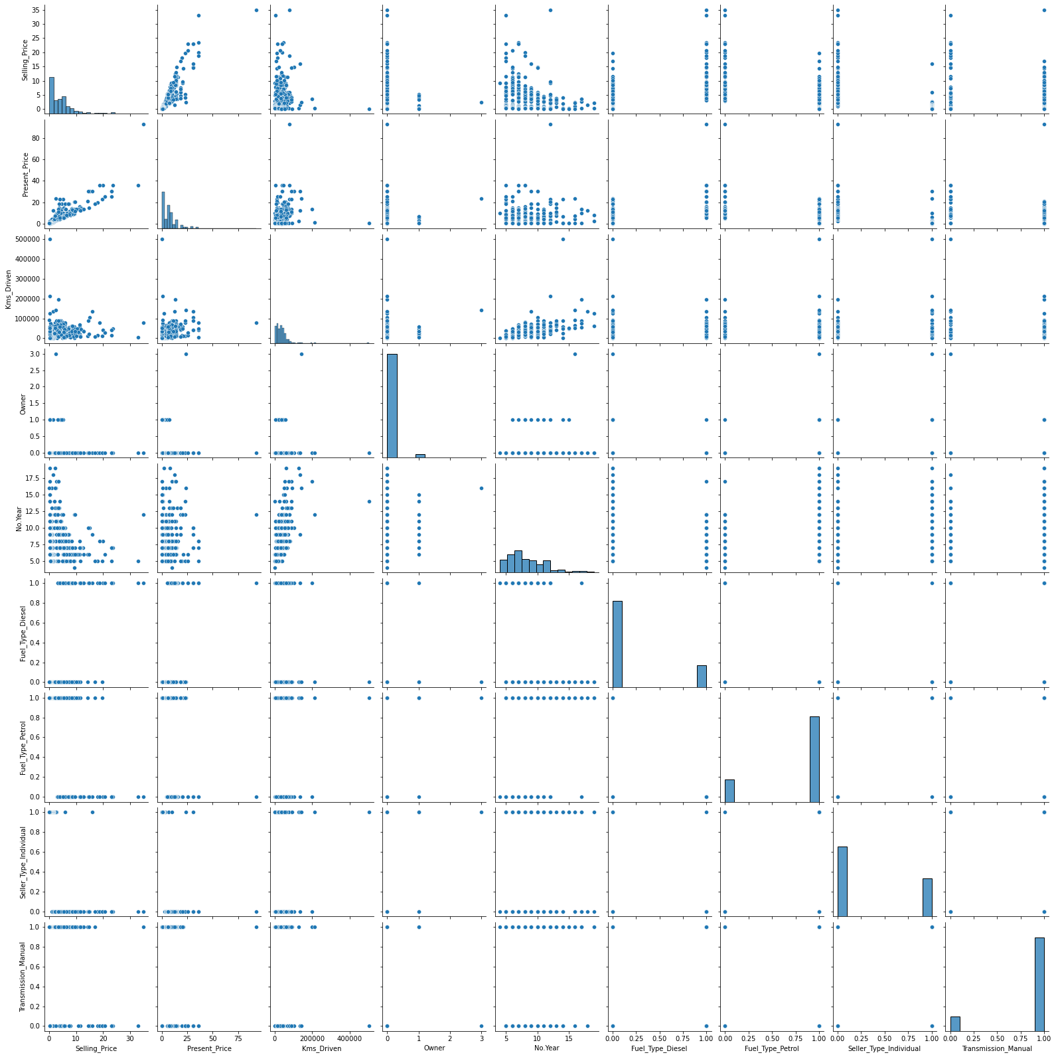Out[29]: <seaborn.axisgrid.PairGrid at 0x15e60c40ac0>

**import** matplotlib.pyplot **as** plt

**%matplotlib** inline

In [30]:

In [31]:

corrmat**=**final_dataset**.**corr() top_corr_features**=**corrmat**.**index plt**.**figure(figsize**=**(20,20))

g**=**sns**.**heatmap(final_dataset[top_corr_features]**.**corr(),annot**=True**,cmap**=**"RdYlGn")

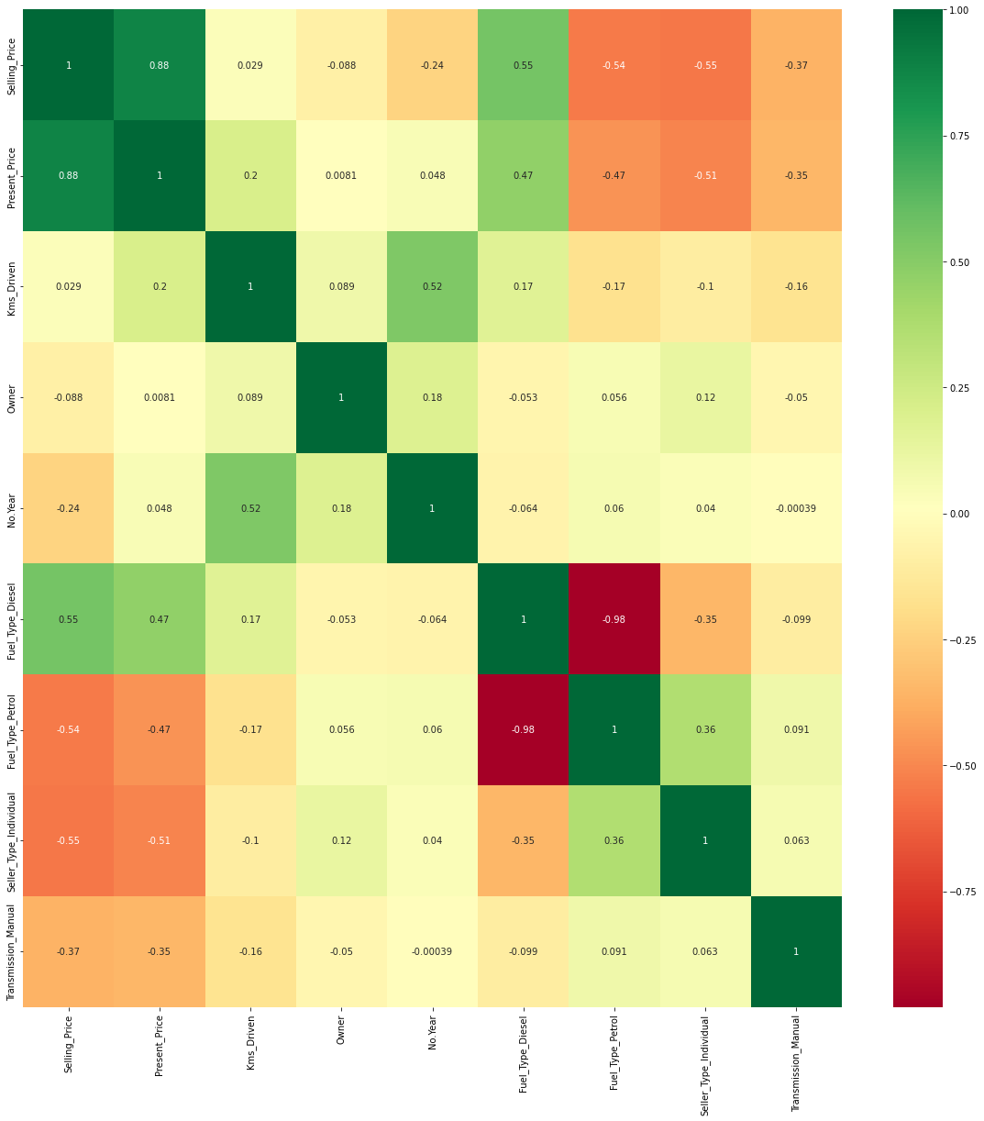

In [32]:

final_dataset**.**head()

# Out[32]: Selling_Price Present_Price Kms_Driven Owner No.Year Fuel_Type_Diesel Fuel_Type_Petrol Seller_Type_Individual Transmission_Manual

|  |  |  |  |  |  |  |  |  |  |
| --- | --- | --- | --- | --- | --- | --- | --- | --- | --- |
| **0** | 3.35 | 5.59 | 27000 | 0 | 8 | 0 | 1 | 0 | 1 |
| **1** | 4.75 | 9.54 | 43000 | 0 | 9 | 1 | 0 | 0 | 1 |
| **2** | 7.25 | 9.85 | 6900 | 0 | 5 | 0 | 1 | 0 | 1 |
| **3** | 2.85 | 4.15 | 5200 | 0 | 11 | 0 | 1 | 0 | 1 |
| **4** | 4.60 | 6.87 | 42450 | 0 | 8 | 1 | 0 | 0 | 1 |

In [33]:

X**=**final_dataset**.**iloc[:,1:] y**=**final_dataset**.**iloc[:,0]

In [34]:

X**.**head()

Out[34]:

# Present_Price Kms_Driven Owner No.Year Fuel_Type_Diesel Fuel_Type_Petrol Seller_Type_Individual Transmission_Manual 0 5.59 27000 0 8 0 1 0 1

**2** 9.85 6900 0 5 0 1 0 1

**3** 4.15 5200 0 11 0 1 0 1

**1** 9.54 43000 0 9 1 0 0 1

**4** 6.87 42450 0 8 1 0 0 1

In [35]:

y**.**head()

Out[35]: 0 3.35

1 4.75

2 7.25

3 2.85

4 4.60

Name: Selling_Price, dtype: float64