Advanced Computer Networks – PCS223
Assignment 1
Name – Kudrat Noor Singh
Subgroup – CS2
Roll No. – 8025320049

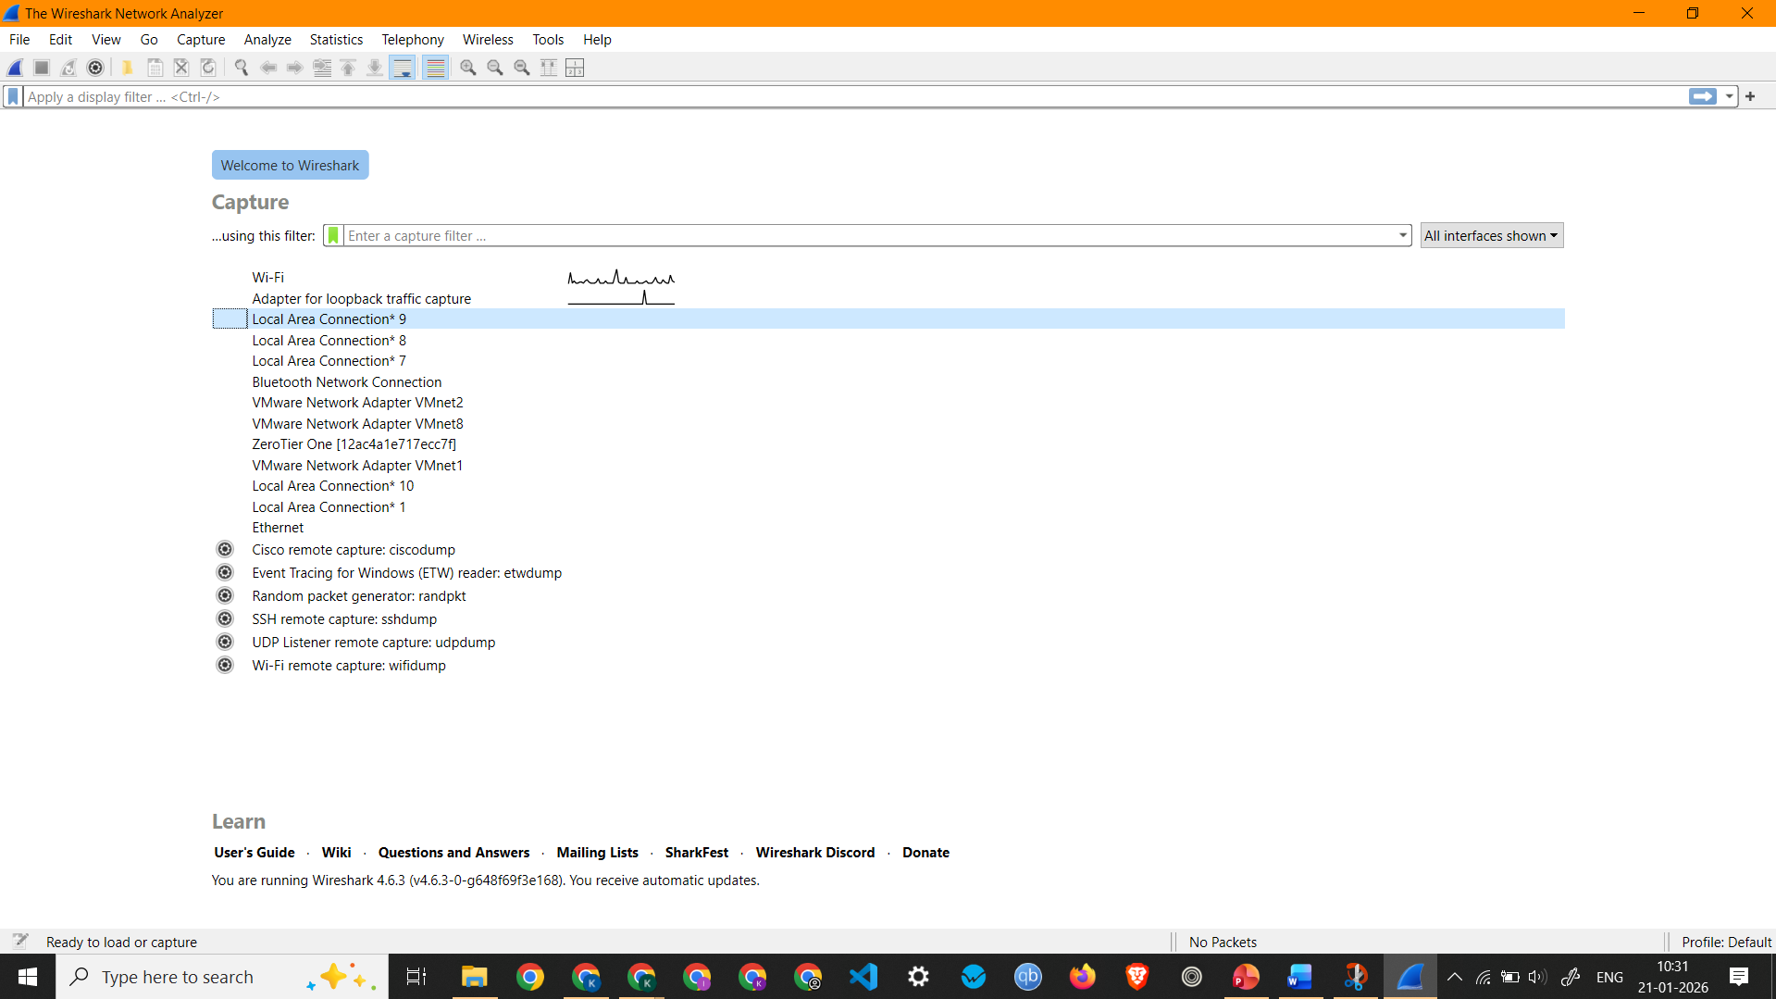
Screenshot showing Wireshark Home screen showing all interfaces and the active interface (Wi-Fi)

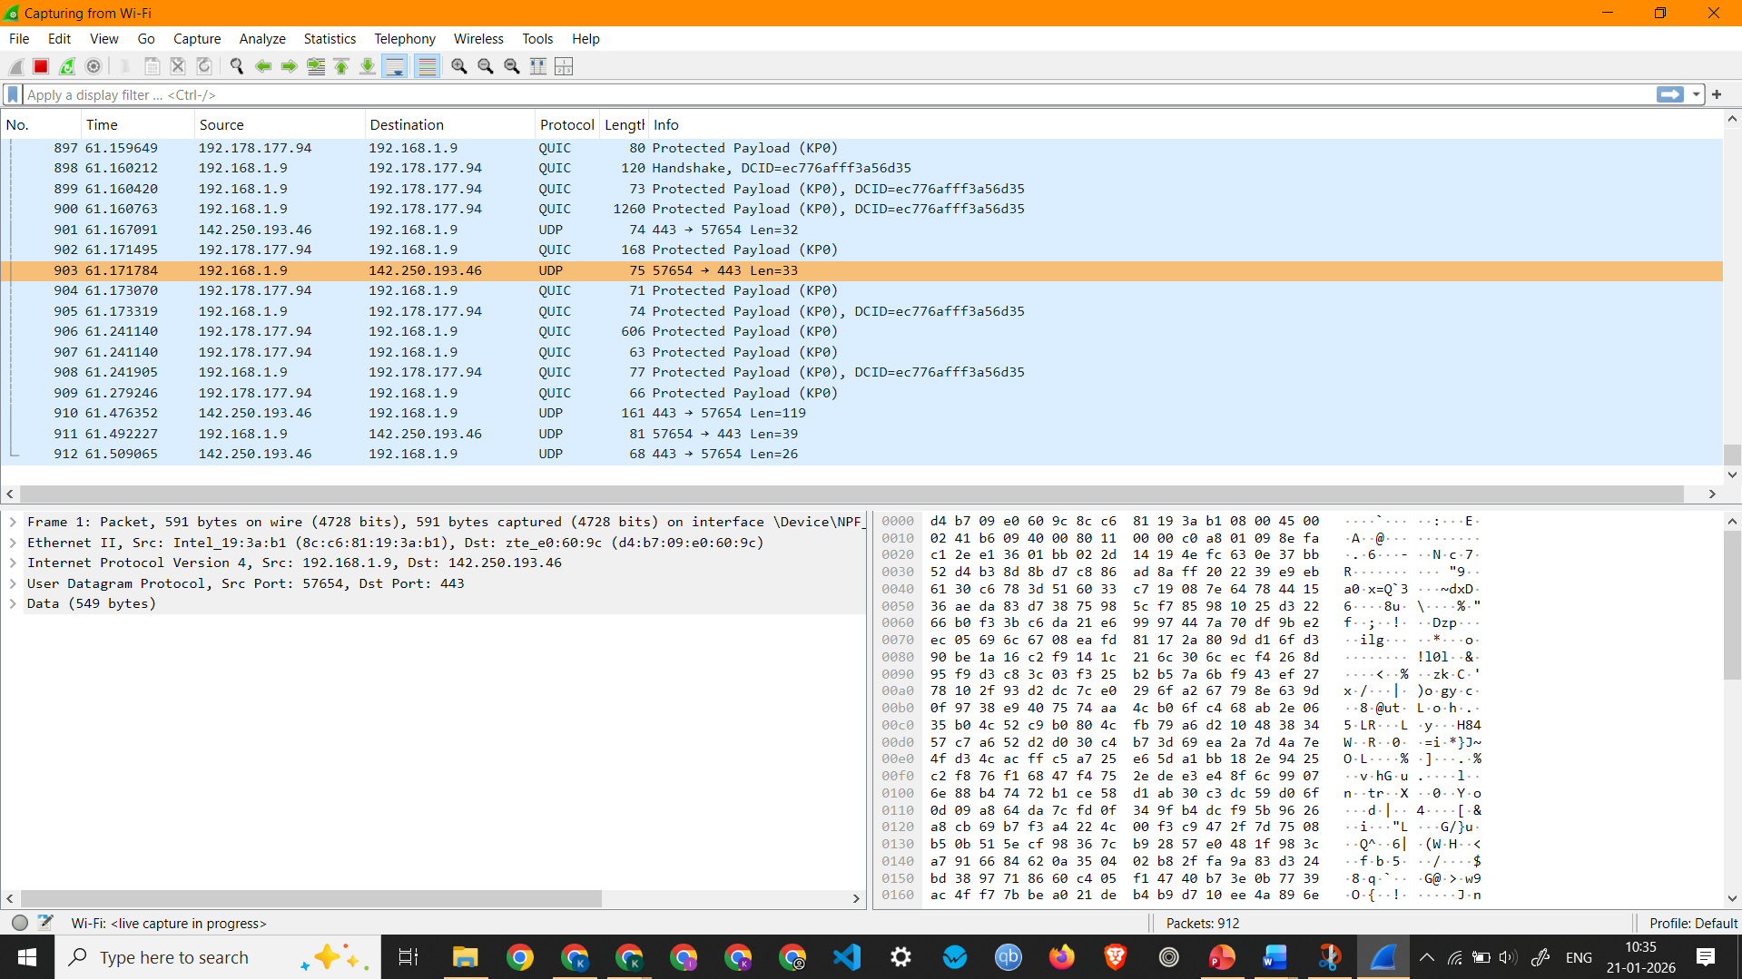
Showing Live Packet Capture on Wi-Fi
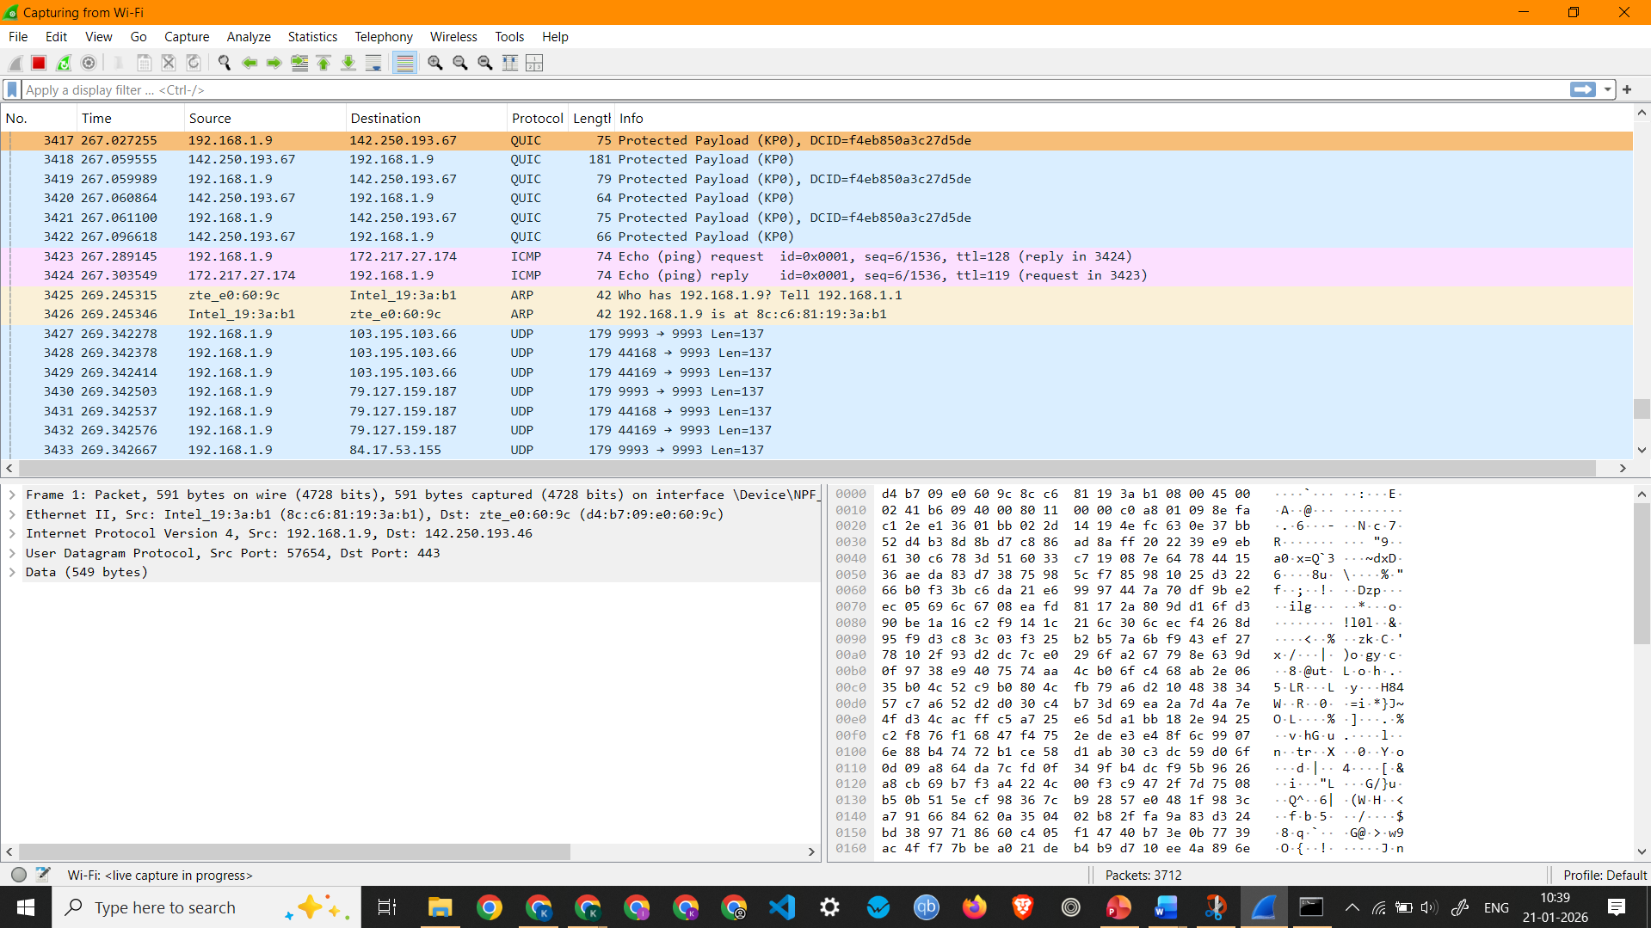
Screenshot showing ICMP Packets Captured by pinging google.com

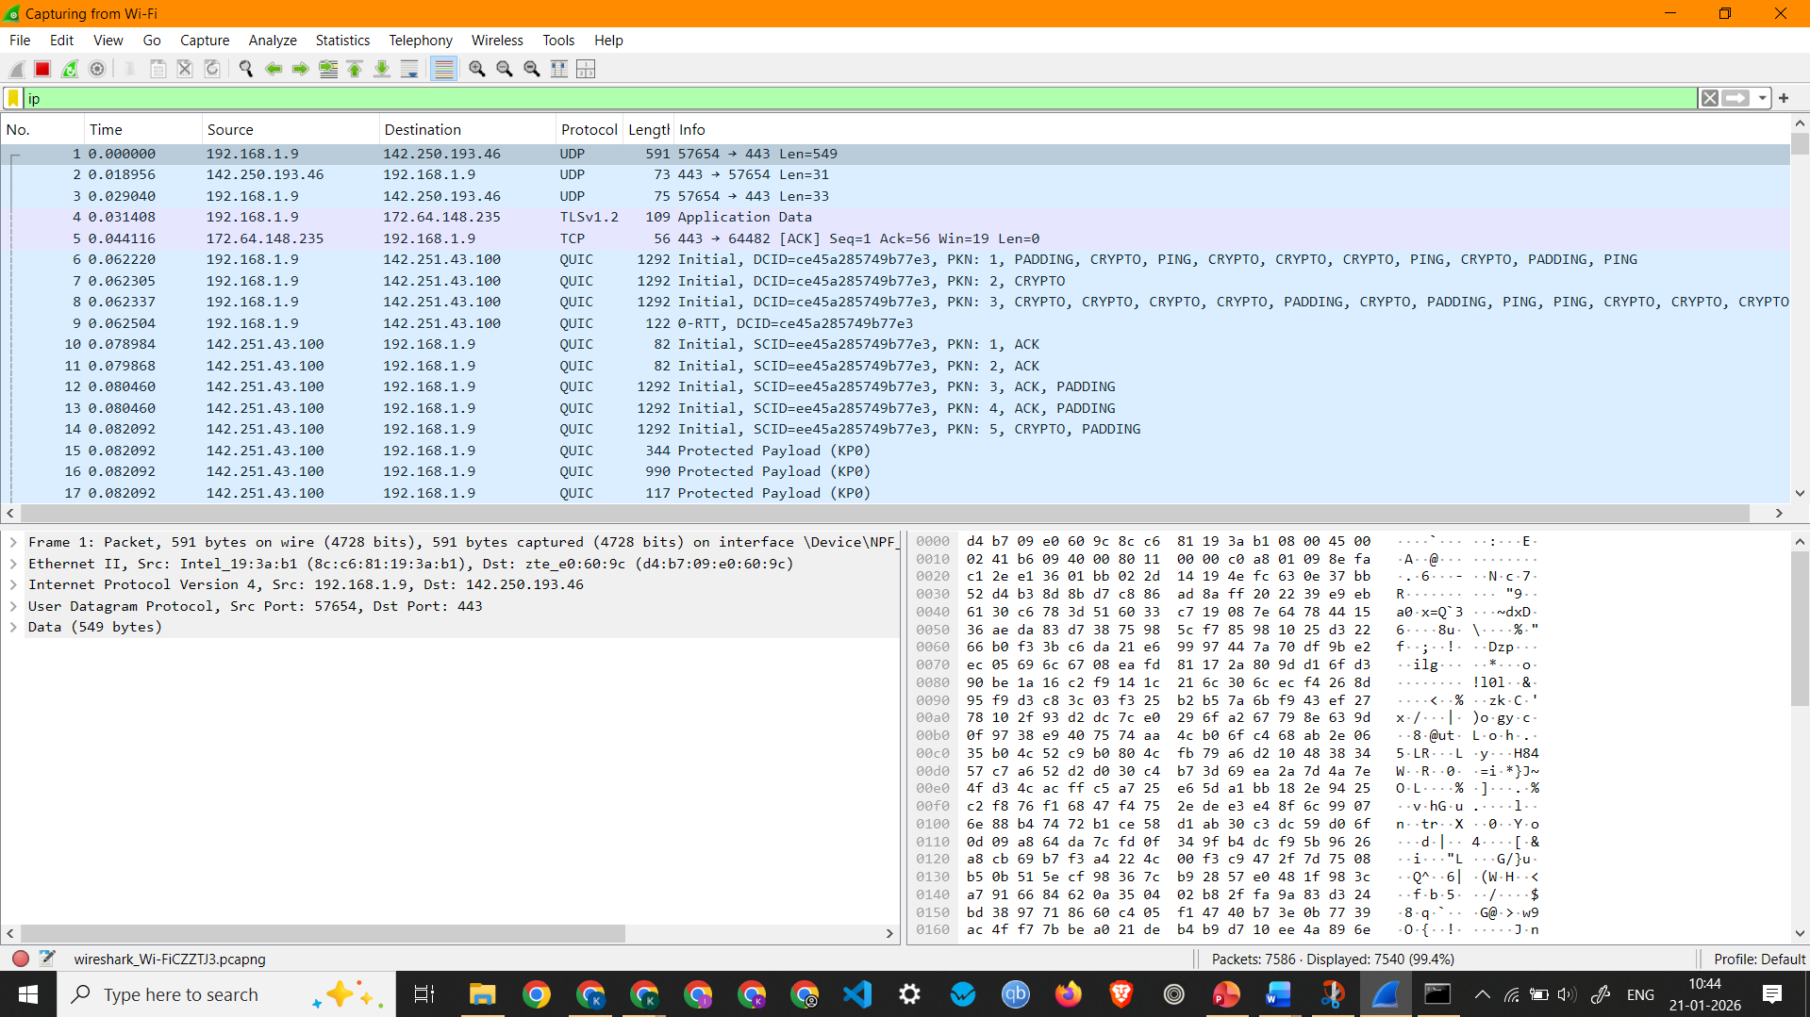
Screenshot showing IP Packets
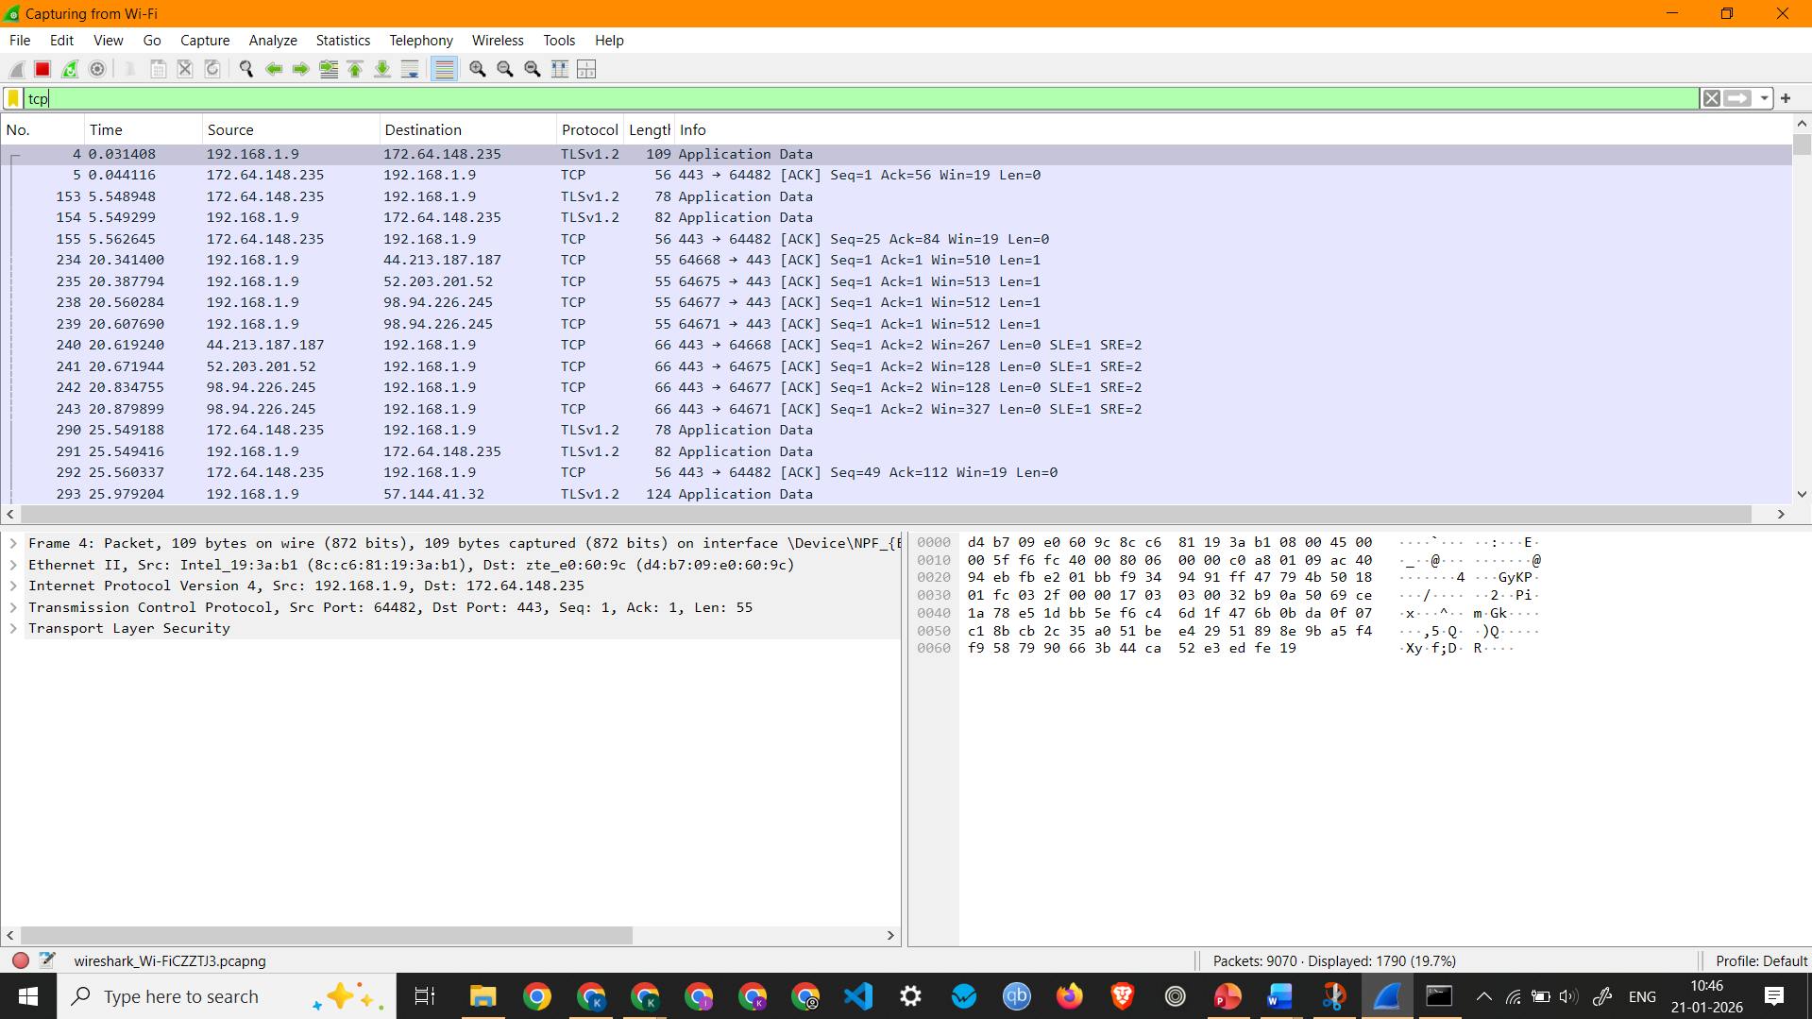
Screenshot showing TCP Packets Capture

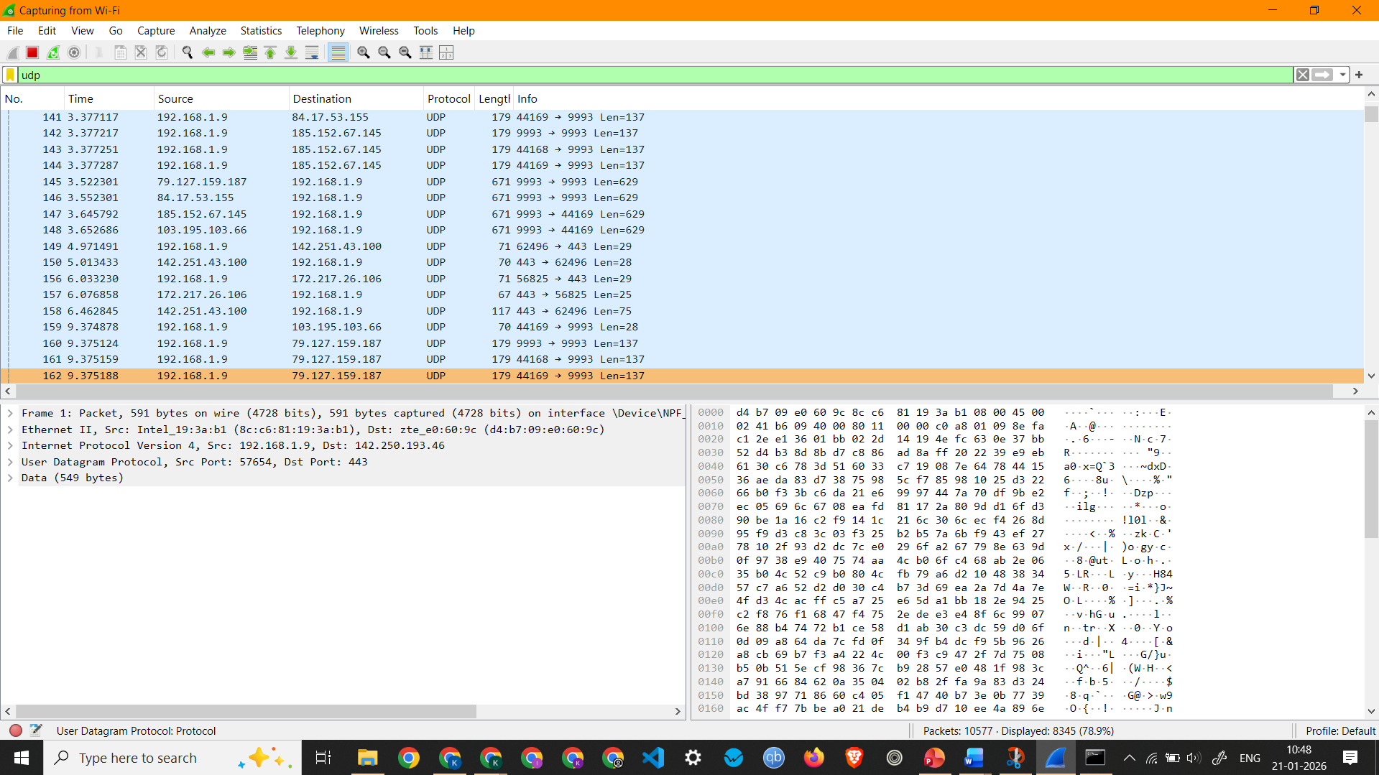
Screenshot showing UDP Packets Capture
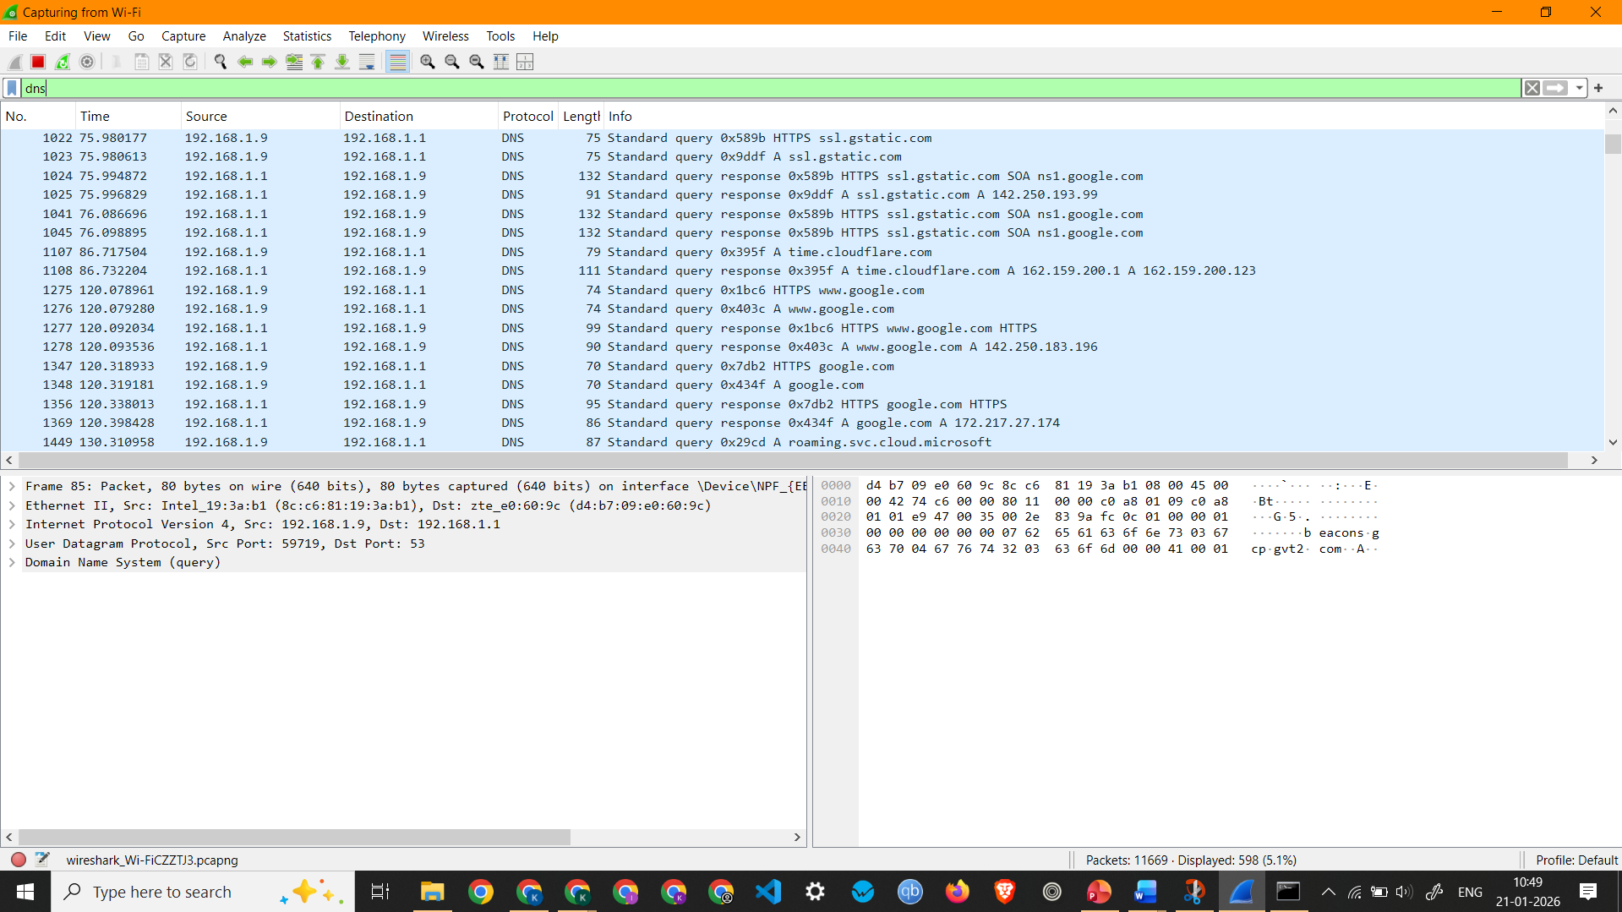
Screenshot showing DNS Packets Capture

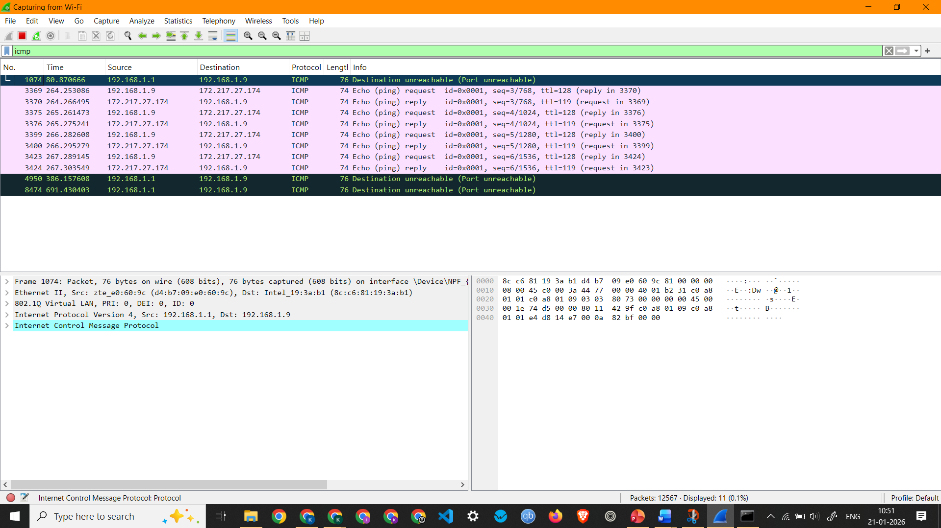
Screenshot showing ICMP Packets Capture
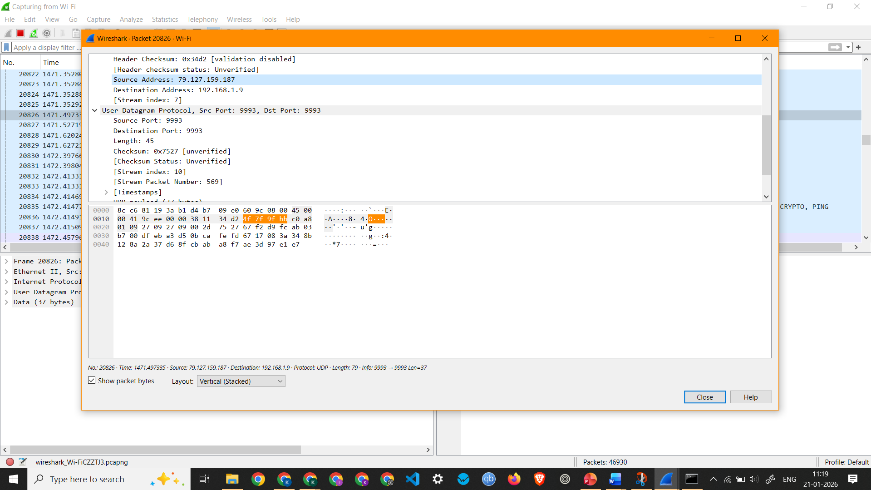
Screenshot showing details of a UDP Packet

Observation: UDP Packet 20826 –
  - Interface Used: Wi-Fi
  - Protocols Observed: Ethernet II, Internet Protocol Version 4, and User Datagram Protocol
  - Source IP Address: 79.127.159.187
  - Destination IP Address: 192.168.1.9
  - Packet Length: 79 Bytes

