TEST

By Muskan Gupta

2K19/SE/077

QUESTION-1

Design a class Time to represent hr/min/sec clock.Provide methods to set time,display time,increment hr by one , increment min by one , increment sec by one ,Instantiate an object to create a fancy clock.Generate a random number.If this number is odd increment time by a second.If it is divisible by 4 increment time by a minute. If it is multiple of 6 increment time by a hr .In all other cases just disply the time.

#include <iostream>

#include<bits/stdc++.h>

using namespace std;

class Clock

{

int hr;

int min;

int sec;

public:

Clock(int hours, int minutes, int seconds)

{

setTime(hours, minutes, seconds);

}

Clock()

{

setTime(0, 0, 0);

}

void setTime(int hours, int minutes, int seconds)

{

if(0<=hours && hours<24)

hr=hours;

else

hr = 0;

if(0<=minutes && minutes<60)

min=minutes;

else

min = 0;

if(0<=seconds && seconds<60)

sec=seconds;

else

sec=0;

}

void incrementSeconds()

{

sec++;

if(sec > 59)

{

sec = 0;

incrementMinutes(); //increment minutes

}

}

void incrementMinutes()

{

min++;

if(min > 59)

{

min = 0;

incrementHours(); //increment hours

}

}

void incrementHours()

{

hr++;

if(hr > 23)

hr = 0;

}

void display()

{

cout<<"Hour: "<<hr<<endl;

cout<<"Minute: "<<min<<endl;

cout<<"Second: "<<sec<<endl;

}

};

int main() {

//cout<<"GfG!";

Clock t;

cout<<"Initial Time is:"<<endl;

t.display();

cout<<"Random Number Generated :"<<endl;

int n=(rand()%100);

cout<<n<<endl;

bool b=true;

if(n%2!=0)

{

t.incrementSeconds();

}

if(n%4==0)

{

t.incrementMinutes();

}

if(n%6==0)

{

t.incrementHours();

}

else

{

b=false;

t.display();

}

if(b==true)

{

t.display();

}

return 0;

}

OUTPUT

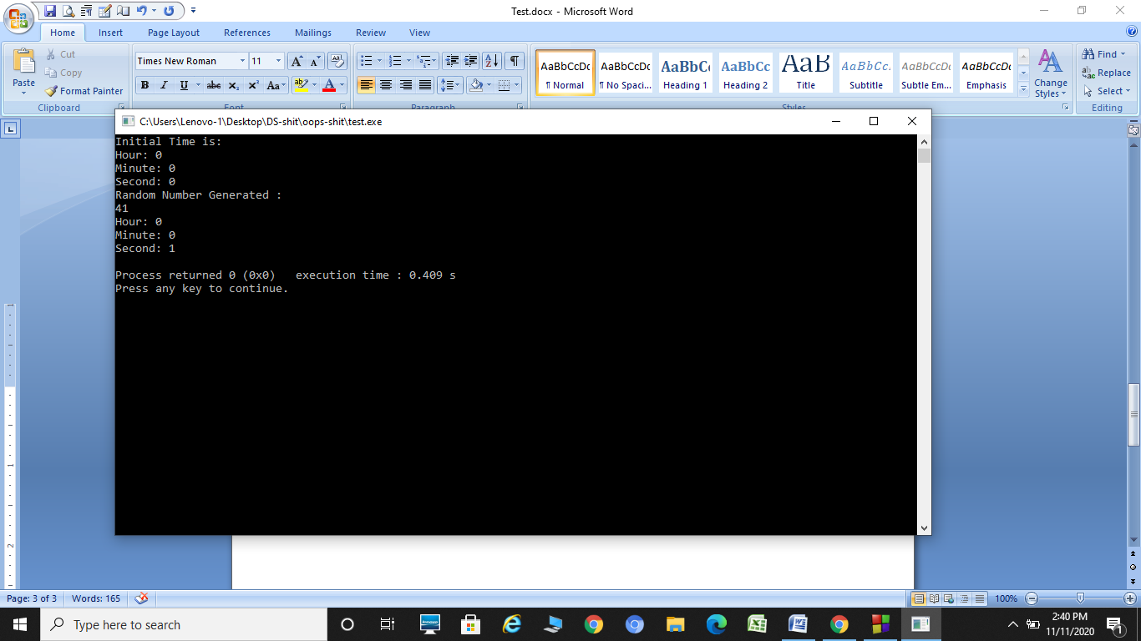

QUESTION-2

Write a program to generate 20 random numbers.For every odd number,it shold generate an object of class Odd. For every even number,it shold generate an object of class Even.Class Odd and Even should display the number and object count.These classes should not be accessible by other classes in the program.

#include<iostream>

#include <stdio.h>

#include <stdlib.h>

class Odd

{

static int oddcount;

int num;

public:

void getdata(int a)

{

num=a;

oddcount++;

}

void display()

{

printf("Number is: %d \n" ,num);

printf("Odd Count is: %d \n ",oddcount);

}

};

class Even

{

static int evencount;

int num;

public:

void getdata(int a)

{

num=a;

evencount++;

}

void display()

{

printf("Number is: %d \n", num);

printf("Even Count is: %d \n ",evencount);

}

};

int Odd::oddcount;

int Even::evencount;

// Driver program

int main(void)

{

for(int i = 0; i<20; i++)

{

int x=rand()%100;

printf("Random Number is: %d \n", x);

if(x%2==0)

{

Even e;

e.getdata(x);

e.display();

}

else

{

Odd o;

o.getdata(x);

o.display();

}

printf("\n");

}

return 0;

}

OUTPUT

