[AI-Based Real-Time Payment Fraud Detection and Risk Scoring System]

Project Report Submitted To
Dr. D. Y. Patil Vidyapeeth, Centre For Online Learning, Pune



In Partial Fulfillment of the Requirement for the Award of the Degree of

MASTER OF BUSINESS ADMINISTRATION

BY

[MUSKAN GUPTA] [241111591]
[2405020011962]

[ Vikas Kumar Atray]

[Qualification]
Dr. D. Y. Patil Vidyapeeth, Centre For Online Learning, Pune.

2024-2026

Declaration

I, the undersigned, hereby declare that the Project Report entitled “[AI-Based Real-Time Payment Fraud Detection and Risk Scoring System]”, submitted by me to Dr. D. Y. Patil Vidyapeeth, Centre for Online Learning, Pimpri, Pune, in partial fulfillment of the requirements for the award of the degree of Master of Business Administration (MBA), is my original work.
The conclusions and findings presented in this report are based on the information and resources collected from reliable sources and compiled by me. This work has not been submitted to any other University or Institution for the award of any degree, diploma, or fellowship.

Place: Pune [Muskan Gupta]
[18-05-2026]

CERTIFICATE

This is to certify that the Project Report entitled “[AI-Based Real-Time Payment Fraud Detection and Risk Scoring System]”, which is being submitted herewith for the award of Master of Business Administration (MBA) of Dr. D. Y. Patil Vidyapeeth, Centre for Online Learning, Pimpri, Pune, is the result of the original research work carried out by Dr./Mr./Ms. [Muskan Gupta] having [2405020011962]under my supervision.
To the best of my knowledge, the Project Report submitted by the student is in accordance with the guidelines prescribed by the Institute and the University.

Internal Supervisor Director DPU COL [Vikas Kumar Atray]

[Date]
Date:

Organization Letter Head

CERTIFICATE

This is to certify that [MUSKAN GUPTA] has successfully completed an internship/training as part of the academic requirements for the MBA Program (Online) at our organization.
During this period, he/she was found to be sincere, diligent, and hardworking in carrying out the assigned tasks and responsibilities.
We wish him/her continued success in all future endeavours.

Authorized Signatory

[ Name ] Seal/Stamp [Date]

Note: This certificate is optional if not engaged in internship/training at any organization.

ACKNOWLEDGEMENTS

I take this opportunity as a privilege to express my deep sense of gratitude to Dr.
D. Y. Patil Vidyapeeth, Centre for Online Learning, Pune , for providing me with the platform and resources to pursue my research.
I extend my sincere thanks to Dr. Safia Farooqui , Director, Dr. D. Y. Patil Vidyapeeth, Centre for Online Learning, Pimpri, Pune, for her continual support in fostering active learning and for her constant encouragement to achieve excellence. I also appreciate the dedicated efforts of the academic team, headed by Dr. Rajendra Takale, along with all the mentors, whose guidance and inspiration have greatly contributed to the completion of this research work.
I am deeply indebted to my research supervisor, ---------------------, Dr. D. Y. Patil Vidyapeeth, Centre for Online Learning, Pune. Without his/her invaluable guidance, constant motivation, and insightful suggestions, the completion of this project would not have been possible. I am sincerely grateful for the knowledge and research orientation imparted to me under his/her mentorship.
I also wish to extend my heartfelt thanks to all the teaching and non-teaching staff members of the Centre for Online Learning for their unwavering support and cooperation throughout this journey.
Finally, I am profoundly thankful to my family members, relatives, and friends for their encouragement, understanding, and support, which enabled me to complete this research successfully.

Place: Pune ] []

TABLE OF CONTENTS

Chapter no. | Content | Page no.
 | DECLARATION BY STUDENT | I
 | ACKNOWLEDGMENT | II
 | CERTIFICATE BY THE GUIDE | III
 | CERTIFICATE BY THE ORGANIZATION | IV
 | TABLE OF CONTENTS | V
 | LIST OF FIGURES | VI
 | LIST OF TABLES | VII
 | LIST OF ABBREVIATIONS | VIII
 | ABSTRACT | IX-X
I | INTRODUCTION | 7
II | OBJECTIVE, SCOPE, AND PURPOSE OF STUDY | 11
III | LITERATURE SURVEY | 18
IV | SYSTEM ANALYSIS AND DESIGN | 21
V | SYSTEM IMPLEMENTATION AND RESULT ANALYSIS | 27
VI | FINDINGS AND INTERPRETATION | 33
VIII | CONCLUSION AND FUTURE SCOPE | 40
 | BIBLIOGRAPHY | 52
 | ANNEXURES | 54

LIST OF FIGURES

Fig. No. | Title | Page No.
1.1 | System Architecture of Digital Payment Fraud Detection System
2.1 | Workflow of Fraud Detection Process
2.2 | Types of Digital Payment Frauds
3.1 | Dataset Structure and Feature Representation
3.2 | Distribution of Legitimate vs Fraudulent Transactions
3.3 | Correlation Matrix of Transaction Features
4.1 | Data Preprocessing Workflow
4.2 | . Handling Missing Values and Data Cleaning Process
4.3 | Feature Scaling and Normalization Process
5.1 | Model Training Process Flow
5.2 | Random Forest Model Structure
5.3 | Model Evaluation Metrics Comparison
5.4 | Confusion Matrix of Fraud Detection Model
5.5 | Precision, Recall, and F1-Score Analysis
6.1 | API Architecture using Flask
6.2 | Request-Response Flow of Fraud Detection API
6.3 | Sample API Input and Output (Postman Testing)
7.1 | Risk Scoring Mechanism for Transactions
7.2 | Real-Time Fraud Detection Workflow
8.1 | GitHub Repository Structure

LIST OF ABBREVIATION

Abbreviation | Description
AI | Artificial Intelligence
API | Application Programming Interface
AUC | Area Under Curve
CV | Cross Validation
CSV | Comma Separated Values
DB | Database
EDA | Exploratory Data Analysis
FN | False Negative
FP | False Positive
FPR | False Positive Rate
HTTP | Hypertext Transfer Protocol
IP | Internet Protocol
JSON | JavaScript Object Notation
KNN | K -Nearest Neighbors
MBA | Master of Business Administration
ML | Machine Learning
REST | Representational State Transfer
RF | Random Forest
ROC | Receiver Operating Characteristic
SQL | Structured Query Language
TN | True Negative
TP | True Positive
TPR | True Positive Rate
URL | Uniform Resource Locator

ABSTRACT
“ AI-Based Real-Time Payment Fraud Detection and Risk Scoring System”
By

[Muskan Gupta]
MBA Sem IV []

Project Supervisor : [Vikas Kumar Atray]
Specializations: [Artificial Intelligence and Machine Learning]

The rapid adoption of digital payment systems has led to a significant increase in online financial transactions, accompanied by a growing risk of fraudulent activities. Detecting such fraud in real time is critical to ensuring secure and reliable payment infrastructures. This paper presents a machine learning–based approach for detecting fraudulent transactions in digital payment systems.
The proposed model utilizes transactional features such as amount, timestamp, location, device information, and user behavior patterns to identify anomalies. Data preprocessing techniques, including normalization and missing value handling, are applied to enhance data quality.
Classification algorithms such as Logistic Regression and Random Forest are implemented and evaluated using standard performance metrics, including accuracy, precision, recall, and F1-score. Additionally, a risk scoring mechanism is developed to quantify the probability of fraud for each transaction. These metrics provide a comprehensive assessment of the model’s ability to correctly classify fraudulent and non-fraudulent transactions. Other than classification, another element called risk score generation is implemented in the proposed solution. This is meant to quantify the risk level associated with each transaction. Through risk score generation, it becomes possible for financial institutions to implement necessary measures, which may include stopping transactions, asking customers to provide more authentication, and others. Thus, security can be ensured while keeping things convenient.
The experimental outcomes show that the system can detect fraudulent activities with high precision and a very low rate of false positives. Besides, the proposed system is efficient in identifying hidden patterns in transaction records. Most importantly, the system can be deployed in real time, making it perfect for modern payment gateway software solutions.
The proposed fraud detection system can help financial institutions improve their operations immensely. Finally, the system can help financial institutions ensure compliance with existing regulations concerning financial transactions and fraud detection.
One of the important strengths of the proposed model is its capability to work in real-time mode. Since the fraud detection scheme is capable of processing information about new transactions and providing predictions regarding them in a very short period of time, it can be effectively implemented into contemporary payment gateways and systems that provide customers with the opportunity to carry out bank-related activities via their computers and mobile devices.
The suggested model is characterized by high flexibility as it is able to keep on learning from new data provided, which means that the more new data there is, the better the performance of the fraud prediction scheme would be since it can easily adapt to changing circumstances and become more effective in its functioning. As a result, the process of fraud detection and prevention becomes more efficient.
It should be mentioned that there are many advantages of the suggested model in terms of helping financial organizations, banks, online shopping websites, and digital payment service providers to protect themselves from potential risks of sustaining financial losses because of the activities of fraudsters.
In conclusion, the integration of machine learning techniques into fraud detection systems provides a highly efficient, scalable, and intelligent solution for securing digital financial transactions. The proposed fraud detection framework demonstrates strong performance in identifying suspicious activities, generating accurate fraud predictions, and adapting to evolving fraud patterns. By combining advanced classification algorithms, data preprocessing methods, and risk scoring mechanisms, the system ensures improved security, reliability, and trustworthiness in digital payment ecosystems. Therefore, the proposed machine learning–based fraud detection system represents an effective approach toward building safer and more secure digital financial environments for the future. The proposed fraud detection system significantly improves the efficiency of identifying suspicious transactions by automating the fraud analysis process and reducing dependency on manual monitoring systems. The integration of machine learning algorithms enables the system to continuously learn from historical and real-time transaction data, thereby improving prediction accuracy and adapting to newly emerging fraud techniques.

CHAPTER I
INTRODUCTION
The rapid growth of digital financial services has greatly changed the way payments are conducted worldwide. Financial transactions are no longer carried out through cash but via digital platforms like online banking, mobile wallets, UPI, debit/credit cards, and internet banking facilities. The process has streamlined financial transactions, making them fast, easy, and easily accessible globally. Digital financial transactions have also facilitated operational efficiency for banks, firms, and customers by ensuring real-time payments.
Nonetheless, while there have been many improvements in the payments system, digital financial fraud has increased greatly. Hackers have developed new ways to penetrate digital payment systems to carry out their nefarious activities. Types of digital financial fraud include identity theft, phishing, account takeover fraud, CNP fraud, and unauthorized transactions. Apart from financial losses, these criminal acts erode consumer confidence and pose great security risks for financial institutions. The increase in fraud has created complex patterns that traditional security systems are unable to detect or mitigate.

Fig
The solution for overcoming these shortcomings of traditional systems requires building smart fraud detection systems using AI and ML. Advanced ML and AI algorithms can analyze huge amounts of transaction data to recognize the underlying patterns and detect any anomalies.
Models can learn from transaction data and keep improving over time. As part of the fraud detection process, many attributes are considered in determining the authenticity of transactions including the amount, time, usage frequency, device details, IP addresses, geolocation, behavior patterns, and historical transactions. All these attributes contribute to establishing the behavior of users and help understand how risky each transaction is. Each transaction is scored based on the calculated risk.
Anomaly detection refers to the identification of unusual patterns in data that could represent either fraud or some legitimate activity. In other words, anomalies detected during the process of fraud detection refer to fraudulent behavior and some rare and unusual legitimate transactions. There are many algorithms used in classification and anomaly detection tasks like Logistic Regression, Decision Trees, Random Forest, SVMs, and Isolation Forest.
The system analyzes multiple parameters such as transaction amount, user behavior patterns, device information, IP address, geolocation, time of transaction, and historical activity to detect anomalies. Based on these factors, a risk score is assigned to each transaction, indicating the probability of fraud. High-risk transactions can be flagged, blocked, or sent for additional verification, while low-risk transactions are processed without disruption.
This research is grounded in key analytical concepts such as Anomaly Detection Theory, which helps in identifying deviations from normal user behavior, and Machine Learning Classification Models, which enable predictive analysis of fraudulent patterns. By integrating these approaches, the system continuously improves its accuracy through learning from new data, making it more effective against emerging fraud techniques.
The outcomes of this study are valuable for multiple stakeholders. Financial institutions can strengthen their security frameworks and reduce fraud-related losses. Customers benefit from safer and more reliable digital transactions. Additionally, businesses and payment service providers can enhance trust and operational efficiency by minimizing false positives and improving transaction approval rates. On a broader scale, the implementation of AI-driven fraud detection systems contributes to the stability and growth of the digital economy by ensuring secure and trustworthy financial ecosystems. Furthermore, continuous model training and updates are essential to maintain system effectiveness, as fraud patterns evolve rapidly over time.
In summary, AI-powered fraud detection systems are a modern solution that is highly relevant in tackling digital financial fraud. These tools, including machine learning, help make digital payment systems more efficient and dependable. The importance of these technologies in ensuring safe and secure financial transactions cannot be overstated.

CHAPTER II
Objectives, Scope and Purpose of Study

Objectives:
The primary objective of this study is to design and develop an AI-Based Real-Time Payment Fraud Detection and Risk Scoring System that can accurately identify fraudulent transactions and enhance the security of digital payment systems. The specific objectives of the study are as follows:
- Analyze different types of digital payment frauds and understand their patterns, causes, and impact on financial systems.
- Identify key transaction features such as transaction amount, time, location, device information, and user behavior that contribute to fraud detection.
- Design and implement a real-time fraud detection system using artificial intelligence and machine learning techniques.
- Develop and train predictive models such as Logistic Regression, Decision Trees, and Random Forest for classifying transactions as fraudulent or legitimate.
- Create a dynamic risk scoring mechanism that assigns a probability score to each transaction based on its likelihood of being fraudulent.
- Ensure real-time processing of transactions with minimal delay while maintaining high accuracy and performance.
- Reduce false positives (legitimate transactions marked as fraud) and false negatives (fraudulent transactions not detected).
- Evaluate the performance of the proposed system using metrics such as accuracy, precision, recall, and F1-score.
- Design a scalable and efficient system capable of handling large volumes of transaction data.
- Implement data preprocessing techniques such as cleaning, normalization, and handling imbalanced datasets to improve model performance.
- Incorporate anomaly detection techniques to identify unusual transaction behavior.
- Ensure data security and privacy while handling sensitive financial information.
- Integrate the system with a real-time or simulated payment gateway environment.
- payment platforms.

Scopes:
The study focuses on creating and developing a concept called AI-Based Real-Time Payment Fraud Detection and Risk Scoring System that will be used to improve digital transaction security measures through the use of Machine Learning concepts. The scope includes data preprocessing, model development, system implementation, and performance evaluation while ensuring scalability, efficiency, and reliability in handling financial transaction data.
In this context, the study includes a number of aspects including but not limited to applying machine learning methods to analyze the information about transactions, detecting any suspicious transactions or trends in data, generating risk scores, and making real-time fraud detection a reality.
Scope Includes:
- Analysis of different kinds of digital payment frauds including unauthorized transactions, phishing attacks, identity fraud, and others. Using transaction datasets for the purpose of fraud detection and analysis.
- Data preprocessing includes data cleaning and normalization, handling missing or imbalanced data. Feature selection based on transaction attributes like time, amount, location, device, and others.
- Implementing several machine learning algorithms like Logistic Regression, Decision Trees, and Random Forest.
- Development of a real-time fraud detection system. Designing a risk scoring system that will estimate the risk level of each transaction. System performance evaluation and optimization using performance metrics.
- Large-scale transaction data management and handling. Basic integration of the algorithm into a simulation of payments environment.
Limitations in Scope:
- It is built based on sample or open-source data and does not capture all the real-life examples of fraud.
- Deep learning algorithms and very complicated network structures are not considered in detail. The simulation of real-time application is done without connecting the system to real-time banking systems.
- The model cannot recognize entirely new types of fraud unless it is trained further.

Purpose of Study-
The objective of this research is to design and create an AI-Based Real-Time Payment Fraud Detection and Risk Scoring System. As the online financial sector evolves, there have been more incidences of fraud. Therefore, there arises a need for the creation of systems that will effectively help identify any fraud attempts and counter such threats to enhance the reliability and security of the transactions conducted in a digital environment. This study aims to leverage artificial intelligence and machine learning techniques to analyze transaction data, identify suspicious patterns, and provide real-time decision-making support while maintaining a smooth and secure user experience.
Purpose Includes:
- Enhance the security of digital payment systems by identifying and preventing fraudulent transactions through real-time analysis.
- Reduce financial losses caused by fraud and unauthorized activities in online payment systems.
- Develop a reliable risk scoring mechanism to support effective decision-making during transaction processing.
- Elevate the effectiveness of the process of fraud identification by implementing machine learning algorithms.
- Create an appropriate risk score model that will facilitate decision making while conducting transactions.
- Provide the safety and speed of processing transactions to improve customer experience.
- Make fraud detection more adaptive to changing trends and fraud techniques.
- Optimize the usage of transaction information in terms of analysis and prediction.
- Limit the amount of time spent on fraud detection due to increased automation and use of transaction data.
- Support the adoption of advanced technologies in the financial sector for risk management.
- Promote the usage of data and information for financial security and management.
- Increase the resilience and reliability of financial ecosystems.
- Comply with financial regulations and standards for transactions.
- Enable early detection and prevention of potential fraudulent activities.
- Improve system performance for handling large volumes of transaction data.
- Enhance real-time monitoring capabilities for identifying high-risk transactions.
2.5 Necessity of the Study-
With the growing use of digital payment systems, the risks of fraud and cybercrime have also risen significantly.
The need for this study arises from the following reasons:
- The fast- growing number of fraudulent transactions through digital payment methods.
- The limited effectiveness of traditional fraud detection methods.
- The inefficiency of manual fraud monitoring processes.
- The need for real-time fraud detection systems to reduce financial losses.
- The requirement for effective fraud prevention systems by financial institutions.
- The benefits of improved efficiency through automated fraud analysis.
- The potential of AI and ML technologies for advanced fraud detection.
- The importance of transaction security and customer trust in digital payment platforms.
2.6 Importance of the Study
This study is significant because it contributes to the development of fraud detection prevention capabilities in digital payment systems using Artificial Intelligence and Machine Learning.
Some key points highlighting the importance of this research include:
- Enhanced transaction security.
- Support for real-time fraud detection.
- Reduction in fraud-related financial activities.
- Better fraud monitoring capabilities.
- Development of efficient machine learning-based fraud analysis.
- Ability to enable smart transaction classification.
- Improvement in cybersecurity within financial systems.
- Increased confidence in digital payment solutions.
- Enhanced smart decision-making capabilities
- Ability to enable smart transaction classification.
- Improvement in cybersecurity within financial systems.
- Increased confidence in digital payment solutions.
- Enhanced smart decision-making capabilities
- Ability to enable smart transaction classification.
- Improvement in cybersecurity within financial systems.
- Increased confidence in digital payment solutions

CHAPTER III
Literature Review
3.1 Introduction-
Digital payment systems have changed the way people handle money in today's world. These systems provide a simple and easy way to do financial transactions online. Services like internet banking, online shopping platforms, mobile wallets, and other e-payment methods have become increasingly popular and widely used.
The shift towards cashless payments has made online payment systems an essential part of everyday financial activities.People use banking apps, payment apps, credit and debit cards, and UPI-based systems to complete transactions every minute.
However, as more people use digital payment options, there has also been an increase in cybercrime related to financial activities.
Some common types of fraud in digital payment systems include:
- Credit card fraud
- UPI fraud
- Identity theft
- Phishing scams
- OTP scams
- Account takeover attacks
- Unauthorized online transactions.
Cybercrime involving digital payments can harm both individuals and financial institutions.
These actions result in large financial losses, security risks, and unhappy customers.
Traditional fraud detection methods relied on rules and manual checks. These methods worked well for catching standard fraud cases, but they struggled with complex and fast-changing fraud types in today's digital payment systems.
Some issues with the old methods include-
- Slow fraud detection process.
- Heavy reliance on manual work.
- Trouble scaling with large volumes of transactions.
- Too many false alarms.
- Difficulty handling high transaction volumes.
To solve these problems, AI and ML have become key tools for smarter fraud detection.
ML algorithms process past transaction data, find patterns, and automatically spot fraud.
These systems also keep learning about transaction behaviors over time, which helps them get better at detecting fraud.
Some advantages of using ML in fraud detection are:
- Automatic fraud detection.
- Real-time analysis of transactions.
- Better efficiency in fraud detection.
- Faster and more accurate decision-making.
- Less need for manual involvement.
- Stronger ability to detect unusual activities.
- Reduction in operational workload.
- Address complex fraud patterns.
The main goal of this framework is to create a smart and scalable system for detecting fraudulent transactions, helping to reduce the risk of fraud.
There is a greater need for intelligent fraud monitoring systems due to the rapid growth of online financial services.
Transaction processes on online payment platforms generate a huge amount of data each day, which is difficult to analyze manually.
Fraudulent activities can occur within seconds, so there is a demand for quick and efficient fraud detection solutions.
Monitoring fraud attempts is essential to ensure transparency and accountability in digital transactions.
Fraudulent operations affect not only financial institutions but also their service providers regarding transaction activity.
Financial organizations invest a lot in fraud detection technologies for economic protection and security.
Contactless transactions, which are becoming more common, require dependable monitoring system. In most cases, cyber fraud activities have hidden patterns and are hard to detect using simple analysis techniques.
Fraud detection system with artificial intelligence can help track fraudulent activities in real time
This chapter covers a review of existing research and related work on fraud detection systems and the use of machine learning in digital payment environments.
3.3 Traditional Fraud Detection Techniques-
The traditional fraud detection system relied on rules and manual checks.
Some of the rules used were:
- Limiting transaction amounts.
- Checking geographic locations.
- Analyzing how often transactions happened.
- Identifying users on a blacklist.
These conventional methods could catch basic fraud cases, but they had some serious issues.
The shortcomings of traditional fraud detection systems included-
- Poor real-time monitoring capability.
- Inability to learn from historical transaction data.
- Poor adaptability to changing fraud techniques.
- Limited capability for behavioral transaction analysis.
- Difficulty in identifying hidden fraud patterns.
- Delayed fraud detection response time.
- Manual effort.
- Slow analysis of fraud case
- Difficulty in scaling up.
- Inability to spot new types of fraud.
- High false positive rates
Traditional system struggled to handle many online payment and modern cybercrime techniques.
Traditional fraud detection approach mainly depends on fixed rules created by financial institutions and security analysts. Although rule-based systems were simple to implement, they lacked adaptability and intelligence.
These rules were set in advance and used to identify suspicious transactions. If a transaction broke one of these rules, it was flagged as potentially fraudulent.
However, systems that worked this way were simple but not very smart or flexible.
They had several problems. A big issue with these traditional methods was that the rules were too strict.
These limitations encouraged researchers and financial organizations to adopt Artificial Intelligence and Machine Learning-based fraud detection systems for improved security and fraud prevention capability.
3.5 Review of Existing Research Papers-
3.5.1 Detection of Fraud by Machine Learning Techniques-
- Bhattacharyya et al. (2011) found that looking at past transaction data can help identify common patterns of fraud.One key point from their research was that fraud detection system need to be flexible and able to keep up with new fraud methods.
- Phua et al. (2010) also noted that in banking systems,fraud detection methods using data mining and machine learning proved to be more adaptable and precise compared to traditional Rule-based systems.
- IEEE (2020) stated that applying machine learning algorithms for fraud detection allows
for the analysis of large volumes of transaction data in real time, making the process of monitoring fraud more efficiently.
3.5.2 Real-Time Fraud Detection and Risk Scoring-
- According to IBM (2021), AI-driven real-time fraud detection tools are important for reducing financial risks because they allow for immediate identification of suspicious activities and assign fraud risk scores to each transaction.
- Google (2022) pointed out that AI can detect small changes in customer behavior that that traditional fraud detection systems might miss, leading to better fraud prevention outcomes.
- Ngai et al. (2011) looked into using data mining techniques for fraud detection and found that classification models work well for spotting fraudulent transactions.
- The European Central Bank (2020) emphasized that risk scoring is a key part of payment systems,as it helps categorize transactions based on how likely they are to involve fraud.
- Visa (2022) mentioned that real-time transaction scoring helps reduce losses from fraud
by quickly evaluating payments as they happen, often in just milliseconds.
- The Bank for International Settlements (2021) highlighted the importance of integrating
Fraud prevention systems into payment platforms to keep analyzing transactions
continuously.
3.5.3 Application of Advanced Technologies for Fraud Prevention-
- Elsevier (2022) explained that neural networks and autoencoder, are advanced tools used in the finance sector to detect complicated fraud cases.
- World Bank (2021),using AI in finance improves security, builds customer trust and helps grow digital economies.
3.8 Requirement of Proposed System-
The growing rate of digital payment frauds makes it highly important to have intelligent fraud detection solutions to mitigate such risks.
The requirement for a proposed system can be explained by the following reasons:
- Rapid increase of digital payments.
- Current systems cannot address complex fraud patterns.
- Real-time transaction fraud detection is needed.
- Automation of the fraud prediction process.
- Better security of online transactions using machine learning.
- Requirement for scalable fraud protection systems for financial institutions.
Machine learning technology allows for better fraud detection ability.The proposed system will help improve transaction security.
3.9 Conclusion of Literature Review
The literature review emphasized the importance of implementing machine learning into digital payment fraud detection systems.
It was found in the previous works that machine learning algorithms give much more accurate results compared to traditional rule-based approaches.
Some limitations in current systems were also found during the literature review, such as inability to provide real-time fraud detection, unbalanced data sets used, difficulties with scaling, and high false-positive rate.
These problems should be solved in the proposed AI-Based Real-Time Payment Fraud Detection and Risk Scoring System through Random Forest Classification and Flask API integration.
The literature review demonstrated that digital payment fraud has become a major challenge for financial institutions and online payment systems.
Previous studies highlighted the importance of intelligent fraud detection mechanisms for improving digital payment security.
Traditional rule-based fraud detection systems were found to have limitations in scalability, adaptability, and real-time monitoring capability.
Machine learning techniques showed better capability in identifying hidden fraud patterns and suspicious transaction behavior.
Several researchers emphasized the importance of real-time fraud detection systems for minimizing financial losses and improving transaction security.

CHAPTER IV
SYSTEM DESIGN
4.1 Introduction
This chapter describes the methods and designs used to develop the AI-Based Real-Time Payment Fraud Detection and Risk Scoring System. It covers the machine learning models, techniques, data preparation processes, and integration strategies that were used to build a reliable fraud detection solution.
The primary goal of this system is to create a dependable framework that can analyze online payment transactions and detect possible fraudulent activities as they happen. The system combines transaction analysis, risk scoring, and API-based communication to enhance the security and trustworthiness of digital payment systems.
The methodology includes the following steps:
- Data collection and preprocessing
- Feature selection and extraction
- Exploratory Data Analysis (EDA)
- Model training and testing
- Fraud prediction and risk scoring
- Performance evaluation and validation
- Real-time API integration using Flask
The complete workflow ensures that the fraud detection model can effectively identify suspicious transactions while maintaining fast processing speed and high prediction accuracy.
4.2 System Design-
The proposed framework uses an intelligent machine learning-based architecture to identify and predict fraudulent transactions in real time. The system is built to quickly detect suspicious activities without slowing down transaction processing.
4.2.1 Key Features of System Design-
- The system uses machine learning algorithms to automatically analyze transaction behavior and detect unusual payment patterns that might signal fraud.
- The architecture supports continuous monitoring of digital payment transactions, allowing for immediate fraud detection and quick response to any suspicious activities.
- A modular architecture is implemented to make the system more flexible, scalable, and easier to maintain. Each module is responsible for a specific task and operates independently.
- Feature extraction helps in identifying the most important transaction attributes that affect fraud prediction. Relevant features increase model accuracy and reduce unnecessary data complexity.
- Classification algorithms are used to analyze transaction patterns and classify transactions as either fraudulent or non-fraudulent.
- The prediction engine evaluates each incoming transaction based on previously learned fraud patterns.
- The system generates probability-based risk scores for every transaction. Based on the calculated score, transactions are categorized into: Low Risk ,Medium Risk and High Risk.
- Transactions flagged as high risk automatically trigger alerts and require additional verification before they can be processed.
- Flask API is integrated into the system to allow real-time communication between the machine learning model and external applications or payment systems.
- The architecture is scalable and can be expanded for use in:
- Banks
- Financial institutions
- Digital wallets
- Payment gateways
- Online banking systems
- The preprocessing stage converts raw transaction data into a clean and structured format that is suitable for machine learning models. This step includes:
- Data normalization
- Encoding categorical variables
- Removing duplicate records
- Handling Missing Values

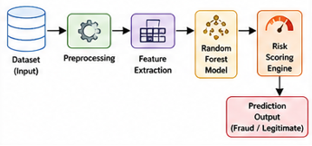
Fig 4.2.1 Overall System Design of Fraud Detection System
4.2.2-Advantages of the Proposed System Design-
- The proposed system provides real-time fraud detection in digital payment transactions, leveraging machine learning algorithms for more accurate fraud detection compared to rule-based approaches.
- It reduces financial losses associated with fraudulent activities, enables automated fraud analysis, and minimizes reliance on manual review.
- The risk scoring mechanism aids in making informed decisions, while real-time monitoring enhances transaction security.
- The system is designed to handle high volumes of transactions and maintains low false positives and false negatives.
- Continuous monitoring helps identify emerging fraud patterns, bolstering trust and reliability in digital transactions.
- The system ensures efficient processing and enhanced security, with a machine learning approach offering adaptive and intelligent fraud detection.
- The framework is flexible for future enhancements and optimizes operational efficiency for banks and financial institutions.
- It supports data-driven decision-making via predictive analytics and risk evaluation, improving detection of suspicious activities.
- The machine learning model keeps learning from past and present transaction activities, which makes the fraud detection process more efficient.
- The model quickly identifies any suspicious transaction activity allowing organizations to take immediate action to stop fraud.
- The design help build trust among customers and improves their overall experience when making payments through the online platform.
- This system reduces the workload on fraud analysts by automatically sending alerts and categorizing fraudulent activities.
- The use of API communications ensures smooth interaction between payment gateways, databases, and the fraud detection system.
- The model can detect complicated and hidden types of fraud that traditional, fixed model might miss.
- The proposed design helps banks better meet security standards and financial regulations related to transaction processing.
4.3 System Architecture of Digital Payment Fraud Detection System-
- The proposed fraud detection system consists of the following major components:
- Transaction Dataset
- Data Preprocessing Layer
- Feature Extraction Layer
- Machine Learning Model Layer
- Risk Scoring Engine
- Flask API Integration
- Prediction and Alert System
- Real-Time Monitoring Module
- The transaction dataset is made up of historical data on payments that are utilized in the fraud detection process and training models. This dataset is essential for training, testing, and validating the fraud detection system and allows Machine Learning models to learn fraud patterns and anomalies.
- The architecture of the digital payment fraud detection system includes interdependent modules working collaboratively for secure transactions, fraud predictions, and risk assessments, using machine learning algorithms.
- It efficiently processes transaction data with high accuracy and minimal delay.
- The transaction dataset contains historical payment data, including authentic and fraudulent records, transaction amounts, timing, behavioral patterns, and fraud classifications.
- This dataset is essential for training, testing, and validating the fraud detection system and allows machine learning models to learn fraud patterns and anomalies.
- The high-quality data improves real-time fraud detection capabilities, supporting better prevention strategies. The architecture ensures efficient handling of large transaction volumes with a balance between accuracy and rapid response.
- The dataset consists of-
- Authentic transaction records.
- Illegal transaction records
- Transaction amounts
- Timing of transactions
- Transaction behavior patterns
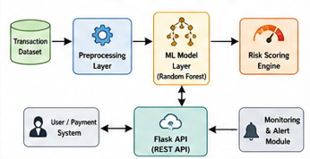
Fig 4.3.1 System Architecture Diagram
4.4 Workflow of Fraud Detection Process-
The workflow of the fraud detection system follows a systematic sequence of operations for transaction analysis and fraud prediction.
The process flow consists of the following stages:
- Transaction data is received from the payment system.
- Transaction details are validated and preprocessed.
- Missing values and noisy data are handled.
- Features are scaled and normalized.
- Important transaction features are extracted.
- Machine learning models analyze transaction behavior.
- Fraud probability scores are generated.
- Risk levels are assigned to transactions.
- Fraud alerts are generated for suspicious activities.
- Legitimate transactions are approved and processed.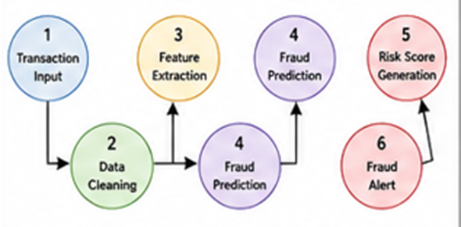
Fig 4.2.1 Workflow Diagram of Fraud Detection Process
4.5 Data Collection Methodology
The dataset used for this project was obtained from publicly available sources on Kaggle, which hosts digital payment transaction data.
It's common to use Kaggle datasets for machine learning projects, especially those focused on fraud detection. The chosen dataset includes historical financial transaction records that are used to identify fraudulent activities and train machine learning models.
The dataset includes the following:-
- Legitimate transactions
- Fraudulent transactions
- Transaction amounts
- Transaction time
- Transaction behavior features
- Fraud categories
This dataset was selected because it has realistic transaction patterns that are useful for analysis and classification.
It contains a large number of digital payment records collected specifically for fraud analysis.
4.5.1-Data Collection Process-
- Downloading the dataset from Kaggle and importing it into the project.
- Organizing the transaction data and identifying fraud categories.
- Checking the quality of the data.
- Preparing the dataset for preprocessing and analysis.
- The dataset has many transaction records that can be used for ML tasks such as training, testing, and validation.
4.5.2-Purpose of Data Collection-
- Extracting and creating features from the data.
- Training machine learning models.
- Testing and validating the models.
- Developing a risk scoring system.
- Identifying fraudulent and legitimate transaction patterns.
- Detecting suspicious activities and unusual transaction behavior.
- Reducing false positives and false negatives in fraud prediction.
- Evaluating transaction trends and customer behavior patterns.
4.5.3 - Advantages of Using a Kaggle Dataset-
- Easily accessible public dataset.
- Suitable for machine learning applications.
- Contains realistic transaction patterns.
- Widely used for fraud detection research.
- Supports classification and prediction tasks.
- Provides enough transaction records for analysis.
4.5.4-Characteristics of the Dataset-
The dataset includes both legitimate and fraudulent transaction records, making it suitable for supervised learning-based fraud classification.
Key characteristics of the dataset are-
- Highly imbalanced transaction classes
- Large volume of transactions
- Numerical features related to transactions.
- Labels for fraud classification.
- Realistic transaction behavior patterns.
- Time-based transaction details for behavioral analysis.
- Contains multi-dimensional transactional information
- Appropriate for supervised and semi-supervised learning approaches
- Useful for performance evaluation using accuracy, precision, recall, and F1-score
- Allows analysis of transaction trends and fraud probability.
- Supports real-time monitoring and automated fraud alert generation.
- Includes historical transaction data for model training and validation
- Provides balanced insights into normal and suspicious transaction activities
The imbalance in the dataset reflects real-world financial systems where fraudulent transactions occur less frequently compared to legitimate transactions.
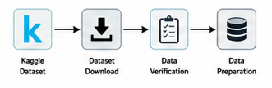
Fig 4.2.1 Data Collection Process
4.6 Dataset Structure and Feature Representation
The dataset includes various transaction-related features that are used for fraud detection and prediction. These features allow machine learning models to identify transaction patterns and
classify transactions as legitimate or fraudulent.
The dataset is organized in a structured way, with each row representing a separate transaction and each column showing a specific transaction feature.The dataset contains multiple transaction-related attributes that describe different aspects of digital payment activities.
4.6.1 Structured Dataset Format-
The dataset is kept in a structured format to make it easier to process and analyze for ML tasks.
This structured format helps with:
- Easy analysis of transactions.
- Efficient extraction of features.
- Faster preprocessing tasks.
- Training machine learning models.
- Visualizing and analyzing data.
The table format of transaction records makes dataset organized and more effective.
4.6.2 Target Feature-
In classification tasks, the fraud class label is used to identify fraudulent transactions:
- 0 – Legitimate Transaction
- 1 – Fraudulent Transaction
- The fraud label enables ML models to distinguish between normal and suspicious transaction behavior.
4.6.3 Feature Representation-
Feature representation is essential for helping algorithms understand transaction pattern and user behavior.
All transaction features are provided in numerical form to support machine learning and prediction processes.
Feature representation includes:
- Numerical transaction features.
- Time-related transaction features.
- Behavioral patterns of transactions.
- Fraud detection labels.
4.6.4-Numerical Feature Representation-
Most of the properties related to transactions in the dataset are shown as number in ML models work better with numerical data.
Numerical feature representation helps with:
- Better efficiency in calculations.
- Improved training of the model.
- Creating accurate predictions.
- Precisely estimating the chance of frauds.
Examples of transaction features that are represented numerically include the amount of the transaction, how often transactions happen, and time-related information.
4.6.7 Time-Based Feature Representation-
Features that include time are important for spotting any unusual patterns in how transaction happen or for identifying fraud.
Time-based features help with-
- Finding suspicious times when transactions occur
- Quickly organizing transactions in the order they happened.
- Analyzing trends in transaction behavior.
- Tracking unusual activity during late-night hours.
Using time-based features improves the ability to find problems or irregularities.
4.6.8 Behavioral Feature Representation-
Features that describe transaction behavior are important because they give ML models information about how people spend money and how transactions usually happen.
Behavioral analysis helps with-
- Spotting unusual transaction behavior.
- Detecting odd payment patterns.
- Identifying fraud patterns.
- Making accurate fraud prediction.
Behavioral features play a key role in smart fraud detection systems.
    - Significance of Feature Selection-
- Removing unnecessary transaction details.
- Reducing the complexity of calculations.
- Improving the accuracy of predictions
4.7 Data Preprocessing
4.7.1 Introduction-
Data preprocessing was done to ensure high-quality datasets and prepare the transactional data for machine learning.
The steps involved in preprocessing include:
- Handling missing values
- Removing duplicate records
- Noise removal
- Cleaning the dataset
- Transformation of features
- Normalization of the data
- Feature scaling
Purpose of Data Preprocessing
- Data preprocessing is important in machine learning since raw data usually contain inconsistencies, missing values, duplicates, and irrelevant records.
- Preprocessing improved the consistency, reliability, and usability of the data.
The key goals of the process are:
- Improvement of the quality of the dataset.
- Improvement of machine learning performance.
- Prediction improvement.
- Enhancement of data consistency.
- Structured input preparation for machine learning.
4.7.2 Importance of Data Preprocessing for Fraud Detection-
Data preprocessing is one of the most important steps when using ML for fraud detection.
The data collected from digital payments can have missing values, inconsistent entries, repeated records, and irrelevant or incorrect information, which can result in wrong predictions.
Data preprocessing helps turn raw transaction data into a format that is suitable for ML and fraud detection.
Good preprocessing leads to-
- Better data quality.
- More efficient performance of machine learning models.
- Improved ability to identify fraudulent activities
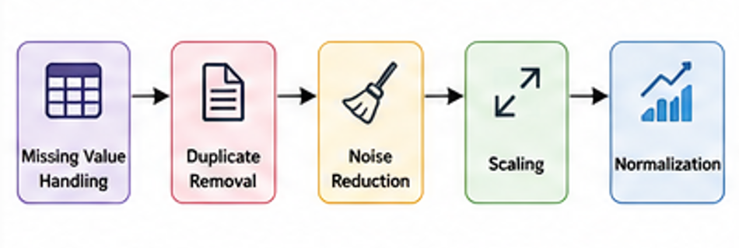
Fig 4.2.1 Data Preprocessing Workflow
4.7.2-Data Cleaning Process-
The data cleaning process was conducted to improve the reliability of the dataset by eliminating inconsistencies in the dataset.
The data cleaning process entails:
- Detection of incomplete records
- Elimination of duplicates
- Correction of data format issues
- Detection of invalid records
- Identification of noise
- Elimination of invalid entries
4.7.3-Handling Missing Values-
Handling missing values is important because incomplete data can reduce machine learning performance and affect fraud prediction accuracy.
The missing value handling process included:
- Identification of null or incomplete records
- Replacing missing values using suitable techniques
- Removing highly incomplete records when necessary
- Handling missing values improved the completeness and reliability of transaction information.
Techniques used for handling missing values include:
- Removing incomplete records
- Replacing missing values with statistical measures.
4.7.4 Removing Duplicate Records-
Duplicate records can cause information to be repeated and affect the accuracy of identifying fraud.
Eliminating duplicates helps in:
- Preventing redundant transaction records.
- Ensuring the dataset remains consistent.
- Reducing bias in machine learning processes.
- Enhancing the efficiency of data processing.
4.7.5 Noise Removal-
Data cleansing involves removing unnecessary transaction details, correcting inconsistent format and overall data quality. This process help in achieving more accurate ML prediction and aids in detecting fraudulent activities.
Noise filtering plays a key role in this by cleaning up data and ensuring it's reliable for analysis.
Data cleaning operations help in:
- Removing irrelevant transaction entries
- Correcting inconsistent data formats
- Eliminating corrupted records
- Improving transaction data quality
4.7.4-Feature Transformation-
Feature transformations enhanced the compatibility of machine learning algorithms and efficiency of processing.
Feature transformation helps standardize transaction data and improves consistency among dataset features.
The following techniques were used to transform features to fit machine learning algorithms:
- Transforming transaction is attributed to structured form.
- Arranging numeric transactions.
- Constructing feature vectors for training.
Transformation techniques help in:
- Improving feature representation.
- Enhancing machine learning understanding.
- Simplifying data analysis.
- Supporting fraud pattern identification.
4.7.5- Structured Input Preparation-
The structured input data is essential for accurate fraud detection through the ML process.
Benefits of using structured input data include-
- Better training of models.
- Faster generation of predictions.
- Exact categorization of fraud.
- Effective analysis of transactions.
It was confirmed during the input preprocessing stage that all transactions were properly
structured for use in machine learning.
4.7.5-Feature Scaling and Normalization Process-
Various methods were used to make sure numerical transaction features are consistent.
Methods used:
- Standardization
- Min-Max Scaling
- Normalization
Feature scaling is a key part of machine learning because transaction features often have different scales and units.
Feature scaling helps with-
- Better performance of machine learning models
- Uniformity in data values
- More accurate predictions
- Equal influence from all features
- Better handling of numerical data
Min-Max Scaling puts numerical transaction values into a range, usually between 0 and 1.
Normalization helps adjust values so they are comparable across different features.
Feature scaling improves how well machine learning models can detect transaction patterns.
Proper normalization leads to a balanced data distribution and better results in fraud detection.
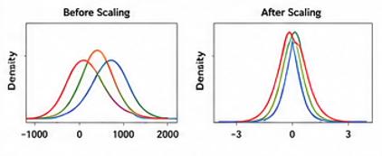
Fig 4.2.1 Imbalance Dataset Representation
4.7.6-Handling Imbalanced Data-
- Dealing with Imbalanced Data Detection of class imbalance between two types of classes: fraud and non-fraud. Oversampling through SMOTE (Synthetic Minority Over-sampling Technique).
- Under sampling of transactional data to make it balanced
- Identification of class distribution to understand the ratio of fraudulent to legitimate transactions before model training.
- Use of advanced oversampling techniques such as ADASYN (Adaptive Synthetic Sampling) to generate more realistic synthetic samples.
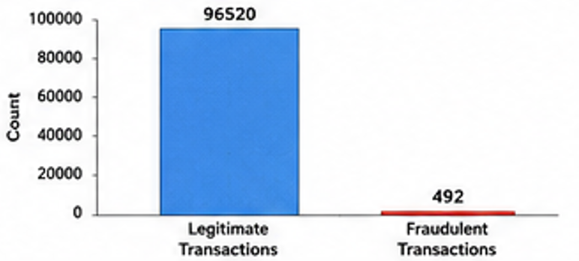
Fig 4.2.1 Imbalance Dataset Representation
Benefits of dealing with an imbalanced dataset include:
- Better ability to detect fraud.
- More accurate classification.
- Less biased predictions.
- Improved ability to recall important cases.
- Higher sensitivity in identifying fraudulent transactions.
- Fewer false negatives in predictions.
- Better overall performance of machine learning models
Over-sampling is a technique where the number of fraudulent transaction examples is increased to improve the effectiveness of machine learning models.
Under-sampling is a method where the number of normal or legitimate transaction examples is reduced to achieve better balance between the classes.
Synthetic Minority Over-sampling Technique (SMOTE) is a method that creates new artificial examples of fraudulent transactions to improve machine learning performance.
4.7.10 Advantages of Data Preprocessing-
The data preprocessing stage provided several benefits to the fraud detection model, including:
- Enhanced data quality.
- Efficient execution of machine learning.
- Reduced prediction errors.
- Improved fraud detection abilities.
- Greater consistency in the dataset.
Data preprocessing played a vital role in improving the efficiency and accuracy of the proposed fraud detection model.
4.7.11 Importance of Preprocessing in Machine Learning
Data preprocessing is essential in machine learning applications.
The data preprocessing stage enables machine learning algorithms to-
- Identify patterns in transactions effectively
- Simplify the training process.
- Improve their ability to generalize.
- Generate accurate fraud predictions
- Improves dataset quality
- Enhances machine learning performance
- Removes noisy and inconsistent data
- Handles missing values effectively
- Improves data consistency
- Supports efficient feature analysis
- Reduces processing errors
- Improves reliability of prediction results
- Enhances fraud detection capability
Properly preprocessed data helps algorithms to uncover hidden fraud patterns.
4.7.12 Significance in Real-Time Fraud Detection-
Preprocessing plays a crucial role in ensuring that fraud detection systems can analyze transactions effectively and efficiently.
Preprocessing helps achieve-
- Real-time transaction monitoring.
- Real-time fraud prediction
4.13 Machine Learning Workflow-
The ML workflow refers to the steps taken to build a fraud detection model. It includes data preparation, model training, making predictions, and evaluating the model's performance.
This workflow helps organize the fraud detection process and makes it easier to deploy machine learning models efficiently. In the project, the machine learning workflow supports-
- Automating fraud detection.
- Analyzing patterns in transactions.
- Predicting which transactions might be fraudulent.
- Generating risk scores for each transaction.
- Assessing how well the model is performing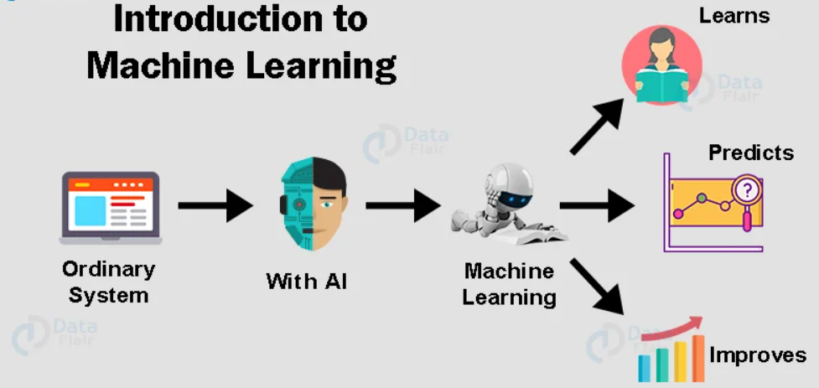
Fig Machine Learning Concept
4.13.1 Stages of the Machine Learning Workflow-
The machine learning workflow consists of several stages that help in building a fraud detection system. These stages include:
- Collecting a dataset of transactions.
- Preparing and cleaning the data.
- Processing missing, duplicate data and removing noise.
- Performing feature engineering, selecting features, scaling the data.
- Handling the imbalance in transaction classes.
- Splitting the dataset into training and test sets.
- Training a Random Forest model.
- Generating predictions for fraudulent activity.
- Assigning risk scores to transactions.
- Evaluating model performance using various metrics.
- Making real-time predictions using a Flask API.
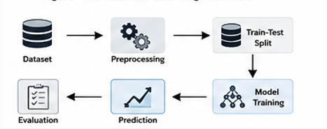
Fig 4.2.1
4.13.X Importance of the Machine Learning Process Workflow-
- The machine learning workflow is a clear and organized way to find fraud and study transactions.
- It helps data move smoothly from cleaning and preparing it, to training and testing models.
- It enables quick spotting of unusual activities in payment transactions through real-time systems.
- It supports growth because it can handle more and more transactions as needed.
- It improves model performance due to proper data cleaning and feature creation.
- It also boosts the consistency of predictions and reduces mistakes during processing.
- It helps make decisions about whether a transaction might be fraudulent.
- It makes machine learning more effective through careful checking and testing.
- It makes it easier to connect with other payment apps using APIs.
- It allows ongoing study of patterns in how payment transactions behave.
Applications of Machine Learning Workflow in Fraud Detection-
- Transaction behavior analysis
- Fraudulent transaction identification.
- Real-time transaction monitoring.
- Risk score generation.
- Fraud classification.
- Prediction of suspicious transaction activities.
- Automated fraud analysis.
- Pattern recognition in transaction data.
- Detection of abnormal transaction behavior.
4.8- Concepts of Machine Learning and Classification Methods
Machine learning classification techniques were used to classify transactions as legitimate or fraudulent.
Significant concepts utilized in this case include:
- Supervised Learning
- Classification Algorithms
- Predictive Modeling
- Ensemble Learning
4.8.1 Supervised Learning-Supervised learning refers to the process of training a machine learning model by labeling the transaction data.
The dataset has:
- Labels for legitimate transactions
- Labels for fraudulent transactions
4.8.2 Classification Algorithms-Classification algorithms are applied to sort the transactions into predetermined categories like legit or fraud.
The classification procedure entails:
- Evaluating transaction attributes
- Detecting fraud patterns
- Predicting class membership of transactions
- Calculating fraud probabilities
4.8.3 Predictive Modeling-Predictive modeling tools are applied to determine the probability of frauds arising from previous transaction patterns.
Predictive models analyze:
- Behavior of the transactions
- Frequency of the transactions
4.8.4 Ensemble Learning-Ensemble learning involves combining several decision models to enhance classification and prediction performances.
The advantages of ensemble learning are:
- Increased prediction accuracy
- Minimized overfitting
- Enhanced fraud classification abilities
- Improved handling of imbalanced data

4.8.5 Role of Machine Learning in Fraud-
Machine learning techniques help identify hidden fraud patterns that are difficult to detect using traditional rule-based systems.
Machine learning supports:
- Automated fraud analysis
- Real-time transaction monitoring
- Dynamic fraud prediction
- Intelligent risk assessment
4.8.6 Fraud Classification Process-
The process of fraud classification includes the following stages:
- Gathering transaction information
- Preprocessing transaction data and extracting features
- Training machine learning models
- Generating predictions about fraudulent activity
- Assigning risk scores
- Generating fraud alerts
4.8.7 Advantages of Machine Learning-
- Minimizing the manual monitoring effort required
- Predicting frauds in real-time
- Identifying hidden anomalies within transactions
- Scaling fraud detection system capabilities
- Processing high volumes of transaction data
- Increasing the decision-making abilities of the algorithm
- Adjusting to evolving techniques of committing frauds
- Machine learning systems represent a superior approach to detecting fraudulent digital payment transactions.
4.8.8 Importance of Classification Methods-
It is essential to utilize classification algorithms due to their potential to separate normal from abnormal transactions.
Classification approaches enhance:
- Fraud identification capability
- Prediction reliability
4.9-Train-Test Split and Validation
The dataset was split into training and testing datasets to build and validate the predictive model. Dataset splitting aims at training the machine learning model using transaction history and evaluating its performance on unseen transaction data.
Data set splitting helps with:
- Model training
- Testing fraud predictions
- Evaluating performance
4.17.1 Train-Test Splitting
The train-test splitting method divides the dataset into two parts: Training data and Test data.
In this study, the train-test split ratio is set as follows: 80% Training Data and 20% Test Data.
The training data is used to teach the model, while the test data is used to check how well the model can make predictions. Splitting the data into training and test sets improves the ability to work well with new, unseen data. It also allows for an accurate evaluation of how effectively the model can detect fraudulent transactions. Additionally, train-test splitting ensures that data from the training phase does not the testing phase, keeping the results reliable.
4.9.1-Training Dataset-
The training dataset comprises most transaction records used for training the machine learning model on detecting fraud.
Through training, the model learns about:
- Transaction behavior patterns
- Fraud related anomalies
- Relationships between transaction attributes
- Boundaries between real and fraud transactions
4.9.2-Testing Dataset –
The testing dataset contains transaction records not seen during the training process of the machine learning model. It will help in evaluating the performance of the trained machine learning model on:
- Prediction accuracy
- Fraud detection capability
- Performance Reliability
4.9.3-Validation Techniques-
Validation techniques were used to evaluate model performance on unseen transaction data.
Validation helps in:
- Measuring prediction performance
- Identifying overfitting issues
- Improving model reliability
- Ensuring consistent classification results
Validation improves confidence in machine learning predictions and fraud detection capability.
4.17.5 Importance of Validation-
Validation plays an important role in making machine learning models more accurate.
Some key reasons why validation is important include:
- It helps improve accuracy when detecting fraud.
- It makes the model more consistent.
- It stops the model from becoming too focused on specific data.
- It helps the model work well with new, unknown data.
- It makes predictions more reliable.
- It checks how well the model performs on data it hasn't seen before.

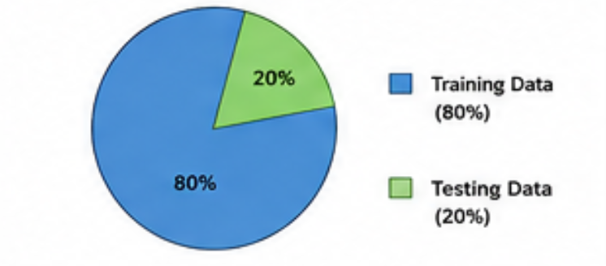
4.17.5 Importance of Validation
This figure illustrates how the transaction database is divided for training and testing in the machine learning process. According to the project requirements, 80% of the data is used for training, while the remaining 20% is reserved for testing.
The training dataset is used by the Random Forest algorithm to learn transaction behavior patterns and fraud characteristics.
4.10 Random Forest Algorithm Structure-
Random Forest is a machine learning technique that uses many decision trees to improve its ability to make accurate predictions and ensure more dependable results.
This algorithm looks at the features of transactions and decides whether a transaction is genuine or not.
4.10.1 Working Principle of Random Forest-
Random Forest works by creating multiple decision trees during training.
Each tree looks at different features of the transactions and makes its own decision based on that. The final outcome is decided by all the trees voting together.
The process involves these steps-
- Selecting a random set of transactions
- Building many decision trees
- Each tree analyzes and makes its own decision
- All trees vote to decide the final result.
- Fraud prediction output generation
This ensemble approach improves model stability and reduces prediction errors.
4.10.2 Integration of Decision Trees
Multiple decision trees work together in a method called Random Forest to enhance the ability to classify fraud. Each decision tree can spot different patterns in the transactions.
Combining decision trees is helpful because:
- It helps make predictions more consistent
- It reduces variance
- It boosts the ability to detect fraud
- It makes the classification process more stable
Using multiple trees increases the reliability of the model.
4.10.3 Application of Random Forest for Fraud Detection
A random forest is very good at detecting fraud because fraudulent activities often have complicated and hidden patterns in how people behave.
The algorithm can be used in these ways:
- Identifying transaction activities
- Spotting unusual patterns in transaction
- Looking at transactions from different angles.
4.10.4 Feature Importance Analysis-
A major advantage of RF is that they can determine which features are most important. The model looks at the features that influence whether a transaction is fraudulent.
Feature importance analysis helps with:
- Understanding how people behave during transactions
- Removing features that don’t matter much
- Choosing the most relevant features efficiently
Some key features include the amount of the transaction, the time it happen, and how transaction
behaves.
4.10.5 Reducing Overfitting-
Overfitting occurs when a machine learning model learns the specific details of the training data instead of understanding the general patterns in the transactions.
The Random Forest technique helps reduce overfitting by using:
- Many decision trees
- Picking features at random
- Combining the results from each tree's prediction
4.10.6 Fraud Detection through Random Forest-
Once the training is complete, the Random Forest Algorithm checks new transaction data to predict whether a transaction might be fraudulent.
The prediction process includes:
- Looking at the features of the data
- Finding patterns in how transactions behave
- Calculating how likely a transaction is to be fraudulent
- Putting transactions into categories based on these predictions
4.10.7 Importance of Random Forest in Machine Learning
Random Forest is a widely used machine learning method, especially for classification tasks.
Random Forest is important due to the following reasons:
- It provides high accuracy in predictions.
- It takes advantage of ensemble learning, which improves performance.
- It boosts the accuracy of classification outcomes.
- It works well with real-world data.
- It can handle large volumes of data efficiently.
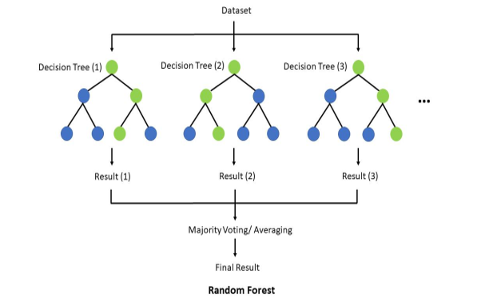
Fig 4 Random Forest Structure
The following explains how the Random Forest machine learning algorithm works for detecting fraud-
As shown in the figure, the set of transactions is split among the decision trees, each tree process the transaction data on its own and makes a prediction based on the patterns it has learned. Once all the trees have made their predictions, their results are combined into one final prediction.
This is done using a method called majority voting, where the prediction is based on the most \common outcome from all the trees. This is because the algorithm helps prevent overfitting and improves the precision and accuracy of classification.
Key Functionalities of Random Forest Algorithm-
- Random Forest carries out analysis processes in a parallel manner with the use of numerous decision trees, thus increasing efficiency in terms of fraud classification.
- Decision trees' construction in this algorithm is done using random feature selection, which helps enhance diversity in decision trees and reduces bias.
- Random Forest algorithm allows analysis of high dimensional transaction data sets comprising of numerous transaction related features.
- High performance is provided by the algorithm despite the presence of noise in transaction data or missing data points.
4.11- Evaluation Metrics
The performance of the machine learning models was measured using different evaluation
metrics to check how well they could predict and classify fraud.
These metrics help in understanding how accurate the predictions made by the ML algorithm are when identifying fraudulent users compared to regular customers.
Evaluating the ML model was important for checking how reliable, consistent, and effective the fraud detection system is.
Evaluation Metrics Used are-
- Accuracy
- Precision
- Recall
- F1-Score
- Confusion Matrix
4.11.1 Accuracy-
The accuracy measure shows how well the model can predict the right outcomes.
It is calculated by dividing the number of transactions that were correctly classified by the total number of transaction records.
Accuracy is calculated using the formula below:
Accuracy = (TP + TN) / (TP + FP + TN)
Where:
- TP = True Positive
- TN = True Negative
- FP = False Positive
- FN = False Negative
4.11.2 Precision-
Precision refers to how many of the transactions marked as fraudulent are actually fraudulent.
Precision is calculated using the formula below:
Precision = TP / (TP + FP)
Where:
- TP = True Positive
- FP = False Positive
Precision helps reduce the number of false fraud alerts sent to users.
4.11.3 Recall
Recall measures the ability of the machine learning model to identify actual fraudulent transactions.
Recall is calculated using:
$$Recall=\frac{TP}{TP+FN}$$
- High recall is important in fraud detection because it reduces the chances of missing fraudulent transactions.
- A higher recall value improves fraud prevention capability.
4.11.4 F1-Score
F1-score provides a balanced measure between precision and recall.
It is calculated using:
$$F1\text{-}Score=2×\frac{Precision×Recall}{Precision+Recall}$$
- F1-score is useful when dealing with imbalanced datasets where fraudulent transactions are much fewer than legitimate transactions.
- A high F1-score indicates balanced fraud detection performance.
4.11.5-Confusion Matrix-
The confusion matrix is used to visualize classification performance.
It contains:
- True Positive (TP)
- True Negative (TN)
- False Positive (FP)
- False Negative (FN)
The confusion matrix helps analyze:
- Correct fraud predictions
- Incorrect fraud classifications
- Model strengths and weaknesses
4.11.6- Role of Metrics in Fraud Detection
Different evaluation metrics provide insights into different aspects of model performance.
For example:
- Accuracy measures overall prediction correctness
- Precision measures fraud prediction reliability
4.12 API Architecture using Flask
API architecture based on Flask technology was employed to facilitate interaction between the fraud detection algorithm and digital payments applications.
The API architecture features:
- Real-time fraud detection
- Communication via JSON format
- Request-response cycle management
- Integration of the machine learning model
This API allows for flawless deployment of the fraud detection mechanism within digital payment systems.
4.12.1-Introduction to Flask API
Flask is a straightforward web framework in Python, specifically crafted for developing RESTful APIs and web-based projects involving machine learning.
In this Project endeavor, the Flask API served to connect the machine learning algorithm responsible for fraud detection with external transaction systems, allowing for immediate fraud monitoring.
The advantages of using Flask API: -
- Streamlined development process for APIs
- Effortless integration of machine learning algorithms
- Adaptable architectural design
- Robust request management capabilities
Flask promotes efficient communication between the client software and the fraud detection system.
4.12.2 Communication Through Requests and Responses
The Flask API operates on a request-response communication model.
This process consists of several key steps:
- Initiating transactions via API requests
- Preparing transaction information beforehand
- Inputting transaction characteristics into the machine learning model
- Generating forecasts regarding potential fraudulent activities
- Returning response data formatted in JSON
This methodology guarantees an efficient assessment of fraudulent behaviors.
4.12.3 Data Transmission in JSON Format
The transfer of data between the payment system and the fraud detection mechanism utilizes the JSON format.
The benefits of using JSON for communication are:
- Efficient data transfers
- Structured representation of transaction information
- Rapid data delivery
- Simplified processing within applications
4.12.4 Integration of Machine Learning Models
The developed Random Forest machine learning model was integrated in the Flask API to provide prediction functionality.
Integration of the model consists of such stages as:
- Loading of trained machine learning models
- Receiving transactions features
- Data passing to the prediction engine
- Calculating probability of frauds
- Returning classification results
4.12.5 API Work Process
In accordance with the above, the work process of the Flask API is the following:
- The transaction request is accepted
- Validation of transaction data is executed
- Preprocessing actions are performed
- Features are extracted and normalized
- A machine learning model makes predictions
- Risk scores are calculated
- A response regarding fraud prediction is returned.
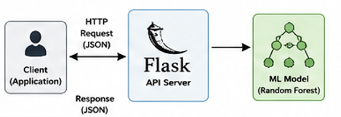
4.13 Machine Learning Workflow
4.13 Risk Scoring Mechanism
4.13.1 Introduction
- A dynamic risk scoring mechanism was developed to evaluate the probability of fraud for every digital payment transaction. The system analyzes transaction behavior and assigns a risk score based on how suspicious the transaction appears.
- The purpose of the risk scoring mechanism is to help the fraud detection system make faster and smarter decisions during transaction processing.
- The mechanism classified transactions into:
- Low Risk
- Medium Risk
- High Risk
- Transactions categorized as high risk required additional verification before approval.
4.13.2 Working of the Risk Scoring Mechanism
The risk scoring mechanism works by analyzing different transaction-related factors such as:
- Transaction amount
- Transaction timing
- Frequency of transactions
- User behavior patterns
- Unusual transaction activity
- Historical fraud-related patterns
The machine learning model studies these attributes and generates a probability score indicating the likelihood of fraud.
Higher scores indicate higher chances of fraudulent activity, while lower scores represent safer transactions.
4.13.3 Risk Categories
The generated risk scores were divided into different categories to simplify fraud analysis and decision-making.
4.13.3.1 Low-Risk Transactions-
These transactions showed normal transaction behavior and had a very low probability of fraud.
Characteristics include:
- Regular transaction patterns
- Trusted user behavior
- Normal transaction amounts
4.13.3.2-Medium-Risk Transactions
These transactions showed slightly unusual patterns and required additional monitoring.
Characteristics include:
- Slightly abnormal transaction behavior
- Moderate transaction amounts
- Unusual transaction timing patterns
- Medium-risk transactions were monitored carefully to prevent potential fraud attempts.
4.13.3.3 High-Risk Transactions
High-risk transactions showed strong indicators of suspicious or fraudulent behavior.
Characteristics include:
- Abnormally high transaction amounts
- Rapid repeated transactions
- Unusual payment behavior
- Suspicious activity patterns
- These transactions required additional verification or temporary blocking to prevent unauthorized financial activities.
4.13.4 Importance of Risk Scoring in Fraud Detection
Risk scoring improves fraud detection systems by enabling intelligent transaction evaluation.
The mechanism helps in:
- Improving fraud detection accuracy
- Supporting real-time fraud prevention
- Reducing financial losses
- Enhancing payment security
- Improving transaction monitoring efficiency
- The system can quickly identify high-risk transactions and take preventive actions before fraud occurs.
4.13.5 Real-Time Risk Assessment
The proposed risk scoring system supports real-time analysis of incoming transactions.
As soon as a transaction request is received:
- Transaction data is analyzed
- Fraud probability is calculated.
- Risk level is assigned.
- Decision response is generated.
4.20 Request-Response Cycle of Fraud Detection API
The request-response cycle of the fraud detection API explains how the payment transaction software interacts with the fraud detection system.
The API gathers transaction information, analyzes the data, generates predictions about whether a transaction is fraudulent, and sends back real-time responses to the payment application.
The request-response pattern enables:
- Real-time fraud prediction.
- Automatic transaction analysis.
- Communication between different parts of the software.
- Faster transaction processing.
- Creation of dynamic risk scores.
4.20.1 Sending a Transaction Request-
Fraud prediction starts when a transaction request is sent to the fraud detection API, which is built using a Flask web application server.
A transaction request includes key details about the payment, such as:
- The amount of the transaction.
- The time the transaction was made.
- Information about the user’s behavior.
- Details about the transaction and the device used.
The transaction data is sent in JSON format, which allows the different parts of the software to communicate effectively.
4.20.5 API Response Generation-
The response provided by the API contains:
- Status of fraud prediction.
- Probability of fraud prediction.
- Classification of risk levels.
- Verification status of transactions.

Fig 4.2.1 Imbalance Dataset Representation
4.25 GitHub Repository Structure-
The development and implementation files for the project were managed with GitHub to ensure efficient project management and version control.
GitHub offered an ideal platform where all the project files could be managed and stored during the development process.
These included:
- Dataset files
- Python scripts
- API implementation files
- Documentation files
- Postman collections
GitHub made it easier to control versioning and project management activities.
4.25.1 Reasons for Using GitHub-
GitHub was used in the project to facilitate the management of the development process and organize the files efficiently.
Some reasons for the use of GitHub in this project include:
- Secure storage of files
- Versioning of the files
- Change tracking
- Project management
- Backup of the implementation files
Using GitHub made machine learning and API development more manageable.
4.25.2 Structure of the Repository-
The repository was divided into various directories and files to enhance the structure of the repository. Repository structure helped improve file management.
The structure included:
- Directory for datasets
- Directory for Machine learning models
- Directory for Flask API
- Directory for documentation
- Directory for Generated images.
- Directory for Python script
4.25.3 Dataset Files-
Transaction data was provided in the dataset file, which is useful for fraud analysis and the training of machine learning algorithms.
Dataset files included:
- Fraud transaction files
- Preprocessed transactions
- CSV transactions
The dataset files help keep transaction details organized for purposes of fraud analysis.
4.25.4 Python Script Files-
Python scripts can be used for implementing data pre-processing, machine learning training, and fraud detection as well as fraud prediction.
Python files included:
- Data pre-processing script
- Machine learning training script
These scripts enable automation of machine learning processes.
4.25.5 Machine Learning Model Files
Machine learning model files were included for purposes of reusing already-trained machine learning algorithms without the need for their repetitive training.
Reuse of these files saves time for training machine learning algorithms each time predictions need to be made.
4.25.6 Flask API Implementation Files-
These files are for implementation of the API that enables communication between the machine learning fraud detection algorithm and other transaction systems.
API implementation files include:
- API routing files
- Request-response handler scripts
4.25.7 Documentation Files-
Files for documentation include project reports and README files among others.
Documentation includes:
- Project reports
- README files
- PPT
4.25.8 Postman Collections
Postman collections were used to test API endpoints and response from the fraud detection model.
It includes-
- API endpoint testing.
- Verification of API responses.
Postman helped improve the reliability and functionality of the API.
4.25.9 Benefits of Using GitHub Repository Management
Some benefits arose from using a GitHub repository for managing the project.
Benefits include:
- Effective version control.
- Facility to create backups.
- Facilitated collaboration within the project.
- Code management.
- Facilities to track changes.
- Improved project maintenance.
- Effective file storage.
It improved project management capabilities.
4.25.10 Significance of Version Control
Version control was essential in facilitating modification tracking.
Use of GitHub version control facilitated-
- Collaboration and coordination among team members during project development.
- Efficient handling of multiple project versions and updates.
- Easy identification and correction of coding errors through change tracking.
- Improved project organization and maintenance throughout the development lifecycle.
- Simplified backup and restoration of project files and source code.
- Support for continuous development and incremental feature implementation.
- Enhanced project reliability through proper code monitoring and version management.
- Easy rollback to previous stable versions in case of system failures or bugs.
- Better documentation of project progress and development activities.
- Facilitated integration of new modules and functionalities without affecting existing code.

CHAPTERV
Data Collection and Analysis
5.1-Introduction-
The effectiveness of any fraud detection mechanism relies highly upon the characteristics and properties of the datasets utilized. In this study, transaction data is collected and analyzed to identify patterns that distinguish fraudulent transactions from legitimate ones. The gathered dataset will be examined via various analytical approaches including statistical analysis and visualization techniques. This analysis plays a crucial role in selecting relevant features, handling data imbalance, and improving the performance of machine learning models.
5.2 Data Collection-
- Data collection is the foundation of project. The data set used for this research is sourced from publicly available sources and consists of real transaction data.
- The data set holds transaction data concerning Legitimate and Fraudulent digital payments. The data is stored in table form, with each row holding one transaction and each column containing data on an attribute of the transaction.
- Transaction data is sourced from reputable websites like Kaggle, where transaction data used for detecting credit card fraud is uploaded. This data is extensively used by many researchers in the field of credit card fraud.
- The Large data set is used to train and test the model. Inclusion of both normal and fraudulent transactions so that classification can be done.
- It is structured in tabular format, where each row represents a transaction and each column represents a specific attribute of that transaction.
- Transaction logs based on time have also been included in the dataset, which will be useful to understand any irregularities in transaction behavior.
- It has also been ensured to take ethical factors into consideration while collecting data. The dataset collected is of an anonymous nature, and hence there is no risk of exposing any private data.
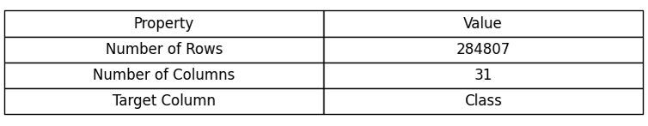
Figure 5.1: Dataset Loading and Structure Output
5.3 Dataset Structure and Feature Representation-
The dataset used in this study is structured in a tabular format, which consists of rows and columns, where each row represents a transaction, whereas each column represents the features related to the transaction.
- The dataset consists of high-dimensional data, where multiple features contribute to identifying fraudulent patterns.
- Some datasets use anonymized features (V1, V2, V3, …) to protect sensitive information while preserving statistical properties.
- Data is stored in CSV format, allowing easy integration with tools like Python, Pandas, and machine learning libraries.
- Proper feature representation helps in capturing hidden relationships and patterns in the data.
- Feature engineering plays a key role in improving model performance by selecting the most relevant attributes.
- Redundant or irrelevant features are removed to reduce computational complexity and avoid overfitting.
- Categorical features are converted into numerical formats using encoding techniques to make them suitable for machine learning algorithms.
- Numerical features are analyzed to understand their distribution and variation.
The dataset is divided into:
- Independent variables (features): Used as input for the model
- Dependent variable (target): Indicates whether the transaction is fraudulent
Features used in this data set are:
- Transaction ID
- Transaction Time
- Transaction Amount
- Data Fraud Flagging (0- legitimate transaction; 1-fraudulent transaction)
- Region Device
- User Id
- Account
Each of these features will help to determine the pattern of fraudulent transaction. In particular, the transaction amount and time will help detect the abnormality in the transactions.
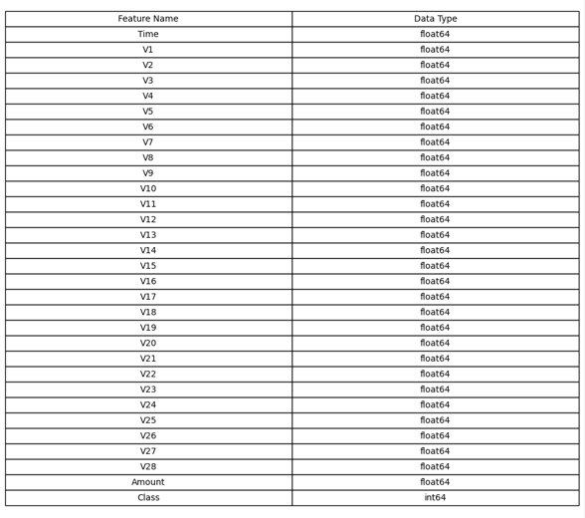
Figure 5.2: Dataset Structure and Feature Representation
5.4 Types of Digital Payment Frauds
Different kinds of fraud need to be understood to analyze the data set. Fraud trends could involve many small transactions followed by a big transaction to verify the security of the system. Social engineering is one of the reasons why many frauds happen because the users would be coerced into giving away their private details. E-wallet fraud is growing due to the increased utilization of the mobile payment applications. Detecting frauds becomes difficult due to the dynamic trends used for committing fraud.
Some common types of digital payment fraud include:
- Unauthorized Transaction- Transactions that have been conducted without authorization from the account owner.
- Phishing Attack- A kind of attack where attackers deceive victims to reveal their private details. Identity Theft: Personal details are used in fraudulent activities.
- Account Takeover (ATO) -The attackers use stolen login details to gain access to a victim’s account and commit fraud.
- Card Fraud-The use of cards stolen by the attacker. These kinds of frauds have different patterns within the data set.
- Card-Not-Present (CNP) Fraud- This fraud involves making purchases or payments without physically having the card.
- Identity Theft -The fraudsters steal personal and financial details and use them to make unauthorized transactions and create fake accounts.
- Skimming and Cloning -Using skimmers, the attackers steal the card details and use them to make counterfeit cards.
- SIM Swap Fraud -The attackers transfer the victim’s mobile phone number to a different SIM card to steal the OTP and make unauthorized transactions.
- Friendly Fraud (Chargeback Fraud) -The legitimate user falsely claims an authorized transaction to be unauthorized and requests a chargeback or refund.
- Merchant Fraud- The attackers pose as merchants or compromise the merchants' account to carry out fraudulent transactions.
- Application Fraud - Fraudsters use false identities or stolen information to apply for credit cards and loans.
- Transaction Laundering-The fraudsters process illegal transactions via legal financial institutions to disguise their illegal business dealings.
5.5 Distribution of Legitimate vs Fraudulent Transactions
Legitimate and fraud transaction distribution is defined by the ratio and distribution rate of valid transactions and fraud transactions in the dataset. The information derived from such an analysis is useful in establishing the imbalance between the two types of transactions and the characteristics of fraud cases.
The distribution of transaction classes plays a vital role in fraud detection. In any data set, there are more legitimate transactions compared to fraudulent transactions. This results in a situation referred to as a Class Imbalance Issue. It can affect model performance because the model may become biased toward the majority class and fail to detect minority fraud cases accurately.
Some of the key observations include-
- Most of the transactions are from the legitimate category. Fraudulent transactions make up a small portion of the data set.
- Bar charts, Pie Charts, and Histograms provide a visual representation of the class imbalance issue.
- The class imbalance issue underscores the importance of applying specific methods like Oversampling and Under sampling when building models.
- Fraudulent transactions typically represent less than 1–2% of the total dataset, making detection more challenging.
- The imbalance in the dataset can lead to biased model performance, where the model may predict most transactions as legitimate.
- Fraudulent transactions often show clustered patterns, appearing in specific time intervals or regions.
- Distribution analysis helps in identifying peak fraud periods, such as late-night transactions or high-activity hours.
- Box plots can be used to compare transaction amount distributions between fraud and non-fraud cases.
- Density plots help visualize the probability distribution of transaction features.
- Distribution analysis supports the identification of threshold values for risk scoring.
- It also helps in understanding the impact of class imbalance on recall and precision metrics.
- Visualization of cumulative distribution functions (CDF) can provide deeper insights into transaction patterns.
5.7 Exploratory Data Analysis
EDA is visualization of transaction amount distribution to gain insights into spending habits and uncover any abnormality. It analyzes transaction frequency patterns over time to discover peak times and any unusual increases.
Types of Exploratory Data Analysis-
5.6.1. Univariate Analysis
- Histograms and bar charts used to understand distributions
- Most numerical features showed right-skewed distributions
5.6.2. Bivariate Analysis
- Scatter plots and box plots analyzed relationships
- Strong correlation observed between selected numerical variables
5.6.3. Multivariate Analysis
- Heatmaps used to analyze correlation between multiple features
- Detected multicollinearity between some variables
Analytical Insights from Exploratory Data Analysis-
- Analysis of feature distributions separately for fraud and non-fraud classes.
- Detecting any skewness present in the data, particularly in transaction amount. Spotting any pattern or anomaly in the data might suggest fraud.
- Analyzing time-related patterns, such as abnormal transaction timings. Observing customer behavior trends, for instance, numerous transactions over a short period of time. Discovering risky transaction zones or regions.
- Scatter Plots are used to examine the relationship between multiple features. Analyzing transaction velocity (transactions/second). Detecting duplicate or recurring transactions.
- EDA helps in identifying hidden patterns and anomalies in the dataset.
- It provides insights into fraud behavior vs normal behavior.
- Identifying extreme values in transaction amount or frequency that may indicate suspicious activity.
- Analyzing the imbalance between fraud and non-fraud cases and understanding its impact on model performance.
- Checking for null or missing data and deciding appropriate handling strategies.
- Evaluating the number of features and their relevance to avoid unnecessary complexity. Using statistical or visualization methods to detect unusual transaction patterns
5.8 Outlier Detection
Outlier detection is an important step in fraud detection systems because fraudulent transactions often behave differently from normal transactions. Outliers are data points that significantly deviate from the normal transaction pattern and may indicate suspicious or fraudulent activities.
Important observations through Outlier Detection include-
- Identification of unusually high transaction amounts that differ from normal spending behavior.
- Detection of abnormal transaction frequency within a short period of time.
- Use of statistical methods such as mean, standard deviation, and interquartile range (IQR) for identifying outliers.
- Analysis of transactions occurring at unusual times, such as late-night hours.
- Detection of transactions from unexpected geographic locations.
- Identification of multiple rapid transactions performed consecutively.
- Use of box plots to visually identify extreme transaction values.
- Detection of sudden spikes in transaction activity for a specific user or account.
- Analysis of inconsistent user behavior patterns compared to historical data.
- Identification of transactions involving unusually large withdrawals or transfers.
- Detection of repeated failed transaction attempts, which may indicate fraud attempts.
- Use of scatter plots to identify isolated or abnormal transaction patterns.
- Analysis of deviations in device usage, such as transactions from unknown devices.
- Detection of transactions exceeding predefined threshold limits.
- Identification of outliers in transaction velocity (number of transactions per minute/hour).
- Use of z-score analysis to measure how far a transaction deviates from the average behavior.
- Application of machine learning algorithms for anomaly detection.
- Identification of irregular spending patterns that differ from normal customer behavior.
- Detection of sudden changes in transaction locations within short intervals.
- Analysis of outlier clusters that may represent coordinated fraud attacks.
- Comparison of outlier behavior between legitimate and fraudulent transactions.
- Identification of anomalies in transaction timing and sequence patterns.
- Detection of transactions with inconsistent feature combinations.
- Use of visualization techniques such as histograms and density plots to analysis.
IQR-
- IQR is a statistical technique used to measure the spread of data.
- IQR helps in identifying outliers by focusing on the middle 50% of the dataset.
- It is calculated as the difference between the third quartile (Q3) and the first quartile (Q1).
$$IQR=Q3-Q1$$
- The lower and upper bounds are calculated as:
- $\text{Lower Bound}=Q1-1.5(IQR),\text{Upper Bound}=Q3+1.5(IQR)$
- IQR is widely used because it is resistant to extreme values.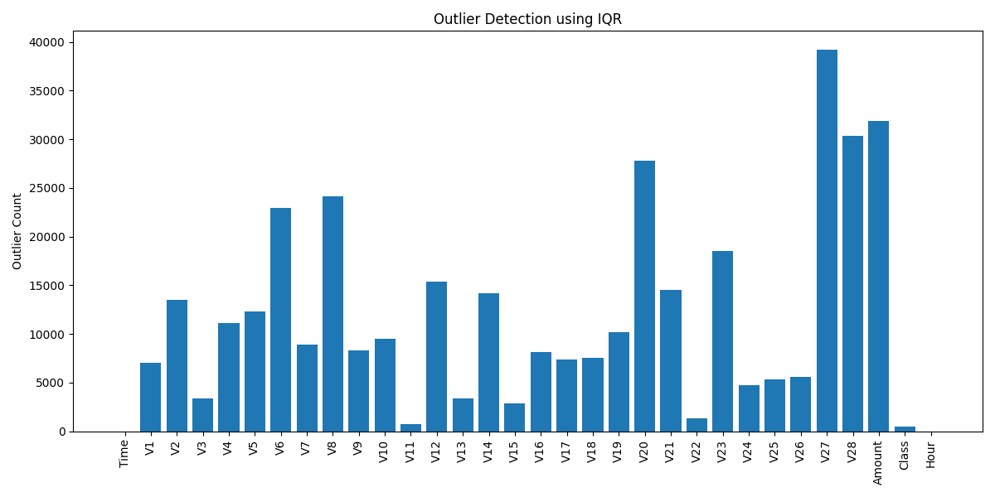
Figure 5.7: Outlier Detection in Transaction Dataset
- Some of the features with many outliers are V27, V28, Amount, and V20, which suggest these have a wide range of values. Variables like V6, V8, and V23 also have a significant number of outliers, which might point to uncommon transaction activities. On the other hand, features like Time, Hour, and Class have very few outliers.
- Outliers identified through IQR can be handled with techniques such as transformation, capping, normalization, or using robust machine learning methods.
- From the analysis, it's clear that the dataset is very imbalanced and contains a lot of abnormal transaction behaviors.
- Detecting and analyzing outliers is an important preprocessing step as it helps improve model reliability and reduces the impact of noise on prediction accuracy.
5.9 Time-Based Transactions Analysis –
- It is analysis of transactions in varying time spans (hourly, daily, weekly) for behavioral patterns. It is analysis of peak transaction times, which is usually when the majority of legitimate transactions happen.
- It identifies abnormal transaction times, like midnight or early morning transactions.
- Frequent fraudulent transactions are done during off-peak hours when there is little surveillance.
- Detection of multiple rapid transactions in short time periods, which could mean fraud by bots.
- Behavioral analysis based on user activity during specific time frames (normal/abnormal). Identification of transactions repeating at regular intervals, indicating bot behavior, analysis of weekdays vs weekends, seasonality analysis, Time-zone analysis, especially in cross-border transactions and analysis of time lags between login time and transaction time.
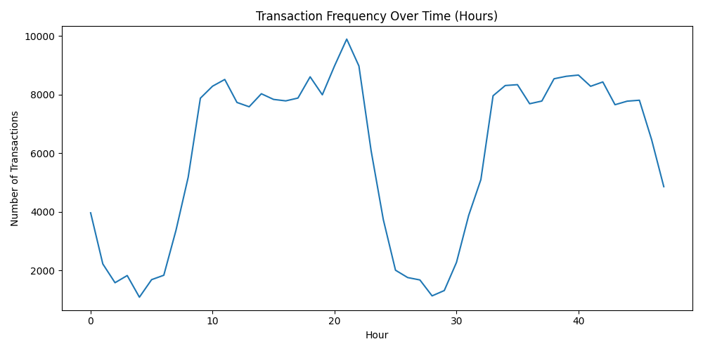
Fig Time-Based Transaction Analysis
The figure shows the distribution of transactions across different time intervals in the dataset.
Transaction activity is spread throughout the entire time range, indicating continuous system usage without major downtime periods. No strong periodic or cyclical pattern is observed in transaction frequency. This suggests that fraud detection cannot rely solely on time-based features and must consider multiple variables. The absence of clear temporal clustering indicates that time alone is not a strong predictor of fraud.

CHAPTER V
FINDINGS AND INTERPRETATION
6.1 Introduction-
In this chapter, the findings arising out of the analysis of the transactions and machine learning models developed for detecting fraud will be discussed. The results obtained will be analyzed using various analytical techniques, such as Performance measures and Visualization. The objective of this chapter is to analyze transaction patterns and the performance of the fraud detection system, as well as interpret the results produced by the proposed AI-based payment fraud detection and risk scoring system.
6.2 Findings from Exploratory Data Analysis (EDA)-The Exploratory Data Analysis is used in understanding the structure, distribution, and characteristics of the transaction dataset. Several Visualization methods and Descriptive Statistics tests were used.
- It was found out that the transaction dataset in question is highly Imbalanced-Legitimate transactions exceed the number of Fraudulent transactions by several times.
- Fraudulent transactions represent only a very small percentage of the overall dataset, making fraud detection a challenging task.
- Analysis of the transaction amount distribution showed that legitimate transactions generally happen for smaller amounts while fraudulent transactions are often associated with unusual or extreme amounts.
- Outlier detection identified several abnormal transactions that significantly deviated from normal user behavior.
- Time-based analysis indicated that fraudulent transactions frequently occur during unusual hours and often involve rapid consecutive transactions.
- The correlation analysis showed that most transaction features have low direct correlation with each other, indicating that fraud detection depends on multiple independent factors rather than a single feature.
- Box plots and histograms effectively highlighted anomalies and irregular transaction patterns. Scatter plot analysis helped to identify isolated clusters of suspicious transactions. It revealed that fraudulent behavior is complex and cannot be identified using single feature.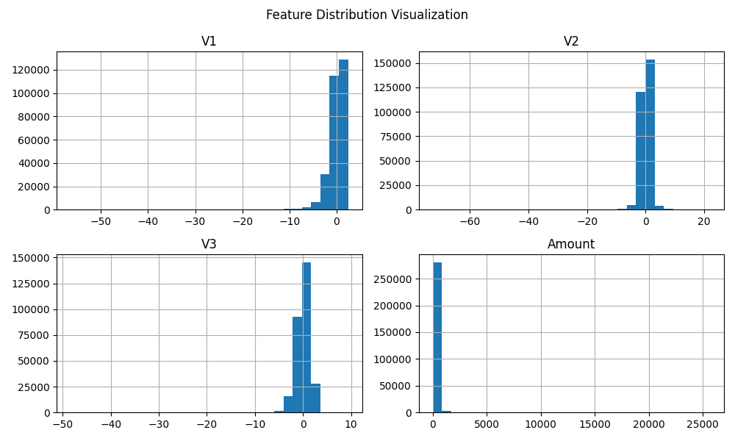
Figure 5.6: Feature Distribution Visualization of Transaction Attributes
Interpretation of Results-
- The chart shows how different transaction features such V1, V2, V3, and Amount, are spread out in the dataset. Histograms help us see how the values of transactions are spread across various ranges.
- Looking at the graphs for V1, V2, and V3, it's clear that most transaction values are near zero and drop off towards the extremes. Because of this, the transformed features have a more balanced or normalized distribution which is good for training ML models.
- The Amount feature has a right-skewed distribution, meaning most transactions are for smaller amounts, while only a few are large. This pattern matches what we see in real-world digital payment systems, where most transactions are small compared to the few larger ones.
- The graph shows how each feature behaves, how their values are spread out, any skew in the data, and whether there might be any unusual or extreme values in the dataset.
- Distribution analysis supports effective preprocessing and feature scaling.
- The graph assists in identifying abnormal transaction patterns and potential outliers.
- The analysis contributes to better machine learning model performance and fraud detection accuracy.
6.3 Findings from Distribution Analysis-The Distribution Analysis of the legitimate and fraudulent transactions highlighted the severe imbalance present in the dataset. The legitimate transactions dominated as the majority class, whereas the fraudulent transactions made up the minority. The Imbalance Ratio indicated that conventional classification models could develop bias towards the prediction of legitimate transactions. This justified the need for advanced fraud detection techniques and balancing methods such as oversampling and undersampling. Visualization of the data through graphs showed that there was rare occurrence of fraud in the online payment systems.
Key Findings from Distribution Analysis-
- The analysis revealed that fraudulent transactions accounted for only a very small percentage of the total dataset, making fraud detection a highly challenging task.
- The imbalance in class distribution posed risks to the model being biased towards the majority class when predicting classes.
- Rarity in fraud transactions made it important to use specialized metrics like precision, recall, and F1-score when evaluating the algorithm's performance.
- It helped in understanding the true nature of transaction datasets in the real world.
- Visualization technique clearly shows that legitimate transaction records far outweigh those involving fraudulent activities.
- Dataset imbalance posed a challenge that required balancing of the datasets.
- Oversampling methods helped in increasing the presence of frauds in training datasets.
- Under-sampling techniques were helpful in minimizing the number of legitimate transactions to produce balanced datasets.
- It was found out that mishandling of imbalanced datasets reduces fraud detection efficiency. It helped in reducing false negatives when detecting frauds.
- Transactions that involved fraud differed from legitimate transactions in behavioral traits regarding amounts, timing, and frequency.
- The imbalance also had implications for model generalization and prediction performance.
- Data imbalance management enhanced fraud detection efficiency and effectiveness.
- Transaction distribution analysis facilitated fraud detection system and scaling.
- Proper visualization of transaction distribution enhanced decision-making 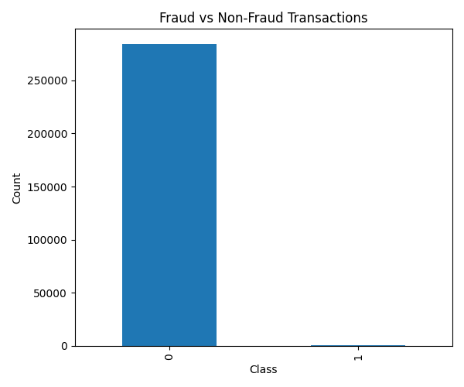
Fig Distribution Analysis of Fraudulent Transactions
Interpretation of Result-
- The graph illustrates how many type of transactions are present in the dataset. It clearly shows there is a difference between normal and fraudulent transactions.
- In the graph, Class 0 represents non-fraud transactions and Class 1 represent Fraudulent Transactions. It shows that fraudulent activity is quite rare in the dataset.
- The imbalance in the data means there are far more normal transactions than fraudulent ones. This skew can cause problems when training a model because the model might end up favoring the more common class.
- To avoid this, data balancing techniques should be used during the preparation phase before building the fraud detection model.
- The graph reflects a real-world scenario in fraud detection, where non-fraud transactions are much more common than fraud cases.
- Fraud detection is challenging because fraudulent activities are rare compared to normal transactions.
6.4 Findings from Correlation Analysis-
Correlation matrix analysis proved helpful in determining correlations between different transaction attributes. Most features showed weak or moderate correlation, indicating independent behavior among variables. Moreover, some transaction attributes had more impact on identifying fraud than others. It was also determined that no single attribute could be used to detect fraud effectively without the help of Machine Learning Algorithms. Correlation analysis also helped in reducing redundant features and improving model efficiency.
Key Finding-
- The Heatmap visualization gave an accurate view of the association between various transaction features.
- Highly correlated positive features meant there is behavioral patterns among transactions. Negative correlation helped to determine the existence of inverse relationships between variables.
- Most features were found to be relatively independent, reducing the risk of multicollinearity.
- The analysis enabled the determination of important variables in fraud prediction. Correlation analysis assisted in the determination of the right features.
- Redundant or highly correlated features were minimized to improve model performance and reduce complexity. This made fraud detection possible as it required multiple factors acting together.
- The attributes of the transactions had more correlation with fraudulent behavior than the legitimate ones.
- Correlation analysis enhanced the understanding of hidden associations among different transaction variables.
- Features such as transaction amount, frequency, and time had some effects on fraud behavior. This helped to reduce the dimensions within the data set to increase processing speed.
- Correlation analysis reduced the chances of overfitting by removing unnecessary dependencies among variables.
- Feature interaction analysis enhanced the ability of the system to detect sophisticated fraud patterns.
- Correlation-based analysis improved overall fraud detection accuracy.
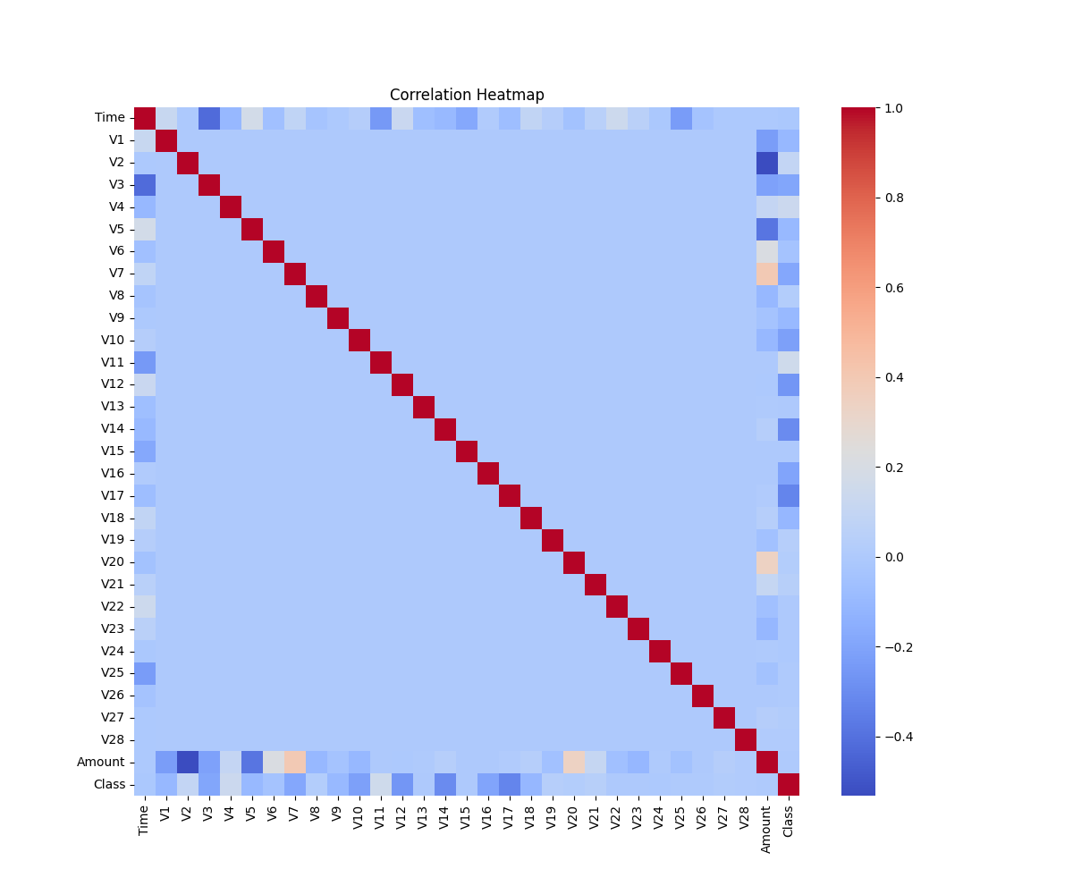
Figure 5.5: Correlation Matrix of Transaction Features
Interpretation of Results-
- Above figure shows how different characteristics in the dataset relate to each other when trying to find fraudulent transactions.
- The colors on the heatmap show the strength and direction of the relationship between two transaction features.
- The red cells along the diagonal show that each feature is perfectly related to itself, with a correlation value of one.
- Most of the other pairs of features have light blue colors meaning they have a weak relationship.
- Some transaction features have a moderate connection with the target feature, which is whether a transaction is fraudulent or not.
- These features are important for predicting fraud. Features that are more strongly connected help models learn better.
- The heatmap also shows that there is no multicollinearity in the dataset. It happens when some features are too closely related to each other.
6.5 Findings from Data Preprocessing
The preprocessing phase helped to enhance the quality and usability of the data set. The process of dealing with Missing Values and Inconsistent Records ensured the Integrity of the data was not compromised. The application of Feature Scaling and Normalization Techniques helped to enhance the performance of machine learning models by promoting consistency between numerical values. Data resampling helped to increase the capacity of the algorithm to detect fraud through balanced data processing. Data preprocessing reduced noise and improved overall model accuracy.
- Data preprocessing played an instrumental role in converting transaction data from its raw form into useful and structured input for machine learning.
- Duplications in the data set were eliminated to ensure unbiased model predictions.
- Invalid and erroneous transaction entries were fixed to increase data accuracy.
- Data was imputed in case of missing values to keep the data complete. Transaction data was cleaned to enhance consistency and integrity.
- Numerical features in transaction data sets were standardized to ensure equal contribution of all variables.
- Feature scaling was performed to minimize variances in transaction features. Normalization ensured uniformity in large and small transaction features.
- Outliers were appropriately handled to improve stability in model training.
- Data preprocessing facilitated faster convergence when training models.
- Oversampling and under sampling balanced the data to reduce model bias towards normal cases. Resampling techniques made sure that minority classes were also equally represented in the data set.
- Feature engineering increased the prediction power of significant transaction features.
- Data preprocessing techniques allowed conversion of categorical features into numeric forms.
- The clean and normalized data helped improve the generalization ability of machine learning algorithms. The process of preprocessing has made the data more efficient for computation purposes.
- Preprocessing has proven to be an essential step in developing the fraud detection model. Transforming the data has allowed the system to identify hidden patterns.

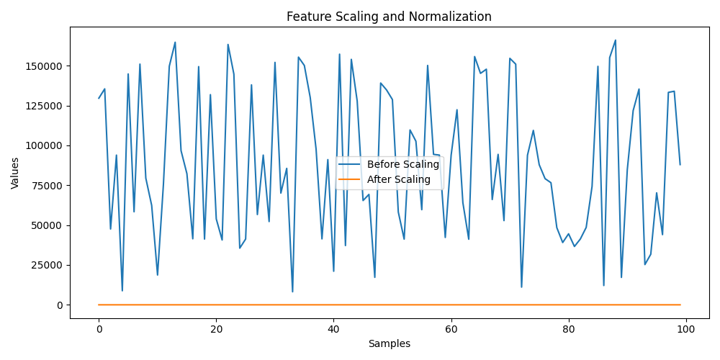
Figure 6.5: Feature Scaling and Normalization Results
Interpretation of Results-
- The graph below depicts the changes that have occurred in the value of the transaction feature as a result of the feature scaling process implementation. The figure presents a comparison between the original values and the scaled values obtained after applying the scaling approach.
- In the graph above, the blue line depicts the feature values before scaling. In this case, the transaction feature values exhibit significant variations, meaning that the feature values are not consistent and cover a broad numerical span. This situation might lead to poor performance of the machine learning algorithm since it will experience difficulties in dealing with such values during its training phase.
- On the other hand, the orange line shows the scaled feature values. After the application of the feature scaling approach, the variation is eliminated. The transaction values become more stable and consistent due to the transformation process implemented by means of feature scaling. Consequently, all transaction features will influence the process of learning within the machine learning model.
- As can be seen from the results of the scaling procedure, the variations in transaction values have been effectively minimized.
6.6 Findings from Model Training and Testing-
Several machine learning algorithms were trained and tested for detecting fraud. Among the tested models, the Random Forest Algorithm is more accurate in recognizing frauds than the others. The trained models could distinguish between legitimate and fraudulent transactions with high accuracy. This shows how effective the methods are in predicting suspicious transactions. The algorithms learned from past data to recognize transaction patterns and accurately predict future instances of transactions.
Major Observations from Model Training and Testing-
- Multiple Classification methods were applied to analyze fraud detection effectiveness.
- The Random Forest model achieved superior performance due to its ensemble learning approach and ability to handle complex datasets.
- High ability of the model to uncover hidden fraud patterns made it applicable for transaction analysis.
- Training and testing phases were helpful to assess generalization capabilities of machine learning approaches.
- Train-test split was applied to test the model on the unseen data for reliable performance assessment.
- The models were trained to learn relationships between transactions and fraud characteristics.
- Random Forest model worked efficiently with high-dimensional transaction data. It was capable to minimize the risk of overfitting of the model.
- Random Forest provided higher stability of predictions comparing to the model based on single decision trees.
- Machine learning models greatly outperformed conventional rule-based fraud detection systems.
- Training the models improved automatic fraud detection without having to rely heavily on manual detection.
- Cross-validation techniques improved the robustness and consistency of model performance.
- The feature importance analysis helped determine transaction attributes that played an important role in fraud prediction. The model was successfully trained on imbalanced transaction data following necessary adjustments.
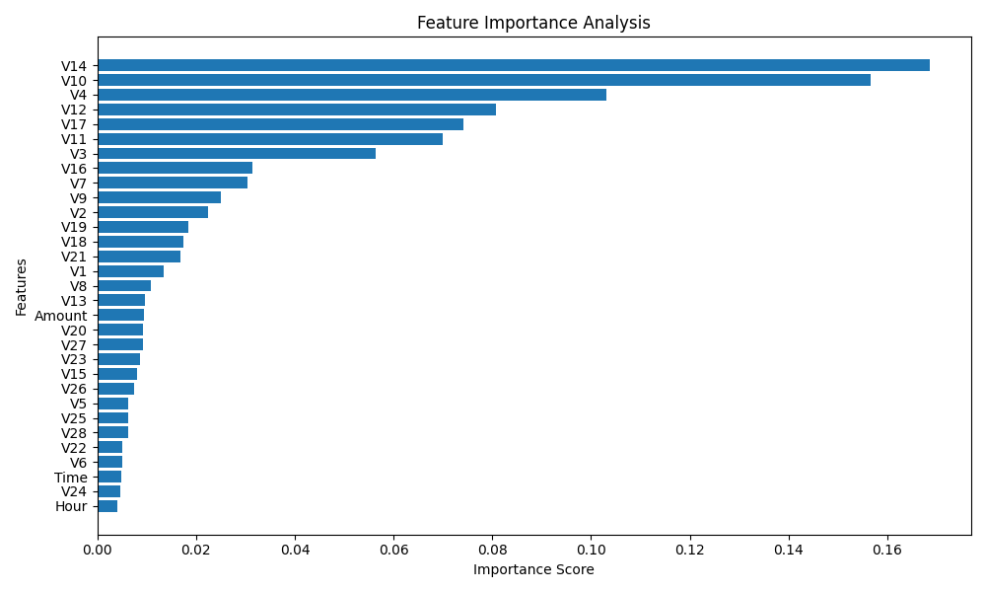
Figure 6.x: Feature Importance Analysis using Random Forest Algorithm
The graph shows the results of a feature importance analysis done using the Random Forest algorithm for detecting fraud.
- It's observed that features like V14, V10, V17, V12, and V4 have the highest importance scores. These features are very important in deciding whether a transaction is fraudulent
or not.
- On the other hand, features with lower scores have less impact on the prediction result.
For example, V14 has the highest importance score, which means it is very helpful in predicting fraud.
- Features like V10 and V17 also play a major role in predicting fraud. In contrast, feature
such as V6, V22, and contrast, features such as V6, V22, and V24 have lower scores, means they have less effect on the prediction outcome.
- The analysis supports feature selection and optimization in machine learning models.
- Important features can be prioritized for future fraud monitoring systems.
- The Random Forest algorithm efficiently handled high-dimensional transaction data and identified significant fraud-related attributes.
- Feature importance analysis enhances model interpretability and transparency.
- The model effectively learned hidden patterns from historical transaction data.
6.7 Confusion Matrix Interpretation-
Confusion Matrix was used to evaluate the assessment of classification accuracy in the fraud detection algorithm.
True Positive (TP): The fraud detection algorithm accurately detected fraud.
True Negative (TN): The algorithm accurately recognized genuine users.
False Positive (FP): Genuine users were incorrectly flagged as frauds.
False Negative (FN): Fraudulent users were incorrectly classified as genuine users.
Major Observations from Model Training and Testing-
- The result obtained from the analysis revealed that the model had a good true positive and true negative rate, which implied that it was efficient in detecting fraud.
- High true positive numbers proved high fraud detection ability of the developed model.
- High true negative numbers helped to prove high legitimacy detection ability of the model.
- Confusion matrix gave detailed information about the right and wrong model predictions.
- Confusion matrix helped to determine how well the model classifies the transactions as fraudulent or legitimate ones.
- Confusion matrix helped to get more information on classification and prediction errors.
- The results confirmed that the Random Forest model effectively handled imbalanced transaction data.
- Confusion matrix allowed calculating some essential evaluation metrics, including accuracy, precision, recall, and F1-score.
- Stable and consistent classification performance was proved by the results obtained through confusion matrix.
- It offered a visual depiction of the predictions made, making it easier to analyze the results. The model was able to detect most of the abnormal transactions without impacting the performance of the genuine users.
- Based on the confusion matrix, the use of preprocessing and balancing made the classification process more efficient.
- Classification improved the credibility of the digital payment system. The confusion matrix also suggests the need for constant improvement of the model due to evolving patterns of fraud.
- The confusion matrix findings validated the reliability and robustness.
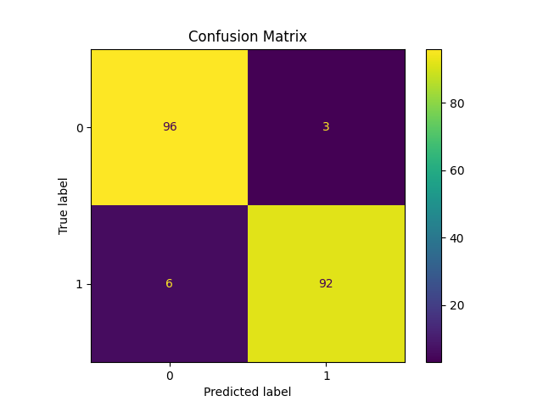
Figure: Confusion Matrix of Fraud Detection Model
The figure shows the confusion matrix-
- 96 transactions were correctly labeled as non-fraudulent (true negatives).
- 92 transactions were correctly labeled as fraudulent (true positives).
- 3 non-fraudulent transactions were incorrectly labeled as fraudulent (false positives).
- 6 fraudulent transactions were incorrectly labeled as non-fraudulent (false negatives).
Interpretation of Results-
- The results of this study demonstrate that the machine learning classifier can classify the transactions as genuine and fraudulent with high effectiveness.
- The amount of properly classified transactions is much greater than the number of improperly classified transactions.
- The low number of FP will decrease the number of unneeded alerts about possible frauds, whereas the number of false negatives demonstrates that most of the fraudulent transactions were identified.
- In general, the confusion matrix proves that the created fraud detection model classifies the transactions accurately, consistently, and reliably.
6.8 Performance Metrics Interpretation
The performance of the fraud detection algorithm was tested using different metrics like accuracy, precision, recall, and F1-score.
- Accuracy determined how accurate the model predictions were.
- Precision determined how many transactions were fraudulent among those predicted by the model.
- Recall measured how well the model could detect fraud transactions.
- F1-score measured the average of both precision and recall.
The test results revealed that the Random Forest model demonstrated impressive performance in all measures. It was important to have high recall values in the detection of fraud since it minimized the chance of overlooking any fraud.
Major Observations from Performance Metrics Interpretation-
- The performance metrics gave a quantitative assessment of the effectiveness of the fraud detection system.
- The evaluation process assisted in comparing the efficiency of various machine learning models.
- High accuracy values indicated that the model correctly classified the majority of transactions.
- Precision was vital in reducing false positives and unnecessary blocking of legitimate transactions.
- Recall was crucial in detecting the maximum fraudulent transactions from the data set.
- A high F1-score indicated a proper balance between precision and recall.
- The metrics demonstrated the effectiveness of using the Random Forest algorithm on imbalanced transaction data.
- Evaluation results confirmed the accuracy and reliability of the suggested fraud detection system.
- The machine learning model performed well during both training and testing phases.
- Metrics analysis helped highlight the strengths and weaknesses of the classification model.
- The performance metrics proved that the system provided efficient fraud detection without prediction mistakes.
- Precision and recall helped optimize the trade-off between security convenience.

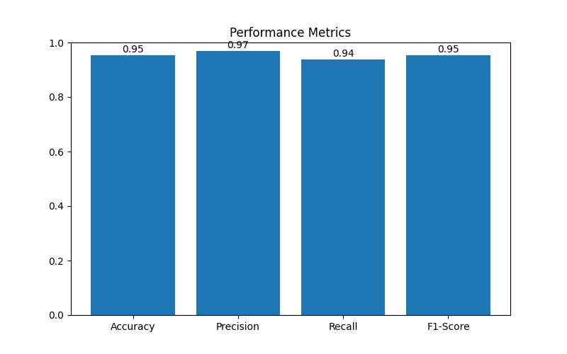
Figure: Performance Metrics of Fraud Detection Model
The graph above shows the evaluation metrics for the fraud detection model.
Interpretation of Results-
The performance metrics graph demonstrates that the proposed fraud detection model achieves high classification performance with strong accuracy, precision, recall, and F1-score values.
1. Accuracy- It shows the overall percentage of transactions correctly classified by the Model. An accuracy of 95% means the model successfully identified most transactions. It reflects the overall effectiveness of the fraud detection model.
2. Precision-Precision measures how many of the transactions labeled as fraud by the model are fraudulent. A precision value of 97% means there are very few false alarms. It shows how many fraud alerts are real.
3. Recall-Recall measures how well the model can find all fraudulent transactions. A recall value of 94% means the model detected almost all fraudulent transactions. Recall is important in fraud detection because missing even one fraud case can lead to financial loss.
4. F1-Score-The F1-score is a balance between precision and recall. An F1-score of 95% shows the model performs well overall.
It ensures the model can detect fraud effectively while keeping false alarms low. It is especially useful when dealing with imbalanced data.
6.9 ROC Curve Analysis-
- The ROC curve is used to check how well a fraud detection model works by looking at the TPR and FPR at different settings.
- If the ROC curve is near the top left corner, it means the model is very good at finding fraud and has high accuracy. From the results of the ROC curve, it's clear that the ML method works well because it has high detection rates and low mistakes.
- The Area Under the Curve, or AUC, shows the overall ability of the model. A higher AUC means the model is more accurate and better at distinguishing between fraud and real transactions. If the AUC is close to 1, the model is performing very well, but if it's near 0.5, the model is not doing much better than just guessing.
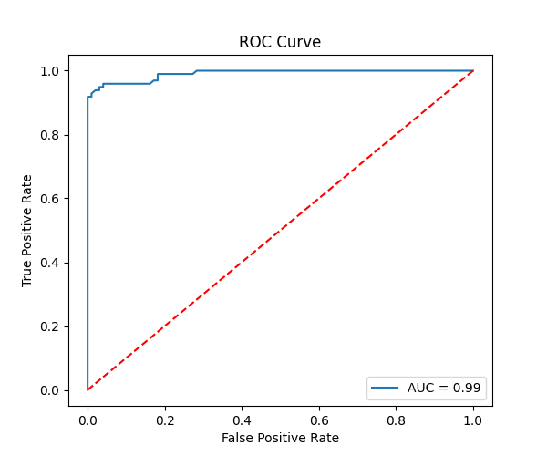
Figure 6.10: ROC Curve Analysis of Fraud Detection Model
Interpretation of Results-
- Above curve shows that the model has strong fraud detection abilities. It keeps a high TPR rate while keeping the FPR very low.
- An AUC of 0.99 means the model is doing a great job at classification.
- The ROC curve staying above the baseline clearly shows the model is performing better than random guessing. The fraud detection model can effectively tell the difference between fraud and non-fraud transactions.
- Above curve indicates that the trained Random Forest algorithm is both reliable.
- The ROC analysis validates the effectiveness of approach used in the project.
6.10 Findings from Risk Scoring Mechanism-
The risk scoring system assigned probability ratings to transactions depending on whether they were likely to be fraudulent. Transactions with higher risk scores were considered suspicious and required additional verification. Low-risk transactions were processed normally without interruption. Dynamic Risk scores made it easier to decide what to do because high-risk transactions could be flagged first. Overall, it made the payment system much more efficient and secure.
Major Observations from Risk Scoring Mechanism-
- The risk scoring model aided in categorizing transactions based on their risk factors such as low, medium, and high-risk transactions.
- The risk scores of each transaction were calculated through machine learning algorithms and transactional behavior analysis.
- The use of the risk scoring model helped in the determination of risk level in transactions in real-time.
- High-risk transactions triggered alerts and additional authentication procedures.
- Medium-risk transactions had the potential to escalate, and hence they were flagged.
- Low-risk transactions were processed quickly, improving user convenience and payment efficiency.
- The use of risk scoring models in transaction management helped in effective fraud prevention.
- Dynamic risk evaluation helped make the process more adaptive to changes in fraud tactics.
- The scoring model helped to reduce dependency on manual fraud monitoring procedures.
- Risk scoring automated the decision-making in digital payments.
- The scoring model balanced the need for security with speed in transaction processing.
- Risk-based transaction classification helped prioritize transactions that required inspection.
- The model made the process of managing transactions efficient. Historical transaction patterns were used in risk score calculations.
- Behavioral analysis greatly aided the creation of precise risk scores. It was observed that the combination of machine learning and risk scoring resulted in better fraud detection.
- Risk scoring increased the interpretability of the fraud prediction outcomes.
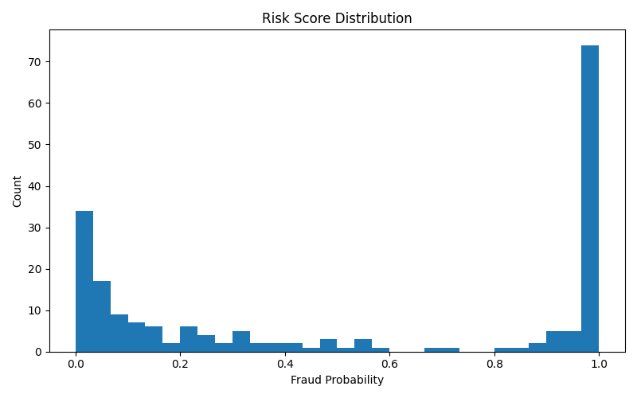
Figure 6.8 Transaction Risk Score Analysis
Interpretation of Results-
- The histogram represents the distribution of risk scores generated by the fraud detection model, with values ranging from 0 to 1.Most of the transactions fall near the 0 mark meaning that the majority are considered low risk or legitimate. But there's another group of transactions that cluster close to 1, indicating that some are flagged as high risk or are flagged as high risk or fraudulent.
- This makes the distribution of risk scores bimodal, showing that the model can clearly tell the difference between normal and fraudulent activities.
- There are very few transactions that fall between 0.3 and 0.7which suggests that the model doesn’t label them as risky.
- The sharp peak near 1 indicates that the system strongly identifies fraudulent patterns in certain transactions.
- The distribution is skewed, it means that although fraudulent activities are less common, they are more intense. This ability to distinguish between different kinds of transactions is a major advantage of using ML models.
- Additionally, this chart shows that using threshold-based methods for fraud detection can be very effective.
6.11 Findings from Real-Time Fraud Detection-
The real-time fraud detection system successfully analyzed transactions instantly and generated predictions with minimal delay. The API-based architecture enabled smooth communication between the transaction system and the fraud detection model.
The system demonstrated the ability to process large volumes of transaction data efficiently while maintaining accuracy and speed.
Major Observations from Real-Time Fraud Detection-
- Real-time monitoring improved the capability of identifying suspicious activities immediately, thereby reducing potential financial losses.
- The real-time fraud detection system enabled instant analysis of incoming payment transactions.
- The system generated fraud predictions within a very short response time, ensuring fast transaction processing.
- API integration improved communication between frontend applications and the machine learning model.
- The Flask API successfully handled request-response operations for fraud prediction.
- Real-time transaction monitoring enhanced the security of digital payment systems.
- Immediate fraud detection reduced the possibility of unauthorized transactions being completed successfully.
- The system effectively processed continuous streams of transaction data without significant performance degradation.
- Real-time analysis improved the responsiveness and efficiency of fraud prevention mechanisms.
- The architecture supported scalable deployment for handling large transaction volumes.
- The fraud detection API maintained consistent prediction performance under varying transaction loads.
- Real-time alerts enabled quicker response to suspicious transaction activities.
- The system minimized manual intervention by automating fraud identification processes.
- API-based implementation improved flexibility and ease of integration with payment platforms.
- The system demonstrated reliable performance in both normal and high transaction traffic conditions.
- Real-time fraud detection enhanced customer trust and confidence in digital payment.
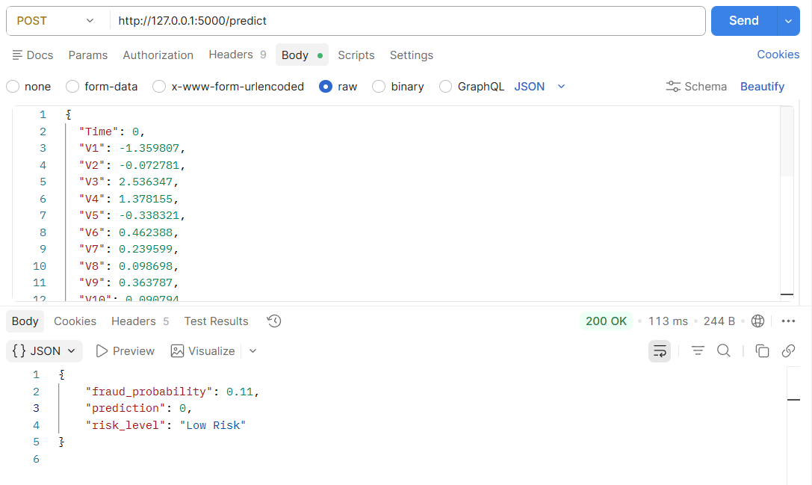Fig
Interpretation of Result-
- The image shows a successful API request sent to the fraud detection model using the POST method at http://127.0.0.1:5000/predict.
- Transaction details such as Time, V1, V2, V3, etc., were provided in JSON format as input features to the machine learning model.
- The API returned a 200 OK status, indicating that the request was processed successfully without any server error.
- The model generated a fraud probability of 0.11, which means there is only an 11% chance that the transaction is fraudulent.
- The prediction result is 0, where:
0 represents a normal/non-fraudulent transaction
1 would represent a fraudulent transaction
- Based on the predicted probability, the system classified the transaction under “Low Risk” category.
- The response demonstrates that the deployed machine learning model is capable of analyzing transaction data in real time and producing fraud risk predictions through an API.
- This output confirms that the fraud detection system is functioning correctly.

CHAPTER V
CONCLUSION AND SUGGESTIONS
7.1 Introduction
This chapter contains the general conclusions from the development of the AI-Based Real-Time Payment Fraud Detection and Risk Scoring System. The chapter describes the results achieved as part of the implementation of this project and also provides information about the effectiveness of machine learning methods in detecting digital payment fraud.
Finally, it contains ideas for improvement, system limitations, and future prospects in the field of AI-based fraud detection systems.
7.2 Overview of the Results of the Proposed Project
The fraud detection system suggested was able to analyze the transactions conducted via digital payment systems and detect any signs of fraud using machine learning algorithms.
The Random Forest algorithm proved effective at predicting possible cases of fraud using learning patterns.
The system was capable of:
- Identifying fraudulent transactions in real-time mode
- Producing scores on the likelihood of fraud occurring
- Classifying transactions into different risk levels
- Automated fraud monitoring
- Processing transaction data
The use of the Flask API allowed seamless integration of the fraud detection system with the transaction systems to process predictions in real-time mode.
Data preprocessing methods provided better results concerning data quality and machine learning models' efficiency.
EDA was applied to reveal valuable information on transaction patterns, the prevalence of fraud, its distribution, correlation, and anomalies.
Model evaluation metrics such as accuracy, precision, recall, and F1-scores confirmed efficient and reliable classification.
Confusion matrix analysis indicated that the system could distinguish fraudulent transactions from normal transactions without making mistakes.
Dynamic risk scores helped to increase the ability to make decisions by assigning transactions to one of three categories – low-risk, medium-risk, and high-risk transactions.
7.4 Recommendations for Enhancement
While the proposed system exhibited good fraud detection capability, there are various suggestions that can be made regarding future versions of the project.
Recommendations include:
- Utilization of deep learning algorithms to improve fraud detection capability
- Use of blockchain for improved transaction security
- Deployment on cloud to allow for massive transaction processing
- Increase in size of training transaction data sets
- Enhancement of scalability and performance in real time
- Incorporation of biometric methods of authentication
- Use of more efficient methods of anomaly detection
7.5 Future Scope
The future scope of an AI-based fraud detection system is very wide owing to the widespread use of digital payment methods and online financial operations.
Future advancements might be seen in the form of:
Real-time integration with banking and payment gateway networks
- AI-based behavioral transaction analysis
- Fraud prediction system using deep learning
- Integration of cloud computing in fraud detection platform
- Big data transaction monitoring
- A combination of machine learning and deep learning framework
- Fraud prevention system in mobile wallets
- Cross-platform fraud detection system
- Secure blockchain technology for transaction verification
- Self-learning intelligent fraud detection system
The use of advanced AI technology can greatly enhance the capabilities of a fraud detection system in identifying cyber attacks and other fraudulent activities.
The system designed in this study offers a solid ground for further research in intelligent digital payment security systems.
The AI-Based Real-Time Payment Fraud Detection and Risk Scoring System was developed to
tackle these challenges by using machine learning algorithms for fraud detection and transaction analysis.
7.6 Limitations of the System
Despite its efficiency, there are some limitations to the proposed fraud detection system.
The limitations include:
The dependence of fraud detection on historical transactions data sets
- A significant amount of computational power may be required to work with vast transaction databases.
- The real-time performance of fraud predictions depends on the speed of servers and network connectivity.
- At present, the system concentrates only on structured transaction data and ignores unstructured data types.
- Occasionally, false predictions can disrupt the process of authentic customer transactions.
- In certain cases, false negative predictions will result in undetected fraudulent transactions.
- The proposed approach was developed and implemented within the scope of a project
7.7 Conclusion for the Final Project
An AI-driven fraud detection model has been created to analyze digital payment transactions to detect any fraud activity in real time.
This project shows how artificial intelligence can be applied in practice to enhance digital payment security and fraud prevention frameworks.
The proposed solution is one step towards establishing a more secure, intelligent, and efficient digital environment for financial transactions.
The developed system successfully performs preprocessing, feature scaling, fraud classification, and transaction risk analysis using machine learning techniques.
The project demonstrates the effectiveness of machine learning algorithms in identifying suspicious financial transaction patterns with improved accuracy and efficiency.
Data visualization and exploratory data analysis helped in understanding transaction behavior
The proposed model consists of the following components:
- Fraud detection using machine learning algorithms
- Scoring based on risk assessment
- Real-time API integration
- Transaction monitoring
- Fraud prediction

BIBLIOGRAPHY
Books References
- Hands-On Machine Learning with Scikit-Learn, Keras, and TensorFlow,O’Reilly Media- This book was referred to for understanding ML Algorithms, preprocessing techniques, and model evaluation methods. It provided practical implementation guidance for fraud detection using Python libraries.
- Python for Data Analysis, O’Reilly Media, 2022-The book was used to understand data
manipulation, cleaning, and analysis using Pandas and NumPy. It helped in handling and preprocessing transaction datasets efficiently.
- Introduction to Machine Learning with Python, O’Reilly Media, 2016-This reference provided knowledge about supervised learning algorithms and machine learning workflows. It also assisted in implementing classification models for fraud detection.
Software & Tools References
- Python –It was used as the primary programming language for implementing the fraud detection system.
- Scikit-learn –It was used to implement classification algorithms, preprocessing methods, and evaluation metrics.
- Pandas –It was used for loading, cleaning, filtering, and transforming transaction data. It improved the efficiency of data preprocessing operations.
- NumPy –It was utilized for performing mathematical and numerical computations on transaction datasets. It supported efficient array handling and feature processing.
- Matplotlib – It was used for generating graphs and visualizations. It was used to create performance graphs, risk score analysis, ROC curves, and confusion matrices.
- Visual Studio Code is used as the primary development environment for coding and debugging. It improved productivity through extensions and integrated development tools.
- Postman- Used for testing REST API endpoints and request validation. It was used to test API requests, responses, and validation scenarios for the fraud detection system. It enabled efficient testing of real-time transaction prediction APIs.
Dataset References
- Kaggle Credit Card Fraud Detection Dataset –The dataset provided real-world financial transaction records for fraud analysis and model training. It was used to evaluate the effectiveness of the proposed fraud detection system.
Documentation & Website References
- Official Python Documentation-The official Python documentation was referred to for understanding syntax, built-in functions, and programming concepts. It assisted in implementing efficient Python code during development.
- Scikit-learn Documentation-The documentation provided detailed information about machine learning algorithms and preprocessing methods. It was used to implement model training and evaluation functionalities.
- Pandas Documentation-Pandas documentation was referred to for handling dataframes, missing values, and dataset transformations. It supported efficient preprocessing and data analysis implementation.
- Matplotlib Documentation-The documentation was used to generate graphs and performance visualizations for the fraud detection system. It assisted in presenting analytical results effectively.
- Flask Documentation- Flask documentation was referred to for building REST APIs and integrating machine learning models. It supported the implementation of real-time fraud prediction services.
- Postman Official Website-The official Postman website was used for understanding API testing workflows and request handling techniques. It supported API validation and endpoint testing activities.
- Git Documentation-Git documentation was referred to for version control operations such as commits, branching, merging, and repository management. It assisted in maintaining project versions efficiently.
Machine Learning Documentation References
- Random Forest Classifier Documentation-This documentation was referred to for understanding ensemble learning and Random Forest model implementation. It supported fraud classification and prediction model development.
- Standard Scaler Documentation-The documentation was referred to for feature scaling and normalization techniques. It improved consistency among transaction features during preprocessing.
- Train-Test Split Documentation-This documentation helped in dividing datasets into training and testing subsets for machine learning evaluation.
- Confusion Matrix Documentation-The confusion matrix documentation was used for evaluating fraud prediction accuracy and classification performance.

