Outputs:
- challenge1_mountain_peak.py
Output:
- challenge2_balanced_scales.py
Output:
- challenge3_mirror_quest.py
Output:
- challenge4_royal_treasury.py
Output:
- challenge5_master_scheduler.py
Output:
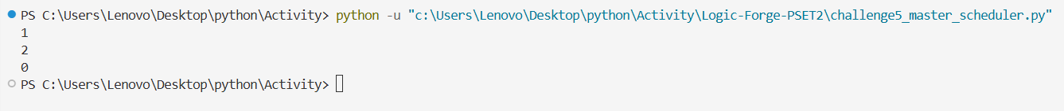
- challenge6_high_stakes_freelancer.py
Output:
- challenge7_koko_banana_buffet.py
Output:
