Outputs:
- challenge_01_smart_city_temperature_alerts.py
Output:
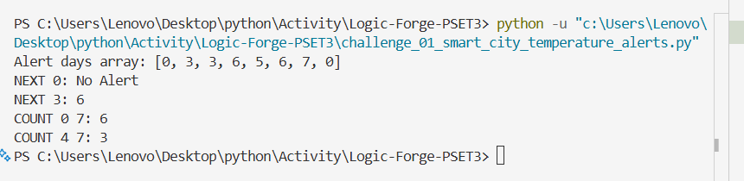
- challenge_02_emergency_evacuation_boats.py
Output:
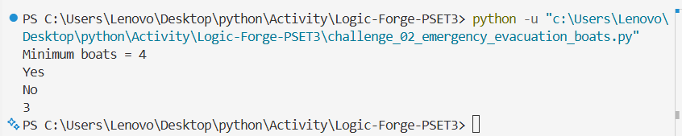
- challenge_03_broadcast_network_feed.py
Output:
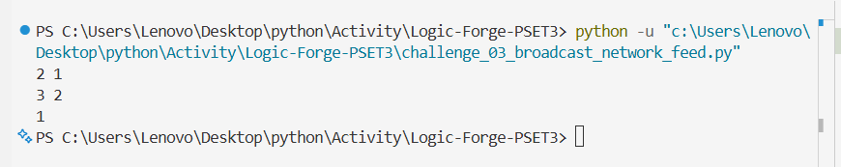
- challenge_04_scrambled_keyword_detection.py
Output:
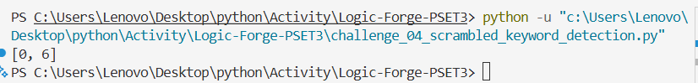
- challenge_05_longest_mirrored_phrase.py
Output:
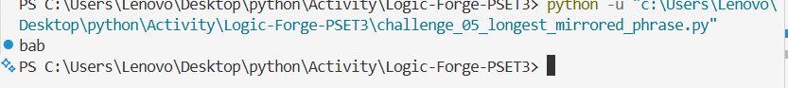
- challenge_06_suspicious_device_detection.py
Output:
