IMPLEMENTATION AND PILOT RESULTS (ADDENDUM TO THE RESEARCH PROPOSAL)
SecTwin: A Verifier-Grounded Reflection Agent and Security Digital Twin for O-RAN Compliance
Project: Pinnacle Research Project (P32), Agentic AI for O-RAN in 6G. SSN College of Engineering, Department of Information Technology.
Document generated 2026-10-19 from the experiment logs in results/. Every number in a table is computed from logged runs.

1. Summary
- The narrative summary is written after all experiment phases finish; see the tables below for current numbers.
Status labels used in this addendum follow the proposal: [PUBLISHED] for cited sources, [PROPOSED] for design choices, [HYPOTHESIS] for expectations, [UNVERIFIED] for unconfirmed material. Results below are pilot scale and simulated where stated.

2. What was built
Component | What it does | Where
Config layer | libconfig parser for OAI-style gNB files, security view, profile-aware oracle (ground truth), line-level patcher | sectwin/conf
Knowledge base | 34 clauses (TS 33.501 and O-RAN WG11 paraphrases, synthetic Operator Security Baseline, distractors) with SHA-256 provenance manifest | sectwin/kb
Dataset | 62 labelled configurations: clean, vendor default, single, multiple, decoy, context pair, noise; 45 test / 17 dev | sectwin/dataset, data/
Retrieval | Clause-aware hybrid BM25 + nomic-embed-text with reciprocal-rank fusion | sectwin/retrieval
Agents | Assessor, query generator, A0 scanner, verifier C1-C5, LLM critic, arms A0-A7 and A5x; local Qwen2.5-7B and Llama-3.1-8B via Ollama | sectwin/agents
SMT repair | Clause compiler + z3 Optimize: minimal configuration change that satisfies the cited clauses | sectwin/repair
Network twin | Hexagonal multi-site 5G network, TR 38.901 UMa radio, handover, traffic, throughput/latency, AS security negotiation from each gNB's config, attackers, config drift, SMO loop | sectwin/twin
RL scheduler | PPO policy deciding when to push verified fixes (exposure vs. disruption) | sectwin/rl
Dashboard | Network topology, assurance, compliance console, audit trail, experiments, inventory | ui/, sectwin/api
Table 1. Components. All software runs locally on one laptop GPU (RTX 4060, 8 GB).

3. Method

3.1 Ground truth and deployment profiles
[PROPOSED] A profile has two dimensions: whether unauthenticated emergency sessions are a regulatory requirement (from TS 33.501), and the baseline, either standards minimum or a stricter, explicitly synthetic Operator Security Baseline (OSB-1 to OSB-5). The same file can therefore be compliant under one profile and non-compliant under another; eight context-pair items test exactly this. drb_integrity = "no" is compliant under every profile because user-plane integrity is optional to use; it is the main decoy (gap G4 in the proposal).
The oracle that labels the dataset is never available to an arm. The verifier's re-scan in C5 uses the naive A0 scanner, and A7's repair compiles only the clauses an arm itself cited.

3.2 Reflection Agent
Check | Deterministic test (no LLM)
C1 schema | Output validates against the Assessment schema
C2 grounding | Flagged parameter exists with the stated value and line
C3 citation | Clause was retrieved, its hash matches the trusted manifest, and the quote is in the clause text (fuzzy >= 90)
C4 strength / applicability | A violation needs a shall / shall-not usage sentence about this parameter; rejects 'shall support' capability sentences, conditional 'when ... is used' requirements for switched-off features, algorithm sentences cited against on/off switches, and requirements already met by the current value
C5 fix | Legal value, file still parses, only flagged lines change, literal re-scan finds nothing new
LLM critic | Looks for missed violations and scope errors; each claim must itself pass C3 and C4 before it is fed back
Table 2. Two-stage Reflection Agent. Findings still unverified after three rounds are dropped and the case is escalated.

3.3 Arms and metrics
Arm | Configuration
A0 | Rule-based literal scanner
A1 | LLM only
A2 | LLM + RAG
A3 | Agentic RAG (single agent)
A4 | A3 + LLM-only reflection
A5 | A3 + verifier-grounded reflection
A6 | A3 + verifier only
A7 | A5 + SMT minimal repair
A5x | A5 with cross-family critic
Metrics: configuration-level accuracy, exact match of the violation set, parameter-level precision / recall / F1, citation correctness (clause exists, quote found, and the clause is one of the oracle's governing clauses for that parameter), fix correctness on non-compliant files (all violations resolved, none introduced, every UE capability class can still attach), unnecessary-change rate on compliant files, reflection flips (wrong-to-right vs right-to-wrong per parameter), latency and tokens. Uncertainty: 95% bootstrap intervals over configurations and exact McNemar tests on paired per-configuration outcomes.

4. Results: compliance agents

4.1 E1: detection, citation and fix quality
Arm | Runs | Cfg acc. | Exact | Prec. | Rec. | F1 [95% CI] | Cite ok | Fix ok | Unneeded | Flips W>R/R>W | s
A0 | 8 | 37.5% | 12.5% | 0.20 | 1.00 | 0.33 [0.00, 0.58] | 6.7% | 100.0% | 83.3% | - | 0
A1 | 8 | 25.0% | 0.0% | 0.11 | 1.00 | 0.20 [0.00, 0.41] | 0.0% | 50.0% | 100.0% | - | 60
A2 | 8 | 25.0% | 0.0% | 0.12 | 1.00 | 0.21 [0.00, 0.41] | 3.8% | 0.0% | 100.0% | - | 58
A3 | 8 | 25.0% | 0.0% | 0.12 | 1.00 | 0.21 [0.00, 0.42] | 8.0% | 0.0% | 100.0% | - | 66
A4 | 6 | 50.0% | 16.7% | 0.19 | 1.00 | 0.32 [0.00, 0.56] | 12.5% | 0.0% | 75.0% | 5/3 | 126
A5 | 6 | 66.7% | 33.3% | 0.25 | 0.67 | 0.36 [0.00, 0.67] | 25.0% | 0.0% | 50.0% | 9/1 | 93
A6 | 6 | 50.0% | 16.7% | 0.22 | 0.67 | 0.33 [0.00, 0.62] | 22.2% | 0.0% | 75.0% | 8/1 | 52
A7 | 6 | 66.7% | 33.3% | 0.25 | 0.67 | 0.36 [0.00, 0.67] | 25.0% | 50.0% | 50.0% | 9/1 | 93
Table 3. E1 on the held-out test split. Fix ok is measured on non-compliant files, Unneeded on compliant files.
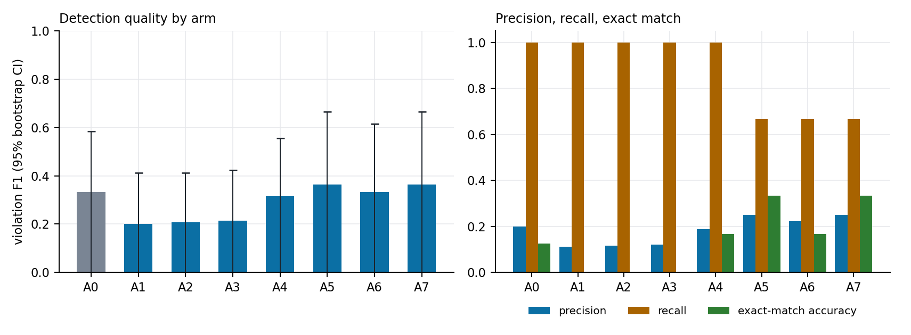
Figure 1. Detection quality by arm.
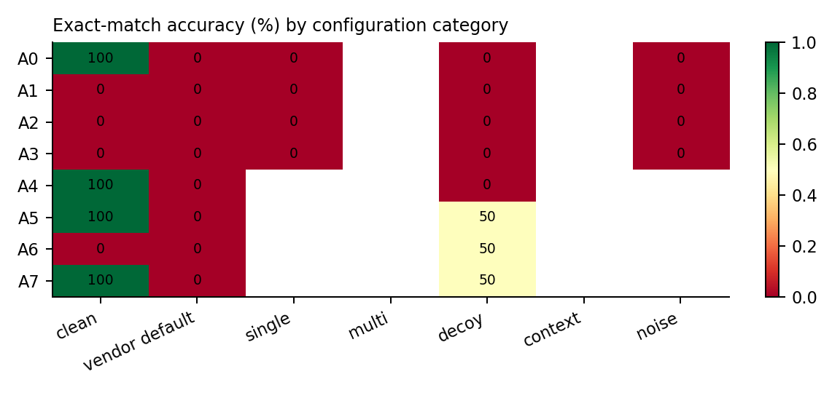
Figure 2. Exact-match accuracy by configuration category.
Comparison | Only first correct | Only second correct | p (exact McNemar)
A3 vs A1 | 0 | 0 | 1
A3 vs A2 | 0 | 0 | 1
A4 vs A3 | 1 | 0 | 1
A5 vs A3 | 2 | 0 | 0.5
A5 vs A4 | 1 | 0 | 1
A6 vs A3 | 1 | 0 | 1
A5 vs A6 | 1 | 0 | 1
A0 vs A3 | 1 | 0 | 1
A0 vs A5 | 0 | 1 | 1
Table 4. Paired tests on per-configuration exact-match correctness.

5. Network digital twin
[PROPOSED] The twin answers the question the proposal could not: what a compliance error costs in a running network. Each gNB carries a full configuration file; at every attach and handover the gNB selects the first algorithm in its configured list that the UE supports (TS 33.501 6.7.3). A wrong configuration therefore produces null-ciphered user traffic, RRC signalling on NIA0 (spoofable), or UEs that cannot attach.
Aspect | Model
Layout | Hexagonal tri-sector macro grid, configurable sites (7/19/37) and inter-site distance; 3.5 GHz, 100 MHz, 49 dBm per sector
Propagation | TR 38.901 UMa path loss (LOS-probability weighted), 6 dB shadowing, 50 m decorrelation, 0.5 inter-site correlation, 3GPP sector pattern
Link and scheduling | 0.75 x Shannon capped at 7.4 b/s/Hz, rank 2 above 12 dB, 14% overhead; water-filling time-share scheduler per cell
Mobility | Static, pedestrian (0.8-1.8 m/s), vehicular (8-17 m/s) random waypoint; A3 handover (4 dB, L3 filter, TTT); T310-style RLF
Traffic | Video, web, VoIP, IoT, bulk, fixed wireless access with a diurnal busy-hour profile; TCP-limited queues
Security | Algorithm selection from each gNB's file at attach and handover; PDCP MAC-I overhead when UP integrity is on; IPsec processing on N3
Threats | Passive sniffer, RRC injector (succeeds only against NIA0), backhaul tap (N3 without IPsec), O1 man-in-the-middle pushing malicious configs over plaintext O1
SMO loop | O1 change notification, one assessment at a time on the GPU, human approval delay, remediation policy, outage on push, 24 h manual audit
Table 7. Twin model summary (system-level simulator, not a protocol stack).

5.1 E5: cost of security features
Setting | Goodput ratio | VoIP header overhead | Latency p50 / p95 / p99 (ms)
Baseline (UP integrity off, N3 IPsec) | 99.49% | 6.54% | 5.9 / 65.9 / 286.48
UP integrity on | 99.20% | 9.91% | 5.95 / 65.95 / 286.53
N3 IPsec off | 99.49% | 6.54% | 5.8 / 65.8 / 286.38
VoIP-heavy, UP integrity off | 99.46% | 6.54% | 5.9 / 5.9 / 65.9
VoIP-heavy, UP integrity on | 99.15% | 9.91% | 5.95 / 5.95 / 65.95
Table 9. Busy hour, 19 sites, 1500 UEs, 20 simulated minutes per setting.

5.3 E6: learning when to remediate
Policy | Exposure UE-h | Disruption UE-h | Pushes | Reward (mean ± sd)
immediate | 0.4 | 6.75 | 27.0 | -169.3 ± 40.9
maintenance window | 3162.2 | 1.76 | 13.8 | -3206.4 ± 1659.5
severity threshold | 26.5 | 4.92 | 23.7 | -149.6 ± 39.4
PPO (learned) | 16.3 | 4.87 | 21.6 | -138.0 ± 38.5
PPO compared with | Mean reward gain | 95% CI | PPO better in
immediate | 31.3 | [29.5, 33.1] | 98%
maintenance window | 3068.3 | [2854.5, 3303.0] | 100%
severity threshold | 11.5 | [8.3, 14.9] | 74%
Table 11. 200 paired 24-hour episodes. Remediation-scheduling environment calibrated from the twin (users per site, diurnal load, outage durations). Severity weights are a stated modelling choice. Paired evaluation on 200 identical episodes; reward gain CI by bootstrap.
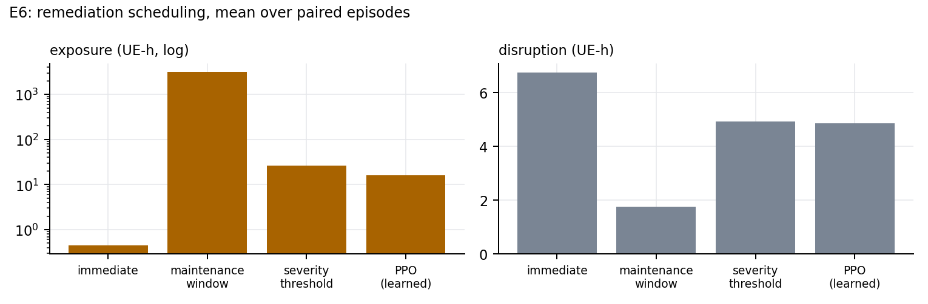
Figure 6. Exposure and disruption by remediation policy.

6. Limitations and threats to validity
- Clause texts for TS 33.501 and O-RAN WG11 are paraphrases [UNVERIFIED]; the C3 quote check runs on whatever text is in the knowledge base, so replacing it with the official sentences needs no code change, but all citation results must be re-run afterwards.
- The dataset is synthetic and oracle-labelled, with one annotator (the oracle). The proposal's two-annotator protocol has not been carried out.
- Pilot scale: 45 test configurations and one to two repeats per arm. Intervals are wide; differences whose interval includes zero are reported as unresolved.
- The local 7B model is much smaller than the models in the closest published work; absolute accuracy is not comparable, only relative effects between arms.
- The twin is a system-level simulator; absolute KPIs are indicative. Comparisons between arms and policies on identical seeds are the meaningful output.
- The interface_security block and the Operator Security Baseline are project constructs, not part of OAI or any standard.
- The RL environment's severity weights are a modelling choice; the learned policy is valid for this environment only.

7. Reproducing the results
python -m sectwin.dataset.generate
bash scripts/run_shard.sh 0/2 and bash scripts/run_shard.sh 1/2 (E1-E3, resumable)
python -m sectwin.eval.twin_experiments e5 ; python -m sectwin.rl.train 400000 ; python -m sectwin.eval.twin_experiments e4 6
python -m sectwin.eval.analyze ; python scripts/make_figures.py ; node scripts/report/build_report.js
python -m uvicorn sectwin.api.server:app --port 8600 (dashboard at http://localhost:8600)

