RESEARCH PROPOSAL (DRAFT FOR FACULTY REVIEW)
Reflection Agent for Agentic AI-Based Security Compliance in O-RAN
A controlled study of whether a Reflection Agent adds value over ordinary RAG and a single-agent compliance system
Project: Pinnacle Research Project (P32), Agentic AI for O-RAN in 6G
Institution: SSN College of Engineering, Department of Information Technology
Investigators: Muskan Kumari V, Raghul Krishna V
Guides: Dr. G. Sornavalli, Dr. E. Suganya
Date: 19 October 2026

Contents
How to read this document
Executive summary
1. Introduction and literature review
2. O-RAN architecture and placement of the Reflection Agent
3. Research gap
4. Proposed solution: the Reflection Agent
5. Implementation methodology
6. Architecture diagrams
7. Simulation and demonstration
8. Expected outputs and evaluation
9. Scope and future extensions
10. Conclusion and references
Appendix A. Corrections to earlier project notes
Appendix B. Starter clause list for the knowledge base

How to read this document
Every claim in this proposal carries one of four labels, so that evaluators can tell evidence from design from expectation. The labels appear at the start of the relevant statements.
Label | Meaning
[PUBLISHED] | Reported in a source that was opened and read for this proposal (paper, specification clause, or documentation). The source is cited.
[PROPOSED] | A design choice made by this project. It is our decision, not a finding.
[HYPOTHESIS] | An expected outcome or suspected issue that must be tested. It may turn out to be wrong, and a refuted hypothesis is an acceptable result.
[UNVERIFIED] | Could not be confirmed. It comes from secondary material, project notes, or the identifier of a source that was not opened.

Limits of the evidence base
The compliance paper by Chatzimiltis et al. [1] (arXiv v2, 14 April 2026, with its supplementary prompts) was read in full. The reflection literature [5]-[8] was checked at abstract and key-finding level. TS 33.501 clauses were read through a third-party mirror and must be re-checked against the official 3GPP text before any label is frozen. This was a targeted search, not a systematic review, so statements such as “not reported” or “to our knowledge” mean “not found in the sources read”, not “does not exist”.

Executive summary
Open RAN splits the radio access network into functions from different vendors and adds software controllers (RICs) that apply configuration changes automatically. Every gNB configuration file therefore carries security-relevant parameters (ciphering and integrity algorithms, for example) that must agree with 3GPP and O-RAN security requirements. Checking this by hand does not scale, so recent work asks whether LLM agents with retrieval-augmented generation (RAG) can do it.
[PUBLISHED] The closest published work [1] builds such a system, including a Reflection Agent that critiques the assessor’s output, and evaluates it as an initial case study on four OAI configuration files. Its headline result concerns retrieval design: plain RAG scored below no RAG, while RAG with an LLM-generated query step scored highest. The Reflection Agent’s own contribution is never reported separately.
[PROPOSED] This project therefore does not assume that a Reflection Agent helps. Its central question is stated below, and the answer may be “no”.
Central research question
Does a Reflection Agent improve security-compliance assessment of O-RAN gNB configuration files beyond (a) a rule-based checker, (b) ordinary RAG, and (c) a single-agent agentic-RAG assessor? If it does, does the gain come from the LLM critic itself, or from deterministic verification of the evidence (parameter exists, quote appears in the cited clause, “shall” versus “may” strength, fix is valid)?

[PROPOSED] The proposed design anchors reflection to checks performed by code, because the general literature reports that LLMs correcting themselves without external feedback can fail or even get worse [7], and that tool-based external feedback is what makes critique reliable [8]. A controlled comparison of seven arms (A0 to A6, Section 5.7) isolates each component.
[PROPOSED] A network simulator is not needed to answer this question, because the object under test is a static configuration file plus standards text. The recommended demonstration is a software pipeline with a dashboard (Section 7), with an optional OAI rfsim demonstration as a stretch goal. We make no claim that reflection is novel, and no claim about 6G radio behaviour: configurations and specifications are 5G O-RAN artifacts used as a proxy for the 6G control-plane vision.

1. Introduction and literature review

1.1 Background and motivation
O-RAN disaggregates the gNB into a central unit (CU), distributed unit (DU) and radio unit (RU) and adds the Service Management and Orchestration (SMO) framework with a Non-RT RIC and a Near-RT RIC. This increases programmability, but it also increases the number of configuration artifacts, interfaces and vendors that must remain consistent with security requirements. In OAI, for instance, a security block in the gNB configuration selects the ciphering and integrity algorithms and the user-plane protection switches [14].
Security compliance checking has two parts: reading long, multimodal standards (3GPP TS 33.501, O-RAN WG11 specifications) and applying them to a concrete configuration. The first part is where language models and retrieval could help. The second part is where mistakes are costly, because a wrongly reported or wrongly “fixed” parameter can weaken a deployment.

1.2 What existing researchers implemented
Work | Approach | Reported results | Limitations (authors’ or ours)
Chatzimiltis et al. [1]  Agentic AI for 6G: RAN security compliance  (arXiv 2512.12400, v2 Apr 2026) | [PUBLISHED] LLM agents with RAG assess CU configuration files against O-RAN and 3GPP standards. Compliance Assessment Agent, Reflection Agent and a RAG Query Generator, built in n8n. Knowledge base of about 1,000 pages split into 6,400 chunks of 1,000 characters; OpenAI 1536-d embeddings, cosine similarity, reranker. Models: GPT-4.1 Mini, Gemini 2.5 Flash, Mistral Large. | [PUBLISHED] 4 OAI configs, each run 3 times. Accuracy (No-RAG / RAG / Agentic RAG): GPT-4.1 Mini 0.58 / 0.25 / 0.75; Gemini 2.5 Flash 0.67 / 0.17 / 0.83; Mistral Large 0.50 / 0.33 / 0.67. BERTScore above 0.85 everywhere. Response time 31 to 126 s. | [PUBLISHED] Authors state it is an initial case study, report citation-level hallucinations, and call for standardized benchmarks. [PUBLISHED] Static CU configs only. Reflection effect not reported separately; accuracy definition and ground truth not described in the text read.
Sharma et al. [2]  MobiLLM  (arXiv 2509.21634) | [PUBLISHED] Multi-agent LLM framework for closed-loop threat mitigation in O-RAN: Threat Analysis, Threat Classification (RAG over MITRE FiGHT and 3GPP specs) and Threat Response agents, with safety guardrails. | [UNVERIFIED] Quantitative results were not read for this proposal. | Security response rather than configuration compliance. Included to show that RAG plus agents plus guardrails is an established pattern in O-RAN security.
Chatzistefanidis et al. [3] MX-AI;  Elkael et al. [4] AgentRAN | [UNVERIFIED] Agentic observability and control (MX-AI) and hierarchical multi-agent RAN control (AgentRAN), described in the project’s earlier research notes and in the reference list of [1]. | [UNVERIFIED] Not re-verified; no numbers quoted here. | Neither targets configuration security compliance. Cited for context only.
Telecom RAG benchmarks  TeleEmbedBench [18] | [PUBLISHED] Embedding benchmark for telecom RAG over O-RAN, 3GPP and srsRAN corpora; 9,000 question-chunk pairs at 512, 1024 and 2048 tokens. | [PUBLISHED] Reports that adding instructions to embedding prompts weakened retrieval, especially for 3GPP and O-RAN text. | Retrieval quality, not compliance. Relevant because retrieval quality can decide the outcome (see [1], plain RAG below no RAG).

1.3 What the reflection literature says
“Reflection” is a general technique, not a telecom invention. Four works frame the question this project asks:
- Self-Refine [5] [PUBLISHED]: one LLM generates, critiques and refines its own output iteratively, with no training. Across seven tasks with GPT-3.5 and GPT-4 the authors report about 20% absolute average improvement over one-step generation.
- Reflexion [6] [PUBLISHED]: agents store verbal reflections on task feedback in memory and improve over later trials; the authors report 91% pass@1 on HumanEval versus 80% for GPT-4. The feedback can come from external sources, such as unit tests.
- Huang et al. [7] [PUBLISHED]: when models try to correct themselves without external feedback, they struggle and sometimes perform worse after the attempt. The paper argues that earlier gains often relied on oracle labels.
- CRITIC [8] [PUBLISHED]: the model verifies and revises its output by calling external tools, and the authors stress that external feedback is crucial for reliable self-improvement.
The consistent lesson is that reflection helps when the critique is anchored to a checkable signal, and may not help (or may hurt) when it is only the same model re-reading its own text. [HYPOTHESIS] A compliance task is a good test-bed because it has checkable signals: the clause text can be searched, the configuration can be parsed, and a corrected file can be re-scanned.

1.4 Critical comparison
- [PUBLISHED] The only direct precedent for LLM-agent compliance assessment in O-RAN that we found [1] is explicitly an initial case study. It shows the pipeline is feasible, not that each component is necessary.
- [PUBLISHED] Its strongest finding is about retrieval: targeted queries helped, untargeted retrieval hurt. Any reflection result must therefore be measured on top of the best retrieval setting, or it will be confounded by retrieval quality.
- [PUBLISHED] Reflection in [1] is LLM-to-LLM. The published Reflection Agent prompt asks the model to check scope, citations and missed violations, but does not describe external tools, such as a parser or a quote check.
- [HYPOTHESIS] Reflection by an LLM from the same model family can share the assessor’s blind spots. Section 3.2 gives one concrete example from the supplementary material of [1] where this may have happened.

2. O-RAN architecture and placement of the Reflection Agent

2.1 Relevant layers and interfaces
The table summarizes the O-RAN architecture elements that matter for this project. It matches the architecture described in the project’s Review 1 slides and in [1]; exact normative wording should be checked in the O-RAN architecture specifications [19]. [UNVERIFIED]
Element | Role | Time scale | Relevance here
SMO | Service Management and Orchestration. Hosts the Non-RT RIC and management functions; connects to the RAN over O1 and to cloud infrastructure over O2. | Seconds and longer | Natural home for non-real-time analysis, policy and configuration management.
Non-RT RIC | Hosts rApps; sends policies and ML guidance to the Near-RT RIC over A1. | Above 1 s | Where slow, reasoning-heavy applications belong.
Near-RT RIC | Hosts xApps that control RAN behaviour through E2. | 10 ms to 1 s | Too fast for multi-second LLM calls.
O-CU / O-DU / O-RU | gNB split: CU carries RRC and PDCP, DU carries MAC and PHY, RU is the radio. | Sub-ms to seconds | CU holds the security configuration under assessment (cipher and integrity selection).
O1 interface | Management interface for fault, configuration, accounting, performance and security (FCAPS). | Management plane | Path for reading configurations and, after approval, writing corrections.

2.2 Where should the Reflection Agent operate?
[PROPOSED] The Reflection Agent, together with the Assessor it supervises, should run as a compliance service in the SMO / Non-RT RIC layer. It reads configuration artifacts over O1, evaluates them against standards text, and proposes corrections that are applied only after human approval. It should not run in the Near-RT RIC or in the CU/DU. Figure 1 (Section 6) shows this placement. The reasons are:
- Timing. [PUBLISHED] The prototype in [1] needed roughly 31 to 126 seconds per assessment depending on model and retrieval setting (Table II of [1]). That is far outside the 10 ms to 1 s Near-RT loop and fits the non-real-time scale.
- Nature of the data. The inputs are configuration files and standards documents, not radio measurements. Nothing in the task requires sub-second reaction.
- Interface fit. Configuration reading and change belong to the management plane (O1), which is reached from the SMO.
- Precedent. [PUBLISHED] [1] deploys its compliance module in the SMO layer and realizes enforcement through O1.
- Safety. A fault in a compliance agent should not be able to affect real-time radio behaviour. A non-real-time placement with a human approval gate bounds the blast radius.
- Compute. LLM inference, a vector database and a dashboard fit a cloud or SMO environment, not a RAN node.
Caveats
[UNVERIFIED] Strictly, rApps run in the Non-RT RIC while configuration management is an SMO function. We therefore call the design a “SMO / Non-RT RIC-hosted compliance service”. Whether it should be packaged as a standard-conformant rApp is not claimed and would need to be checked against the O-RAN architecture and rApp specifications.
[PROPOSED] In the demonstration there is no live O1 connection. Configuration files are read from disk and corrections are written to disk. The O1 path is architectural context, not an implemented interface.

3. Research gap
This section separates what published sources establish from what this project proposes as gaps. Each proposed gap states its evidence and how confident we are.

3.1 Established findings used as evidence
ID | Finding | Source
E1 | [PUBLISHED] A framework with a Compliance Assessment Agent and a Reflection Agent was prototyped and tested on 4 OAI CU configuration files, each evaluated 3 times, with 3 LLMs. | [1] Section III-B
E2 | [PUBLISHED] Accuracy rose with agent-generated retrieval queries (0.75, 0.83, 0.67) and fell with plain RAG (0.25, 0.17, 0.33) relative to no RAG (0.58, 0.67, 0.50), for GPT-4.1 Mini, Gemini 2.5 Flash and Mistral Large respectively. | [1] Table II
E3 | [PUBLISHED] Agentic RAG latency was 54.12, 109.70 and 126.41 s versus 31.10, 37.95 and 55.84 s for no RAG (about +74%, +189%, +126%). | [1] Table II
E4 | [PUBLISHED] The authors report cases where the right non-compliant portion is found but linked to the wrong specification identifier, and suggest post-hoc verification. | [1] Section III-B
E5 | [PUBLISHED] The authors list standardized evaluation frameworks, agent security (for example, poisoned RAG documents) and multi-vendor configuration formats as open issues. | [1] Section IV
E6 | [PUBLISHED] Without external feedback, LLM self-correction can fail or degrade; tool-based external feedback improves reliability. | [7], [8]

3.2 Proposed gaps and the evidence for each
ID | Gap | Evidence | Status
G1 | The contribution of the Reflection Agent is not isolated. | Table II compares three retrieval settings only. Figure 3 of [1] includes the Reflection Agent in the workflow, but the text does not say whether reflection was active in each arm, and no reflection-on versus reflection-off result is reported. | [PUBLISHED] observation from [1]. Later or unpublished work may exist.
G2 | Very small sample and no variance. | 4 files times 3 runs gives 12 runs per cell. The reported accuracies (0.58, 0.67, 0.50, 0.25, 0.17, 0.33, 0.75, 0.83) are exactly what 7, 8, 6, 3, 2, 4, 9 and 10 correct out of 12 would give. No confidence intervals are reported, and the accuracy definition and ground-truth construction are not described in the text read. | [PUBLISHED] numbers; the k/12 reading is our arithmetic inference.
G3 | Citation correctness is acknowledged but unmeasured. | E4 states the problem. The three reported metrics (accuracy, BERTScore, time) do not measure whether a cited clause actually supports a finding. | [PUBLISHED] for E4; [HYPOTHESIS] that this matters in practice.
G4 | Ground truth is context-dependent, and the example may contain a questionable finding that reflection approved. | In the supplementary example of [1], drb_integrity = "no" is reported as a violation, and the Reflection Agent returned no issues. Our reading of TS 33.501 clause 5.3.3 (via a mirror) is that user-plane integrity is optional to use, while NIA0 must not be used for it and must be disabled in the gNB when unauthenticated emergency sessions are not a regulatory requirement. Annex D.1 also states NIA0 shall not be used for data radio bearers. OAI’s own sample configurations ship with the same values for lab use [14]. | [HYPOTHESIS] Needs a human check against the official specification. If confirmed, it shows that labels need a deployment profile, and that LLM-only reflection missed an error.
G5 | No non-LLM baseline is reported. | Several example violations (nea0, nia0) are literal values that a short script can find. Whether the LLM adds value beyond string matching is not quantified in [1]. | [PUBLISHED] not reported; [HYPOTHESIS] that simple cases need no LLM. Tested by arm A0.
G6 | Verifier-grounded reflection is untested for compliance. | The Reflection Agent prompt in [1] reviews text; it describes no parser, no quote check and no strength check. CRITIC [8] and Huang et al. [7] suggest external grounding is what makes reflection work. | [HYPOTHESIS] To our knowledge, from a limited search.
G7 | Scope limits stated by the authors. | Static CU configs only; runtime evidence, other vendors’ formats (YAML, JSON) and scale are future work (E5). | [PUBLISHED]. Not addressed in version 1 of this project.

3.3 What this project does not claim
- It does not claim that reflection, RAG or agent-based compliance checking is new. Each exists in prior work.
- It does not claim that no one has evaluated reflection for compliance; it claims only that we did not find such an evaluation.
- It does not assume the Reflection Agent will help. The contribution is a controlled, reproducible evaluation and a verifier-grounded design, and both are valuable if the result is negative.
- [HYPOTHESIS] There is a real risk that the authors of [1] or others publish a larger evaluation first. The mitigation is a rigorous dataset with documented labels, a deployment-profile concept, and the A6 ablation, which separate this work from a simple re-run.

4. Proposed solution: the Reflection Agent
[PROPOSED] Design principle: reflection must be anchored to evidence that code can check, not only to another LLM’s opinion. The Reflection Agent is therefore built in two stages. A deterministic verifier checks every claim the Assessor makes against the configuration and the retrieved clause text. An LLM critic then looks for what the verifier cannot judge, such as missed violations and whether a clause really applies. The critic receives the verifier’s results as evidence, and any new claim the critic makes passes through the same verifier.

4.1 What the Assessor produces
The Assessor (LLM with RAG, adapted from the published prompt in [1]) must answer in a fixed structure instead of free text, so that each claim can be checked:
{
"config_id": "cu_gnb.conf", "profile": {"emergency_unauth_supported": false},
"findings": [{
"parameter": "integrity_algorithms", "line": 41, "value": "nia2, nia0",
"verdict": "violation | compliant | needs_profile",
"clause_id": "TS33.501-5.3.3", "quote": "<exact sentence from retrieved chunk>",
"normative_level": "shall | shall_not | should | may | optional",
"proposed_fix": "integrity_algorithms = ( \"nia2\" );"
}],
"corrected_config": "<full file or null>"
}

4.2 What the Reflection Agent does
Stage 1 is the deterministic verifier. Each check returns pass or a typed issue:
ID | Check | How it is done (no LLM) | Typed issue on failure
C1 | Output is well-formed | Validate against the JSON schema (Pydantic). Reject unknown fields and wrong types. | SchemaError
C2 | Flagged parameter exists | Parse the config; confirm the parameter and value are present at the stated line. | ParamNotFound
C3 | Citation is real | The clause ID must be among the retrieved chunks, and the quoted sentence must appear in that chunk (exact or fuzzy match above a threshold). | UnsupportedCitation, QuoteNotFound
C4 | Strength matches verdict | Detect normative keywords in the quote. A “violation” may not rest on a sentence that says “may” or “optional”. A “shall not” sentence must relate to the flagged value. | WrongStrength
C5 | Fix is valid and minimal | Corrected file parses; only flagged lines differ; re-running the rule scan on the corrected file finds no remaining listed violation and no new one. | BadFix, OverChange

Stage 2 is the LLM critic, a second pass with a different system prompt (and, in some arms, a different model). It receives the original configuration, the parsed list of security parameters, the Assessor’s findings, and the C1 to C5 results. It is asked to report only: (a) security parameters present in the file that the Assessor did not assess (MissedViolation), (b) findings whose quoted requirement does not actually apply to that parameter under the stated profile (ScopeError), and (c) treating a missing feature as a violation (ScopeError). Every critic claim must carry a clause ID and quote, and is itself checked by C3 and C4, so the critic cannot add unsupported claims.

4.3 How incorrect or unsupported LLM outputs are handled
Failure mode | Detected by | Action
Invalid or malformed JSON | C1 | Reject and return to Assessor with the schema error. After N tries, escalate.
Finding about a parameter that is not in the file | C2 | Drop the finding; log it as a hallucinated finding.
Fabricated clause ID or quote not in the retrieved text | C3 | Downgrade the finding to “unverified”; ask the Assessor to retrieve again or withdraw it. An unverified finding never appears as a confirmed violation.
Violation claimed from a “may” or “optional” sentence | C4 | Return WrongStrength; the Assessor must justify with a “shall” or “shall not” sentence or withdraw.
Fix breaks syntax or changes unrelated lines | C5 | Reject the fix; request a minimal change.
Missed violation | LLM critic, plus rule scan in C5 | Return MissedViolation with clause evidence; Assessor must address it.
Verdict depends on deployment context | Profile field, critic | Mark “needs_profile” and ask the operator rather than guessing.
No convergence after N iterations, or low retrieval scores | Loop counter, retrieval score | Escalate to a human; keep the original configuration unchanged.

Safe fallback
[PROPOSED] The system never applies a change automatically in version 1. If anything fails, the original configuration stays as it is and the case is flagged for a human. This follows the human-in-the-loop and rollback considerations discussed in [1].

4.4 Why this design isolates the question
The two stages can be switched on separately. Arm A4 uses an LLM reflection with no verifier (similar to [1]). Arm A5 uses verifier plus critic. Arm A6 uses the verifier alone. If A6 matches A5, the LLM critic adds little and the value lies in verification. If A5 beats A6, the critic finds things code cannot. If A4 does not beat A3, reflection by itself did not help, which would be consistent with [7].

5. Implementation methodology

5.1 Workflow
Figures 2 and 3 (Section 6) show the architecture and the reflection loop. In words:
- Offline: collect the standards, split them by clause with clause-ID metadata, embed, and store them in a vector index.
- Per configuration: parse the file; the user selects a deployment profile; the query generator produces standards-style queries; retrieval and reranking return clauses; the Assessor produces structured findings and a proposed fix.
- Reflection: run C1 to C5, then the LLM critic; if anything fails and the iteration count is below N (default 3), return typed issues to the Assessor; otherwise approve or escalate.
- Output: report with clause evidence, corrected configuration and diff, and an append-only audit record; display in the dashboard.

5.2 Technology stack
Layer | Choice | Reason | Alternative
Language | Python 3.11 | Libraries for RAG, validation and evaluation; the team already knows it. | -
Orchestration | Plain Python state machine with Pydantic models | Few moving parts; every step is logged and testable. [PUBLISHED] [1] used n8n. | LangGraph if a graph view is wanted
Config parsing | libconfig-style parser (for example libconf) with a regex fallback | OAI .conf files use libconfig syntax [14]. Needed for C2 and C5. | Custom parser
Vector store | Qdrant (local mode) | [PUBLISHED] Qdrant appears in the workflow of [1]; runs in-process. | Chroma, FAISS
Embeddings and reranker | bge-base-en-v1.5 and a bge reranker (local) | No API cost. [PUBLISHED] [1] used OpenAI embeddings and a hosted reranker. Compare on a retrieval test; see [18] for telecom embedding caveats. | OpenAI embeddings
LLMs | At least two families: one local (for example Llama 3.1 8B via Ollama) and one hosted model available to the team | Allows a cross-model view as in [1]. Pin model versions, temperature and seeds in the logs. | Any comparable models
Matching | rapidfuzz | Fuzzy quote matching for C3. | difflib
Dashboard | Streamlit | Fastest path to a working demo. | Gradio
Tracking | JSONL run logs and Git (DagsHub optional) | Reproducibility: dataset, prompts and results versioned together. | MLflow

5.3 RAG pipeline
- Corpus. [PROPOSED] 3GPP TS 33.501 [10]; O-RAN security requirements and protocols, available as ETSI publications [11], [12]; optionally the SCAS documents (TS 33.511, TS 33.523) that [1] also used. Record spec ID and version for every chunk.
- Chunking. [PUBLISHED] [1] used chunks of 1,000 characters. [PROPOSED] We chunk by clause, so each chunk has a clause ID, title and version, and normative sentences (containing shall, shall not, should, may) are flagged. This is what makes C3 and C4 possible.
- Retrieval. Dense retrieval over the query sentences plus a keyword (BM25) channel for parameter names such as nea0; top-k followed by reranking. Retrieval recall at k is measured against labeled clause IDs before any agent is built.
- Known failure risk. [PUBLISHED] [1] found that untargeted retrieval reduced accuracy below no RAG. We therefore test retrieval first and keep the agentic query step as the single-agent baseline.

5.4 Validation logic
The core of C3 and C4 is short and deterministic. A sketch (not yet tested):
def check_citation(f, chunks):
ch = chunks.get(f.clause_id)
if ch is None:
return Issue("UnsupportedCitation", f)
if fuzz.partial_ratio(f.quote, ch.text) < 95:
return Issue("QuoteNotFound", f)
level = normative_level(f.quote) # shall / may / optional ...
if f.verdict == "violation" and level in {"may", "optional"}:
return Issue("WrongStrength", f)
return None

5.5 Dataset and labeling
The dataset decides whether the evaluation means anything, so it is designed to be hard to pass by string matching alone.
Category | Content | Purpose
Clean | Public OAI configurations with a compliant security block. | False-positive rate.
Single injected violation | One mutation, for example nea0 or a disabled protection switch. | Basic detection.
Multiple violations | Two or more mutations in one file. | Recall per violation.
Decoys | Unusual but permitted values (for example the drb_integrity case in G4, if confirmed). | Tests over-flagging.
Context-dependent | Same values, different deployment profiles (emergency sessions supported or not). | Tests profile handling.
Noise | Non-security parameters changed or reordered. | Tests scope control.

- Size. [PROPOSED] Pilot of 12 to 20 files for the review demonstration; target of 40 to 60 files for the full study. Small samples give wide confidence intervals, and the report will say so.
- Labels. For each parameter: verdict, governing clause ID, normative level, and profile. Two annotators label independently against the official specification text; disagreements are resolved by discussion; agreement (Cohen’s kappa) is reported.
- Discipline. Labels are frozen before any arm is run. Prompts are tuned on a development split only; the test split is run once per configuration.

5.6 Models and agents
[PROPOSED] The Assessor prompt starts from the published prompt in the supplementary material of [1] (config-surface-only evaluation, minimal-change fixes, mandatory query generation) and changes only the output format. The Reflection Agent prompt starts from the published one and adds the verifier evidence. Prompts are identical across arms except for the component under test, and are stored with the results.

5.7 Experimental arms
Arm | System | RAG | Query gen. | LLM reflect. | Verifier (C1-C5) | LLM critic
A0 | Rule-based checker from a clause-to-rule table (no LLM) | - | - | - | - | -
A1 | LLM only | - | - | - | - | -
A2 | LLM + RAG | Yes | - | - | - | -
A3 | Single-agent agentic RAG (the strongest setting in [1]) | Yes | Yes | - | - | -
A4 | A3 + LLM-only reflection (as in [1]) | Yes | Yes | Yes | - | -
A5 | A3 + verifier-grounded reflection (proposed) | Yes | Yes | - | Yes | Yes
A6 | A3 + verifier only (ablation) | Yes | Yes | - | Yes | -

5.8 Evaluation metrics
Metric | Definition | Why it matters
Config-level accuracy | Share of files classified correctly as compliant or non-compliant. | Comparable to [1].
Violation precision, recall, F1 | Per-parameter match against labeled violations. | Shows missed and invented findings.
False-positive rate on decoys | Share of decoy parameters wrongly flagged. | Over-flagging cost.
Citation correctness | Share of findings whose cited clause exists, contains the quote, and supports the verdict (automatic check plus human audit of a sample). | Addresses G3.
Fix correctness | Fix parses, resolves the violation, introduces none, and changes only flagged lines. | Safety of remediation.
Reflection net effect | Count of outcomes flipped from wrong to right versus right to wrong after reflection, following the analysis style of [7]. | Shows whether reflection helps or harms.
Iterations, escalation rate | Mean reflection rounds; share of cases sent to a human. | Cost and reliability.
Latency and token cost | End-to-end time and tokens per file. | E3 shows cost is large.
Retrieval recall@k | Labeled clause IDs found in the top k. | Separates retrieval from reasoning errors.

5.9 Statistical plan
- Each file is run at least 5 times per arm and model at fixed temperature, and every run is logged.
- Report mean and standard deviation, and 95% bootstrap confidence intervals over files. Compare arms pairwise on the same files (paired bootstrap, McNemar test for per-file outcomes).
- A gain is called meaningful only if its confidence interval excludes zero. With a few dozen files, intervals will be wide and the report must say what differences cannot be resolved.

5.10 Hypotheses
ID | Hypothesis | Tested by
H1 | [HYPOTHESIS] LLM-only reflection (A4) does not significantly improve detection F1 over A3. | A4 vs A3
H2 | [HYPOTHESIS] Verifier-grounded reflection (A5) improves citation correctness and reduces unsupported findings relative to A3 and A4. | A5 vs A3, A4
H3 | [HYPOTHESIS] Most of A5’s gain is already obtained by the verifier alone (A6), so the LLM critic adds little; the alternative is that the critic improves recall of missed violations. | A5 vs A6
H4 | [HYPOTHESIS] Simple literal violations are caught equally well by the rule-based baseline (A0); LLM arms add value mainly on context-dependent and decoy cases. | A0 vs A3 by category
H5 | [HYPOTHESIS] Any improvement costs additional latency and tokens that must be reported next to accuracy. | All arms

Decision rule: all hypotheses are reported whether supported or not. If A5 does not beat A3 and A6 with a confidence interval that excludes zero, the conclusion is that reflection did not demonstrably help on this dataset.

5.11 Implementation steps
When | Work | Output
Review demo (2 days) | Parse 12 to 20 configs; hand-write 15 to 20 clause entries from TS 33.501 into a small index; implement Assessor (A3) and verifier C1 to C5; run A3 and A5 on the pilot set; Streamlit page showing findings, diff and verifier results. | Working end-to-end demo and a first, clearly labeled pilot table.
Weeks 1-2 | Full corpus ingestion with clause-aware chunking; retrieval test; second annotator; rule baseline A0. | Frozen labeled dataset; retrieval recall.
Weeks 3-4 | LLM critic; arms A1 to A6; logging; second model family. | All arms runnable.
Weeks 5-6 | Full runs on the test split; statistics; error analysis; dashboard comparison page. | Results and analysis.
Week 7 | Report, limitations, optional rfsim demonstration. | Final document and demo.

6. Architecture diagrams
Three diagrams follow: where the service sits in O-RAN, how its components connect, and how the reflection loop works. Colours mark which parts are deterministic code and which are LLM-based.
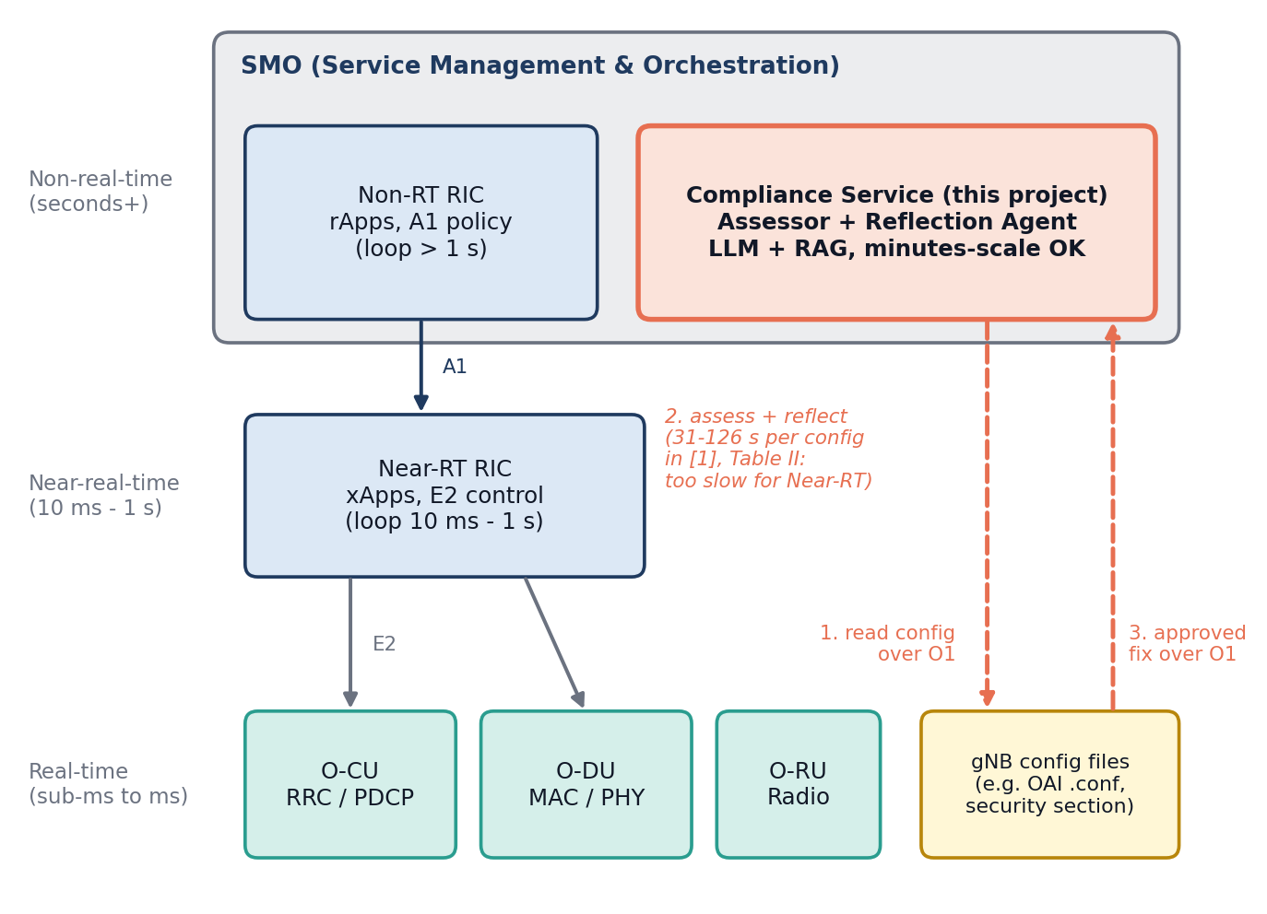
Figure 1. Placement of the compliance service in the O-RAN architecture. The service sits in the SMO / Non-RT RIC layer and reaches configuration files over O1. The Near-RT path (A1, E2) is shown for context only. Timing figures are from Table II of [1].
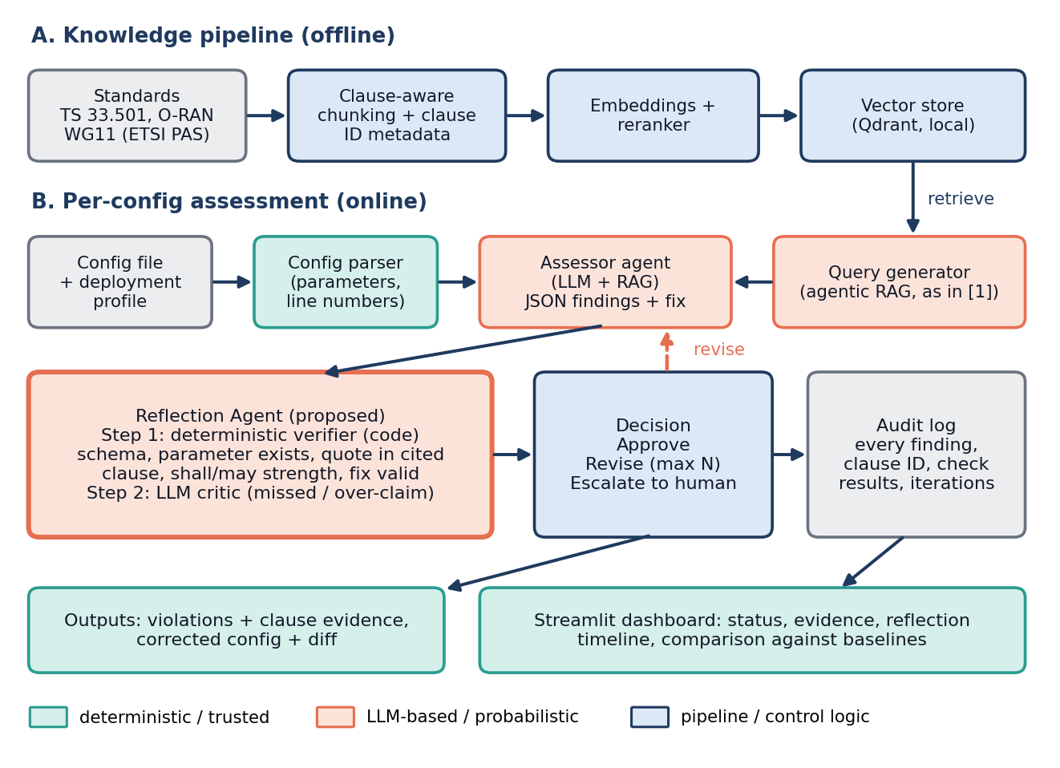
Figure 2. System components. Part A builds the knowledge index offline; part B assesses one configuration online. The Reflection Agent combines deterministic verification (stage 1) with an LLM critic (stage 2).
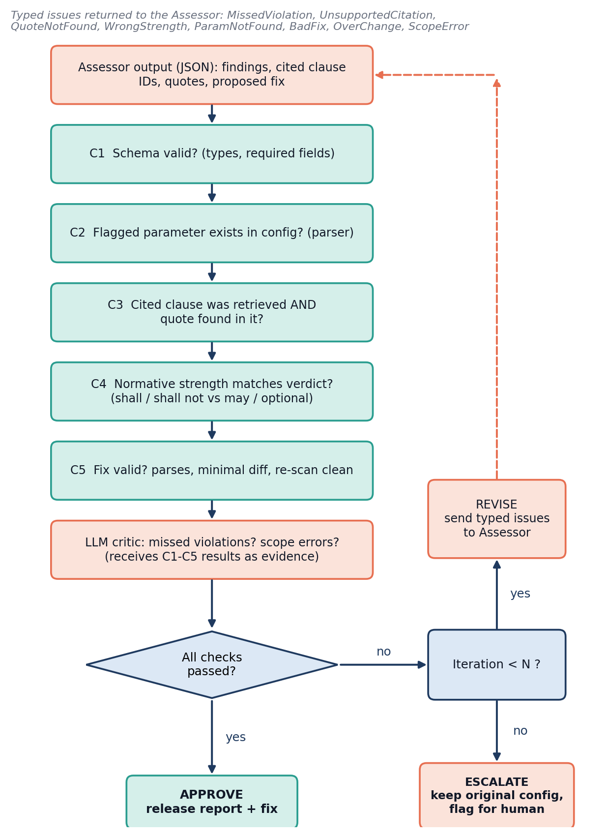
Figure 3. Reflection Agent workflow. Checks C1 to C5 run in code; the LLM critic receives their results. Failures return typed issues to the Assessor up to N iterations, after which the case is escalated and the original configuration is kept.

7. Simulation and demonstration

7.1 Is a network simulator necessary?
[PROPOSED] No, not for the research question asked here. The object under test is a static configuration file plus standards text. Detection accuracy, citation correctness, fix correctness and reflection effect can all be measured without simulating a single packet. A simulator becomes relevant only if the claim were about network performance after applying corrected settings (for example, the throughput cost of enabling integrity protection), and this project does not make that claim.

7.2 Options compared
Option | What it adds | Effort and risk | Fit to the question
A. Configuration-based software demo | Full pipeline on real OAI-format files: ingestion, retrieval, assessment, reflection, corrected file, dashboard, baselines. | Low. No radio stack. Everything is reproducible on a laptop or one VM. | Direct. All metrics are measurable.
B. A plus OAI rfsim (and optionally FlexRIC) | Shows that an original and a corrected configuration are accepted by a running gNB software stack, and that the security block takes effect (visible in logs). Strengthens the “real software” story. | Medium to high. [UNVERIFIED] The project’s earlier notes describe OAI and FlexRIC version compatibility as a known pain point and setup as taking weeks for newcomers; a standalone SA gNB also needs a core network. [1] and [3] used OAI-based setups. | Useful as a stretch demonstration for one or two files. Not needed for any metric.
C. ns-3 / ns-O-RAN | Realistic E2 control loops, KPM reports and RAN traffic for xApp research [15], [16]. | Medium. Already used by the other sub-team for energy and traffic agents. | Poor. [UNVERIFIED] To our knowledge ns-3 does not model OAI-style cipher and integrity algorithm selection, so the security block we assess has nothing to act on. This should be confirmed before any reuse.

7.3 Recommendation
- Core demo: Option A. It answers the research question completely and can be finished and evaluated in the available time.
- Stretch: Option B for one or two files, only after the core results exist: load the original and corrected .conf in OAI rfsim and show the effect in logs. If setup is unstable, drop it; no result depends on it.
- Not recommended: Option C for this question. Keep the compliance project independent of the energy and traffic simulation work. A possible later link is described in Section 9.

7.4 Suggested demonstration script
[PROPOSED] For the panel: (1) load a configuration and choose a deployment profile; (2) run arm A3, then arm A5, on the same file; (3) show findings with clause IDs and quote-check results; (4) show any finding the verifier rejected, but only if it was actually observed in pilot runs; (5) show the corrected diff and the audit record; (6) show the comparison table of arms with its confidence intervals, labeled as pilot data.

8. Expected outputs and evaluation

8.1 Dashboard
The dashboard (Figure 4) presents one configuration at a time and a comparison view across arms. The layout is illustrative; no value shown in it is a result.
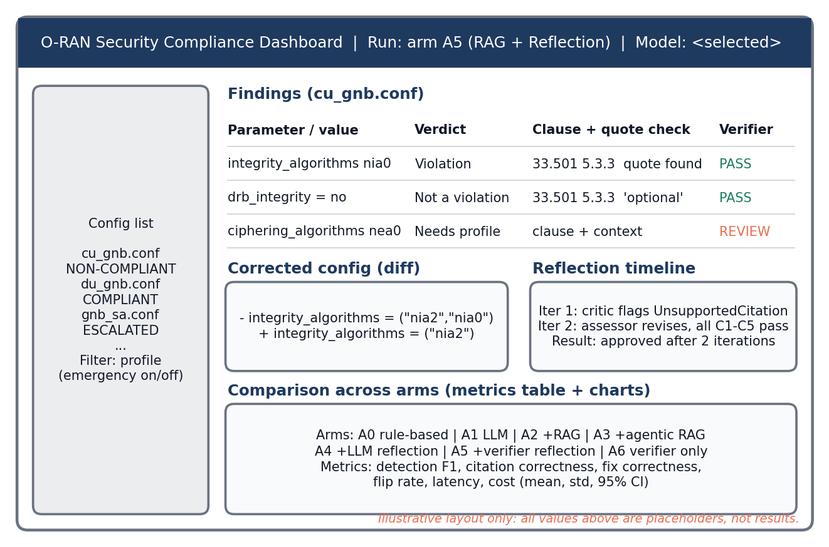
Figure 4. Dashboard wireframe (illustrative layout, placeholder values only).

8.2 Outputs for each configuration
- Detected violations: parameter, value, line, verdict, and whether the finding is verified, unverified or needs a profile.
- Supporting clause: clause ID, specification and version, the exact quoted sentence, and its normative strength.
- Corrected configuration: full file and a line diff showing only the changed lines.
- Reflection result: for each round, the typed issues raised, C1 to C5 outcomes, what the Assessor changed, and the final decision (approved, escalated).
- Audit record: timestamp, model name and version, prompt hash, configuration hash, retrieved clause IDs and scores, all findings, all checks, iterations, final action. Records are append-only.

8.3 Comparison against baselines
The results table below is a template. Its cells stay empty until experiments are run.
Arm | Config accuracy | Violation F1 | Citation correct. | Fix correct. | Time (s) | Tokens
A0 | to measure | to measure | n/a | to measure | to measure | n/a
A1 | to measure | to measure | to measure | to measure | to measure | to measure
A2 | to measure | to measure | to measure | to measure | to measure | to measure
A3 | to measure | to measure | to measure | to measure | to measure | to measure
A4 | to measure | to measure | to measure | to measure | to measure | to measure
A5 | to measure | to measure | to measure | to measure | to measure | to measure
A6 | to measure | to measure | to measure | to measure | to measure | to measure

8.4 Possible outcomes
[HYPOTHESIS] These are scenarios, not predictions, and none is assumed:
- Reflection helps (A5 above A3 and A6). The critic finds problems that code cannot. Report the categories where it helps and the extra cost.
- Verification helps, critic does not (A6 matches A5). The value is in grounding. The LLM critic can be dropped to save cost.
- LLM reflection alone does not help or hurts (A4 not above A3). This would agree with [7]. The evaluation is still a valid and useful negative result for the field.
- Rules suffice on simple cases (A0 matches LLM arms on literal violations). The LLM’s value is then limited to context and semantic cases, which would itself be a finding.

8.5 Threats to validity
- Small and partly synthetic data. Injected violations may be easier than real misconfigurations. Mitigation: decoys, context-dependent cases, and honest confidence intervals.
- Label subjectivity. Compliance can depend on deployment context. Mitigation: explicit profile, two annotators, reported agreement.
- Training-data leakage. OAI configurations and TS 33.501 are public and may be known to the models, which can flatter the no-RAG arms. Mitigation: report it, and include modified or unusual configurations.
- Same-model critic bias. Mitigation: use a different model for the critic in some arms and report both.
- Model drift and nondeterminism. Mitigation: pinned versions, repeated runs, stored prompts and outputs.
- Specification source. Clause readings in this draft came partly from a mirror. Mitigation: all labels are checked against official text before freezing.

9. Scope and future extensions
[PROPOSED] Version 1 deliberately contains only what is needed to answer the central question: static gNB configuration files, one standards corpus, seven arms, and a dashboard. The table lists extensions to consider only after the core results exist.
Extension | Why it is valuable | Added complexity | When
Runtime evidence (events over O1 or KPM-style data) | Moves from compliance by design toward compliance by evidence, as proposed in [1]. | High: needs live data and a stream design. | After core results
Other formats (YAML, JSON, multi-vendor) | Authors of [1] name multi-vendor formats as a challenge. | Medium: more parsers and datasets. | After core results
RAG-poisoning robustness test | [1] lists poisoned RAG documents as a threat to the agent itself. | Medium: adversarial dataset. | Good second paper topic
Different-family and fine-tuned small critic | Tests whether critic diversity or training helps. | Medium to high. | If H3 favours the critic
Specification-update monitoring | [1] describes a Policy Intelligence Hub that tracks new releases; re-assess affected configs when a clause changes. | Medium. | Later
Reuse of the verifier idea for xApp / rApp policy actions | The same pattern (claim, clause evidence, check) could vet policies in the energy and traffic conflict-resolution work of the other sub-team. | Medium; needs agreement on interfaces. | Only by joint decision

Features to resist in version 1: live RIC integration, runtime telemetry, fine-tuning, multi-agent negotiation and additional use cases. Each adds integration risk without helping answer the central question.

10. Conclusion and references

10.1 Conclusion
Automated security-compliance checking of O-RAN configurations with LLM agents and RAG has an initial published prototype [1]. That work shows feasibility and that retrieval design strongly affects accuracy, but it does not isolate the effect of its Reflection Agent, uses a very small sample without variance, and does not measure citation correctness. The general literature suggests that reflection helps when anchored to external checks and may fail when it only re-reads the model’s own text [5]-[8].
This project proposes a verifier-grounded Reflection Agent and, more importantly, a controlled evaluation of seven arms that separates retrieval, single-agent assessment, LLM-only reflection, verification and an LLM critic, against a rule-based baseline. The contribution is the evidence: a labeled dataset with an explicit deployment profile, metrics that include citation and fix correctness, and a statistically honest comparison. A negative result for reflection would still be a result. No simulator is required, and the recommended demonstration is a configuration-based pipeline with a dashboard.

10.2 References
Status key: Opened means the page or document was opened and read in this work. Id from [1] means the identifier was taken from the reference list of paper [1] and the page itself was not opened. Landing page means a general page, not a specific document; check it before citing.
# | Reference | Link | Status
[1] | S. Chatzimiltis, M. Boloursaz Mashhadi, M. Shojafar, M. Debbah, R. Tafazolli, “Agentic AI for 6G: A New Paradigm for Autonomous RAN Security Compliance,” arXiv:2512.12400, v2, 14 Apr 2026 (IEEE Communications Standards Magazine format). | https://arxiv.org/abs/2512.12400 | Opened (full text)
[2] | P. Sharma, H. Wen, V. Yegneswaran, A. Gehani, P. Porras, Z. Lin, “MobiLLM: An Agentic AI Framework for Closed-Loop Threat Mitigation in 6G Open RANs,” arXiv:2509.21634, 2025. | https://arxiv.org/abs/2509.21634 | Opened (abstract, intro)
[3] | I. Chatzistefanidis et al., “MX-AI: Agentic Observability and Control Platform for Open and AI-RAN,” arXiv:2508.09197, 2025. | https://arxiv.org/abs/2508.09197 | Id from [1]
[4] | M. Elkael, S. D’Oro, L. Bonati, M. Polese, Y. Lee, K. Furueda, T. Melodia, “AgentRAN: An Agentic AI Architecture for Autonomous Control of Open 6G Networks,” arXiv:2508.17778, 2025. | https://arxiv.org/abs/2508.17778 | Id from [1]
[5] | A. Madaan et al., “Self-Refine: Iterative Refinement with Self-Feedback,” NeurIPS 2023, arXiv:2303.17651. | https://arxiv.org/abs/2303.17651 | Opened (abstract)
[6] | N. Shinn, F. Cassano, E. Berman, A. Gopinath, K. Narasimhan, S. Yao, “Reflexion: Language Agents with Verbal Reinforcement Learning,” NeurIPS 2023, arXiv:2303.11366. | https://arxiv.org/abs/2303.11366 | Opened (abstract)
[7] | J. Huang et al., “Large Language Models Cannot Self-Correct Reasoning Yet,” ICLR 2024, arXiv:2310.01798. | https://arxiv.org/abs/2310.01798 | Opened (abstract)
[8] | Z. Gou et al., “CRITIC: Large Language Models Can Self-Correct with Tool-Interactive Critiquing,” ICLR 2024, arXiv:2305.11738. | https://arxiv.org/abs/2305.11738 | Opened (abstract)
[9] | P. Lewis et al., “Retrieval-Augmented Generation for Knowledge-Intensive NLP Tasks,” NeurIPS 2020, arXiv:2005.11401. | https://arxiv.org/abs/2005.11401 | Not opened (background)
[10] | 3GPP TS 33.501, “Security architecture and procedures for 5G System.” Clauses 5.3.3 and Annex D.1 were read through the mirror below; verify against the official text. | https://www.3gpp.org/dynareport/33501.htm ; mirror: https://www.itecspec.com/3gpp/33.501/s/5.3.3 | Mirror opened; official page not opened
[11] | ETSI TS 104 104 V9.1.0 (2025-06), O-RAN Security Requirements and Controls Specifications (O-RAN.WG11.SecReqSpecs-R003-v09.01). | https://www.etsi.org/deliver/etsi_TS/104100_104199/104104/09.01.00_60/ts_104104v090100p.pdf | Opened (front matter)
[12] | ETSI TS 104 107 V9.0.0 (2025-05), O-RAN Security Protocols Specifications. | https://www.etsi.org/deliver/etsi_TS/104100_104199/104107/09.00.00_60/ts_104107v090000p.pdf | Opened (front matter)
[13] | O-RAN ALLIANCE Security Working Group, “The O-RAN ALLIANCE Security Working Group Continues to Advance O-RAN Security” (blog). | https://www.o-ran.org/blog/the-o-ran-alliance-security-working-group-continues-to-advance-o-ran-security | Opened
[14] | OpenAirInterface 5G, “Running the OAI 5G gNB (nr-softmodem)”, security section (doc/RUNMODEM.md). Read through a mirror of the repository; the official repository is on the EURECOM GitLab. | https://git.yigid.dev/yigid/openairinterface5g/src/tag/2026.w27/doc/RUNMODEM.md ; official: https://gitlab.eurecom.fr/oai/openairinterface5g | Mirror opened; official not opened
[15] | “ns-O-RAN: Simulating O-RAN 5G Systems in ns-3,” arXiv:2305.06906 (authors: see the arXiv listing). | https://arxiv.org/abs/2305.06906 | Opened (listing only)
[16] | “Demo: Enabling Deep Reinforcement Learning Research for Energy Saving in Open RAN,” arXiv:2601.02240; code: ns-o-ran-gym. | https://arxiv.org/abs/2601.02240 ; https://github.com/wineslab/ns-o-ran-gym | Opened (excerpts)
[17] | A. Lacava et al., “Programmable and Customized Intelligence for Traffic Steering in 5G Networks Using Open RAN Architectures,” arXiv:2209.14171. | https://arxiv.org/abs/2209.14171 | Opened (excerpts)
[18] | “TeleEmbedBench: A Multi-Corpus Embedding Benchmark for RAG in Telecommunications,” arXiv:2604.17778. | https://arxiv.org/abs/2604.17778 | Opened (excerpts)
[19] | O-RAN ALLIANCE, O-RAN specifications (architecture and WG documents). | https://www.o-ran.org/specifications | Landing page; not opened

Appendix A. Corrections to earlier project notes
While preparing this proposal, the full text of [1] was compared with the project’s earlier research summary. Three statements in that summary do not match the paper, and this proposal does not rely on them.
Earlier statement | What [1] shows | Consequence
The paper “did not publish” the idea. | [PUBLISHED] It is published (arXiv v2, 14 Apr 2026). It reports an initial case study. | The accurate gap is the missing controlled evaluation of the Reflection Agent, not a missing paper.
Expected pattern: No-RAG, then RAG, then RAG plus reflection improve in order. | [PUBLISHED] Plain RAG was below No-RAG for all three models; agentic RAG was highest. | Retrieval design must be treated as a first-order variable.
The paper uses four metrics including clause correctness. | [PUBLISHED] It reports accuracy, BERTScore and response time. | Citation correctness is not measured there; we add it.

Appendix B. Starter clause list for the knowledge base
Paraphrased from TS 33.501 as read through a third-party mirror [10]. [UNVERIFIED] Each entry must be checked against the official specification text, and the exact sentences copied from the official document for the quote-check (C3), before use.
Clause | Content (paraphrased) | Relevance to configuration
5.3.3 (gNB) | The gNB must support integrity protection of user data and RRC signalling. Integrity protection of user data is optional to use, and when used must not use NIA0. RRC signalling must use an integrity algorithm other than NIA0 except for unauthenticated emergency calls. NIA0 must be disabled in the gNB where support of unauthenticated emergency sessions is not a regulatory requirement. | integrity_algorithms, drb_integrity; profile-dependent.
Annex D.1 | NEA0 and NIA0 provide no security. NIA0 must not be used for signalling radio bearers except for unauthenticated emergency sessions, and must not be used for data radio bearers. | nea0, nia0 values.
6.7.3.6 and 10.2.2 | Rules for algorithm negotiation and null algorithms for unauthenticated emergency sessions. | Defines the exception that creates the deployment profile.
5.2.3 (UE) and 5.5.2 (AMF) | Parallel integrity requirements for the UE and the AMF. | Not gNB configuration; useful as distractors in retrieval tests.

