**TEAM MEMBERS :** **ROLL NO:**

Yesha Shastri 1741035

Devshree Patel 1741075

Muskan Matwani 1741027

Naishi Shah 1741033

**Motivation:**

Robots are gadgets which can be programmed by the humans in order to give them human-like abilities. Since humans cannot always be accurate in performing certain tasks, robots can be useful to provide us with unbiased and accurate results. In the areas where human intervention is not possible like, in military surveillance, use of robots becomes a necessity. Robots in the agricultural sector will be of great help to the nation. Looking at the magnificence of the applications of the robot and the ease of availability of the Android technology motivated us to think of developing a robot which will be useful in the real-life scenario.

**Description:**

The system will work on the control commands sent by the app. The commands could either be in the form of touch on the app screen or by the speech. These commands will be received by the Bluetooth module attached to the robot. The received data would then be passed on to Arduino which will further send instructions to the motor driver. The motor driver will amplify the low-current control signal to high-current control signal for the purpose of driving the motors. Ultimately, the motors will make the robot move in desired directions. In return, the robot also sends back information regarding the distance from the closest obstacle to the phone and if it reaches very close to a certain obstacle it will automatically stop.

**Final Outcome:**

The robot will be able to move in forward, backward, left and right directions. The user will also be able to control the speed of the robot through the app interface. Speech commands could be from (forward, backward, left, right and stop). The spoken commands will be visible on the app screen. Hence, it will result in a full-fledged Android phone controlled robot ready for the addition of features in future to work for real-life applications.

2) Market Survey:

**BLOCK DIAGRAM :**

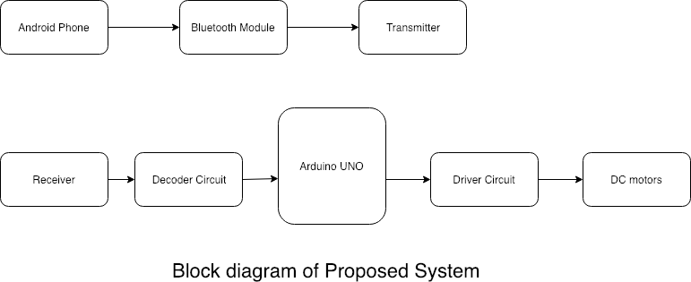

The system comprises of 2 parts namely, the software and the hardware(circuit).

* The software: The command from the Android phone is sent to the transmitter of the bluetooth module
* The hardware: The circuit consists of

**COMPONENTS REQUIRED :**

1. 1 X Arduino Uno R3 Board
2. 4 X Geared motor with wheels
3. 2 X Motor Driver L293D
4. 1 X Bluetooth module HC-06
5. 2 X Li-ion battery 18650
6. 4 X LEDs + resistors 220 Ohm
7. 1 X Buzzer
8. Connecting wires

**FLOWCHART :**



**SELECTION CRITERIA OF COMPONENTS:**

**Arduino Uno:**

It is an open-source electronics prototyping platform based on flexible, easy-to-use hardware and software. It is intended for artists, designers, hobbyists and anyone interested in creating interactive objects or environments.

The board is very easy to use as the user simply needs to connect it to a computer with a USB cable, or power it with an AC-to-DC adaptor or battery to get started. The microcontroller on the board is programmed using Arduino programming language using the Arduino development environment.

**DC motor:** A DC motor is a type of motor with a magnetic coil inside. When an electric current passes through the coil, the magnetic force generated proceeds to turn the motor. The current is passed through a commutator before entering the coil, which switches the direction of the current at the apex point, so the spinning continues. The speed of the motor can be controlled by limiting the current, and the direction is affected by the direction of the current.

**HC 06 Bluetooth Module:** The HC-06 is a class 2 slave Bluetooth module designed for transparent wireless serial communication. Once it is paired to a master Bluetooth device such as PC, and tablet, its operation becomes transparent to the user. All data received through the serial input is immediately transmitted over the air. When the module receives wireless data, it is sent out through the serial interface exactly at it is received. No user code specific to the Bluetooth module is needed at all in the user microcontroller program. The HC-06 will work with a supply voltage of 3.6VDC to 6VDC, however, the logic level of RXD pin is 3.3V and is not 5V tolerant. It is responsible for enabling Bluetooth Communication between Arduino and Android Phone.

**L293D:-**

L293D is a 16-pin IC which can control a set of two DC motors simultaneously in any direction. It means that you can control two DC motor with a single L293D IC. Here, 2 L293D drivers control 4 DC Motors which are connected to wheels of the robot. Also, it is one of the most popular drivers in the market. There are several reasons which make L293D the preferred driver to the users, such as, cheap price (compared to other drivers), proper shape and size, easy control, no need for protective circuit and diodes, no need for heat sinks and good resistance to temperature and high-speed variations. This IC can set up motors with a voltage between 5V to 36V and a current of up to 600 mA. However, it can withstand a current up to 1200 mA in 100 microsecond and non-repetitive. The frequency of this IC is 5 kHz.

**CIRCUIT DIAGRAM:-**

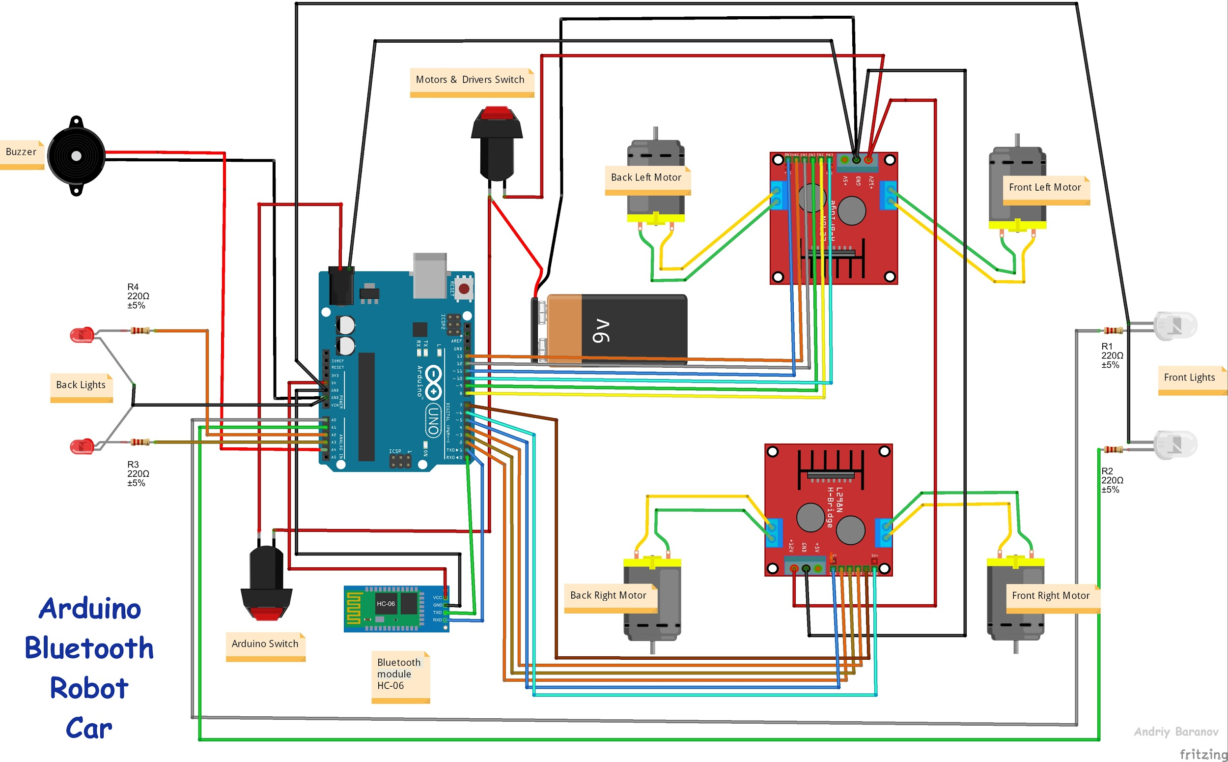

**DATASHEET OF MAJOR COMPONENTS:**

1. **Arduino Uno R3 board:**

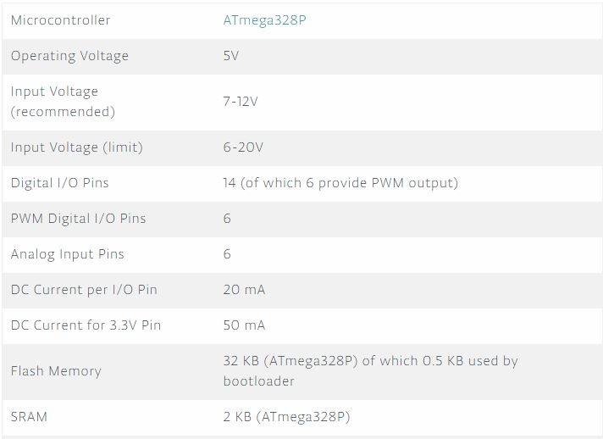

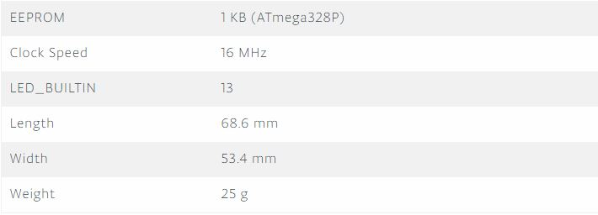

**2. DC Motor:**

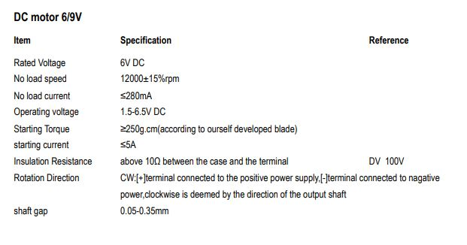

**3. HC 06 Bluetooth Module:**

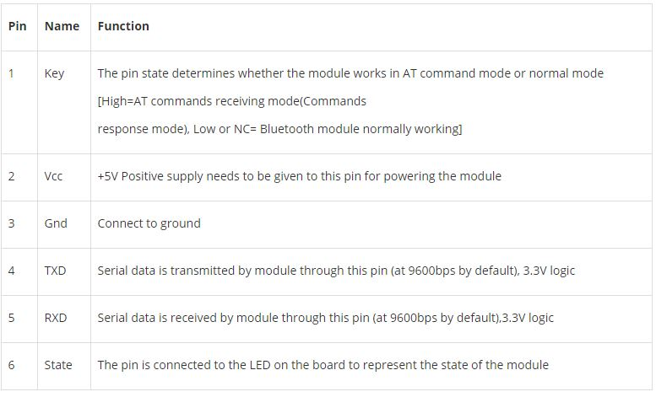

**4. L293D:**

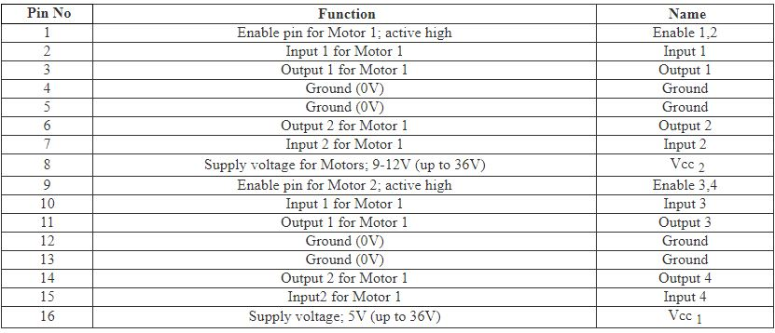

**TIMELINE OF THE PROJECT :**

|  |  |
| --- | --- |
| **TASK** | **FINISH DATE** |
| Selection of project topic and preparing list for components required | 07/02/19 |
| Understanding the working of components | 13/02/19 |
| Integrating all components and finalizing the circuit design | 25/02/19 |
| Updating report 1 to submit report 2 | 5/03/19 |
| Writing a primary code to dump on the system | 10/03/19 |
| Debugging the code | 15/03/19 |
| Submission of report 3 | 19/03/19 |
| Making android application and integrating the app with Bluetooth module | 25/03/19 |
| Integrating the final project and prepare the presentation | 30/03/19 |
| Final presentation | 06/04/19 |