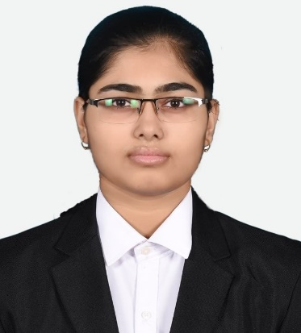

Muskan Manvi

(21111331)

4 BBA A

Mobile – 7970314575

Email – [muskan.manvi@christuniversity.in](mailto:muskan.manvi@christuniversity.in)

Personal Profile Statement –

I am a personable, driven, and self-assured person with the capability to surpass documentation objectives and make a significant contribution to the university placement cell. I have opted for good social skills, which help me to develop strong relationships with my fellow mates.

Education –

* Completed class 10th with 94.60% in CBSE Board by Jeevan Deep Public School in 2016.
* Completed class 12th with 73.8% in CBSE Board by Jeevan Jyoti Public School in 2018.
* Completed semesters 1 ,2 & 3with 3.46, 3.59 & 3.8 GPA.

Achievements –

* School representative for the house, club & Cultural wing.
* Different certifications for debate, writing, singing, etc. competitions in school.
* Completed 4 courses at Coursera with certificates.
* Completed 2 Eduedge Pro courses i.e., Excel & Global Marketing.
* Completed 1 Leap & scale course i.e., Product Management.
* Won in Festivista dance (1st place).

College Experience –

* Participated in Ignite & Imperio.
* Participated in NRITTA.
* Current member of CSA for Project Bridge & Activity Centre.

Skills –

* Hands-on with MS Word, Excel & Powerpoint.
* Strong communication skills with strong interpersonal skills.
* Proactive, prepared, and an excellent team player.

Hobbies & Interests –

I love socializing with my friends and family. I am eager to learn new skills and develop my opportunities for the present market, as well as stay up to date on current industries and markets. In addition, I am an enthusiastic cricket fan who enjoys watching both international and national matches. I also enjoy dancing and singing with everyone.