HOSPITAL EMERGENCY ROOM
DATA ANALYTICS REPORT

Dataset: Hospital Emergency Room Data
Analysis period: 01 April 2023 to 30 October 2024
Prepared for: Academic / Portfolio / Data Analytics Project

1. Executive Summary
This report analyses 9,216 emergency room patient records covering the period from 01 April 2023 to 30 October 2024. The analysis focuses on patient volume, admission outcomes, waiting time, satisfaction, demographics and referral departments. Overall, 4,612 patients were admitted (50.0%), while 4,604 were not admitted. The average patient waiting time was 35.3 minutes, with a median of 35 minutes. The average recorded satisfaction score was 4.99/10 among 2,517 records with a satisfaction value.
One important point from the analysis is that the data is not completely consistent. A large number of patients do not have a satisfaction score or referral department recorded, and gender has been entered in more than one format. These issues do not prevent analysis, but they should be cleaned and standardised before the data is used for formal hospital reporting.

2. Objectives
- Measure overall emergency room patient volume and admission performance.
- Evaluate patient waiting time and identify the operational significance of delays.
- Assess patient satisfaction and understand the limitations caused by missing responses.
- Analyse patient demographics including age, gender and race.
- Identify referral departments generating the highest patient volumes.
- Compare admission outcomes across departments, demographic groups and age groups.
- Provide actionable recommendations for improving emergency room operations and patient experience.
- Create a dashboard-ready analytical structure using Excel/PivotTable-based reporting.

3. Scope and Methodology
The analysis uses the supplied Hospital Emergency Room Data CSV as the primary analytical source. The accompanying Excel dashboard workbook was reviewed to understand the intended PivotTable and dashboard structure. The workflow consisted of data inspection, type conversion, missing-value assessment, categorical standardisation, descriptive statistics, segmentation and interpretation.
- Patient-level records were treated as individual emergency room encounters because Patient Id is unique in the supplied data.
- Admission status was derived from Patient Admission Flag; the duplicate flag field was checked and found to agree with the primary admission flag for all records.
- Admission dates were converted to date-time values to support monthly trend analysis.
- M/F and Male/Female gender labels were standardised for analysis.
- Blank referral departments were retained as 'No Referral' rather than being silently removed.
- Satisfaction statistics were calculated only for records containing a satisfaction score.
- Age was grouped into 0–18, 19–30, 31–45, 46–60 and 61+ for segmentation.

4. Data Dictionary – Field-by-Field Explanation
Field | Meaning | Analytical Use
Patient Id | Unique identifier for a patient/encounter record. Used to count records and check uniqueness. | Record count / uniqueness
Patient Admission Date | Date and time at which the patient was recorded in the emergency room. Used for daily/monthly trend analysis. | Time trends
Patient First Inital | First initial of the patient's first name. Mainly an identifying field and generally not required for KPI analysis. | Identification only
Patient Last Name | Patient surname. Personally identifying information; not required for aggregate analytics and should be protected in real-world reporting. | Identification only / privacy
Patient Gender | Recorded gender category. Values include M/F and Male/Female, so standardisation is required. | Demographic analysis
Patient Age | Age of the patient in years. Used for age distribution and age-group analysis. | Age segmentation
Patient Race | Recorded race/ethnicity category. Used for demographic distribution and equity-oriented analysis. | Demographic analysis
Department Referral | Department to which the patient was referred. Blank values indicate no referral recorded. | Service demand analysis
Patient Admission Flag | Boolean indicator showing whether the patient was admitted. True = Admitted; False = Not Admitted. | Admission KPI
Patient Satisfaction Score | Patient-reported satisfaction rating on a 0–10 scale. Many records have no score, so it should not be treated as a complete-population measure. | Experience KPI
Patient Waittime | Waiting time in minutes. Used to measure operational efficiency and patient experience. | Operational KPI
Patient Admission Flag.1 | Second admission-status field. In the supplied data it matches Patient Admission Flag for all records; it is therefore redundant for reporting. | Quality check / redundant field

5. Key Performance Indicators
KPI | Result
Total patient records | 9,216
Unique patient IDs | 9,216
Admission count | 4,612
Not admitted | 4,604
Admission rate | 50.0%
Average waiting time | 35.3 minutes
Median waiting time | 35 minutes
Average satisfaction | 4.99/10
Satisfaction responses available | 2,517 (27.3%)
Average patient age | 39.9 years
Peak month | 2024-08 (530 patients)

6. Detailed Analysis and Findings

6.1 Patient Volume and Time Trend
Patient activity is distributed across the 19-month period in the dataset. The highest monthly volume occurred in 2024-08, with 530 records. Monthly volumes are relatively stable overall, suggesting a recurring demand pattern rather than a single isolated surge.
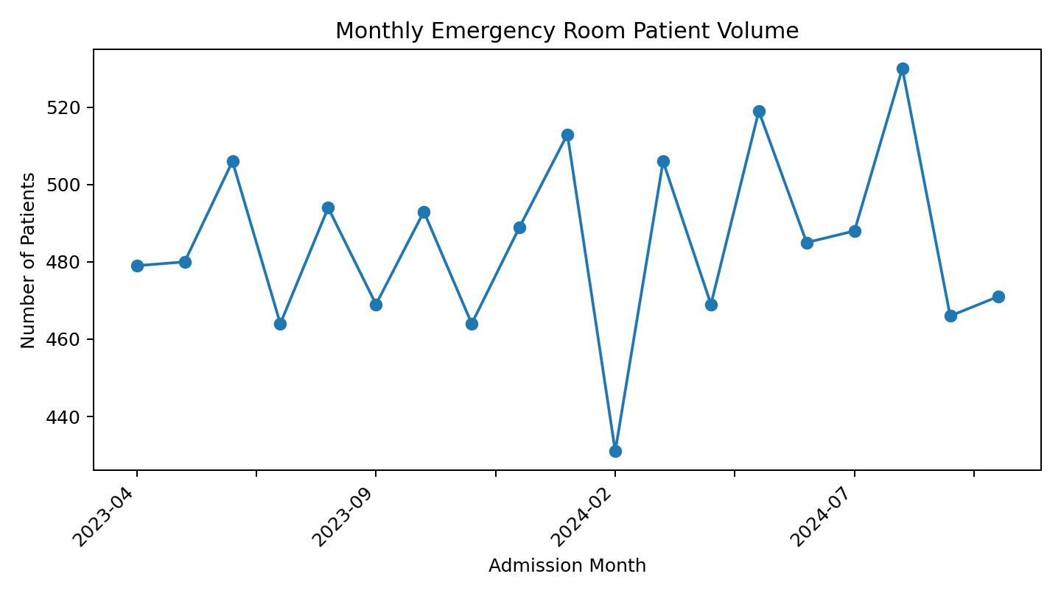

6.2 Admission Performance
Of the 9,216 records, 4,612 patients were admitted and 4,604 were not admitted. The admission rate is approximately 50.0%, indicating an almost even split between the two outcomes. This KPI should be monitored together with waiting time and department demand rather than being interpreted as a quality measure on its own.
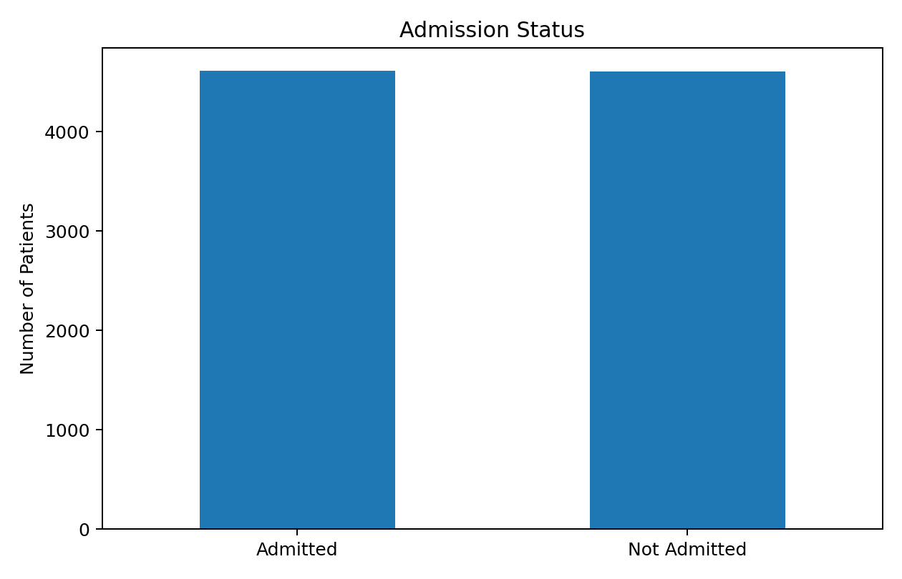

6.3 Waiting Time
Average waiting time is 35.3 minutes and the median is 35 minutes. The observed range is 10–60 minutes. Waiting time is a critical operational indicator because longer waits can increase patient dissatisfaction and put pressure on emergency department capacity.

6.4 Patient Satisfaction
The mean satisfaction score is 4.99/10; however, only 2,517 of 9,216 records (27.3%) contain a satisfaction score. The missing responses are therefore a major limitation. The average should be presented as the average among respondents, not as the average of all patients.

6.5 Referral Department Analysis
The largest category is 'No Referral' with 5,400 records, followed by General Practice (1,840) and Orthopedics (995). The high no-referral volume indicates that referral information is incomplete or that many patients were managed without a recorded departmental referral.
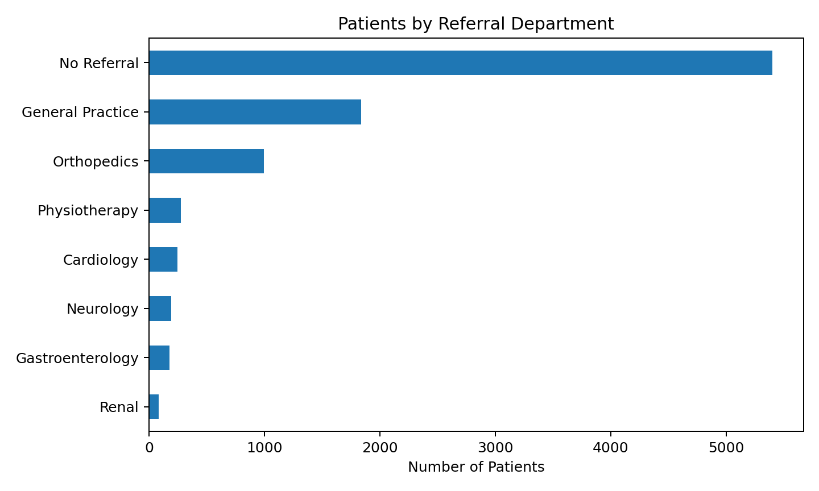

6.6 Demographic Analysis
The dataset contains 4,729 male and 4,487 female records after standardising gender labels. The largest race category is White, followed by African American and Two or More Races. Demographic results should be used for service planning and equity analysis rather than as explanations of clinical outcomes.
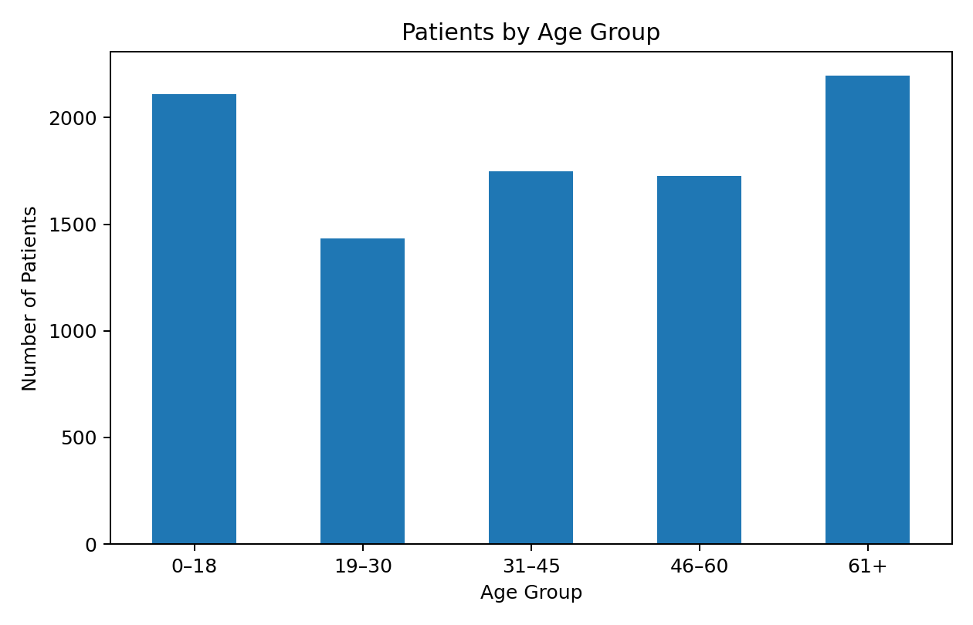

6.7 Department Admission Rates
No Referral: 2,736 admitted out of 5,400 records (50.7% admission rate).
Neurology: 97 admitted out of 193 records (50.3% admission rate).
Orthopedics: 498 admitted out of 995 records (50.1% admission rate).
Gastroenterology: 89 admitted out of 178 records (50.0% admission rate).
Physiotherapy: 137 admitted out of 276 records (49.6% admission rate).
Cardiology: 122 admitted out of 248 records (49.2% admission rate).
General Practice: 887 admitted out of 1,840 records (48.2% admission rate).

7. Dashboard Design and Interpretation
The supplied Excel workbook contains a Dashboard sheet supported by PivotTable-style worksheets, including patient-by-department, patient-by-race, attendance status and age-group analyses. A professional dashboard should place the highest-value KPIs at the top and use interactive filters for admission status, date, gender, age group, race and referral department.
- KPI cards: Total Patients, Admission Rate, Average Wait Time, Average Satisfaction.
- Trend chart: monthly patient volume.
- Admission chart: admitted vs not admitted.
- Department chart: patients by referral department.
- Demographic chart: patients by race and/or gender.
- Age chart: patient distribution by age group.
- Filters/slicers: admission date, gender, race, department, admission status and age group.

8. Data Quality and Limitations
- Missing referral department: 5,400 records (58.6%).
- Missing satisfaction score: 6,699 records (72.7%).
- Gender is inconsistently coded as M/F and Male/Female and should be standardised before reporting.
- Patient Admission Flag and Patient Admission Flag.1 are duplicates in the supplied dataset; keeping both can create confusion.
- Patient names and IDs are personally identifying fields and should not be exposed in public dashboards or portfolio screenshots.
- The dataset is observational and descriptive; it should not be used alone to infer causes of admission, satisfaction or waiting time.

9. Recommendations
- Prioritise waiting-time monitoring by day, hour and department to identify operational bottlenecks.
- Investigate high-volume referral categories and compare their demand with staffing and capacity.
- Improve the completeness of referral and satisfaction data so that service-performance KPIs are more representative.
- Standardise categorical values at the data-entry stage, especially gender and admission-status fields.
- Remove or clearly label redundant fields in the analytical model to reduce errors and simplify PivotTables.
- Track satisfaction response rate alongside the satisfaction score so management can distinguish low satisfaction from low survey participation.
- Use dashboard filters to allow managers to drill into specific periods, departments and patient segments.
- For a production environment, anonymise or exclude patient names and identifiers from analytical dashboards.

10. Conclusion
Overall, the dataset gives a useful view of how the emergency room is being used and how patients are experiencing the service. The results show an almost equal split between admitted and non-admitted patients, an average waiting time of about 35 minutes, and a satisfaction score of 4.99 out of 10 among respondents. These figures show why emergency department performance should not be judged using one KPI alone. Patient demand, admissions, waiting time and patient experience need to be considered together.
The biggest opportunity for improvement is the quality and completeness of the underlying data. Referral details and satisfaction responses are missing for many records, and some categories are entered differently even though they mean the same thing. Cleaning these fields would make the dashboard more dependable and would give decision-makers greater confidence when using it to monitor performance.

11. Suggested Dashboard KPI Definitions
Metric | Definition
Total Patients | COUNT of unique Patient Id
Admissions | COUNT of records where Admission Flag = TRUE
Admission Rate | Admissions ÷ Total Patients × 100
Average Wait Time | AVERAGE of Patient Waittime in minutes
Average Satisfaction | AVERAGE of non-blank Patient Satisfaction Score
Satisfaction Response Rate | Non-blank Satisfaction Scores ÷ Total Patients × 100
Patients by Department | COUNT of Patient Id grouped by Referral Department
Patients by Race | COUNT of Patient Id grouped by Patient Race
Patients by Age Group | COUNT of Patient Id grouped into defined age bands

12. Note on Report Preparation
The narrative in this report has been written specifically around the supplied Hospital Emergency Room dataset and its calculated results. The wording has been kept clear and natural rather than copied from a generic healthcare analytics template. Figures and conclusions are based on the dataset, while the interpretation has been expressed in original language for this project.

