Home Automation



Group-2 (2021-2025)

Ankit Kumar Singh 21UEI006

Muskan Gupta 21UEI007

Golu Kumar 21UEI008

Ashish Kumar 21UEI009

Abantika Deb 21UEI010

Electronics and Instrumentation Engineering

National Institute of Technology, Agartala

# Introduction

# Home automation is building automation for a home. A home automation system will monitor and/or control home attributes such as lighting, climate, entertainment systems, and appliances. It may also include home security such as access control and alarm systems.

# The phrase smart home refers to home automation devices that have internet access. Home automation, a broader category, includes any device that can be monitored or controlled via wireless radio signals, not just those having internet access. When connected with the Internet, home sensors and activation devices are an important constitute of the Internet of Things(‘IoT’).

# In this project , we are going to control an LED and a FAN using HC-05 Bluetooth module, Arduino Uno and an Android Application.

Component List

|  |
| --- |
| 1. Arduino UNO R3 2. HC-05 Bluetooth Module 3. L298N Motor Driver 4. Resistor(100-Ohm) 5. LED 6. Jumper Wires 7. PCB |

* Application Back-End Code

Here we used MIT App Inventor website to create the android application to control the LED and Fan.

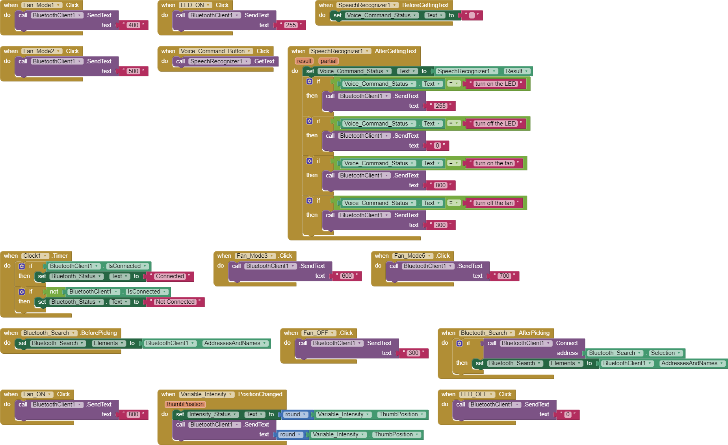

* Arduino Code

#define ENA 3

#define in1 4

#define in2 7

#define led 9

int speed1=0;

int speed2=51;

int speed3=102;

int speed4=153;

int speed5=204;

int speed6=255;

int i;

void setup() {

Serial.begin(9600);

pinMode(ENA,OUTPUT);

pinMode(in1,OUTPUT);

pinMode(in2,OUTPUT);

pinMode(led,OUTPUT);

}

void loop()

{

while(Serial.available()>0)

{

i=Serial.parseInt();

if(i>=0&&i<=255){

analogWrite(led,i);

}

else if(i==300){

digitalWrite(in1,LOW);

digitalWrite(in2,HIGH);

analogWrite(ENA,speed1);

}

else if(i==400){

digitalWrite(in1,LOW);

digitalWrite(in2,HIGH);

analogWrite(ENA,speed2);

}

else if(i==500){

digitalWrite(in1,LOW);

digitalWrite(in2,HIGH);

analogWrite(ENA,speed3);

}

else if(i==600){

digitalWrite(in1,LOW);

digitalWrite(in2,HIGH);

analogWrite(ENA,speed4);

}

else if(i==700){

digitalWrite(in1,LOW);

digitalWrite(in2,HIGH);

analogWrite(ENA,speed5);

}

else if(i==800){

digitalWrite(in1,LOW);

digitalWrite(in2,HIGH);

analogWrite(ENA,speed6);

}

Serial.print("Received value: ");

Serial.println(i);

}

}

----------------------------------------------------