*Screenshots*

**1. HOME PAGE**

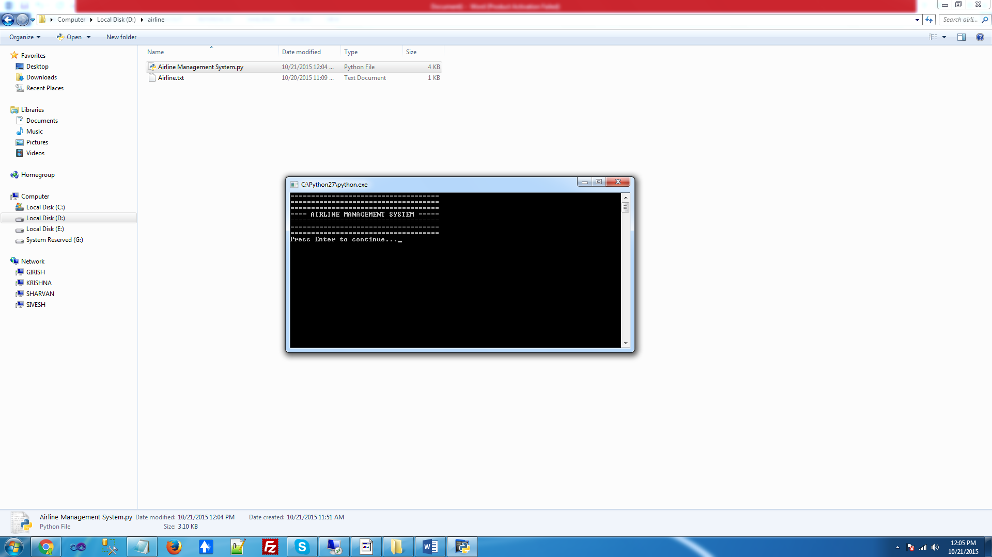

**2. MAIN MENU**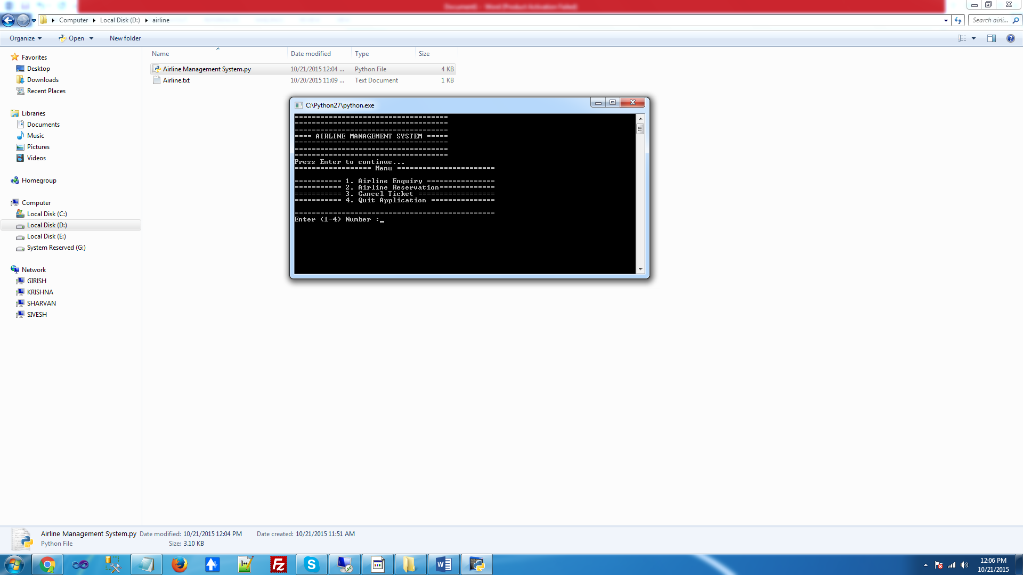

**3. AIRLINE ENQUIRY**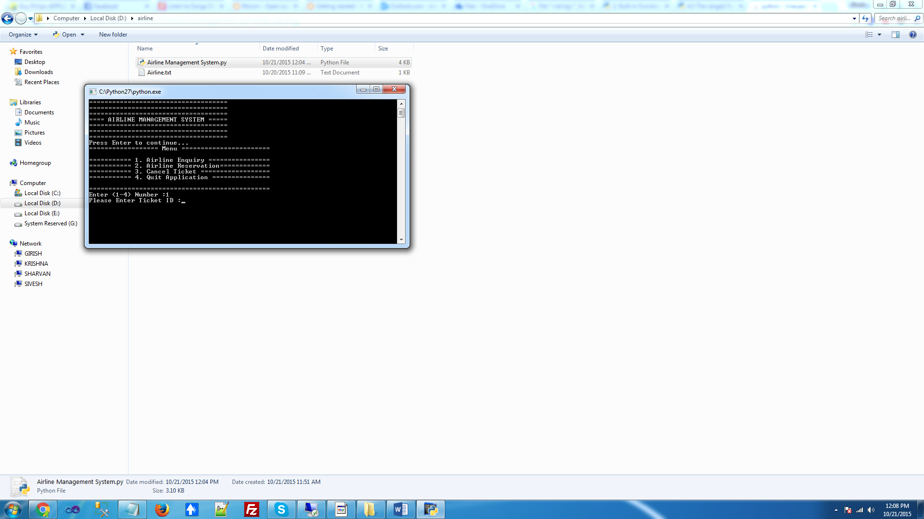

**4. AIRLINE DETAILS**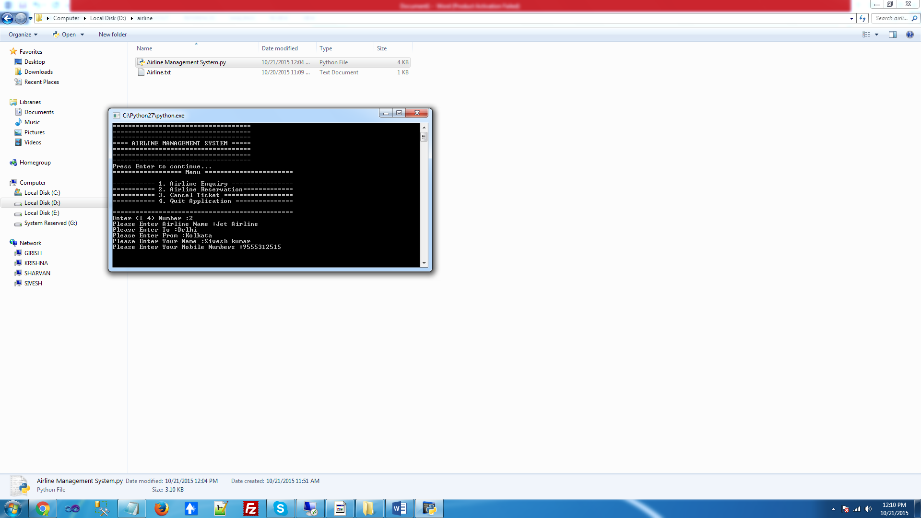

**5. RESERVATION PAGE**

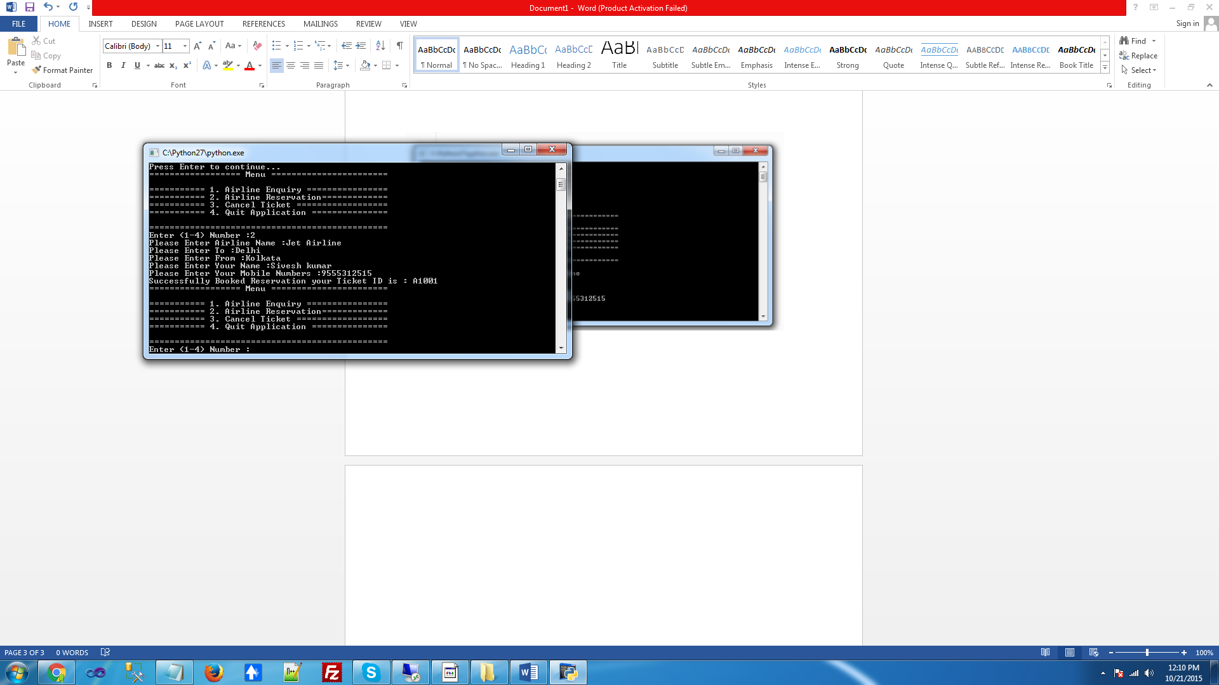

**6. CANCEL TICKET**

