

Experiment 1
Student Name: Shivanshu Ranjan UID: 23BCS10193
Branch: CSE Section/Group: KRG 3-B
Semester: 6th Date of Performance:12/01/2026 Subject Name: Full Stack Development – II Subject Code: 23CSH-309

- Aim: To design and implement the foundational frontend architecture of the EcoTrack application using modern React practices, Vite tooling, and ES6+ JavaScript features.

Objective:
- To set up a React project using Vite with proper project structure
- To understand component-based architecture in React
- To apply ES6 array methods (map, filter, reduce) for data-driven UI rendering
- To separate concerns using components, pages, and data modules

Implementation / Code:

Tools & Technologies Used:
- React (Functional Components)
- Vite (Build Tool)
- JavaScript (ES6+)
- HTML & CSS
- Visual Studio Code

Implementation Description:
The EcoTrack application is implemented using React with Vite to ensure fast development and optimized build performance.
The application follows a component-based architecture, where data and UI logic are clearly separated.
A predefined list of activities with their respective carbon emission values is maintained.
Using ES6 array methods:
- map() is used to display activity data on the UI
- filter() is used to classify activities into high and low carbon categories
- reduce() is used to calculate the total carbon emission
This structure improves code readability, reusability, and maintainability.

Sample Code Snippet:
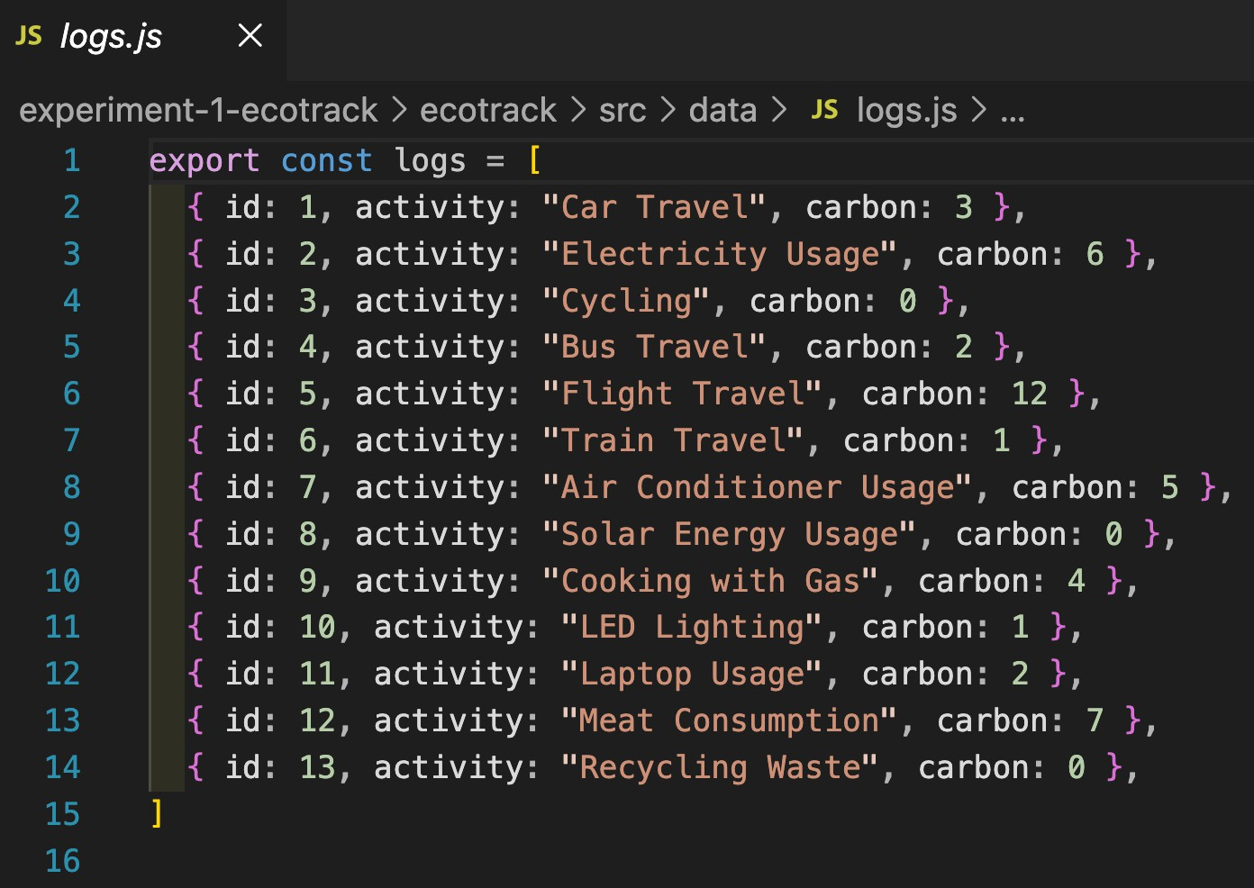
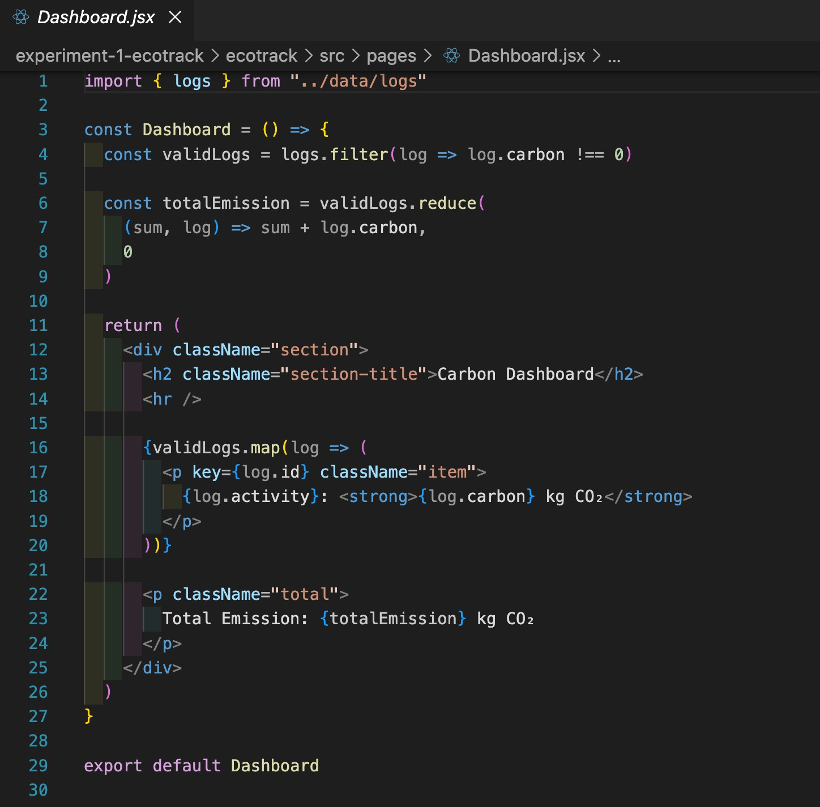

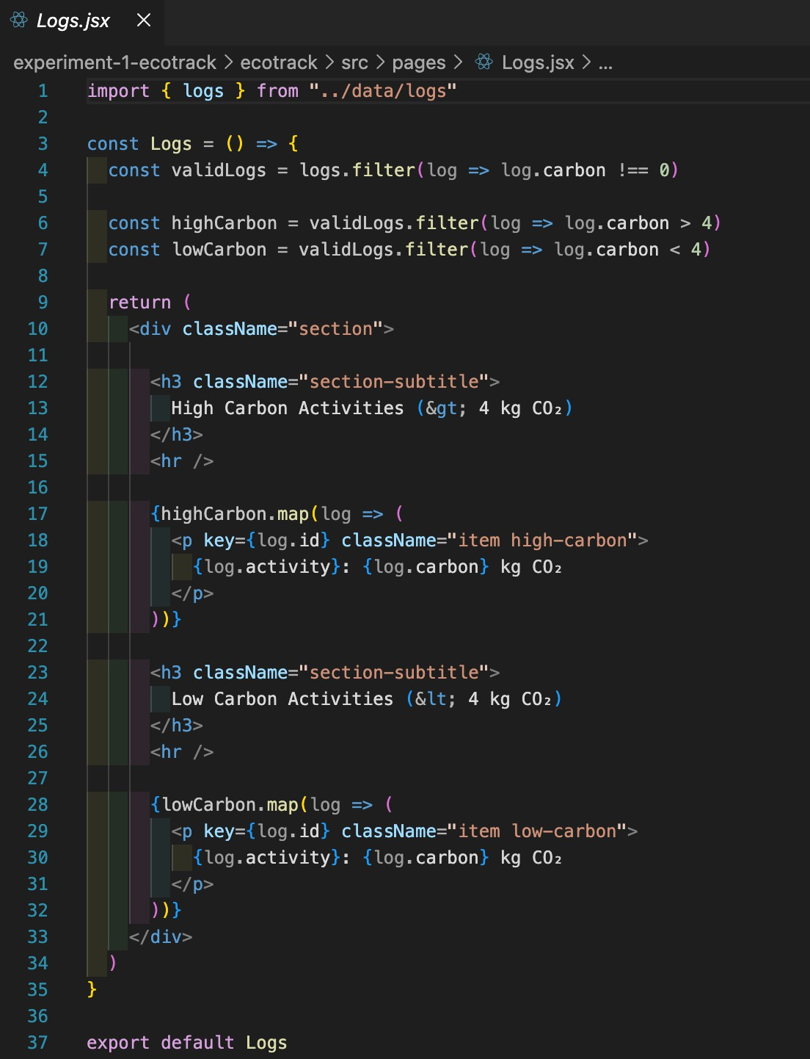
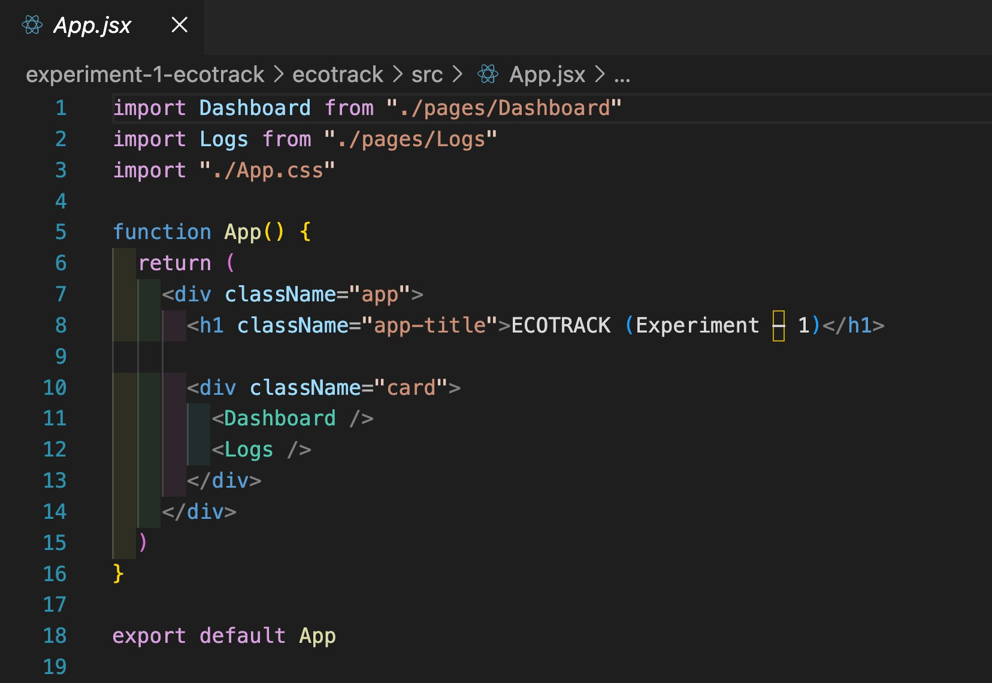

Output:
- The EcoTrack application displays a Carbon Dashboard
- Activities and their corresponding CO₂ emission values are rendered dynamically
- The total carbon emission is calculated using reduce()
- Activities are classified into:
  - High Carbon Activities
  - Low Carbon Activities
- The UI reflects proper separation of data and presentation logic
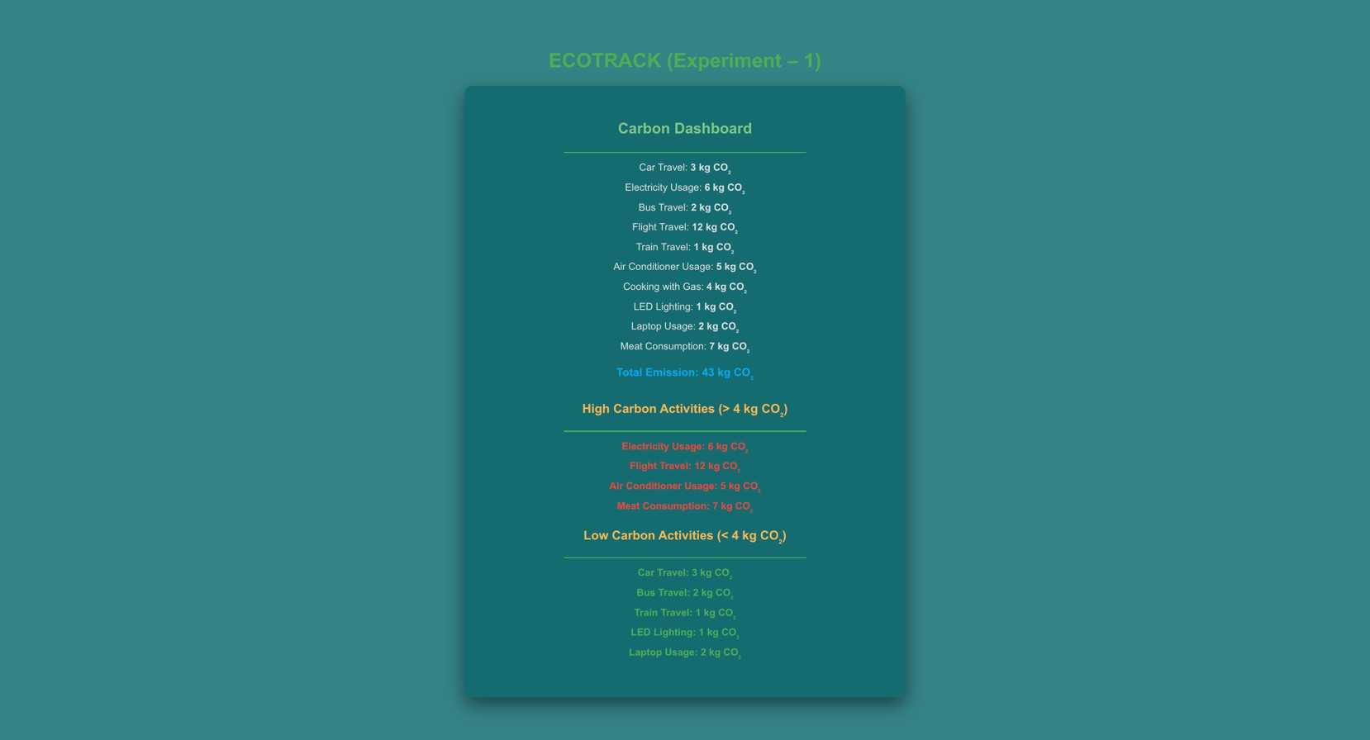
- (Output verified using the EcoTrack React application interface)

Learning Outcomes:
After completing this experiment, the student is able to:
- Set up a React project using Vite
- Understand and implement component-based design
- Use ES6 array methods for dynamic UI rendering
- Structure a React application using separation of concerns
- Build a foundational frontend architecture for a real-world application

