**OUTPUT(Gephi)**

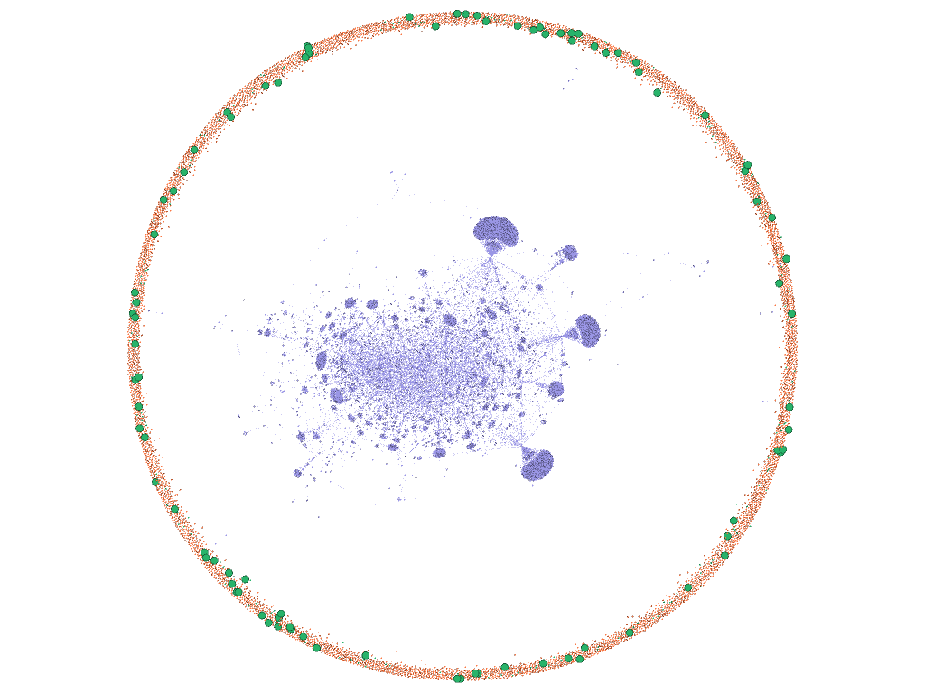After getting the two layouts of our Network Analysis on Amber Heard’s Twitter thread to analyze it in more detail we partitioned them as per the category and colored them. The Quoted Tweets as GREEN and Twitter users as orange whereas the purple spots in the middle are of the network of Null values presented in the dataset.

As it is clearly visible in the (fig 3)

fig 3

To extract the more valuable insights the quoted tweets nods are further portioned as per the is_retweet and increased the size of the nods to make them clearly visible on the rim.

Now to gain insights and to eliminate the null values the Multimode Partition is being executed where after doing the load attribute, the attribute type was selected as CAT, the left matrix was selected as Twitter-null and the right matrix was selected as null-Twitter after that the option to remove nodes edges were selected and the command was executed that provided the output in (fig4)

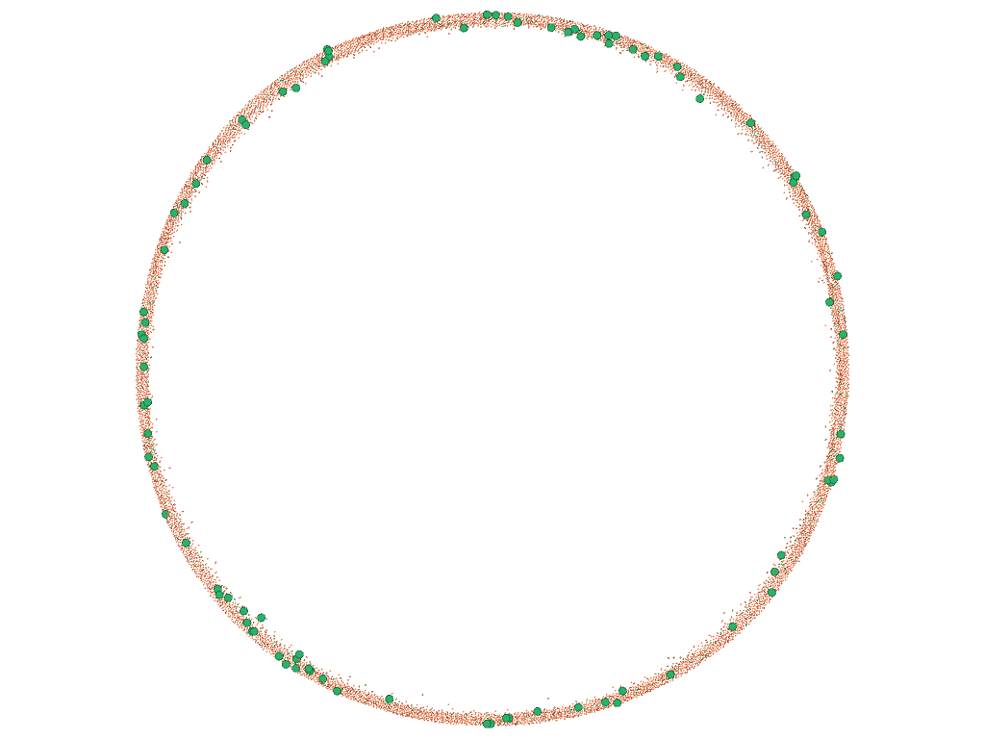

fig 4

After this, the following steps can be undertaken as well: -

* Modularity test
* Filter to check the connection

The Modularity Test needs to be executed multiple times to minimize the communities and the filtration can be done to check the connection between the quoted tweets and the Twitter users