COMPUTER GRAPHICS (E1CSA377) – MicroProject-1

Name: Muskan Kumari  Reg no: 2411021061512 | Date: 18/08/2026  Sec: IT - AR/VR

Visualization of Parallel-Line Preservation Under Affine Transformations

1. About the Project
This project, Visualization of Parallel-Line Preservation Under Affine Transformations, is a graphical application developed using Python, NumPy, and Matplotlib. It demonstrates one of the most important geometric properties of affine transformations: parallel lines in an object always remain parallel after the object is translated, rotated, scaled, or sheared.
A parallelogram is used as the demonstration object because it has two clearly identifiable pairs of parallel sides. Interactive sliders let the user apply different affine transformations to the object and visually confirm that, no matter how the shape moves, spins, grows, or slants, its parallel sides never lose their parallelism. This is contrasted conceptually with projective (perspective) transformations, which do not guarantee this property.
The project builds an intuitive, visual understanding of why affine transformations are widely used in Computer Graphics, CAD systems, image warping, and AR/VR environments — they preserve straightness, parallelism, and ratios of distances along a line, even though angles and lengths may change.

2. Technologies Used
- Programming Language: Python
- Library: Matplotlib
- Library: NumPy
- Interface: Matplotlib interactive sliders
- Concept: Affine transformations and parallel-line invariance

3. Affine Transformations Used
An affine transformation is any transformation that can be expressed as a linear transformation (rotation, scaling, shearing) followed by a translation. In homogeneous coordinates, every affine transformation of a 2D point can be written as a single 3×3 matrix multiplication:
[x' y' 1]ᵀ = M · [x y 1]ᵀ
3.1 Translation
Translation shifts every point of the object by a fixed offset (tx, ty).
x' = x + tx
y' = y + ty
Translation Matrix T
1 | 0 | tx
0 | 1 | ty
0 | 0 | 1
3.2 Rotation
Rotation turns the object by an angle θ about the origin.
x' = x cosθ − y sinθ
y' = x sinθ + y cosθ
Rotation Matrix R
cosθ | −sinθ | 0
sinθ | cosθ | 0
0 | 0 | 1
3.3 Scaling
Scaling changes the size of the object along the X and Y axes by factors Sx and Sy.
x' = Sx · x
y' = Sy · y
Scaling Matrix S
Sx | 0 | 0
0 | Sy | 0
0 | 0 | 1
3.4 Shearing
Shearing slants the object along the X-direction while keeping the Y-coordinate unchanged.
x' = x + Shx · y
y' = y
Shear Matrix Hx
1 | Shx | 0
0 | 1 | 0
0 | 0 | 1

4. Why Affine Transformations Preserve Parallel Lines
Consider two parallel line segments in the original object. Because they are parallel, their direction vectors d₁ and d₂ are scalar multiples of each other: d₂ = k · d₁ for some constant k.
Every affine transformation applies the same linear part (the 2×2 sub-matrix of rotation, scaling, or shear) to every point of the object, and adds the same translation vector to every point. When the linear part M is applied to both direction vectors:
M·d₂ = M·(k·d₁) = k·(M·d₁)
The transformed direction vectors are still scalar multiples of one another, so the transformed segments remain parallel. Translation only shifts both lines by the same amount and therefore cannot change their relative direction. This proves that translation, rotation, scaling, and shearing — all affine maps — preserve parallelism. Only non-affine (projective) transformations, which include a perspective division, can make previously parallel lines appear to converge.

5. Flowchart of the Problem Statement
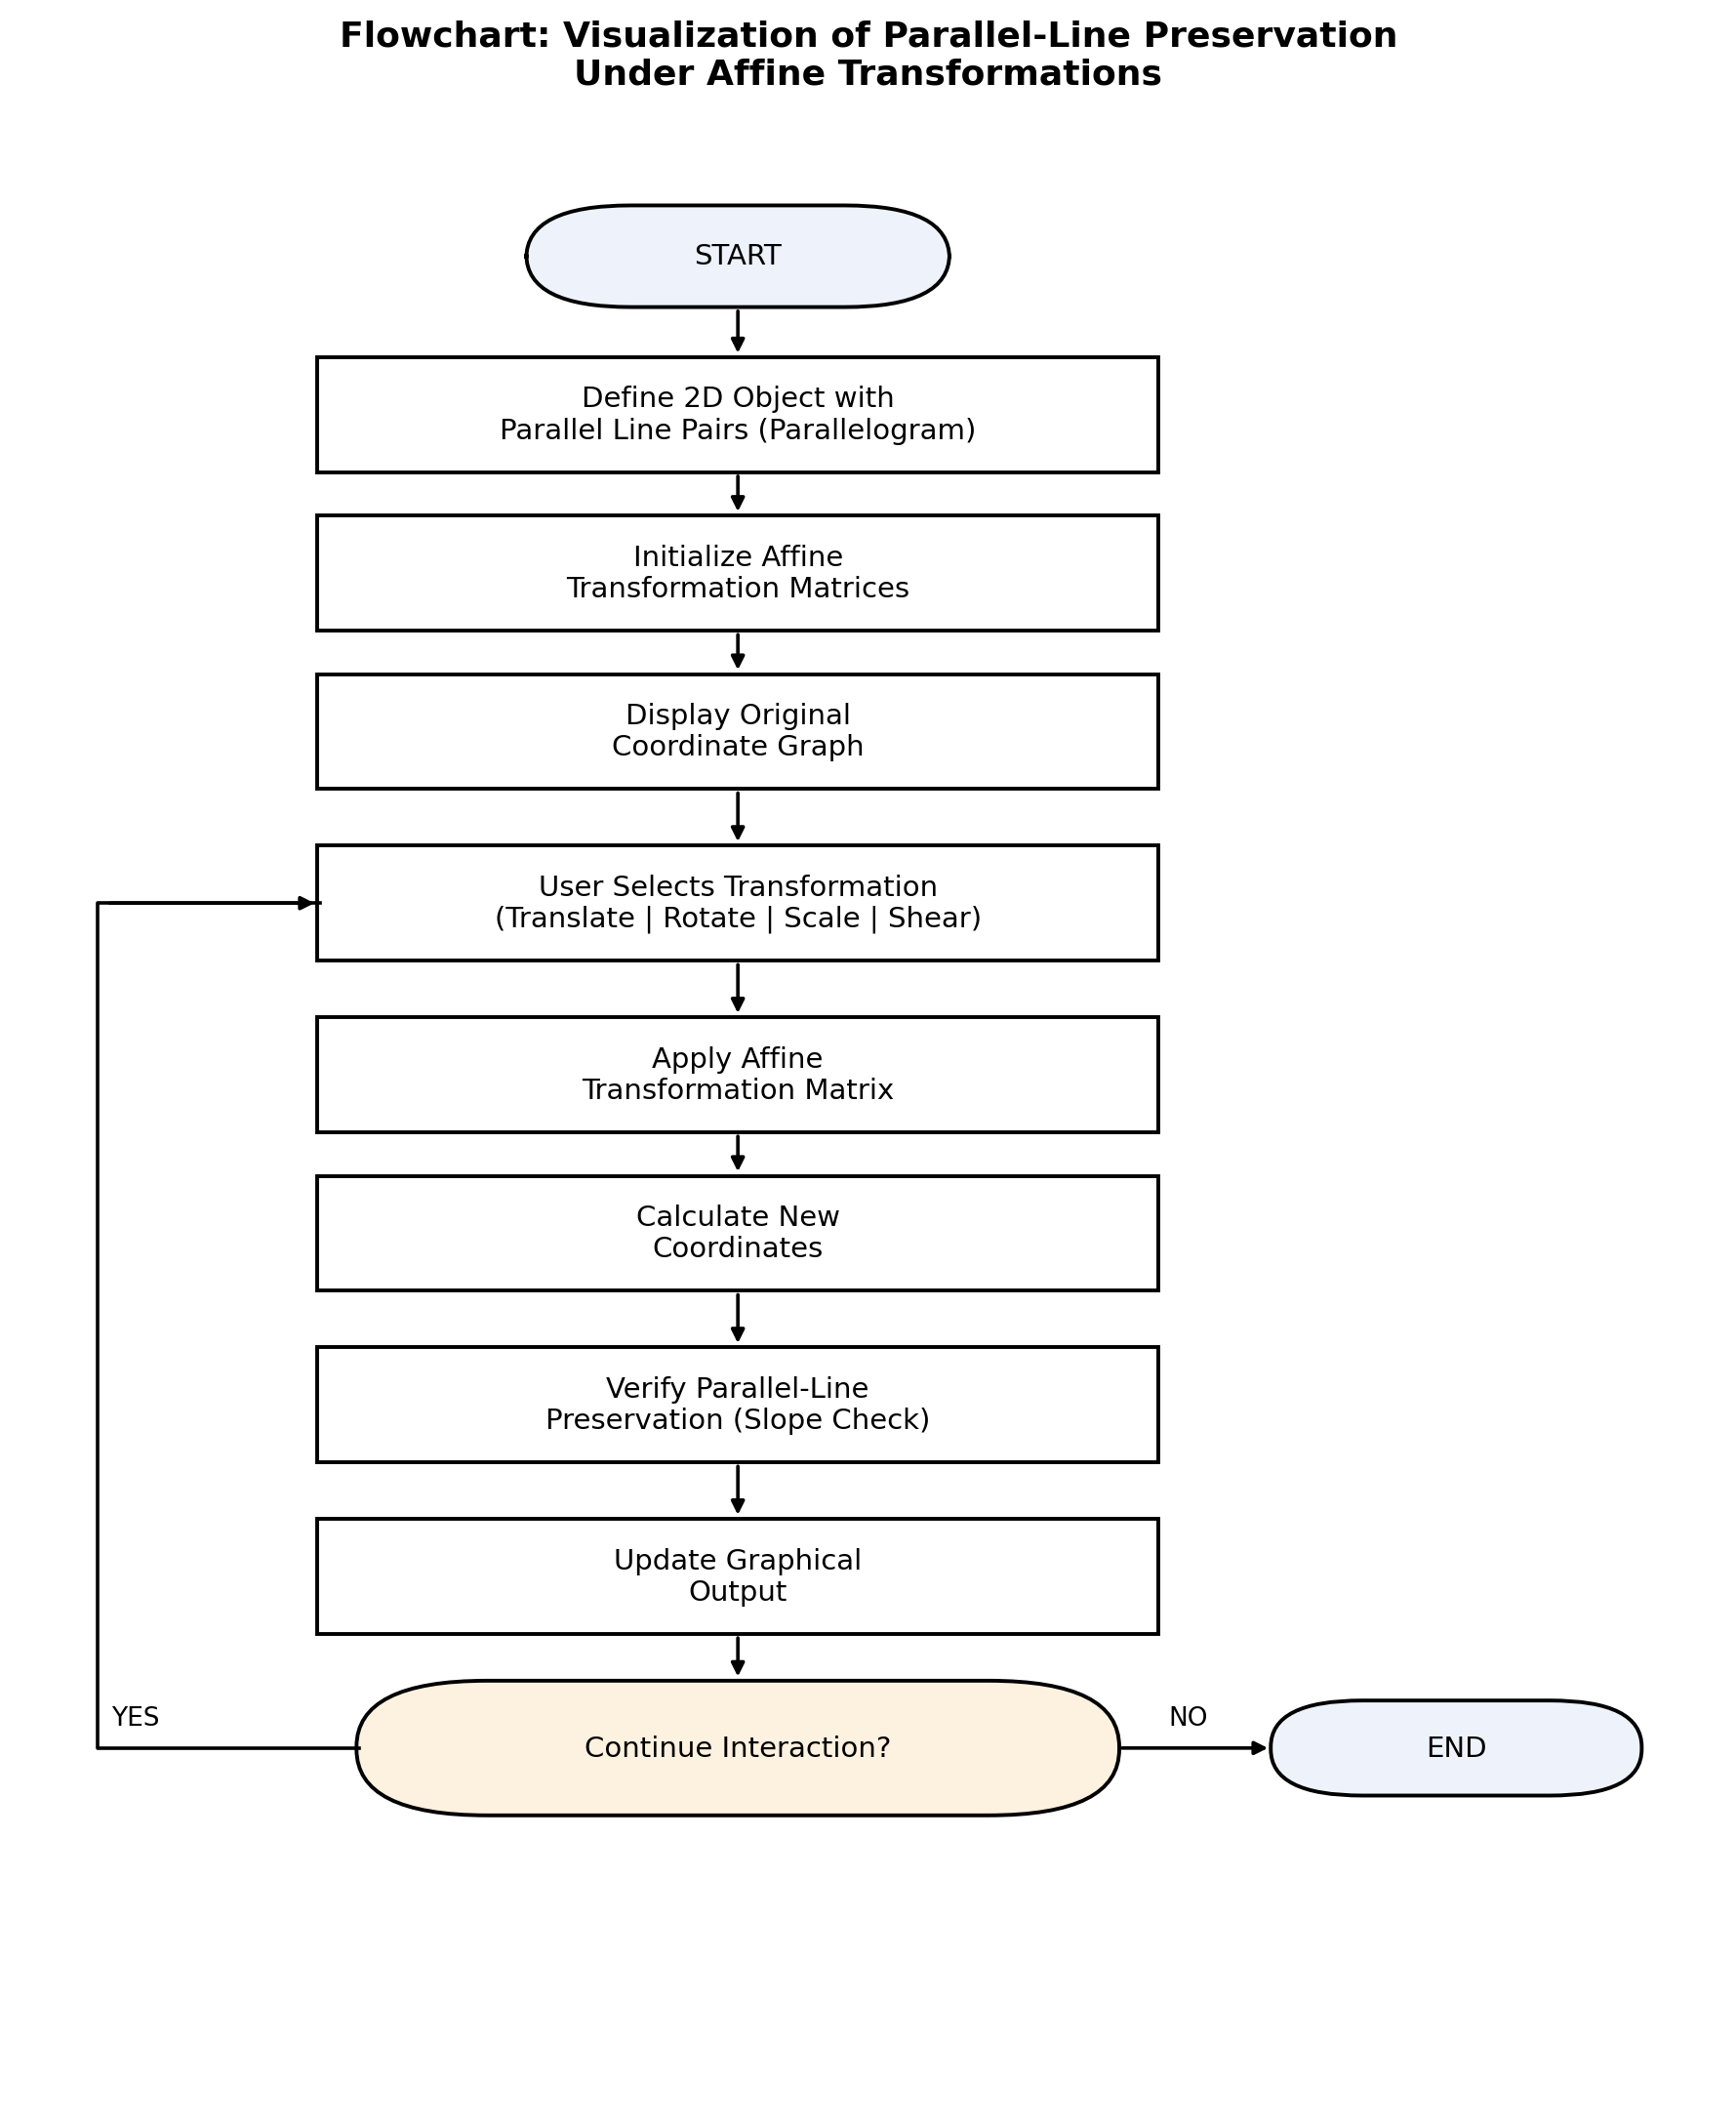

6. Output of the Problem Statement
The parallelogram's two side-pairs are colour-coded (green and red) in the figures below. In every panel, the dashed blue outline is the original object and the solid orange outline is the transformed object. Observe that each coloured pair of sides stays parallel to itself after the transformation, even though the object's position, orientation, size, or slant has changed.
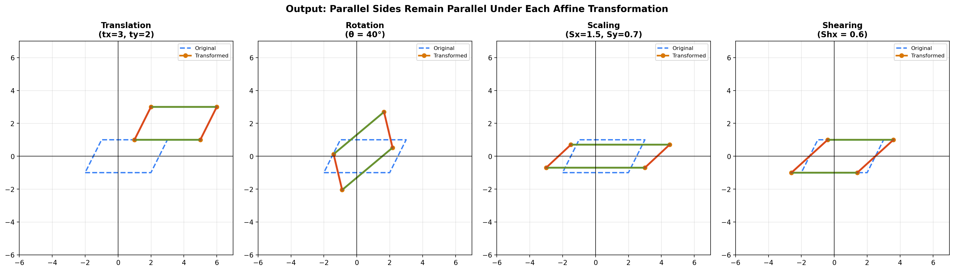
Fig: Parallel side-pairs (green and red) remain parallel under translation, rotation, scaling, and shearing.
Slope verification confirms this numerically. For example, under rotation by 40°, the green pair of sides both have slope 0.839 after transformation, and the red pair both have slope −4.186 — equal slopes within each pair confirm parallelism is preserved.

7. Methodology
Step 1: Define the 2D Object
A parallelogram with two clear pairs of parallel sides is represented using a NumPy coordinate array.
Step 2: Initialize the Coordinate System
A Matplotlib graph is created with X and Y axes, grid lines, and a fixed coordinate range. The original object is displayed on the graph.
Step 3: Create Affine Transformation Matrices
- Translation matrix
- Rotation matrix
- Scaling matrix
- Shearing matrix
Step 4: Add Interactive Controls
Matplotlib sliders let the user adjust X/Y translation, rotation angle, scale factor, and shear value.
Step 5: Apply the Transformation
Whenever a slider changes, the selected affine matrix is applied to every vertex of the parallelogram to compute new coordinates.
Step 6: Verify Parallel-Line Preservation
The slopes of each pair of opposite sides are recomputed after transformation and compared to confirm they remain equal, proving the sides are still parallel.
Step 7: Update the Output
The transformed and original parallelograms are redrawn on the same coordinate plane so the user can visually compare them in real time.

8. Analysis
The demonstration confirms the theoretical result: every affine transformation — translation, rotation, scaling, and shearing — preserves the parallelism of lines, because each is built from a single linear map applied uniformly to every point, plus a constant translation. This is the reason affine transformations are the standard tool for object placement, animation, and modelling in computer graphics: they distort shapes predictably without breaking the parallel structure that many models rely on (grids, wireframes, textures, UI layouts). Non-affine (projective) transformations, by contrast, can make parallel lines converge, which is precisely the effect used to create perspective/depth in 3D rendering.

9. Conclusion
This project successfully visualizes and verifies that affine transformations — translation, rotation, scaling, and shearing — preserve the parallelism of lines in a 2D object. By combining matrix-based transformation mathematics with interactive graphical visualization, the project turns an abstract linear-algebra property into a directly observable result. It strengthens the understanding of affine geometry and its central role in Computer Graphics, 2D/3D modelling, and AR/VR systems.

