oop lab#1 assignment



**1. Code:**

System.out.printn(“Hello World”)

**Output:**

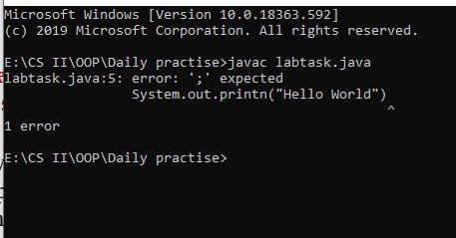

The code tells that there is mistake of semicolon in line 5

**2. Code:**

System.out.printn(Hello World)

**Output:**

The code tells that there is mistake iin line 5

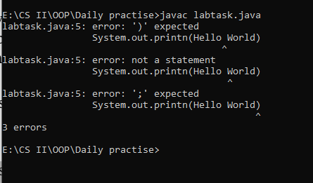

**3.Code:**

System.out.println”Hello World”;

**Output:**

The code tells that there is mistake iin line 5

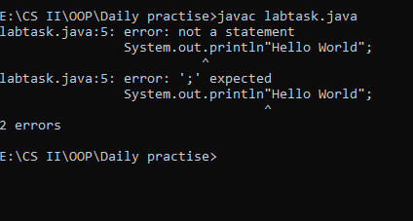



**Code:**

import java.util.Scanner;

class Evenchecker

{

public static void main( String args[] )

{

Scanner sc= new Scanner(System.in);

System.out.println("Enter your number:\t");

int num = sc.nextInt();

if(num%2==0)

System.out.println("Your number is even ");

else if(num%2!=0)

System.out.println("Your number is odd");

}

}

**Output:**

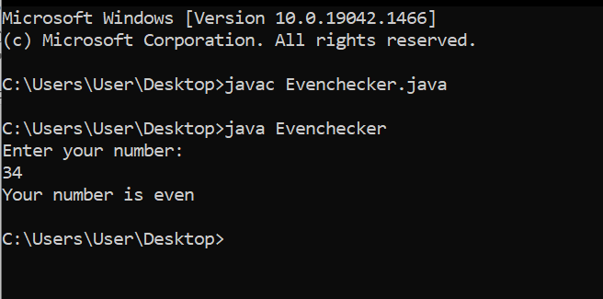



**Code:**

import java.util.Scanner;

class Divide

{

public static void main (String args [])

{

Scanner sc= new Scanner (System.in);

double num1, num2;

int d;

System.out.print("Enter the first number:\t");

num1 = sc.nextDouble();

System.out.print("Enter the second number:\t");

num2 = sc.nextDouble();

d= (int) num1/ (int) num2;

System.out.print("The result after dividing the number =\t"+d);

}

}

**Output:**

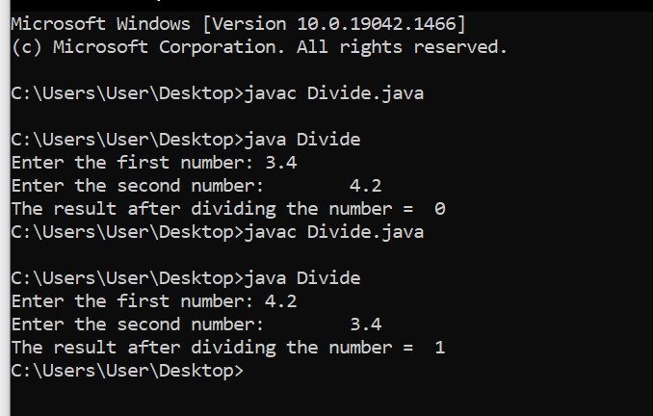





**Code:**

import java.util.Scanner;

class Largest

{

public static void main(String args[])

{

Scanner sc = new Scanner(System.in);

int a,b,c;

System.out.print("Enter Value 1: ");

a = sc.nextInt();

System.out.print("Enter Value 2: ");

b = sc.nextInt();

System.out.print("Enter Value 3: ");

c = sc.nextInt();

if(a>b && a>c)

{

System.out.println("Largest value is: "+a);

}

else if(a<b && b>c)

{

System.out.println("Largest value is: "+b);

}

else if(c>b && a<c)

{

System.out.println("Largest value is: "+c);

}

else

{

System.out.println("Largest can not find");

}

}

}

**Output:**

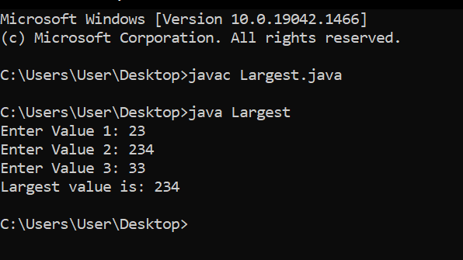

**Question to ponder**

1. **Can you cast string into int?**

We can convert String to an int in java using Integer.

* Use Integer.parseInt() to Convert a String to an Integer. This method returns the string as a primitive type int. ...
* Use Integer.valueOf() to Convert a String to an Integer. This method returns the string as an integer object.

1. **Why JAVA when there are other OOP languages?**

Java database connectivity is the most popular and widely used to connect various devices. If you look at the practical agility, Java provides more undeviating refactoring support than other languages because of its static type system. And is more commonly used for mobile and web applications.