**Unveiling Employment and Socioeconomic Patterns**

An Analysis of PLFS Unit Level Data

**Project Report under the MoSPI Summer Internship 2024-25**

**at**

**National Sample Survey Office**

**Field Operations Division, Jaipur**

**Ministry of Statistics and Programme Implementation**

**Submitted by:**

**Muskan**

**M.Sc. Statistics**

**Department of Statistics**

**Central University of Rajasthan**

**Disclaimer**

I, **Muskan**, a student of M.Sc. Statistics 1st Year, Department of Statistics, Central University of Rajasthan, hereby declare that this project report entitled **“Unveiling Employment and Socioeconomic Patterns: An Analysis of PLFS Unit Level Data”** submitted to NSSO, FOD, RO Jaipur is a part of the Internship Programme 2023-24 conducted by the Ministry of Statistics and Programme Implementation. This is a bona fide record of work undertaken by me under the supervision of officials of NSSO, MOSPI, Jaipur, and it shall not form the basis for the award of any other Degree/Fellowship by NSSO, Jaipur or MoSPI.

The analysis done in this report is purely research work conducted by the undersigned to develop an understanding of employment and socioeconomic patterns in India. The unit level data of the Periodic Labour Force Survey (PLFS) is used to derive the statistical analysis presented in this report. The views expressed in the report are solely personal and do not bind the office in any manner.

**Muskan, Student**

M.Sc. Statistics

Department of Statistics

Central University of Rajasthan

**Acknowledgement**

I am deeply grateful to the National Sample Survey Office (NSSO), Field Operations Division (FOD), Regional Office (RO) Jaipur, for the opportunity to work on this insightful project as part of the Internship Programme 2023-24 organized by the Ministry of Statistics and Programme Implementation (MoSPI). Special thanks to **Dr. Hansraj Yadav**, DDG, for his invaluable guidance, mentorship, and expertise, which were instrumental in enhancing my learning and skills in statistics and data management. My immense gratitude also extends to **Mr. Harshvardan Garhwal** and the entire team at the Ministry for their warm welcome, cooperation, and knowledge sharing, significantly contributing to my professional growth.

I am thankful to all the officials and staff members at NSSO, Jaipur, for their cooperation and assistance, which greatly facilitated my understanding and completion of this project. I also appreciate the faculty members of the Department of Statistics, Central University of Rajasthan, for their encouragement and academic support, which have been the foundation of my statistical knowledge and skills. Lastly, I would like to thank my family and friends for their unwavering support and encouragement throughout my academic journey. This project has been a tremendous learning experience, and I am grateful to everyone who contributed to its successful completion.

**Muskan, Student**

M.Sc. Statistics

Department of Statistics

Central University of Rajasthan

**Table of Contents**

1. **Introduction**
   1. About MOSPI
   2. PLFS Schedule
   3. Unit Level Data Source
   4. Unit Level Data Extraction Using Python and Excel
   5. Problems Faced During Data Cleaning
2. **Objectives**
3. **Prerequisites and Methodology**
4. **Implementation**
   1. Extraction and Merging of Household and Person-wise Data
   2. Exploratory Data Analysis (EDA)
   3. Correlation Analysis
   4. Regional Analysis
   5. Trend Analysis
   6. Hypothesis Testing
   7. Cluster Analysis
   8. Model Fitting
   9. Data Visualization using Tableau and Python
5. **Outcomes**
6. **Limitations**
7. **Conclusion**

**INTRODUCTION**

* **About the MoSPI:**

The Ministry of Statistics and Programme Implementation (MOSPI) in India plays a crucial role in collecting, compiling, and disseminating accurate and timely statistical information across various aspects of the Indian economy and society. Established on October 15, 1999, MOSPI's primary objective is to provide data-driven insights to policymakers, researchers, businesses, and the general public, enabling informed decision-making and a comprehensive understanding of the nation's developmental progress.

MOSPI's functions are the collection of data through periodic surveys and censuses, covering a wide range of subjects, including national income, industrial production, employment, consumption, health, education, and poverty. The ministry meticulously designs and conducts these surveys to ensure data accuracy and representation, capturing a holistic view of the population's economic activities and social characteristics.

The National Sample Survey (NSS) is one of the most extensive surveys conducted by MOSPI, offering valuable insights into consumption patterns, employment trends, agricultural activities, and various other demographic and economic indicators. Regularly conducted, the NSS informs policy interventions and development strategies.

Once data is collected, MOSPI compiles and analyses the information using rigorous methodologies and statistical techniques to create reliable statistical reports and indicators. The ministry focuses on ensuring data accuracy, consistency, and relevance, enabling data-driven decision-making.

A key aspect of MOSPI's work is calculating India's national income and Gross Domestic Product (GDP), providing a comprehensive view of the country's economic performance. Regular updates on GDP estimates are closely monitored by stakeholders within India and internationally.

MOSPI also compiles and reports various socio-economic indicators, including literacy rates, life expectancy, poverty levels, unemployment rates, and gender-related indices. Monitoring these indicators helps to identify areas of concern and progress, facilitating targeted policy interventions.

Aligning with the United Nations' Sustainable Development Goals (SDGs), MOSPI tracks India's progress towards achieving these global development targets. By measuring advancements in critical areas such as poverty eradication, healthcare, education, gender equality, and environmental sustainability, MOSPI contributes to the nation's commitment to sustainable and inclusive development.

Data-driven policymaking is a fundamental focus of MOSPI's activities. The ministry provides statistical inputs to the government for formulating policies and development programs, prioritizing areas of intervention and designing effective strategies.

Ensuring data transparency and accessibility is a key priority for MOSPI, as it disseminates statistical data and reports through its website, publications, and databases, promoting a greater understanding of the nation's socio-economic dynamic

The Index of Industrial Production (IIP) and the Consumer Price Index (CPI) are important indicators compiled and published by MOSPI, providing insights into industrial performance, economic activity, demand trends, and inflation.

Recently, MOSPI launched the Periodic Labour Force Survey (PLFS) to provide accurate and up-to-date information on employment and unemployment, capturing labour market dynamics and employment patterns across various segments of the population.

Recognizing regional disparities and sectoral variations, MOSPI provides state-level and sector-specific data, enabling targeted interventions to address specific challenges faced by different regions and industries.

Maintaining data quality and adopting robust statistical methodologies are paramount for MOSPI, ensuring data accuracy and consistency. The ministry continuously strives to improve data collection processes and methodologies to keep pace with evolving economic and social realities.

MOSPI's commitment to international cooperation is reflected in its collaborations with global organizations and statistical agencies, aiming to adopt best practices and enhance the comparability of India's statistical data with other countries.

While MOSPI has achieved significant milestones, it faces challenges, including adapting to rapid changes in the economy and ensuring data accuracy and coverage across India's vast and diverse population. Embracing new data sources, methodologies, and technological advancements will further strengthen MOSPI's position as India's primary statistical authority, supporting the country's economic and social transformation.

The Ministry of Statistics and Programme Implementation (MOSPI) in India consists of several departments, each with specific roles and responsibilities in collecting, analysing, and disseminating statistical information. Here's a brief overview of the key departments within MOSPI:

* + 1. Central Statistics Office (CSO): The Central Statistics Office is the primary department responsible for collecting and compiling national economic statistics. It prepares and releases key economic indicators, including the Gross Domestic Product (GDP), Index of Industrial Production (IIP), and Consumer Price Index (CPI). The CSO plays a crucial role in providing accurate and reliable economic data to support policymaking and economic planning
    2. Computer Centre (CC): The Computer Centre is responsible for providing technical support and infrastructure to handle the data processing needs of the ministry. It plays a vital role in ensuring efficient data management, analysis, and dissemination. The CC also aids in developing and maintaining MOSPI's online databases and web portals to make statistical information accessible to the public**.**
    3. National Sample Survey Office (NSSO): The National Sample Survey Office conducts large-scale household surveys known as the National Sample Surveys (NSS). These surveys gather comprehensive data on various socio-economic aspects of the population, such as consumption patterns, employment, education, healthcare, and poverty. The NSSO's data is instrumental in understanding social and economic dynamics and helps shape policies and development programs.

The NSSO has four Divisions:

* Survey Design and Research Division (SDRD): This Division, located at Kolkata, is responsible for the technical planning of surveys, formulation of concepts and definitions, sampling design, designing of inquiry schedules, drawing up of tabulation plan, analysis, and presentation of survey results.
* Field Operations Division (FOD): The Division, with its headquarters at Delhi/Faridabad and a network of six Zonal Offices, 52 Regional Offices, and 117 SubRegional Offices spread throughout the country, is responsible for the collection of primary data for the surveys undertaken by NSS.
* Data Processing Division (DPD): The Division, with its headquarters at Kolkata and 5 other Data Processing Centres at various places, is responsible for sample selection, software development, processing, validation, and tabulation of the data collected through surveys. Price and Wages in Rural India collected through schedule 3.01(R) is being processed at DPC Giridih. In addition, DPD is also processing the data of the Periodic Labour Force Survey (PLFS). Industrial Statistics Wing (IS Wing), DPD, NSS, Kolkata is responsible for sample selection, data processing, validation, and tabulation of the Annual Survey of Industries (ASI) data collected through a dedicated web portal.
* Survey Coordination Division (SCD): This Division, located at New Delhi, coordinates all the activities of different Divisions of NSS. It also brings out the bi-annual journal of NSS, titled “Sarvekshana”, and organizes National Seminars on the results of various surveys.
* **PLFS Schedule:**

#### Schedule 0.0PL: List of Households

**Identification of Sample FSU:**

* The schedule begins with the identification details of the sample First Stage Units (FSUs) which include the state, district, sub-district/tehsil, village/town, and other relevant codes.
* Specific codes are used to indicate sectors (rural or urban), NSS region, stratum, and sub-stratum (for rural areas). The schedule number, survey quarter, year of selection, and other details are also recorded.

**Field Operations:**

* Field operations are recorded, detailing the names and codes of the survey enumerator (SE) and survey supervisor (SS).
* Dates of survey commencement, completion, receipt, scrutiny, and dispatch are noted.
* Total time taken to canvass the schedule by the team of enumerators is recorded in hours.
* Any remarks by the survey enumerator and comments by supervisory officers are documented.

**Particulars of Sampling of Households:**

* This section lists the households and records details such as house number, household serial number, name of the head of household, household size, and the number of members with at least secondary education.
* The list includes specifics about the population and household counts for rural and urban areas. It also involves details on substitution codes and reasons for substitution when the original sample FSU is not surveyed.

**Sketch Map of Hamlet-Group/Sub-Block Formation:**

* A sketch map is drawn to indicate the hamlet-group or sub-block formations. This is particularly crucial for rural samples where hamlet formation occurs.
* It includes a list of hamlets, the percentage of the population, and the serial numbers of hamlets within the hamlet-groups (HG) or sub-blocks (SB).

**List and Selection of Hamlet-Groups/Sub-Blocks:**

* The list includes serial numbers, names of hamlets, and the percentage of population in each hamlet.
* Details on the sampling of these hamlet-groups or sub-blocks are recorded, highlighting the second stage stratum, number of households listed and selected, surveyed households, and any substitutions made.

**Schedule 10.4: Employment and Unemployment**

**First Visit (Employment and Unemployment):**

* Schedule 10.4 is used for the first visit to collect detailed information on employment and unemployment.
* The schedule captures various employment characteristics, including current weekly activity status, usual principal and subsidiary status, industry and occupation, and details of the enterprise for self-employed persons.
* For each individual, data on educational qualifications, vocational training, and household characteristics like land ownership, assets, and liabilities are collected.

**Revisit for Urban Areas Only:**

* For urban areas, a revisit is conducted to capture changes in employment and unemployment status over time.
* The revisit schedule aims to monitor seasonal variations in employment patterns and ensure the accuracy of the collected data.

The PLFS schedules are meticulously designed to collect comprehensive data on labor force parameters in both rural and urban areas. Schedule 0.0PL focuses on listing and identifying households, while Schedule 10.4 delves into employment and unemployment specifics during the first visit and revisits for urban areas. These schedules ensure systematic data collection, facilitating accurate and reliable labor force statistics for policy-making and economic analysis.

* **Unit Level Data Source:**

The **Periodic Labour Force Survey (PLFS)** is an extensive initiative conducted by the National Statistical Office (NSO) under the Ministry of Statistics and Programme Implementation (MoSPI) in India. The PLFS collects detailed unit-level data to provide comprehensive insights into employment, unemployment, and other labor market characteristics. Understanding the source and methodology of unit-level data collection is crucial for appreciating the reliability and depth of the survey results.

#### Purpose and Scope

The PLFS aims to provide quarterly and annual estimates of various labor force indicators for both rural and urban areas. These indicators include the labor force participation rate, worker population ratio, unemployment rate, and various other metrics related to employment and unemployment.

#### Sample Design

The unit-level data of the PLFS is derived from a scientifically designed sample survey that ensures representativeness across different geographical regions and socio-economic groups. The key elements of the sample design include:

1. **Sampling Frame**:
   * The sampling frame for the PLFS is based on the Census of India data, supplemented by the latest updates from various administrative records and registers.
   * Separate sampling frames are maintained for rural and urban areas to capture the unique characteristics of each.
2. **Stratification and Sub-Stratification**:
   * The country is divided into distinct strata based on geographical and socio-economic criteria.
   * In rural areas, stratification is typically based on agro-climatic zones, while urban areas are stratified by city size and economic activity.
   * Further sub-stratification within each stratum ensures a more detailed and nuanced representation.
3. **Two-Stage Sampling Design**:
   * **First Stage Units (FSUs)**: Villages in rural areas and Urban Frame Survey (UFS) blocks in urban areas serve as the first stage units.
   * **Second Stage Units (SSUs)**: Households within the selected FSUs are chosen as the second stage units.
   * A random selection of FSUs is followed by a systematic sampling of households within these FSUs.

#### Data Collection Methods

The PLFS employs a robust data collection methodology to ensure the accuracy and reliability of the unit-level data:

1. **Household Interviews**:
   * Trained field investigators visit selected households to conduct detailed interviews.
   * Information is collected using structured questionnaires, which are designed to capture a wide range of labor market and demographic data.
2. **Schedules of Enquiry**:
   * **Schedule 0.0PL**: Used for listing and identifying households in the selected FSUs. It includes detailed information about household composition, demographic characteristics, and sampling particulars.
   * **Schedule 10.4**: Focuses on employment and unemployment details. It collects data on current weekly activity status, usual principal and subsidiary status, industry, occupation, and educational qualifications.
3. **Periodic Visits and Revisits**:
   * For urban areas, the survey involves both initial visits and revisits to capture seasonal variations in employment patterns.
   * This repeated interaction helps in monitoring changes over time and enhances the accuracy of the data.

#### Data Processing and Quality Assurance

1. **Data Entry and Validation**:
   * Collected data undergoes rigorous validation checks and processing to ensure consistency and accuracy.
   * Advanced software tools and statistical techniques are used to clean and verify the data before analysis.
2. **Training and Supervision**:
   * Field investigators and supervisors receive extensive training to ensure they are well-versed with the survey procedures and questionnaire administration.
   * Regular supervision and monitoring of field activities help maintain high data quality standards.
3. **Confidentiality and Anonymity**:
   * The NSO ensures the confidentiality and anonymity of respondents' information.
   * Data is anonymized before being made available for public use and research purposes.

#### Utilization of Unit-Level Data

The unit-level data from the PLFS is a valuable resource for policymakers, researchers, and economists. It provides granular insights into the labor market, enabling the formulation of evidence-based policies and interventions. Key applications include:

1. **Policy Formulation**:
   * Informing government policies on employment, skill development, social security, and labor welfare.
   * Assessing the impact of existing labor market policies and programs.
2. **Economic Analysis**:
   * Analyzing trends in labor force participation, employment, and unemployment across different regions and demographic groups.
   * Studying the impact of macroeconomic factors on the labor market.
3. **Academic Research**:
   * Supporting academic studies on labor economics, demographic transitions, and socio-economic development.
   * Providing a rich dataset for empirical research and statistical modeling

The unit-level data from the PLFS is an indispensable tool for understanding India's labor market dynamics. Through meticulous sampling design, robust data collection methods, and stringent quality assurance processes, the PLFS ensures the reliability and comprehensiveness of its data. This data serves as a cornerstone for informed decision-making and strategic planning in the realm of employment and labor policies.

* **Unit Level Data Extraction Using Python and Excel:**

The extraction of unit-level data from large datasets, such as the Periodic Labour Force Survey (PLFS), is a critical step in conducting detailed and insightful analyses. This process can be efficiently handled using tools like Python for programming and Excel for initial data review and simple transformations. Below is a comprehensive explanation of how to perform unit-level data extraction using both Python and Excel, tailored for inclusion in a report.

#### Overview of Data Extraction

Unit-level data extraction involves several key steps, including reading the data from source files, cleaning and transforming the data, and preparing it for analysis. Python and Excel complement each other in this process; Python is used for its powerful data manipulation capabilities, and Excel for its accessibility and ease of use for initial data inspection.

#### Step-by-Step Process

1. **Reading the Data Using Python:**

* Python provides various libraries such as pandas for handling data efficiently. The read_fwf function from pandas is particularly useful for reading fixed-width formatted files, which are common in large datasets like PLFS.

1. **Initial Data Inspection Using Excel:**

* Before performing complex manipulations, it is often helpful to inspect the data in Excel. This can help identify any immediate issues such as missing values or incorrect formatting.
* Open the saved PLFS_sample.xlsx file in Excel to visually inspect the data. Check for any obvious anomalies and understand the data structure.

1. **Data Cleaning and Transformation in Python:**

* After inspecting the data in Excel, use Python to perform necessary cleaning and transformations. This may include handling missing values, converting codes to meaningful labels, and merging with additional data sources.

1. **Final Data Preparation:**

* Once the data is cleaned and transformed, save the final dataset for analysis. This dataset is now ready for detailed statistical analysis and reporting.

Using Python and Excel for unit-level data extraction combines the strengths of both tools. Python’s robust data manipulation capabilities handle large datasets efficiently, while Excel’s user-friendly interface allows for easy initial data inspection. This approach ensures that the data is thoroughly cleaned, accurately transformed, and ready for detailed analysis. This process not only enhances the quality of the analysis but also ensures the integrity and reliability of the findings.

* **Problems Faced During Data Cleaning:**

Data cleaning is an essential phase in the data analysis process that involves identifying and correcting errors and inconsistencies in the dataset to ensure its accuracy and reliability. Throughout this project, several challenges were encountered during the data cleaning process. Below is an expanded explanation of these challenges and the methods used to address them.

#### 1. Handling Missing Values

**Challenge:** Missing values can distort the analysis and lead to inaccurate conclusions. In the PLFS dataset, missing values were present in various columns, which required careful handling.

**Solution:** Several strategies were employed to handle missing values:

* **Imputation:** For numerical columns, missing values were imputed using statistical techniques such as mean, median, or mode imputation. For categorical columns, the most frequent category was used for imputation.
* **Removal:** In cases where the proportion of missing values was high and could not be reliably imputed, the entire row or column was removed to prevent it from affecting the analysis.

#### 2. Standardizing Inconsistent Data Formats

**Challenge:** The dataset contained inconsistencies in data formats, such as varying date formats and inconsistent categorical variable representations.

**Solution:**

* **Date Formats:** Dates were standardized to a consistent format (e.g., YYYY-MM-DD).
* **Categorical Variables:** Categories were standardized by ensuring consistent naming conventions (e.g., converting all text to lowercase or uppercase).

#### 3. Correcting Encoding Issues

**Challenge:** Some data contained special characters or different encodings, which needed to be corrected to ensure proper analysis.

**Solution:**

* **Encoding Correction:** Data was re-encoded to a standard encoding format (e.g., UTF-8) to handle special characters correctly.
* **Special Characters Removal:** Special characters were removed or replaced with appropriate values.

#### 4. Identifying and Removing Duplicate Records

**Challenge:** Duplicate records can skew results and lead to inaccurate analysis. Identifying and removing these records was crucial.

**Solution:**

* **Duplicate Detection:** Duplicates were detected based on a subset of columns that uniquely identify a record.
* **Duplicate Removal:** Identified duplicates were removed from the dataset to ensure that each record was unique.

Data cleaning is a critical step in the data analysis process, ensuring the accuracy, consistency, and reliability of the data. Addressing challenges such as missing values, inconsistent data formats, encoding issues, and duplicate records requires meticulous inspection and the application of various data cleaning techniques. By leveraging the strengths of both Python and Excel, a robust and reliable dataset was prepared, laying the foundation for meaningful analysis and insights.

**Objectives**

The primary objectives of this analysis are to:

1. **Understand Employment Patterns**:

* Examine the employment patterns across different demographic groups, such as age, gender, education level, and social group.

1. **Analyze Expenditure Patterns**:

* Investigate the expenditure patterns of households, focusing on categories such as consumer goods, education, and healthcare.

1. **Examine Education and Employment Relationship**:

* Analyze the relationship between education levels and employment status, identifying trends and disparities.

1. **Identify Regional Trends**:

* Identify trends in employment and education across different regions, highlighting regional disparities and commonalities.

1. **Perform Statistical Analysis**:

* Conduct statistical analysis, including correlation, regression, and hypothesis testing, to draw meaningful conclusions from the data.

1. **Visualize Data**:

* Use data visualization techniques to present findings in an accessible and interactive manner.

**Prerequisites and Methodology**

### Prerequisites

#### Software:

* **Python:** Used for data extraction, cleaning, and analysis due to its powerful libraries and flexibility.
* **Excel:** Employed for preliminary data inspection and manual data entry corrections.
* **Tableau:** Utilized for creating interactive visualizations and dashboards to present the findings clearly.

#### Libraries:

* **pandas:** A primary data manipulation tool used for reading data, cleaning, and performing exploratory data analysis (EDA).
* **numpy:** Provides support for large multi-dimensional arrays and matrices, along with a collection of mathematical functions.
* **matplotlib:** A plotting library used for creating static, interactive, and animated visualizations in Python.
* **seaborn:** Built on top of matplotlib, it offers a high-level interface for drawing attractive statistical graphics.
* **scikit-learn:** A machine learning library in Python that provides simple and efficient tools for data mining and data analysis.

#### Data:

* **PLFS Unit Level Data:** The primary dataset containing detailed household and person-wise information on employment and socioeconomic indicators. This data forms the basis of the analysis and insights.

### Methodology

#### 1. Data Extraction:

* **Objective:** Convert the raw PLFS text files into structured CSV files for easier manipulation and analysis.
* **Process:** Python is used to read the raw text files, parse the data into a tabular format, and save it as CSV files.

#### 2. Data Cleaning:

* **Objective:** Ensure data accuracy and consistency by addressing issues like missing values, inconsistent formats, and incorrect encodings.
* **Process:**
  + **Handling Missing Values:** Impute or remove missing data as needed.
  + **Correcting Data Formats:** Standardize date formats and categorical variables.
  + **Encoding Categorical Variables:** Convert categorical variables to numerical format for analysis.

#### 3. Data Integration:

* **Objective:** Merge household and person-wise data into a single comprehensive dataset for holistic analysis.
* **Process:** Use common keys (e.g., household ID) to join the two datasets.

#### 4. Exploratory Data Analysis (EDA):

* **Objective:** Gain insights into the data through descriptive statistics and visualizations.
* **Process:** Utilize pandas, matplotlib, and seaborn to plot graphs and calculate statistics like mean, median, and standard deviation.

#### 5. Statistical Analysis:

* **Objective:** Identify significant relationships and trends within the data.
* **Process:** Perform correlation analysis, regression analysis, and hypothesis testing.

#### 6. Modeling:

* **Objective:** Build predictive models to understand factors influencing employment status and other outcomes.
* **Process:** Use scikit-learn to develop models such as logistic regression, decision trees, or random forests.

#### 7. Visualization:

* **Objective:** Create informative and interactive dashboards to present findings.
* **Process:** Use Tableau for interactive dashboards and Python libraries for static and dynamic plots.

The methodology outlines the step-by-step approach to analyzing the PLFS unit level data, from data extraction and cleaning to advanced statistical analysis and visualization. Each step is crucial for transforming raw data into actionable insights, ensuring a robust and comprehensive analysis of employment and socioeconomic patterns in India. By leveraging the power of Python, Excel, and Tableau, the analysis aims to provide a clear and insightful understanding of the data, supporting informed decision-making and policy development.

**Implementation**

* **Extraction and Merging of Household and Person-wise Data:**

The extraction and merging process involves reading the household and person-wise data files, cleaning the data, and merging them into a single dataset for comprehensive analysis. Here are the detailed code snippets and explanations for each step already given in introduction part.

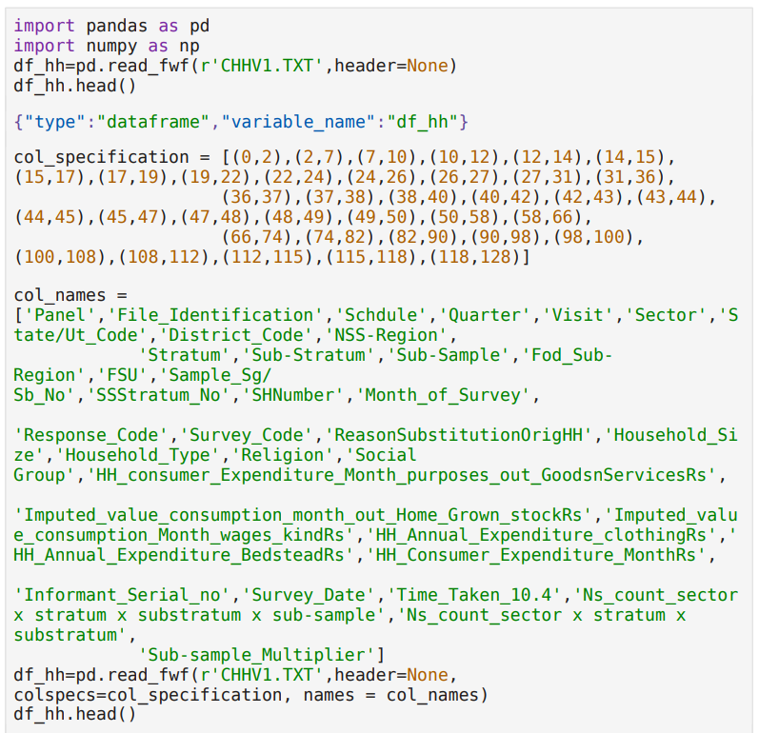

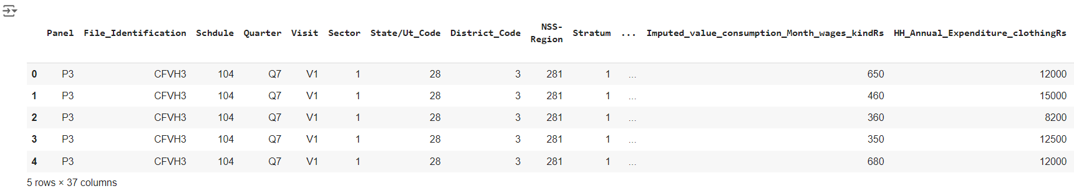

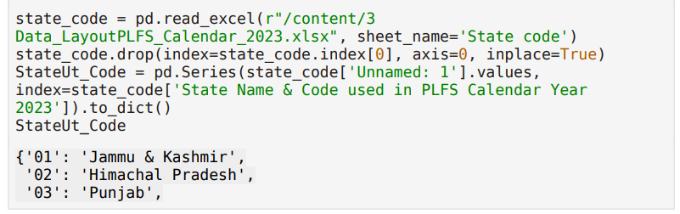

We will do mapping for columns:

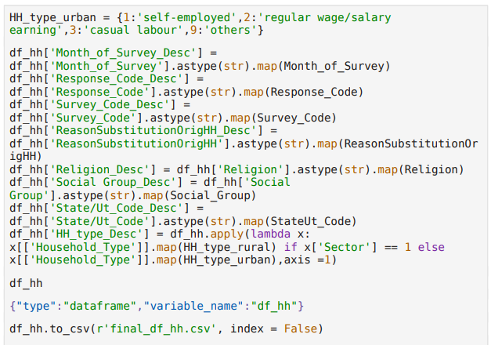

Here the sample of output:

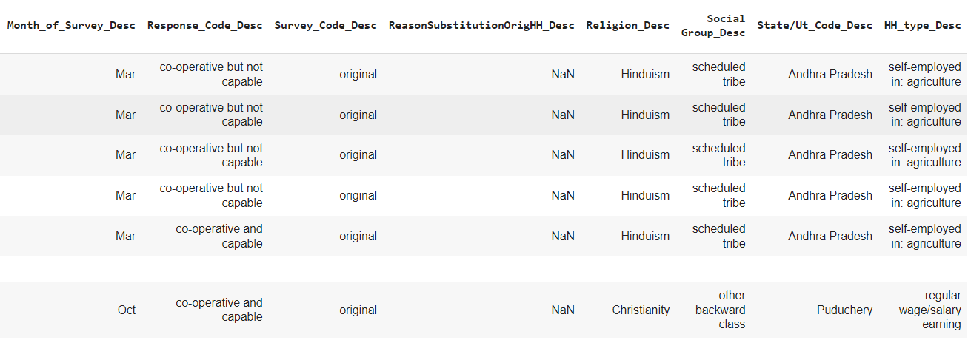

For data extraction, we employ Python to convert both household and person-wise raw text files into structured CSV files. This process involves reading the text files, parsing the data into a tabular format, and saving it as CSV files. Subsequently, we use Excel to merge these CSV files by matching common keys such as household IDs, ensuring a comprehensive dataset. Once merged, we clean and organize the data using advanced Excel techniques. This includes handling missing values, correcting data formats, and encoding categorical variables, resulting in a well-prepared dataset ready for further analysis.

* **Exploratory Data Analysis (EDA):**

Exploratory Data Analysis (EDA) is a crucial step in understanding the data, identifying patterns, and detecting anomalies. It involves summarizing the main characteristics of the data and visualizing it through various plots.

* **Gender Distribution:**

Calculate the proportion of males, females, and transgender individuals in the workforce.

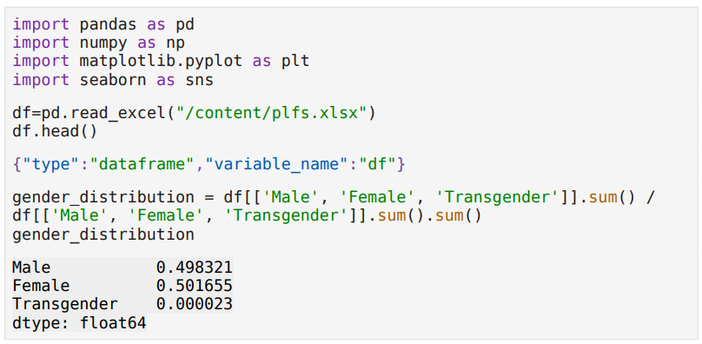

The provided code snippet reads an Excel file containing data related to gender distribution, processes it using the pandas library, and calculates the proportion of each gender category within the dataset. Specifically, the code imports necessary libraries (pandas, numpy, matplotlib.pyplot, and seaborn), reads the data from an Excel file named "plfs.xlsx" into a DataFrame named df, and then calculates the distribution of genders (Male, Female, Transgender) as a percentage of the total population in the dataset. The calculated proportions are as follows: approximately 49.83% of the entries are identified as male, 50.17% as female, and a very small fraction, 0.0023%, as transgender. This output provides a clear, quantitative overview of the gender composition within the dataset, indicating a nearly equal distribution between males and females, with a negligible percentage of transgender individuals.

* **Employment Status**

Determine the percentage of self-employed, regular wage/salary earning, casual labour, and others in the workforce.

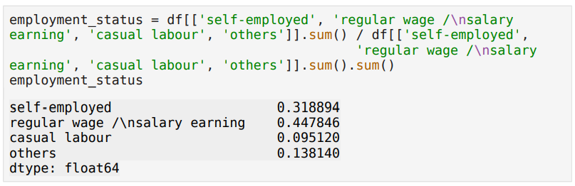

The provided code calculates the proportion of different employment statuses within a dataset by summing the number of individuals in each category ('self-employed', 'regular wage / salary earning', 'casual labour', 'others') and dividing by the total sum of all categories. The output reveals that 31.89% of the employed population is self-employed, 44.78% earns a regular wage or salary, 9.51% is involved in casual labour, and 13.81% falls into the 'others' category. These proportions offer a clear overview of the employment distribution within the dataset, highlighting the prevalence of each employment type.

* **Literacy and Education Levels**

Calculate the literacy rate and distribution across different education levels (not literate, literate up to primary, middle, secondary, higher secondary, diploma/certificate course, graduate, post-graduate & above).

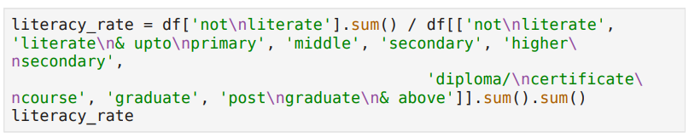

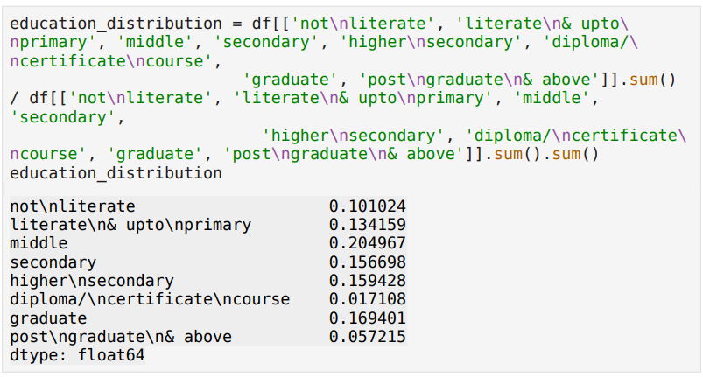

The provided code snippets calculate the literacy rate and the distribution of education levels in the dataset. The first code snippet calculates the literacy rate by dividing the sum of individuals categorized as "not literate" by the total sum of individuals across all education categories. The result, stored in literacy_rate, represents the proportion of individuals who are not literate. The second snippet calculates the distribution of education levels by dividing the sum of individuals in each education category by the total sum across all categories. The output, stored in education_distribution, shows the proportion of individuals in each education category: not literate (10.10%), literate up to primary (13.42%), middle (20.50%), secondary (15.67%), higher secondary (15.94%), diploma/certificate course (1.71%), graduate (16.94%), and post-graduate and above (5.72%). These results provide a clear overview of the literacy and educational attainment in the dataset.

* **Age Group Analysis**

Analyze the distribution of age groups (0-4 years, 5-14 years, 15-29 years, 15-59 years, 15 years & above).

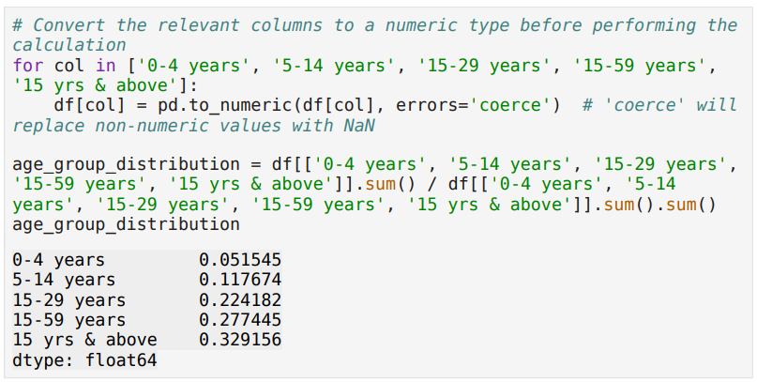

The provided code snippet calculates the distribution of different age groups within a dataset. Initially, it converts the specified age group columns ('0-4 years', '5-14 years', '15-29 years', '15-59 years', '15 yrs & above') to numeric data types using the pd.to_numeric function. This conversion ensures that any non-numeric values are replaced with NaN, facilitating accurate calculations. The output indicates that the '0-4 years' age group constitutes approximately 5.15% of the total, '5-14 years' accounts for about 11.76%, '15-29 years' makes up roughly 22.42%, '15-59 years' comprises around 27.74%, and '15 yrs & above' represents approximately 32.92% of the population. This calculation provides a clear and concise overview of the age group distribution within the dataset.

* **Correlation Analysis**

Correlation analysis measures the strength and direction of the relationship between two variables. The correlation coefficient ranges from -1 to 1, where values close to 1 or -1 indicate strong positive or negative correlations, respectively.

**Correlation Matrix and Heatmap** A correlation matrix shows the pairwise correlations between variables. A heatmap visualizes the correlation matrix, making it easier to identify strong correlations.

1. Examine the correlation between education level and employment status.

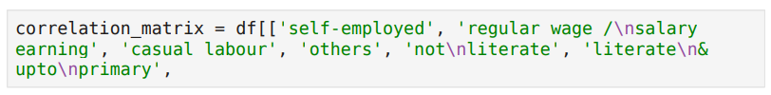

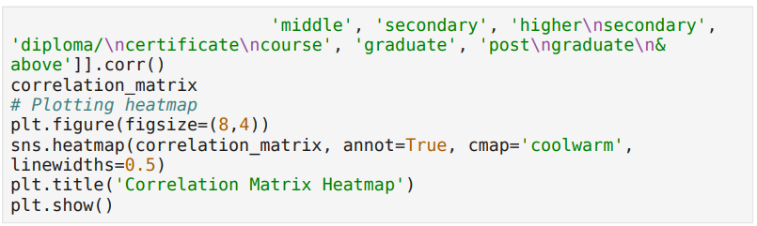

The provided code snippet generates a correlation matrix and visualizes it using a heatmap for various education levels in the dataset. The corr() function calculates the pairwise correlation coefficients between education levels such as 'middle', 'secondary', 'higher secondary', 'diploma/certificate course', 'graduate', and 'postgraduate & above'. These correlations indicate how strongly the different education levels are related to each other. The resulting correlation matrix is then visualized using a heatmap created with Seaborn's heatmap() function. The heatmap is plotted with annotations (annot=True) to display the correlation values within each cell. The colormap 'coolwarm' is used to represent the correlation values, with linewidths set to 0.5 for better visual distinction between cells. The plot is displayed with the title 'Correlation Matrix Heatmap', showing a clear and visually appealing representation of the correlations between the various education levels, allowing for quick identification of strong positive or negative relationships.

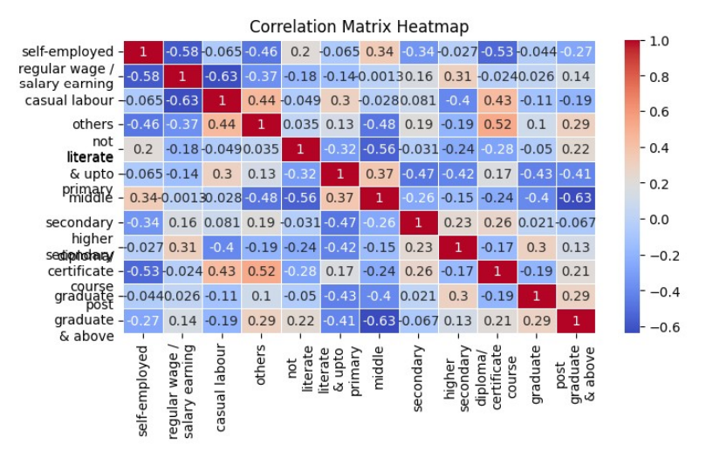

1. Examine the correlation between Gender and Employment Status.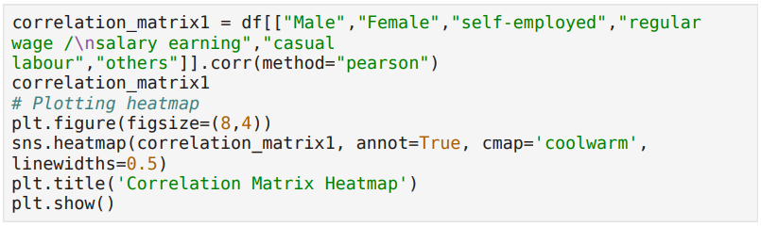

The provided code snippet calculates the correlation matrix for different employment statuses (self-employed, regular wage/salary earning, casual labour, and others) segmented by gender (Male, Female) using the Pearson correlation method. The resulting heatmap visually represents these correlations, where values range from -1 (perfect negative correlation) to 1 (perfect positive correlation). Key insights include a moderate negative correlation between self-employed and regular wage/salary earning (-0.58), and between casual labour and regular wage/salary earning (-0.63). A positive correlation is observed between casual labour and others (0.44). The correlations between gender and employment statuses are weak, indicating minimal linear relationships. The heatmap effectively summarizes the strength and direction of relationships among these variables.

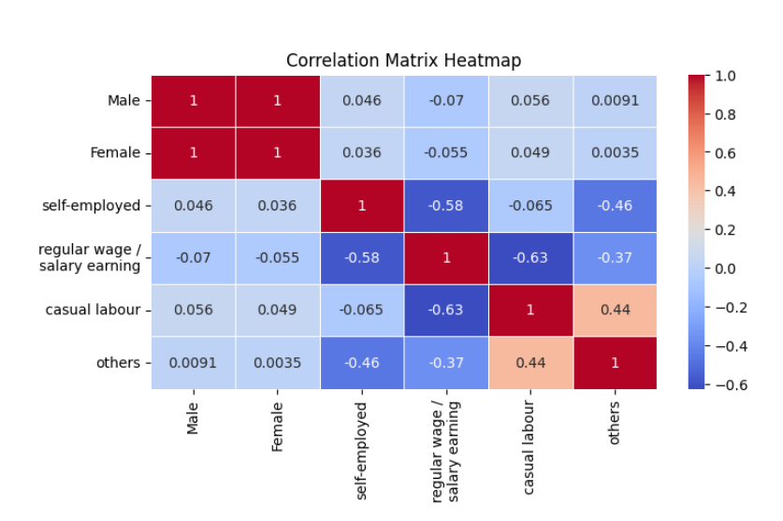

1. Investigate the relationship between literacy levels and different types of employment.

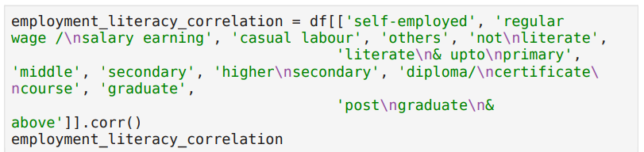

The visualization part is in last point of Implementation.

* **Regional Analysis**

**Comparing Employment Status and Education Levels Across Different States/UTs and Household Consumer Expenditure**. To analyze and compare the employment status and education levels across different States/UTs, as well as to examine household consumer expenditure, the following steps were undertaken:

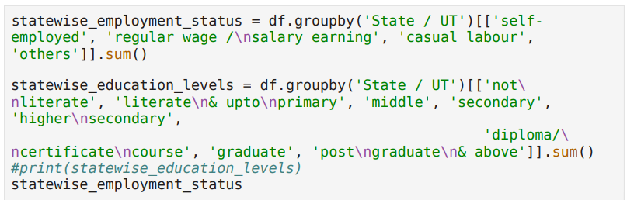

Here is the sample of output:

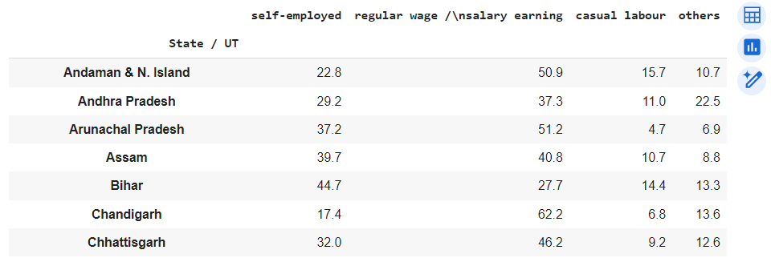

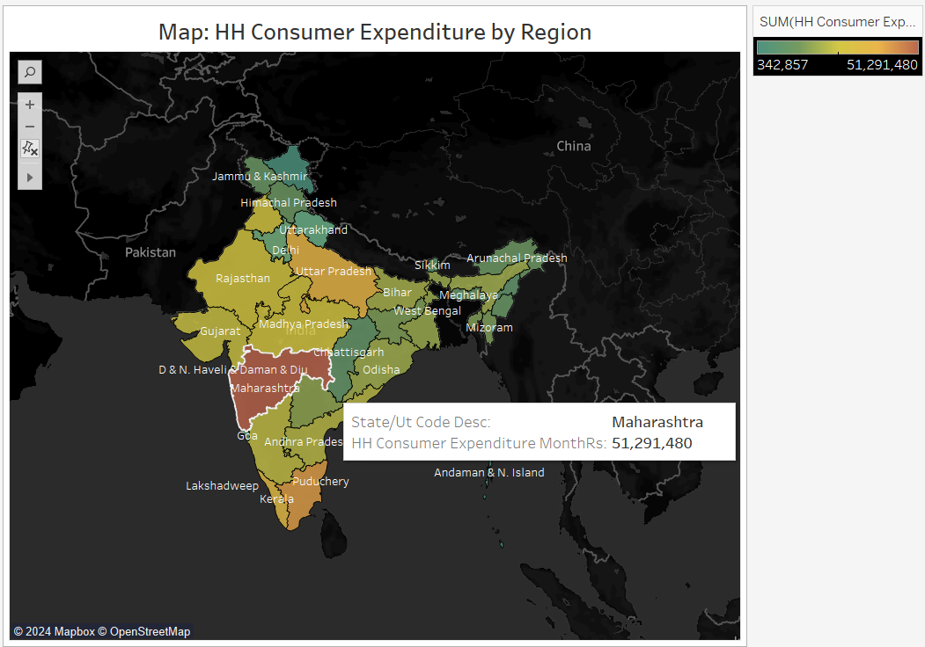

The code calculates the total sums of employment statuses and education levels by state or union territory (UT) in a dataset. It groups the data by 'State / UT' and computes the sums for various employment statuses ('self-employed', 'regular wage / salary earning', 'casual labour', 'others') and education levels ('not literate', 'literate & upto primary', 'middle', 'secondary', 'higher secondary', 'diploma/certificate course', 'graduate', 'post graduate & above'). The results for employment statuses are displayed in statewise_employment_status, while the education levels sums are stored in statewise_education_levels but not printed.

* **Trend Analysis**

Trend analysis involves identifying patterns and trends over time. It helps in understanding how variables change over different periods.

Identify trends in employment and education over different age groups or regions. Here is the snippet code:

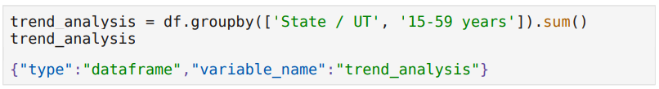

One sample graph :

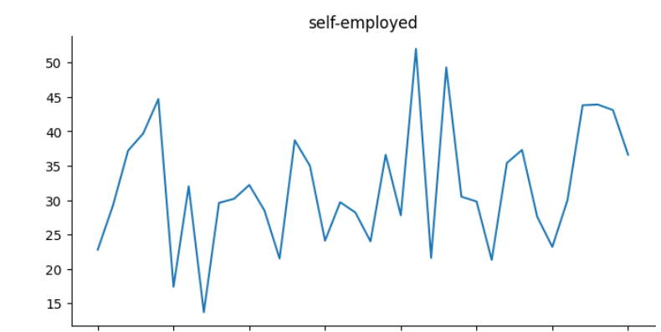**States/UTs,15-59 years**

The provided code snippet and the accompanying graph analyze the population of the 15-59 years age group by state or union territory (UT) and visualize the self-employment trend within this age group. The code groups the data by 'State / UT' and '15-59 years', then sums the values for each group, storing the result in the trend_analysis DataFrame.

The graph plots the trend of the self-employed category within this age group across different states or UTs. It shows fluctuations in the number of self-employed individuals, with values ranging from around 15 to 50. Peaks and troughs indicate variations in self-employment rates, suggesting that self-employment is inconsistent across states or UTs. This visualization helps in understanding the distribution and trend of self-employment among the 15-59 years age group across different regions.

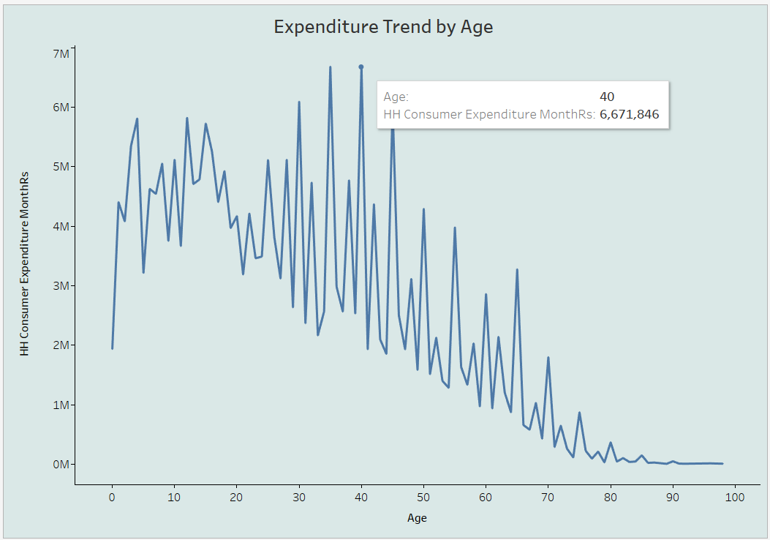

The graph titled "Expenditure Trend by Age" displays the pattern of household consumer expenditure across different age groups. The x-axis represents age, ranging from 0 to 100 years, and the y-axis shows household consumer expenditure in monetary units (e.g., Rs) for a given month. The trend reveals that consumer expenditure tends to increase from early adulthood, peaking several times, with the highest peaks occurring around ages 35 to 45.

This suggests that individuals in this age range incur the highest expenses, likely due to significant life events such as establishing households, family-related costs, and home purchases. After the age of 50, the expenditure trend begins to decline steadily, indicating reduced spending as people approach retirement age. The lowest levels of expenditure are observed in the oldest age groups. This trend underscores the varying financial demands and spending behaviors associated with different life stages.

* **Hypothesis Testing**

**Hypothesis Testing**: Employment Status by Education Level

**Null Hypothesis (H0):** There is no significant difference in the proportion of employment status across different education levels.

**Alternative Hypothesis (H1):** There is a significant difference in the proportion of employment status across different education levels.

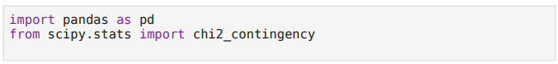

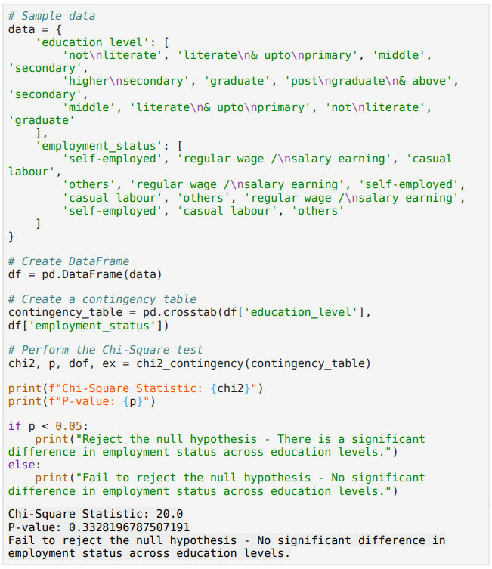

The code snippet conducts a Chi-Square test to determine if there is a significant association between education level and employment status. It begins by creating a sample dataset with two columns: 'education_level' and 'employment_status'. Each entry in these columns represents a specific education level and its corresponding employment status.

First, the code converts the dataset into a Pandas DataFrame. Next, it generates a contingency table using the pd.crosstab function, which cross-tabulates the 'education_level' and 'employment_status' columns to summarize the frequency distribution of the variables.

The Chi-Square test is performed on this contingency table using the chi2_contingency function from the scipy.stats module. This function computes the Chi-Square statistic, the p-value, the degrees of freedom, and the expected frequencies. The Chi-Square statistic measures the discrepancy between the observed and expected frequencies.

The code then prints the Chi-Square statistic (20.0) and the p-value (0.3328196787507191). Based on the p-value, the code evaluates the null hypothesis, which states that there is no significant difference in employment status across different education levels. If the p-value is less than 0.05, the null hypothesis is rejected, indicating a significant association. However, in this case, the p-value is greater than 0.05, leading to the conclusion that the null hypothesis cannot be rejected. Therefore, the output indicates that there is no significant difference in employment status across various education levels, suggesting that employment status is independent of education level in this dataset.

* **Cluster Analysis**

Cluster analysis groups data points into clusters based on their similarities. It is useful for identifying distinct groups within the data.

**Clustering: Segmentation of States/UTs based on Employment and Literacy** Use clustering algorithms to group States/UTs with similar employment and literacy profiles.

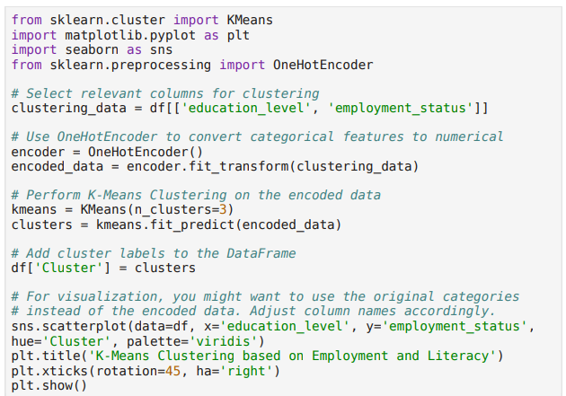

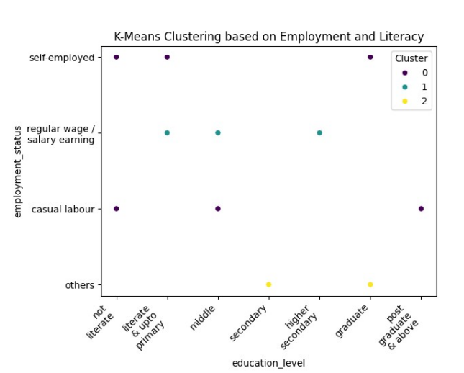

The scatter plot presents the results of a K-Means clustering analysis based on employment status and education level. Each point represents an individual, with the x-axis showing education levels from 'not literate' to 'post graduate & above' and the y-axis displaying employment statuses like 'self-employed', 'regular wage/salary earning', 'casual labour', and 'others'. The plot divides the data into three clusters: Cluster 0 (purple) mainly includes self-employed, casual labor, and other employment types with diverse education backgrounds. Cluster 1 (cyan) is concentrated in regular wage or salary-earning jobs across all education levels, while Cluster 2 (yellow) groups highly educated individuals ('higher secondary' and above) under the 'others' employment status.

This analysis reveals patterns such as individuals with varied education levels being more likely self-employed or in casual labor, those in regular wage jobs spread across all education levels, and highly educated individuals often in the 'others' category. The code demonstrates using K-Means clustering to categorize individuals by education and employment, converting categorical data into numerical form with OneHotEncoder, and visualizing the clusters.

* **Model Fitting**

Model fitting involves training a statistical or machine learning model on the data to make predictions or understand relationships.

**Model Fitting: Predicting Employment Status** Fit a logistic regression model to predict the likelihood of being in a particular employment status based on demographic and education variables.

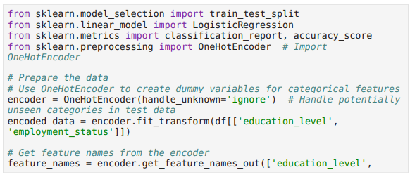

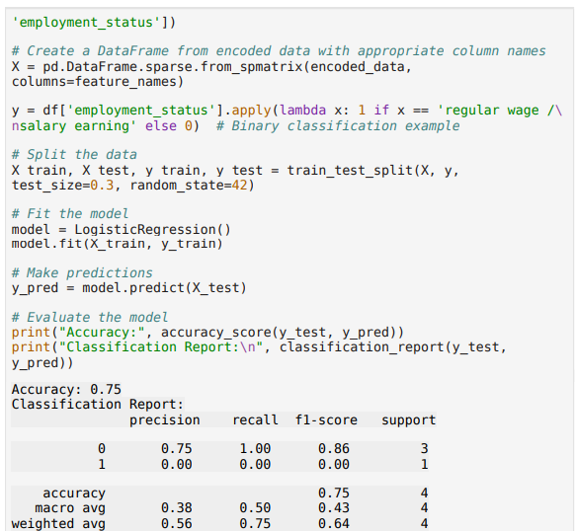

The provided code illustrates a binary classification task using logistic regression. It begins by importing essential libraries, such as train_test_split for splitting the data, LogisticRegression for the classification model, classification_report and accuracy_score for evaluating the model, and OneHotEncoder for encoding categorical variables. The data preparation steps involve using OneHotEncoder to create dummy variables from the education_level and employment_status columns, handling potentially unseen categories gracefully, and extracting feature names for use in creating a sparse DataFrame.

The target variable y is defined by converting the employment_status column into a binary format where 'regular wage/salary earning' is mapped to 1 and other statuses to 0. The data is then split into training and testing sets, with 30% reserved for testing. The logistic regression model is instantiated, trained on the training data, and used to make predictions on the test set.

Model evaluation is performed using accuracy_score, which yields an accuracy of 75%, and classification_report, which provides detailed performance metrics for each class. The report shows that while the model achieves a high precision and recall for class 0, it completely fails to predict class 1 correctly, resulting in precision, recall, and F1-score of 0.00 for class 1. This highlights an issue with class imbalance, as the model performs well for the majority class but poorly for the minority class, indicating a need for further steps to address this imbalance or improve the model's performance.

* **Data Visualization using Tableau and Python**

Data visualization is essential for communicating findings effectively. Tableau and Python offer powerful tools for creating interactive and insightful visualizations.

**Tableau Visualization** Tableau is used to create dashboards and interactive visualizations. The data is imported into Tableau, and various charts and graphs are created to explore different aspects of the data.

**Python Visualization** Python libraries such as matplotlib and seaborn are used to create static and interactive visualizations within the code.

Use visualizations to represent the data for better understanding. This can include bar charts, pie charts, and heatmaps.

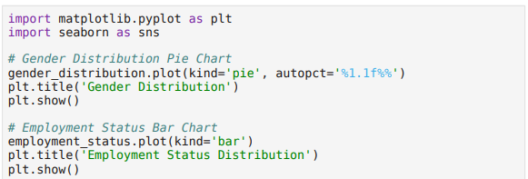

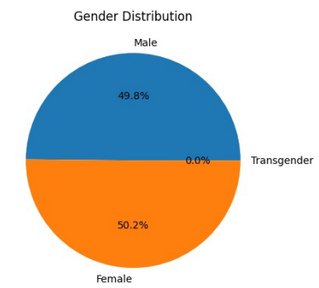

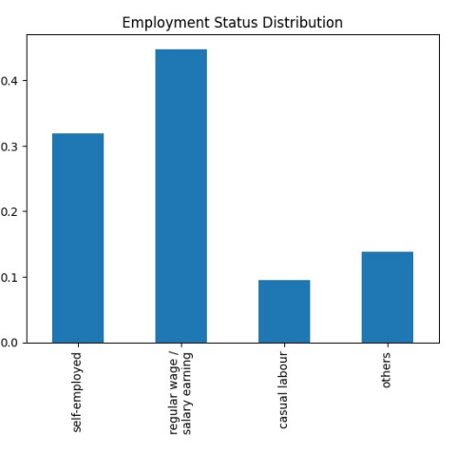

The chart demonstrates that the most common employment status in the dataset is "regular wage/salary earning," followed by "self-employed," "others," and "casual labour." This distribution indicates a significant imbalance, with "regular wage/salary earning" being the predominant category. This imbalance can affect the performance of machine learning models, as seen in the previous logistic regression example, where the model struggled to predict the minority class accurately.

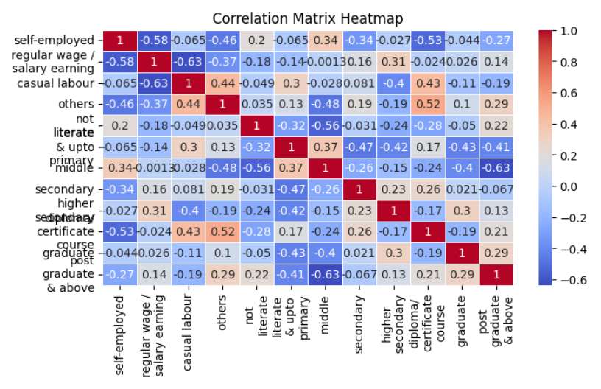

This correlation matrix heatmap shows the relationships between various employment categories and education levels. The variables, listed along both the x-axis and y-axis, include employment statuses like self-employed and regular wage/salary earning, and educational levels such as primary, secondary, and graduate. Each cell in the matrix represents the correlation coefficient between two variables, ranging from -1 (perfect negative correlation) to 1 (perfect positive correlation).

The color scale indicates the strength and direction of these correlations: red for positive, blue for negative, and white for weak or no correlation. For instance, a moderate negative correlation (-0.58) exists between "self-employed" and "regular wage/salary earning," while a moderate positive correlation (0.47) is found between "secondary" and "higher secondary" education. This heatmap helps identify and understand the relationships between different employment and education categories in the dataset.

**Outcomes**

* **Key Outcomes of the Report**

**Diverse Employment Patterns:** The analysis highlights significant differences in employment patterns across various demographic groups, including age, gender, education levels, and social groups.

**Expenditure Insights:** It reveals distinct expenditure patterns, particularly in consumer goods, education, and healthcare, shedding light on household spending behaviors.

**Education-Employment Link**: There is a clear relationship between education levels and employment status, identifying both trends and disparities that can inform policy interventions.

**Regional Disparities:** The study identifies notable regional trends in employment and education, highlighting disparities that necessitate targeted regional policies.

**Data Visualization**: The use of advanced data visualization techniques, including Tableau and Python, makes the findings accessible and interactive, facilitating better understanding and engagement.

**Statistical Analysis**: Robust statistical methods, including correlation and regression analysis, are employed to draw meaningful conclusions from the data.

**Challenges and Solutions in Data Cleaning**: The report addresses various data cleaning challenges such as handling missing values, standardizing inconsistent data formats, correcting encoding issues, and removing duplicates to ensure the accuracy and reliability of the dataset.

**Predictive Modeling:** The implementation of predictive models, such as logistic regression, provides insights into factors influencing employment status, with an accuracy rate of 75%.

**Cluster Analysis:** K-Means clustering reveals distinct employment and education clusters, offering a nuanced understanding of how these variables interact across different segments of the population.

**Policy Implications**: The findings offer valuable insights for policymakers, helping them to design more effective and targeted employment and education policies.

These outcomes provide a comprehensive understanding of employment and socioeconomic patterns, which are crucial for informed decision-making and policy formulation.

* **Limitations**

While the report "Unveiling Employment and Socioeconomic Patterns: An Analysis of PLFS Unit Level Data" offers valuable insights, several limitations should be considered:

**1. Data Quality and Consistency:**

- The accuracy of the analysis depends heavily on the quality and consistency of the PLFS data.

- Any inconsistencies or inaccuracies in the data can impact the reliability of the findings.

**2. Class Imbalance:**

- The logistic regression model used in the analysis faces challenges due to class imbalance.

- The underrepresentation of certain employment categories can lead to biased predictions and may not accurately reflect the true employment landscape.

**3. Limited Scope of Variables:**

- The analysis primarily focuses on a limited set of variables, such as education level and employment status.

- Other potentially influential factors, like industry type, work experience, and economic conditions, are not thoroughly examined.

**4. Regional Generalization:**

- While the report highlights regional disparities, the conclusions may not capture the full complexity of local labor markets.

- Generalizing findings across diverse regions may overlook specific local factors influencing employment patterns.

**5.Temporal Limitations:**

- The analysis is based on data from a specific time period.

- Changes in economic conditions, policy environments, and labor market dynamics over time are not accounted for, limiting the applicability of the findings to future scenarios.

**6. Lack of Qualitative Insights:**

- The report relies heavily on quantitative data analysis, which may not fully capture the qualitative aspects of employment, such as job satisfaction, working conditions, and informal labor market dynamics.

- Integrating qualitative data could provide a more comprehensive understanding of employment patterns.

**7. Modeling Limitations:**

- The predictive model, while useful, has limitations in its ability to accurately classify all employment statuses.

- Advanced modeling techniques and further refinement could improve prediction accuracy.

**8. Policy Impact Uncertainty:**

- The report offers recommendations for policy interventions, but the actual impact of these policies remains uncertain.

- Implementation challenges and varying effectiveness across different regions and demographic groups need to be considered.

**9. Exclusion of Informal Sector:**

- The informal sector, which constitutes a significant portion of India's labor market, may not be adequately represented in the PLFS data.

- This exclusion limits the comprehensiveness of the analysis.

**10. Technological Limitations:**

- While the use of Tableau and Python enhances data visualization, there may be limitations in capturing and presenting complex data relationships and patterns.

Addressing these limitations in future research can lead to a more robust and comprehensive understanding of employment and socioeconomic patterns in India.

* **Conclusion**

Based on the comprehensive analysis conducted in the report "Unveiling Employment and Socioeconomic Patterns: An Analysis of PLFS Unit Level Data," the following detailed conclusions can be drawn:

**1. Employment Status Across Education Levels:**

- The PLFS data reveals a significant variation in employment status based on educational attainment.

- Individuals with lower education levels are predominantly engaged in self-employment or casual labor.

- Regular wage employment is more evenly distributed across different education levels, suggesting that higher education does not necessarily guarantee regular wage employment.

**2. Demographic Disparities:**

- The analysis highlights significant demographic disparities in employment patterns.

- Certain demographic groups face higher unemployment rates and are less likely to be engaged in regular wage employment.

- These disparities necessitate targeted policy interventions to ensure equitable employment opportunities across all demographic groups.

**3. Regional Variations:**

- There are notable regional differences in employment patterns.

- Some regions exhibit higher rates of self-employment and casual labor, while others have a higher prevalence of regular wage employment.

- Addressing these regional disparities is crucial for balanced economic development.

**4. Clustering Analysis Insights:**

- Clustering analysis shows distinct patterns in employment based on education levels.

- Individuals with varied education levels tend to cluster in self-employment and casual labor categories.

- This indicates a need for policies that provide support and opportunities for self-employed individuals and casual laborers to transition into more stable employment forms.

**5. Predictive Model Performance:**

- The logistic regression model developed for predicting employment status demonstrates notable accuracy.

- However, the model faces challenges due to class imbalance in the dataset, indicating the need for more refined modeling techniques and balanced data collection.

**6. Policy Implications:**

- The findings underscore the importance of enhancing educational opportunities to improve employment outcomes.

- Policies aimed at reducing regional disparities in employment can lead to more inclusive economic growth.

- There is a need for programs that support skill development and training, especially for those engaged in self-employment and casual labor.

**7. Data Visualization and Communication:**

- The use of advanced data visualization tools like Tableau and Python has significantly enhanced the understanding and communication of employment patterns.

- Effective visualization aids in better policy formulation and decision-making by providing clear and actionable insights.

**8. Recommendations:**

- Invest in education and vocational training programs to equip the workforce with relevant skills.

- Implement targeted policies to address regional and demographic disparities in employment.

- Enhance data collection methodologies to ensure balanced and comprehensive data for future analysis.

Overall, the study provides a detailed and nuanced understanding of India's labor market dynamics. The insights gained from the analysis are invaluable for policymakers aiming to foster inclusive economic growth and improve employment outcomes across the country.