Project Proposal (KhammTheBuilders)

Project Title
IRBS (IBA Room Booking System)

2. Project Type
Web Application
☐ Mobile Application
☐ SaaS Platform
☐ ERP/CRM Customization
☐ Integration Project
☐ Other: [Specify]

3. Stakeholders & Users
Role | Description / Responsibility
Stakeholder 1: Developers | Build frontend, backend, and database.
Stakeholder 2: IBA Management / Administration | Oversee system usage and data accuracy.
End User Type 1: Program Office | Adds buildings and assigns building incharge. Hardcoded login.
End User Type 2: Building Incharge | Manages rooms in their assigned building (create rooms, update availability, view bookings).
End User Type 3: Students | Searches for rooms and books available rooms.

4. High-Level Scope
Feature / Module | Description
Room Booking System (Core Feature) | Students can view available rooms (classrooms or breakout rooms) and book them based on date, time, and building, view building-related announcements, cancel their approved bookings, view reservation history, and receive approved/rejected notifications.
Building Management (PO) | PO can add new buildings, assign building incharge, and reject approved bookings, and book classrooms.
Room Management (Building Incharge) | Building incharge can add announcements, book breakout rooms, cancel approved breakout room bookings, and view all announcements.

5. Out of Scope
- Room types other than classroom and Breakouts (Conference rooms, Sports grounds etc) cannot be booked yet through this webapp.
- Password encryption
- Sending notifications on email
-sending OTP on email for account confirmation and password update
- Teachers cannot book any type of room through this webapp.

6. Trello Board Link

https://trello.com/invite/b/68d0322b9d53c11fe3015732/ATTI15c08490440072a8ffe4ef5deb8e31d90303723B/my-trello-board

7. Project Overview

7.1 Tech Stack
Layer | Technology
Frontend | React.js
Backend | Node.js (Express.js) for server-side logic and REST APIs
Database | Oracle Database using SQL Developer
Deployment | Vercel
Tools/Integrations | GitHub (version control), Trello (Agile project management)

7.2 Architecture
The system follows a 3-tier architecture:
1. Client Layer (Frontend)
- Built using React.js
- Located in the public and src folders of the repo.
- This layer handles all user interactions through web pages rendered in the browser.
User Interfaces / Functionality:
- Pages for login / registration
- Student room search and booking
- Admin/PO dashboards for building & room management
This layer sends requests to the backend for data and actions.
2. Application Layer (Backend)
- Located in the backend directory.
- Built using Node.js
- Implements server logic and REST APIs.
Core Responsibilities:
- Handling HTTP requests from frontend
- User authentication & authorization
- Room search, booking, building and room management
- Business validation (e.g., availability checks)
- Routing to database operations
This layer acts as the middleman, processing data and enforcing business rules.
3. Database Layer
- The repo includes a Database folder.
- The backend communicates with a database.
Data Storage:
- Users
- Buildings
- Rooms
- Bookings
- Building Incharges
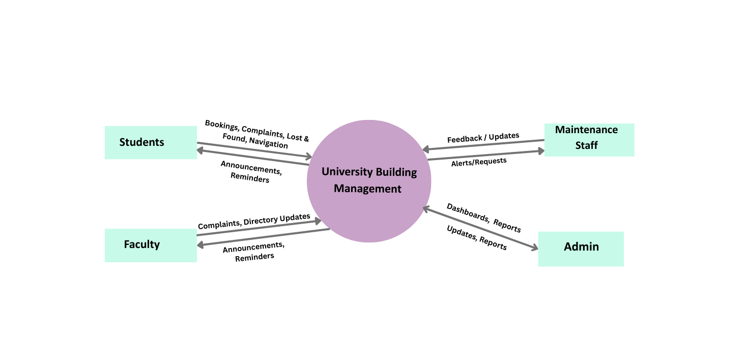
Context Diagram:

