NAME:RAHMON OPEYEMI ZAINAB

APPLICATION NUMBER:FPI/HND/23/00004277

DEPARTMENT:COMPUTER SCIENCE

LEVEL:HND 1

COUSRE CODE:COM 316

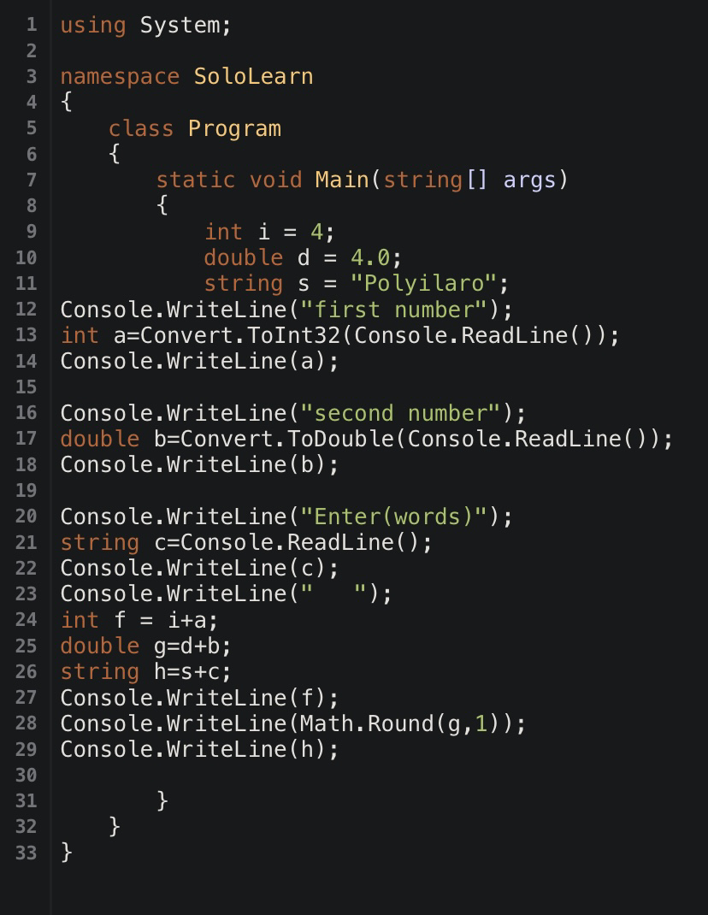

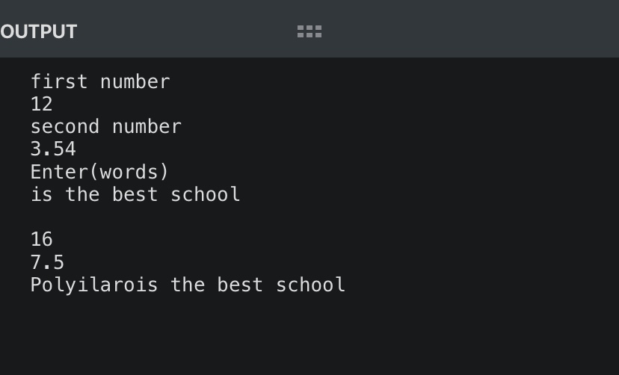

using System;

namespace SoloLearn

{

class Program

{

static void Main(string[] args)

{

int i = 4;

double d = 4.0;

string s = "Polyilaro";

Console.WriteLine("first number");

int a=Convert.ToInt32(Console.ReadLine());

Console.WriteLine(a);

Console.WriteLine("second number");

double b=Convert.ToDouble(Console.ReadLine());

Console.WriteLine(b);

Console.WriteLine("Enter(words)");

string c=Console.ReadLine();

Console.WriteLine(c);

Console.WriteLine(" ");

int f = i+a;

double g=d+b;

string h=s+c;

Console.WriteLine(f);

Console.WriteLine(Math.Round(g,1));

Console.WriteLine(h);

}

}

}