171.23-guruh talabbasi Abdumannonova Muslima.
Student Portfolio.
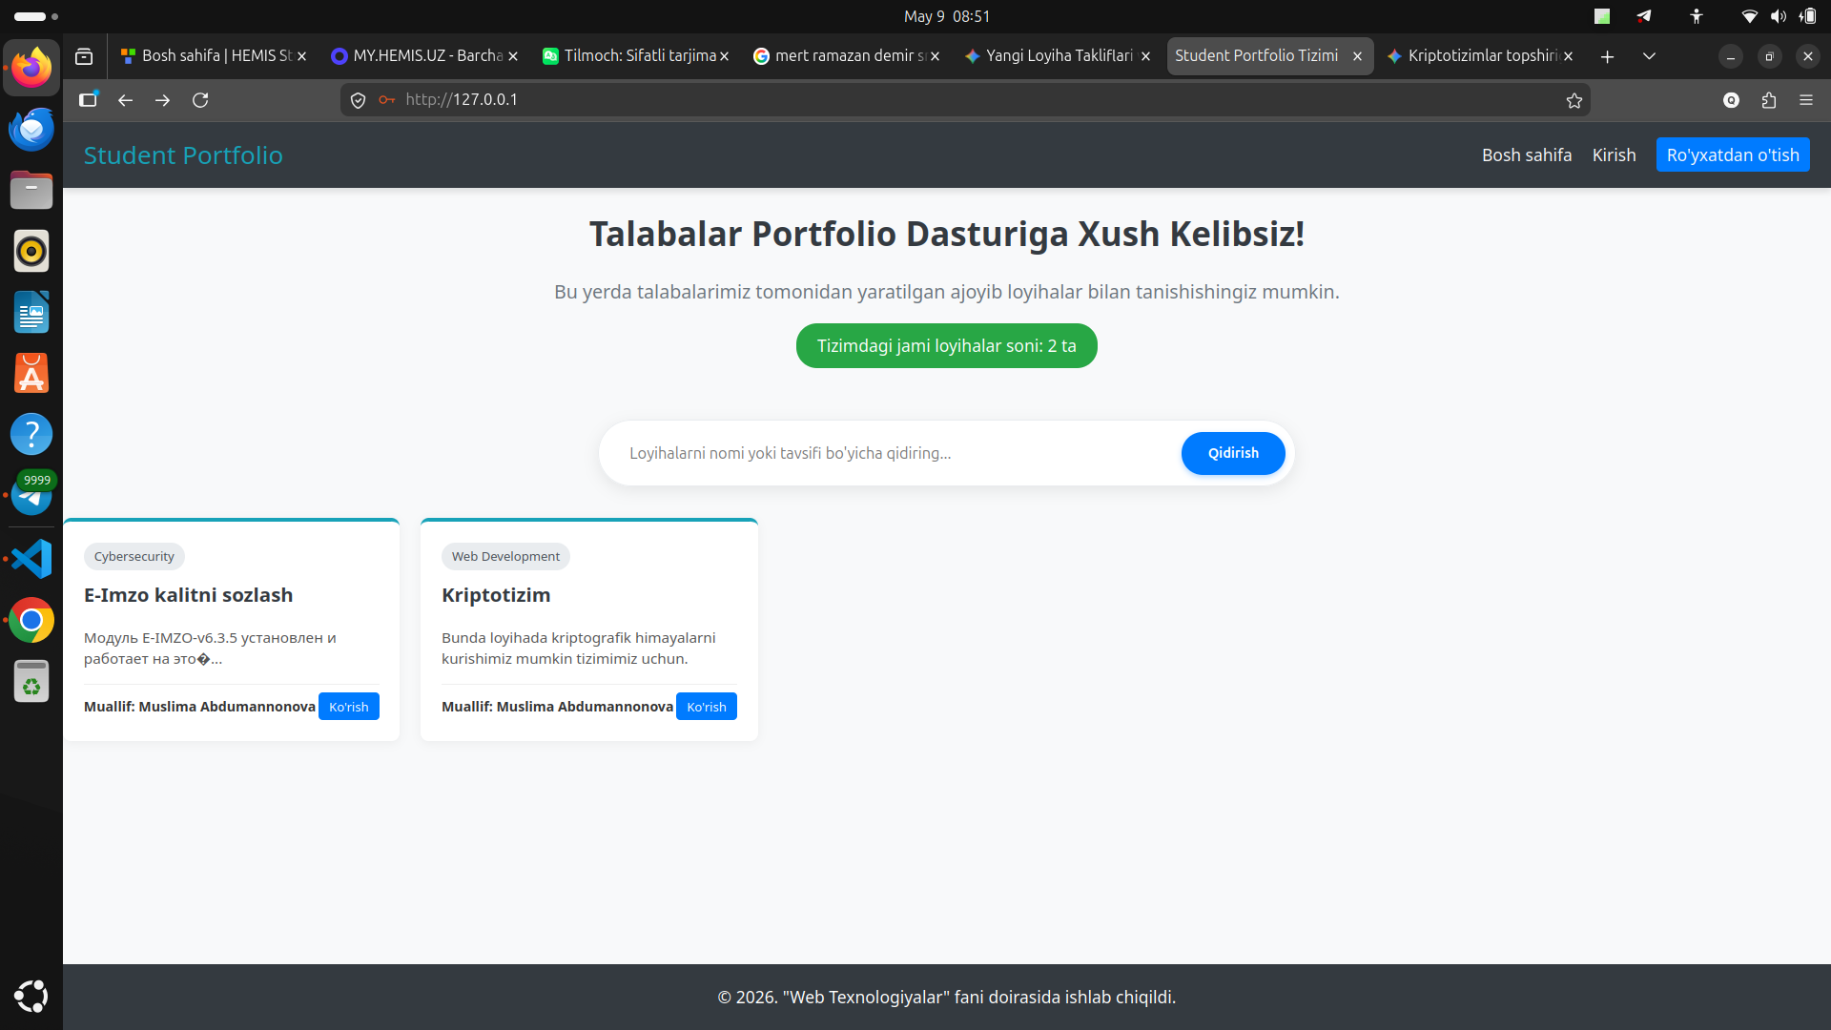
E-imzo loyihasini ko`rishni bossam man quygan loyihamni linkiga pereslat qilib beradi, yani loyihmni ochib beradi.

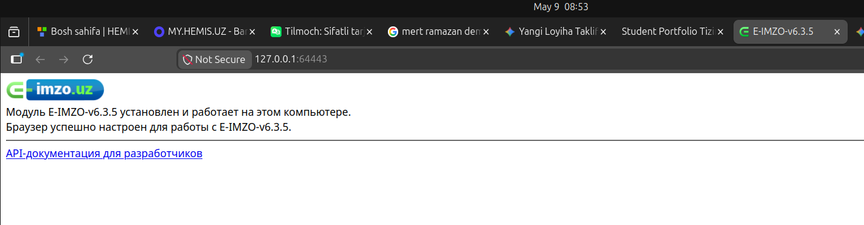
Shunga o`xshab.

Endi tizimga kirish va ruyxatdan utish qismlari.
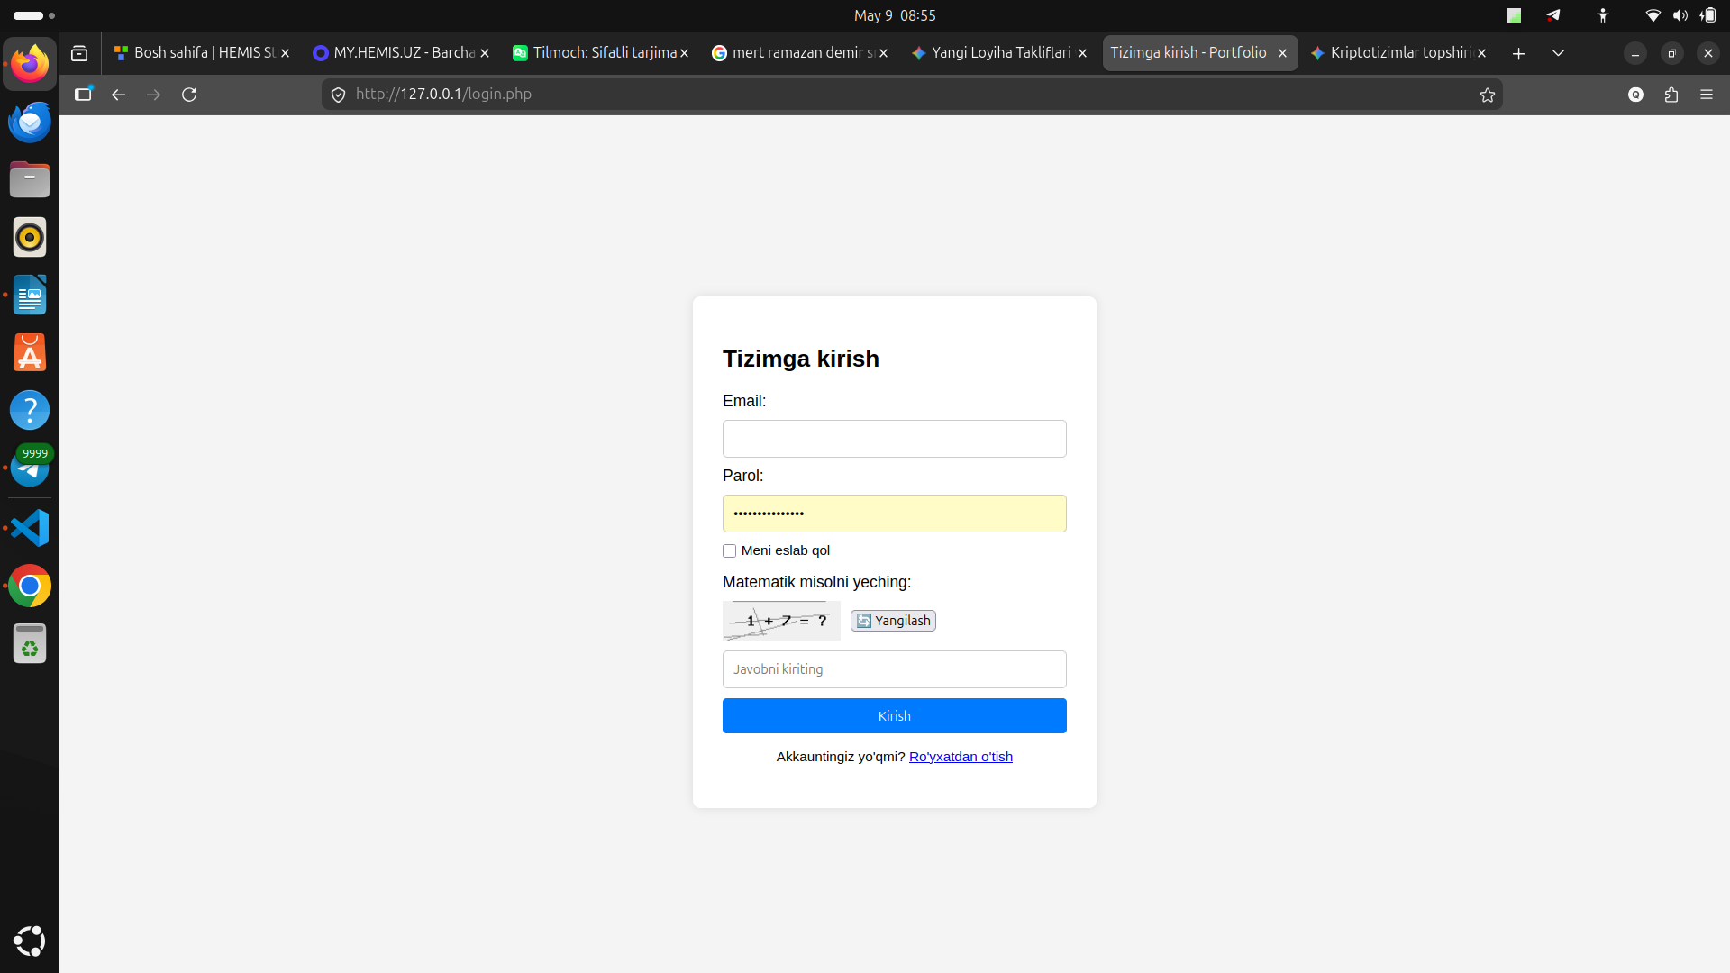
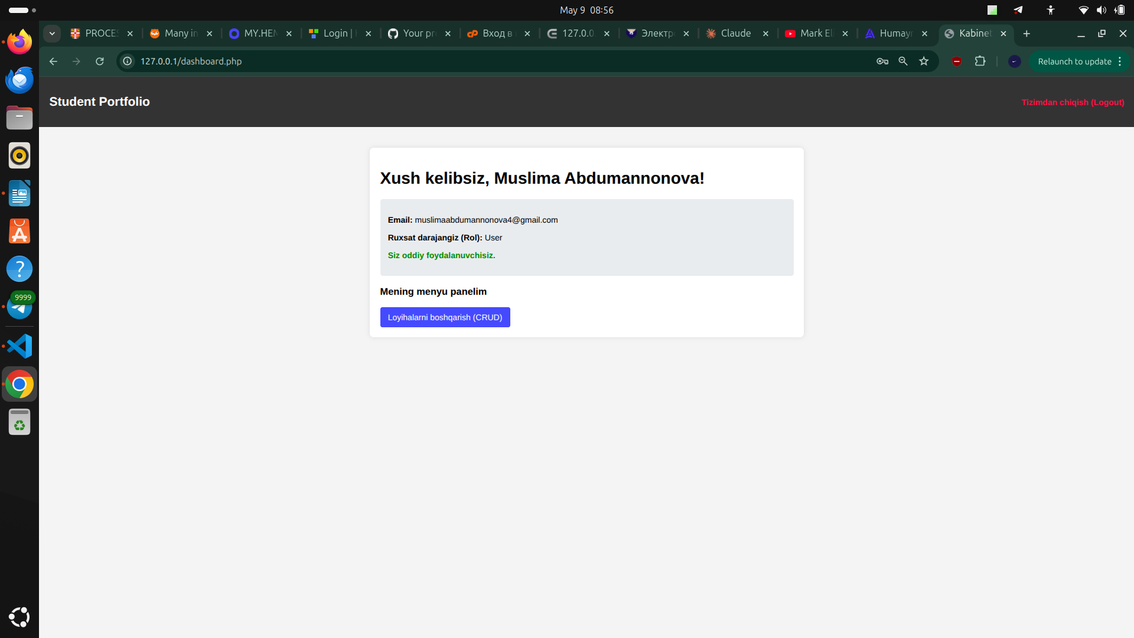
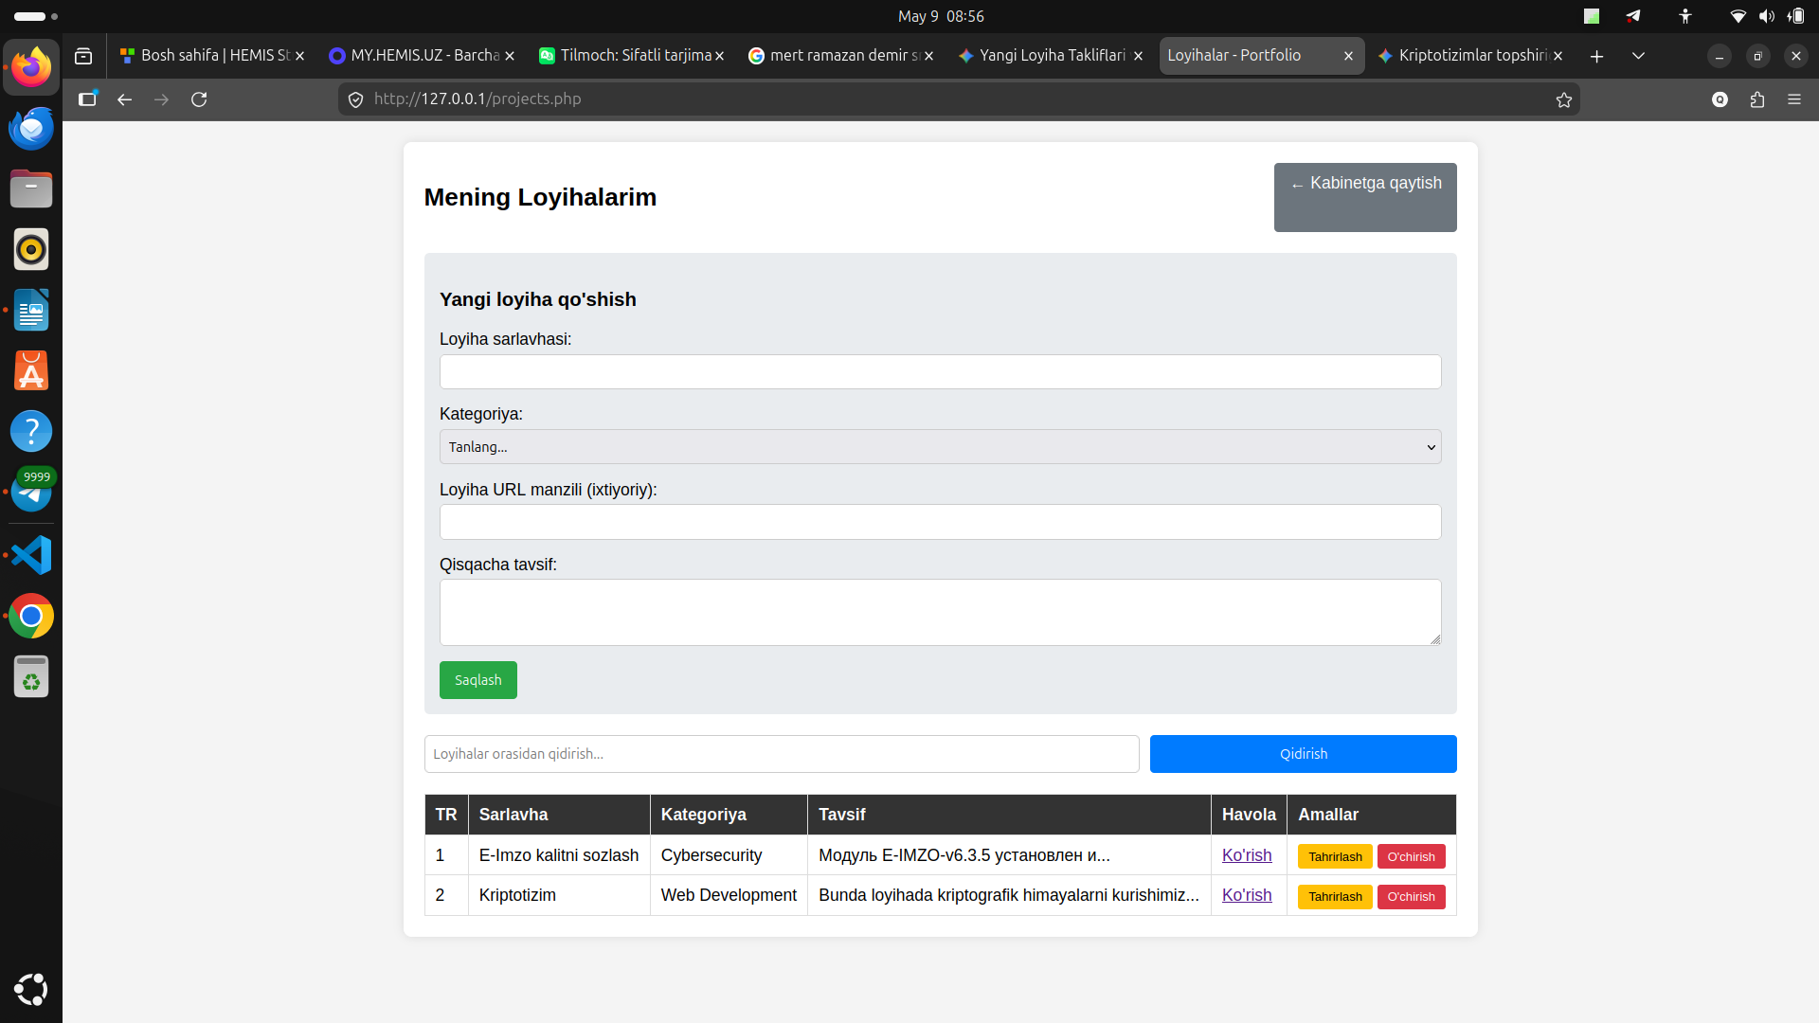
Loyihalarni boshqarish qismini crud amali bilan amalga oshirdek.

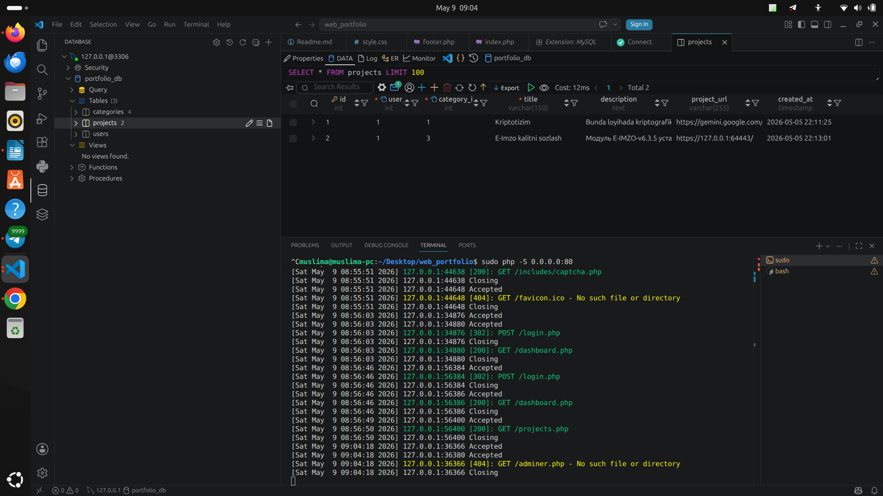
Mana databaseda ham kurishimiz mumkin 2 ta loyihani, va tizimdan 1 ta user ruyxatdan utgani qachon utganini.

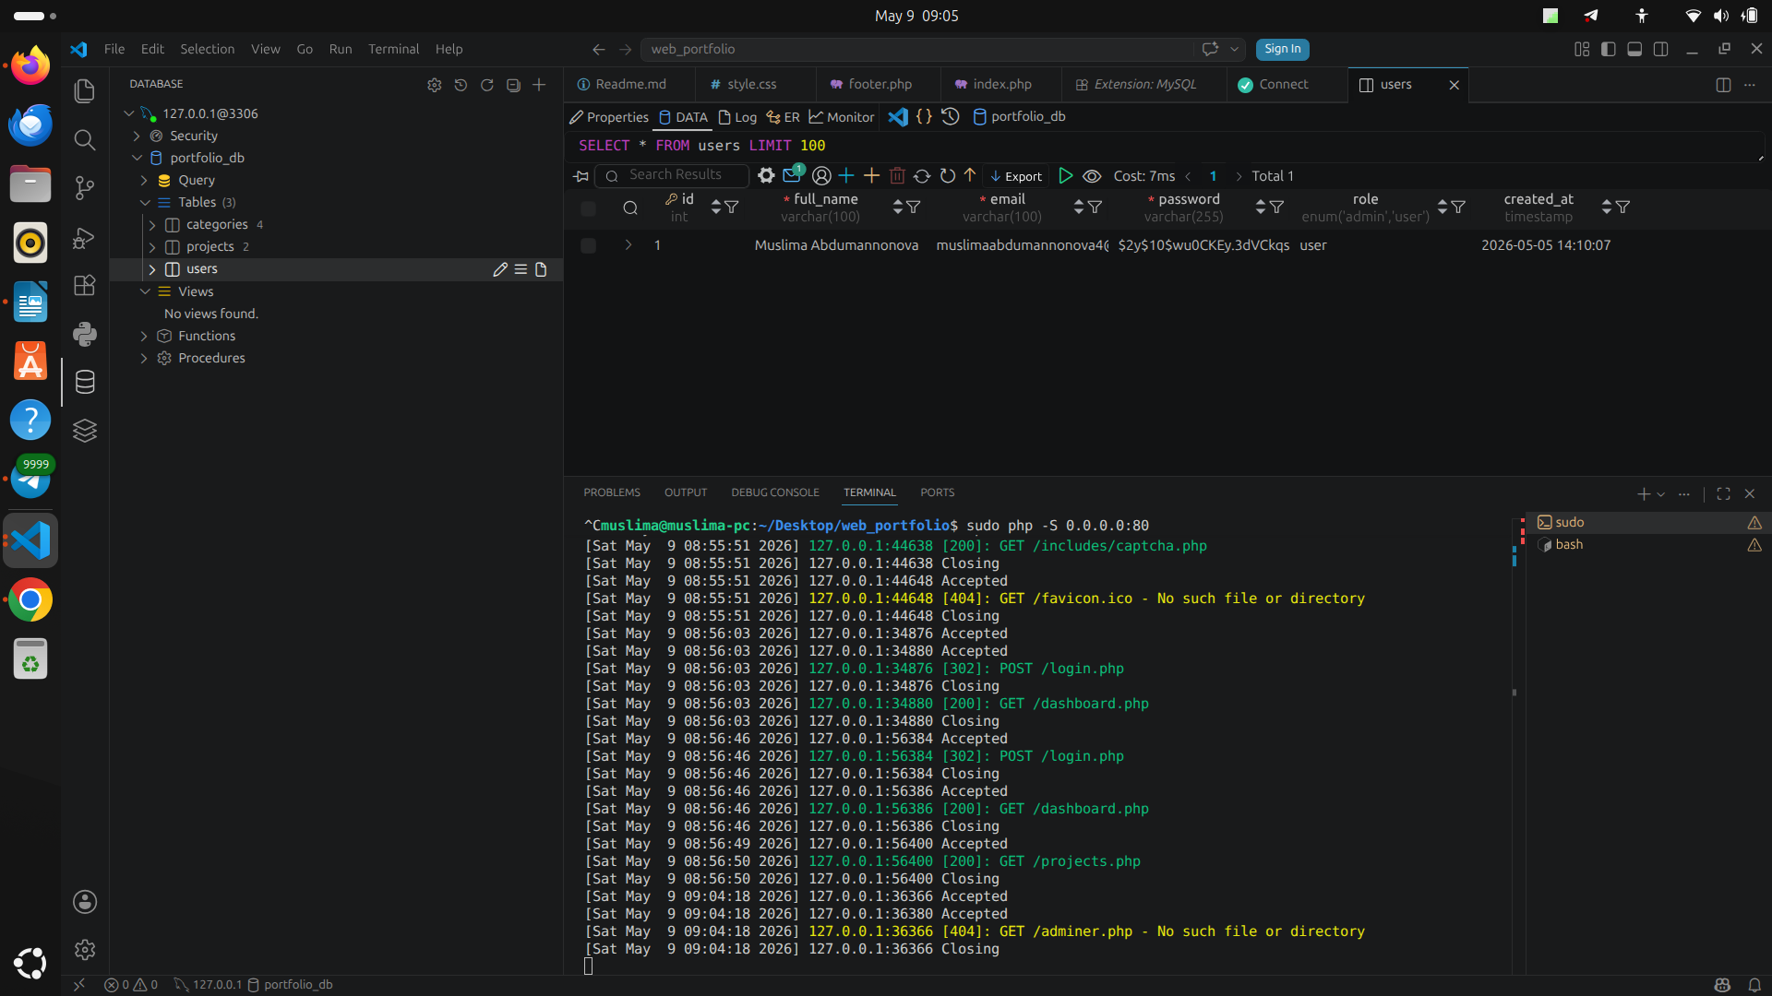
Bu databaseni kurinishi.

<?php
session_start();
require_once 'config/db.php';
require_once 'classes/User.php';
$userObj = new User($pdo);
$error = '';
$success = '';
// 1. CSRF Token yaratish (agar yo'q bo'lsa)
if (empty($_SESSION['csrf_token'])) {
$_SESSION['csrf_token'] = bin2hex(random_bytes(32));
}
// 2. Captcha urinishlarini sanash uchun o'zgaruvchi
if (!isset($_SESSION['captcha_attempts'])) {
$_SESSION['captcha_attempts'] = 0;
}
// 3. Formadan ma'lumot kelsa (POST so'rov)
if ($_SERVER['REQUEST_METHOD'] == 'POST') {
// Bloklangan vaqtni tekshirish
if (isset($_SESSION['blocked_until']) && $_SESSION['blocked_until'] > time()) {
$remaining = $_SESSION['blocked_until'] - time();
$error = "Siz 3 marta xato qildingiz. Iltimos, $remaining soniya kuting.";
} else {
// CSRF ni tekshirish
if (!hash_equals($_SESSION['csrf_token'], $_POST['csrf_token'])) {
$error = "Xavfsizlik xatosi (CSRF). Iltimos formani yangilang.";
} else {
// Captcha'ni tekshirish
$user_captcha = trim($_POST['captcha']);
if ($user_captcha != $_SESSION['captcha_answer']) {
$_SESSION['captcha_attempts']++;
$error = "Captcha noto'g'ri kiritildi. Urinishlar soni: " . $_SESSION['captcha_attempts'];
// 3 marta xato qilsa, 1 daqiqa (60 soniya) bloklash
if ($_SESSION['captcha_attempts'] >= 3) {
$_SESSION['blocked_until'] = time() + 60;
$_SESSION['captcha_attempts'] = 0; // Urinishlarni nolga qaytaramiz
$error = "3 marta xato qildingiz. Forma 1 daqiqaga bloklandi!";
}
} else {
// Hamma narsa to'g'ri bo'lsa, ma'lumotlarni tozalab (XSS dan himoya) o'qiymiz
$full_name = htmlspecialchars(trim($_POST['full_name']));
$email = filter_var(trim($_POST['email']), FILTER_SANITIZE_EMAIL);
$password = $_POST['password'];
// A10 Talabi: Parol uzunligi va murakkabligi (Katta-kichik harf, raqam, belgi)
$password_pattern = '/^(?=.*[a-z])(?=.*[A-Z])(?=.*\d)(?=.*[\W_]).{8,}$/';
// Validatsiya (Bo'sh joylarni tekshirish va hokazo)
if (empty($full_name) || empty($email) || empty($password)) {
$error = "Barcha maydonlarni to'ldiring.";
} elseif (strlen($password) < 8) {
$error = "Parol kamida 8 ta belgidan iborat bo'lishi kerak.";
} elseif (!preg_match($password_pattern, $password)) {
$error = "Parol juda zaif! Unda kamida 1 ta katta harf, 1 ta kichik harf, 1 ta raqam va 1 ta maxsus belgi (@,#,$,%,^,&,*) bo'lishi shart.";
} else {
// Bazaga yozish
try {
if ($userObj->register($full_name, $email, $password)) {
$success = "Muvaffaqiyatli ro'yxatdan o'tdingiz! <a href='login.php'>Tizimga kiring</a>";
$_SESSION['captcha_attempts'] = 0; // Muvaffaqiyatli bo'lsa urinishni tozalaymiz
}
} catch (PDOException $e) {
// Agar email bazada mavjud bo'lsa (UNIQUE sharti ishlaganda)
$error = "Bu email avval ro'yxatdan o'tgan!";
}
}
}
}
}
}
?>
<!DOCTYPE html>
<html lang="uz">
<head>
<meta charset="UTF-8">
<title>Ro'yxatdan o'tish - Portfolio</title>
<style>
body { font-family: Arial, sans-serif; background: #f4f4f4; display: flex; justify-content: center; align-items: center; height: 100vh; }
.form-container { background: white; padding: 30px; border-radius: 8px; box-shadow: 0 0 10px rgba(0,0,0,0.1); width: 350px;}
input[type="text"], input[type="email"], input[type="password"] { width: 100%; padding: 10px; margin: 10px 0; border: 1px solid #ccc; border-radius: 4px; box-sizing: border-box; }
.btn { width: 100%; padding: 10px; background: #28a745; color: white; border: none; border-radius: 4px; cursor: pointer; }
.error { color: red; margin-bottom: 10px; font-size: 14px; line-height: 1.4; }
.success { color: green; margin-bottom: 10px; font-size: 14px; }
.captcha-box { display: flex; align-items: center; gap: 10px; margin-top: 10px; }
</style>
</head>
<body>
<div class="form-container">
<h2>Ro'yxatdan o'tish</h2>
<?php if ($error): ?>
<div class="error"><?php echo $error; ?></div>
<?php endif; ?>
<?php if ($success): ?>
<div class="success"><?php echo $success; ?></div>
<?php else: ?>
<form action="register.php" method="POST">
<input type="hidden" name="csrf_token" value="<?php echo $_SESSION['csrf_token']; ?>">
<label>Ism-sharifingiz:</label>
<input type="text" name="full_name" required>
<label>Email:</label>
<input type="email" name="email" required>
<label>Parol (min 8 belgi, katta-kichik harf, raqam va belgi):</label>
<input type="password" name="password" required>
<label>Matematik misolni yeching:</label>
<div class="captcha-box">
<img src="includes/captcha.php" alt="Captcha" id="captcha-img">
<button type="button" onclick="document.getElementById('captcha-img').src='includes/captcha.php?'+Math.random()">🔄 Yangilash</button>
</div>
<input type="text" name="captcha" placeholder="Javobni kiriting" required autocomplete="off">
<?php if (isset($_SESSION['blocked_until']) && $_SESSION['blocked_until'] > time()): ?>
<button type="button" class="btn" style="background:#ccc; cursor:not-allowed;" disabled>Forma bloklangan</button>
<?php else: ?>
<button type="submit" class="btn">Ro'yxatdan o'tish</button>
<?php endif; ?>
</form>
<p style="text-align: center; font-size: 14px; margin-top: 15px;">
Akkauntingiz bormi? <a href="login.php">Kirish</a>
</p>
<?php endif; ?>
</div>
</body>
</html>

register.php ning kodi yani tizimda ruyxattan utish jarayonidagi xavfsizlik jarayonlari va session vacaptcha ham shetta amalga oshirilgan, yani 3 marta xatodan keyingi 1 minutle time va parol uchun talablar ham shetta htmlspecialchars ham shetta tekshirilgan.

<?php
// Ma'lumotlar bazasi sozlamalari
$host = 'localhost';
$db = 'portfolio_db';
$user = 'portfolio_user'; // Ubuntu'dagi mysql foydalanuvchi nomingiz
$pass = '12345'; // Ubuntu'dagi mysql parolingiz
$charset = 'utf8mb4';
$dsn = "mysql:host=$host;dbname=$db;charset=$charset";
$options = [
PDO::ATTR_ERRMODE => PDO::ERRMODE_EXCEPTION, // Xatolarni ko'rsatish
PDO::ATTR_DEFAULT_FETCH_MODE => PDO::FETCH_ASSOC, // Ma'lumotlarni massiv ko'rinishida olish
PDO::ATTR_EMULATE_PREPARES => false, // Haqiqiy prepared statementlardan foydalanish
];
try {
$pdo = new PDO($dsn, $user, $pass, $options);
} catch (\PDOException $e) {
// Xatolik yuz bersa, xabarni ko'rsatamiz (ishlab chiqarishda buni yashirish kerak)
die("Ma'lumotlar bazasiga ulanib bo'lmadi: " . $e->getMessage());
}
?>

config/db.php
malumotlar bazasi bilan ulanish sozlamalari.

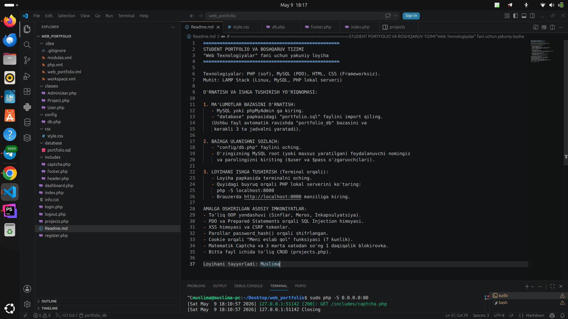

bu suratta fayllar tuzilmasi va Readme.md ni kurishimiz mumkin.

