

**Hospital Management System Database Design**

**Part A: ER Diagram**

**Business Situation Description**

The Hospital Management System database is designed for a medium-sized private hospital offering a broad range of medical services, consultations, specialist care, diagnostics, surgeries, inpatient care, and emergency services. The hospital interacts with external entities such as government health agencies, insurance providers, and medical suppliers.

Internally, it employs doctors, nurses, lab technicians, and administrative staff. The hospital needs to manage electronic health records, which include patient details, visit history, diagnoses, prescriptions, lab reports, insurance claims, and billing.

Doctors can treat multiple patients and may work across departments. Patients may have several appointments and can be treated by various doctors. Treatments may involve prescribed medicines and procedures and are sometimes covered by insurance.

A significant challenge lies in handling many-to-many relationships (e.g., patients and doctors) and derived data (e.g., calculating age from date of birth or billing totals from itemized charges). The system must also comply with regulatory requirements that mandate audit data retention..

**Assumptions**

* Each patient must register before accessing any hospital services.
* Doctors can belong to multiple departments or specializations.
* Appointments are always associated with a patient and at least one doctor.
* A treatment is provided during or after an appointment and may include procedures and medicines.
* External vendors supply medicines with tracked delivery and expiration details.
* Each insurance claim is tied to a specific patient visit or treatment.
* Billing is generated per appointment/visit and can cover multiple components (consultation, medicines, procedures).
* Age is not stored but calculated from date of birth.
* Staff have defined roles and are assigned to departments accordingly.
* Each medicine has a unique batch number and can be traced back to a supplier.

**Business Rules**

* Each Patient is uniquely identified and can have multiple appointments.
* Each Doctor can treat multiple patients and may belong to one or more departments.
* A Patient can have multiple diagnoses and different treatments over time.
* Each Treatment may involve one or more medicines and/or procedures.
* Each Medicine must have an associated supplier, expiration date, and batch number.
* Insurance claims must be linked to specific patients and treatments.
* Billing is generated per visit, covering consultation, diagnostics, treatments, and medicines.
* Only registered patients are allowed to book appointments.
* The age of a patient is derived from the date of birth.
* All Staff are assigned to departments with designated roles (e.g., Doctor, nurse, admin).

**Key Stakeholders of Hospital Management System:**

* Hospital Administrator
* Doctors
* Nurses
* Reception Staff
* Patients
* Pharmacy Staff
* Laboratory Technicians
* Suppliers
* Insurance Providers
* IT/System Administrator
* Government Health Agencies

**Entities And Attributes of Hospital Management System:**

|  |  |
| --- | --- |
| **Entity** | **Attributes** |
| **Patient** | Patient_ID  Name (First, Last) DOB Gender Contact_Info (Phone, Email) Address |
| **Doctor** | Doctor_ID (PK),  Name (First, Last),  Specialization,  Department,  Contact_Info,  License_No |
| **Appointment** | Appointment_ID (PK),  Date, Time, Status,  Patient_ID (FK),  Doctor_ID (FK) |
| **Treatment** | Treatment_ID (PK),  Description,  Start_Date,  End_Date,  Patient_ID (FK),  Doctor_ID (FK) |
| **Medicine** | Medicine_ID (PK),  Name,  Type,  Expiry_Date, S Supplier_ID (FK),  Batch_No |
| **Supplier** | Supplier_ID (PK),  Company_Name,  Contact_Info, License_No |
| **Insurance_Claim** | Claim_ID (PK),  Insurance_Provider,  Policy_No,  Claim_Status,  Claim_Amount,  Patient_ID (FK),  Treatment_ID (FK) |

**ER diagram of Hospital Management System**

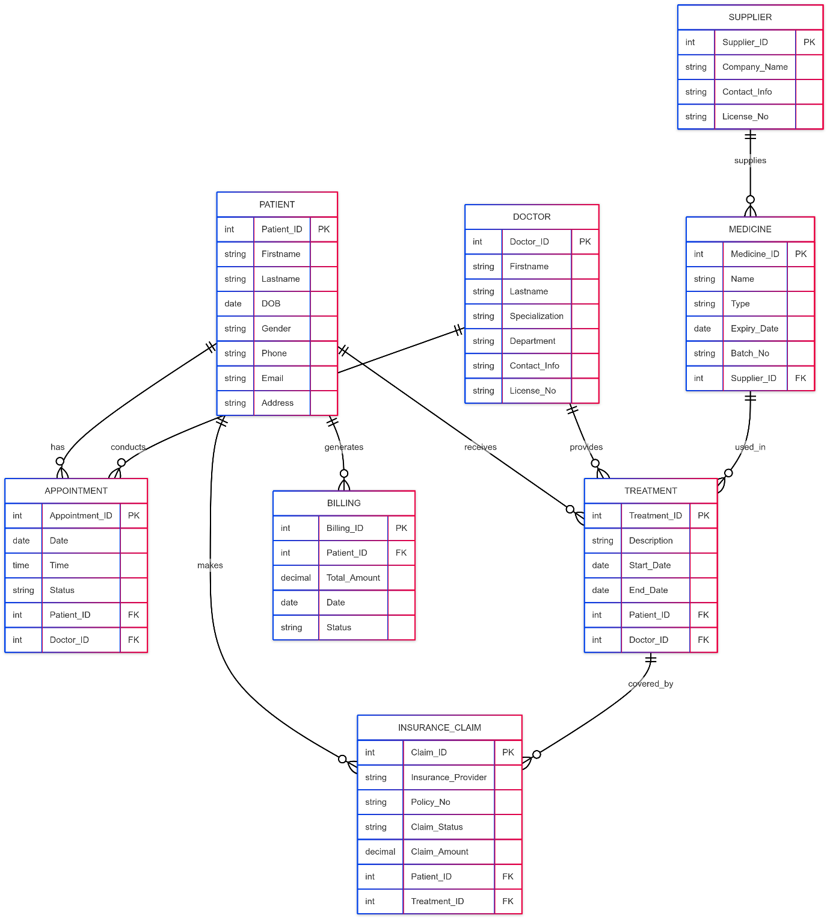

**Part B: Map the ER diagram to 3NF & Normalisation**

**1-Map the ER diagram to 3NF**

Step 1:

1. Patient Table (No composite attributes)

|  |  |  |  |  |  |  |  |  |  |  |
| --- | --- | --- | --- | --- | --- | --- | --- | --- | --- | --- |
| Patient_ID | Firstname | Lastname | DOB | Gender | Phone | Email | Street_Address | City | State | Zip_Code |

2. Doctor Table

|  |  |  |  |  |  |  |  |
| --- | --- | --- | --- | --- | --- | --- | --- |
| Doctor_ID | Firstname | Lastname | Specialization | Department | Phone | Email | License_No |

3. Appointment Table

|  |  |  |  |  |  |
| --- | --- | --- | --- | --- | --- |
| Appointment_ID | Date | Time | Status | Patient_ID (FK) | Doctor_ID (FK) |

4. Treatment Table

|  |  |  |  |  |  |
| --- | --- | --- | --- | --- | --- |
| Treatment_ID | Description | Start_Date | End_Date | Patient_ID (FK) | Doctor_ID (FK) |

5. Medicine Table

|  |  |  |  |  |  |
| --- | --- | --- | --- | --- | --- |
| Medicine_ID | Name | Type | Expiry_Date | Supplier_ID (FK) | Batch_No |

6. Supplier Table

|  |  |  |  |  |
| --- | --- | --- | --- | --- |
| Supplier_ID | Company_Name | Phone | Email | License_No |

7. Insurance_Claim Table

|  |  |  |  |  |  |  |
| --- | --- | --- | --- | --- | --- | --- |
| Claim_ID | Insurance_Provider | Policy_No | Claim_Status | Claim_Amount | Patient_ID (FK) | Treatment_ID (FK) |

8. Billing Table

|  |  |  |  |  |
| --- | --- | --- | --- | --- |
| Billing_ID | Patient_ID (FK) | Total_Amount | Date | Status |

All composite attributes like Name, Contact_Info, and Address are now separated into individual atomic fields (e.g., Firstname, Lastname, Phone, Email, Street_Address, City, etc.).

The derived attributes :

* Patient’s Age (derived from DOB) — removed completely, only DOB remains.
* Billing’s Total_Amount (derived from individual costs) — removed, so Billing just stores raw data or could keep a manual total.

1**.** Patient Table

|  |  |  |  |  |  |  |  |  |  |  |
| --- | --- | --- | --- | --- | --- | --- | --- | --- | --- | --- |
| Patient_ID | Firstname | Lastname | DOB | Gender | Phone | Email | Street_Address | City | State | Zip_Code |

2. Doctor Table

|  |  |  |  |  |  |  |  |
| --- | --- | --- | --- | --- | --- | --- | --- |
| Doctor_ID | Firstname | Lastname | Specialization | Department | Phone | Email | License_No |

3. Appointment Table

|  |  |  |  |  |  |
| --- | --- | --- | --- | --- | --- |
| Appointment_ID | Date | Time | Status | Patient_ID (FK) | Doctor_ID (FK) |

4. Treatment Table

|  |  |  |  |  |  |
| --- | --- | --- | --- | --- | --- |
| Treatment_ID | Description | Start_Date | End_Date | Patient_ID (FK) | Doctor_ID (FK) |

5. Medicine Table

|  |  |  |  |  |  |
| --- | --- | --- | --- | --- | --- |
| Medicine_ID | Name | Type | Expiry_Date | Supplier_ID (FK) | Batch_No |

6. Supplier Table

|  |  |  |  |  |
| --- | --- | --- | --- | --- |
| Supplier_ID | Company_Name | Phone | Email | License_No |

7. Insurance_Claim Table

|  |  |  |  |  |  |  |
| --- | --- | --- | --- | --- | --- | --- |
| Claim_ID | Insurance_Provider | Policy_No | Claim_Status | Claim_Amount | Patient_ID (FK) | Treatment_ID (FK) |

8. Billing Table

|  |  |  |  |
| --- | --- | --- | --- |
| Billing_ID | Patient_ID (FK) | Date | Status |

**Step 2: Weak Entity**Weak Entities:

* Appointment (depends on Patient and Doctor)
* Possibly Insurance_Claim (if Claim_ID is not unique on its own)

**Step 3: Binary Relationship**

|  |  |  |
| --- | --- | --- |
| **Relationship Name** | **Entity 1 (PK)** | **Entity 2 (PK)** |
| Patient — Appointment | Patient (Patient_ID) | Appointment (Appointment_ID) |
| Doctor — Appointment | Doctor (Doctor_ID) | Appointment (Appointment_ID) |
| Patient — Treatment | Patient (Patient_ID) | Treatment (Treatment_ID) |
| Doctor — Treatment | Doctor (Doctor_ID) | Treatment (Treatment_ID) |
| Supplier — Medicine | Supplier (Supplier_ID) | Medicine (Medicine_ID) |
| Patient — Insurance_Claim | Patient (Patient_ID) | Insurance_Claim (Claim_ID) |
| Treatment — Insurance_Claim | Treatment (Treatment_ID) | Insurance_Claim (Claim_ID) |
| Patient — Billing | Patient (Patient_ID) | Billing (Billing_ID) |

**Step 4: Associative Entity**

|  |  |
| --- | --- |
| **Entity** | **Foreign Keys** |
| Appointment | Patient_ID (FK), Doctor_ID (FK) |
| Insurance_Claim | Patient_ID (FK), Treatment_ID (FK) |

**2-Normalisation**

Flat Table:

|  |  |  |  |  |  |  |  |
| --- | --- | --- | --- | --- | --- | --- | --- |
| Patient_ID | Firstname | Lastname | DOB | Gender | Phone | Email | Address |
| Doctor_ID | Doctor_Firstname | Doctor_Lastname | Specialization | Department | Doctor_Phone | Doctor_Email | License_No |
| Appointment_ID | Appointment_Date | Appointment_Time | Appointment_Status |  |  |  |  |
| Treatment_ID | Treatment_Description | Treatment_Start_Date | Treatment_End_Date |  |  |  |  |
| Medicine_ID | Medicine_Name | Medicine_Type | Medicine_Expiry | Batch_No | Supplier_ID |  |  |
| Supplier_Name | Supplier_Phone | Supplier_Email |  |  |  |  |  |
| Claim_ID | Insurance_Provider | Policy_No | Claim_Status | Claim_Amount |  |  |  |
| Billing_ID | Billing_Date | Billing_Status |  |  |  |  |  |

First Normal Form (1NF)

* All attribute values must be atomic (indivisible).
* No repeating groups or arrays.
* Each record must be uniquely identified by a primary key.

Second Normal Form (2NF)

* Must be in 1NF.
* No partial dependency: Every non-key attribute must depend on the whole primary key, not just part of it.
* Applies only when the primary key is composite (made of multiple columns).

Third Normal Form (3NF)

* Must be in 2NF.
* No transitive dependency: Non-key attributes must not depend on other non-key attributes.

1. Patient

|  |  |
| --- | --- |
| **Step** | **Explanation** |
| 1NF | Ensure atomic attributes — no multiple phone numbers or addresses in one field; unique Patient_ID as PK. |
| 2NF | Patient_ID is single PK, so no partial dependency possible. All non-key attributes depend fully on Patient_ID. |
| **3NF** | No attribute depends on another non-key attribute; e.g., no attribute like Age derived from DOB is stored. |

2. Doctor

|  |  |
| --- | --- |
| **Step** | **Explanation** |
| 1NF | Atomic values only; Doctor_ID as PK; separate fields for Doctor_Name, Email, Phone, etc. |
| 2NF | Doctor_ID is single PK → no partial dependency. |
| 3NF | Ensure no attribute depends on another non-key attribute; e.g., Department Head info not stored here but in Department entity if needed. |

3. Appointment

|  |  |
| --- | --- |
| **Step** | **Explanation** |
| 1NF | Unique Appointment_ID as PK; atomic values for Date, Time, Status; no repeating groups. |
| 2NF | Single PK → no partial dependency. Patient_ID and Doctor_ID are foreign keys, fully functionally dependent. |
| 3NF | No attribute depends on another non-key attribute (e.g., Status does not depend on Date alone). |

4. Treatment

|  |  |
| --- | --- |
| **Step** | **Explanation** |
| 1NF | Treatment_ID as PK; atomic fields for Description, Start_Date, End_Date; no multi-valued fields. |
| 2NF | No composite key, so no partial dependencies. |
| 3NF | Treatment_Description or dates don’t depend on other non-key attributes → no transitive dependency. |

5. Medicine

|  |  |
| --- | --- |
| **Step** | **Explanation** |
| 1NF | Medicine_ID as PK; atomic fields (Name, Type, Expiry, Batch_No); no repeating groups. |
| 2NF | Single PK → no partial dependency. |
| 3NF | Supplier info should **not** be stored here (transitive dependency) → Supplier info moved to Supplier entity; Medicine only stores Supplier_ID as FK. |

6. Supplier

|  |  |
| --- | --- |
| **Step** | **Explanation** |
| 1NF | Supplier_ID as PK; atomic values for Name, Phone, Email. |
| 2NF | Single PK → no partial dependency. |
| 3NF | No transitive dependencies within Supplier attributes. |

7. Insurance Claim

|  |  |
| --- | --- |
| **Step** | **Explanation** |
| 1NF | Claim_ID as PK; atomic fields for Provider, Policy_No, Status, Amount. |
| 2NF | Single PK → no partial dependencies. |
| 3NF | Ensure Insurance Provider info is not duplicated in other fields or dependent on Policy_No only (depends on design). |

8. Billing

|  |  |
| --- | --- |
| **Step** | **Explanation** |
| 1NF | Billing_ID as PK; atomic fields for Date, Status. |
| 2NF | Single PK → no partial dependencies. |
| 3NF | No transitive dependencies within billing info. |

* All entities have atomic attributes and unique primary keys → satisfy 1NF.
* All entities have single-attribute primary keys, so no partial dependencies → satisfy 2NF.
* Removed transitive dependencies by moving Supplier info to Supplier entity → satisfy 3NF.

**Final Tables After 3NF**

* Patient (Patient_ID, Firstname, Lastname, DOB, Gender, Phone, Email, Address)
* Doctor (Doctor_ID, Doctor_Name, Specialization, Department, Phone, Email)
* Appointment (Appointment_ID, Patient_ID, Doctor_ID, Date, Time, Status)
* Treatment (Treatment_ID, Appointment_ID, Description, Start_Date, End_Date)
* Medicine (Medicine_ID, Name, Type, Expiry, Batch_No, Supplier_ID)
* Supplier (Supplier_ID, Name, Phone, Email)
* Insurance_Claim(Claim_ID, Patient_ID, Treatment_ID, Provider, Policy_No, Status, Amount)
* Billing (Billing_ID, Patient_ID, Date, Status)

|  |  |  |  |  |  |  |  |
| --- | --- | --- | --- | --- | --- | --- | --- |
| **Patient_ID** | **Firstname** | **Lastname** | **DOB** | **Gender** | **Phone** | **Email** | **Address** |
| P002 | Jahan | Marjia | 1985-07-20 | F | 0403456789 | jahan.marjia@email.com | Wanguri |
| **Doctor_ID** | **Doctor_Firstname** | **Doctor_Lastname** | **Specialization** | **Department** | **Doctor_Phone** | **Doctor_Email** | **License_No** |
| D102 | Mehjabin | Chowdhury | General Practitioner | General Medicine | 0412123456 | mehjabin.chowdhury@hospital.com | 523789 |
| **Appointment_ID** | **Appointment_Date** | **Appointment_Time** | **Appointment_Status** |
| A9002 | 27.05.2025 | 11:00 AM | Confirmed |
| **Treatment_ID** | **Treatment_Description** | **Treatment_Start_Date** | **Treatment_End_Date** |
| T3002 | Low Blood Pressure | 27.05.2025 | 27.05.2025 |
| **Medicine_ID** | **Medicine_Name** | **Medicine_Type** | **Medicine_Expiry** | **Batch_No** | **Supplier_ID** |
| M7002 | Panadol | Tablet | 2026-12-31 | B200 | S502 |
| **Supplier_Name** | **Supplier_Phone** | **Supplier_Email** |
| S502 | HealthMed Pty Ltd | 0399123344 |
| **Claim_ID** | **Insurance_Provider** | **Policy_No** | **Claim_Status** | **Claim_Amount** |
| C123 | BUPA | BUP123456 | Approved | 180.00 |
| **Billing_ID** | **Billing_Date** | **Billing_Status** |
| B645 | 27.05.2025 | Pending |