Musrat Jahan S380098
HIT391 Assignment 2: Individual Coding Exercise
Introduction:
An algorithm for machine learning is a set of guidelines or techniques used by computers to identify patterns in data, aiding in decision-making or prediction. Heart stroke risk prediction and medical insurance cost prediction are two machine learning challenges that include real-world healthcare datasets. This report shows data, the steps of the tasks, and the results for regression and classification.
For Task 1 Classification:
- D2 Predict whether a patient will likely get a heart stroke.
Step 1: Loading Data, Preprocessing, and Exploratory Data Analysis (EDA)
- Age, avg_glucose_level, and bmi: Floats-Points
- Hypertension, heart_disease, and stroke: Integers
- Gender, ever_married, work_type, Residence_type, and smoking_status : String
- pandas DataFrame : bmi column
- EDA: the distribution of age, glucose levels, and stroke patients.
Step 2: Feature Engineering, Creating Train, and Test Datasets
- Label Encoding.
- Training Set (80%) & Testing Set (20%)
Step 3: Apply at least two algorithms for classification (Training and Testing)
Logistic Regression Algorithm classifies patients at risk of having a stroke. Using a sigmoid function, it analyzes the relationship between input features and stroke probability ( Data Science, 2020).
Random Forest Classifier predicts stroke risk based on medical and lifestyle factors. This machine-learning algorithm uses decision trees to predict strokes.
Step 4: Generate at least 2 Evaluation Metrics on each algorithm.
Accuracy Score: Indicates the proportion of cases that were accurately anticipated.
F1-Score: Provides a balanced score that considers recall and precision. it is beneficial when the data is unbalanced (more "No stroke" than "Yes stroke").
Step 5: Comparing the results.
While simple and fast, the Logistic Regression model struggled with complex patterns and imbalanced data, leading to the adoption of Random Forest for better performance.
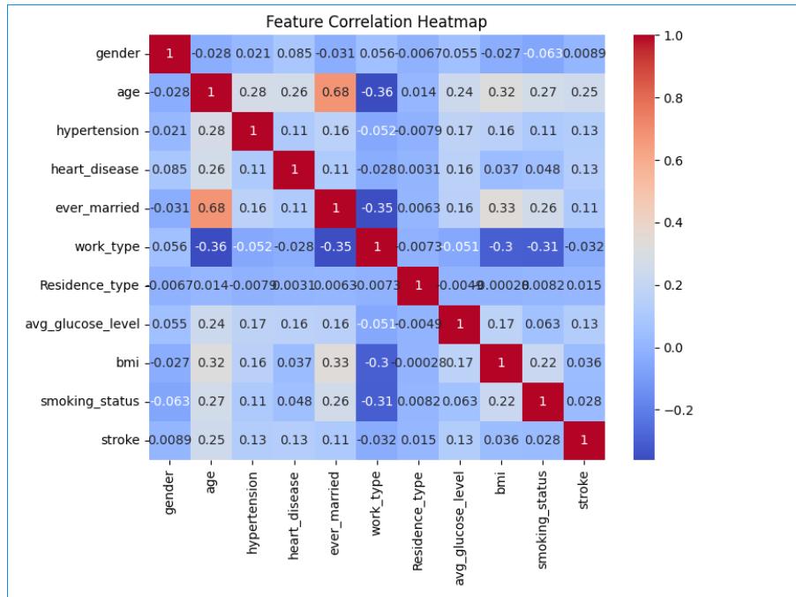
Step 6: Fine-tune the best algorithm.
The Random Forest Classifier is a more suitable algorithm for stroke prediction after testing the Logistic Regression and Random Forest Classifier. Hyperparameter Tuning and Grid Search with Cross-Validation (GridSearchCV) were used for fine-tuning, improving the model's performance and accuracy, predicting stroke cases, and reducing false negatives.

For Task 2 Regression: Dataset (D3) Predicting medical insurance costs.
Step 1: Loading Data, Preprocessing, and EDA
- Integers: age, children
- Float: bmi, Charges
- String: sex, smoker, region
EDA (Exploratory Data Analysis) was performed using:
- Info and describe functions to identify missing values and basic statistics.
- Graphs like boxplots, distribution plots, and correlation heatmaps to observe feature relationships and detect outliers.
Step 2: Feature Engineering, Train/Test Split
- The target variable is insurance cost, with features in columns.
- . A dataset of 80% training and 20% testing is used, with feature scaling for improved model performance.
Step 3: Apply at least two algorithms for Regression (Training and Testing)
Linear Regression predicts costs based on age, bmi, and smoker status. It tries different weights to minimize the difference between predictions and actual values. Assume cost increases or decreases in a straight-line way when any of these features change.
The Random Forest Regressor creates multiple decision trees based on random input, such as age, bmi, and smoking status. The model's accuracy is confirmed by averaging the final forecast (Data Science, 2020).
Step 4: Generate at least 2 Evaluation Metrics on each algorithm.
The R² Score measures how well the model explains variation in medical insurance costs, with a high score indicating accurate predictions.
The RMSE measures the average difference between predicted values and real insurance costs, with lower scores indicating more accurate predictions.
• Step 5: Comparing the results.
A high RMSE indicates the model is unreliable for cost prediction, while a lower RMSE indicates it is more useful for real-world use.

Model | MAE | R² Score
Linear Regression | Higher | Lower
Random Forest Regressor | Lower | Higher

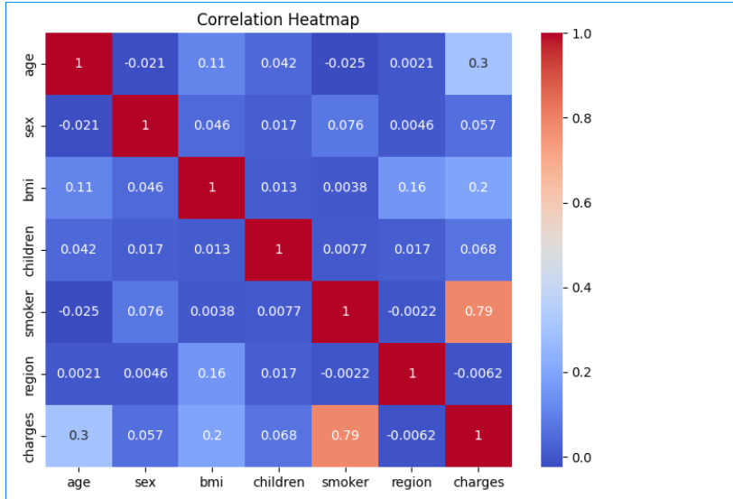
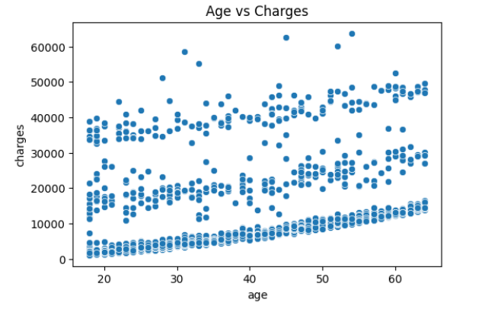
Step 6: Fine Tune the best algorithm.
The Random Forest Regressor model is effective for medical insurance prediction because it handles complex data relationships(CDU Portal, 2025). Hyperparameter tuning, using methods like GridSearchCV or RandomizedSearchCV, improves accuracy, stability, and reliability across different test cases, ensuring predictions are reliable for real-world patients.
Conclusion:
In conclusion, real healthcare data to solve classification and regression problems, the Random Forest Classifier proving more accurate for stroke prediction and outperforming Linear Regression in insurance cost prediction, highlighting the potential of machine learning in healthcare-related issues for informed decision-making.

References:
CDU Portal 2025, S125 HIT391 Machine Learning: Advancement and Applications, Charles Darwin University
https://online.cdu.edu.au/ultra/courses/_62278_1/outline/edit/document/_6099997_1?courseId=_62278_1&view=content&state=view
Chicco D, Warrens MJ, Jurman G 2021, The coefficient of determination R-squared is more informative than SMAPE, MAE, MAPE, MSE and RMSE in regression analysis evaluation, PeerJ Comput Sci, doi: 10.7717/peerj-cs.623. PMID: 34307865; PMCID: PMC8279135.
Data Science 2020, Scikit-learn cheat sheet: methods for classification & regression, Educative , https://www.educative.io/blog/scikit-learn-cheat-sheet-classification-regression-methods
Fares S 2023, Practical Guide to 6 Classification Algorithms, Kaggle, https://www.kaggle.com/code/faressayah/practical-guide-to-6-classification-algorithms

