LAB # 6
Deadlock in concurrency:
OBJECTIVE:
Implementing multiple thread blocked resources with help of lock and deadlock conditions.
Task :
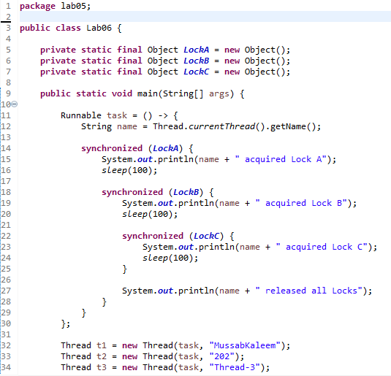
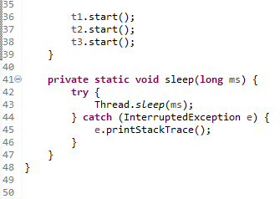
Output:
