  - SIMONE LEONELLI / W230 STUDIO

What Web Design Studio adds to an LLM
  - A visual guide for designers and founders building cinematic websites
Web Design Studio gives a coding agent reusable design decisions, implementation patterns and checks. Its clearest advantage is a more explicit working process: the story, the motion and the evidence are part of the brief from the beginning.
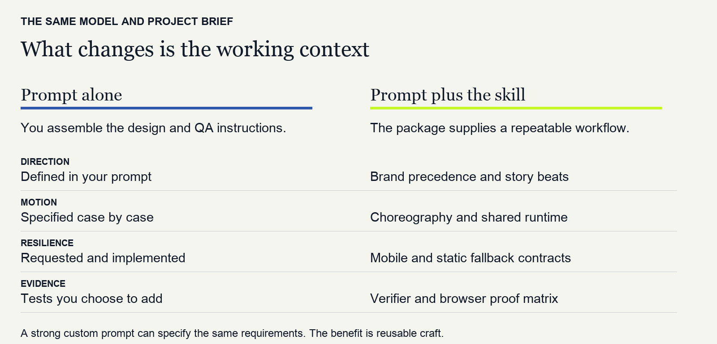
01 Capability comparison based on the skill contract [1]. This diagram compares supplied guidance, not measured model performance.

The practical advantage
For repeated product stories, interactive portfolios and 3D experiences, you can reuse a tested starting point instead of reconstructing the same instructions. The model still writes the code; the skill gives it references, constraints, reusable tools and a definition of completion.

Where a plain prompt can be enough
A capable model with a detailed brief can produce excellent work without this skill. Simple static pages and ordinary dashboards may gain little from a cinematic workflow. The value here is most tangible when motion, brand consistency and fallback behaviour matter together.
The examples and checks below demonstrate available capabilities. They do not establish a higher win rate, lower cost or better conversion than an LLM alone. A fair comparison is specified on page 5.

  - 02 REAL EXAMPLES

One skill can support different visual worlds
A reusable workflow does not require a repeated look. These existing 3D examples use different subjects, materials and spatial narratives. Each image below is a real browser capture, not an invented before and after result.
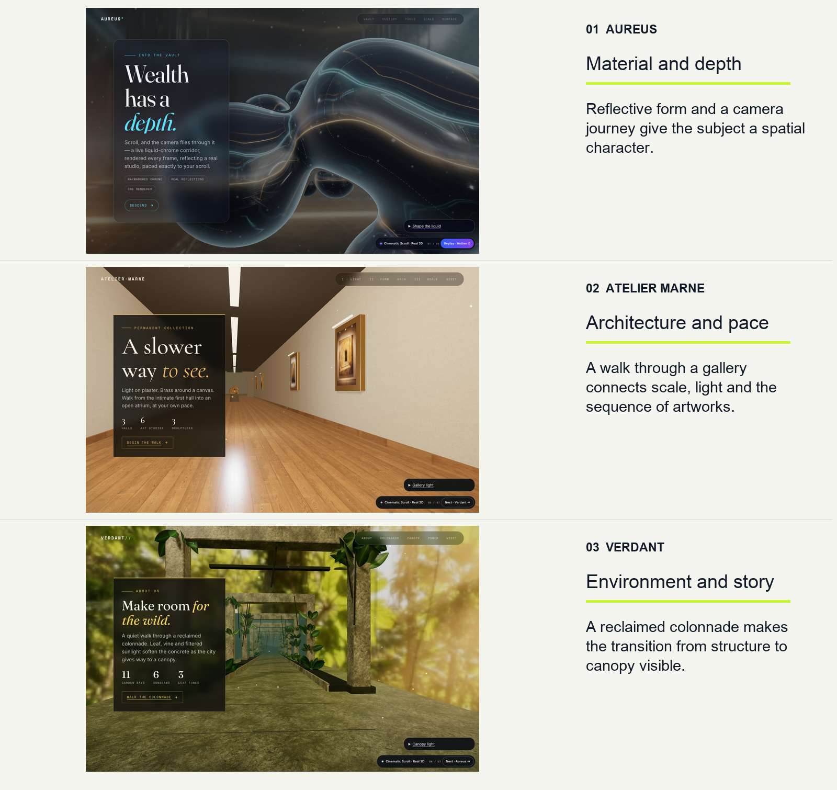
02 Full-frame opening captures of the local examples, 12 September 2026. Legacy in-page Cinematic Scroll labels remain visible in the source. Example links are on page 5. [2]
What to inspect: how the subject determines the camera, the scale of the text and the rhythm of discovery. Open the examples and scroll: a still image cannot validate how an interaction feels.

  - 03 FROM EFFECT TO STORY

Motion should explain a decision
“Make it cinematic” names an ambition. A useful instruction names what the visitor should learn. The skill asks the agent to describe each beat as a start, a transformation, a readable hold and an exit. [1]
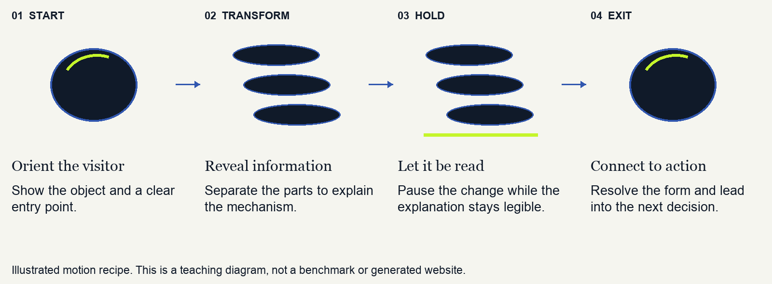
03 Constructed example: separating an object to explain its mechanism. No preference score or model comparison is implied.

Turn a vague request into an observable result
Instead of “add an impressive animation”, specify: “Keep the object in view while its parts separate. Hold the labels long enough to read. Reassemble it before the primary action.” The result can be inspected against those visible decisions.
Design decision | What the skill asks the agent to preserve
Scroll and pointer together | Give each animated property one owner; use nested wrappers so entrance, parallax and tilt do not overwrite each other.
A smaller or touch screen | Compose a readable flow; reserve tilt for a fine pointer with hover.
Reduced motion or failed enhancement | Keep the information and the primary action available in a static composition.
Integration into an existing app | Preserve the framework and clean up only the listeners, triggers and resources owned by the scene.

These are implementation requirements, not automatic guarantees. They become evidence only when the generated page is tested. The same requirements can be written manually; the skill makes them reusable. [1, 3]

  - 04 LOCAL VALIDATION

A working page comes with inspectable evidence
FIELD was checked in five browser profiles at the opening, midpoint and end of scroll. All five reports were CLEAN, with no runtime or automated layout errors recorded. The opening captures are shown here. [3, 4]
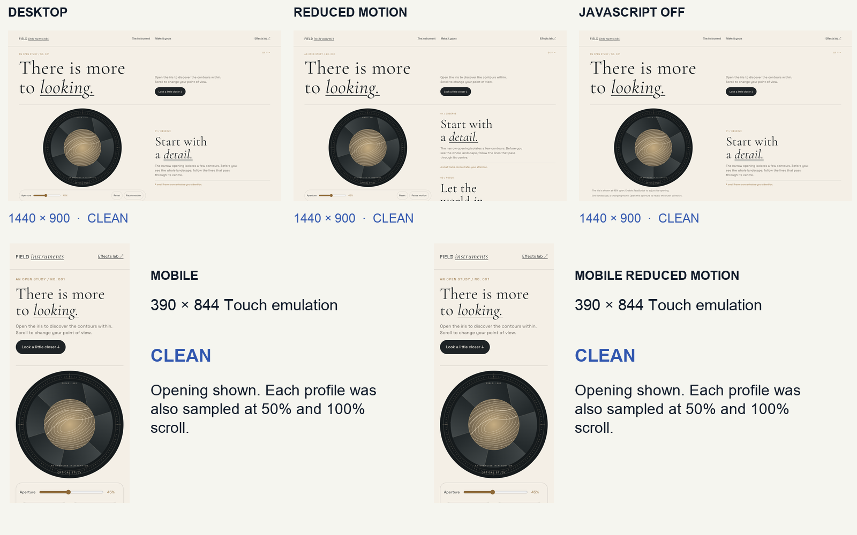
04 Actual FIELD screenshots from the five-profile run. Desktop 1440 × 900; mobile 390 × 844. Three sampled depths per profile, 1.5-second settle time.
Check run on 12 September 2026 | Result | What it establishes
Reference fixture evaluation | 6 of 6 pass | The committed reference files satisfy their defined static checks.
Verifier failure-path tests | 9 of 9 pass | The tested verifier paths reject failures and missing evidence.
FIELD browser profile matrix | 5 of 5 clean | The sampled profiles produced clean runtime and layout reports.

Scope: local source version 2.7.6 at commit 5d37540. Mobile is Chromium emulation, not physical iPhone Safari. These checks do not certify WCAG conformance, conversion, smoothness on every device or superiority over a prompt-only build. Trigger accuracy and the three agent build specs were not evaluated.

  - 05 A FAIR COMPARISON AND A PRACTICAL START

Make the better claim earn its evidence
The next useful proof is a controlled comparison. Include a strong custom prompt as well as a short one, so the test measures the value of the package rather than the weakness of a deliberately poor baseline.
Condition | What the agent receives
A Short prompt | The project brief, content and assets; no skill.
B Detailed prompt | The same brief plus explicit design, fallback and QA requirements; no skill tools or examples.
C Skill assisted | The same brief plus Web Design Studio, its references and tools.

Hold the experiment steady
Use the same model version, tools, assets and total token budget, including skill reads. Run three briefs in fresh contexts, three times per condition: 27 builds. Save every first build, prompt, cost, elapsed time and repair. Run identical external checks on all outputs, without feeding the results back before the first-build comparison.
Randomise the labels and ask three reviewers to score brand fit, composition, motion purpose and mobile readability from 1 to 5. Report all runs, medians, spread, critical failures and ties. Treat this as a pilot: publish the comparison only after results exist, including cases where the skill loses.

Try the workflow on your own page
After installing the skill, use this brief: “Use cinematic-scroll to build a one-page story for [product]. Follow the existing brand and supplied assets. Make one interaction explain a real product feature. Preserve readable mobile, reduced-motion and no-JS versions. Show the browser evidence and disclose checks that did not run.”
Free MIT edition. No Pro purchase or provider key is required for the first build. npm and CLI remain cinematic-scroll-skill; the skill name remains cinematic-scroll. [1]

Sources and examples
[1] Skill contract and implementation requirements
[2] Real 3D examples and source
Open Aureus
Open Atelier Marne
Open Verdant
[3] Browser proof method and its limits
[4] Evaluation scope
Install Web Design Studio from the current repository
Local evidence: evidence/field/matrix.json, the five profile reports, fixtures.txt and verifier-tests.txt accompany the authoring files. The three 3D captures were served over local HTTP; earlier file-URL CORS failures were retained separately. No head-to-head LLM benchmark has been run.

