Optimizing Programs - Podcast Edition
A guided tour through practical performance optimization, from measurement and algorithms down through memory, operating systems, concurrency, input and output, hardware, and compiler behavior.
The topics follow the cheat sheet in order, and each one explains what the optimization changes inside the computer and why that change can matter in a real program.

Golden Rules (Read This First)

Start from a good baseline
Rust is already fast and memory-efficient by default - just don't forget release mode. A debug build favors fast compilation and extra runtime checks, while a release build enables aggressive optimization. Performance measurements from debug builds often describe compiler settings rather than the program you would actually ship. Compiler optimization changes the machine code the CPU actually executes: it can remove unused work, simplify expressions, inline calls, and reorganize loops. That is why a trustworthy performance baseline has to resemble the production build and production workload.
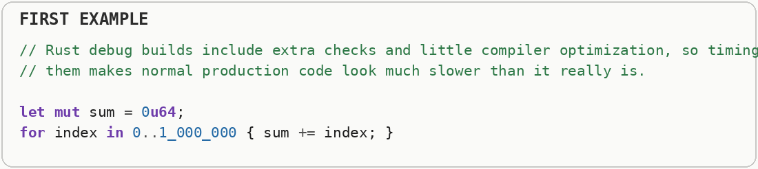
Measure optimized release builds.
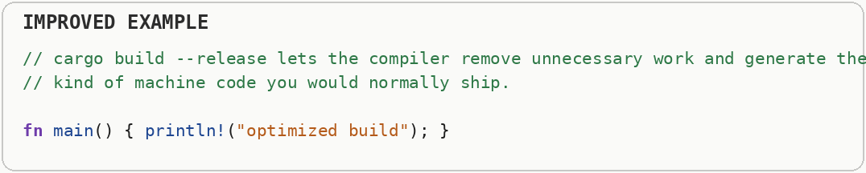

Only optimize what's hot
Optimized code is harder to read and buggier. Spend that budget only where a profiler proves it matters. A profiler is a measurement tool that shows where a program spends CPU time, allocates memory, waits on input and output, or stalls between operations. Different profiler types answer different performance questions, so one timing number is rarely the whole diagnosis. The word hot means disproportionately important to total cost, not merely code that looks complicated. A tiny function called millions of times can matter more than a large function that runs once, so optimization begins by finding where time, memory, or waiting is concentrated.
This spends engineering time changing code before we know whether that code is causing any noticeable slowdown. A hot path is code that runs very often or takes a large share of the program's total time.
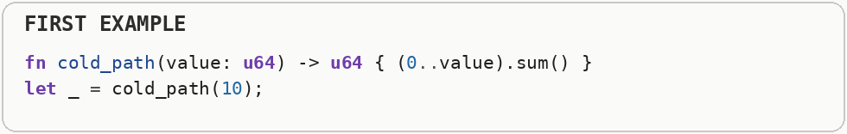
Measure the real workload first, then optimize the functions that actually consume meaningful time or memory. This gives you a performance improvement users can notice instead of making random code harder to maintain.
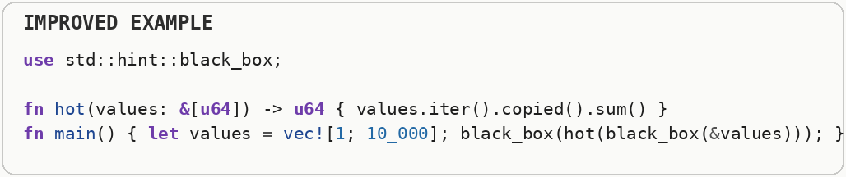

Algorithms beat micro-tuning
Moving from quadratic time to N log N time crushes any low-level trick. Fix the algorithm first. Big O notation describes how the amount of work grows as the input grows. Linear or N log N growth scales much better than quadratic growth, because doubling the input does not multiply the work nearly as aggressively. Algorithmic complexity is about how quickly the amount of work grows as the input grows. A quadratic algorithm can do roughly four times as much work when the input doubles, while linear or N-log-N approaches grow far more gently, so the algorithm often dominates every instruction-level tweak.
This searches the same lists again and again. As the lists grow, the amount of work grows much faster than the amount of data; this is called poor algorithmic complexity.
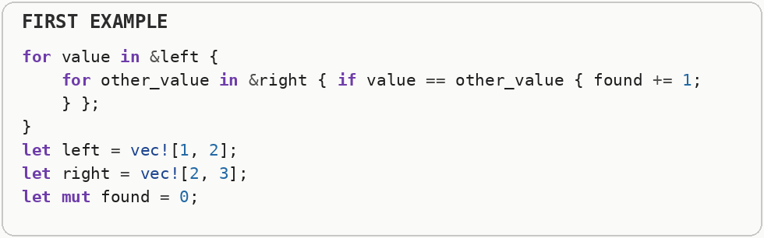
Choose an algorithm that avoids repeated searching. A better algorithm can remove thousands or millions of operations, which usually matters far more than making one CPU instruction slightly faster.
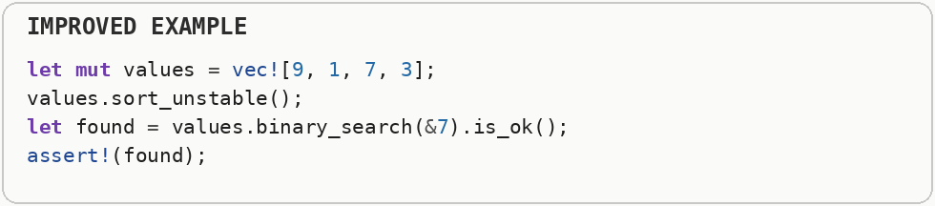

Design for the hardware
Minimizing cache misses and branch mispredictions genuinely speeds up real CPUs. A CPU cache is a small, very fast memory close to the processor. A cache miss happens when the needed data is not there and the CPU must wait for slower main memory; cache locality means arranging access so nearby work tends to reuse nearby bytes. Modern CPUs predict which way a conditional branch will go so their instruction pipelines can stay busy. A wrong prediction forces the processor to discard speculative work and refill the pipeline, which is a branch misprediction. A modern processor is not limited only by arithmetic speed; it also spends time waiting for data and recovering from incorrect predictions. Caches hide slow main-memory access, while branch prediction guesses future control flow so the instruction pipeline can stay full.
The linked-list version stores elements in separately allocated nodes, so walking the collection can make the processor chase pointers from one memory location to another.
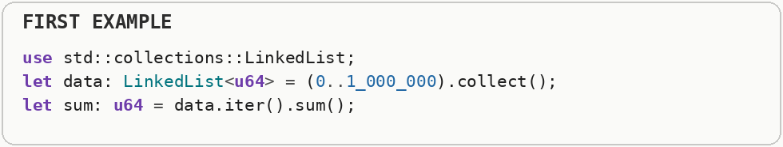
The contiguous version places the numbers next to one another, which lets the processor fetch useful neighboring values into cache together and sum them with fewer waits on main memory.
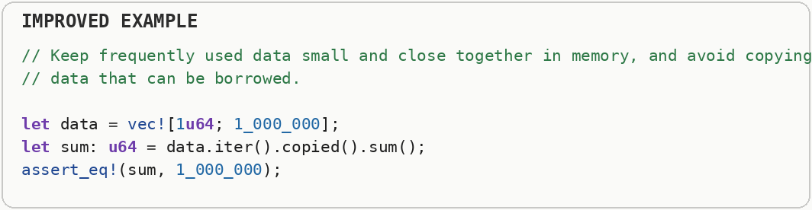

Small wins compound
Dozens of 1-2% gains add up - don't dismiss "minor" optimizations. Performance is often the product of many stages, so several independently measured improvements can accumulate into a meaningful end-to-end gain. The important part is that each small win is real and survives measurement, rather than being assumed from source-code appearance.
The first sample grows a collection piece by piece and then uses a fully stable sort even though the example does not need stability. Each choice is small, but both add work.
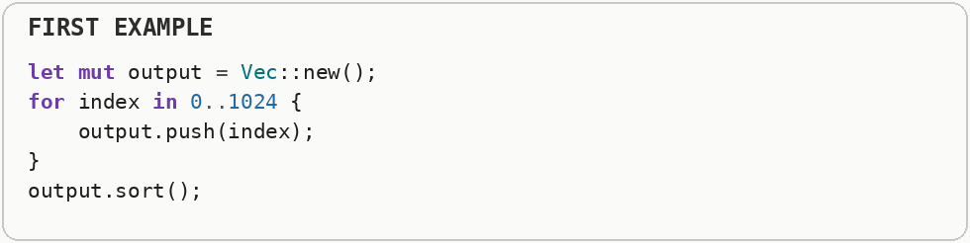
The revised sample reserves the expected space before filling the collection and chooses the lighter unstable sort. Neither change is dramatic alone; the point is that measured small savings can accumulate.
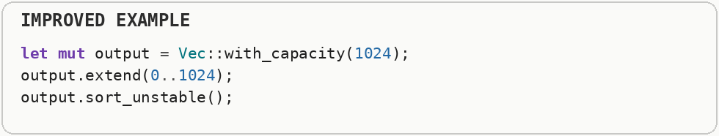

Use multiple profilers
CPU, memory, and causal profilers each surface different bottlenecks. A profiler is a measurement tool that shows where a program spends CPU time, allocates memory, waits on input and output, or stalls between operations. Different profiler types answer different performance questions, so one timing number is rarely the whole diagnosis. Different bottlenecks leave different evidence. CPU sampling finds where processor time is spent, allocation profiling finds where memory is created and retained, and tracing follows latency across waits, queues, threads, and external services.
This timer answers only one question: "How long did the whole operation take?" If it reports 500 milliseconds, you still do not know whether the program spent that time calculating, allocating memory, reading a file, waiting for the network, or waiting for another thread.
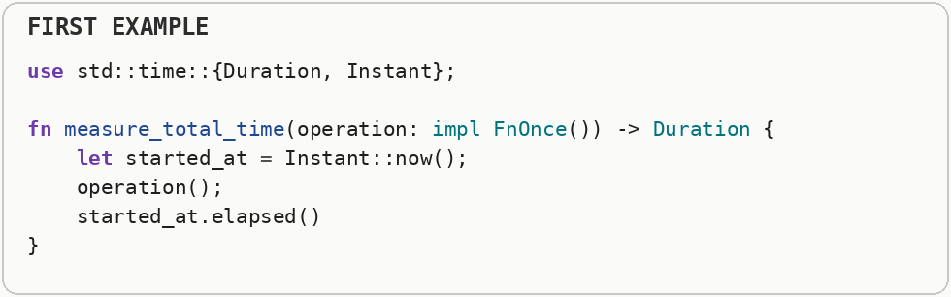
Keep a small timing helper like this for real application measurements, but combine it with specialized tools when a slowdown matters. For example: - a CPU profiler shows which functions keep the processor busy; - a memory profiler shows where allocations and memory growth happen; - tracing shows where a request spends time waiting between operations.
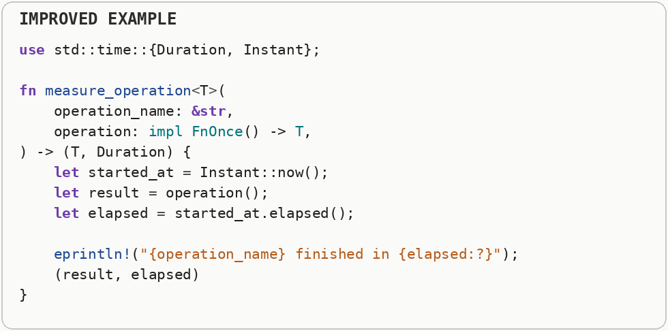

Two ways to fix a hot function:
make it faster, or call it less often. The second is often the bigger, easier win. A hot path is code that runs very frequently or consumes a large share of total execution time. Optimizing cold code may make the source more complicated without producing a noticeable improvement. Total cost is roughly the cost of one call multiplied by how often that call happens. That gives you two independent levers: reduce the work inside the function, or redesign the surrounding code so the function is needed less often.
Here the expensive calculation receives the same input one thousand times, so the program pays for the identical answer one thousand times.
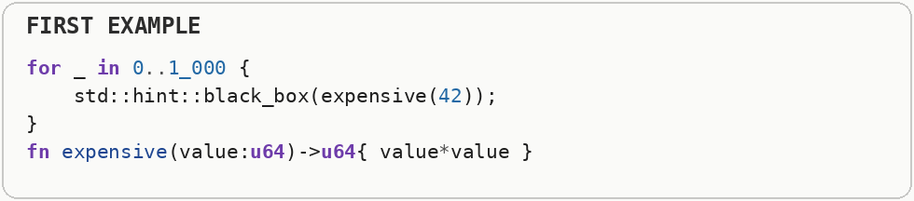
Calculating that answer once and reusing it attacks the call count instead of the speed of the calculation itself. When repeated work is identical, avoiding the call can be the larger optimization.
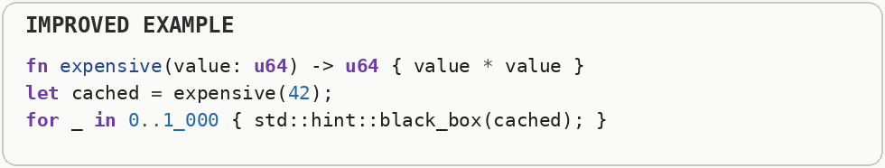

Fix silly slowdowns first
An accidental quadratic time loop, a stray clone, or unbuffered input and output beats inventing a clever optimization. Buffered input and output collects many small reads or writes in memory and performs fewer larger operations. This reduces system-call overhead and gives disks, filesystems, and networks larger chunks to process efficiently. Big O notation describes how the amount of work grows as the input grows. Linear or N log N growth scales much better than quadratic growth, because doubling the input does not multiply the work nearly as aggressively. Large accidental costs usually come from repeated allocation, copying, unnecessary input and output, or an algorithm that revisits the same data far too many times. Removing those structural mistakes is usually safer and more valuable than reaching immediately for obscure CPU tricks.
The loop makes a fresh owned copy of the same text on every iteration. That copy can allocate memory and duplicate bytes even though the consumer does not need a different string each time.
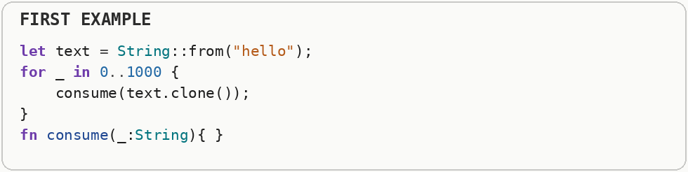
The leaner form keeps one owned string and uses a borrowed view of it. Borrowing means another part of the program can read existing data without creating another owned copy.
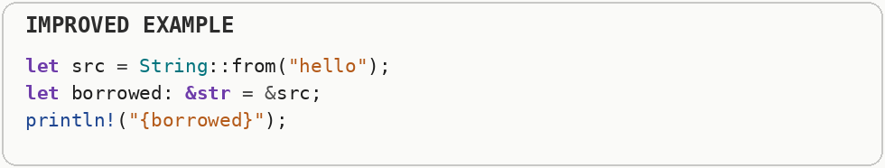

Don't compute what you don't need
Lazy evaluation, early returns, and short-circuiting often beat speeding up the computation itself. Short-circuit evaluation stops evaluating a condition as soon as the final true-or-false answer is known. Early exit applies the same principle to a function or loop: stop once later work cannot change the result. Lazy evaluation means producing a value only when a consumer actually asks for it. Short-circuit evaluation and early exits apply the same idea to control flow: once later work cannot change the answer, the processor should not keep spending time on it.
This creates one million squared numbers and stores all of them in a new vector before checking which one is large enough. Most of that calculation and memory is wasted because the program only needs the first matching value.
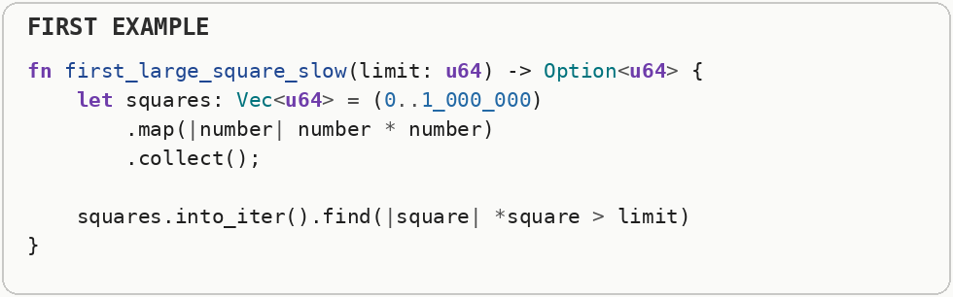
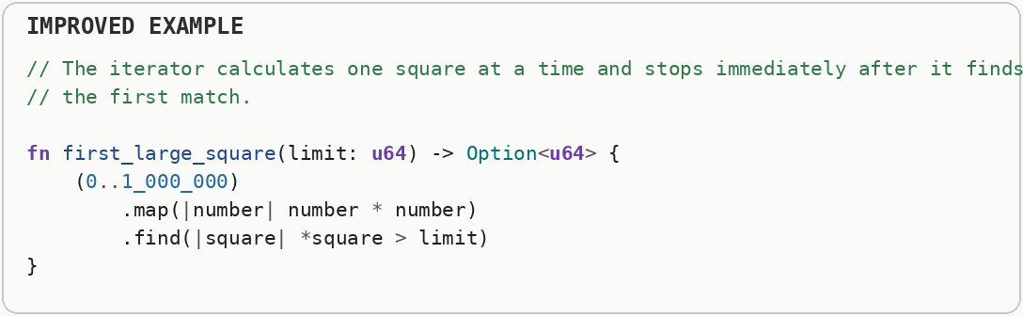

Fast-path the common case
If 90% of calls fit a simple pattern, special-case it before the general logic. ASCII is the older character set for basic English letters, digits, punctuation, and control characters. Unicode is the much larger system used to represent writing systems and symbols from around the world; UTF-8 keeps ASCII bytes compact but can use multiple bytes for other characters. ASCII represents basic English letters, digits, punctuation, and control characters with values that fit in a single byte. Unicode represents characters from writing systems around the world, and UTF-8 encodes Unicode so ASCII remains one byte while many other characters use multiple bytes; handling the full Unicode case can therefore require more decoding work.
ASCII text uses one byte per character, so that extra Unicode decoding work is unnecessary for the common ASCII case.
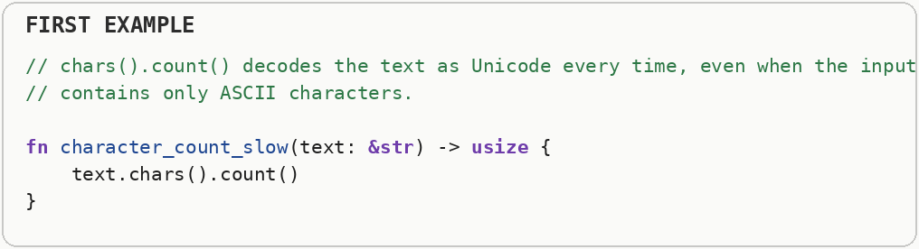
Check the cheap common case first. For ASCII, the byte length is already the character count. Non-ASCII text still uses the fully correct Unicode path. A fast path is a simple path designed for the input the program receives most often.
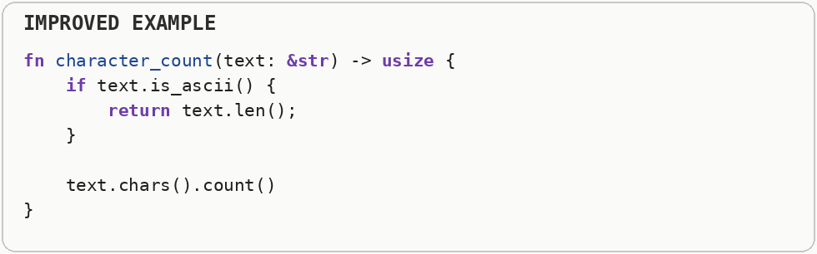

Compress repetitive data
Pack common values compactly; fall back to a secondary table for rare ones. Compression works by representing repeated or predictable information with fewer bits or bytes. Even simple schemes such as replacing repeated strings with small numeric identifiers can reduce memory traffic, which sometimes improves speed because less data must move through caches and memory.
The first representation stores the same short text repeatedly, so identical information occupies memory again and again.
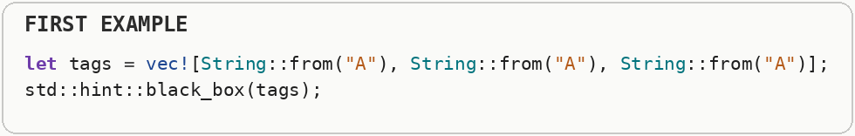
The compact representation turns repeated categories into small numeric tags. That is a form of data compression: represent common information with fewer bytes and reserve larger storage for the uncommon cases.
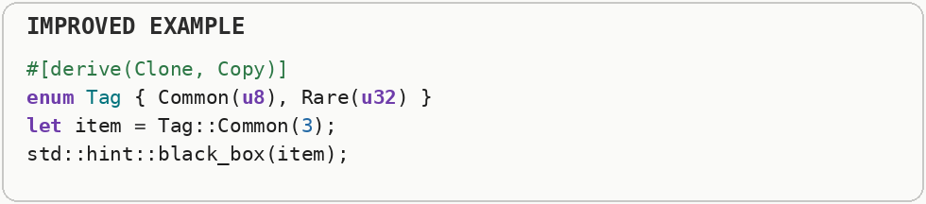

Profile before ordering branches
Put the statistically most frequent case first in if or match branches. Branch predictors learn patterns in conditional control flow and try to guess which path will execute next. If the guess is wrong, the CPU may throw away instructions it started speculatively and refill its pipeline, so real input frequencies can affect the best branch layout.
The first branch puts a rare case first even though nearly every input takes the other path. If real profiling shows that distribution, the processor has a harder layout for the path it executes most often.
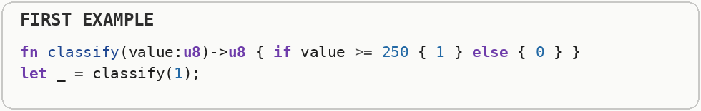
The reordered branch makes the frequent case the straight-through path. Branch ordering should follow measured input frequencies rather than intuition, because the useful order depends on real data.
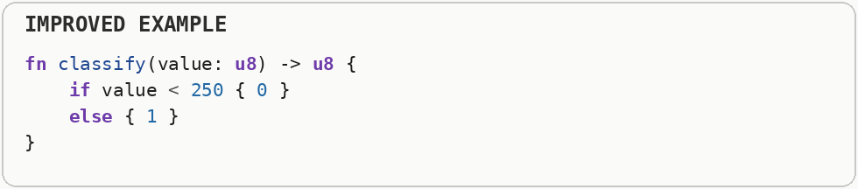

Cache in front of hot lookups
A small cache absorbs repeated queries to the same few keys. An application cache stores the result of an expensive operation so later requests can reuse it. Unlike a CPU cache, this cache is managed by the program itself and is useful when database queries, network calls, parsing, or other repeated work returns the same answer for the same key. A software cache trades memory for avoided work by storing a previously computed or fetched result under a key. A cache hit returns that stored result quickly, while a cache miss falls back to the expensive operation; the usefulness of a cache depends on how often the same information is reused.
This calls the expensive data source every time the same user is requested.
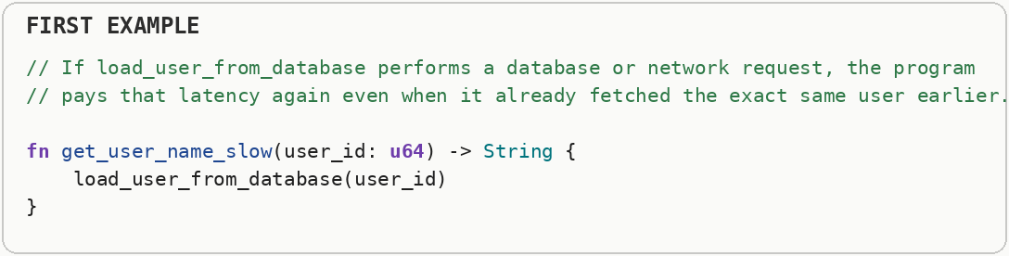
Check a small in-memory cache first. Memory lookup is usually far cheaper than another database or network round trip. A cache stores recently used results so repeated requests can reuse work that has already been completed.
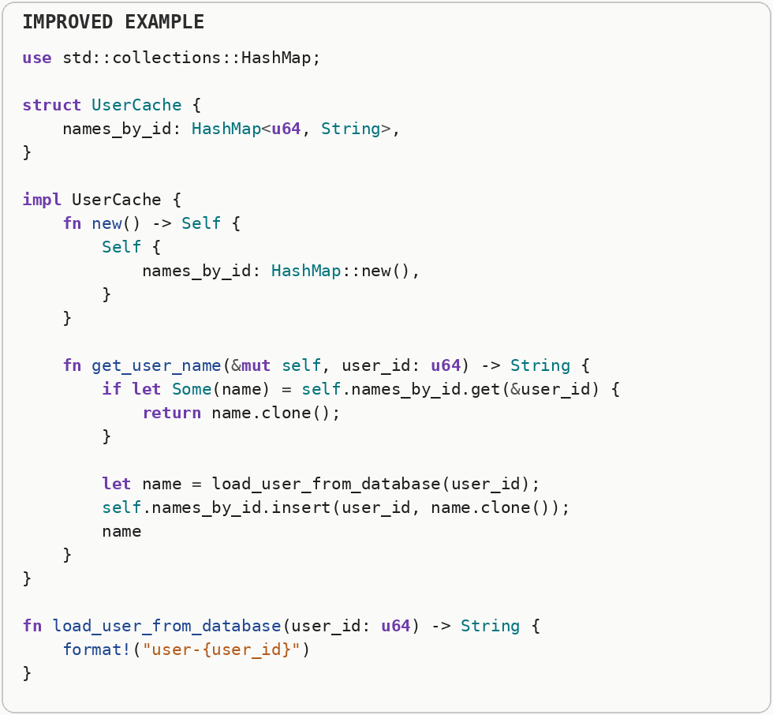

Comment the why
Explain the profiling data behind a non-obvious optimization, not just what the code does. A profiler is a measurement tool that shows where a program spends CPU time, allocates memory, waits on input and output, or stalls between operations. Different profiler types answer different performance questions, so one timing number is rarely the whole diagnosis. Performance code often depends on a non-obvious invariant: a particular data layout, batching size, unsafe precondition, or measured workload assumption. Writing down that reason protects the optimization from being accidentally removed later and helps future readers know when the assumption is no longer true.
This comment only repeats what the code already says. It does not tell the next developer what problem was measured, why this unusual code exists, or what could happen if it is simplified later.
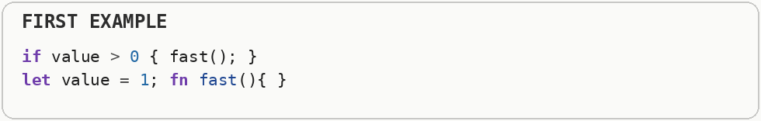
Write the reason the code exists: include the measured behavior, the real bottleneck, and the trade-off. That gives future developers enough information to decide whether the optimization is still needed.
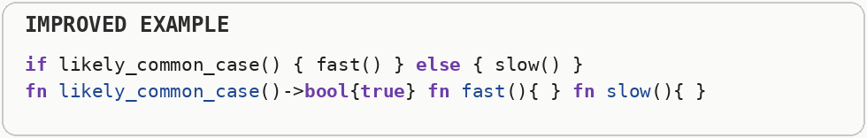

High-Level Design

The Space vs. Time Trade-off
Almost every optimization is really a decision about which resource you're willing to spend more of: memory or CPU time. Know which direction you're trading in, and pick deliberately based on what's actually scarce for your program. Time and memory are often interchangeable resources. A lookup table can spend extra memory to avoid recomputation, while recomputing a value can save memory at the cost of CPU time; the correct choice depends on the resource that is actually limiting the system.
A linear search uses almost no extra memory, but every lookup may scan element after element until it finds the target.
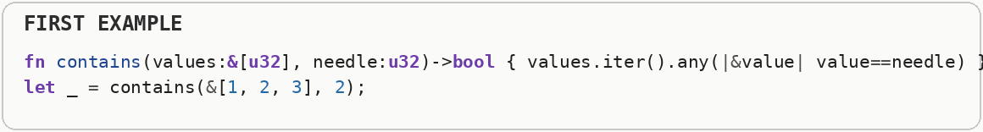
The indexed version spends additional memory building a hash table so later lookups can jump close to the answer. This is the classic space-time trade-off: extra stored structure buys less search work.
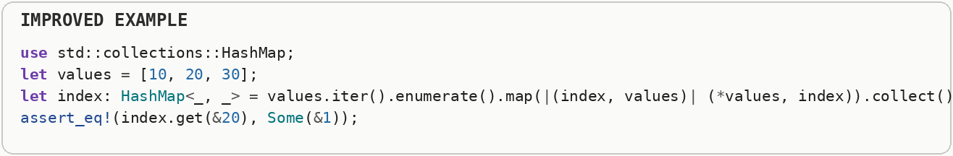

Basic Coding Principles

Eliminate Excessive Function Calls
Move computations out of loops whenever possible. You might even consider selective compromises of program modularity to gain greater efficiency. A function call transfers control to another function and usually passes arguments, records a return location, and later returns to the caller. Modern compilers can inline small calls, but repeated calls still matter when they prevent optimization or occur millions of times in a hot loop. A function call can involve argument passing, a control-flow jump, return bookkeeping, and sometimes saving registers or preventing other compiler optimizations. Modern compilers can inline many small calls, but calls that remain in a very tight loop can still add measurable overhead.
The first loop recalculates the same scale for every element even though the scale never changes.
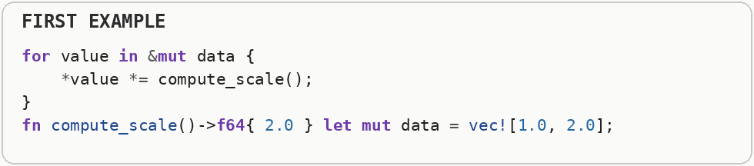
The improved version computes the scale once before the loop and reuses it. The optimization is hoisting loop-invariant work: move a calculation outside a loop when its answer is identical on every iteration.
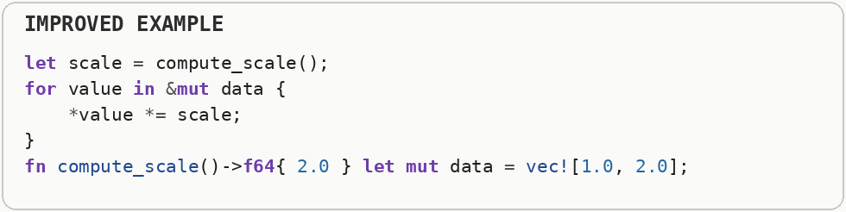

Eliminate Unnecessary Memory References
Introduce temporary variables to hold intermediate results instead of mutating references directly. Registers are tiny storage locations directly inside the CPU and are much faster to access than ordinary memory. Repeatedly loading through a pointer or reference can create extra memory operations, while keeping an intermediate value in a local variable can give the compiler a better chance to keep it in a register.
The first loop repeatedly updates a value through an extra memory reference. Even a tiny memory dependency can make a tight loop harder for the compiler and processor to keep in registers.
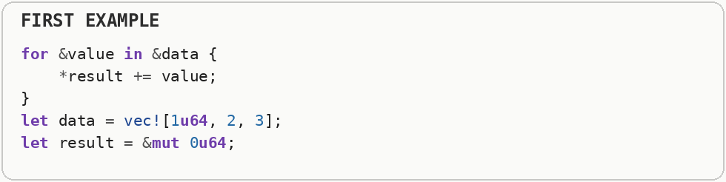
The second version accumulates into a local scalar and writes the final result once. A register is a tiny storage location inside the CPU, so keeping a running total there can avoid repeated memory traffic.
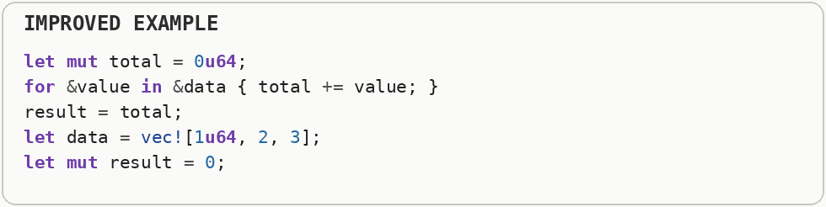

Low-Level Optimizations & Rust Patterns

Memory References & Passing by Value
Eliminate unnecessary pointer dereferences by passing small types by value. Small values such as integers, booleans, and short machine-word-sized structures can often be copied directly through CPU registers. Passing a pointer instead can add an extra dependency because the CPU first receives an address and then has to load the value stored at that address.
That means the CPU may need an extra memory read just to reach a tiny value that would fit comfortably in registers, the CPU's fastest small storage locations.
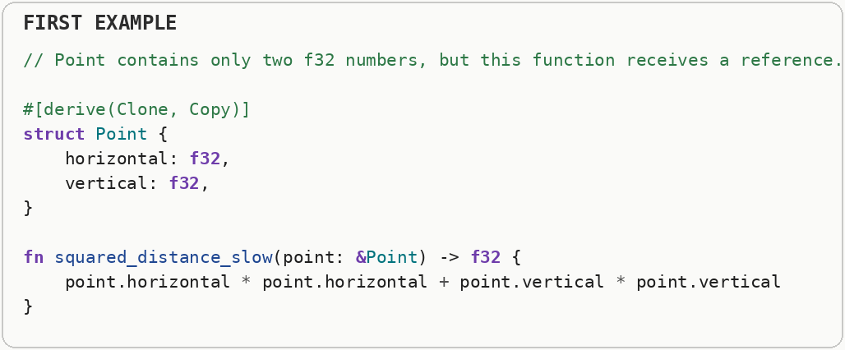
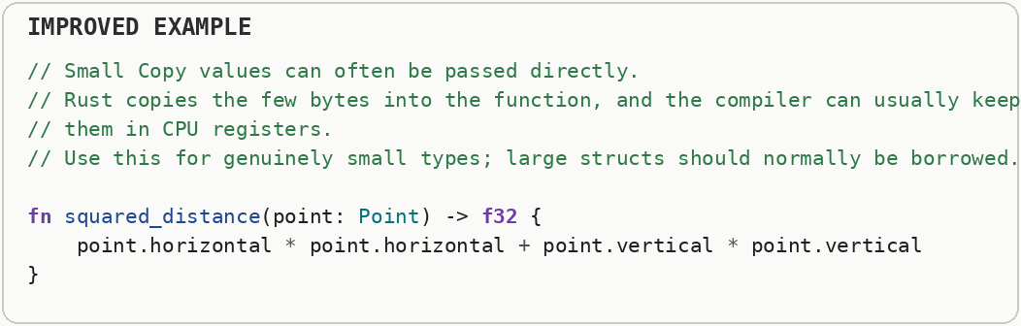

Loop Locality & Bounds Checking
Structure loops to utilize spatial locality and use Iterators to remove hidden bounds checks. A bounds check verifies that an index stays inside an array or slice before memory is accessed. An overflow check verifies that arithmetic still fits the destination integer type; removing either check trades safety for a small amount of work and must be justified carefully. Bounds checking verifies that an array or slice index stays inside the valid range before memory is accessed. Compilers can often prove repeated checks unnecessary, especially when iteration follows a simple pattern, while sequential access also improves locality by touching nearby memory in order.
The compiler can remove many of these checks, but complicated indexed loops may make that proof harder and the index itself does not explain what the code needs.
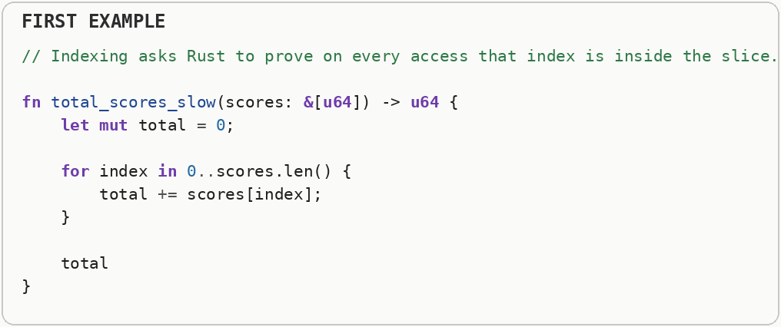
Iterate over the values directly. The code says exactly what it means-read every score once-and gives the compiler a simple sequential memory-access pattern. Sequential access also helps the CPU cache, which keeps recently used memory nearby.
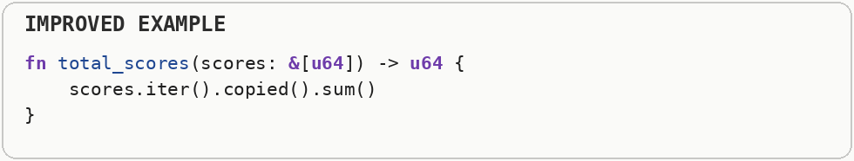

Bounds Safety, Unchecked Access & Pointers

Unchecked APIs (Bounds & Overflow Check Elimination)
Only after profiling shows bounds and overflow checks are a hot-path bottleneck and you can prove the access is always valid, use unchecked memory access or similar. A profiler is a measurement tool that shows where a program spends CPU time, allocates memory, waits on input and output, or stalls between operations. Different profiler types answer different performance questions, so one timing number is rarely the whole diagnosis. A bounds check verifies that an index stays inside an array or slice before memory is accessed. An overflow check verifies that arithmetic still fits the destination integer type; removing either check trades safety for a small amount of work and must be justified carefully. Safety checks prevent invalid indexes and, in some configurations, arithmetic overflow from silently producing dangerous results. Removing a check can save work only when that check is actually present in the hot path, and it transfers the proof of correctness from the language runtime or compiler to the programmer.
If the position is wrong, the program may read memory that belongs to something else or crash. That risk is called an out-of-bounds memory access.
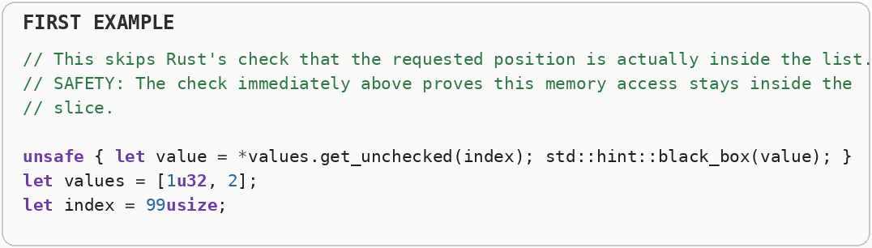
Keep normal checked access unless a profiler proves the check itself is a real bottleneck.
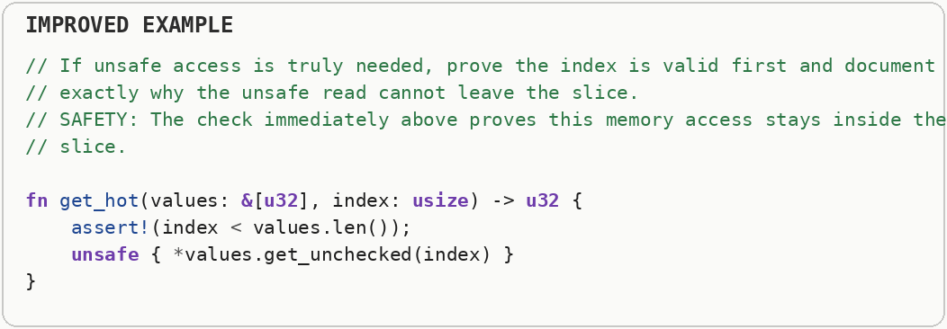

Pointer Arithmetic vs. Pointer Indexing
Prefer indexing (bounds-checked slice or array access, or iterator-based traversal) over raw pointer arithmetic; reach for pointer arithmetic only in proven hot paths where you've already established the access pattern is safe. A hot path is code that runs very frequently or consumes a large share of total execution time. Optimizing cold code may make the source more complicated without producing a noticeable improvement. A raw pointer is essentially a memory address with very few safety guarantees attached. Pointer arithmetic changes that address manually, so a wrong offset can reach unrelated memory even though the arithmetic itself looks simple. A raw pointer is fundamentally a memory address. Pointer arithmetic changes that address numerically, so a wrong offset can point outside the intended object; ordinary indexed or iterator-based access carries more information that the compiler can often optimize while preserving safety.
A raw pointer is only a memory address. If the math is wrong, the program can read unrelated memory, return incorrect data, or crash. Use raw pointers only when measurements prove normal safe access is too slow.
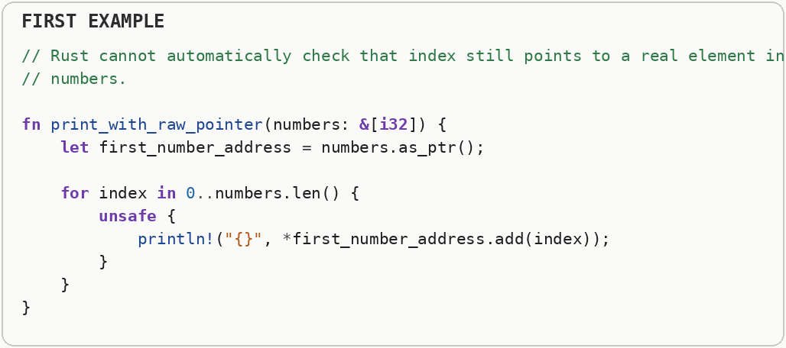
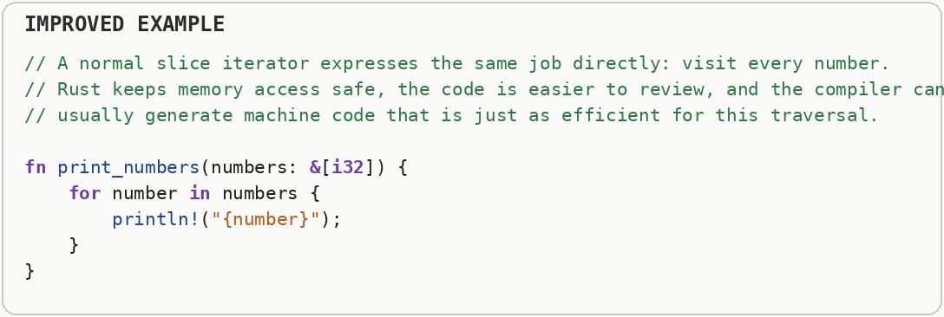

Allocation & Collection Management

Hoisting Allocations Out of Loops
Move expensive string and heap allocations out of loops . Heap allocation asks an allocator to find a block of memory at runtime. Growing a collection can require a reallocation: a larger block is acquired, existing data is moved or copied, and the old block is released. Heap allocation asks a memory allocator to find and track storage while the program is running. If that happens every loop iteration, allocator bookkeeping and repeated initialization become part of the loop cost; moving reusable storage outside the loop pays that setup less often.
Creating and later freeing all of those temporary strings makes the memory allocator do work that is not part of the actual business task.
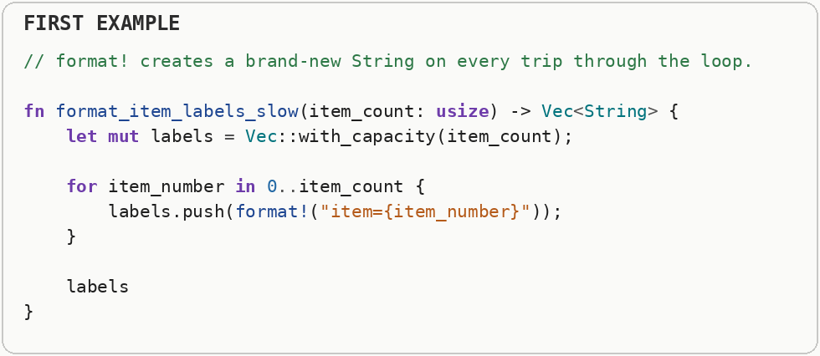
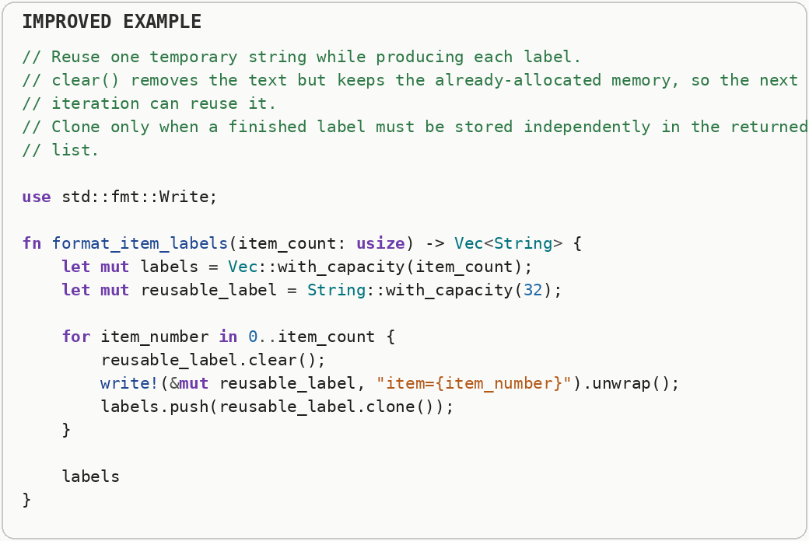

Reserve Capacity & Amortized Complexity
If you know (or can estimate) the final size of a collection, reserve the expected capacity up front. Judge structure cost by average cost over a long sequence of operations, not the worst single call. Heap allocation asks an allocator to find a block of memory at runtime. Growing a collection can require a reallocation: a larger block is acquired, existing data is moved or copied, and the old block is released. Amortized complexity looks at the average cost across a long sequence of operations. An occasional expensive resize can still be cheap on average if most insertions are constant-time. Dynamic arrays usually grow geometrically rather than one element at a time. Most appends are cheap, but an occasional growth step allocates a larger block and moves existing elements, so the average cost is amortized across many appends; reserving expected capacity can avoid several of those growth events.
As more values are pushed in, the vector may run out of room, ask the allocator for a larger memory block, copy the existing values into that new block, and free the old block.
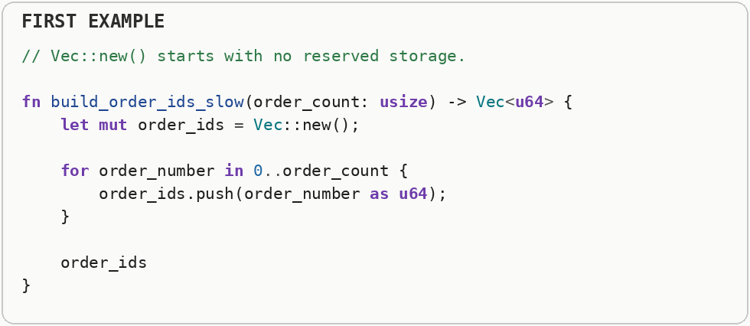
If the expected size is already known, reserve that space once. This pattern is reusable anywhere a function builds a collection with a predictable final size.
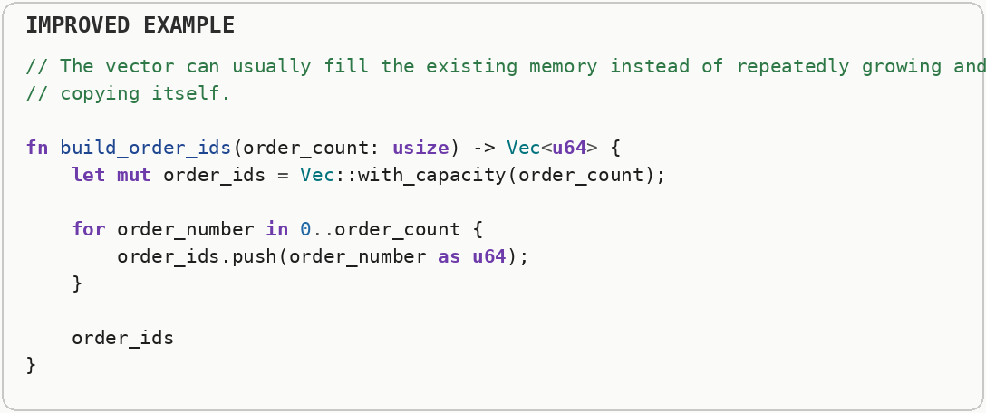

Recycle Collections (Allocation Churn)
Inside a loop that rebuilds the same collection each iteration, clearing and reusing the collection and reuse it instead of creating a new one. Heap allocation asks an allocator to find a block of memory at runtime. Growing a collection can require a reallocation: a larger block is acquired, existing data is moved or copied, and the old block is released. Allocation churn means repeatedly creating and destroying temporary memory of similar size. Reusing an existing collection keeps its backing storage available, reducing trips through the allocator and often reducing pressure on caches and the memory subsystem.
Every chunk in the first loop creates a new scratch buffer and then throws it away, which repeatedly asks the allocator for temporary storage.
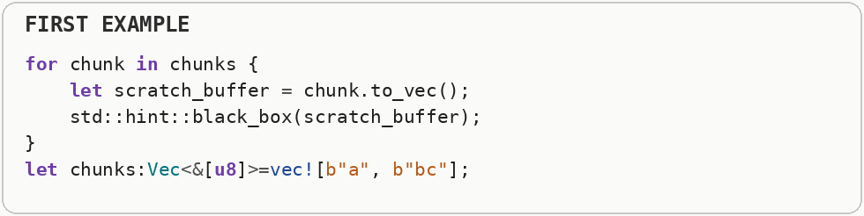
The second loop keeps one buffer, clears its logical contents, and refills the same capacity. Recycling a collection removes allocation churn while preserving the same scratch-space behavior.
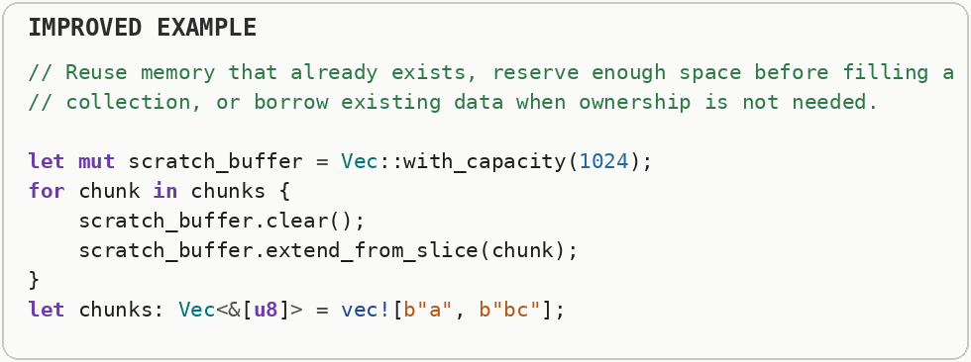

Append to Strings (Double-Allocation in String Building)
When building a string piece-by-piece, prefer appending directly to the existing string (via the std::fmt::Write trait) over building a temporary formatted string and then appending it. Heap allocation asks an allocator to find a block of memory at runtime. Growing a collection can require a reallocation: a larger block is acquired, existing data is moved or copied, and the old block is released. Strings are variable-sized byte buffers, so building text through repeated temporary strings can allocate and copy the same characters multiple times. Appending into one reusable buffer reduces the number of intermediate objects and the amount of memory copied.
The first string builder formats each number into a temporary string and then appends that temporary string to the growing message. That can mean two pieces of string work for one piece of output.
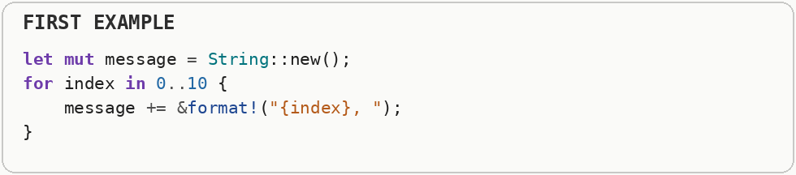
The improved form writes formatted text directly into one preallocated destination. It avoids constructing a separate temporary string for every append.
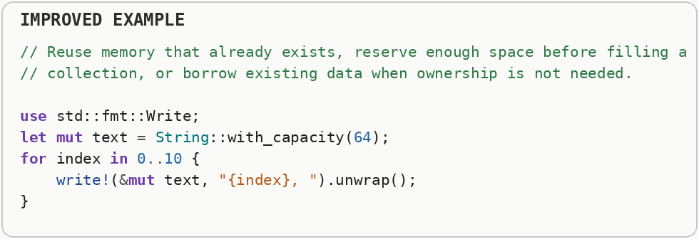

Const Generics: Stack Arrays Instead of Heap Vecs
If a collection's size is fixed and known at compile time (a 3D vector's a fixed three-element floating-point array, a fixed-size buffer, a small lookup table), use a plain array or a const-generic type instead of vector. Heap allocation asks an allocator to find a block of memory at runtime. Growing a collection can require a reallocation: a larger block is acquired, existing data is moved or copied, and the old block is released. Compile-time evaluation performs work while the program is being built and stores the finished result in the executable. That shifts repeated deterministic work out of runtime entirely when all required inputs are already known. Stack storage belongs to a function's call frame and can often be reserved with simple pointer movement, while heap storage requires a runtime allocator. When a collection has a small size known at compile time, fixed-size inline storage can avoid heap allocation entirely.
The first example uses a growable heap collection for a position whose size is fixed and known in advance.
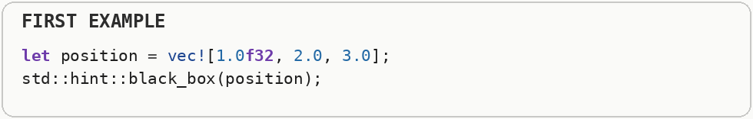
The alternative uses fixed-size arrays and a compile-time size parameter. Fixed-size data can live inline instead of requiring a separate heap allocation, while the size parameter still lets the same function work with different array lengths.
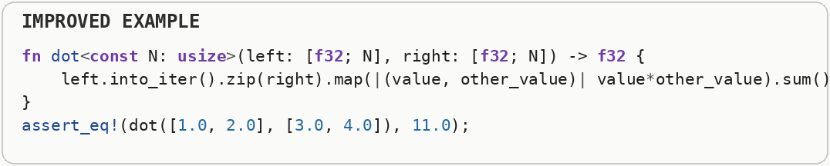

Memory Arenas (Per-Object Allocation Overhead)
If you need to create thousands of small, short-lived objects (like parsing nodes in a compiler), do not use standard global allocations (a separate heap allocation). Use an Arena (Bump Allocator). Heap allocation asks an allocator to find a block of memory at runtime. Growing a collection can require a reallocation: a larger block is acquired, existing data is moved or copied, and the old block is released. An arena obtains memory in larger chunks and then serves many small objects from those chunks. Individual objects usually are not freed separately; the entire arena is released together, which can make allocation extremely cheap when many objects share a similar lifetime.
The first form allocates every node separately. Thousands of tiny allocations mean thousands of allocator decisions and scattered objects in memory.
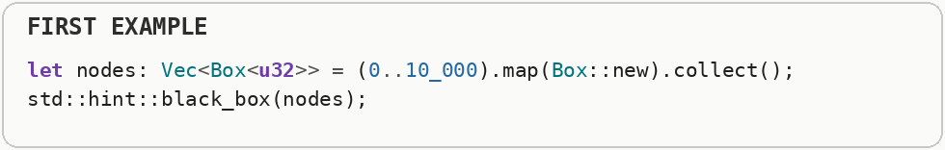
An arena reserves larger blocks and hands out many small objects from those blocks. Individual objects become cheap to allocate, and the entire group can be released together when the arena is finished.
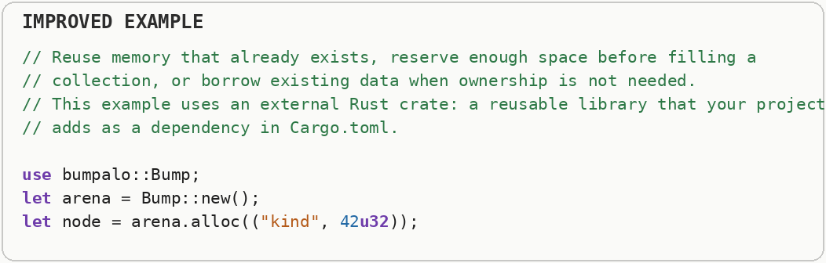

Global Allocator (Default Allocator Contention)
For allocation-heavy workloads, swap Rust's default system allocator for a faster drop-in like mimalloc or jemalloc. Heap allocation asks an allocator to find a block of memory at runtime. Growing a collection can require a reallocation: a larger block is acquired, existing data is moved or copied, and the old block is released. Contention happens when multiple workers compete for the same lock, cache line, memory allocator, or other shared resource. More threads do not help if they spend their time waiting for one another. A general-purpose allocator must safely serve many allocation sizes and often many threads. Under heavy allocation, threads can contend for allocator metadata or internal locks, so specialized or thread-friendly allocators can help workloads where allocation itself is a measured bottleneck.
The workload creates a very large number of short-lived strings, so the global memory allocator becomes part of the hot path and may also become shared contention in multithreaded code.
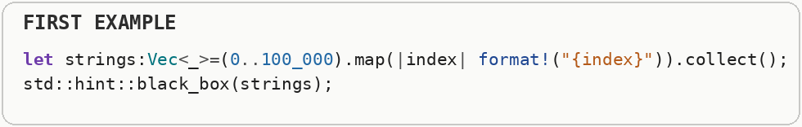
The second sample demonstrates replacing the process-wide allocator with one designed for high allocation throughput. That does not remove allocations; it changes the machinery servicing them, so it is something to benchmark rather than assume.
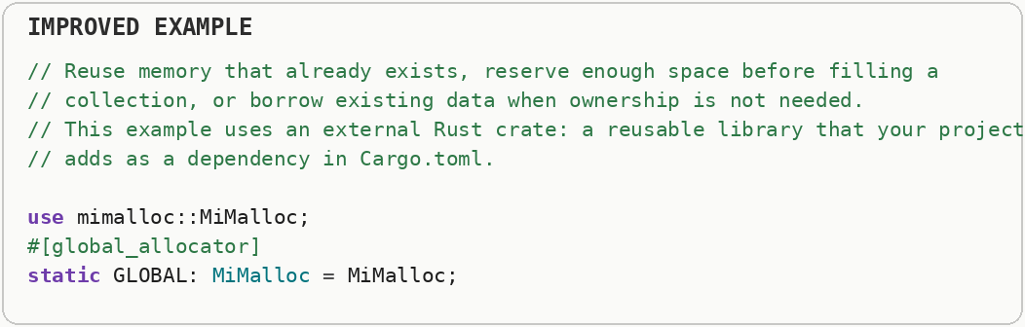

Avoid Unnecessary Clones & Copies
Prefer borrowing (a borrowed value, a borrowed string slice, a borrowed slice) and moving over .clone(); treat every clone in a hot path as a bug until profiling proves it is cheap. A profiler is a measurement tool that shows where a program spends CPU time, allocates memory, waits on input and output, or stalls between operations. Different profiler types answer different performance questions, so one timing number is rarely the whole diagnosis. A hot path is code that runs very frequently or consumes a large share of total execution time. Optimizing cold code may make the source more complicated without producing a noticeable improvement. Copying duplicates bytes, while cloning can also allocate new owned storage for data such as strings and collections. Ownership and borrowing let code share access to existing data without duplicating it, which can remove both memory traffic and allocator work.
The first function takes ownership of the whole byte collection even though it only needs to read the bytes. Callers may be forced to move or copy data just to satisfy that interface.
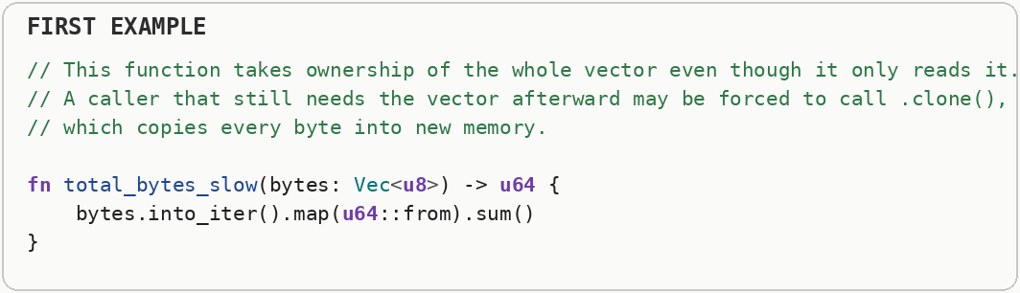
The second function accepts a read-only view of existing bytes. The computation stays the same, but the interface makes ownership transfer unnecessary.
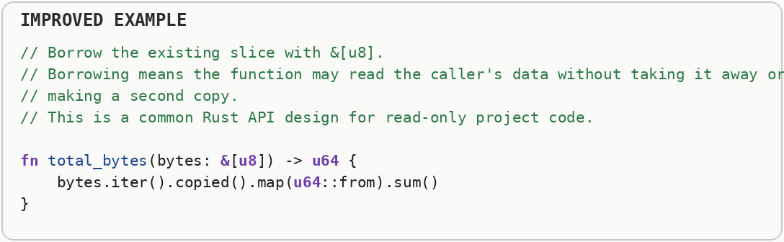

Small-Buffer Optimization (Inline Storage)
For collections that are usually small (0-N elements with small N), use inline storage (small-vector inline storage, fixed-capacity inline vector storage, fixed-capacity inline string storage, or a custom enum { Inline(a fixed-size array), Heap(vector) }) to avoid heap allocation in the common case. Small-buffer optimization keeps a small amount of storage inside the object itself and falls back to heap memory only when that inline capacity is exceeded. It avoids allocator work and pointer chasing for the common small case. Heap allocation asks an allocator to find a block of memory at runtime. Growing a collection can require a reallocation: a larger block is acquired, existing data is moved or copied, and the old block is released. Small-buffer optimization stores short values directly inside the object and switches to heap storage only when they grow beyond that inline capacity. This avoids an allocation for the common small case while still allowing the value to grow when necessary.
A normal growable collection usually stores its elements in heap memory even when it contains only a handful of values.
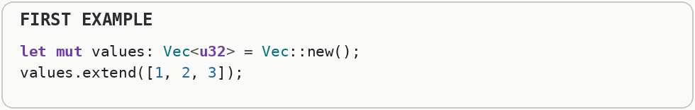
Small-buffer optimization keeps the common small case directly inside the collection object and moves to heap storage only when it outgrows that inline space. That removes a heap allocation from the common path.
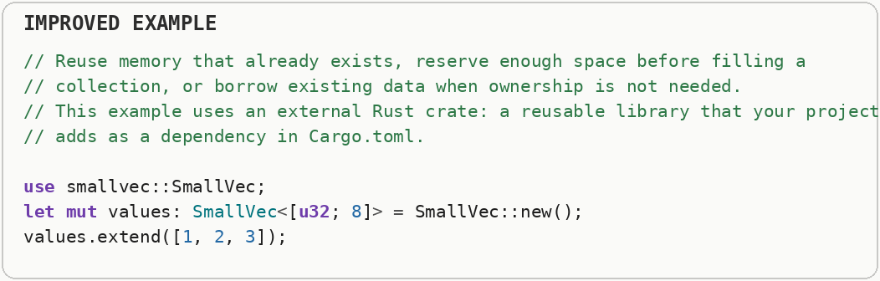

Defer Drop (Synchronous Deallocation Stalls)
If dropping a large object (huge vector, big hash map) is expensive, send it to a background thread to be dropped instead of blocking the current one. Deallocation returns memory or other resources when an object is destroyed. Large deallocations can pause a latency-sensitive thread because destructors may release many nested allocations or synchronize with an allocator. Heap allocation asks an allocator to find a block of memory at runtime. Growing a collection can require a reallocation: a larger block is acquired, existing data is moved or copied, and the old block is released. Destroying an object can trigger more than a tiny bookkeeping step: it may recursively destroy children, free heap blocks, close resources, or update shared allocator state. If a large destruction happens on a latency-sensitive path, that cleanup can create a noticeable pause even though the useful work is already finished.
Destroying a very large allocation can take noticeable time because memory bookkeeping and nested destructors run synchronously on the current thread.
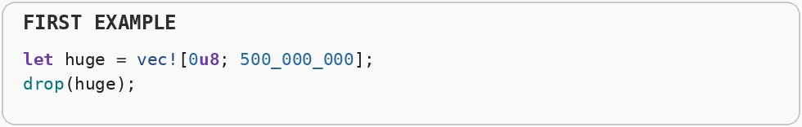
The second sample moves that destruction to another worker. The memory still has to be released, but a latency-sensitive thread no longer has to wait for all of the cleanup before continuing.
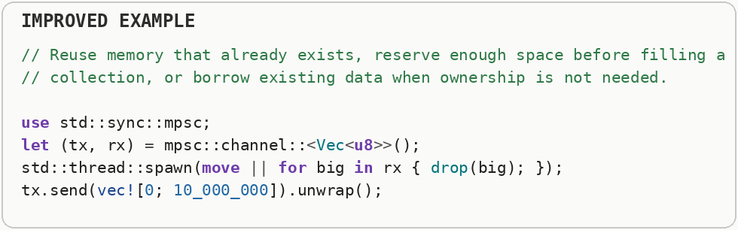

Instruction-Level Parallelism & Branch Optimization

Explicit SIMD & Auto-Vectorization
Prefer idiomatic iterators and contiguous data so LLVM auto-vectorizes; drop to explicit SIMD intrinsics or specialized vector libraries only when the auto-vectorizer fails on a proven hot loop. SIMD stands for single instruction, multiple data: one machine instruction performs the same operation on several values at once. Auto-vectorization is the compiler recognizing a loop that can safely be converted into those wider operations. LLVM is the compiler infrastructure Rust uses for much of its low-level optimization and machine-code generation. It can optimize aggressively only when the program structure gives it enough information to prove that a transformation is safe. SIMD means single instruction, multiple data: one CPU instruction performs the same operation on several values packed into a vector register. Auto-vectorization is the compiler's attempt to discover those opportunities automatically, while explicit SIMD gives the programmer more control when the compiler cannot infer a safe vector form.
The indexed version grows a new output collection while also loading two input arrays. That extra growth and indexing can make the loop more complicated than the arithmetic itself.
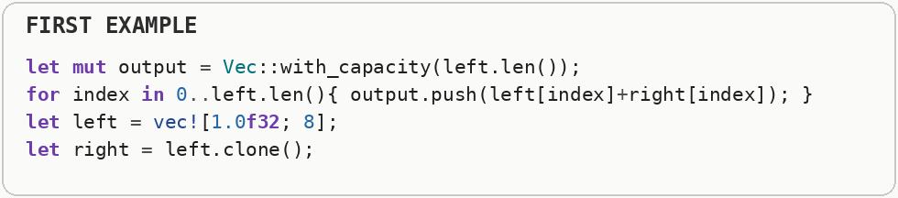
The second loop writes into storage that already exists and walks all three slices sequentially. A simple, regular loop is easier for the compiler to auto-vectorize, meaning it can turn several scalar operations into one SIMD instruction when the target CPU supports it.
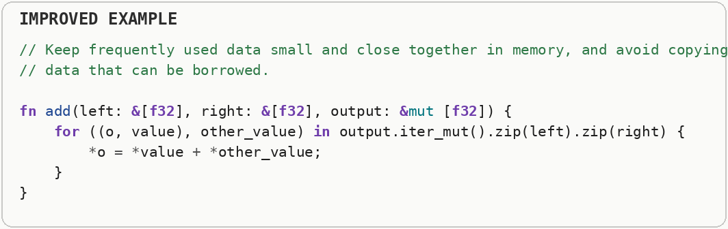

Multiple Functional Units & Instruction-Level Parallelism
Unroll loops and use multiple accumulators to break calculation dependency chains, allowing the CPU to use multiple Arithmetic Logic Units (ALUs) concurrently. Instruction-level parallelism is the CPU executing independent instructions at the same time on different internal execution units. Long dependency chains limit that overlap because each step must wait for the previous result. Modern CPUs contain multiple execution units for arithmetic, loads, stores, and other operations. Instruction-level parallelism is the ability to keep several of those units busy at once by providing independent instructions instead of one long chain where every result waits for the previous result.
Every addition depends on the total produced by the previous addition. The CPU must keep extending one long chain, so it has fewer independent additions available to execute at the same time.
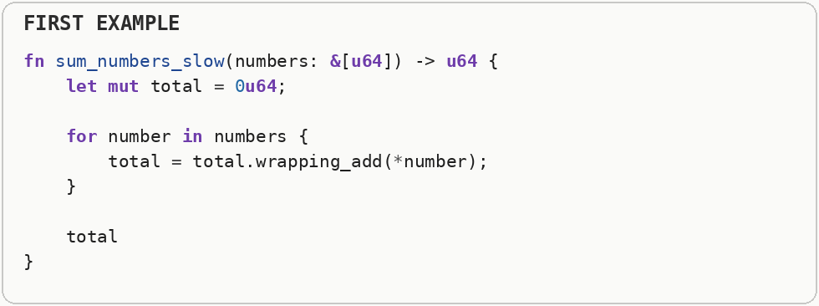
Two running totals create two independent chains of additions. Some CPUs can work on those chains at the same time using separate arithmetic hardware.
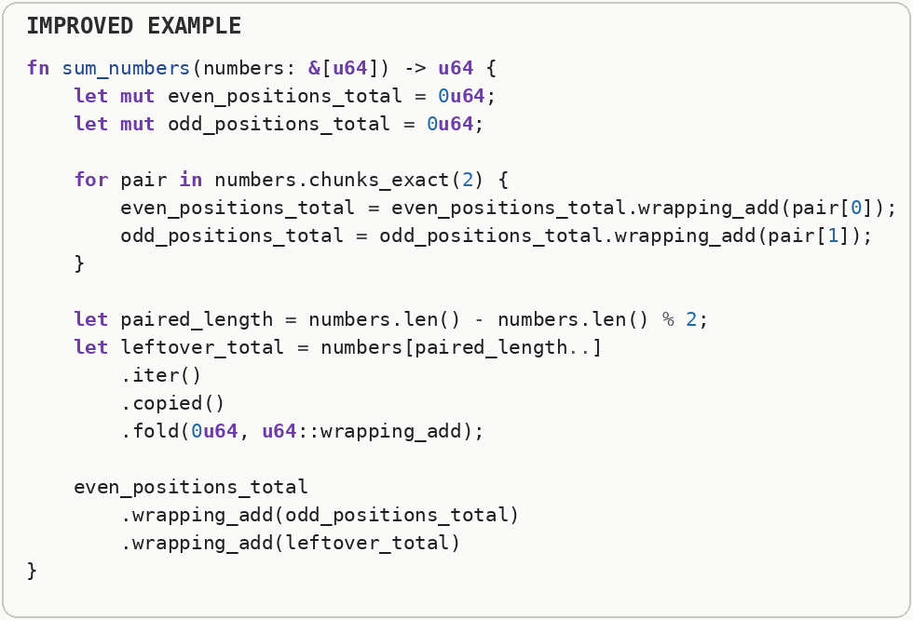

Functional Style Conditional Operations
Break branching logic by using functional branching (.map(), .filter()). Branchless code replaces some control-flow decisions with data-flow operations. That can reduce unpredictable branches, but it is only a win when the extra arithmetic is cheaper than the branch behavior it replaces. Branchless or data-flow-oriented code tries to express selection without unpredictable jumps in control flow. This can help when branches are hard to predict, but it can also do extra arithmetic or memory work, so the value comes from the hardware behavior of the specific workload rather than from the style itself.
The explicit loop performs a conditional test for every value and manually decides whether to append the transformed result.
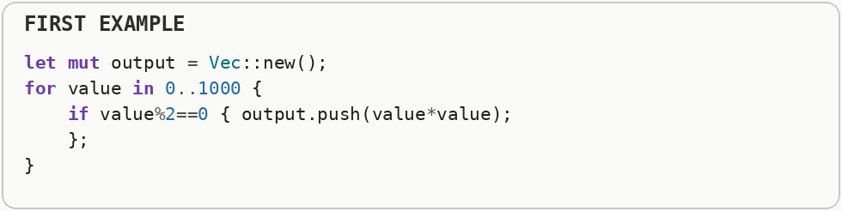
The pipeline expresses the operation as filtering followed by mapping. The important performance idea is not that functional syntax is automatically faster; it gives the optimizer a regular data-flow pattern that can sometimes be simplified or vectorized.
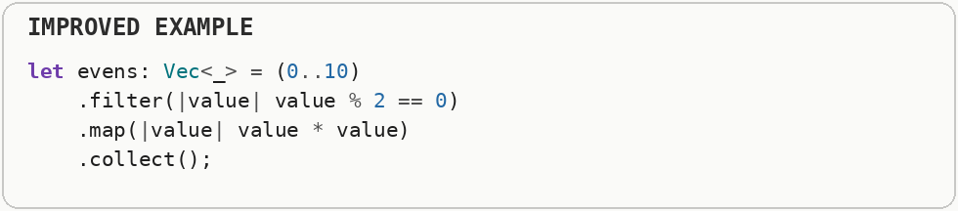

Loop Unswitching (Loop-Invariant Branching)
Move conditional if statements that do not change during the loop outside of the loop. Loop unswitching moves a condition that never changes during the loop outside of it. The program chooses a loop version once instead of rechecking the same condition on every iteration. A loop-invariant condition has the same answer for every iteration. Loop unswitching evaluates that condition once and then enters a specialized loop, trading a little more code size for fewer repeated branches inside the hot loop body.
The first loop checks the same condition on every iteration even though that condition never changes while the loop is running.
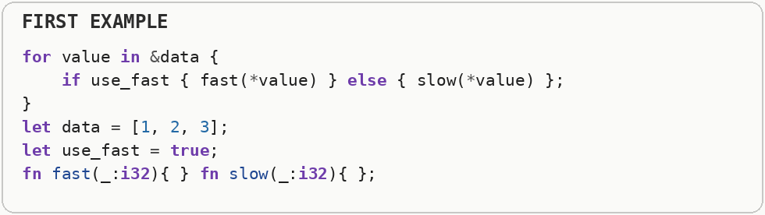
Loop unswitching makes the decision once and then runs the appropriate loop body. One branch outside the loop replaces a branch repeated for every element.
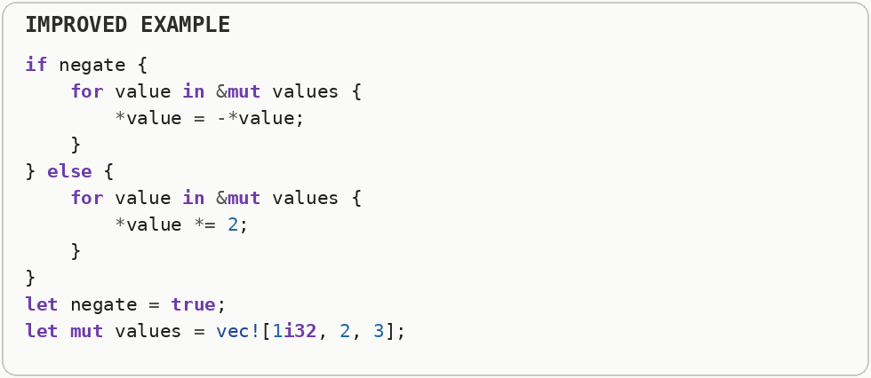

Branch Prediction Hints (Branch Misprediction on Rare Paths)
For branches where one side is overwhelmingly rare (error handling, panics, one-time setup), mark the rare side a cold-path annotation so the compiler optimizes the common path harder. Modern CPUs predict which way a conditional branch will go so their instruction pipelines can stay busy. A wrong prediction forces the processor to discard speculative work and refill the pipeline, which is a branch misprediction. An expected failure is part of normal control flow and is usually best represented explicitly. Panics or exceptions are designed for exceptional situations; unwinding or constructing diagnostic state can be much more expensive than an ordinary branch. A branch hint tells the compiler or processor which path is expected to be common, but modern predictors already learn from runtime history. Hints are most useful for genuinely rare error paths and can backfire when the real data does not match the assumption.
An ordinary error branch sits beside the common path even when failures are extremely rare.
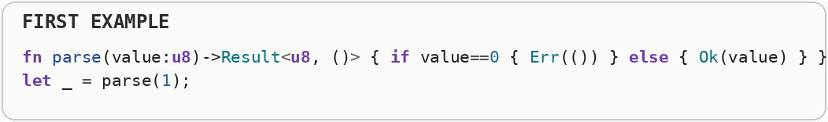
The revised layout moves the rare failure into a cold path. A cold-path annotation tells the compiler that this code is unlikely to execute, allowing the frequently executed instructions to stay tighter together.
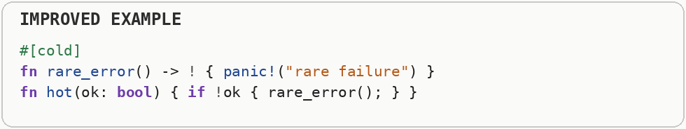

Strength Reduction (Expensive Ops to Cheap Ops)
Replace expensive arithmetic (division, modulo, multiply by non-constant) with cheaper equivalents the CPU can execute in fewer cycles - shifts, adds, or multiplies by a compile-time inverse. Strength reduction replaces an expensive operation with a cheaper equivalent, such as using shifts or additions when the math allows it. Modern compilers already perform many obvious cases, so manual rewrites matter mainly when the compiler cannot prove the equivalence. A logical right shift fills new high bits with zero. An arithmetic right shift preserves the sign bit of a signed integer, which effectively extends the sign as the value moves right. Strength reduction replaces an expensive operation with an equivalent cheaper one, such as replacing repeated multiplication by a constant with incremental addition when that transformation is valid. Compilers already perform many of these rewrites, so hand-written versions matter mainly when the optimizer cannot see the equivalence.
The first expression uses an arithmetic operation that can be more expensive than the simpler operation implied by a power-of-two constant.
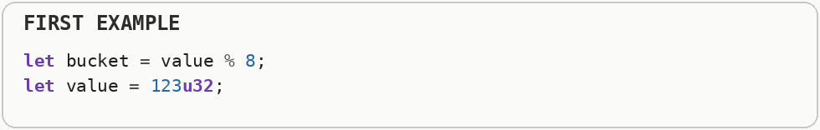
The second sample shows shifts, where moving bits left multiplies by a power of two and moving unsigned bits right divides by a power of two. Modern compilers often perform this strength reduction automatically, so hand changes are most useful when generated machine code proves they matter.
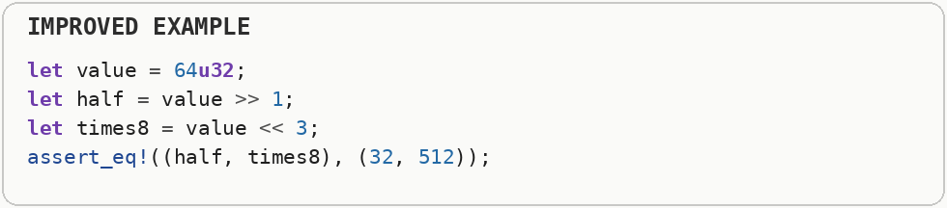

Loop Fusion & Fission
Fuse consecutive loops that touch the same data to cut memory traffic; split (fission) a loop only when it enables better vectorization or cache behavior for distinct phases. Loop fusion combines passes over the same data so values can stay hot in cache and memory traffic drops. Loop fission does the opposite when separating phases gives the compiler cleaner vectorization or keeps unrelated data out of the same hot loop. A CPU cache is a small, very fast memory close to the processor. A cache miss happens when the needed data is not there and the CPU must wait for slower main memory; cache locality means arranging access so nearby work tends to reuse nearby bytes. Loop fusion combines passes over the same data so values can stay hot in cache and loop overhead is paid fewer times. Loop fission splits one large loop into smaller passes, which can improve vectorization or reduce the amount of unrelated data each pass touches; the best choice depends on memory behavior and dependencies.
The first version walks the same arrays twice and stores an intermediate array between the two passes.
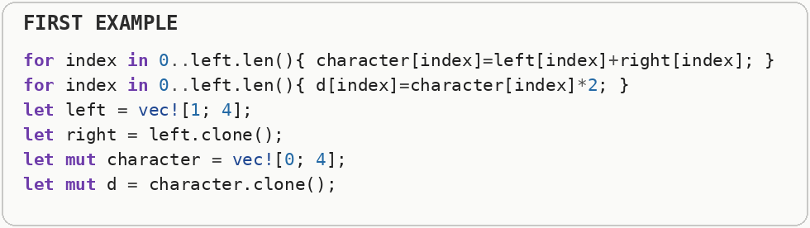
The fused loop performs both transformations while each value is already in hand. Fusion can reduce loop overhead and temporary memory traffic; fission, the opposite transformation, can help when separating unrelated work improves cache behavior or vectorization.
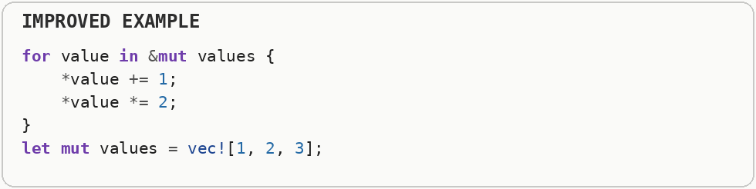

Measurement, Testing & Caution

Micro-Benchmarking (Dead-Code Elimination in Benchmarks)
Never trust intuition about which version is faster - measure it with a dedicated benchmark harness, and guard against the compiler "cheating" by optimizing your benchmark away. A micro-benchmark measures a small operation in isolation. Compilers can delete or simplify benchmark work whose result is unused, a form of dead-code elimination, so a benchmark must force the computation to remain observable. A micro-benchmark isolates a very small operation so tiny differences are measurable. The danger is that an optimizing compiler may prove the result is unused and remove the work entirely, so a benchmark must prevent dead-code elimination and use inputs that resemble realistic execution.
A tiny benchmark can accidentally measure code the optimizer has partly or completely removed, especially when the calculated result is never used.
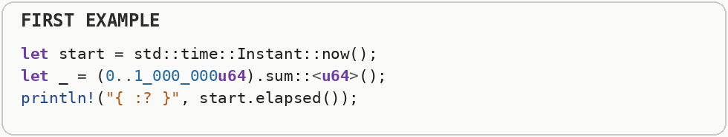
The improved benchmark makes the input and result observable to the compiler. That keeps the operation present while still allowing realistic optimization inside the code being measured.


Algorithms & Execution Patterns

Batching: N+1 Queries & Batch APIs
Never run network or database requests or heavy per-item application programming interface calls inside a loop. Batch into one bulk request, and design your own APIs to accept slices so callers are not forced into N+1 patterns. An N-plus-one pattern performs one operation to discover N items and then another expensive operation for each item. Batching replaces many round trips with one larger request, reducing repeated setup and network or database latency. The N-plus-one pattern performs one operation to discover N items and then performs another expensive operation for each item. Batching groups those requests so setup cost, network latency, parsing, locking, or system-call overhead is paid once for many items instead of once per item.
The first loop models the N-plus-one pattern: one expensive request is made for every identifier. Network and database round trips then multiply with the number of items.
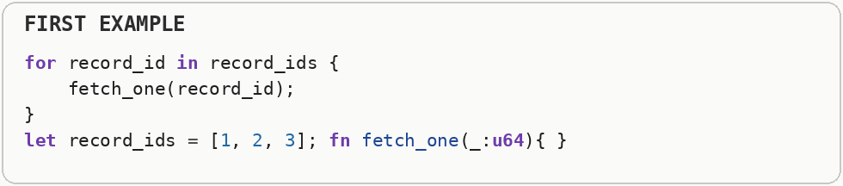
The batch interface sends the collection of identifiers through one bulk operation. Batching reduces repeated request setup, protocol overhead, and latency even though the logical number of records is unchanged.
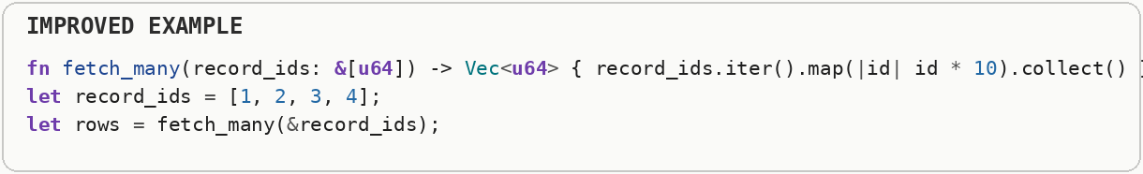

Sliding Windows (Unlocking $O(N)$ Speed)
Never use nested for loops if you can solve the problem in a single pass. A sliding window tracks a contiguous subset of data, shifting the boundaries instead of recalculating overlapping segments. Big O notation describes how the amount of work grows as the input grows. Linear or N log N growth scales much better than quadratic growth, because doubling the input does not multiply the work nearly as aggressively. A sliding window keeps track of a contiguous region of data while its boundaries move. Instead of recomputing every overlapping region from scratch, the algorithm updates only what entered or left the window. A sliding-window algorithm keeps a summary of a moving contiguous region instead of recomputing that region from scratch at every position. By adding the new element and removing the old one, many problems that look quadratic can be reduced to a single linear pass.
The first version slices out every window and recomputes its sum from scratch, so neighboring windows repeat most of the same addition work.
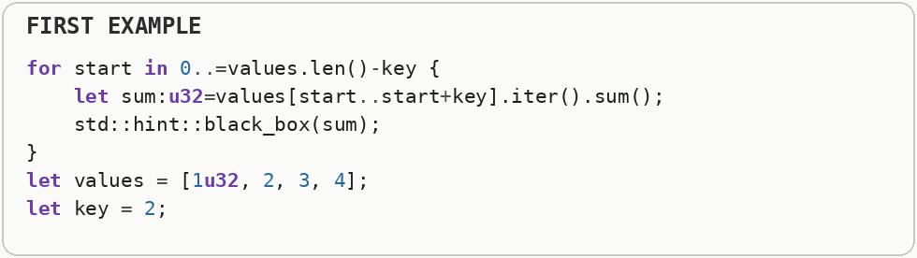
The second snippet demonstrates an overlapping-window abstraction. The full sliding-window optimization goes one step further by carrying state forward, subtracting the value that leaves the window and adding the value that enters, which turns repeated window work into a single pass.
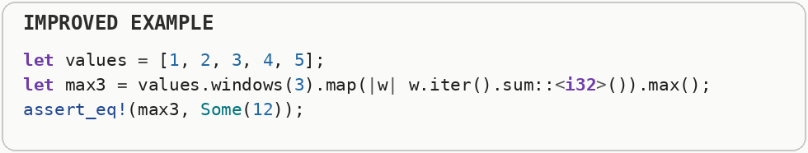

Two Pointers & Fast and Slow Pointers
Turn quadratic time brute-force searches into linear time scans by traversing from both ends inward, or use different traversal speeds to detect cycles. Big O notation describes how the amount of work grows as the input grows. Linear or N log N growth scales much better than quadratic growth, because doubling the input does not multiply the work nearly as aggressively. A two-pointer algorithm tracks two positions through the same data instead of restarting a search for every element. Fast-and-slow pointers use different movement rates and are especially useful for cycle detection. Two-pointer algorithms maintain two positions that move through the same data according to different rules. They can avoid nested searching in sorted arrays, partition data in place, or detect cycles when one pointer advances faster than the other.
The nested loops try every pair, so the amount of comparison work grows quadratically as the input grows.
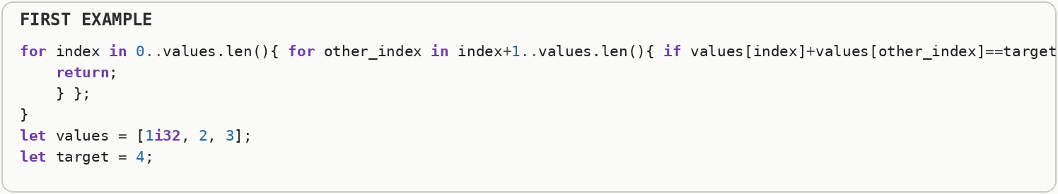
For sorted data, two pointers start at opposite ends and move inward according to whether the current sum is too small or too large. Each pointer only moves in one direction, so the search can finish in linear time.
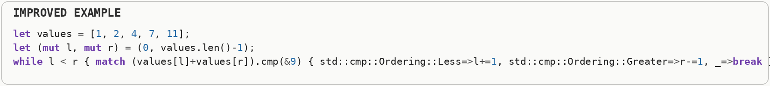

DFS vs. BFS: Choosing the Right Graph Traversal
Pick your traversal strategy based on what you're looking for, not habit. Depth-First Search (DFS) and Breadth-First Search (BFS) have the same V plus E time complexity, but wildly different memory footprints and behavior depending on the shape of the graph. Depth-first search follows one path as far as it can before backtracking, usually using a stack. Breadth-first search explores all nodes at the current distance before moving outward, usually using a queue; breadth-first search naturally finds shortest paths in an unweighted graph. Big O notation describes how the amount of work grows as the input grows. Linear or N log N growth scales much better than quadratic growth, because doubling the input does not multiply the work nearly as aggressively. Depth-first search follows one path deeply before backtracking, usually using a stack or recursion. Breadth-first search explores all nodes at the current distance before moving farther, usually using a queue; that level-by-level behavior is why BFS finds shortest paths in an unweighted graph.
The stack-based traversal follows one branch deeply before backing up; that is depth-first search.
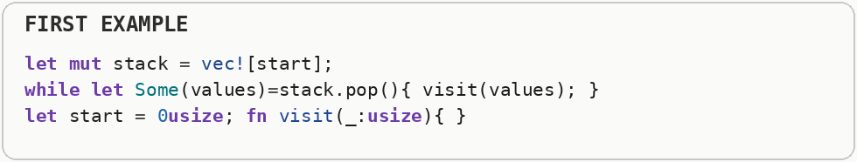
The queue-based traversal visits all nearby nodes before moving farther away; that is breadth-first search. Both can visit every vertex and edge, but a stack and a queue create different search order and memory behavior, and breadth-first search naturally gives shortest paths in an unweighted graph.
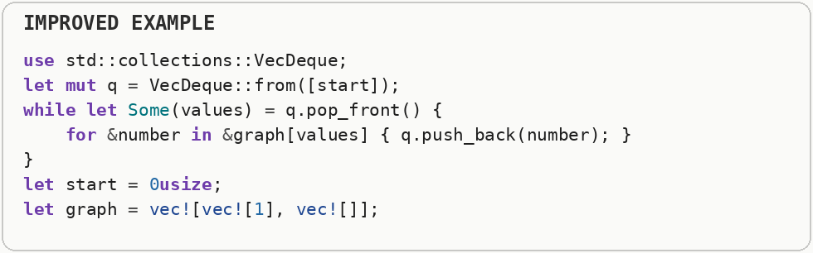

Recursion to Iteration (Call-Stack Pressure)
Convert deep or unbounded recursion into an explicit loop (or heap-allocated stack) so you do not blow the call stack and so the compiler can optimize a flat control-flow graph. Heap allocation asks an allocator to find a block of memory at runtime. Growing a collection can require a reallocation: a larger block is acquired, existing data is moved or copied, and the old block is released. The call stack stores active function calls, local state, and return information. Deep recursion consumes more of this limited stack space and can overflow it, while an explicit loop can keep control flow flatter. Every ordinary recursive call creates another stack frame containing return information and local state. Deep recursion can consume significant stack memory or overflow the stack, while an iterative version can represent the pending work explicitly in a loop or data structure.
The recursive walk creates another call-stack frame for every level. Deep input can therefore consume a large amount of stack space or overflow the stack entirely.
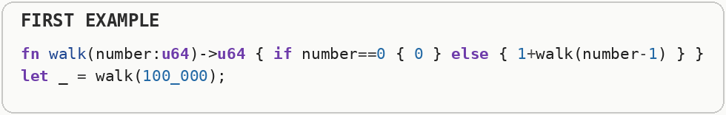
The iterative form stores pending work in an explicit collection instead. The traversal is still depth-first, but its temporary storage is under program control rather than hidden in nested function calls.
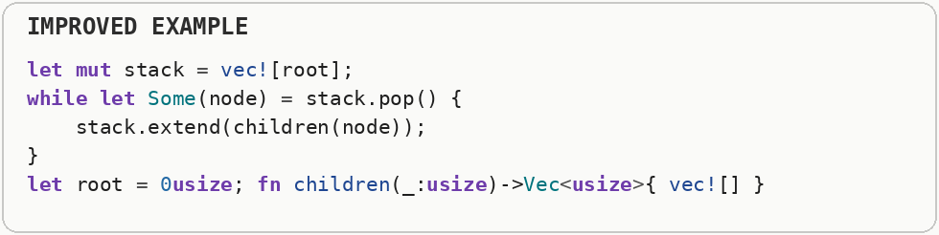

Dynamic Programming: Memoization vs. Tabulation
Never compute the exact same sub-problem twice. Cache redundant work! Dynamic programming avoids solving the same overlapping subproblem repeatedly. Memoization stores answers as recursion asks for them, while tabulation fills a table in a deliberate order from smaller answers to larger ones. Dynamic programming applies when a problem contains overlapping subproblems whose answers are reused. Memoization discovers and caches those answers on demand, while tabulation computes them in a chosen bottom-up order; both exchange extra memory for less repeated computation.
The naive Fibonacci function asks for the same smaller Fibonacci values again and again, producing an exponential explosion of repeated calls.
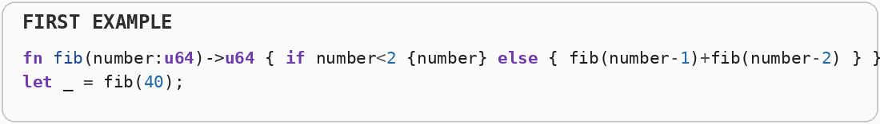
Tabulation computes the smaller answers once in order and stores them for later steps. Memoization achieves the same reuse on demand by caching recursive answers; tabulation fills the table iteratively.
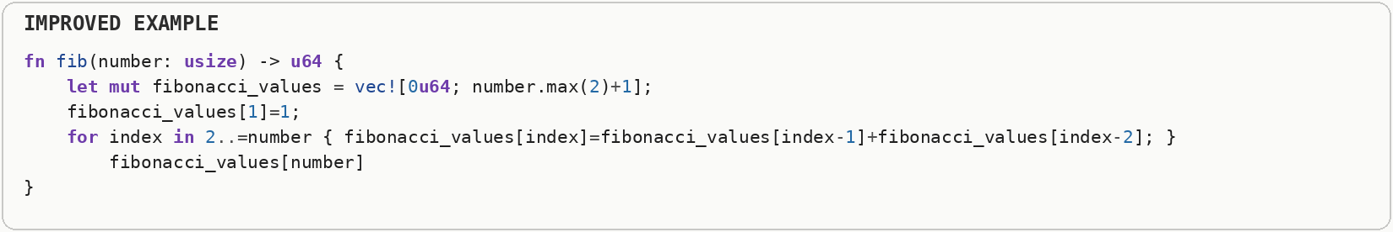

Greedy Algorithms & Heuristics
Don't brute-force an exact optimal answer if it takes exponential time and a "good enough" approximation (or greedy choice) takes N log N time. A greedy algorithm makes the best-looking local choice at each step. A heuristic is a practical shortcut that aims for a good answer without guaranteeing the mathematically optimal one. Big O notation describes how the amount of work grows as the input grows. Linear or N log N growth scales much better than quadratic growth, because doubling the input does not multiply the work nearly as aggressively. A greedy algorithm repeatedly takes the locally best-looking choice and never revisits earlier decisions. Some problems have mathematical structure that makes this globally optimal, while a heuristic merely aims for a good answer quickly when finding the exact optimum is too expensive.
The exhaustive loop represents searching every possible subset, which grows exponentially as more items are added.
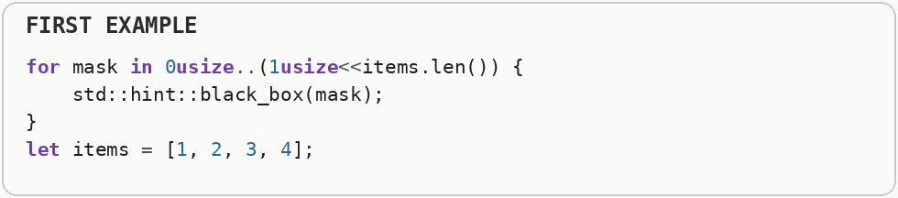
The greedy scheduling example sorts jobs by finishing time and then can choose the next compatible job without exploring every combination. Greedy algorithms make locally best choices; they are exact only for problems whose structure guarantees those choices lead to a global optimum, otherwise they are heuristics.
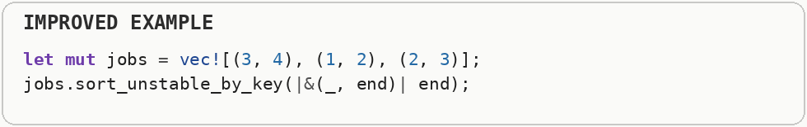

Lazy vs. Eager Evaluation (Unnecessary Upfront Computation)
Don't compute heavy data transformations until the exact moment you actually need the result. Use Lazy Iterators. Lazy evaluation delays work until a result is actually requested. Eager evaluation performs the work up front, which can be useful when every result will be consumed but wasteful when only a small portion is needed. Eager evaluation produces results immediately, even if some are never consumed. Lazy evaluation represents pending computation and performs it only as values are requested, which can save both CPU time and memory when consumers stop early or use only part of a sequence.
The eager version computes a million transformed values and stores all of them even though the program only inspects the beginning of the result.
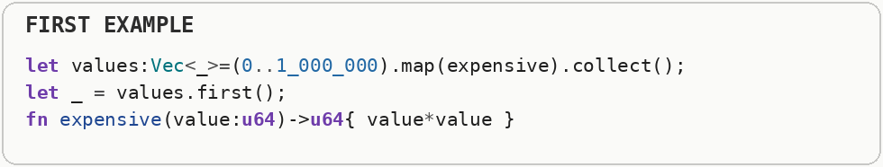
The lazy version produces values only as the search asks for them and stops when a match appears. That is lazy evaluation: computation is delayed until a result is actually demanded.
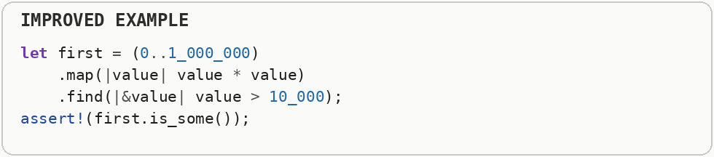

Short-Circuit Evaluation & Early Exit (Fail-Fast)
Order conditions and checks so the cheapest rejecting work runs first - abort before expensive computation, allocation, parsing, or input and output. Short-circuit evaluation stops evaluating a condition as soon as the final true-or-false answer is known. Early exit applies the same principle to a function or loop: stop once later work cannot change the result. Heap allocation asks an allocator to find a block of memory at runtime. Growing a collection can require a reallocation: a larger block is acquired, existing data is moved or copied, and the old block is released. Short-circuit logic stops evaluating a Boolean expression once the final answer is determined. Fail-fast code extends the idea to whole operations: detect invalid input or a completed search as early as possible so later expensive work is skipped.
The first condition performs the expensive test before checking the cheap fact that the text is empty, so it can pay for work that cannot affect the answer.
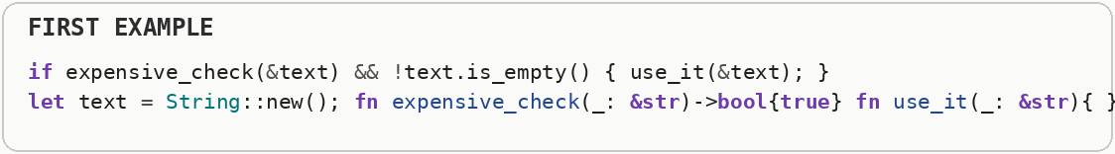
The revised order uses cheap rejection tests first. Boolean short-circuiting stops as soon as the final true-or-false result is already determined, so the expensive check is reached only when it can matter.
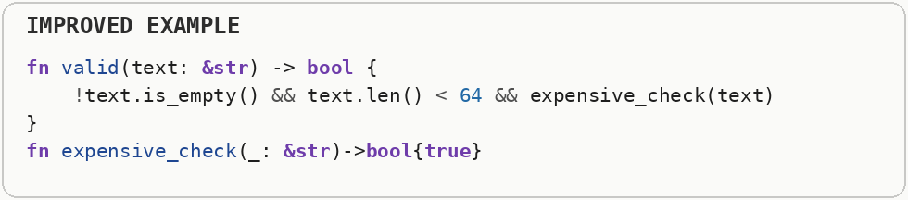

Stream Processing vs. Batch Processing
Choose streaming when latency, memory footprint, or infinite or unknown input size matter; choose batch when throughput, vectorization, and simple control flow matter. Streaming handles data incrementally as it arrives, which keeps latency and memory use low. Batch processing collects a larger group first, which can improve throughput because setup work, vectorization, and storage access can be shared across many items. SIMD stands for single instruction, multiple data: one machine instruction performs the same operation on several values at once. Auto-vectorization is the compiler recognizing a loop that can safely be converted into those wider operations. Batch processing collects a group of items and processes them together, often improving throughput through larger sequential operations. Stream processing handles data incrementally as it arrives, which can reduce memory usage and latency because the whole dataset does not need to exist at once.
Reading an entire huge file at once requires enough memory for the whole input before processing can begin.
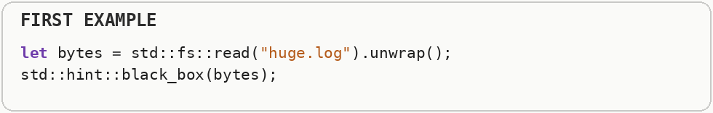
Streaming processes one line or chunk at a time, so useful work can start immediately and memory usage stays bounded. Batch processing still makes sense when later stages truly need the complete data set at once.
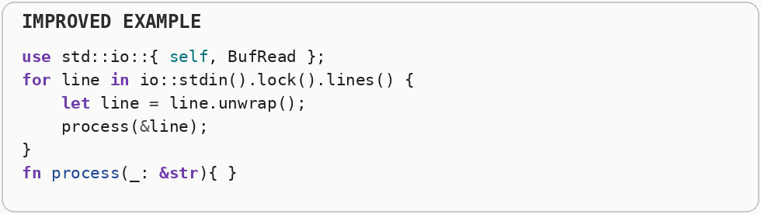

Compression (CPU vs. Bandwidth and Storage Trade-off)
Compress when the cost of CPU cycles to (de)compress is lower than the cost of moving or storing the uncompressed bytes - profile both sides on realistic data. Compression trades processor work for fewer bytes in memory, storage, or transit. It helps when moving or storing bytes is more expensive than compressing and decompressing them. Compression spends CPU work to reduce the number of bytes stored or transmitted. It is valuable when moving bytes is more expensive than the encode and decode cost, such as slow networks or large storage systems, but can hurt when CPU is the scarce resource or the data is already compact.
Compressing a tiny payload can cost more CPU time and add more bytes of framing than it saves in transmission or storage.
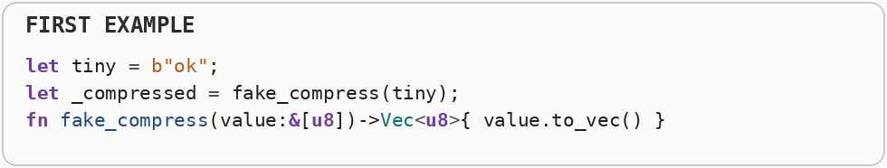
Compression pays off when the data contains enough repetition that fewer bytes are more valuable than the processor time needed to encode and decode them. The correct choice depends on both the data and which resource is scarce.
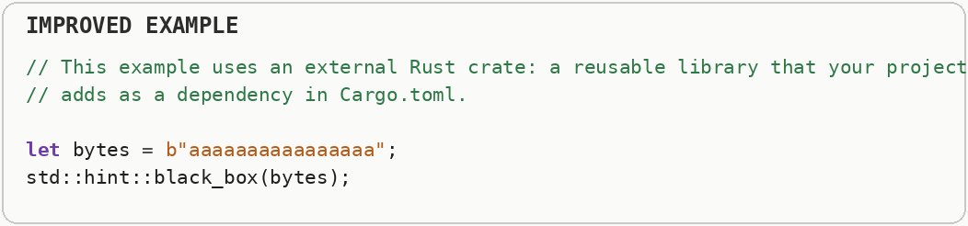

Sorting Algorithm Selection
Use the standard library sort for almost everything; specialize only when profiling shows sort is hot and your data has exploitable structure (almost-sorted, tiny keys, integers in a narrow range). Sorting rearranges values into order, usually in N log N time for general comparison-based algorithms. Specialized algorithms can be faster when keys have a narrow numeric range, data is already nearly sorted, or stability requirements allow a simpler strategy. A profiler is a measurement tool that shows where a program spends CPU time, allocates memory, waits on input and output, or stalls between operations. Different profiler types answer different performance questions, so one timing number is rarely the whole diagnosis. Sorting algorithms differ in time complexity, memory usage, stability, and behavior on partially ordered data. Stability means equal keys preserve their original relative order; choosing an unstable sort can be cheaper when that guarantee is unnecessary.
The first sort preserves the relative order of equal elements, which is useful only when the program needs that stability.
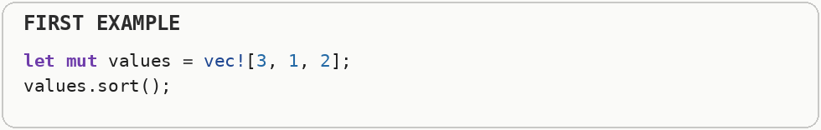
The unstable sort can use less bookkeeping when equal-item order does not matter. Sorting algorithm selection is about matching guarantees and data shape to the actual requirement, not choosing one algorithm universally.
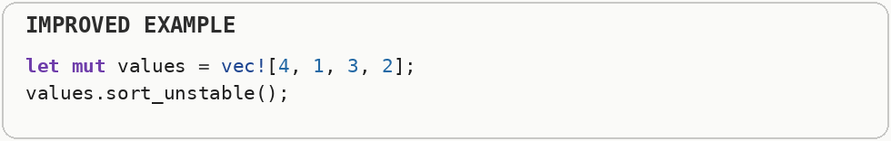

Binary Search vs. Hash Lookup
Prefer hash maps or hash sets for unstructured key lookup at scale; prefer sorted vector + binary search when the set is small, ordered iteration matters, or you want simpler memory layout and better cache behavior. Binary search repeatedly halves a sorted search range, giving logarithmic lookup time. A hash table uses a hash function to jump toward a key directly, trading ordering and predictable layout for very fast average lookup. A CPU cache is a small, very fast memory close to the processor. A cache miss happens when the needed data is not there and the CPU must wait for slower main memory; cache locality means arranging access so nearby work tends to reuse nearby bytes. Binary search repeatedly halves a sorted search range and typically takes logarithmic time with excellent memory locality. A hash table computes a hash to jump near the desired bucket and offers average constant-time lookup, but uses extra memory and depends on hash quality and table load.
A linear scan checks values one after another, so repeating that search across a large collection repeats a large amount of comparison work.
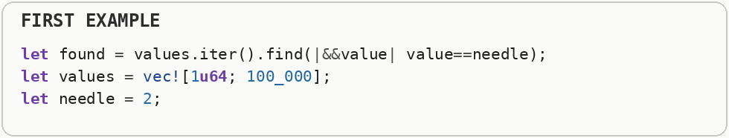
A sorted collection supports binary search, which repeatedly discards half of the remaining range. A hash table offers a different trade-off by spending memory on an index to make repeated key lookup close to constant time on average.
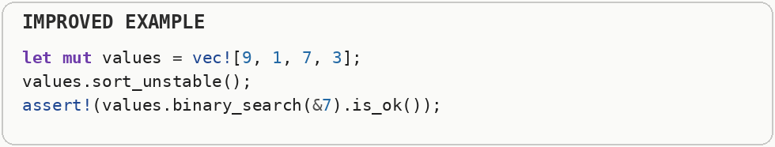

Deterministic vs. Non-Deterministic Logic (Memoization Eligibility)
Isolate non-deterministic operations (randomness, system time, input and output) from your core logic. Favor pure, deterministic functions. Deterministic code produces the same output from the same input. That predictability makes caching and memoization safe; randomness, time, input and output, or hidden mutable state can make the same call produce different results. Dynamic programming avoids solving the same overlapping subproblem repeatedly. Memoization stores answers as recursion asks for them, while tabulation fills a table in a deliberate order from smaller answers to larger ones. A deterministic computation produces the same output whenever it receives the same inputs and relevant state. That repeatability is what makes memoization safe: a cached answer remains valid; nondeterministic inputs such as time, randomness, or changing external state can make the same key produce a different result.
The first function mixes its input with a changing value, so the same input is not guaranteed to produce the same output.
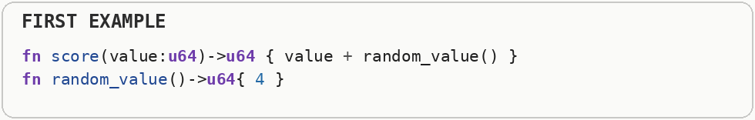
The deterministic version always maps the same input to the same result. Determinism is what makes memoization safe: a cached answer is reusable only when repeating the same request should produce the same answer.
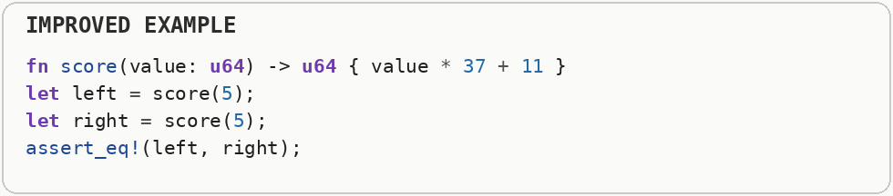

Stateless vs. Stateful Design
Prefer stateless functions and components by default; introduce state deliberately, only where it earns its keep. Stateless code depends only on the data passed into it, which makes behavior easier to cache, parallelize, test, and retry. Stateful code remembers previous activity, which is sometimes necessary but creates coordination and invalidation costs. State is information that survives from one operation to the next. Stateless components are easier to replicate, retry, cache, and parallelize because each request carries what it needs, while stateful components can be more efficient for repeated context but require synchronization, consistency, and lifecycle management.
The stateful example changes global mutable state, which means its behavior depends on history and can require synchronization when multiple parts of the program use it.
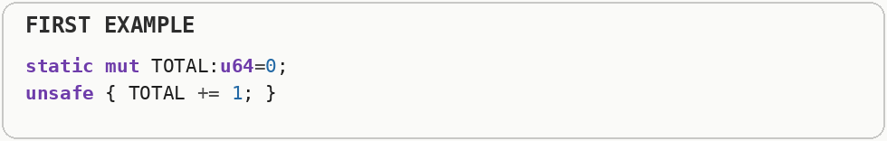
The stateless calculation depends only on its arguments. That makes calls independent, easier to parallelize, and easier to cache because the same inputs describe the whole computation.
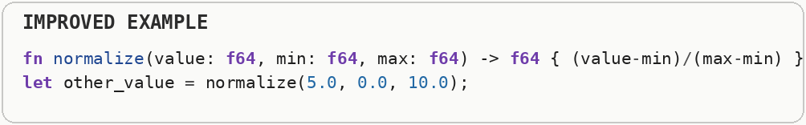

Operating Systems, Kernels, Boot & User Space

Boot Loaders & Early Init
Boot path length is pure latency before useful work - minimize firmware, bootloader, and kernel init for devices that must start fast (embedded, serverless snapshots, appliances). A bootloader runs before the main operating system or application and prepares the machine to start. Every initialization step on that path adds latency before useful work can begin. User space is where normal applications run with limited privileges; the kernel controls protected resources such as files, devices, memory mappings, and scheduling. A system call crosses that boundary, and the transition plus validation work is called syscall overhead. A boot loader runs before the full operating system and prepares enough hardware and memory state to load the next stage of software. Early initialization happens before many runtime services exist, so code in this phase must avoid assumptions about allocators, filesystems, threads, or device drivers that have not been initialized yet.
The first startup path constructs a large index before the service can begin useful work, so every launch pays that cost whether or not the index is immediately needed.
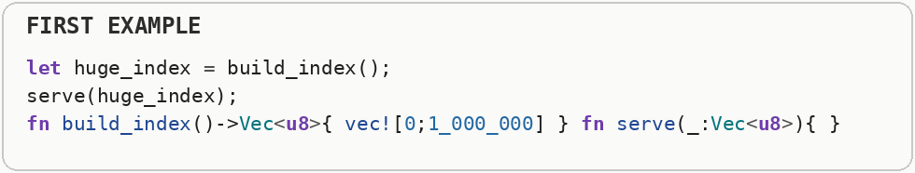
The shorter startup path begins serving without that heavyweight initialization. Boot and cold-start optimization is largely about moving optional work off the critical path between process start and the first useful response.
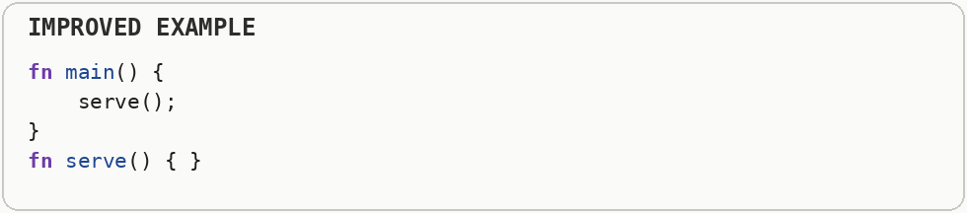

Kernel vs. User Space
Cross the kernel boundary as rarely as practical on hot paths. Every syscall is a mode switch, validation, and potential scheduler decision. A hot path is code that runs very frequently or consumes a large share of total execution time. Optimizing cold code may make the source more complicated without producing a noticeable improvement. User space is where normal applications run with limited privileges; the kernel controls protected resources such as files, devices, memory mappings, and scheduling. A system call crosses that boundary, and the transition plus validation work is called syscall overhead. The kernel runs with privileged access to hardware and manages memory, processes, devices, and scheduling. Applications normally run in user space with restricted privileges and request kernel services through system calls, which creates a protection boundary and some crossing overhead.
Writing one byte at a time repeatedly crosses from user space into the operating-system kernel. Every crossing requires validation and bookkeeping even when the payload is tiny.
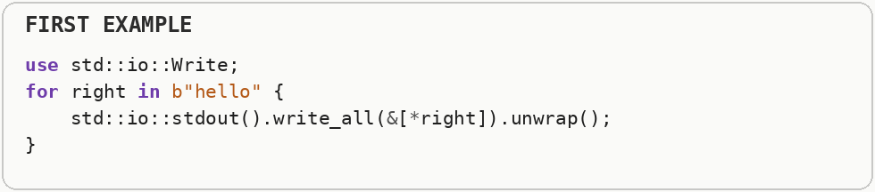
Buffering collects many writes in memory and sends larger chunks across the kernel boundary. The same bytes are written, but the program pays syscall overhead far fewer times.
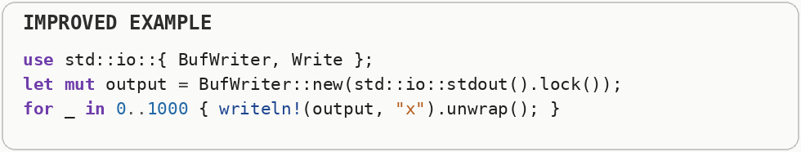

Traps, Interrupts, Exceptions & Events
Treat asynchronous control-flow transfers as expensive - they flush pipelines, disturb cache and translation lookaside buffer locality, and can preempt critical sections. An interrupt is an asynchronous signal, often from hardware, that asks the CPU to run a handler. A trap or exception transfers control because of a software event or fault; these transfers disrupt the normal instruction stream and may disturb caches and pipelines. An expected failure is part of normal control flow and is usually best represented explicitly. Panics or exceptions are designed for exceptional situations; unwinding or constructing diagnostic state can be much more expensive than an ordinary branch. Interrupts are usually asynchronous signals from hardware, while traps and exceptions transfer control because of something that happened during instruction execution, such as a fault or explicit system call. Event systems generalize the idea at higher levels by notifying code when something happens instead of constantly polling for it.
The event handler allocates a large collection and performs heavyweight work at the moment the event arrives, when latency and safety constraints may be tight.
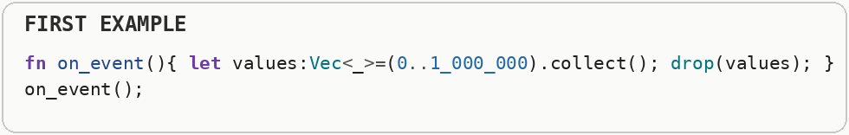
The lightweight handler records a small atomic flag and lets normal program code do the expensive work later. Interrupts, traps, and signal-like events are usually best handled by doing the minimum necessary in the immediate handler.
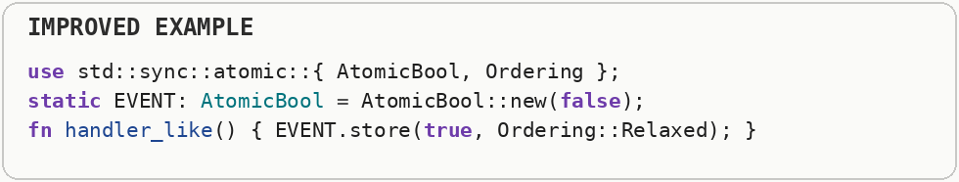

Processes vs. Threads
Threads share an address space (cheap communication, careful synchronization); processes isolate memory (safer, more overhead to spawn and to inter-process communication). A process has its own isolated address space, while threads inside one process share the same memory. Shared memory makes thread communication cheap, but it also requires synchronization when multiple threads touch the same mutable state. Inter-process communication, or IPC, is how separate processes exchange data. Pipes, sockets, shared memory, and message queues have different trade-offs in copying, latency, synchronization, and portability. A process owns an isolated virtual address space and operating-system resources, while threads inside a process normally share that address space. Processes provide stronger isolation but make communication more expensive; threads communicate cheaply through shared memory but require careful synchronization.
Starting a separate process creates an isolated address space and involves operating-system process setup, which is heavy when the task only needs parallel work inside one program.
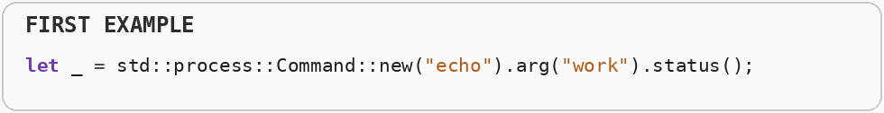
A thread shares the process address space, so starting and communicating with it can be cheaper. Processes buy stronger isolation; threads buy cheaper sharing, and the right choice depends on which property matters.
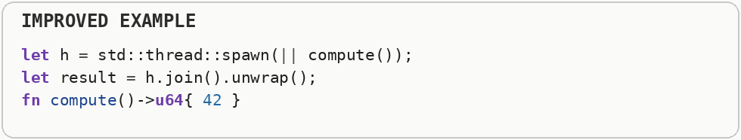

IPC (Inter-Process Communication)
Pick inter-process communication by bandwidth and latency needs - don't use JSON-over-TCP between two processes on the same machine if shared memory fits. Inter-process communication, or IPC, is how separate processes exchange data. Pipes, sockets, shared memory, and message queues have different trade-offs in copying, latency, synchronization, and portability. Because processes do not normally share arbitrary memory, they need explicit inter-process communication mechanisms. Pipes and sockets copy or stream messages through kernel-managed channels, while shared memory can avoid copies but requires both sides to coordinate access correctly.
The first sample builds a text message before sending information elsewhere. Text is easy to inspect but costs formatting, parsing, and extra bytes.
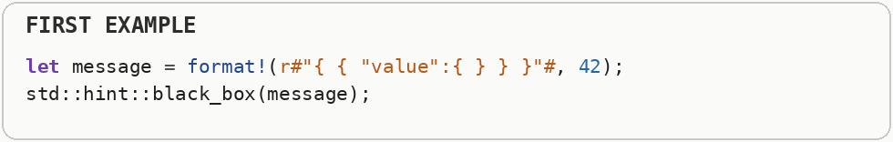
Inter-process communication can use local sockets, pipes, shared memory, or other transports. The performance question is how much copying, serialization, and kernel coordination each message requires, not merely which API name is used.
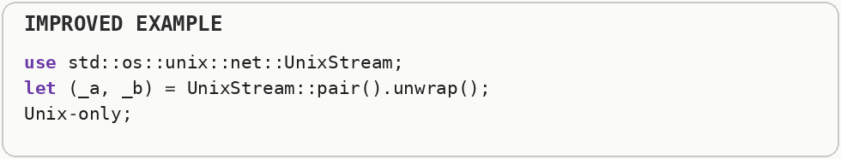

Input and Output Multiplexing
Never block one thread per connection at scale - multiplex readiness (e poll, k queue, or I O completion ports) or use asynchronous runtimes built on them. Input and output multiplexing lets one thread watch many sockets or file descriptors for readiness instead of dedicating a blocked thread to each connection. Operating systems expose mechanisms such as e poll, k queue, and I O completion ports for this purpose. Blocking input and output parks the current thread until an operation finishes. Asynchronous input and output lets the thread work on something else while completion is reported later, which is valuable when many operations spend most of their time waiting. Input and output multiplexing lets one thread watch many file descriptors or sockets and react only to those that are ready. Instead of dedicating a blocked thread to every connection, interfaces such as epoll, kqueue, or similar event mechanisms allow one event loop to manage large numbers of mostly waiting operations.
The thread-per-connection design can create a large number of sleeping operating-system threads when many connections spend most of their time waiting for input.
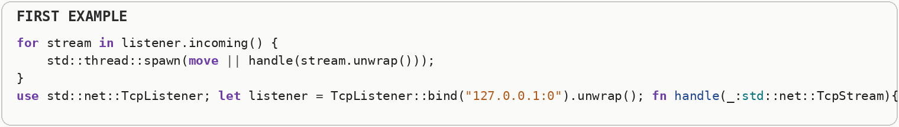
Input and output multiplexing lets a smaller set of workers watch many descriptors and wake only for connections that are ready. Interfaces such as epoll, kqueue, and I O completion ports are built around that readiness or completion model.
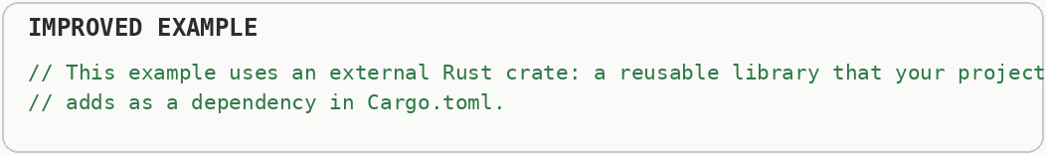

Synchronization Across Processes
Process-shared synchronization must use process-shared primitives (mutex with shared memory, file locks, semaphores) - thread-only mutexes do not work across address spaces. A process has its own isolated address space, while threads inside one process share the same memory. Shared memory makes thread communication cheap, but it also requires synchronization when multiple threads touch the same mutable state. Synchronization coordinates access to shared state. Mutexes provide exclusive access, read-write locks allow multiple readers, semaphores limit concurrent users of a resource, and message passing can avoid shared mutable memory entirely. Separate processes can still race when they modify the same file, shared-memory region, or external resource. Cross-process locks, semaphores, file locks, and message protocols establish ordering so multiple processes do not corrupt shared state.
A normal in-process lock cannot by itself coordinate unrelated processes because those processes do not automatically share the same memory containing the lock.
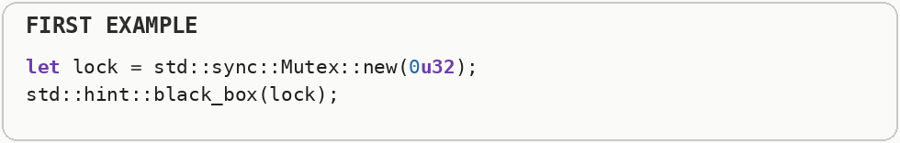
Cross-process synchronization requires an operating-system or shared-memory primitive that every participating process can observe. The cost comes from coordination and wakeups, so the design should minimize how often independent processes must enter the same critical section.


Concurrency, Parallelism & Async

Concurrency with Threads (Spawn & Join Overhead)
Prefer a fixed-size thread pool (or work-stealing pool) over spawning a fresh operating system thread for every unit of work. Creating an operating-system thread requires stack memory, kernel bookkeeping, and scheduler setup. A thread pool pays that setup cost once and reuses a fixed group of workers for many tasks. An operating-system thread needs its own stack, scheduler state, and kernel bookkeeping. Creating and destroying threads for tiny jobs can cost more than the job itself, which is why pools amortize that setup across many tasks.
Spawning a new operating-system thread for every tiny job repeats thread creation, stack allocation, scheduling, and cleanup.
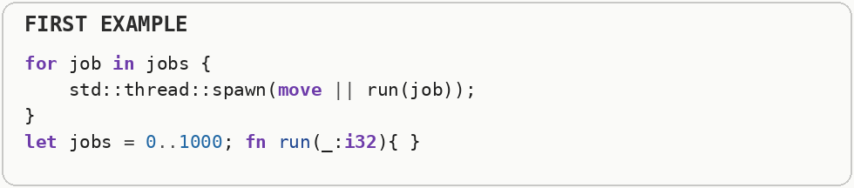
The parallel-iterator version represents using a reusable worker pool. A thread pool pays thread startup once and feeds many jobs to the existing workers, which is far better for large numbers of short CPU tasks.
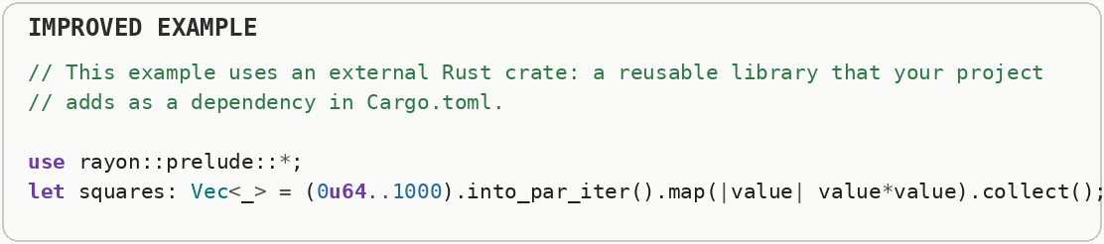

Thread Synchronization Strategies (Beyond a Single Mutex)
Match the synchronization primitive to the access pattern - a global mutex is rarely the right default for hot shared state. Synchronization coordinates access to shared state. Mutexes provide exclusive access, read-write locks allow multiple readers, semaphores limit concurrent users of a resource, and message passing can avoid shared mutable memory entirely. Synchronization primitives express different sharing rules. A mutex allows one owner at a time, a read-write lock permits many readers but one writer, a semaphore limits concurrency to a chosen count, and message passing can replace shared mutation with ownership transfer.
One exclusive mutex makes readers wait for one another even when none of them is modifying the shared data.
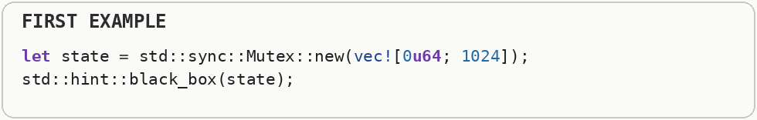
A read-write lock permits multiple readers at the same time and becomes exclusive only for a writer. It is useful for genuinely read-heavy state, although its extra bookkeeping means it should still be measured.
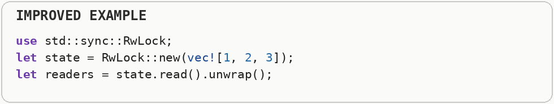

Synchronous vs. Asynchronous & Event Blocking
Never use synchronous, blocking input and output inside an asynchronous function. Blocking input and output parks the current thread until an operation finishes. Asynchronous input and output lets the thread work on something else while completion is reported later, which is valuable when many operations spend most of their time waiting. Synchronous code waits for an operation before continuing along that path. Asynchronous code represents an operation that may finish later, allowing the underlying thread to do other work while waiting on slow input and output; it improves concurrency, not the raw speed of the external device.
Sleeping an operating-system thread inside asynchronous code blocks that worker completely; while it sleeps, the runtime cannot use that thread to advance other tasks.
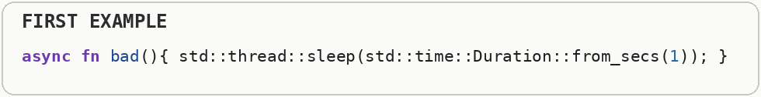
An asynchronous file operation yields control while the operation is waiting. Asynchronous programming improves concurrency when tasks spend time waiting on input and output; it does not make ordinary CPU arithmetic inherently faster.
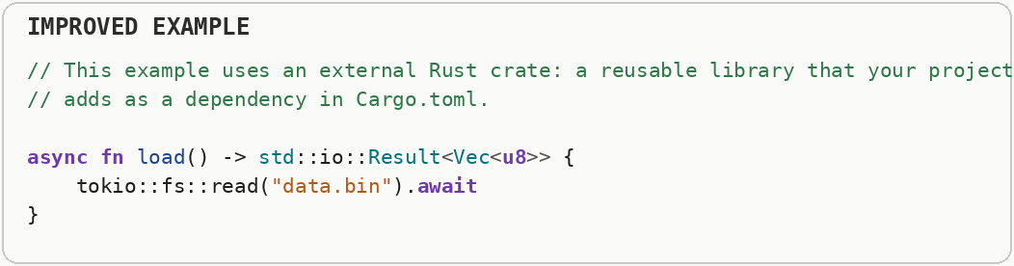

Where to Put Async: App vs. Library Internals vs. Library Callers
asynchronous is usually great in applications, risky inside a library's internal implementation, and excellent when offered to a library's callers. Asynchronous design affects API shape, runtime dependencies, cancellation, and how callers compose work. Applications can choose one async runtime consistently, while reusable libraries often benefit from exposing asynchronous operations without secretly forcing a particular runtime or blocking policy on their callers.
Turning a trivial calculation into an asynchronous function adds state-machine and scheduling machinery without creating useful overlap, because the operation never waits for anything.
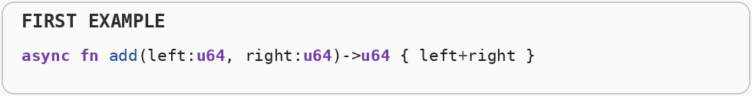
Asynchronous boundaries make sense around operations such as network or file access that can be in flight while other work continues. Libraries should expose that waiting where it naturally exists instead of making every small helper asynchronous.
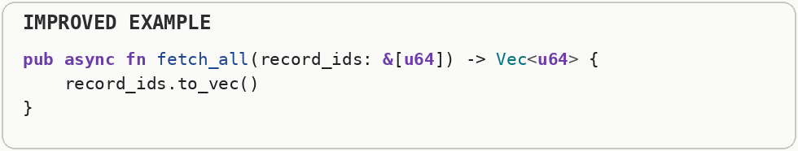

Lock Contention (The Concurrency Bottleneck)
Avoid wrapping highly-contended shared data in a mutex. Prefer hardware-level Atomics, Lock-Free structures, or Message Passing (Channels). Contention happens when multiple workers compete for the same lock, cache line, memory allocator, or other shared resource. More threads do not help if they spend their time waiting for one another. Synchronization coordinates access to shared state. Mutexes provide exclusive access, read-write locks allow multiple readers, semaphores limit concurrent users of a resource, and message passing can avoid shared mutable memory entirely. Contention happens when multiple threads need the same synchronization resource at the same time. A lock that is cheap with one thread can become a scalability wall with many threads because workers spend increasing time waiting rather than executing useful code.
The mutex-protected counter acquires the same exclusive lock for every increment, so competing threads would line up around one shared critical section.
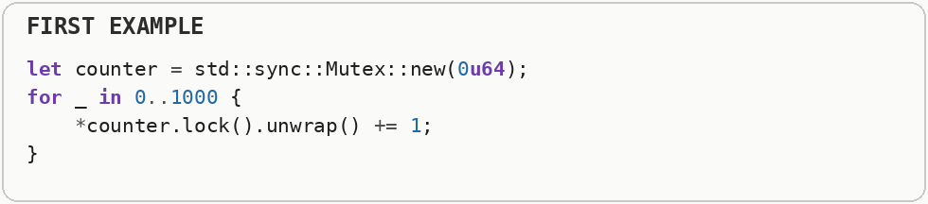
An atomic counter can update a simple numeric value without taking a mutex. Atomics still coordinate CPU caches between cores, so they are not free, but for a small independent counter they can remove lock contention.
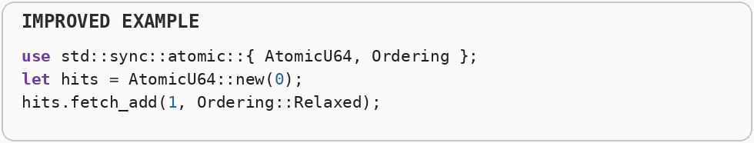

Avoid Needless Atomics (Atomic vs. Non-Atomic Reference Counting)
Use single-threaded reference counting instead of atomic reference counting whenever data never crosses a thread boundary. An atomic operation updates shared data in a way that other CPU cores observe as one indivisible action. That coordination is safer than an ordinary unsynchronized write, but it can require expensive cache-coherence traffic between cores. Garbage collection reclaims unreachable objects automatically, reference counting frees an object when its owner count reaches zero, and manual or ownership-based schemes make lifetimes more explicit. Each strategy changes pause behavior, runtime overhead, safety, and programmer responsibility. Atomic operations coordinate memory updates between threads and impose stronger ordering rules on the CPU and compiler. They are essential for truly shared concurrent state, but they can cost more than ordinary loads and stores, so thread-safe reference counting is unnecessary when ownership never crosses threads.
Atomic reference counting coordinates ownership updates between threads even when the value never leaves one thread, so the program pays cross-core synchronization it does not need.
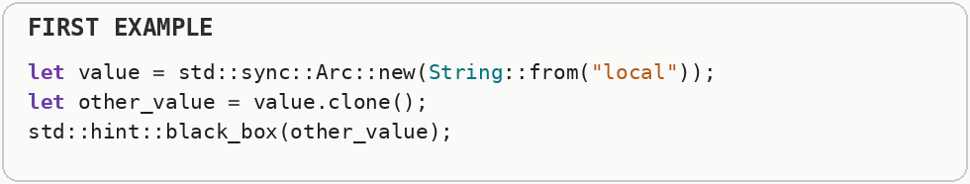
Single-threaded reference counting tracks the same shared ownership without atomic operations. Use atomic reference counting when values can actually cross threads; otherwise the lighter local form avoids unnecessary coordination.
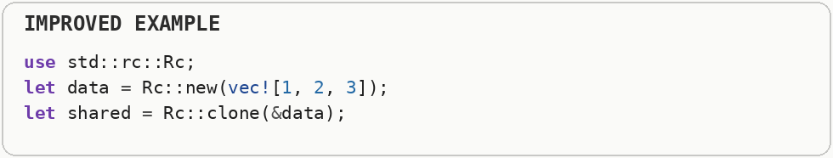

Cache Line Padding & False Sharing (Multi-Core Write Contention)
When multiple threads are mutating different variables, ensure those variables do not sit on the exact same CPU cache line. Force them apart using memory alignment padding. False sharing occurs when different threads modify different variables that happen to occupy the same cache line. The values are logically independent, but the hardware still bounces the whole cache line between cores. Memory alignment places values at addresses that suit the hardware. Compilers may insert padding bytes between fields or at the end of a structure so each field begins at a correctly aligned address. Caches move memory in fixed-size blocks called cache lines, commonly dozens of bytes at a time. False sharing occurs when different threads update different variables that happen to occupy the same line, causing the hardware to repeatedly transfer ownership of that entire line between CPU cores.
Two frequently written counters can sit on the same cache line even though they are logically independent. Different cores then keep invalidating the same cache line as each counter changes.
Padding places the counters on separate cache lines. This avoids false sharing, where cores fight over cache coherence because unrelated variables happen to share the hardware unit that caches and synchronizes memory.
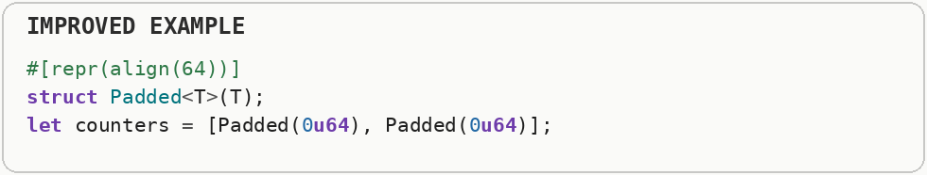

System-on-Chip Awareness: Heterogeneous Cores (Uneven Core Performance)
On modern systems on a chip (Apple Silicon, recent Intel laptop and mobile chips, most Android phones), don't assume every core the operating system reports is equally fast - spawning one identical worker thread for every reported CPU can silently bottleneck on the slowest core in the group. A system on a chip combines several components, often including CPU cores, graphics, memory controllers, and accelerators, on one package. Modern chips may mix fast performance cores with smaller efficiency cores, so equal thread counts do not imply equal compute capacity. Mobile performance is constrained by battery energy and heat as well as raw speed. Sustained heavy work can trigger thermal throttling, where the chip lowers frequency to stay within temperature and power limits. Many modern systems combine high-performance cores with more energy-efficient cores on the same chip. The operating system scheduler may move work between them, so latency and throughput can vary depending on which core executes a task and what power or thermal limits are active.
Starting one heavy worker for every reported CPU can assume that all cores have identical speed and power characteristics, which is not true on many modern system-on-chip designs.
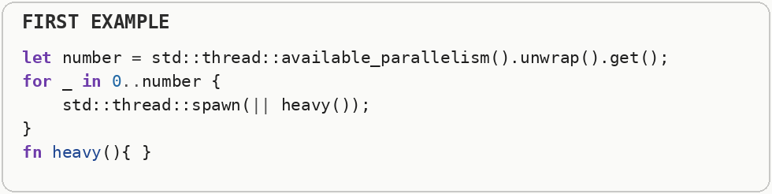
Heterogeneous processors may mix fast performance cores with smaller efficiency cores. Worker counts and task placement therefore need measurement on the target device rather than assuming every reported core contributes the same throughput.
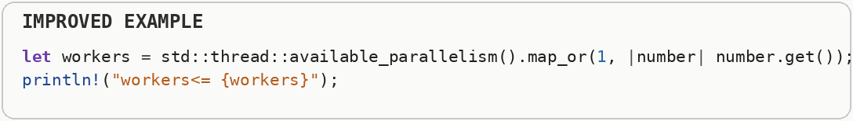

Thread-Local Storage (Avoiding Shared-State Contention)
When each thread can own its own buffer, counter, or pseudo-random number generator, use thread-local storage instead of a shared mutex-guarded resource. Thread-local storage gives each thread its own private instance of a value. Because workers do not share that instance, they can often avoid locks and cache-coherence traffic. Contention happens when multiple workers compete for the same lock, cache line, memory allocator, or other shared resource. More threads do not help if they spend their time waiting for one another. Thread-local storage gives each thread its own independent instance of a value. Because threads do not fight over the same memory location, it can remove locking and cache-line bouncing, at the cost of having multiple copies and needing an explicit merge step when results must be combined.
A single mutex-protected scratch buffer turns temporary workspace into shared state, so otherwise independent threads can block each other just to reuse memory.
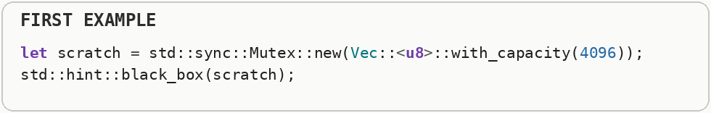
Thread-local storage gives each thread its own scratch buffer. The buffers can be reused without a shared lock because no other thread accesses the same instance.
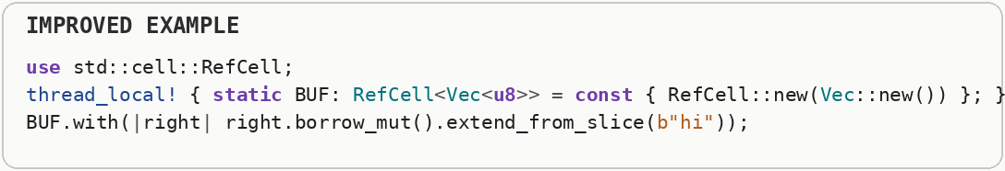

Signal Handling (Async-Signal-Safety & Hot-Path Interference)
Keep signal handlers minimal - set a flag or write to a self-pipe - and never do heavy work, allocate, or take locks inside them. A signal can interrupt a Unix process at an arbitrary point. Signal handlers must therefore do very little and use only operations that are safe in that interrupted context, often called async-signal-safe operations. Heap allocation asks an allocator to find a block of memory at runtime. Growing a collection can require a reallocation: a larger block is acquired, existing data is moved or copied, and the old block is released. Signals can interrupt normal execution at almost any instruction and invoke a handler under very restricted conditions. Many library operations are unsafe inside a signal handler because they may allocate, lock, or depend on state that was interrupted halfway through an update.
Allocating memory or taking locks from a signal handler is dangerous because a signal can interrupt code that was already using those facilities, which can deadlock or corrupt state.
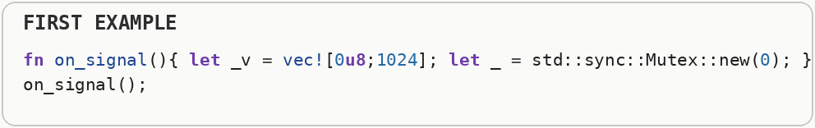
The safe pattern is to record a minimal atomic flag and return. Normal code can notice the flag later and perform allocation, locking, logging, or cleanup outside the signal context.
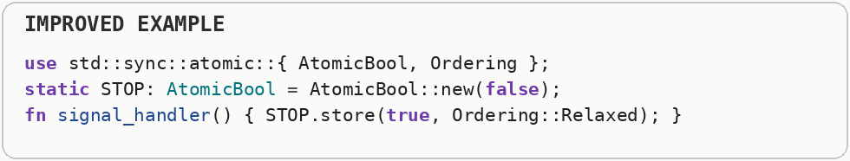

Data Structure Selection

Vectors vs. HashMaps
Default to contiguous memory structures (vector) for small or ordered data, but pivot to hash map when large-scale, repeated lookups are required. Always pre-allocate capacity. A vector stores elements contiguously, which gives compact memory use and excellent sequential access. A hash map spends extra memory on hashing and table structure so keys can usually be found without scanning the whole collection. Heap allocation asks an allocator to find a block of memory at runtime. Growing a collection can require a reallocation: a larger block is acquired, existing data is moved or copied, and the old block is released. A vector stores elements contiguously and is ideal for indexed access and sequential scans. A hash map uses a hash function and buckets to find values by key, trading extra memory and less predictable memory access for fast average lookup when the key is not a simple numeric index.
A hash table carries hashing, bucket storage, and metadata even when the collection has only a few entries that could be scanned almost instantly.
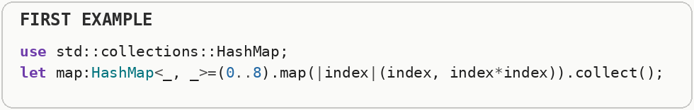
Small collections often perform well as a compact vector of key-value pairs, while hash maps become attractive when repeated lookup dominates at larger sizes. Data-structure choice should follow operation counts and collection size.
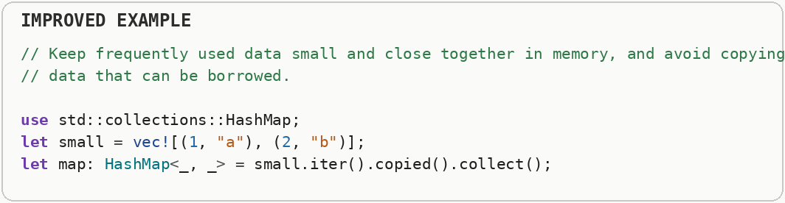

LinkedLists vs. Contiguous Storage (Cache Locality)
AVOID linked list. A linked list stores each element separately and follows pointers from node to node. That pointer chasing often defeats spatial locality, while contiguous arrays let one cache-line fetch bring in several neighboring elements. A CPU cache is a small, very fast memory close to the processor. A cache miss happens when the needed data is not there and the CPU must wait for slower main memory; cache locality means arranging access so nearby work tends to reuse nearby bytes. A linked list stores each element in a separate node connected by pointers. Following those pointers can jump around memory and cause cache misses, while contiguous arrays place neighboring elements together so one cache-line fetch often brings several upcoming values with it.
The linked list allocates nodes separately and follows a pointer to reach each next element. That pointer chasing makes memory access less predictable and can cause frequent cache misses.
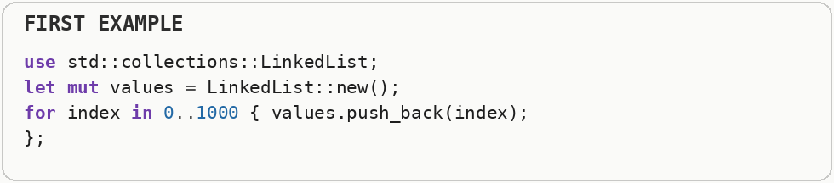
A deque keeps elements in compact blocks and still supports efficient operations at both ends. It usually gives the CPU much better locality than a linked list for queue-like workloads.
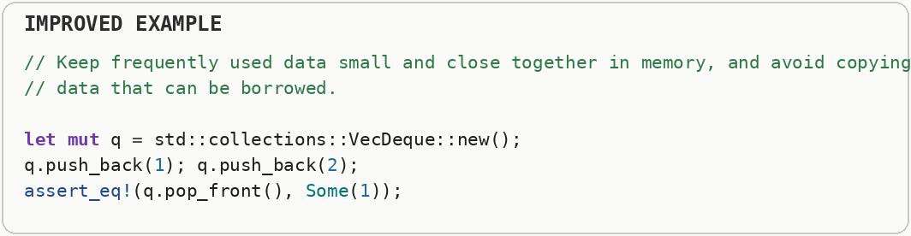

Graph Representation: Pointer Chasing vs. Index-Based Arenas
Don't model graph nodes as single-threaded reference counting> with pointer-based edges. Store nodes in a flat vector and represent edges as plain integer indices into that vector. A linked list stores each element separately and follows pointers from node to node. That pointer chasing often defeats spatial locality, while contiguous arrays let one cache-line fetch bring in several neighboring elements. Graphs can represent connections with heap-allocated node pointers or with compact numeric indexes into arrays. Index-based layouts often reduce per-node allocation overhead and make traversals friendlier to caches because related metadata lives in denser memory.
The pointer-rich graph wraps nodes inside several layers of shared pointers and interior mutability. Traversal then follows many indirections and each node can live in a different allocation.
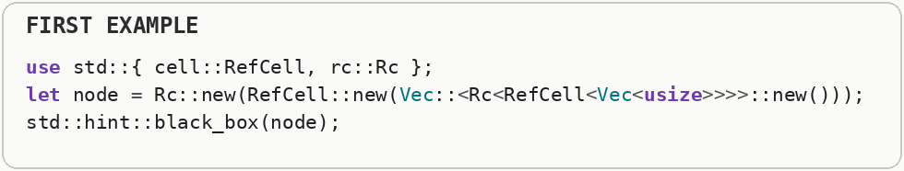
The indexed graph stores nodes together and represents edges as numeric indices. Indices are small, easy to copy, and let traversal move through denser memory instead of chasing ownership pointers.
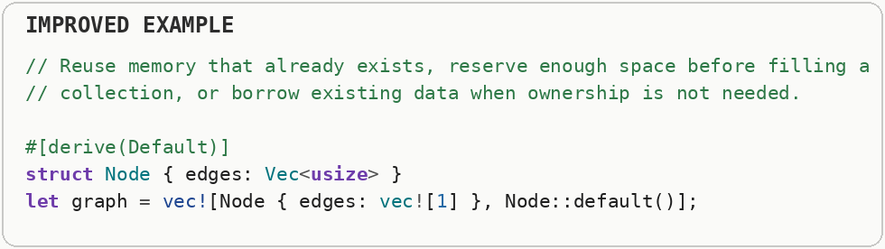

Compressed Sparse Row (CSR): The Densest Graph Layout
For large, mostly-static graphs (millions of nodes, edges rarely change), go a step further than vector> and flatten all edges into a single contiguous array using the CSR format. Compressed Sparse Row stores a sparse graph or matrix in compact arrays: one array marks where each row begins and another stores the neighboring entries. The representation removes most per-node pointer overhead and supports fast sequential traversal. Compressed sparse row stores all outgoing edges in one contiguous edge array plus offsets that mark where each node's edge range begins and ends. It is extremely compact and scan-friendly for mostly static graphs because traversal becomes sequential array access rather than pointer chasing.
A vector for every node creates many small allocation headers and separate adjacency buffers, even when the graph itself is mostly static.
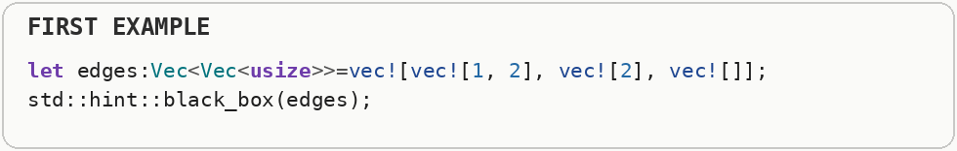
Compressed Sparse Row stores all edges in one flat array plus an offsets array telling where each node's neighbors begin and end. The representation is dense and sequential, which is excellent for large read-mostly graphs.
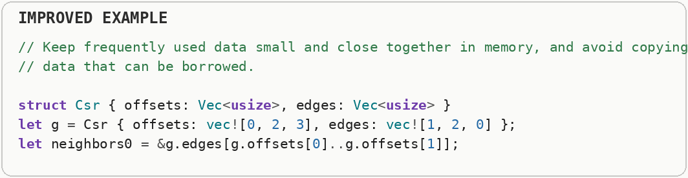

Binary Search Trees (BSTs)
If you need to constantly insert data and keep it perfectly sorted, a vector will choke. Use Rust's B-tree set to keep insertions and lookups at logarithmic time. A binary search tree keeps keys ordered so each comparison chooses a smaller or larger subtree. Balanced tree variants keep their height near logarithmic, preventing the structure from collapsing into a slow linked list. Big O notation describes how the amount of work grows as the input grows. Linear or N log N growth scales much better than quadratic growth, because doubling the input does not multiply the work nearly as aggressively. A binary search tree keeps smaller keys on one side of a node and larger keys on the other. A balanced tree keeps its height logarithmic so searches remain efficient, while an unbalanced tree can degenerate into a long chain and lose that advantage.
Keeping a sorted vector by inserting each new value into the middle can require shifting many existing elements after every insertion.
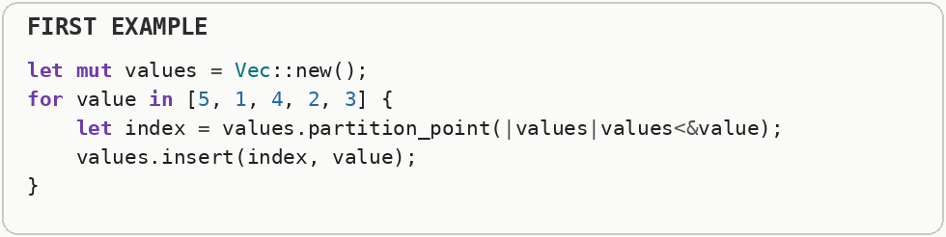
A balanced tree keeps values ordered while supporting logarithmic insertion and lookup. It trades contiguous memory locality for cheaper incremental ordered updates.
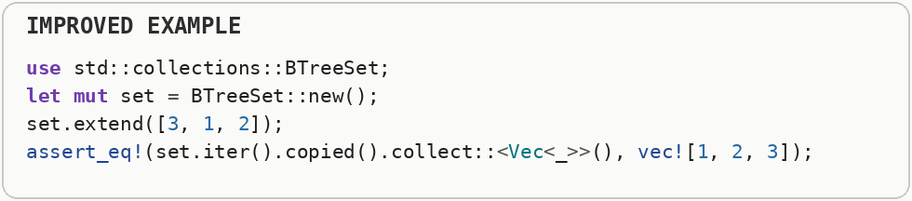

Stacks
Need Last-In-First-Out (LIFO) behavior? You don't need a custom node structure. Just use a standard vector with ordinary push and pop operations. A stack is a last-in, first-out structure: the most recently added item is the first one removed. Contiguous array-backed stacks are compact and cache-friendly. A stack follows last-in, first-out order: the newest item is the first one removed. Array-backed stacks are especially efficient because pushing and popping at the end usually touches contiguous memory and requires no per-element node allocation.
The custom linked-node representation builds a stack out of separately allocated nodes even though the required behavior is only last-in, first-out access.
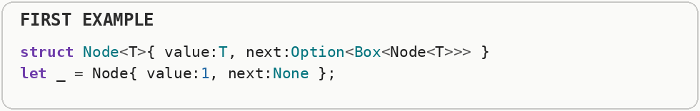
A contiguous growable array already provides constant-time push and pop at the end. A stack is an access pattern rather than a special node type: the last value pushed is the first value popped.
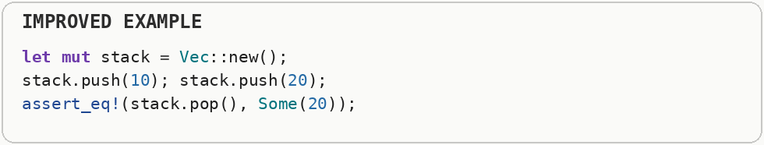

Probabilistic Data Structures (Memory-vs-Accuracy Trade-off)
When working with massive datasets where you just need to know if something might exist, do not use a standard Hash Table. Use a Bloom Filter. A Bloom filter is a compact probabilistic membership structure. It can say that an item is definitely absent or possibly present; false positives are possible, but false negatives are not when the structure is used correctly. Probabilistic structures deliberately allow a controlled chance of error to save large amounts of memory or computation. A Bloom filter, for example, can quickly say that an item is definitely absent or probably present using a compact bit array and several hashes.
An exact set for a million seen values stores every key plus hash-table metadata, which can consume a large amount of memory.
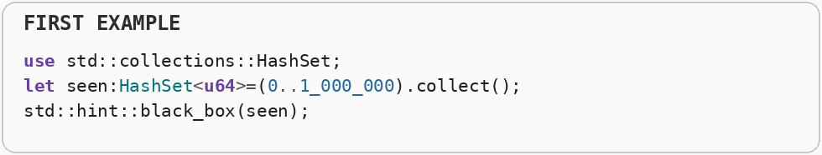
A probabilistic membership structure such as a Bloom filter stores compact bit patterns instead. It can report false positives but not false negatives, so it is useful when saving memory is worth occasionally doing an unnecessary follow-up check.


Data Layout & Memory Footprint

Choosing Data Types
The narrowest type that correctly represents your value range and precision needs is usually the fastest one - every extra byte in a type is an extra byte moved through memory bandwidth and an extra byte competing for cache space. A data type determines how many bits represent a value and what operations are valid. Narrower types move fewer bytes through memory and fit more values in cache, but only if their numeric range and precision are still sufficient. A CPU cache is a small, very fast memory close to the processor. A cache miss happens when the needed data is not there and the CPU must wait for slower main memory; cache locality means arranging access so nearby work tends to reuse nearby bytes. A data type determines not only valid values but also representation size, alignment, arithmetic behavior, and sometimes available CPU instructions. Choosing a type wider than necessary can increase memory traffic and cache footprint, while choosing one too narrow can introduce overflow or conversion costs.
Storing a tiny pixel component in a sixty-four-bit integer uses eight bytes for a value that may need only one byte.
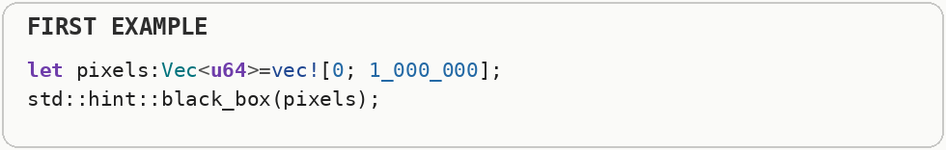
Using narrower types packs more values into each cache line and reduces memory bandwidth. The trade-off is range: the type must still represent every value the program can legitimately hold.
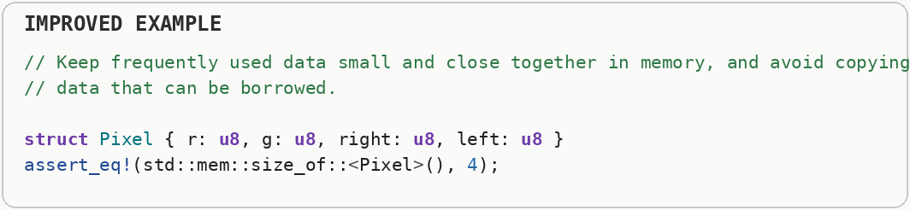

Data-Oriented Design: SoA vs. AoS (Struct Layout & Cache Utilization)
Structure your data for the CPU cache, not for human readability. Group identical properties together (Struct of Arrays) rather than grouping properties by object (Array of Structs). Array of structures stores all fields of one object together. Structure of arrays stores one field for many objects together, which is often faster when a loop touches only a subset of fields because each cache line contains more useful data. A CPU cache is a small, very fast memory close to the processor. A cache miss happens when the needed data is not there and the CPU must wait for slower main memory; cache locality means arranging access so nearby work tends to reuse nearby bytes. Array-of-structures stores complete records next to each other, while structure-of-arrays stores each field in its own contiguous array. If a hot loop uses only one or two fields from many records, structure-of-arrays can load far less irrelevant data into cache and can be easier to vectorize.
The array-of-structures layout places every field of each particle together, so summing only one coordinate still pulls unused fields such as mass into cache.
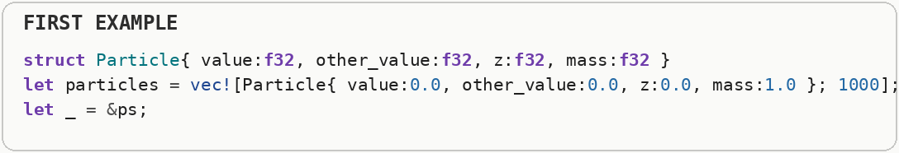
The structure-of-arrays layout stores each field in its own contiguous array. A loop that needs only one coordinate can then stream exactly those values with less wasted memory traffic and better opportunities for SIMD.
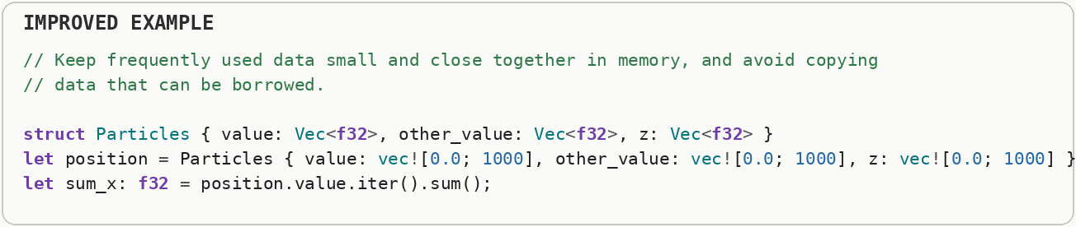

Hot and Cold Data Splitting
Split frequently accessed fields from rarely accessed ones into separate structures (or separate arrays) so hot data stays dense in cache. Hot data is accessed frequently during performance-critical work, while cold data is rarely needed. Separating them reduces the size of the records scanned by hot loops, so each cache line contains a higher fraction of useful bytes.
The first record stores frequently used numeric state beside a large debug string, so scanning the hot field drags cold debugging data through the memory hierarchy too.
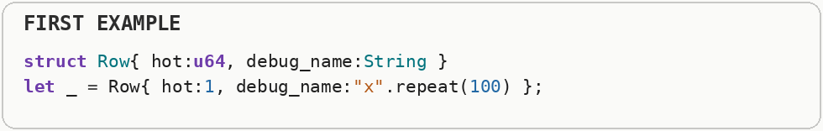
Splitting hot and cold fields keeps the data used every frame or request compact, while names and diagnostics live elsewhere. More hot records then fit in the same cache space.
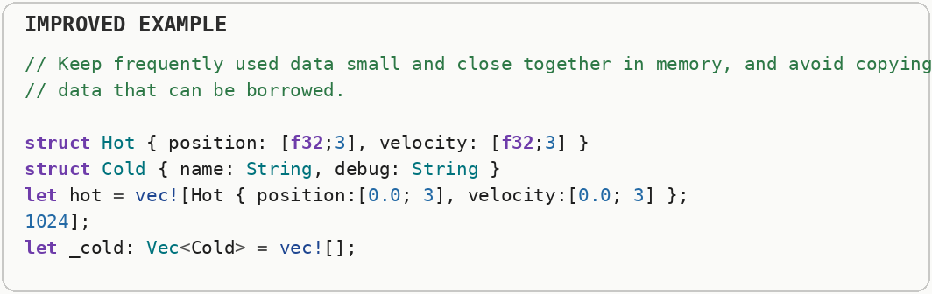

Struct Padding, Field Reordering & External Padding
Order fields largest-to-smallest (especially under C-compatible memory layout) to cut internal padding. Remember trailing (external) padding: size_of::() is rounded up to a multiple of alignment, so padding repeats for every array element. Memory alignment places values at addresses that suit the hardware. Compilers may insert padding bytes between fields or at the end of a structure so each field begins at a correctly aligned address. Processors often require or prefer values to start at aligned addresses, so compilers insert unused padding bytes between fields or at the end of a structure. Reordering fields can sometimes reduce that padding, while deliberate external padding can also be used to separate concurrently modified values onto different cache lines.
The first field order forces the compiler to insert unused padding bytes so the large integer begins at an address aligned for that type.
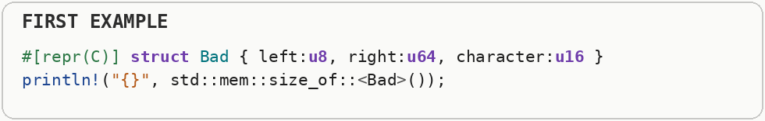
Reordering fields from larger alignment requirements to smaller ones can reduce those gaps. Alignment helps the hardware access values efficiently, while padding is the unused space inserted to satisfy alignment.
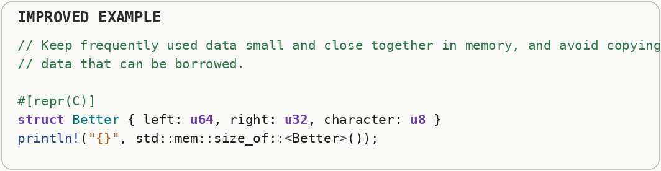

Data Layout & Enum Boxing (Oversized Enum Variants)
Keep your structs and enums small. If an enum has one massive variant, Box it to keep the overall footprint tiny. A tagged union or enum must be large enough to hold its largest variant plus a tag identifying which variant is active. Moving an unusually large payload behind a pointer can keep every ordinary enum value smaller. A sum type stores one value chosen from several possible shapes and records which choice is active. A union overlays several interpretations on the same memory and usually requires the programmer to track which interpretation is valid. A tagged union such as an enum needs enough storage for its largest variant plus information identifying which variant is active. One unusually large variant can therefore enlarge every value; moving that rare large payload behind a pointer can keep the common representation smaller.
An enum that stores a four-kilobyte payload inline must be large enough for that biggest variant even when the current value is only a tiny tag.
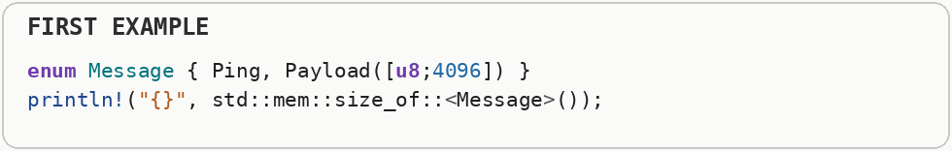
Boxing the rare huge payload keeps the ordinary enum value small and stores the large bytes separately only when that variant is used. That can greatly improve cache density for collections dominated by small variants.
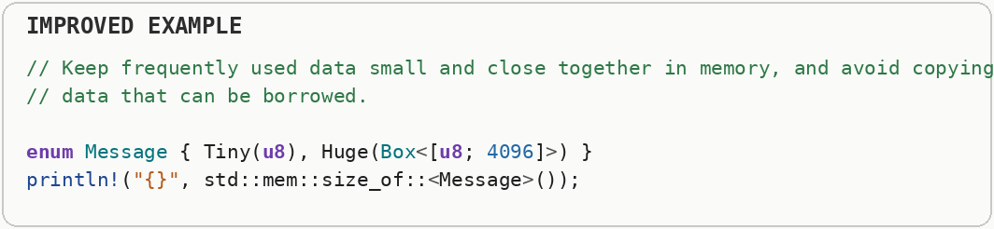

Bitwise Operations & Bitflags (The Boolean Bloat)
When tracking multiple true-or-false states, do not use arrays of bools. Pack them tightly into a single integer using bitwise operations. Bitwise operations manipulate individual bits inside an integer. Bitflags pack many independent true-or-false states into one machine word instead of spending a full byte or more on each state. A machine word contains many individual bits, and bitwise AND, OR, XOR, and shifts let software manipulate those bits directly. Bitflags use one bit per state, so dozens of Boolean properties can fit into a single integer and be tested or combined efficiently.
Eight separate boolean fields can consume more than a single byte once layout and alignment are considered.
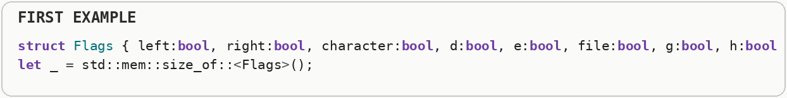
Bitflags pack several yes-or-no states into individual bits of an integer. Bitwise OR turns flags on, AND tests them, and shifts select which bit represents each flag.
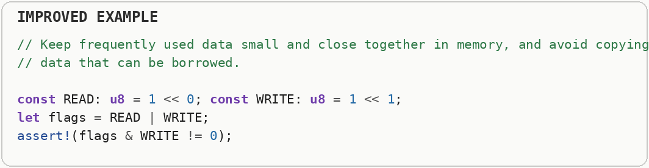

Logical vs. Arithmetic Bit Shifts
Use logical shifts for unsigned data and bit patterns; use arithmetic shifts only when you intentionally want sign extension on signed integers. A logical right shift fills new high bits with zero. An arithmetic right shift preserves the sign bit of a signed integer, which effectively extends the sign as the value moves right. A logical right shift inserts zero bits from the left, while an arithmetic right shift preserves the sign bit of a signed integer. The distinction matters because the same raw bit movement can represent division-like behavior for signed values or simple unsigned bit manipulation.
Right-shifting a signed negative integer preserves the sign on common two's-complement machines, so treating that operation like an unsigned bit move can produce surprising results.
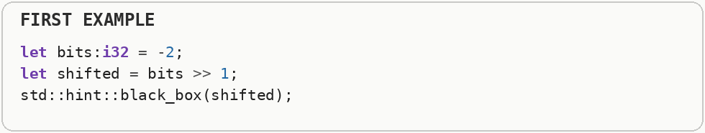
A logical right shift fills the new high bits with zero, while an arithmetic right shift copies the sign bit. The signedness of the value therefore changes the meaning of a right shift.
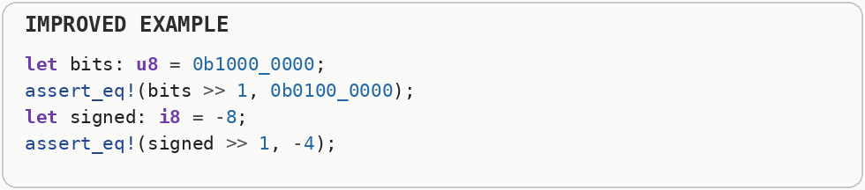

String Interning and Flyweight Pattern (Duplicate String Storage)
When dealing with thousands of identical string values (like JSON keys, tags, or categories), do not store them as independent strings. Use String Interning. String interning stores one canonical copy of repeated text and lets the rest of the program refer to that shared identity. It saves memory when the same labels, keys, or categories occur many times. String interning stores one canonical copy of repeated text and lets the rest of the program refer to that shared copy, often through a compact identifier. The flyweight pattern generalizes this idea by sharing immutable common state instead of duplicating it in every object.
The first collection owns ten thousand separate copies of the same word, paying for the same characters and allocation metadata over and over.
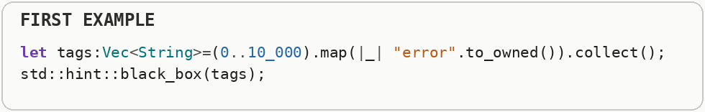
String interning stores one canonical copy and represents later occurrences with a compact identifier or shared reference. It is especially effective for repeated tokens such as field names, status strings, or symbols.
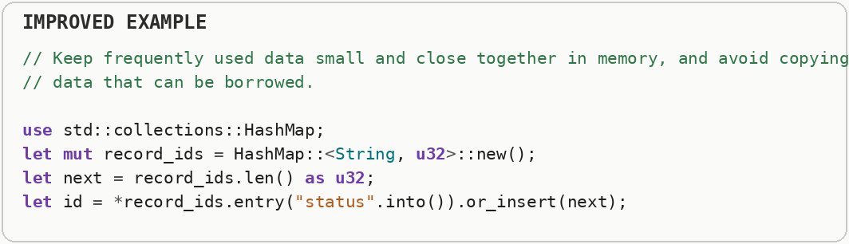

Zero-Copy Parsing & Clone-On-Write (Unnecessary String Duplication)
When parsing data (like JSON or networking packets), never allocate new Strings unless you are physically altering the text. Borrow the original buffer using a borrowed string slice or copy on write. Zero-copy processing tries to interpret data directly from its existing buffer rather than duplicating it. Copy on write shares the original data until a modification actually requires a private copy. Heap allocation asks an allocator to find a block of memory at runtime. Growing a collection can require a reallocation: a larger block is acquired, existing data is moved or copied, and the old block is released. Zero-copy processing keeps references into an existing input buffer instead of allocating new strings for every field. Clone-on-write shares data while it remains read-only and creates a private copy only if somebody needs to modify it, postponing copying until it is actually necessary.
Splitting the line into newly owned strings copies every field even when the parser only needs read-only views into the original input.
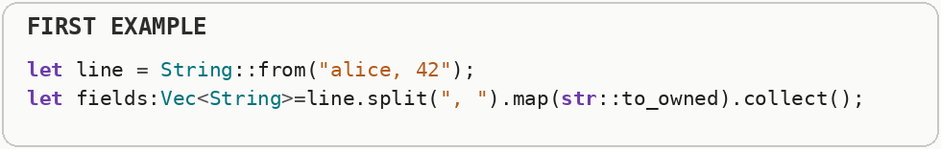
Zero-copy parsing keeps slices that point into the original buffer. Copy-on-write extends that idea by borrowing unchanged text and allocating a new string only when a transformation, such as lowercasing, is actually required.
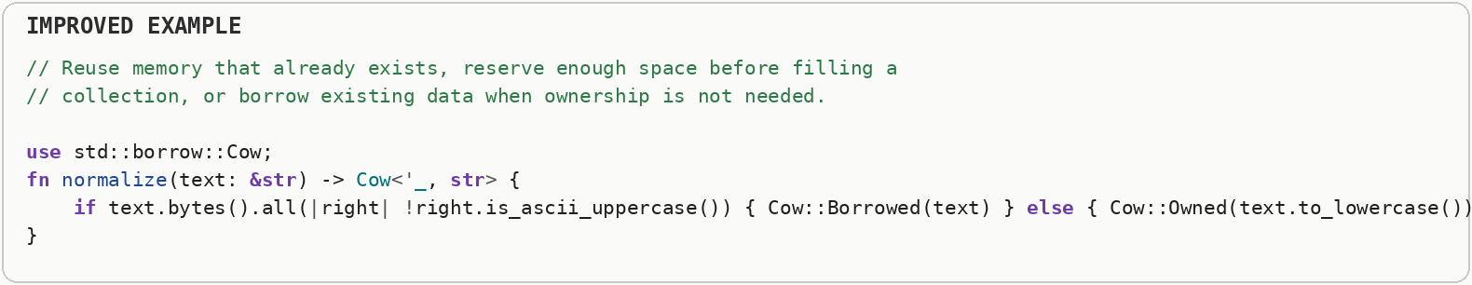

Memory Management Models

Memory Management Strategies: Manual Allocation vs. Garbage Collection vs. Reference Counting vs. Smart Pointers
Every memory-management strategy trades predictability and raw throughput against safety and programmer effort - know which axis your program actually needs before picking (or fighting) a language's default. Garbage collection reclaims unreachable objects automatically, reference counting frees an object when its owner count reaches zero, and manual or ownership-based schemes make lifetimes more explicit. Each strategy changes pause behavior, runtime overhead, safety, and programmer responsibility. Heap allocation asks an allocator to find a block of memory at runtime. Growing a collection can require a reallocation: a larger block is acquired, existing data is moved or copied, and the old block is released. Memory-management systems differ mainly in who decides when storage can be reclaimed. Manual management gives explicit control, garbage collection discovers unreachable objects automatically, reference counting frees an object when its owner count reaches zero, and smart pointers encode ownership policies into safer abstractions.
Using thread-safe reference counting for every heap value pays ownership bookkeeping and atomic coordination even when the data has only one owner or never crosses a thread boundary.
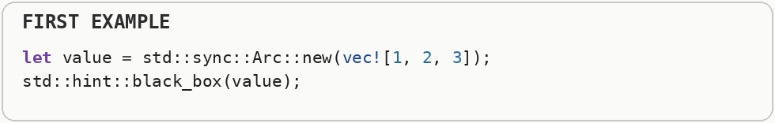
The second sample shows that memory-management tools solve different ownership problems: a unique heap box for one owner, local reference counting for shared single-threaded data, and atomic reference counting for shared cross-thread data.
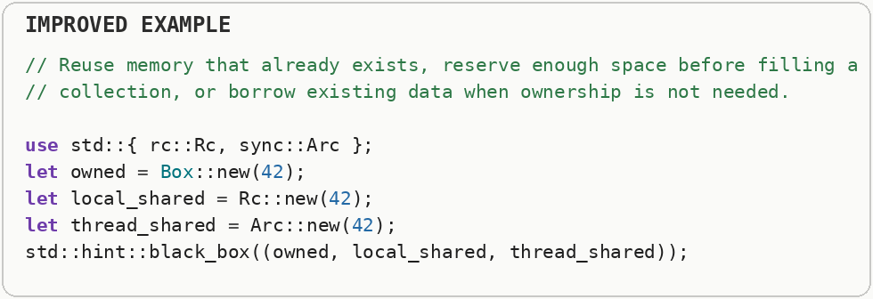

Static Variables vs. Global Variables
Minimize both, but understand they solve different problems - a static gives a value a fixed memory address and program-length lifetime; "global" describes scope (visible everywhere), which is the more dangerous property of the two. A static value has storage that lasts for the lifetime of the program. Global scope is a separate idea: it means many parts of the program can access the name, which increases coupling even when the storage itself is cheap. Static storage lives for the entire duration of the program. The performance issue is usually not lifetime itself but sharing: mutable global state can create synchronization, cache contention, hidden dependencies, and initialization-order problems when many parts of a program access it.
The mutable global configuration can be changed from anywhere that can reach it, so callers depend on hidden shared state and concurrent access requires coordination.
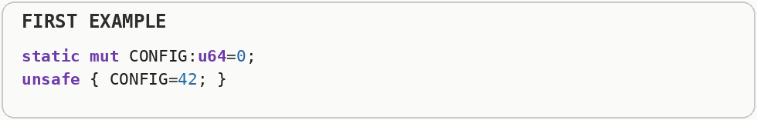
The read-only program-lifetime value keeps the cheap fixed storage without exposing global mutation. Static lifetime describes how long storage exists; global scope describes how broadly code can reach it, and those are separate design choices.
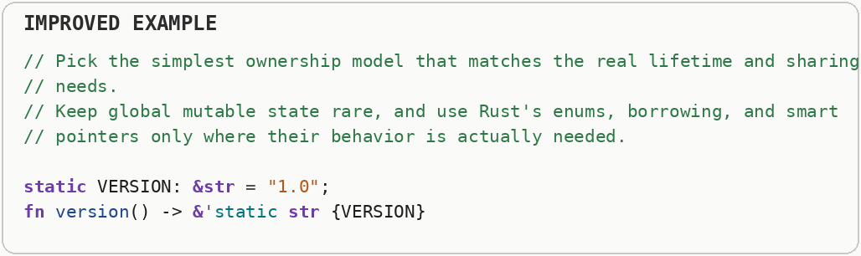

Heterogeneous Data Structures, Unions & Enums
When elements differ in shape, use a sum type (enum) with dense packing; reach for union only when you need C-compatible overlay or proven space savings and are willing to manage safety. A sum type stores one value chosen from several possible shapes and records which choice is active. A union overlays several interpretations on the same memory and usually requires the programmer to track which interpretation is valid. Heterogeneous structures store values that may have different shapes or types. Unions share one block of memory among possible representations without automatically tracking which is active, while tagged enums pair shared storage with an explicit tag so the active variant can be checked safely.
The union overlays several possible interpretations on the same bytes but does not automatically track which interpretation is currently valid, so using the wrong view can misread the stored bits.
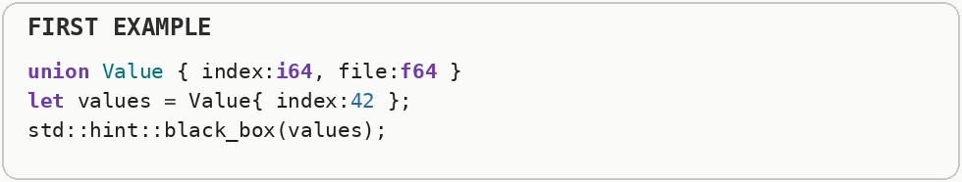
The tagged variant representation stores both the value and which variant it is. That extra tag buys type-safe heterogeneous data, while a raw union is mainly useful when a compatible memory overlay or measured space saving justifies manual safety work.
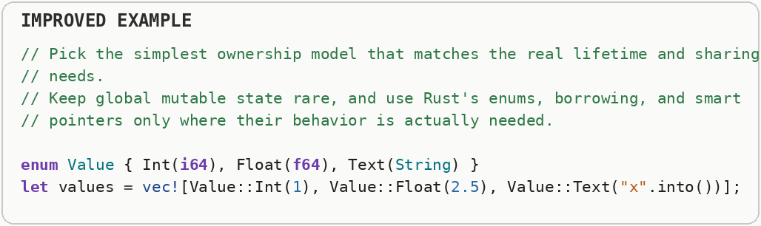

Macros (Codegen vs. Runtime Cost)
Use macros to eliminate repetitive boilerplate and runtime work (generate match arms, lookup tables, parsers) - not to hide heavy runtime logic that should be a plain function. A macro generates or transforms source code before normal runtime execution. It can remove boilerplate or generate static tables without adding runtime cost, but generated code can still increase compile time and binary size. Macros run during compilation and generate source or syntax rather than executing at runtime. That means a macro can remove runtime abstraction cost, but excessive expansion can increase compile time and binary size because the generated code is duplicated before optimization.
A macro can expand to a large runtime computation; generating the source code does not make the generated computation free.
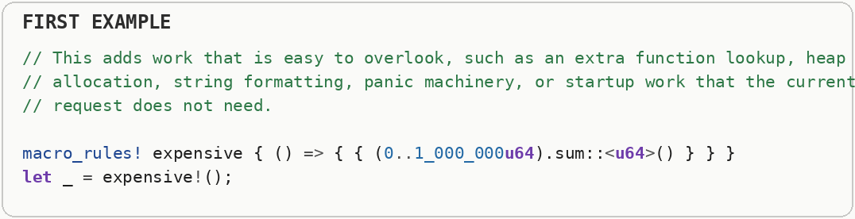
Macros are most useful for moving repetitive source construction to compile time, such as generating a match table. They reduce handwritten boilerplate, but the runtime cost is whatever code the expansion actually produces.
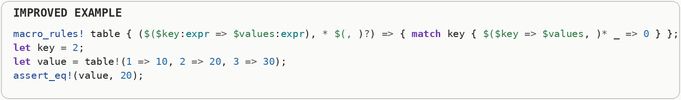

Abstraction & Dispatch Costs

Function Pointers vs. Generics vs. Closures
Prefer generics or generic callables for hot call sites (static dispatch, inlining); use function pointers (function pointers) for thin dynamic callbacks and foreign function interface; avoid a boxed dynamic callable in tight loops. A function pointer chooses a callable target at runtime with a small amount of indirection. Generics let the compiler produce type-specific code, while closures package callable behavior together with any captured state. Static dispatch lets the compiler know the exact function target at compile time, which enables inlining and specialization. Dynamic dispatch chooses the target at runtime, commonly through a virtual method table, adding an indirect call and limiting some compiler optimizations. A function pointer chooses behavior through an indirect callable address, generics let the compiler create specialized code for concrete types, and closures can capture surrounding state. These choices affect inlining, code size, dispatch cost, and how much behavior is known at compile time.
The boxed callable uses dynamic dispatch and a heap allocation so the exact function body is not known at the call site.
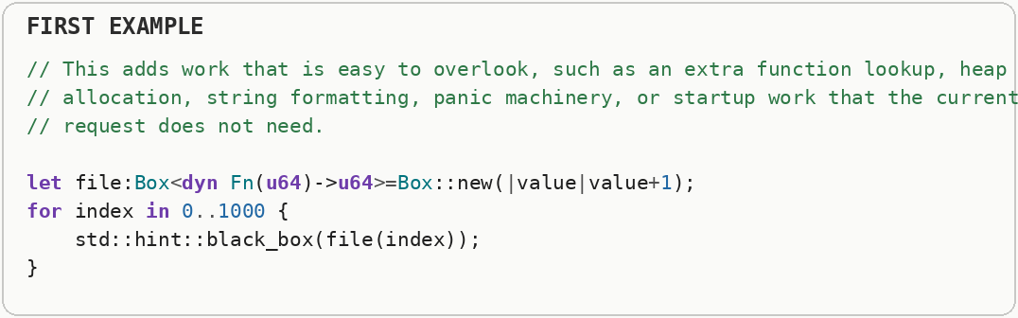
The generic callable lets the compiler specialize the function for the concrete closure. That static dispatch can remove the indirect call and expose the closure body to inlining and other optimizations.
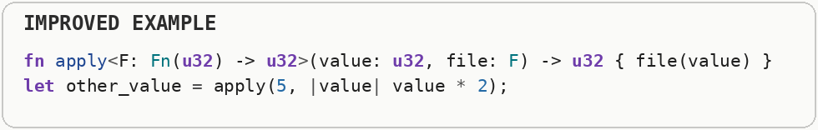

Static vs. Dynamic Dispatch (Virtual Method Table Indirection)
Prefer Generics (generic static dispatch) over Trait Objects (a boxed trait object) unless you absolutely need a collection of mixed types. Static dispatch lets the compiler know the exact function target at compile time, which enables inlining and specialization. Dynamic dispatch chooses the target at runtime, commonly through a virtual method table, adding an indirect call and limiting some compiler optimizations. Static dispatch selects the exact implementation during compilation, which usually enables inlining and further optimization. Dynamic dispatch selects an implementation at runtime through an indirect pointer, often stored in a virtual method table, giving flexibility at the cost of less compile-time knowledge.
Calling through a trait object requires dynamic dispatch: the program loads a function address from a virtual method table at runtime because the concrete type is not known at compile time.
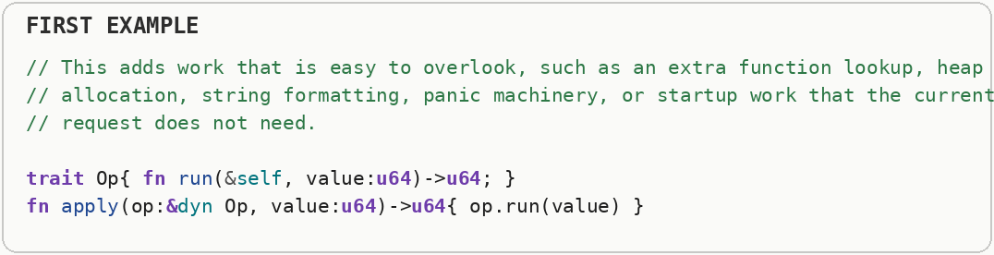
The generic version uses static dispatch. The compiler creates specialized machine code for the concrete type, so the call target is known and can often be inlined.
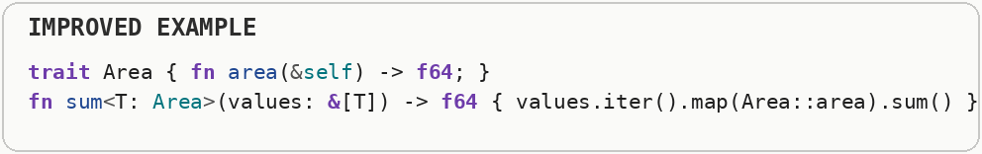

Panic & Exception Costs vs. Result
Use result or optional-value types for expected failure paths; reserve panics for truly unrecoverable bugs. In hot code, avoid patterns that can panic (bounds checks you could prove, unwrap on fallible input and output). An expected failure is part of normal control flow and is usually best represented explicitly. Panics or exceptions are designed for exceptional situations; unwinding or constructing diagnostic state can be much more expensive than an ordinary branch. A bounds check verifies that an index stays inside an array or slice before memory is accessed. An overflow check verifies that arithmetic still fits the destination integer type; removing either check trades safety for a small amount of work and must be justified carefully. Error handling can follow an expected return-value path or an exceptional control-flow mechanism such as stack unwinding. Unwinding walks stack frames and runs cleanup code, so it is designed for uncommon failures rather than routine decisions that occur on a hot path.
The first parser turns an ordinary parse failure into a panic, which is appropriate for a broken program invariant but not for input that can legitimately be invalid.
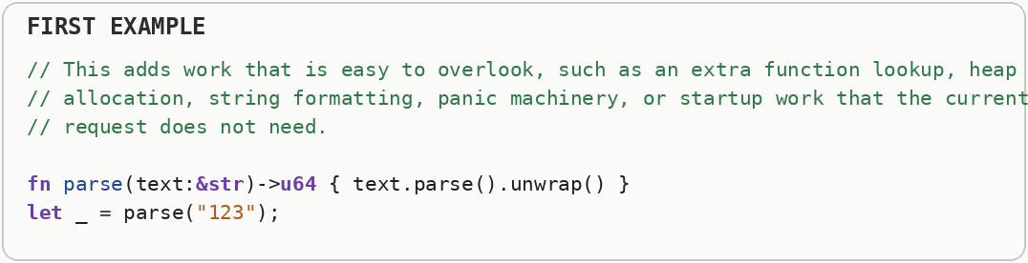
The second parser returns an explicit error value and handles success and failure as normal control flow. Expected errors stay cheap and visible instead of entering panic machinery.
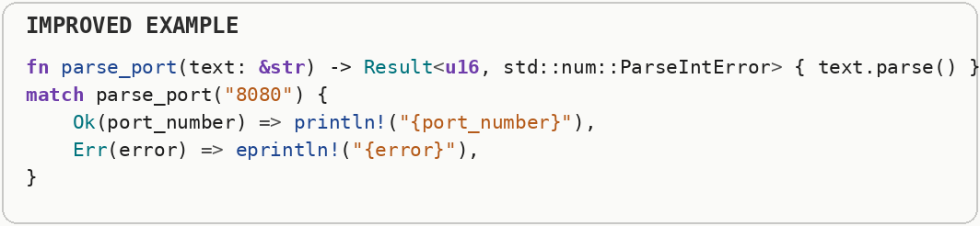

Object-Oriented Programming Costs (Inheritance & Virtual Methods)
Treat classical object-oriented programming (deep inheritance, virtual methods, heap-allocated objects) as a design tool, not a performance default - each layer of indirection and dynamic dispatch has a measurable cost. Heap allocation asks an allocator to find a block of memory at runtime. Growing a collection can require a reallocation: a larger block is acquired, existing data is moved or copied, and the old block is released. Static dispatch lets the compiler know the exact function target at compile time, which enables inlining and specialization. Dynamic dispatch chooses the target at runtime, commonly through a virtual method table, adding an indirect call and limiting some compiler optimizations. Object-oriented designs can introduce indirection when behavior is selected through virtual methods and data is spread across separately allocated objects. Those costs are not inherent to every object-oriented design, but deep pointer-heavy hierarchies can reduce inlining and cache locality.
The object-oriented shape collection stores boxed trait objects, which means separate heap allocations and virtual dispatch through a table of function pointers.
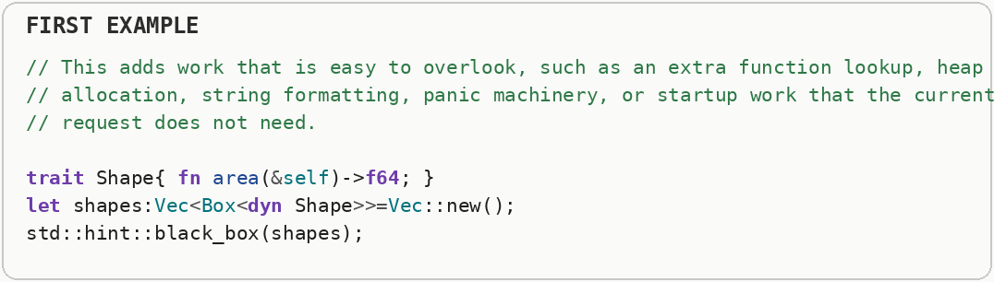
When the set of variants is known, a compact enum can represent them directly and a match selects the operation. That trades extensibility for predictable layout and static control flow.
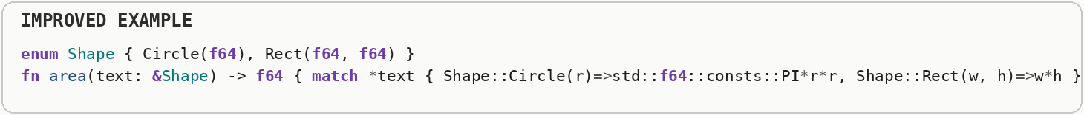

Logging, Tracing & Observability Overhead
Log and trace the minimum needed for operations; never format expensive strings on a disabled level; sample high-volume traces. Logging records discrete messages, while tracing follows work across operations and often records spans, timing, and context. Both can become expensive when formatting, allocation, locking, or output happens at very high frequency. Observability converts internal program activity into records for humans or monitoring systems. Formatting messages, attaching context, acquiring locks, timestamping events, and exporting them to files or networks all consume resources, so high-volume instrumentation can become part of the workload it is measuring.
The logging statement constructs a formatted message and computes expensive diagnostic state before anyone has established that the message will actually be emitted.
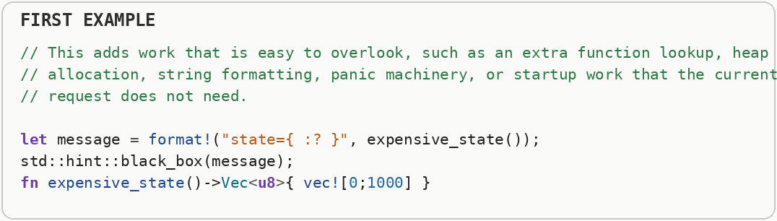
High-throughput logging should test the active log level first and defer expensive formatting or state collection until the event is enabled. Structured tracing has the same principle: observability is valuable, but disabled instrumentation should be close to free.


Loading Code & Data (Startup Path)
Defer work that is not needed to serve the first request - lazy-init heavy modules, load configs on demand, and prefer memory-mapping large read-only assets. Startup latency is the time between launching a program and becoming useful. Parsing configuration, loading libraries, allocating large structures, and touching many memory pages can all land on that critical path. Program startup can involve mapping executable pages, resolving dynamic symbols, loading configuration, opening files, initializing runtimes, and faulting code or data pages into memory. Work placed on this critical path directly affects how quickly the application becomes usable.
Reading and parsing a large configuration file during startup extends the time before the program can do any useful work.
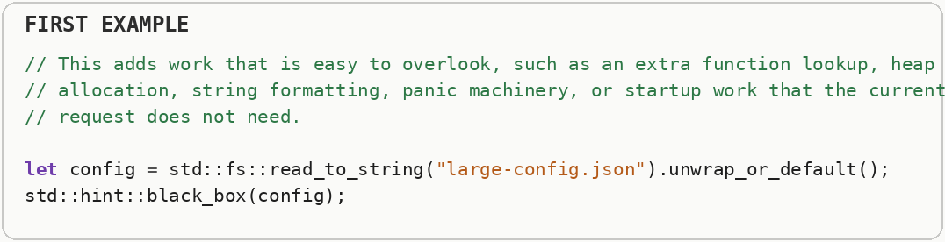
Lazy initialization postpones that load until code first requests the configuration, and then caches the result for later calls. Startup becomes shorter when optional code and data leave the critical launch path.
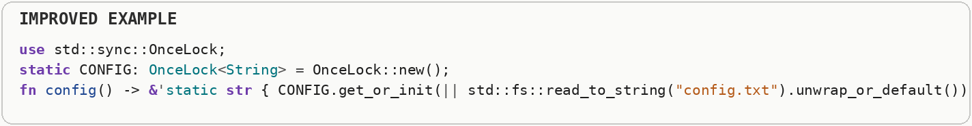

GUI & Interactive UI Performance
Keep the UI thread free - never do heavy work on the event or render thread; update only dirty regions; target stable frame budgets (for example 16 milliseconds for 60 Hz). Interactive interfaces have a frame budget: at sixty frames per second, a frame has about sixteen point seven milliseconds to finish. Blocking the event or render thread causes visible stutter because input and drawing cannot be serviced on time. Interactive interfaces are governed by frame and input-latency budgets. At sixty frames per second, roughly sixteen milliseconds are available for an entire frame, so long main-thread work can cause missed frames, visible stutter, or delayed responses to user input.
The click handler performs a huge calculation directly on the interface thread, so input, painting, and animation cannot run until that calculation finishes.
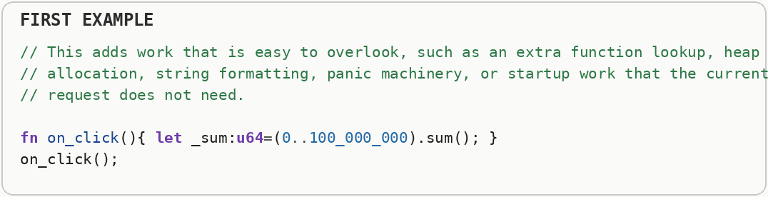
The second design moves heavy work to a background worker and sends the result back. Interactive software usually has a frame or response-time budget, so long CPU tasks must not monopolize the thread responsible for the user interface.
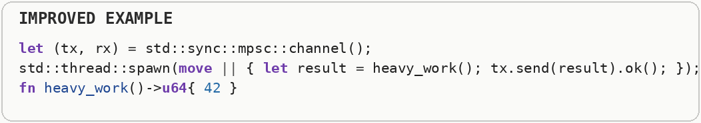

Drivers & Peripherals
Talk to devices in bulk, with interrupt coalescing or polling at high rate; avoid round-tripping userspace↔driver per tiny operation. A device driver translates operating-system requests into commands a hardware device understands. Crossing repeatedly between an application, the kernel, and a device adds latency, so high-throughput device interfaces usually batch work. An interrupt is an asynchronous signal, often from hardware, that asks the CPU to run a handler. A trap or exception transfers control because of a software event or fault; these transfers disrupt the normal instruction stream and may disturb caches and pipelines. Device drivers translate operating-system requests into hardware-specific operations. Peripherals are often much slower than the CPU and may communicate through memory-mapped registers, DMA, interrupts, or command queues, so performance depends heavily on batching and avoiding unnecessary synchronization.
The first loop performs one device write for every byte, multiplying driver and operating-system overhead by the payload length.
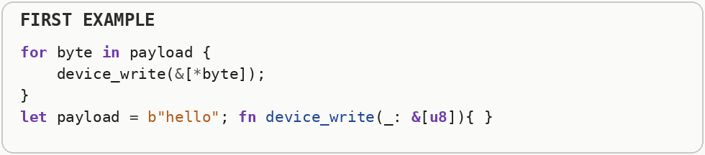
Writing the whole buffer in one operation lets the driver handle a larger transfer. Peripheral performance often depends more on reducing transactions and bus setup than on the arithmetic used to prepare each byte.
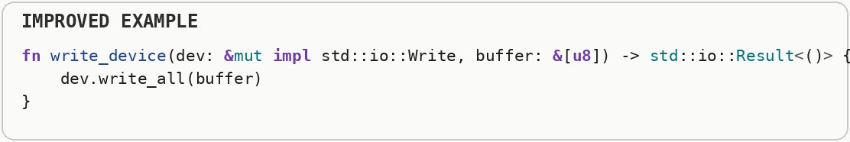

Input and Output Optimizations

Buffered Input and Output (Per-Write Syscall Overhead)
Never issue raw, unbuffered read or write calls in a loop. Wrap the handle in a buffered reader or buffered writer. User space is where normal applications run with limited privileges; the kernel controls protected resources such as files, devices, memory mappings, and scheduling. A system call crosses that boundary, and the transition plus validation work is called syscall overhead. Buffered input and output collects many small reads or writes in memory and performs fewer larger operations. This reduces system-call overhead and gives disks, filesystems, and networks larger chunks to process efficiently. A system call transfers control from user-space code into the operating-system kernel. That transition and the work around it have fixed overhead, so buffering combines many small reads or writes into fewer larger calls and usually improves throughput.
Each system call has setup, permission checks, and bookkeeping before the bytes are written. Paying that setup cost thousands of times can dominate the real work.
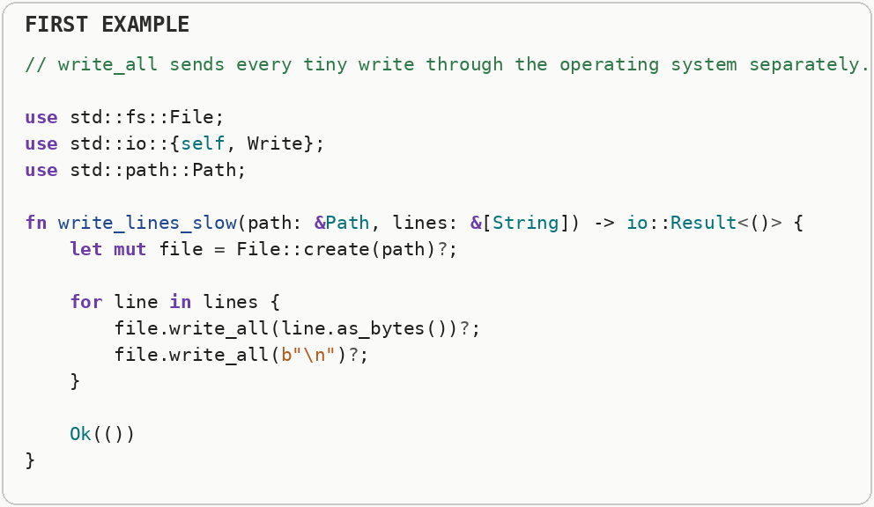
The technical term is buffered input and output: the same bytes are written, but the expensive operating-system boundary is crossed fewer times.
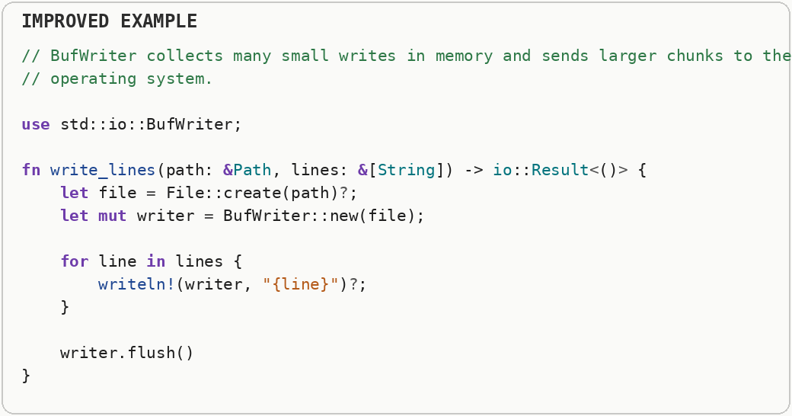

Syscall Batching & io_uring (Submission Overhead)
When you issue thousands of small input and output operations per second, batch them (or use I O uring) so you pay kernel transition cost once per batch instead of once per operation. I O uring is a Linux interface that uses shared submission and completion queues so applications can batch asynchronous input and output with fewer system calls and less repeated setup. User space is where normal applications run with limited privileges; the kernel controls protected resources such as files, devices, memory mappings, and scheduling. A system call crosses that boundary, and the transition plus validation work is called syscall overhead. Batching system calls reduces the number of user-to-kernel transitions and lets the kernel see more work at once. io_uring is a Linux interface built around shared submission and completion queues, allowing many input and output operations to be issued and collected with fewer traditional syscall round trips.
Submitting one input-and-output operation at a time repeats submission bookkeeping and prevents the kernel from seeing a larger batch of pending work.
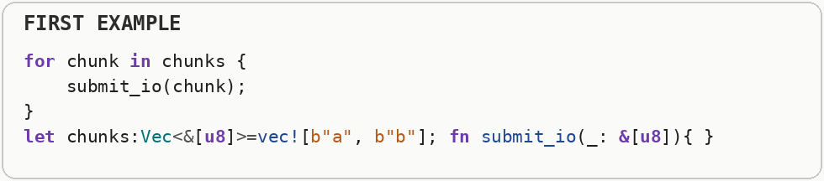
The second snippet demonstrates the batching shape even though it is a simplified stand-in rather than a literal I O uring call. I O uring uses shared submission and completion queues so Linux applications can hand many operations to the kernel with fewer syscall transitions.


Connection Pooling & Socket Options
Reuse expensive remote connections (database, HTTP, TCP) via a pool; tune socket options only after measuring - wrong options can hurt. A connection pool keeps already-established network or database connections ready for reuse. Reusing them avoids repeated handshakes, authentication, congestion setup, and socket creation. Establishing a connection can require DNS work, TCP or transport handshakes, encryption handshakes, authentication, and congestion-control warm-up. A pool keeps established connections ready so later requests can reuse that setup instead of paying it repeatedly.
Opening a fresh TCP connection for every request repeats connection setup, kernel socket work, and often protocol handshakes.
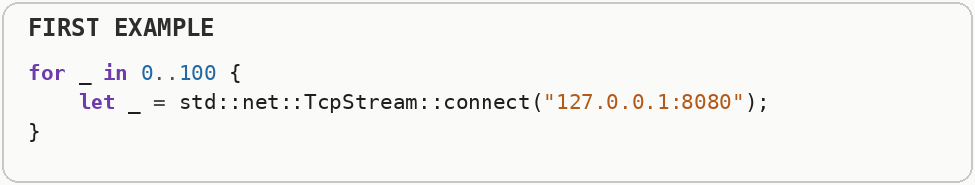
A connection pool keeps a bounded set of established connections and lends them to many requests. Reuse removes repeated setup latency, while socket options should be tuned only for the traffic pattern the application actually has.


Memory-Mapped Files (Kernel-to-User Buffer Copying)
For reading massively large files (gigabytes in size), map them directly into virtual memory instead of chunking them through a buffered reader. A memory-mapped file lets file contents appear inside a process virtual address range. The operating system loads pages on demand, so the program can access file data like memory without manually copying every chunk through a user-space buffer. User space is where normal applications run with limited privileges; the kernel controls protected resources such as files, devices, memory mappings, and scheduling. A system call crosses that boundary, and the transition plus validation work is called syscall overhead. Memory mapping makes file contents appear inside a process's virtual address space. The operating system loads pages on demand through page faults, so code can access file data with ordinary memory reads and may avoid an explicit copy into a separate user-space buffer.
Reading the file normally creates a user-space buffer and asks the operating system to copy the file contents into that buffer before the program can use them.
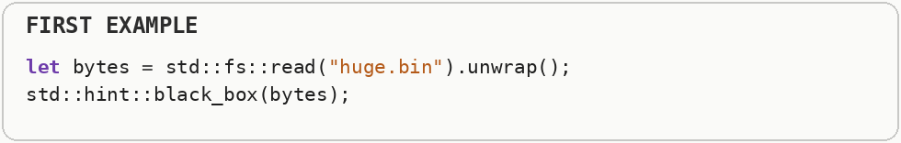
A memory mapping places file-backed pages into the process virtual address space. The operating system loads pages on demand, so large files can be accessed without manually copying the entire file through one user-space buffer first.
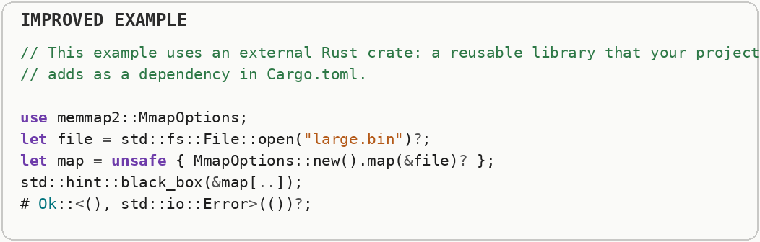

Choosing Network Layers for Speed
Use the highest-level protocol that meets your latency or throughput goals - drop down a layer only when profiling shows the upper layer is the bottleneck. Network protocols trade convenience, reliability, framing, encryption, and compatibility against latency and overhead. Higher layers usually save engineering effort; lower layers give more control only when the extra complexity is justified. A profiler is a measurement tool that shows where a program spends CPU time, allocates memory, waits on input and output, or stalls between operations. Different profiler types answer different performance questions, so one timing number is rarely the whole diagnosis. Network protocols trade reliability, ordering, congestion control, connection setup, and application complexity. A lower-level transport can remove features and overhead, but the application then has to provide any guarantees it still needs, so the fastest useful layer is the simplest one that still matches the protocol requirements.
The text protocol example constructs headers and a body representation for a tiny remote procedure call, adding parsing and formatting bytes around the actual value.
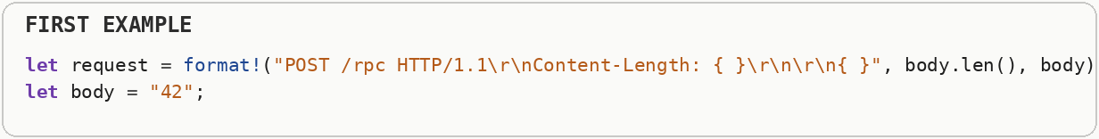
Network layers trade convenience, interoperability, and tooling against framing and parsing cost. A compact binary protocol can reduce CPU work and bytes for hot internal paths, while HTTP remains valuable when its ecosystem and compatibility matter more.

Data Formats, Serialization & Endianness
Pick format by read or write pattern - not by popularity. On hot paths prefer compact binary over text; fix endianness explicitly at the boundary; avoid re-serializing the same object repeatedly. Serialization converts in-memory values into a byte representation for storage or transmission. Endianness is the byte order used for multi-byte numbers, so a portable format must define that order explicitly at system boundaries. A hot path is code that runs very frequently or consumes a large share of total execution time. Optimizing cold code may make the source more complicated without producing a noticeable improvement. Serialization converts in-memory values into a byte representation that can be stored or transmitted. Endianness describes the byte order used to represent multi-byte numbers; portable formats must define that order so machines with different native layouts interpret the same bytes consistently.
The first loop repeatedly converts the same number to a chosen byte order, paying serialization work every time even though the value does not change.
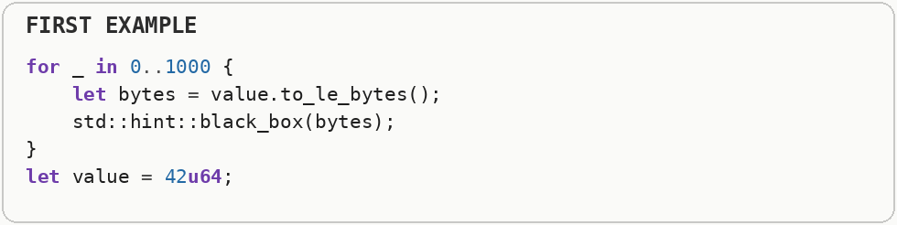
The boundary example converts explicitly to network byte order and back. Endianness is the order of bytes inside multi-byte numbers; defining it at the wire or file boundary keeps data portable across machines with different native byte order.
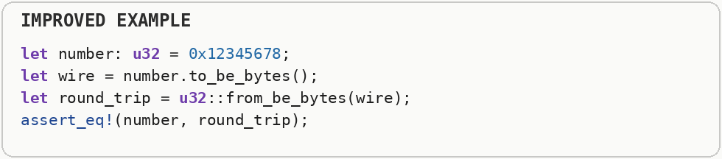

What Makes Newer Computers Faster (And How Code Should Adapt)

Metadata Costs (Indexes, Schemas, Alloc Headers)
Metadata is not free - allocator headers, length fields, vtable pointers, index structures, and schema descriptors consume RAM and cache bandwidth. Keep metadata proportional to the value it provides. Metadata is information that describes or organizes other data, such as lengths, indexes, tags, schema descriptors, allocator headers, and virtual-table pointers. It can make operations faster or safer, but those extra bytes still consume memory bandwidth and cache capacity. A CPU cache is a small, very fast memory close to the processor. A cache miss happens when the needed data is not there and the CPU must wait for slower main memory; cache locality means arranging access so nearby work tends to reuse nearby bytes. Metadata is information about other data: indexes, type tags, length fields, schemas, object headers, and allocator bookkeeping. Each piece can make access safer or faster, but it also consumes memory and may increase the number of bytes moved through caches and storage.
The first item carries length, capacity, and type metadata alongside a one-byte payload, so bookkeeping can dwarf the useful data when millions of items are stored.
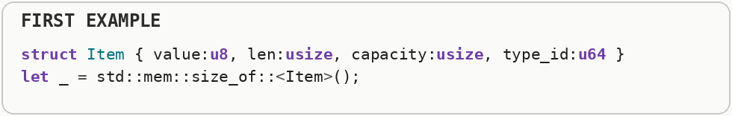
The second sample makes metadata size visible. Metadata is information about the data rather than the payload itself, and compact designs avoid repeating metadata per element when one shared description can serve the whole collection.
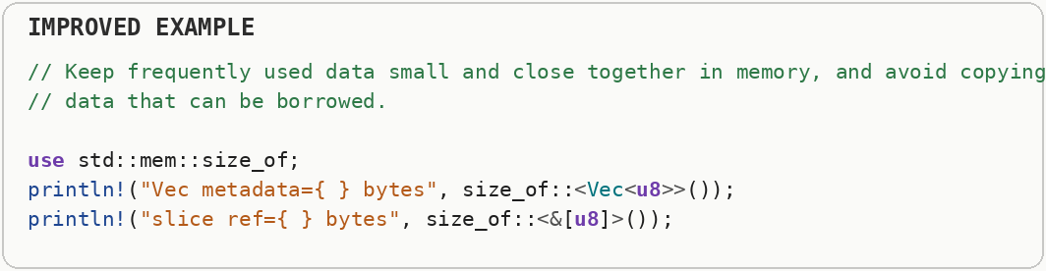

Library Headers (Include Cost, API Surface & Header-Only Libraries)
Treat public headers as part of your build-time performance surface - every include, template, and macro in a widely used header is paid by every translation unit that pulls it in. In C and C++ builds, a translation unit is a source file after its included headers are expanded. Large public headers, templates, and macros are repeatedly parsed and instantiated by every translation unit that includes them, increasing build time. A macro generates or transforms source code before normal runtime execution. It can remove boilerplate or generate static tables without adding runtime cost, but generated code can still increase compile time and binary size. A library's public surface affects how much code downstream builds must parse, instantiate, and recompile when interfaces change. Header-only and heavily generic designs can expose more implementation to the compiler for optimization, but they can also increase build time and duplicate generated code.
A large generic public function can force downstream builds to parse, instantiate, and optimize more code, and the debugging and cloning work in this example also expands the API surface.
A narrow non-generic interface compiles to less duplicated code and exposes fewer implementation details. In C and C++ the same idea appears as keeping heavyweight implementation out of headers; in generic Rust APIs, monomorphization creates a similar code-size and compile-time trade-off.
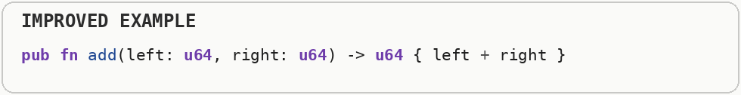

Hardware-Aware Optimizations

Huge Pages (TLB Pressure)
For multi-gigabyte working sets with random or wide sequential access, consider huge pages (two-megabyte or one-gigabyte) to cut translation lookaside buffer misses. The translation lookaside buffer caches recent virtual-to-physical address translations. Huge pages cover much more memory with each translation entry, which can reduce translation lookaside buffer misses for very large working sets. Virtual memory translates program addresses into physical memory using page tables. The translation lookaside buffer, or TLB, caches recent translations; larger pages cover more memory per translation and can reduce TLB misses for very large, regularly accessed datasets.
The large allocation represents the kind of working set that can require many virtual-memory translations when ordinary pages are used.
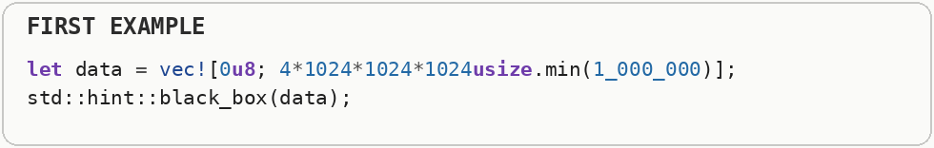
The smaller two-megabyte buffer illustrates huge-page scale, but the snippet does not itself enable huge pages; real huge-page mapping is operating-system-specific. The performance benefit comes from covering more memory with each translation-lookaside-buffer entry.
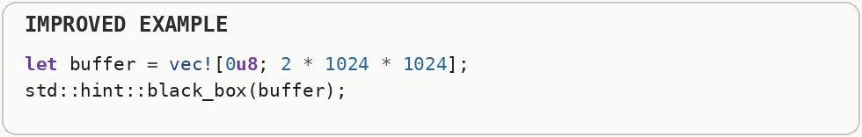

Manual Prefetching (Hiding RAM Latency)
When you're about to iterate through memory in a predictable but non-linear pattern (for example, following a list of indices), hint to the CPU to start loading the next chunk into cache before you actually need it. Prefetching asks the processor to begin loading data before the program reaches the instruction that needs it. The goal is to overlap memory latency with useful computation instead of stopping later to wait for RAM. Prefetching asks the processor to begin bringing data toward the cache before the program actually needs it. It can hide memory latency when access patterns are predictable, but useless prefetches waste bandwidth and can evict data that would have been more valuable.
The indexed loop jumps to distant, unpredictable positions, so the processor may reach each load before the requested memory has arrived from RAM.
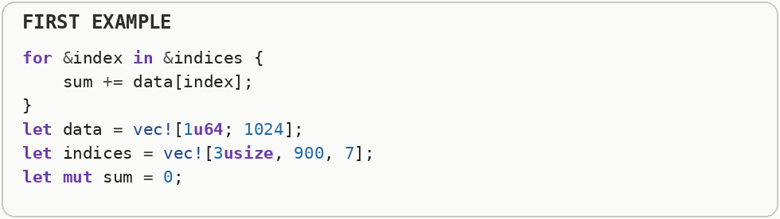
Manual prefetching asks the processor to begin fetching a future address before the program needs its value. It can hide memory latency when the access pattern is predictable far enough ahead, but bad prefetches waste bandwidth and cache space.
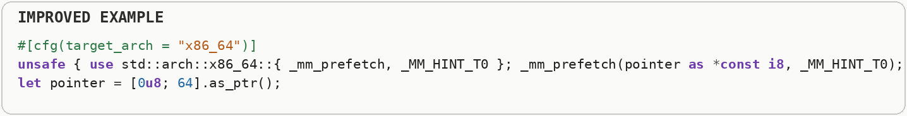

Unified Memory Architecture (CPU-GPU Buffer Duplication)
On systems on a chip with an integrated GPU (Apple Silicon, most mobile chips, Intel or AMD accelerated processing units), don't blindly port desktop-GPU code that copies buffers between "CPU memory" and "GPU memory" - on these chips that memory is often the same physical RAM. Unified memory architecture lets the CPU and integrated GPU access the same physical memory pool. Avoiding unnecessary copies can save both bandwidth and latency, especially on systems where the processors already share RAM. Mobile performance is constrained by battery energy and heat as well as raw speed. Sustained heavy work can trigger thermal throttling, where the chip lowers frequency to stay within temperature and power limits. In a unified memory architecture, CPU and GPU can access the same physical memory pool rather than requiring every buffer to be copied between separate memory systems. That can reduce transfer overhead, although synchronization and cache coherence still determine when each processor can safely see updated data.
Cloning the CPU buffer creates a second full copy before handing data to another processor, doubling memory traffic for no change in information.
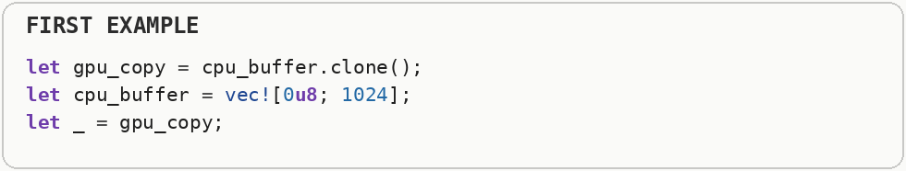
Unified or shared memory lets CPU and GPU work from the same underlying allocation when the platform supports it. The optimization is avoiding redundant transfers and copies, while still respecting synchronization and device-coherency rules.
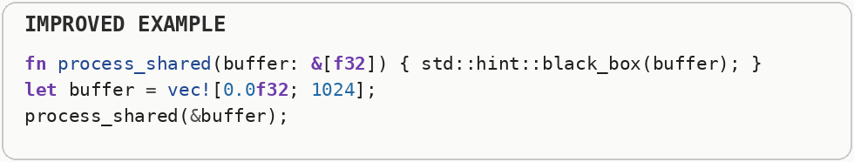

RISC vs. CISC (Instruction Set Architecture Trade-offs)
Understand that x eighty-six and x eighty-six sixty-four (CISC) and ARM or RISC V (RISC) execute your Rust code through fundamentally different instruction pipelines - write portable, branch-light idioms that compile well on both, and gate any architecture-specific intrinsics behind an architecture-specific compile-time guard instead of hardcoding one ISA. An instruction set architecture defines the machine instructions, registers, and conventions software targets. RISC designs traditionally favor simpler instructions, while CISC designs expose more complex instructions; modern performance depends heavily on the microarchitecture that decodes and executes them. An instruction set architecture defines the machine instructions software can target. RISC traditions emphasize simpler, more regular instructions, while CISC traditions include more complex instructions; modern high-performance processors often translate either style into internal micro-operations, so implementation details matter more than the label alone.
Calling an architecture-specific instruction without a matching target guard ties the program to one instruction set and can fail on a different processor.
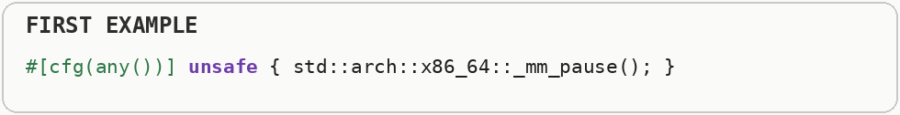
The guarded version chooses code according to the target architecture. An instruction set architecture, or ISA, defines the machine instructions and registers software can use; RISC and CISC describe broad design traditions rather than a simple fast-versus-slow ranking.
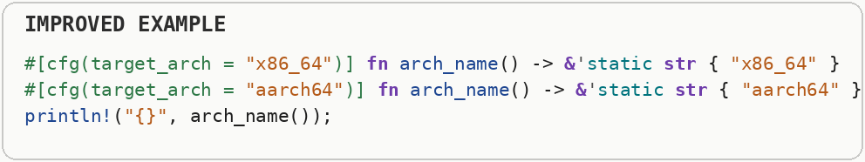

Fast Hashing Algorithms (Cryptographic Hashing Overhead)
Unless your hash map is taking un-sanitized input directly from the internet, replace Rust's default hasher to instantly double your lookup speeds. A hash function turns arbitrary input into a fixed-size value used for lookup, checks, or integrity. Cryptographic hashes deliberately spend more work to resist attacks such as collision construction; ordinary in-process hash tables may prefer a faster non-cryptographic hash when hostile input is not a concern. A hash function maps arbitrary input to a fixed-size value used for table indexing, fingerprints, or integrity checks. Cryptographic hashes are designed to resist deliberate attacks such as finding collisions or reversing inputs, which requires more computation than a non-cryptographic hash intended only for fast in-memory lookup.
A cryptographic hash spends extra computation to resist deliberate collisions and other attacks, which is valuable for security but unnecessary for some trusted in-memory keys.
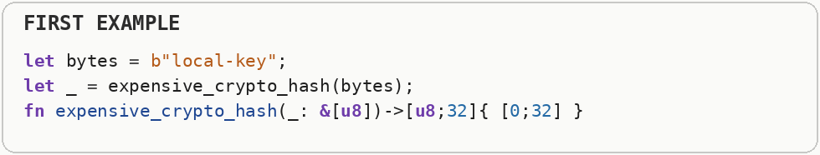
A fast non-cryptographic hash trades those security properties for throughput. Use it only when hostile inputs cannot exploit predictable collisions; otherwise the slower cryptographic protection may be part of correctness, not optional overhead.
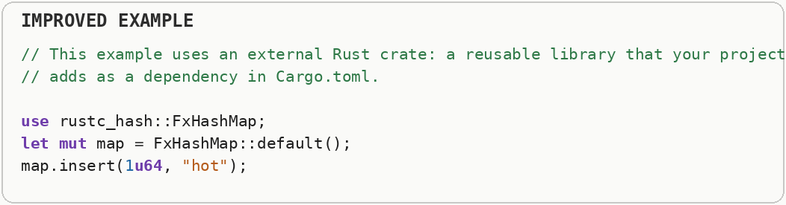

Faster RNG (CSPRNG Overhead)
If you don't need cryptographic security (for example, simulations, games, sampling), swap a cryptographically secure pseudo-random number generator like rand's default for a fast pseudo-random number generator like a fast non-cryptographic generator. A cryptographically secure pseudo-random generator is designed so future output cannot feasibly be predicted from observed values. Simulation and game workloads often need statistical randomness rather than adversarial unpredictability, allowing much faster generators. A cryptographically secure pseudo-random number generator is designed so future or past outputs cannot feasibly be predicted from observed values. That security costs more computation than a simpler pseudo-random generator, so simulation or sampling code can often use a faster generator when unpredictability is not a security requirement.
A cryptographically secure random generator performs extra work so its output is difficult to predict, which is unnecessary for many simulations, randomized algorithms, or test data.
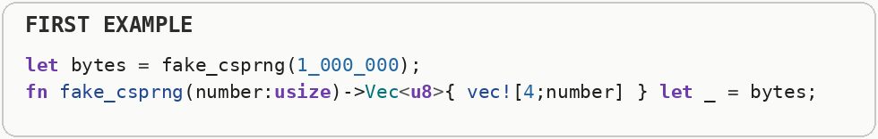
A small pseudo-random generator can produce values much faster when unpredictability is not a security requirement. Random-number selection is therefore a correctness decision first: cryptographic secrets need a CSPRNG, ordinary stochastic workloads often do not.
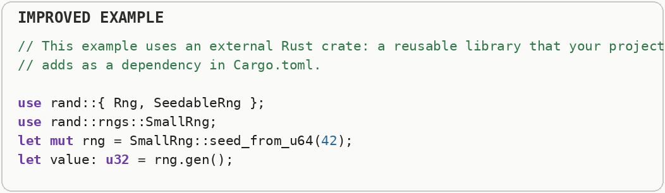

Domain-Specific: Audio, Video, VR, Mobile & Quantum

Audio (Real-Time Callbacks)
Audio callbacks run under hard deadlines (for example every few ms). Never allocate, lock, block on input and output, or take unbounded time on the audio thread. Real-time audio is deadline-driven: the program must refill or process an audio buffer before the hardware needs it. Missing that deadline produces an audible glitch, so unpredictable work such as blocking, locking, or allocation is dangerous on the audio thread. Heap allocation asks an allocator to find a block of memory at runtime. Growing a collection can require a reallocation: a larger block is acquired, existing data is moved or copied, and the old block is released. Real-time audio is deadline-driven: each buffer must be produced before the hardware needs to play it. A missed deadline becomes an audible click or dropout, so callback code must avoid unpredictable pauses from allocation, locks, file input and output, or other operations that can block.
The first audio callback allocates a new output collection while the audio system is waiting for the next block of samples. Allocation can occasionally pause, which risks missing the callback deadline and producing an audible glitch.
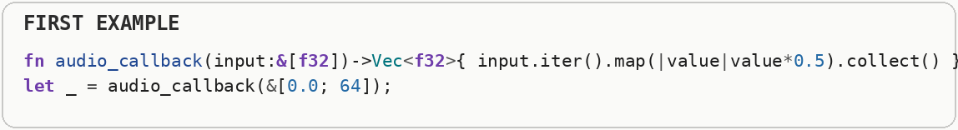
The improved callback writes into an output buffer supplied ahead of time. Real-time audio is deadline-driven: predictable completion before the next audio period matters more than average throughput, so allocation, locks, blocking input and output, and unbounded work stay off the audio thread.
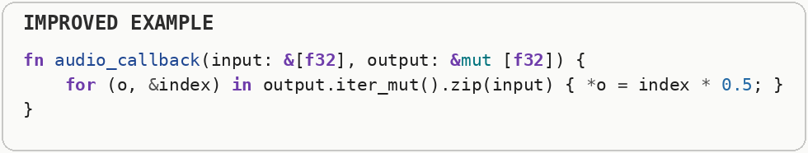

Video (Throughput + Latency)
Move pixels as little as possible; use hardware codecs and direct display paths; pipeline stages so decode, process, and present overlap. Video performance is a pipeline problem involving decode, processing, memory movement, and presentation. Hardware codecs can perform compression and decompression with far less CPU work, and overlapping stages improves throughput. Video pipelines process enormous numbers of pixels per second through decoding, transformation, compositing, and display. Throughput determines whether the pipeline can sustain the target frame rate, while latency determines how long a frame takes to travel from input to the screen.
The first pipeline waits for a complete decode, then a complete processing step, then presentation, so latency accumulates across stages and full-frame buffers can move repeatedly.
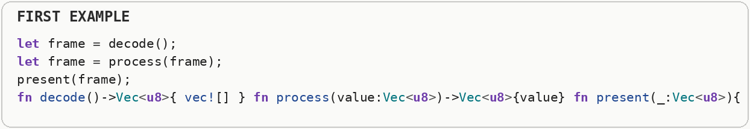
The in-place transformation shows one way to reduce frame copies. High-throughput video systems also overlap decode, processing, and presentation so different frames can occupy different pipeline stages at the same time.
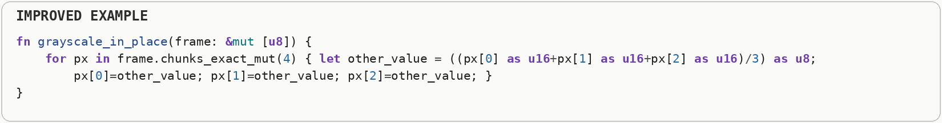

Virtual Reality (Motion-to-Photon)
Missed frame deadlines cause discomfort. Budget time strictly; prioritize pose prediction and late-latching over visual luxury. Motion-to-photon latency is the delay between a user's movement and the updated image reaching the display. Virtual reality is unusually sensitive to that delay, so pose prediction and late updates near display time can matter more than extra visual detail. Motion-to-photon latency is the time between a user's physical movement and the corresponding updated photons reaching the display. Excess latency is especially noticeable in virtual reality because head movement directly changes the expected image, so rendering, tracking, scheduling, and display scan-out all contribute to the budget.
Updating the viewer pose only after an expensive render means the displayed image can be based on an older head position, increasing motion-to-photon latency.
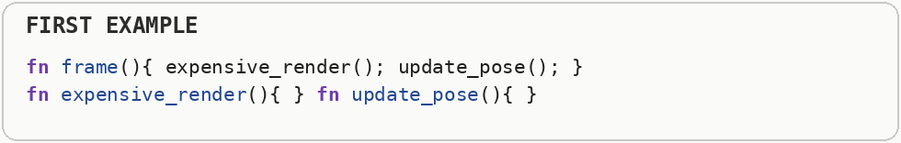
The second sample makes the frame deadline explicit. Virtual-reality rendering is governed by a strict frame budget, and techniques such as late pose sampling and asynchronous reprojection exist to reduce the time between physical motion and the photons shown to the eye.
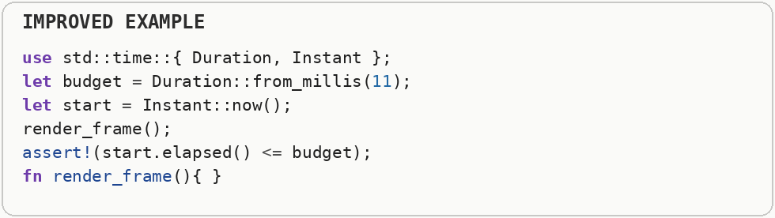

Mobile Devices
Optimize for battery, thermals, and intermittent connectivity - not just peak benchmarks on a plugged-in flagship. Mobile performance is constrained by battery energy and heat as well as raw speed. Sustained heavy work can trigger thermal throttling, where the chip lowers frequency to stay within temperature and power limits. Mobile chips operate inside strict power and thermal envelopes. A workload that is fast for a few seconds may heat the device enough to trigger frequency reduction, so sustained performance often comes from doing less work, using efficient hardware units, and reducing radio and memory activity.
The busy loop repeatedly asks whether background work is finished, keeping a CPU core active even when there is nothing useful to compute.
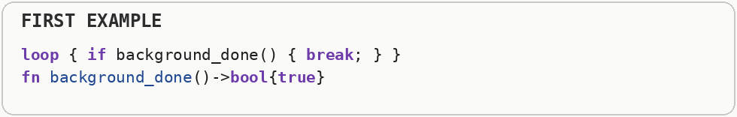
The power-aware path avoids optional expensive refresh work when battery-saving mode is active. Mobile performance includes energy and heat: sustained CPU use can drain the battery and trigger thermal throttling that lowers clock speeds.
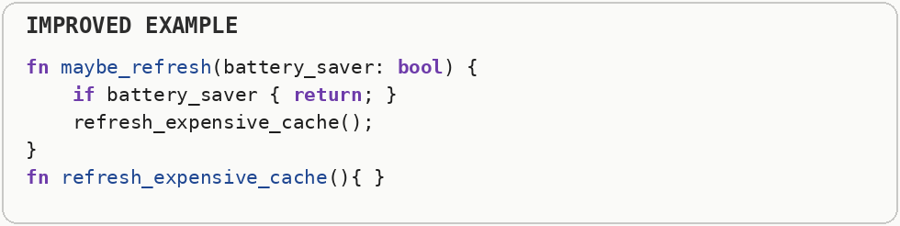

Bluetooth & BLE Optimization
Bluetooth performance is mostly about radio on-air time, connection parameters, and payload packing - not CPU micro-opts. Every extra advertisement, reconnect, or tiny packet costs energy and latency. Bluetooth Low Energy is optimized for short, infrequent radio exchanges. Connection interval, packet size, retransmissions, and how long the radio stays awake often dominate energy and latency more than CPU arithmetic. Bluetooth Low Energy is designed for small, infrequent exchanges with low radio power. Energy use depends heavily on how often the radio wakes, how many packets are sent, connection intervals, payload size, and retransmissions, so batching data can be more efficient than frequent tiny transmissions.
Sending every byte as a separate Bluetooth operation multiplies radio and protocol overhead, which is especially expensive on a power-constrained wireless link.
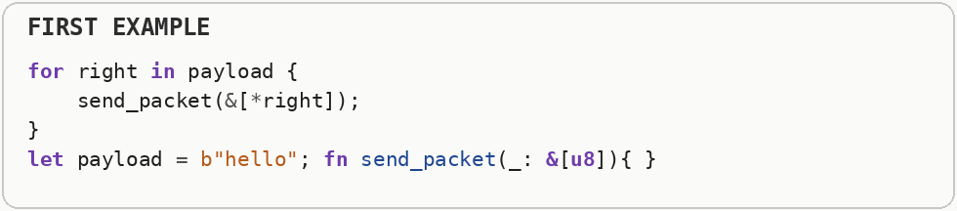
Packing sensor values into one payload reduces the number of transmissions. Bluetooth Low Energy is optimized for small, infrequent exchanges, so batching, connection interval, packet size, and radio wakeups often matter more than local CPU arithmetic.
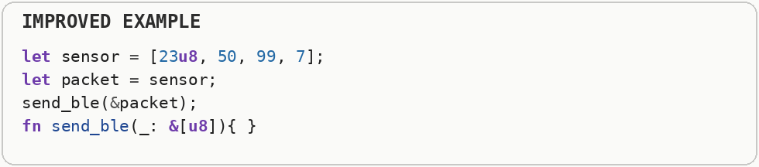

Quantum Computing (Hybrid Classical-Quantum)
Today's quantum programs are hybrid - classical host code optimizes circuit submission, shot count, and post-processing; quantum speedup is lost if the classical pipeline is wasteful. Most current quantum applications are hybrid: classical software prepares circuits, sends them to quantum hardware, collects repeated measurements called shots, and performs post-processing. Classical overhead can erase any advantage if that surrounding pipeline is inefficient. Current quantum workflows are usually hybrid: classical code prepares data and control parameters, a quantum processor executes a circuit, and classical code analyzes the measured results. Communication and repeated circuit execution can dominate total runtime, so optimization includes reducing round trips and the number of required shots.
Submitting every quantum shot as a separate remote job repeats queueing and communication overhead around a tiny unit of quantum work.
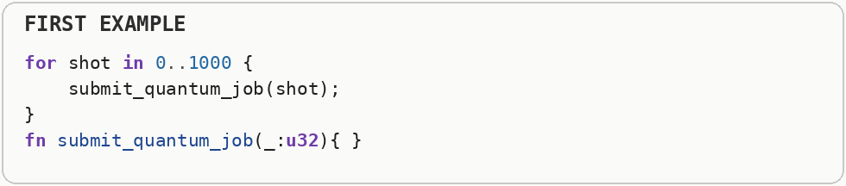
The batched design prepares circuits classically, submits a group together, and post-processes results on the classical machine. Current quantum workflows are hybrid, so minimizing classical-to-quantum round trips is often as important as the circuit itself.
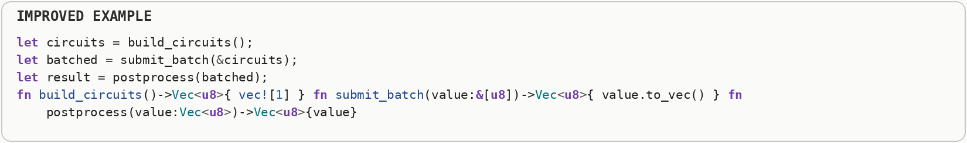

LLVM, Compilers & Writing Programming Languages

Using LLVM Effectively
LLVM optimizes what it can see and prove - feed it clear IR, stable types, and whole-program visibility when performance matters. LLVM is the compiler infrastructure Rust uses for much of its low-level optimization and machine-code generation. It can optimize aggressively only when the program structure gives it enough information to prove that a transformation is safe. LLVM is a compiler infrastructure that represents programs in an intermediate representation before lowering them to machine code. Optimization passes analyze and transform that representation, so giving the compiler clear aliasing, type, control-flow, and target information can unlock better generated code.
The first interface hides behavior behind dynamically dispatched iterator objects, limiting how much concrete loop structure the optimizer can see at the call site.
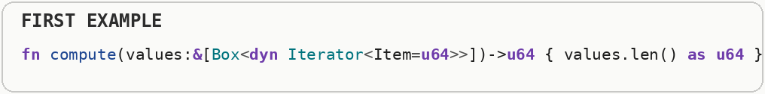
The second form exposes a small numeric function and a regular loop over concrete values. LLVM can inline visible operations, simplify expressions, remove dead code, and vectorize loops more effectively when abstractions have been lowered to clear, optimizable intermediate representation.
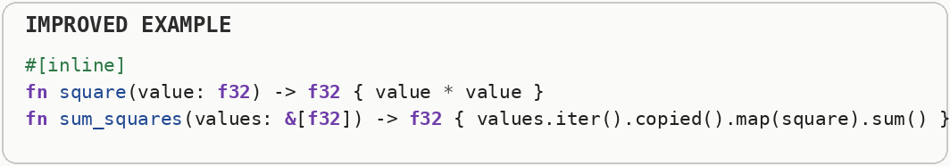

Writing Your Own Language (Performance-Relevant Choices)
Language design is performance design - value representation, evaluation strategy, and memory model set the ceiling before any optimizer runs. A language runtime decides how values are represented, when expressions are evaluated, how memory is managed, and how calls are dispatched. Those choices shape the performance ceiling before later compiler optimizations even begin. Language design determines what the compiler can know about types, memory ownership, dispatch, exceptions, and aliasing. Those semantic guarantees shape which optimizations are safe, so performance characteristics are influenced long before individual machine instructions are selected.
The boxed value representation allocates even tiny integers and booleans separately, making every value larger and turning simple operations into pointer chasing.
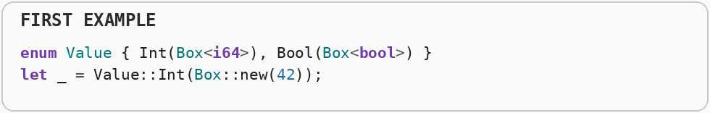
The compact instruction representation uses small tags and fixed-width operands. Language performance is shaped by representation choices such as boxed versus unboxed values, garbage collection, dispatch strategy, object layout, and whether the runtime can specialize hot operations.
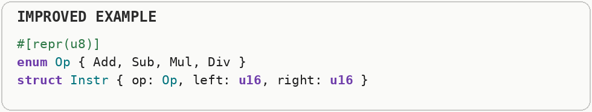

Compiler, Build & Linking

Compile-Time Evaluation (Runtime Computation of Constants)
If a value is known at compile time, never calculate it during program execution. Use compile-time function. Compile-time evaluation performs work while the program is being built and stores the finished result in the executable. That shifts repeated deterministic work out of runtime entirely when all required inputs are already known. Compile-time evaluation executes deterministic calculations while the program is being built and stores the finished result in the binary. It is most useful when the inputs are fixed at build time and the runtime calculation would otherwise repeat or complicate startup.
The first function recomputes a constant product at runtime even though every factor is known before the program starts.
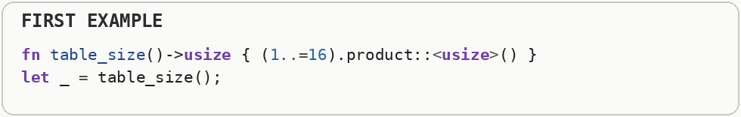
Compile-time evaluation performs that arithmetic during compilation and embeds the result into the program. Runtime then sees the finished constant rather than instructions for recalculating it on every launch or call.
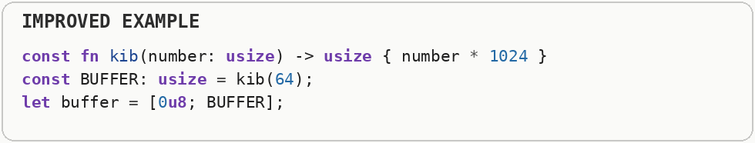

Calling Conventions (Register Args vs. Stack Traffic)
Keep hot-path functions compatible with the platform application binary interface's register-argument limit so arguments stay in registers instead of spilling to the stack; avoid unnecessary large-by-value passes. A calling convention is the part of the application binary interface that specifies how arguments, return values, and registers are used across function calls. Once available argument registers are exhausted, extra data may be passed through stack memory. CPU registers are tiny storage locations inside the processor itself. They are much faster to access than ordinary memory, so small values that stay in registers can avoid extra memory traffic. A calling convention defines where function arguments, return values, and saved state live across a call. Common conventions pass the first several small arguments in CPU registers and spill additional values to the stack, which is one reason very large parameter lists or large by-value objects can create extra memory traffic.
Passing a large structure by value can require copying many bytes and may force arguments onto the stack when they do not fit in the architecture's argument registers.
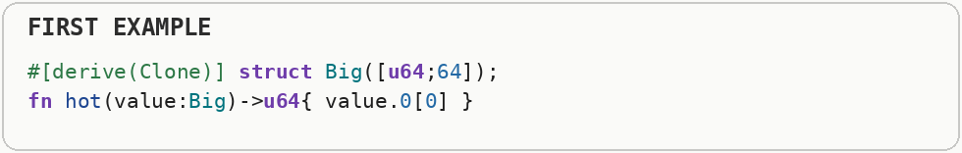
The second function takes a handful of small scalar values that calling conventions commonly pass directly in registers. A calling convention is the agreement between caller and callee about where arguments, return values, and saved machine state live.
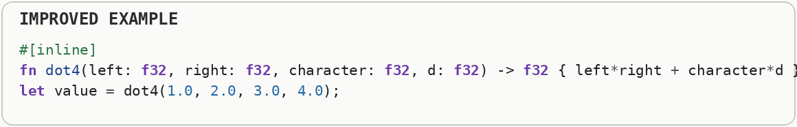

Explicit Inlining (Cross-Crate Inlining Limits)
Use an inline hint for tiny, ultra-hot-path functions that are called thousands of times inside loops, especially across crate boundaries. Inlining replaces a function call with the function body at the call site, exposing more code to optimization and removing call overhead. Monomorphization creates specialized machine code for each concrete generic type, which can be fast but can also duplicate instructions and grow the binary. Inlining replaces a call with the called function's body at the call site. That removes call overhead and can expose constants and surrounding context to further optimization, but it duplicates machine code and therefore can increase binary size and instruction-cache pressure.
A small function in another compilation unit may remain an actual call if the optimizer cannot see its body at the point where the caller is being optimized.
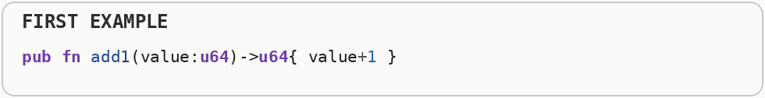
An inline hint can make a small cross-boundary function body available at the call site. Inlining removes call overhead and exposes surrounding code to optimization, but forcing it everywhere can grow the binary.
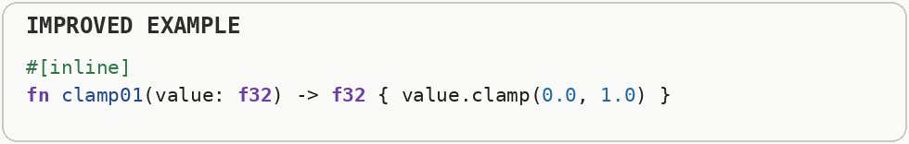

Instruction Cache Pressure (I-Cache Bloat from Over-Inlining)
Inlining and monomorphization aren't free - don't force every function to inline or lean on huge generic functions instantiated for dozens of types, or you'll blow out the instruction cache and make things slower. The instruction cache stores recently executed machine instructions close to the CPU. Excessive code growth can evict useful instructions, creating instruction-cache misses even when the data side of the program is efficient. Inlining replaces a function call with the function body at the call site, exposing more code to optimization and removing call overhead. Monomorphization creates specialized machine code for each concrete generic type, which can be fast but can also duplicate instructions and grow the binary. The instruction cache stores recently executed machine-code bytes close to the CPU. If aggressive inlining or code generation makes a hot working set too large, useful instructions are evicted and the processor must fetch more code from slower cache levels or memory.
Forcing a large function to inline copies its machine instructions into every call site, which can make hot code too large for the CPU instruction cache.
Keeping a rare large slow path out of line leaves the common path compact. The instruction cache stores recently executed machine instructions; code bloat creates instruction-cache misses just as oversized data can create data-cache misses.
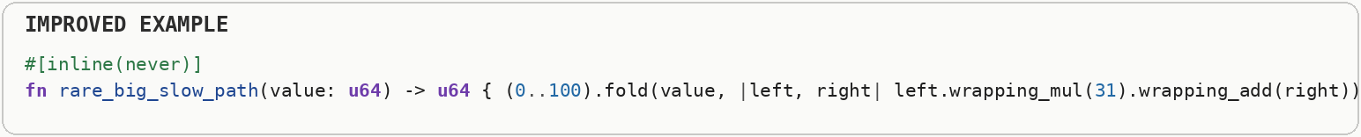

Release Mode (Debug Build Overhead)
Never benchmark or ship a debug build (debug mode). Always use an optimized release build. A debug build favors fast compilation and extra runtime checks, while a release build enables aggressive optimization. Performance measurements from debug builds often describe compiler settings rather than the program you would actually ship. Debug-oriented builds typically preserve more checks and inhibit many transformations so compilation is fast and debugging information remains straightforward. Release optimization changes instruction selection, removes redundant work, and can radically alter loop and function structure, which is why debug timing is not representative.
A debug build preserves extra checks and skips many compiler optimizations, so timing it can make ordinary arithmetic and loops look much slower than the code users will actually run.
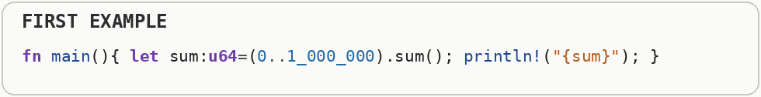
Release mode enables aggressive optimization and is the meaningful baseline for performance testing. Debug builds are for development feedback; production performance decisions should come from optimized builds.
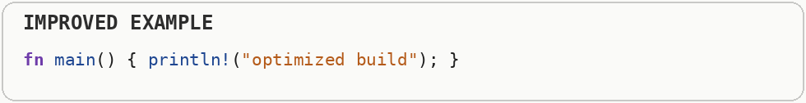

Target Native CPU (Lowest-Common-Denominator Codegen)
If you control the deployment machine, compile for its exact CPU instead of a generic baseline. Compiling for a generic CPU baseline avoids instructions that older machines might not support. Targeting the deployment CPU can enable newer vector instructions and scheduling choices, but the resulting binary may no longer run on older hardware. Compilers often target a conservative CPU feature set so one binary runs on many machines. Targeting the actual processor can enable newer vector instructions, specialized arithmetic, and scheduling choices, but the resulting executable may no longer run on older CPUs lacking those features.
A generic CPU target must avoid instructions that older supported processors might not understand, so it can leave vector width and instruction-set features unused on a known deployment machine.
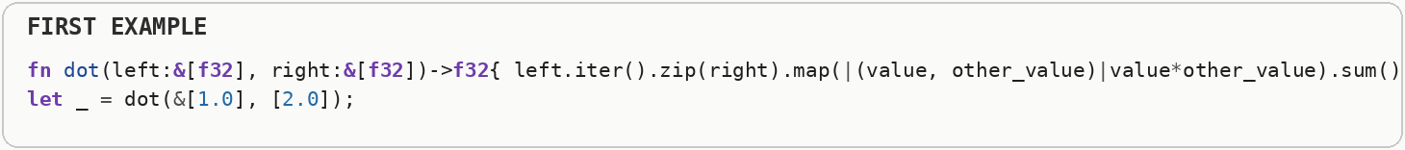
Targeting the actual CPU lets the compiler use its available instruction extensions and scheduling model. The trade-off is portability: a binary built for one modern processor may no longer run on older hardware.
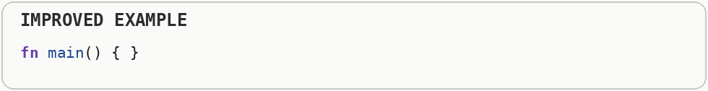

Binary Size Reduction (Binary Size vs. Speed Trade-off)
If startup time, download size, or embedded flash space matters more than raw runtime speed, tune the release profile to shrink the binary instead of maximizing throughput. Binary size affects download time, storage, startup paging, and instruction-cache pressure. Some optimizations trade a larger executable for speed, so the best release profile depends on what the product actually values. Startup latency is the time between launching a program and becoming useful. Parsing configuration, loading libraries, allocating large structures, and touching many memory pages can all land on that critical path. Binary size affects download size, storage, startup paging, and instruction-cache behavior. Some speed optimizations duplicate code, while size-oriented optimization shares or removes code more aggressively, so the best setting depends on whether execution speed or compactness is the tighter constraint.
Forcing even tiny functions to inline everywhere duplicates instructions at each call site. Enough duplication increases executable size and can eventually hurt startup and instruction-cache behavior.
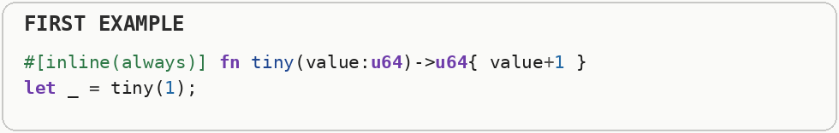
Size optimization balances inlining and code generation against the cost of a larger binary. Smaller code can load faster and fit better in cache, while some carefully chosen inlining may still be worthwhile on genuinely hot paths.

Inspecting Machine Code (Verifying Generated Assembly)
For small, extremely hot functions, don't guess whether an optimization "worked" - look at the generated assembly directly. Assembly is a human-readable representation of machine instructions. Inspecting generated assembly shows what the compiler actually emitted, which is useful when source-level intuition and optimizer behavior disagree. A hot path is code that runs very frequently or consumes a large share of total execution time. Optimizing cold code may make the source more complicated without producing a noticeable improvement. Source code describes intent, but the CPU executes machine instructions after all compiler transformations. Inspecting assembly reveals whether a loop vectorized, a bounds check disappeared, a call was inlined, or an unexpected allocation or branch remains.
High-level source can look efficient while the generated instructions contain unexpected calls, bounds checks, spills, branches, or missed vectorization.
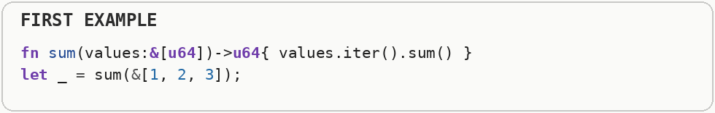
Exporting a small hot function makes its generated assembly easy to inspect. Assembly is the human-readable form of machine instructions, and checking it is how you verify what the compiler actually produced rather than guessing from source syntax.
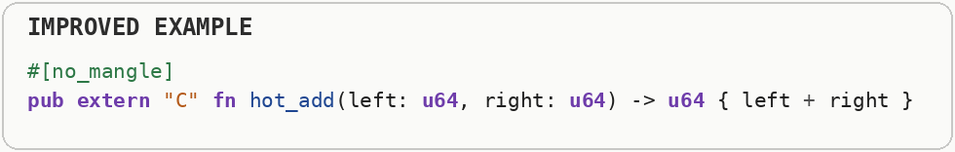

Link-Time Optimization (Cross-Crate Optimization Boundaries)
Don't just rely on an optimized release build. Enable link-time optimization in your the Cargo configuration file for production builds. Link-time optimization lets the compiler optimize across library or crate boundaries after separate compilation units are brought together. That wider view can enable cross-module inlining, constant propagation, and dead-code removal. A debug build favors fast compilation and extra runtime checks, while a release build enables aggressive optimization. Performance measurements from debug builds often describe compiler settings rather than the program you would actually ship. Normal compilation may optimize each module or crate with limited knowledge of the others. Link-time optimization preserves or reconstructs enough intermediate information at the final link stage to inline and simplify code across those boundaries, trading longer builds for a wider optimization view.
When a hot function lives behind a crate or library boundary, separate compilation can prevent the optimizer from seeing both caller and callee at the same time.
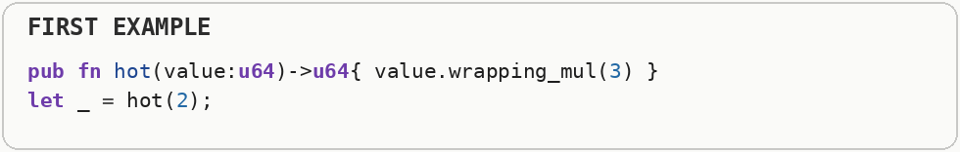
Link-time optimization gives the optimizer a whole-program view after individual units have been compiled. That can enable cross-boundary inlining and dead-code removal, at the cost of longer link times and sometimes larger build memory usage.

Profile-Guided Optimization (Static Heuristics vs. Measured Profiles)
For your most performance-critical binaries, go beyond static analysis - run the program on real workloads first, then feed that data back into a second, smarter compilation pass. Profile-guided optimization records which functions and branches are hot on representative workloads, then recompiles using that evidence. The compiler can arrange code and make inlining or branch decisions using observed behavior rather than static guesses. Compilers normally estimate which branches and functions are hot using heuristics. Profile-guided optimization records behavior from representative runs and feeds those frequencies back into compilation, allowing layout, inlining, and branch decisions to reflect the workload that actually occurs.
Without runtime profile data, the compiler must rely on static heuristics when deciding which branches are common and which functions are worth inlining.
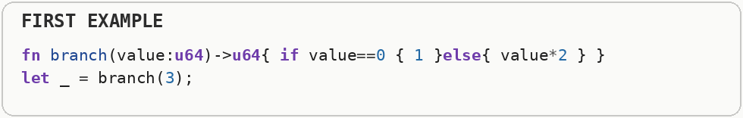
Profile-guided optimization first records behavior from a representative workload and then recompiles using those measurements. The second build can arrange branches, code layout, and inlining decisions around what the program actually did.
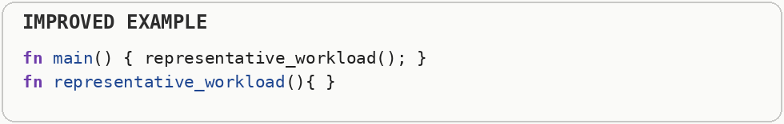

Symbol Visibility & Dead-Code Stripping
Alongside link-time optimization and static or dynamic linking choices, export only the symbols you must - every exported symbol is a root the linker must keep. Link-time optimization lets the compiler optimize across library or crate boundaries after separate compilation units are brought together. That wider view can enable cross-module inlining, constant propagation, and dead-code removal. A symbol is a named function or object the linker may need to preserve or expose. Restricting visibility gives the linker more freedom to remove unreachable code and avoids exporting implementation details that no external component needs. A symbol is a named function or object exposed to the linker or other binaries. Restricting visibility gives the toolchain more freedom to remove unreachable code, fold duplicates, and optimize internal calls because fewer definitions must remain externally replaceable.
Exporting an internal helper as a globally visible unmangled symbol tells the linker that outside code may need it, which can prevent otherwise removable implementation details from disappearing.
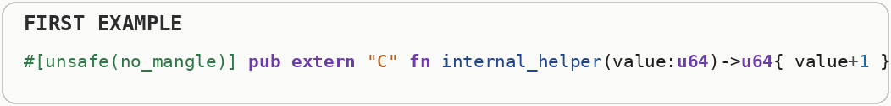
Keeping internal functions private gives dead-code stripping more freedom, while only intentional API entry points remain externally visible. Symbol visibility therefore affects both binary interface and how aggressively unused code can be removed.
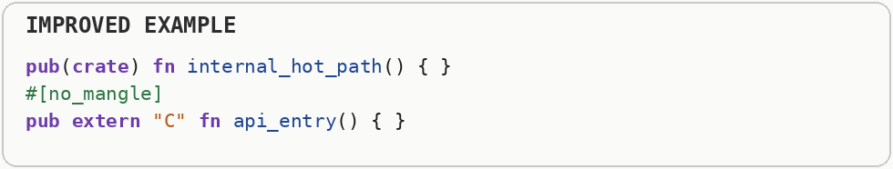

Dynamic Link Libraries (DLLs) vs. Static Linking
Static-link for the fastest, most predictable single binary; dynamic-link (dynamic-link libraries on Windows, .so shared objects on Linux, .dylib on macOS) when you need to share code across multiple processes or patch a dependency without recompiling everything that uses it. Static linking copies required library code into the final executable, producing a self-contained binary. Dynamic linking loads shared libraries at runtime so multiple programs can share code and libraries can be updated independently, at the cost of loader work and more runtime indirection. Static linking copies required library code into the executable, while dynamic linking resolves code from shared libraries at load time or runtime. Dynamic libraries can reduce duplication across processes and make updates easier, while static binaries avoid some loader indirection and deployment dependencies.
A dynamic-library boundary adds symbol lookup and indirect calls and also prevents some whole-program optimization, although it allows code to be replaced or shared without rebuilding the entire executable.
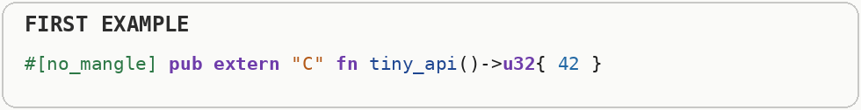
Static linking copies library code into the final program and gives the linker more opportunity for whole-program optimization. Dynamic linking is often the better engineering choice for plugins, independent updates, or shared system libraries, so speed is only one part of the trade-off.
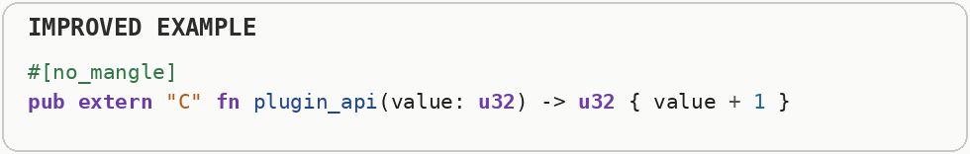

General Performance Principles (Language-Agnostic)

Interpreted vs. Compiled Execution
Understand which execution model your language uses, because it determines where your performance ceiling is and which of the optimizations in this document even apply. Compiled execution translates source into machine code ahead of time or through a just-in-time compiler, while an interpreter executes program instructions through another software layer. The execution model changes startup behavior, optimization opportunities, and the overhead paid for each operation. Compiled execution translates source or intermediate code into machine code ahead of time or through just-in-time compilation, while an interpreter repeatedly examines program instructions and performs their meaning at runtime. Interpretation improves flexibility and startup in some systems, but repeated decoding and dispatch can add overhead in tight computation.
The interpreter walks a list of operations and decides at runtime what each operation means, so every virtual instruction carries decoding and dispatch overhead.
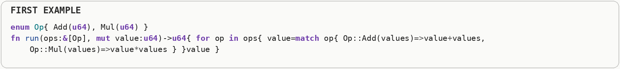
Compiled execution translates the program into native machine instructions ahead of time or through just-in-time compilation. The CPU can then execute those instructions directly, avoiding the interpreter's dispatch loop while trading away some runtime flexibility.
