**DATABASE LAB PROJECT**

GROUP MEMBERS:

**MUHAMMAD UMAID KHAN KHAKWANI**

I19-0666

**GHULAM MUSTAFA**

I19-0677

**IQRA MANZOOR**

I19-0614

SECTION D

FITME

* ERD:

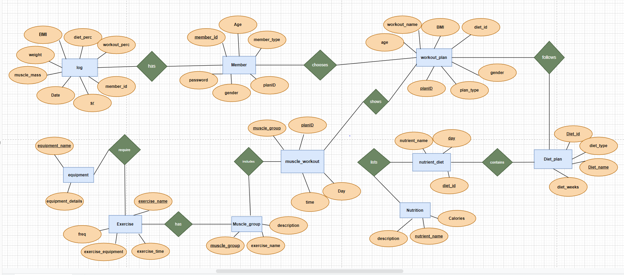

* Table description:
* Member:

Primary key is member_id. It is set to autogenerate the distinct values after every insertion. This table will be used to collect the information about the members and assign them a unique id which is set as primary key.

* Member_id (primary key)
* Password
* planID
* member_type
* Age
* Gender
* Workout_plan:

Primary key is planID. It is set to autogenerate the distinct values after every insertion. this table is used to make a plan for the workout.

* planID (primary key)
* workout_name
* Diet_id (foreign key )
* Age
* Gender
* Plan_type
* BMI
* Muscle_workout:

PlanID and muscle-group are composite primary keys of this table. This table contains the information of which muscle group the user targeted.

* planID (composite primary key)
* muscle_group (composite primary key)
* Day
* Time
* Muscle_group:

Muscle_group is the primary key in this table. This table contains the description and the exercise name of the targeted muscle group.

* Muscle_group (primary key)
* Description
* Exercise_name
* Exercise:

Exercise_name is the primary key in this table. This table stores the descriptions of the exercises to be performed.

* Exercise_name (primary key)
* Freq
* Exercise_equipment
* Exercise_time
* Equipment:

Equipment_name is the primary key in this table. This table stores the descriptions of the equipment on which the exercise is to be performed.

* Equipment_name (primary key)
* Equipment_details
* log:

Sr is the primary key in this table. It is set to autogenerate the distinct values after every insertion. This table maintains the log of each member

* SR (primary key)
* Member_id (foreign key)
* Workout_perc
* Diet_perc
* BMI
* Weight
* Muscle_mass
* Date
* Diet_plan:

Diet_id is the primary key in this table. This table stores the descriptions of the diet plans predefined.

* diet_id (primary key)
* diet_name
* diet_weeks
* diet_type
* nutrient_Diet:

Diet_id and day are composite primary keys in this table. This table stores the descriptions of the day number, the diet has to be followed.

* diet_id (composite primary key)
* day (primary key)
* nutrient_name (foreign key)
* Nutrition:

Nutrient_name is the primary key in this table. This table stores the description of the calories and meals of the day.

* Nutrient_name (primary key)
* Calories
* Description
* Schema diagram

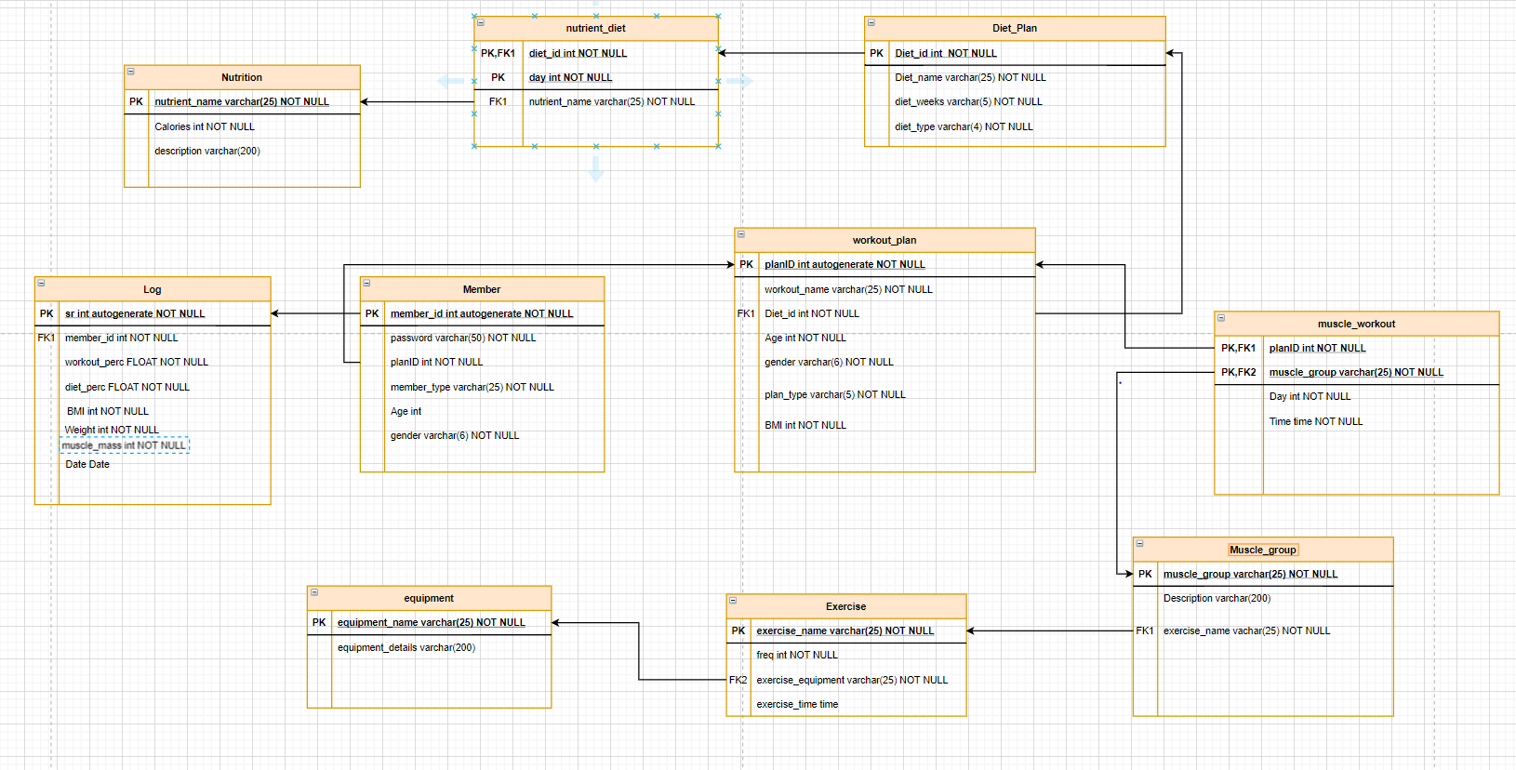

* interface