Project Documentation

CPU Scheduling Algorithms Explanation

project contains 4 scheduling algorithms:

- SRTF (Preemptive SJF)
- Priority Preemptive
- SJF Non-Preemptive
- Priority Non-Preemptive

1) SRTF (Shortest Remaining Time First)
Type Preemptive SJF

Main Idea
The CPU always executes the process with:
- Plain text
- Shortest Remaining Time
If a new process arrives with a smaller remaining time, the current process is interrupted immediately.
This is called:
- Plain text
- Preemption
How It Works Step-by-Step
At every single time unit:
Check all arrived processes
Choose process with smallest remaining time
Execute it for ONLY 1 unit
Decrease remaining time
Repeat again

Advantages
- Best average waiting time
- Very efficient
- Good responsiveness
Disadvantages
- Many context switches
- Complex implementation
- Long jobs may starve

2) Priority Preemptive
Type Preemptive Priority Scheduling
Main Idea
CPU always executes:
- Plain text
- Highest Priority Process
Usually:
- Plain text
- Smaller number = Higher priority
Advantages
- Important tasks execute first
- Good for real-time systems
Disadvantages
- Starvation
- Low-priority processes may wait forever

3) SJF Non-Preemptive
Type Non-Preemptive
Main Idea
Choose process with:
- Plain text
- Smallest Burst Time
BUT:
Plain text
Once CPU starts process,
it finishes completely.
No interruption allowed.
How It Works
- Choose shortest burst
- Execute process
- Then choose next shortest

Advantage
- Simple
- Low overhead
- Fewer context switches
Disadvantage
- Poor response time
- Short jobs may wait long

4) Priority Non-Preemptive
Type Non-Preemptive Priority
Main Idea
- Choose highest priority process.
BUT:
- Plain text
- Once execution starts,
- process cannot be interrupted.
How It Works
- Select highest priority
- Execute completely
- Select next process
Advantages
- Simple implementation
- Stable execution
Disadvantages
- Important processes may wait
- Worse responsiveness

Project scenarios :

Scenario A
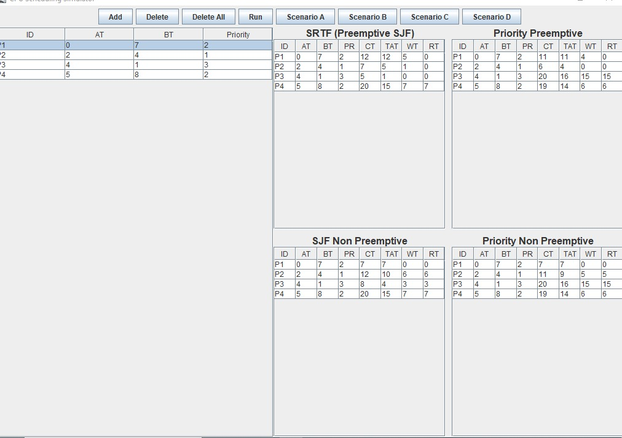
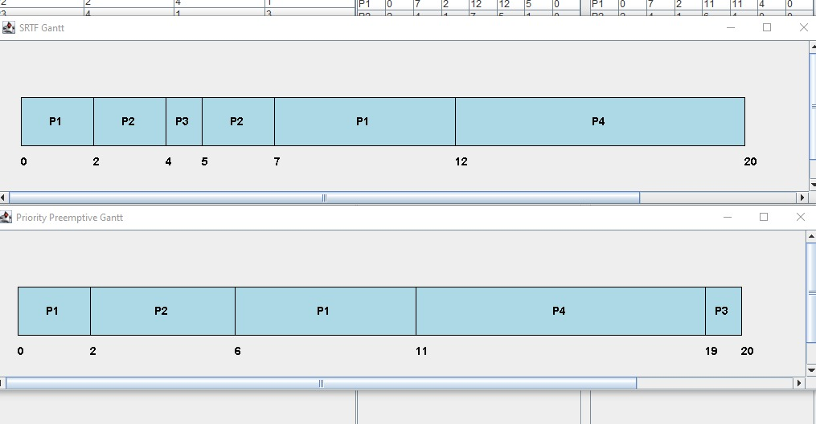
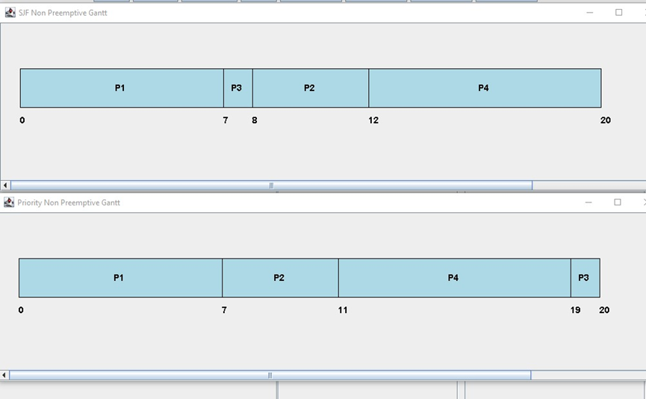
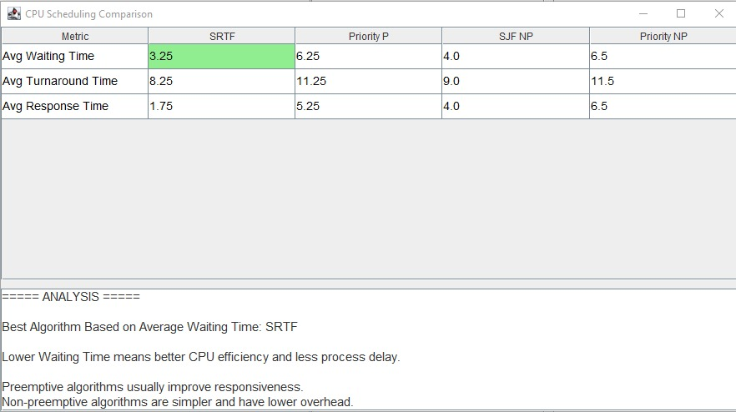

Scenario B
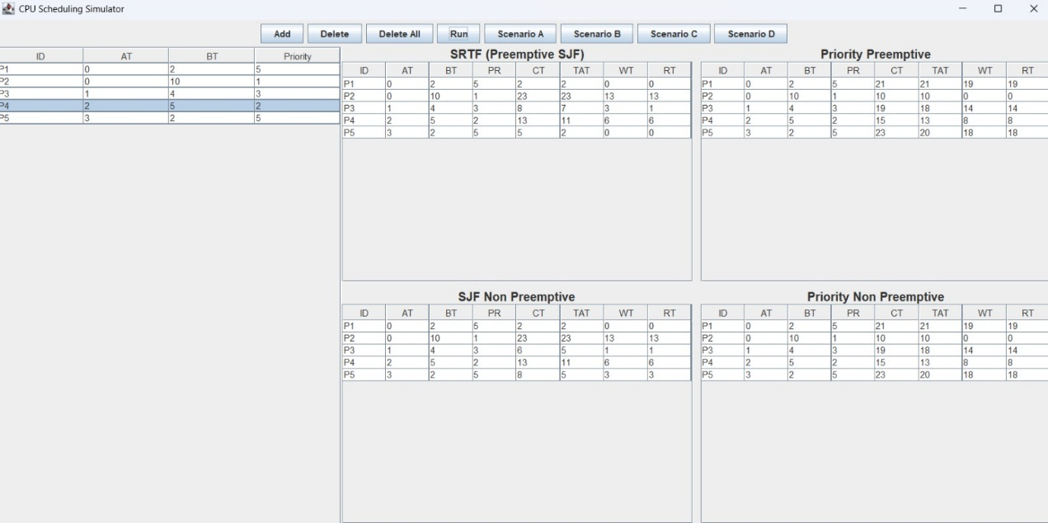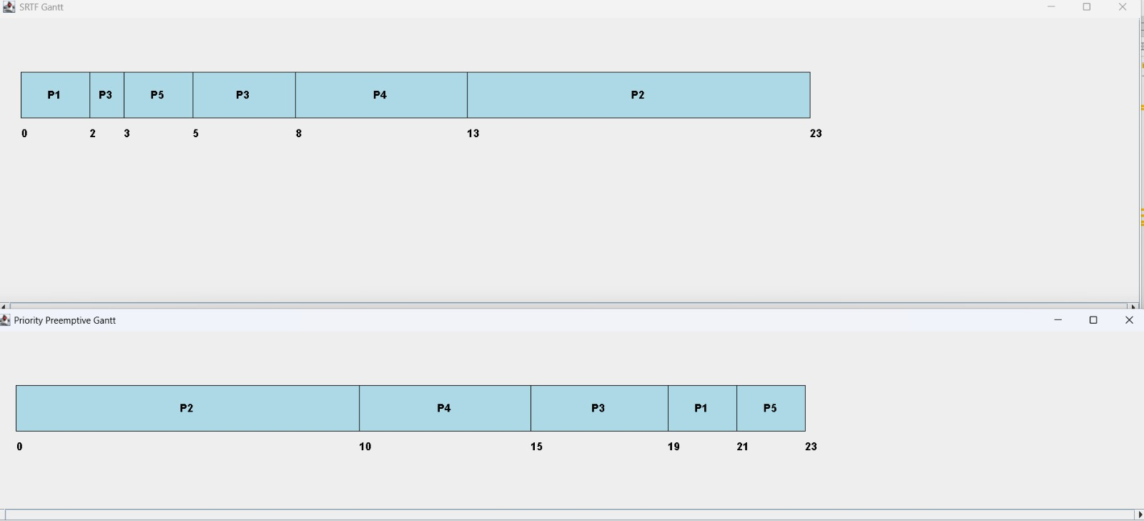
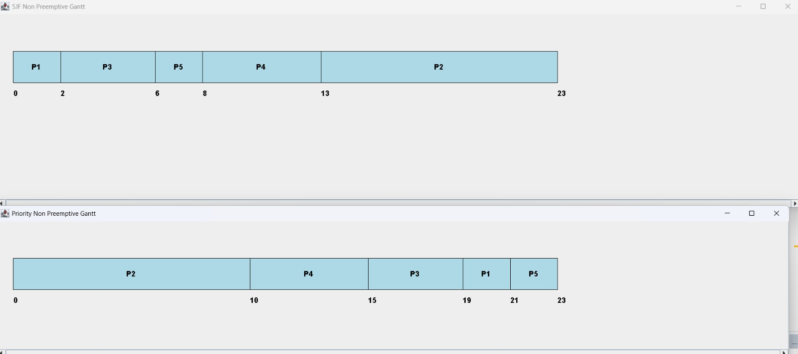
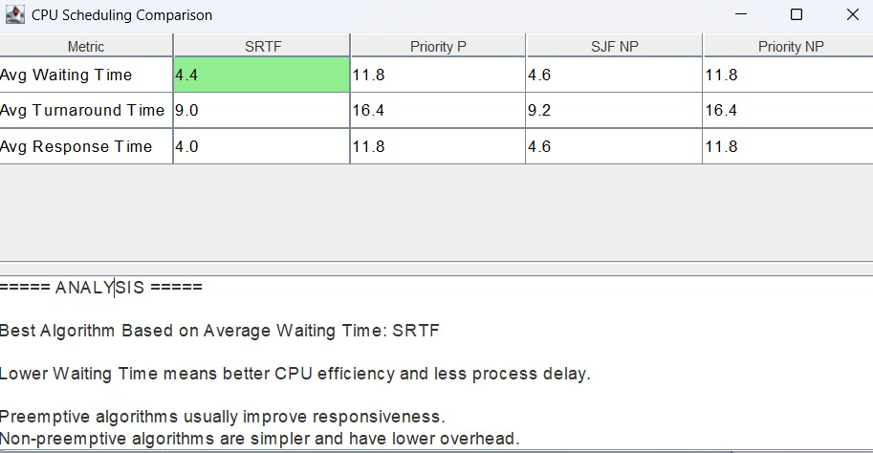

Scenario C

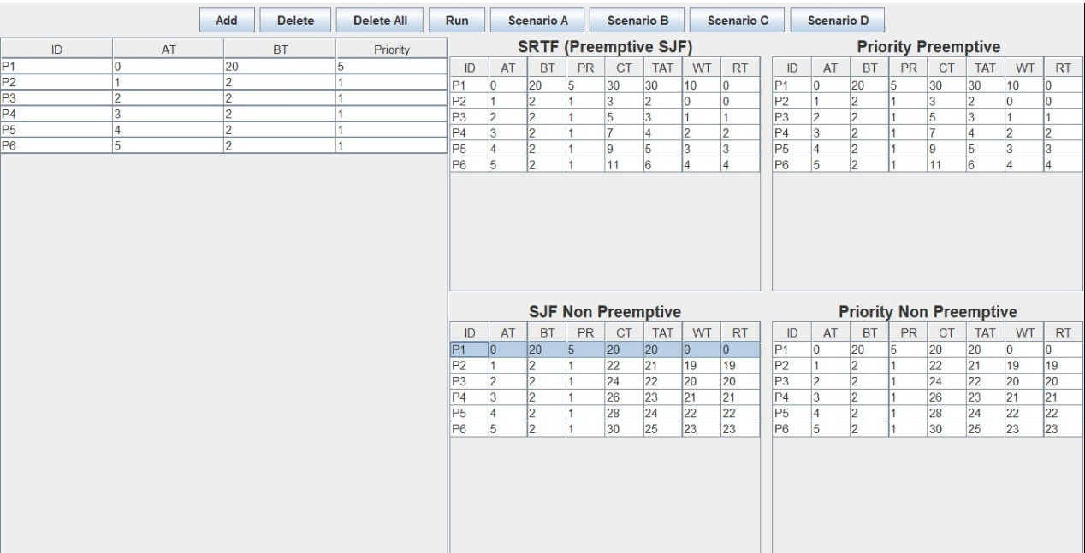
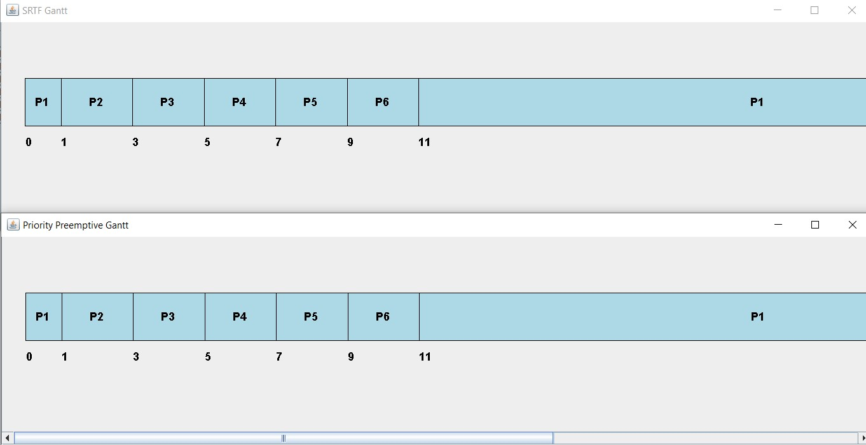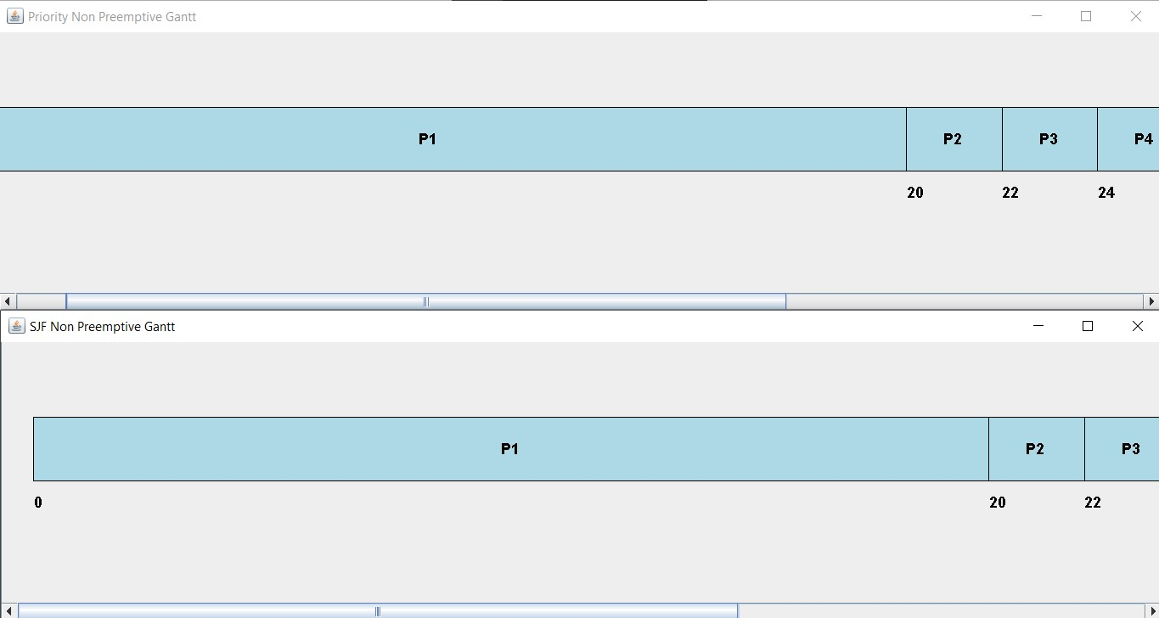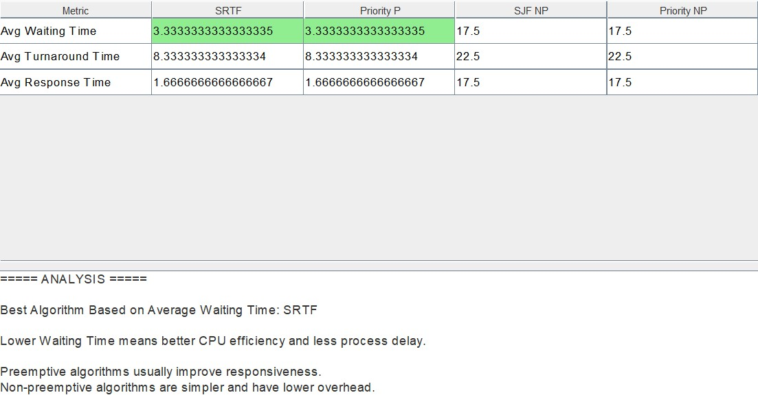

Scenario D
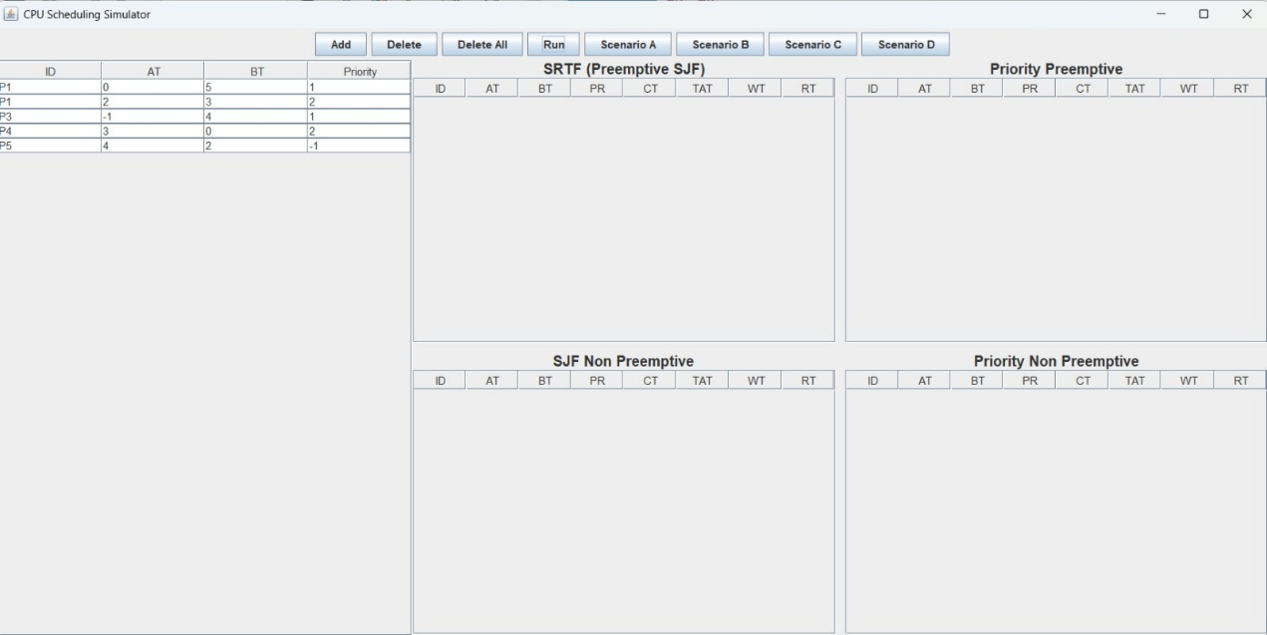
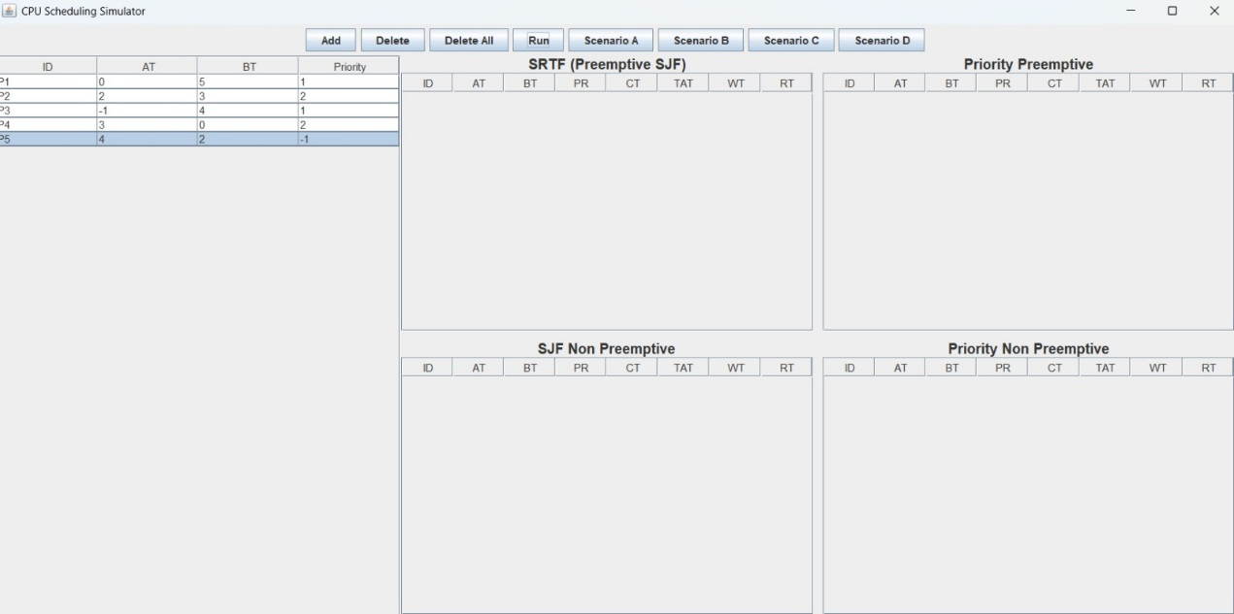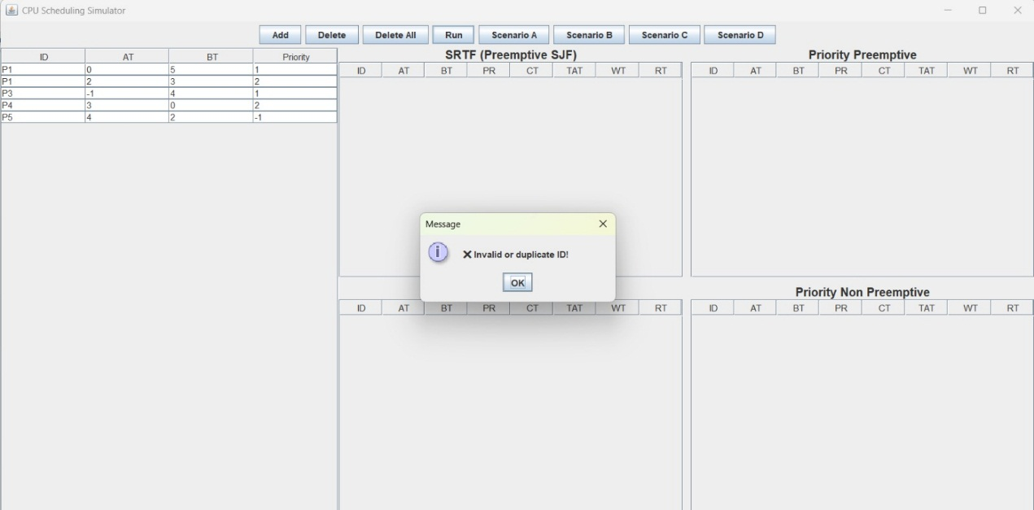
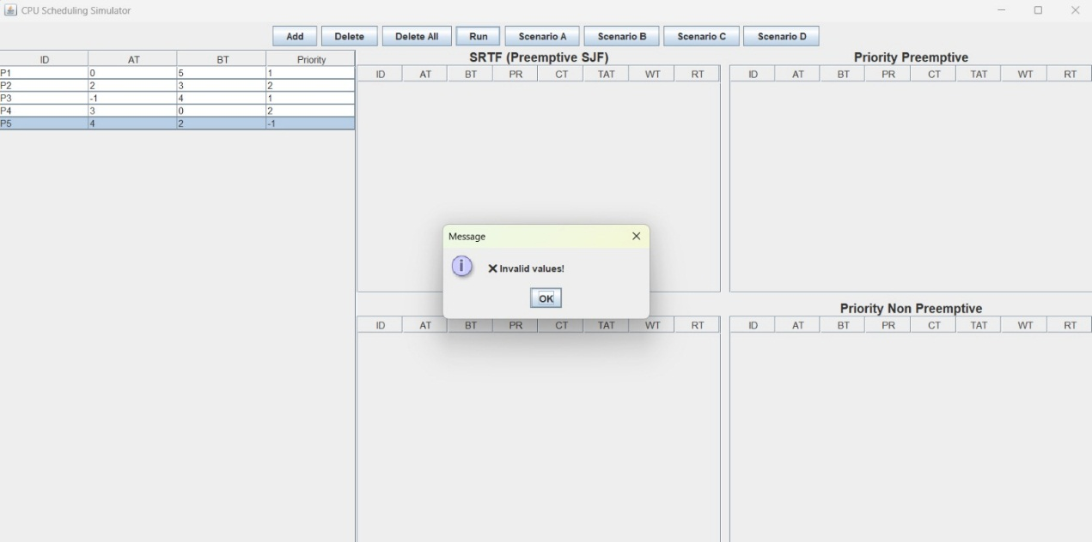

Required Analysis Questions :

1) Which algorithm gave lower average waiting time?
Usually, SJF gives lower average waiting time because it executes the shortest burst time processes first, reducing overall waiting in the system.

2) Which algorithm gave lower average turnaround time?
In most cases, SJF also provides lower average turnaround time since turnaround time depends on waiting time, and SJF minimizes it.

3) Did SJF favor short jobs more strongly?
Yes. SJF is specifically designed to prioritize short CPU burst processes, so it strongly favors short jobs.

4) Did Priority Scheduling favor urgent processes more strongly?
Yes. Priority Scheduling executes higher-priority processes first, so it favors urgent or high-priority tasks depending on how priorities are assigned.

5) Was any starvation or unfair delay observed?
- In SJF, long jobs may experience starvation if short jobs keep arriving.
- In Priority Scheduling, low-priority processes may suffer starvation if high-priority processes keep coming.
So starvation is possible in both algorithms.

6) Which algorithm would you recommend for the tested workload, and why?
If the goal is to minimize average waiting and turnaround time → SJF is generally better.
If the system requires handling urgent tasks first → Priority Scheduling is more appropriate.
For most performance-based workloads, SJF gives better average results, but it may cause starvation.

Required Conclusion

- Which algorithm performed better on the selected datasets?
On the selected datasets, SJF generally performed better in terms of overall performance because it minimized the average waiting time and average turnaround time.

- Which metric each algorithm handled better?
  - SJF handled Average Waiting Time and Average Turnaround Time better.
  - Priority Scheduling handled process importance / urgency better by executing higher-priority processes first.

- Trade-off between efficiency and urgency:
There is a clear trade-off between efficiency and urgency.
SJF focuses on efficiency by reducing total waiting and turnaround time, but it may delay long processes.
Priority Scheduling focuses on urgency, ensuring important processes are executed first, but it may increase waiting time for low-priority processes.

- Which algorithm appeared fairer in practice?
In practice, SJF may cause starvation of long processes, while Priority Scheduling may cause starvation of low-priority processes.
Therefore, neither algorithm is completely fair, but fairness depends on the workload and priority assignment.

